The City Of
Greater Geelong

National HOusing and Homelessness Plan

  - Submission

Contents
Executive summary 3
Introduction 5
Housing affordability issues in Geelong 6
House prices and affordability 6
Housing supply and consumption 6
Housing Stress, Homelessness And Affordable Housing Need 7
A framework for housing delivery 8
Implications of monetary policy and tax treatment of properties 10
Housing Affordability 10
Monetary policies and housing demand 10
Tax treatment of property 10
Improving access to social and affordable housing in Geelong 12
Planning system, housing and sustainability 13
Infrastructure planning and funding 13
Responding to climate change 14
Sustainability in Housing – case studies 14
Supporting and reducing homelessness in Geelong 16
City of Greater Geelong’s Effort in Homelessness and Rough Sleeping 16
Other Homelessness Support Agencies Providing Services within Geelong 16
HOUSING FOR ABORIGINAL AND TORRES STRAIT ISLANDERS 19
References 20

List of figures
Map 1: Boundary of the City of Greater Geelong
Figure 1: Households type and Future Forecast (.id.2023)

Figure 2: Framework for National Housing & Homelessness Plan alignment with National Urban Policy.

Executive summary
A well-functioning system of housing production is essential for the current and future generations in Australia. Housing is a basic need and it plays a vital role in health, wellbeing and economic participation. A sustainable system of housing production must be able to meet current needs without compromising the ability of future generation to meet their own needs. There is a significant risk to future generations if the issues of continuing trend rise in house prices, reduced affordability, dwindling demand supply, lack of housing diversity and lack of affordable housing continue to persist.
There is an estimated current need of 5,000 social and affordable housing dwellings in Geelong (.id 2023 in ABS 2021) and will require 13,500 of all dwellings in 2041 to achieve the 7 per cent target (GoGG 2021). While the overall affordable housing need is increasing, people experiencing homelessness have increased from 743 to 1,533 in the 5 years between 2016 to 2021 which is at 51.5 per cent growth in the period. There are 636 homes required for young Aboriginal families (3-bedroom homes) in this region by 2041 (CoGG 2021). These are highlighted implications for lack of appropriate access within a wide spectrum of housing need, more acute towards the moderate to lower income households.
The City of Greater Geelong is currently implementing its Social Housing Plan with strategies in Leadership, Planning, Investment and Partnerships and are actively negotiating with developers for inclusionary contribution through planning as well enabling partnerships in social housing developments (COGG, 2021). There is a significant gap to fill if the target of 7 per cent social housing is to be achieved by 2041 from the current 4 per cent, requiring approximately 20 -25 per cent of all Geelong’s future housing to be delivered as social and affordable housing.
The National Housing and Homelessness Plan (NHHP) must consider all different policy development options for a national urban policy to balance the unintended consequences of monetary policies and tax settings at national level to achieve its goal in alleviating housing affordability in local communities.
At a macro level, housing affordability issues are complex and related to indirect causes such as growing population, supply and demand issues, planning, infrastructure, investments with taxation at all levels of government (NHSC 2010; Yates 2008). Monetary policies, such as raising interest rates have unintended consequences on house prices that affect demand and supply responsiveness from developers and end users (Ong et.al 2017). Housing prices for detached houses and in expensive areas are more cyclical and are more susceptible to interest rate fluctuations compared to apartments and those in regional areas, which tend to experience a less pronounced cyclical effect. (RBA 2022, Corelogic 2022). Despite being categorised as a regional area, Geelong's housing market has experienced a remarkable surge, with median house prices skyrocketing by 88.5 per cent over the past decade, exceeding the Victorian regional average by 20 per cent (REIV in CoGG 2023; PropTrack in .id 2023). Rental prices have mirrored this trend, escalating by over 20 per cent since 2020, adding to the affordability pressures on Geelong's communities.
Planned intervention to increase supply of land from good land use planning policies alone will not be enough. A well-functioning system of housing production must have the ability to continue supplying housing based on need as an alternative that are ‘counter cyclical’ to the market housing delivery when demand (for both investors and owner occupiers) declines.
Delivery of housing supply based on need, parallel to the private housing market system can provide stability to the overall housing market and its supply chain. For this, consistent funding and financing are required and the substantial increase in housing delivered could be facilitated through the creation of a special entity that invests in land, infrastructure at state or local level to capture the demand based on housing need and enabling supply that meets the objectives of a national urban policy as well as state and local planning objectives.
Federal funding to enable land and infrastructure opportunities for housing could be channelled through state and local funding agreements that are linked to requirements and outcomes that support a range of housing led initiatives:
- Requirement to set targets for housing, including affordable housing.
- Setting a vehicle or entity that increase supply of land, infrastructure for more opportunities in housing.
- Land supply and infrastructure requirements to meet housing targets and increase housing affordability.
- Specific projects that deliver more social and affordable housing, meeting national policy objectives.
- Fund innovation in developing alternative housing and sustainable development.
- Homelessness prevention
- Aboriginal housing provision
A national urban policy should streamline objectives at the national level on housing affordability, climate targets, sustainable transport, infrastructure and denser urban development objectives that can be translated into state and local level planning outcomes. The NHHP needs to have realistic expectations for demand and supply side interventions to find alignment between monetary policies, tax reform along with a national urban policy translated into local planning delivery.
A national urban policy must consist of a framework that guides housing developments toward sustainable outcomes and achieve national objectives in reducing greenhouse emissions, such as through net zero initiatives that are planned at neighbourhood scale.
Planning for sustainability at a neighbourhood scale provides opportunity for integration and assessment with other aspects in planning such as density, infrastructure and transport with economies of scale for a decentralised system (Duhr et al 2023) that support energy efficiency and renewable energy in home networks. Institutional governance can then guide interactions and engagement with communities to achieve social sustainability while aiming to achieve the national policy goals such as climate targets.
We need urban policies that align with funding to deliver infrastructure and amenities that respond to the different housing needs within our communities, including provision of affordable housing. Unless the National Housing and Homelessness Plan aligns monetary policy and tax reform with a national urban policy to achieve a well-functioning system of housing production, affordability issues will perpetuate and become more difficult to mitigate for our future generation.
Streamlining national urban policy and the housing plan with funding will increase opportunities and improve housing outcomes in the Geelong but these alone will not be enough to tackle the issue of homelessness.
In 2022-23, the federal government had provided $1.6 billion through the National Housing and Homelessness Agreement (NHHA) to the states and territories to focus on four key areas prevention, early intervention, transitional housing and supportive housing. Our service agencies prioritise the allocation of funds toward prevention and early intervention programs that address the root causes of homelessness. Additionally, we advocate for a comprehensive study to investigate the unmet needs of those experiencing homelessness, enabling support agencies to tailor their support services. These measures include stocktake of current services, to determine the level of funding required to meet the needs of people experiencing homelessness. The next agreement should include clear roles and responsibilities, with endorsed set of principles for improving outcomes across tenure types and single base funding pool for housing and homelessness services that is allocated to jurisdictions according to need and the costs of providing services.

Introduction
The City of Greater Geelong is Victoria’s largest regional municipality and the primary service and employment hub for the region. The Wadawurrung are the Traditional Owners of the land where the City of Greater Geelong is located.
Located 75 kilometres south-west of Melbourne, the municipality covers an area of 1,252 square kilometres comprising suburban, coastal, and country areas. Map 1 shows the boundary of the City and local areas within it.
The Census usual resident population of the City of Greater Geelong in 2021 was 271,057, living in 120,825 dwellings with an average household size of 2.41. Geelong’s population is expected to grow by an estimated 30% to 360,245 in the next 15 years. Forecast number of dwellings is estimated to grow from 120,587 in 2021 to 177,550 in 2041.
Other important population highlights are in the following:
- Aboriginal and Torres Strait Islanders: 1.3%
- Median Age: 39
- Couples with children: 27%
- Lone persons: 26%
- Older couples without children: 12%
- Households renting: 27%
- Households with mortgage: 33%
- Unemployment Rate: 4.4%
- Participation in labour force: 61%
- University qualification: 24%
It is a popular retirement destination and there is a significant summer increase in temporary residents. There are estimated 74.4% of residents that live and work in the municipality. Geelong’s housing challenges are unique due to population growth and our role as a regional employment hub. These housing challenges are discussed in the following section.
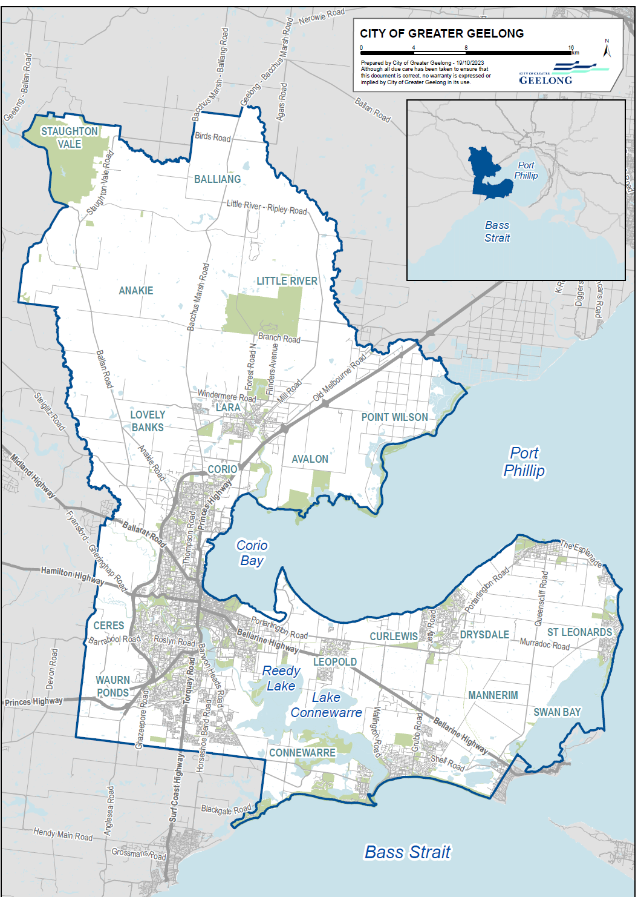
Map 1 –City of Greater Geelong boundary and local areas

Housing affordability issues in Geelong
The following section discusses the overall housing issues in Geelong related to price, affordability, supply and forecast consumption of housing.

House prices and affordability
- Median house prices in Geelong are $730,000 while unit prices are $518,000 (Dec 2022). Prices are higher the overall regional average by at least 20 per cent, comparing with other regional centres (analysed in REIV in CoGG 2023; PropTrack in .id 2023).
- Median house prices in Geelong have increased by 88.5 per cent over the last 10 years. In the period between 2020 to 2022, the increase was around 30 per cent, indicating the intensity of the increase (analysed in CoGG 2023).
- Housing price to income ratio has increased from 6.0x in June 2016 to 10.8x in December 2021 (analysed in .id 2023; ABS 2016; ABS 2021; PropTrack 2022), signalling that the market has become less affordable. The increase of the price to income ratio in the 5 years between 2016 to 2021 usually correlates with higher deposit and lesser ability to obtain a loan.
- Based on median house price, a 20 per cent minimum deposit required now is at $146,000.
- Although wages have increased from $1,242pw to $1,625pw, the time required to save for deposit are longer because of the rate and quantum of house price increase is substantially more that wages.
- Median house rent is $480 while $395 is the median unit rent and these are about 10 per cent higher than the regional average.
- Median rental prices in Geelong have increased by 20 per cent since 2020. This is increase is problematic because it affects a substantial number of households in the municipality, estimated to be about 30-35 per cent of households that are renting.

Housing supply and consumption
- Geelong’s population will grow 30 per cent to 360,245 in the next 15 years. In meeting the demand for growing population, the forecast number of dwellings is estimated to grow from 120,587 in 2021 to 177,550 in 2041 (.id, 2023).
- Household formation is changing, smaller households (lone person and couples) are emerging and expected to outpace larger households with estimated 50 per cent growth in the next 20 years (.id 2023).
- Separate houses make up to 86 per cent of supply in the City while medium and high-density housing typology such as units and apartments makes up the other remaining 14 per cent.
- As a regional city and growth area, the demand of housing in the market system is being met predominantly and large dwellings in greenfield subdivisions (75 per cent of new housing supply) (.id 2023).
- There has not been enough delivery of housing diversity in smaller dwellings for smaller households to have a choice, leading to private rental sharing between smaller households to sustain the effect of rental price increase, leading to the issue of overcrowding.
- Only 0.9 per cent of housing supply is affordable to rent for very low-income households as compared to 15.5 per cent of low-income households. There are 81 per cent of properties that are affordable to rent for moderate income households.
- There are significant home purchase affordability pressures on very low to moderate income households. Less than 1 per cent of dwellings in the municipality are affordable to purchase by low and very low-income households. Only 8.7 per cent of dwellings are affordable for purchase by moderate income households (.id 2023). Without intervention, the proportion of home ownership for these households will continue to decline.
- Lone persons (6.7 per cent) and families (8.7 per cent) in the very low to moderate income group are most in need for affordable housing, compared to all households in Geelong, as these group struggle the most to access the private housing market.
- New homes approvals are declining June 2022 to 2023 by approximately 22 per cent at 3,061. However, water connections by Barwon Water, shows a year-on-year increase of 26 per cent at 4,010 new connections on serviced land that achieved compliance. The overlap between reduction and increase is due to the lag effect between approvals and delivery and the taper off from new supply to existing approved delivery. This data will be tracked again in the following year.

Housing stress, homelessness And affordable housing need
- There are total of 9,056 (8.4 per cent) households in the municipality that are in housing stress.
- There are 25.6 per cent or 6,603 number of households renting in the municipality that are in rental stress. Most households in rentals stress are single and family households.
- At least 7 per cent or 2,463 number of households with a mortgage in Geelong are in mortgage stress, mostly affecting the low to very low-income households.
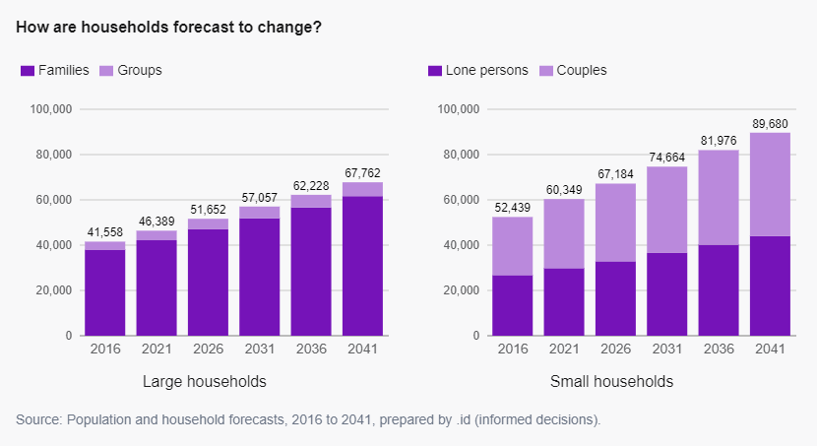
- People that are experiencing homelessness and without a home increased from 743 to 1,533 in the 5 years between 2016 to 2021, registering a 51.5 per cent growth in the period.
Figure 1: Households type and future forecast (.id.2023)

- Social and affordable housing need based on 2021 data:
  - 177,550 estimated overall housing supply required by 2041 compared to current supply in 2022 of estimated 123,450 dwellings.
  - In 2021, there are 4,848 households (4.7 per cent) need affordable housing in Greater Geelong for in the very low, low to moderate income households category.
  - Approximately 12,800 social and affordable housing dwellings are required in the municipality by 2041 to achieve the seven per cent of overall housing target set out in Geelong’s Social Housing Plan.
  - The seven per cent target will require and estimated 23.5 per cent of 53,000 total new dwellings forecast by 2041.

Implications of monetary policy and tax treatment of properties
This section discusses the issues on housing affordability in relation taxation settings and monetary and the prospects of the National Housing and Homelessness Plan.
Australia’s tax setting and monetary policy can both play a role in influencing housing affordability. By carefully considering the impact of tax and fiscal policy on housing affordability, the government can develop policies in the National Housing and Homelessness Plan that help to make housing more affordable for current and future Australians.

Housing Affordability
Housing affordability issues are complex and related to indirect causes such as growing population, supply and demand issues, planning, infrastructure and investment along with taxation at all levels of government (NHSC 2010; Yates 2008). Research shows that current taxation policy settings reduce housing affordability by impacting house prices, reduce mobility, adding to intergenerational wealth gap and reform on tax settings will be required (Wood, Ong et al. 2010; Wood and Winter 2012; Wood, Ong et al. 2014; Worthington 2012; Yates 2011, 2012). Reforms in housing related taxation and transfer system can significantly improve outcomes in housing affordability (Eccleston et al 2018).

Monetary policies and housing demand
Monetary policies are required to achieve a range of economic goals, including price stability, economic growth, and employment targets. Monetary policies can also have unintended consequences, such as increasing or decreasing house prices although the intent of the policy is not directly targeted towards housing. The relationship between housing and monetary policy is multi-dimensional and complex.
It is important for policy options to consider the impact of interest rates and supply responsiveness from developers (Ong et.al 2017). Interest rates movement affect not only developers but owner occupiers and investors that purchase properties from the housing market. Higher interest rates mean less participation in the market by owner occupiers and investors which reduces demand.
The availability and cost of finance is a critical driver of housing supply by which developers respond to (Rowley and Phibbs 2012; Hwang and Quigley 2006). When interest rates rise, it becomes more difficult for developers to obtain finance, even if it is available, there are significant increase of risk to finance development projects. This will add more pressure to the available supply as less housing are being delivered, particularly in the rental market.
The National Housing and Homelessness Plan should have provisions that incentivise developers to deliver counter cyclical housing projects that meet the objectives of national urban policy in achieving consistent supply of housing that is based on need for social and affordable housing.
The availability and cost of finance is a critical driver of housing supply by which developers respond to (Rowley and Phibbs 2012; Hwang and Quigley 2006). When interest rates rise, it becomes more difficult for developers to obtain finance, even if it is available, there are significant increase of risk to finance development projects. This will add more pressure to the available supply as less housing are being delivered, particularly in the rental market.
The National Housing and Homelessness Plan should have provisions that incentivise developers to deliver counter cyclical housing projects that meet the objectives of national urban policy in achieving consistent supply of housing that is based on need for social and affordable housing.

Tax treatment of property
There has been substantial academic analysis (Wood, Ong et al. 2014; Evans and Krever 2009 Worthington 2012; Yates 2008; Disney 2006), national enquiries (Harmer et al. 2009) and discussions from government (Australian Government 2015) to independent institutions such as Grattan Institute (Coates et al. 2018; Daley and Coates 2015), about implications of property tax treatment as one of the many factors that contribute to problems in the housing market, including the income that property generates as investment assets. It was purported that tax treatment and settings influence the provision of:
- new housing supply and land use,
- the demand for housing by level of investment in relation to other assets classes,
- labour mobility
- the capacity for housing mobility with changing needs of households
Federal level income tax arrangements can have indirect but significant impact on housing market decisions by property owners including both owner occupiers and rental investors. Negative gearing allows investors to deduct ongoing expenses and losses pertaining to their rental property in their taxable income. These provisions encourage investors to invest in properties as rental housing, leading to a tax reform discussion that negative may impact the private rental market and supply of housing. (Ong. Wood et al. 2011). At the federal level, reform pathways for federal tax policies will be required such as a cap on negative gearing and Capital Gains Tax discount for investment properties to be reduced over a time. The impact of these tax adjustments that disincentivise individual investments in property can be balanced with redirecting a proportion of these tax adjustments to fund counter cyclical housing initiatives such as affordable housing and its related land or infrastructure projects.
Taxation at the state level indirectly influences housing supply in many ways. Stamp duties are a tax on property transfers and are seen as a barrier to housing supply as it affects not only investors in properties but developers purchasing land to develop incurs stamp duty liability in the process. Windfall Gains Tax for rezoning of land imposes a levy on landowners for unearned profit but may require developers to undertake more risk if the landowners decide to pass on the cost to developers. A developer may decide to be more selective in development projects with consequences on supply of land and housing.
A proportion of these value capture outcomes and levies could be reinvested (through funding or financing) to incentivise developers and landowners to provide housing that is based on need, such as social and affordable housing to maintain the continuity of housing supply.

Improving access to social and affordable housing in Geelong
This section discussed the issues, barrier and need to improve access to increase social and affordable housing.
There are an estimated 4,848 households (4.7 per cent of all households) that need affordable housing, including social housing based on the 2021 Census data analysis (.id 2023).
The City of Greater Geelong’s Social Housing Plan seeks seven per cent social and affordable housing that is for the very low to moderate income households by 2041 (CoGG 2021). There are 12,800 remaining social housing dwellings required to achieve the target. It will require 23.5 per cent of all new dwellings to be delivered as social housing from now until 2041, which is a significant gap to fill.
In general, the funding gap was found to be one of key issues in social and affordable housing delivery, causing a back log of major supply, maintenance and renewal. The funding gap exists due to the gap between the cost of development and low revenues from low-income tenants, making the social housing investments and delivery not viable from a financial feasibility perspective (Lawson J. et al 2018). There is very limited ability for social housing developments to carry debt even with Commonwealth Rental Assistance. Because of the funding gap, other measures were required to reduce operating and development costs leading up reduced renovation and construction, impacting on the quality and supply of new stock over the past 20 years.
A productive housing system should include social affordable housing in creating value, increasing innovation throughout its supply chain, and aligning with urban planning objectives to make the best use of land resources and drive toward a liveable, more inclusive and sustainable outcomes through investments in social affordable housing.
As of March 2022, the city recorded a total of 4,988 social housing dwellings, representing 4 per cent of the total dwellings in the municipality. This is a 16 per cent increase in social housing since the adoption of the Social Housing Plan. There are approximately 200 additional dwellings anticipated for Greater Geelong funded by the Big Housing Build. These dwellings are currently in the planning stages and delivery is expected to take place in the next 2-3 years. These increases are mostly funded through the Victorian Government’s Big Housing Build which demonstrates the importance of funding and continuity of funding.
Recommendations:
How can all levels of government, along with housing organisations, institutional investors, not-for-profits, and private industry, improve access to social housing, which includes public housing and community housing?
- Mandate social and affordable housing inclusion in rezonings and new developments providing certainty to property industry.
- Funding continuity through capital grants and increased efficiency in affordable housing financing.
- Encourage institutional mergers of non-profit businesses to scale up delivery. Thereby increasing opportunities for housing providers to diversify their portfolios.
- Set housing targets in conjunction with state and local authorities including affordable housing.
- Make land available to affordable housing projects through land use planning process that align and meets national objectives in planning outcomes such a in density locations collocated with public transport and amenities.
- Value capture, such as proportion of windfall gains tax in Victoria for rezoning that are financed or invested directly into land and housing related infrastructure in the same locality that will incentivise the delivery of social and affordable housing.
- Incentivise social and affordable housing inclusion with a clear mechanism for delivery with a closed loop system of providing incentives for developments of significant scale.
  - Clear planning approval pathways.
  - Density bonuses, transfer of development rights with an appropriate legislation and mechanism to implement.
  - Cash contributions, tax credit with qualifying mechanism, ways to calculate and allocate the credit and transferability.
  - Funding incentives for social and affordable housing developments through redirecting proportion of tax reform in stamp duties, windfall gains tax at state level, tax depreciation of asset at federal level.

A framework for housing delivery
The following diagram provides a potential framework for the National Housing and Homelessness Plan, indicating how the national urban policy interface with other policies in alignment with funding opportunities to create a system of housing production.
An effective NHHP must work hand in hand with a national urban policy and objectives that can be translated in state and local planning policies and implemented through the planning system within local jurisdictions.
National urban policies within the NHHP should set goals and outcomes in key areas, in relation to housing to create sustainable and equitable cities:
- Housing affordability and diversity
- Transport planning and alignment with housing
- Climate Change with national targets and directions for state/local planning

Infrastructure delivery for urban developments that align with funding opportunities.
Figure 2: Framework for National Housing & Homelessness Plan alignment with National Urban Policy

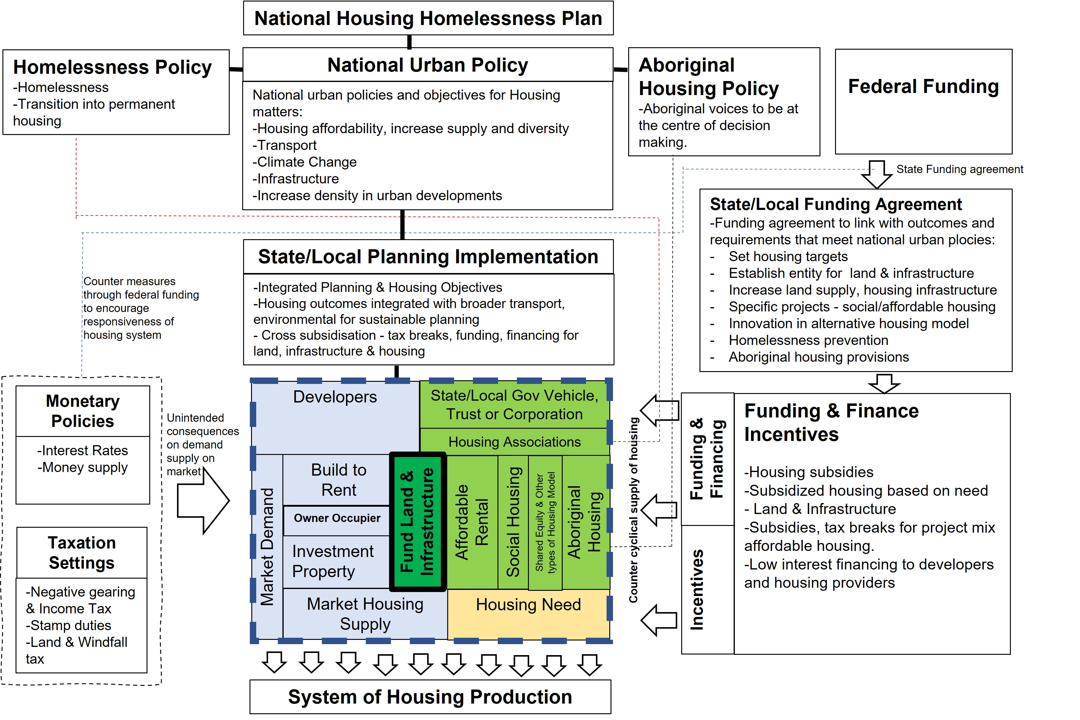
- Increase density within urban development in appropriate locations.
The NHHP should set national urban policies that are in alignment with monetary policies and provide more opportunities to deliver housing, particularly with a mix of private and affordable housing as an alternative that can be leveraged with different policies for housing delivery that are counter cyclical housing market can continue when the regular market housing stalls.
For this, there needs to be targeted funding, an appropriate delivery vehicle at state and local level to plan and make available housing supply (particularly affordable housing) to the address the ongoing need. This is to insulate the housing need from the distortion in housing market from economic downturn or inflationary cycle.
A combination of demand and supply side counter measures such as subsidies, tax breaks, funding, low interest finance facility to end user and developers to fund ongoing land acquisition, infrastructure housing projects would be required to incentivise supply responsiveness that meet the objectives of a national urban policy.
Examples are federal withholding tax rate reduction for eligible residential build-to-rent projects and asset depreciation rate from 2.5 per cent to 4 per cent per year and land tax concession at state level such as 50 per cent reduction for built to rent projects. These counter measures will increase the responsiveness of institutional funded developers to increase supply rental properties and offset the investment demand of individuals that are affected by rise in in interest rates. Further review would be required on its effectiveness and opportunities for expansion into other housing delivery models, such as rent to own and shared equity schemes.
Social and affordable housing projects, that are counter cyclical to the private housing market could be further enabled through greater intervention by a publicly backed development entity. A development entity could acquire land and deliver infrastructure that interfaces with landowners and developers. The entity would be able to plan implementation with state and local jurisdictions where the national urban policies are translated into deliverables through the planning system.
Funding availability an entity, such as Housing Australia Future Fund (HAFF) or other funding streams can be directed through state and local government through broader and specific agreements, depending on the objectives of each funding agreement.
Subsidies in interest rates can be expanded through current National Housing Finance & Investment Corporation (NHFIC) and the National Housing & Infrastructure Financing (for infrastructure) and criteria for qualifying projects should be expanded to increase participation of different housing project delivery models. Tax reform on negative gearing, capital gains tax and stamp and windfall tax (Victoria) that disincentivise individual investments in property can be balanced with redirecting a proportion of these tax adjustments to fund counter cyclical housing initiatives such as affordable housing and its related land or infrastructure projects.
Alternatively, federal funding to enable land and infrastructure opportunities for housing can be channelled through state and local funding agreements that are linked to requirements and outcomes that support a range of housing led initiatives:
- Requirement to set targets for housing, including affordable housing.
- Setting a vehicle or entity that increase supply of land, infrastructure for more opportunities in housing.
- Land supply and infrastructure requirements to meet housing targets and increase housing affordability.
- Specific projects that deliver more social and affordable housing, meeting national policy objectives.
- Fund innovation in developing alternative housing and sustainable development.
- Homelessness prevention
- Aboriginal housing provisions: Set housing target for Aboriginal & Torres Strait Islander, with its voice to be at the centre of decision making. Funding program where a difference can be made for specific housing needs, especially around those levels of disadvantage that are indicators in the close the gap targets.

Supporting and reducing homelessness in Geelong
This section discusses the issues in supporting and reducing homelessness and how community service providers reduce homelessness and/or support people who may be at risk of becoming homeless
The National Housing and Homelessness Agreement (NHHA) has been the main policy framework for addressing homelessness at a national level. The NHHA is a partnership between the Australian Government and the state and territory governments with key goals for reducing the number of people experiencing homelessness or time that people spend homeless and improve the quality of life for people experiencing homelessness. In 2022-23, the federal government had provided $1.6 billion to the states and territories to focus on four key areas prevention, early intervention, transitional housing and supportive housing.
People experiencing homelessness have increased from 743 to 1,533 in the 5 years between 2016 to 2021, registering a 51.5 per cent growth in the period. In the same period, people who are marginally housed and are at risk of homelessness have increased from 438 to 639. It is important to relate to operational homelessness data analysis adopted by the ABS because it includes severe overcrowding (households requiring 4 or more extra bedrooms) in the homelessness count.
This is significant due to the nature of Geelong’s housing supply of having more large dwellings (3-4 bedrooms) leading to overcrowding where homelessness is then ‘hidden’ and not visible on the streets, giving the perception that homelessness is not prevalent.
The homelessness count from agencies and access point provides further clarity to the numbers:
- In the 2021-2022 fiscal year 4,936 people received support for homelessness in Greater Geelong.
- According to DFFH-BLASN data for 4th quarter, 2022 the following people sought homelessness support:
  - 42 per cent were survivors of family and domestic violence.
  - 10 per cent were First Nations People
  - 12 per cent were presenting alone.
- According to local Geelong housing and homelessness support services and the Victoria Housing Register (VHR) there are over 7,000 households on priority access housing register (homeless awaiting housing).
Anecdotally, current Geelong housing and homelessness support and outreach services are inundated with requests of support for their services, struggling to meet the high demand for immediate support. This is further impacted by limited funding and staff resources on the ground to meet this critical need.
City of Greater Geelong local laws team has noticed an increase of those people experiencing homelessness throughout the municipality, this is evident in the increase of people living in their cars, setting up temporary dwellings along rivers, parkland areas and shop fronts.
Anecdotally, homelessness services are increasingly seeing low to middle income families being pushed out of the private rental market, putting increased pressure on an already short supply of suitable affordable properties and social housing options.
Prevention of homelessness is to address the causes and prevent people becoming homeless in the first place.
“The provision of social housing in the first instance is considered the most appropriate response to homelessness and the imminent threat of homelessness.”

City of Greater Geelong’s Effort in Homelessness and Rough Sleeping
The City does not have a policy to provide a direct housing, however, continues to maintain strong relationships with the agencies working with and providing support and services to homeless people. City officers regularly meet and share communication with support agencies collaborating directly with people who are sleeping rough. This includes NEAMI National Towards Home Plus and Victoria Police.
It is important to note that it is not illegal to sleep rough in the City of Greater Geelong. It is an offence to camp in a public open space however, in the absence of a tent it is not deemed camping.

Other Homelessness Support Agencies Providing Services within Geelong
NEAMI National Towards Home Plus is the rough sleeper assertive outreach provider in the City of Greater Geelong. The Assertive Outreach Team engages with people who are sleeping rough focusing on developing trust, providing brief interventions and short-term support including:
- Rapid access to emergency accommodation and health services.
- Access to stable accommodation as quickly as possible (a housing-first approach).
- Connection with existing formal and informal supports.
- Referral to the Supportive Housing Team and other services to meet longer-term needs.
A person can choose not to access assistance, they cannot be made to access accommodation or support services.
Victoria Police engage in the conversation from the first knowledge of a rough sleeper within the municipality. Victoria Police undertake welfare checks and/or offer support to individuals that have not been able to be contacted/sighted during business hours. An awareness for Victoria Police also assists if behaviours escalate.
Geelong Zero project is a collective impact collaborative approach was launched in October 2022. Geelong Zero is bringing local organisations together to reduce homelessness in central Geelong and end rough sleeping by 2025:
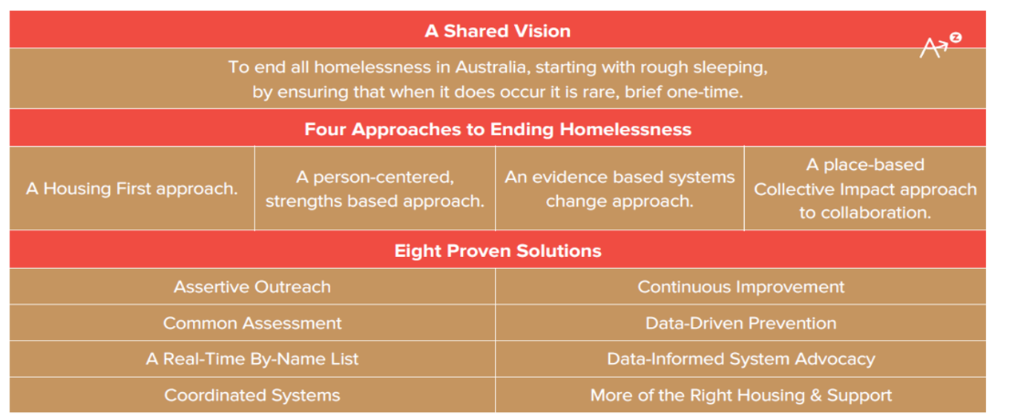
- The project is led by NEAMI Towards Home Plus and includes partners Give Where You Live (allocated $40,000 over a 2-year period to support the project), City of Greater Geelong, Salvation Army, Barwon South West Homelessness Network, GenU, Wathaurong, Victoria Police, Lazarus House, Bethany and Haven Home Safe.
- Towards Zero projects are based on the model from the Australian Alliance to End Homelessness and incorporate the use of a by-name list for rough sleepers within an area. This list allows all agencies to be working off one list.
- By-Name Lists help us gather real-time information about people experiencing homelessness in communities to make sure we can match them to the right support services. As a part of this work, we can build an understanding of how many people are experiencing homelessness in a community and what their needs are –particularly health – and then set about meeting those needs, both housing and support (Australian Alliance to End Homelessness).
- Further information about the Advance to Zero model can be found by visiting Alliance to End Homelessness and the framework is outlined in the diagram below:
Lazarus Community Centre is a place for people to feel safe and welcome. Somewhere where they can take a shower, wash and dry their clothes, have a light lunch, participate in activities, meet with volunteers and receive support from specialist homelessness staff.
Between January and June 2023, Lazarus Community Centre serviced 6,199 clients, with 253 being brand new to the centre. Anecdotal evidence suggests that more than half of these clients are homeless. Sleeping rough, couch surfing, sleeping in cars or moving between emergency accommodation. To address this unmet need in the Geelong area Lazarus Community Centre along with support of the local Geelong Police are working toward establishing a Beddown Project Pilot.
The Beddown Program aim is to use spaces that are commonly used and busy during the day but at night are left vacant or empty. Beddown then activates and repurposes the space at night into pop-up accommodation to ensure people experiencing homelessness/ sleeping rough can access a bed at night.
It is crucial to note that the overarching goal is to end homelessness, but this is multi-faceted and complex and therefore this proposal is just one example of the diverse way in which we need to consider programs to provide immediate capacity for Geelong locals experiencing homelessness.
- It is envisaged that the pilot program accommodates 25 clients initially.
- The pilot program will run at a low cost due to volunteers providing their time. Volunteers will be a combination of trained volunteers, and community members.
- Beddown Offers a place of safety and security. Has the potential to become a longer-term option for emergency overnight accommodation. As it grows, it could establish into a more formal referral process which then offers the opportunities for external organisations to become involved and provide longer term support for individuals.

How can governments and community service providers reduce homelessness and/or support people who may be at risk of becoming homeless in Australia?
In September 2022 the Productivity Commission handed down the National Housing and Homelessness Agreement (NHHA) Study report with suggestions for improvement.

The report highlighted a lot of inefficiencies with the current NHHA and the need for governments to look at new ways of working together to improve housing outcomes for all Australians.
Recommendations:
Some of the ways the current NHHA needs to change to be more effective are:
- Funded prevention and early intervention programs should be a priority to address the causes of homelessness for those at-risk cohorts (people leaving health & correctional facilities and care, First Nations people, young people, people needing support to maintain their tenancy)
- Commit to a study into the unmet need for homelessness support and a stocktake of current services, to determine the level of funding required to adequately meet the needs of people experiencing or at risk of homelessness.
The next Agreement should also include:
- An endorsed set of principles for designing and delivering housing assistance
- Clearer roles and responsibilities
- Revised outcomes focused on improving outcomes for people across all tenure types
- Meaningful, achievable and measurable targets focused on outcomes for people
- A single base funding pool for housing and homelessness services that is allocated to jurisdictions according to need and the costs of providing services
- Alignment with other agreements and policies, including the National Agreement on Closing the Gap and Australia’s Disability Strategy
- A new approach to supporting Aboriginal and Torres Strait Islander housing and homelessness services, including capability building and effective involvement in the co-design of policies and programs
- A greater focus on building the evidence base essential for good policy and accountability.

Housing for Aboriginal and Torres Strait Islanders

This section discusses the challenges and barriers to Housing for Aboriginal and Torres Strait Islanders and recommendation for policy to improve outcomes
There are approximately 3,562 people of Aboriginal and Torres Strait Islander background living in the City (ABS 2021), which is the largest regional population of Aboriginal people in Victoria. Aboriginal people experience higher rates of unemployment, family violence and homelessness.
The Geelong region has among the highest level of Aboriginal homelessness in Australia. There are 636 homes required for young Aboriginal families (3-bedroom homes) in this region by 2041 (CoGG 2021). There are about 1.7 per cent of Geelong’s population are Aboriginal or Torres Strait Islanders compared to 0.5 per cent in Greater Melbourne (ABS 2021). Aboriginal Housing Victoria provides estimated 87 long term properties as social housing, with about half of these in Corio and Norlane.
Opportunities for the National Housing and Homelessness Plan are:
- Realising the aspiration of Aboriginal and Torres Strait Islanders for greater self-determination for that improve housing opportunities for home ownership, access to housing, employment opportunities in their own communities.
- build support for self-determination for housing based on culture and heritage of Traditional Owners that have a spiritual, physical, social and cultural connection with their land. Land management and care are vital for Aboriginal health and provide jobs.
- Support self-determination in housing where Aboriginal communities can set their priorities, co-design in housing and own local housing management plan.
- Support these initiatives by forming partnerships that acknowledges the pivotal role of Aboriginal people in addressing the communities housing needs, where Aboriginal voice is key to decision making.
- Alignment and advocacy through Geelong’s Reconciliation Action Plan.

Recommendations:
How can governments, across all levels, best work with communities to support better housing outcomes for Aboriginal and Torres Strait Islander peoples?
- Aboriginal voices to be at the centre of decision making. In example, National Aboriginal and Torres Strait Islander Housing Association (NATSIHA) has suggested a supplementary funding program where a difference can be made for First Nations Peoples housing needs, especially around those levels of disadvantage that are indicators in the close the gap targets.
- Safe places that are accessible when needed
- Pathways for home ownership that are accessible and focused more on culture and heritage.
- Provide better access to housing in different needs for rental and ownership.
- Collective action to eliminate homelessness.
- Providing better services, share information and work together as well as identify weaknesses in Aboriginal self-determination within the system.
- Support Aboriginal organisations that are under-resourced where funding is inadequate and unifying all effort instead of attempting to solve each of the current challenges separately.
- For the over representation of Aboriginal people experiencing homelessness, it requires innovative approach from a holistic and systems perspective the design homelessness reforms in Victoria by providing tailored support for those at risk increasing the supply of crisis and transitional housing.
- Provide strong housing targets and all relevant mainstream policies legislation strategies and program targets in the National Housing and Homelessness Agreement with relevant legislation.

Planning system, housing and sustainability
This section discusses the planning system in relation to strategic planning and regulation of housing and the importance of integrating sustainability within it.
Integration of housing and planning will be key to outcomes in housing diversity, sustainability and climate resilience outcomes in local areas.
As a regional city, the demand of housing in Geelong is being met by market housing and by significant proportion of large dwellings. There is not enough housing diversity for more choices in communities.
The housing market relies heavily on market participation, by landowners and developers to underwrite the risk in developing diverse housing choices to communities. The trend toward higher densities is changing. However, there are still not enough developers delivering medium density housing projects in Geelong to increase valuations, even in well-planned locations with transport and other infrastructure. Any increase in density happens incrementally over time, with the expectation of alignment with the market valuations and opportunities. The best intention and objectives in planning, including provision of transport infrastructure that are planned with appropriate increase in density, housing diversity strategies with higher densities will not succeed until such time that valuations support it, creating a conundrum.
As such, the role of an effective local planning system both in strategic planning and implementation is vital and required to interface with the National Housing and Homelessness Plan initiatives at state and local levels in alignment with urban policies. The role and operation of the planning system in responding to the required housing functions are complex, requiring a balanced approach in enabling or cutting red tape for a more efficient delivery system. The planning system alone will not solve housing affordability and supply issues unless funding can be directed to support and streamline the delivery of required local infrastructure and boost to the valuation for housing projects that meet objectives of a national urban policy.
The following sections discuss some of the issues faced in planning for Geelong’s growth along with recommendations.

Infrastructure planning and funding
Urban renewal and growth areas mostly rely on state-led infrastructure and public transport delivery program where the public transport options mostly determine the urban structure and density, staging and implementation in a new precinct. The state funded infrastructure program should coordinate closely with local planning authorities on forecasting and identifying locations for greater housing and create infrastructure-ready opportunities for new precincts.
Geelong’s next major growth front is the Northern and Western Geelong Growth Areas and will be home to 110,000 residents. To realise sustainable development outcomes the development will rely on new mass transit services by Department of Transport and Planning (Victoria) and the state government’s commitment to the Geelong-Bannockburn passenger railway line.
While there is no sufficient transport program by the state government to support these growth areas, the density cannot be increased to support greater affordability and more homes that are accessible to public transport. The lack of commitment or funding for city shaping infrastructure also leads to the greater economic burden on households living in areas without access to transport choices that provide access to higher order employment.
Infrastructure cost for roads, drainage, sewer, potable and recycled water in Victorian greenfield developments have risen significantly by 46 per cent between Q2 2018 to Q1 2023 (SMEC 2023) and it is putting pressure on development contributions system to collect and deliver infrastructure that support new housing development in growth areas, including in regional cities like Geelong.
Reducing the scope or scale of local infrastructure charges has been floated as a solution to increasing house prices.
Funding infrastructure with development contributions is justified compared to taxes or rates because it encourages more efficient use of land and economies of scale (Productivity Commission 2014). In turn, developers can predict and account for a wider range of infrastructure costs when developing land for housing.
Any changes to the development contributions system will have to be measured and targeted to achieve housing affordability outcomes that aligns delivery of required community infrastructure. Otherwise, there will be significant trade-off between efficiency in collecting development charges, housing affordability and delivering infrastructure to serve our communities.
Recommendations:
- Coordination of state-led infrastructure planning and local planning in regional cities for greater transparency in the infrastructure planning program that can support planning authorities to align sustainable growth objectives with outcomes on the ground.
- Funding to support state and local planning authorities to prepare an infrastructure and growth alignment plans.
- The state and federal funding for transport infrastructure should be more responsive to and prioritise the infrastructure in the undergoing precinct planning in regional cities to support the delivery of sustainable housing.

Responding to climate change
City of Greater Geelong contains established communities and growth areas subject to natural hazard and climate change risks e.g., bushfire, sea level rise and flood risks. While the current state planning framework encourages new precinct planning to undertake avoidance and mitigation approaches to deal with the risks, providing mitigation measures e.g., flood-proof drainage assets create significant infrastructure costs to new precincts and urban renewal areas as well as an economic burden to the construction of new residential communities.
The National Housing and Homelessness Plan needs to set appropriate scale for housing and integrated land use planning that includes sustainability, such as within a neighbourhood scale. It takes away the focus and discussion of sustainability issues within a regimented and codified built form and site-specific implementation, costs to the importance of sustainability within communities in the wider scale.
These provide more opportunities for integration of land use planning with transport, biodiversity and other planning matters through housing policies with appropriate performance-based outcomes for sustainable neighbourhood developments that can be measured and compared. Integration with land use planning in neighbourhood scale allows for discussion for economies of scale for a decentralised system (Duhr et al 2023) within institutional governance that guide interactions and engagement with communities to achieve social sustainability and achieve the national policy goals such as climate targets. Social sustainability which is one of the three pillars of sustainability (economic, environmental) that is most complex.
Recommendations:
- Provide funding to new precincts for providing mitigation measures including floodplain management assets and renewal of aging infrastructure in areas nominated for urban renewal.
- Provide funding to the construction of new homes with innovative ESD measures and the construction of new precincts’ landscaping and stormwater management approach.

Sustainability in Housing – case studies
The City of Greater Geelong and twenty-four other Victorian councils, supported by the Council Alliance for a Sustainable Built Environment (CASBE) and the Municipal Association of Victoria (MAV) are seeking an amendment to the Victorian planning scheme for new buildings, to elevate sustainability requirements and increase resilience to climate change impacts. Under the proposed changes, new developments would:
- Produce net zero carbon emissions.
- Reduce household bills by making buildings more energy efficient.
- Provide a healthier and more comfortable environment for building occupants.
- Better manage water quality, use and collection.
- Protect and enhance greening and biodiversity.
- Be more resilient to changing climate impacts.
The Victorian Government could expediate the amendment process to improve new sustainable housing and better prepare our Geelong community for climate change.
Climate Safe Rooms was a project funded by State Government and was delivered in partnership with Uniting, City of Greater Geelong and Geelong Sustainability that provided up to $15,000 per participant (10 participants) to install Solar PV, split system heating and cooling and draught proofing/air sealing. The strategic direction is to minimise the need for energy consumption by making households and ambient temperature comfortable to reduce emissions and the ‘comfortability’ can also be extended to tree planting on western and northern fronted windows. These bring about multiple co-benefits, such as reduced energy consumption, reduced bill shock, reduced illness and by extension hospital/doctor visits, and pride in one’s home.
In terms of strategic delivery, identifying need within the home can be conducted by HAC services of City of Greater Geelong, documented, and passed onto the service delivery partner to conduct works. This provides direct access to individuals who are in need with people they trust. Further, we can identify additional participants through the NDIS for Geelong residents and GenU. To reduce costs, draw on the 55-65 age bracket of skilled tradespeople and share salary costs between state and local governments, as well as NDIS and community service organisations, to conduct works and energy efficiency improvements such as insulation, draught proofing and air sealing.
The opportunity should be provided for not only social and public housing, but housing for lower income and vulnerable residents who are not in social or public housing, such as supported private rentals with targeted energy proofing and climate resilient projects that improve the energy efficiency of homes. To undertake these works, a revolving fund or no interest loans are required.

References
Australian Government (2015) Re:think: tax discussion paper, The Treasury, Accessed 15 August 2017, http://apo.org.au/node/53883.
ABS (2021) Australian Bureau of Statistics 2021 - Operational Homelessness Data & Counting dwellings, place of enumeration (HIND Total Household Income (weekly) by SA4 (EN))
Burke, T., Stone, W., and Ralston, L. (2014) Generational change in home purchase opportunity in Australia, AHURI Final Report No. 232, Australian Housing and Urban Research Institute Limited, Melbourne, https://www.ahuri.edu.au/research/final-reports/232.
CoGG (2021), City of Greater Geelong, Social Housing Plan 2021-2041, https://www.geelongaustralia.com.au/common/public/documents/8d7b9e5836a6cf2-socialhousingplan2020-2041.PDF
Eccleston, R., Verdouw, J., Flanagan, K., Warren, N., Duncan, A., Ong, R., Whelan, S. and Atalay, K. (2018) Pathways to housing tax reform, AHURI Final Report No. 301, Australian Housing and Urban Research Institute Limited, Melbourne, http://www.ahuri.edu.au/research/final-reports/301, doi: 10.18408/ahuri-4111001.
REIV, CoGG (2023), City of Greater Geelong, Stats Centre-Median House Price, source: Real Estate Institute of Victoria REIV https://www.geelongaustralia.com.au/business/statistics/article/item/8d01ebfdb936404.aspx
Dühr, S., Berry, S. and Moore, T. (2023) Sustainable housing at a neighbourhood scale, AHURI Final Report No. 396, Australian Housing and Urban Research Institute Limited, Melbourne, https://www.ahuri.edu.au/research/final-reports/396, doi: 10.18408/ahuri3228101.
Daley, J., Coates, B. and Wiltshire, T. (2018) Housing affordability: rebuilding the Australian dream, Grattan Institute, Carlton, Vic.
Daley, J. and Coates, B. (2015) Property taxes, Grattan Institute Working Paper No. 2015-5, Grattan Institute, Carlton, Vic., accessed 15 August, 2017, https://grattan.edu.au/wp-content/uploads/2015/07/826-Property-Taxes.pdf.
Disney, J. (2006) ‘Over our heads: housing costs and Australian families’, Australian Quarterly, vol. 78, no. 2: 4–11.
Henry, K., Harmer, J., Piggot, J., Ridout, H. and Smith, G. (2009) Australia’s future tax system: report to the Treasurer, Commonwealth of Australia, Canberra.
.id (2023) .id Community, Housing Monitor, City of Greater Geelong, https://housing.id.com.au/geelong
.id (2023) .id Community, Population Forecast, City of Greater Geelong, https://forecast.id.com.au/geelong
SMEC (2023), Victorian Construction Costs 2018 - 2023, https://www.smec.com/om/insights/victorian-construction-costs/
Infrastructure VIctoria 2023, Policy evidence for more housing options in Victoria https://www.infrastructurevictoria.com.au/wp-content/uploads/2023/03/Policy-evidence-for-more-housing-options-in-Victoria.pdf
Productivity Commission (2022), In need of repair: The National Housing and Homelessness Agreement https://www.pc.gov.au/inquiries/completed/housing-homelessness/report/housing-homelessness-overview.pdf

Productivity Commission 2014, Public infrastructure, 2014, accessed 14 February 2023, p.169. https://www.pc.gov.au/inquiries/completed/infrastructure/report

Royal Bank of Australia RBA, 2023, Cash rate target
https://www.rba.gov.au/cash-rate-target-overview.html

Kearns J 2022, Royal Bank of Australia RBA, 2022, Interest Rates and the Property Market
https://www.rba.gov.au/speeches/2022/sp-so-2022-09-19.html
Lawson, J., Pawson, H., Troy, L., van den Nouwelant, R. and Hamilton, C. (2018) Social housing as infrastructure: an investment pathway, AHURI Final Report 306, Australian Housing and Urban Research Institute Limited, Melbourne, http://www.ahuri.edu.au/research/final-reports/306, doi:10.18408/ahuri-5314301.
NHSC (2010), National Housing Supply Council, Second State of Supply report, Department of Families, Housing, Community Services and Indigenous Affairs, Canberra.
Ong, R., Dalton, T., Gurran, N., Phelps, C., Rowley, S. and Wood, G. (2017) Housing supply responsiveness in Australia: distribution, drivers and institutional settings, AHURI Final Report No. 281, Australian Housing and Urban Research Institute Limited, Melbourne, http://www.ahuri.edu.au/research/final-reports/281, doi:10.18408/ahuri-8107301.
Ong, R., Wood, G., Whelan, S., Cigdem, M., Atalay, K. and Dodson, J. (2017) Inquiry into housing policies, labour force participation and economic growth, AHURI Final Report No. 285, Australian Housing and Urban Research Institute, Melbourne, https://www.ahuri.edu.au/research/final-reports/285, doi:10.18408/ahuri-8107001.
Wood, G., Ong, R. and McMurray, C. (2011) The impacts of the Henry Review recommendations on the private rental market—savings income discount and rent assistance, AHURI Final Report No. 175, Australian Housing and Urban Research Institute, Melbourne, https://www.ahuri.edu.au/research/final-reports/175.
Winter and Wood, G., I. (2012) ‘Scrapping stamp duties for a land tax’, Insight, no. 6: 24–26.
Wood, G., Ong, R. and Cigdem, M. (2014) Housing affordability dynamics: new insights from the last decade, AHURI Final Report No. 233, Australian Housing and Urban Research Institute, Melbourne, accessed 15 August 2017, https://www.ahuri.edu.au/research/final-reports/233.
Worthington, A.C. (2012) ‘The quarter-century record on housing affordability, affordability drivers, and government policy responses in Australia’, International Journal of Housing Markets and Analysis, vol. 5, no. 3: 235–52.
Yates, J. (2008) ‘Australia's housing affordability crisis’, Australian Economic Review, vol. 41, no. 2: 200–214.
Yates, J. (2011) ‘Housing in Australia in the 2000s: on the agenda too late?’, in H. Gerard and J. Kearns (eds), The Australian Economy in the 2000s: Proceedings of a Conference, Reserve Bank of Australia, Sydney: 261–296.
Yates, J. (2012) ‘Housing and distribution of wealth’, 2012 Giblin Lecture, University of Tasmania, Hobart, 18 October, accessed 19 December 2017, http://sydney.edu.au/arts/economics/downloads/documents/pdf/Yates-2012-Giblin-lecture.pdf.

