The City Of
Greater Geelong

Residential Parking permit
POLICY

  - Version: 1

Approval Date: 28 June 2023
Approved by: ELT
Review Date: June 2027
Responsible Officer: Director, City Infrastructure
Authorising Officer: CEO

Contents
Introduction 3
Purpose 3
Scope 3
Background 3
Definitions 4
Policy 5
Residential Parking Permits 5
1. Eligibility 5
2. Number of Residential Parking Permits 6
3. Appeals Process 6
4. Proposed Fee Structure 6
5. Permit Conditions 6

Introduction

Purpose
To outline the City’s management of residential parking permits to ensure that Residents can enjoy reasonable opportunities for residential parking while preserving parking access for other road users.

Scope
The policy applies to all Residents within the City of Greater Geelong who have time restricted on-street parking in their street, or in an adjacent street to their property.

Background
In some areas within the municipality, on-street parking is becoming increasingly difficult to secure, especially in areas near retail/commercial activity, employment precincts, recreational activity, multi-unit developments, hotels, nightclubs and commuters driving to public transport. The combination of these activities and the growing demand on parking resources has led to a decrease in the availability of on-street and off-street parking in many unrestricted residential and commercial areas.

Parking time restrictions are often implemented to balance the needs and access of all users.

Definitions

This section defines the key terms used in this policy.
CITY
The City of Greater Geelong organisation, led by the CEO.
COUNCIL
The City of Greater Geelong Council comprised of elected councillors and led by the Mayor.
EMPLOYMENT PRECINCT
An area that is designated specifically to create and provide jobs or places of work for people.
MULTI-UNIT DWELLING
When more than one dwelling is built on a single lot, including more than one house, unit or townhouse. Typically these properties are managed under a strata plan.
PARKING COMMITTEE
The committee comprises the Manager of Local Laws, Co-ordinator Amenity Protection, and Co-ordinator Transport (Civil Infrastructure) and department officers to assess applications for Residential Parking Permits.
PRIVATE VEHICLE
Means a sedan/station wagon or hatch and includes a small van or utility which is currently registered to a City of Greater Geelong address. If not registered to a City of Greater Geelong address, documentary proof can be provided that the applicant is afforded primary use of the vehicle (i.e. company vehicle). Private vehicles do not include any van over 4.5 tonne in weight, any truck, caravan, boat or trailer and does not include any vehicle over 7.5 metres in length.
RESIDENCE
Means a Resident’s principal home is the address the permit is being applied for.
RESIDENT
Means a person who lives and sleeps at a Residence and is so named on the Council electoral register, or who provides documentary proof of such, e.g. copy of lease, contract, tenancy agreement or rent book, etc.
RESIDENTIAL PARKING PERMIT
A permit issued to a Resident who is in possession of a Private Vehicle.

Policy

RESIDENTIAL Parking PERMITS

Where parking restrictions have been introduced and implemented throughout the City, a Resident who lives in the segment of street where there are parking restrictions, may apply to be the holder of parking permits.

Eligibility
  - A Resident must make an application to the City for a Residential Parking Permit using the form on the City’s website, in accordance with the terms and conditions outlined in that application form.
  - A Resident must have timed parking restrictions of 2 hours or greater in the segment of their street. Corner properties are eligible for a Residential Parking Permit on either street their property abuts but must designate only one street upon application.
  - The following image shows an example of which properties would be entitled to parking permits for the timed parking area:
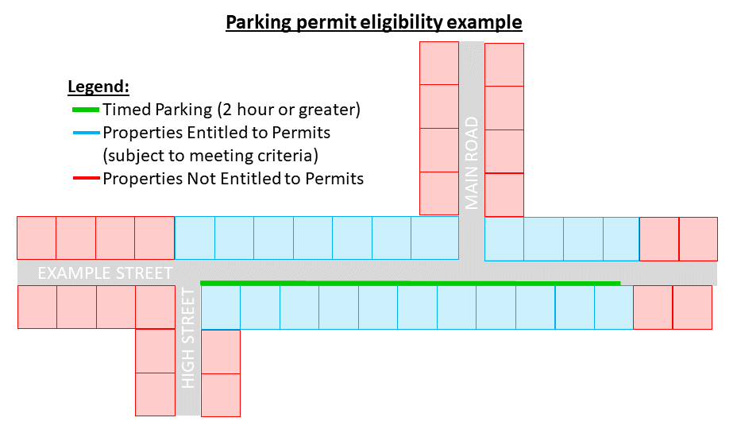
Figure 1.1 Parking permit eligibility example.
  - The City will not issue parking permits where:
    - a property has been granted a parking waiver as part of a planning (or other) permit associated with the property;

    - the property is used for business or is rated as ‘Commercial’ or used for commercial purposes.

    - the intended vehicle is over (4.5) tonnes gross weight or 7.5 metres or more in length.

    - a multi-unit development with four or more dwellings on the one property.

    - the City has resolved not to provide Residential Parking Permits during the statutory planning approval process for the subject property.

2. Number of Residential parking Permits
​2.1 If the subject Residence is a:
- Single residence – it is entitled to a maximum of two permits
- Multi-unit development of three or less properties – it is entitled to a maximum of one permit per Residence
2.2 Additional permits may be granted subject to a Resident being able to demonstrate exceptional circumstances as outlined in section 3 below. In considering the exceptional circumstances, if parking permits are supported, the Residence will be entitled to a maximum of two permits.

Residential Parking Permits are transferrable between vehicles and can be placed in the vehicle of a visitor to the Residence.

3. appeals process
The City may issue a Residential Parking Permit outside of the standard requirements under this policy where a Resident can demonstrate exceptional circumstances during the application process. The application must outline the nature of the exceptional circumstances to support the application, the number of additional permits sought, who the permits will be provided to and the timeframe the permit is required for.

Exceptional circumstances may include, but are not limited to, reasons such as:

- Physical hardship such as impairment, age or frailty, which would severely impact the capacity of the individual to satisfactorily function, and which would be compounded with the loss/withdrawal/non-eligibility of a Resident Parking Permit.
- Previous Resident Parking Permit allocations to a specific property that are no longer entitled to under this new Parking Permit Policy during a 12 month transition phase on the new policy implementation.
- The impact of parking restrictions or loss of available parking due to temporary construction activities.
The above examples are not automatic exemptions. Applications will be evaluated on a case-by-case basis, determined at the discretion of the Parking Review Panel.

4. Proposed Fee Structure
Residential Parking Permits are currently free, but this may be reviewed at a future time.

5. permit conditions
5.1 Permits are issued at the discretion of the City of Greater Geelong.
5.2 The issue of a parking permit does not guarantee the availability of a parking space.
5.3 Council reserves the right to review permit costs.
5.4 Parking permits are not valid in:
- paid parking spaces;
- short-term timed spaces of one hour or less;
- Prohibited parking areas as specified in the Road Rules Victoria including but not limited to Clearways, No Stopping, No Parking, Loading Zones, Taxi Zone and Bus Zones.
5.5 The City of Greater Geelong may withdraw parking permits if deliberate abuses of the scheme are determined.
5.6 All parking permit conditions can be found on the City’s website.

