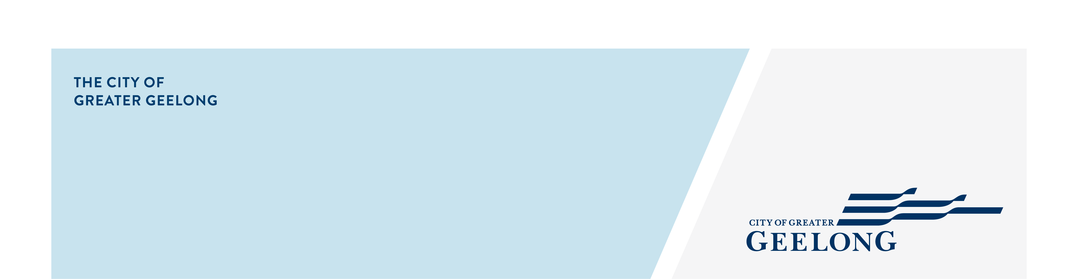
rainbow ready roadmap

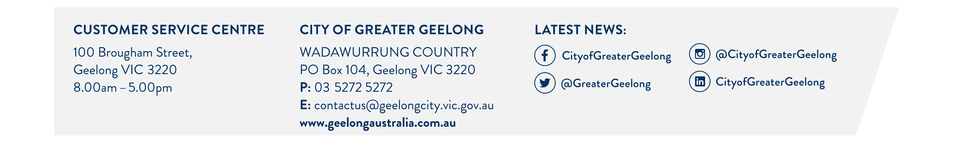
assessment:

Summary report
background

The City of Greater Geelong (the City) has been a leader in LGBTQIA+ inclusion for many years, particularly in the youth space. Our Gender and Sexuality Program (GASP) has its beginnings in 1996, making it one of Australia’s first LGBTQIA+ youth social groups.
The Victorian Government has a 10-year LGTBQIA+ strategy: Pride in Our Future. This plan frames how all government work can drive equality and inclusion for our LGBTQIA+ communities. The Victorian Government also released a set of resources called the Rainbow Ready Roadmap to help regional and rural communities progress this work. The community consultation that informed the Rainbow Ready Roadmap was one of the largest consultations undertaken with LGBTIQA+ Victorians, and included the Geelong community.
Rainbow Ready Roadmap
The Rainbow Ready Roadmap is being used by the City to frame and guide our progress in LGBTQIA+ inclusion.
The Rainbow Ready Roadmap is based on four core LGBTQIA+ principles: understanding, inclusion, visibility, and safety. There are 15 indicators for local governments to achieve. The following tables provide a summary our progress against the indicators, showing what we are doing well and where further work is needed.
This report captures actions taken up to April 2024 and is a high-level summary; there may be further City work that has not captured.
Next steps
The Rainbow Ready Roadmap guides us from assessing where we are now, to planning how we will achieve each indicator. Following this assessment, we will:
- consult with the LGBTQIA+ Advisory Committee and other community partners;
- determine resources and opportunities; and
- identify priorities.


Understanding
LGBTQIA+ inclusion is underpinned by education and understanding.
Indicator 1: Council educates its staff and volunteers on LGBTQIA+ inclusion
Achievements  LGBTQIA+ inclusion e-learning available to staff.  Annual IDAHOBIT (international day against LGBTQIA+ discrimination) awareness raising event for employees.  The City’s Inclusion and Diversity Roadmap 2021 commits to ongoing and evolving employee education. | Inclusive Practice Training has been delivered to some staff teams and to community organisations.  Awareness raising messaging is regularly included in employee communications.
Gap Analysis
- A low number of employees have completed the available LGBTQIA+ inclusion training opportunities.
- Specific LGBTQIA+ inclusion education is not provided to volunteers, except for the L2P program volunteers.


Inclusion
LGBTQIA+ people are included in the journey.
Indicator 2: LGBTQIA+ residents take part in council committees and in council planning.
Achievements  LGBTQIA+ Advisory Committee established. | Rainbow Youth Advisory Group has provided input to key youth projects, such as the Geelong Youth Hub.
Gap Analysis
- The overall level of input from the LGBTQIA+ community in general community consultations on the Have Your Say platform is unknown.
Indicator 3: Council grants are provided to support local LGBTQIA+ initiatives.
Achievements  LGBTQIA+ projects have been funded through the City’s grants program, e.g. Geelong Pride Film Festival Diapsalmata Orchestral Performance and Geelong Rainbow Festival. | The Healthy and Connected Communities grant prioritises projects promoting gender equity and diversity.
Gap Analysis
- The City demonstrates strong performance against indicator 3, but there may be an opportunity to include the LGBTQIA+ community as a priority group for other grants streams, in line with the Social Equity Framework.
Indicator 4: The council supports local LGBTQIA+ events.
Achievements  Annual IDAHOBIT and Wear It Purple events.  IDAHOBIT and Wear It Purple day are celebrated within our Family Services education and care settings.  Support for local schools to hold queer events. | Attracting to Geelong and sponsoring the Better Together conference, at GMHBA Stadium in June 2024.  Launch event for the Rainbow Crossing.  Free promotion of local events and initiatives through the events ‘Events Geelong’ webpage.
Gap Analysis
The City demonstrates strong performance against indicator 4.
Indicator 5: The council provides an inclusive workplace for LGBTQIA+ employees and volunteers.
Achievements  Commitment to the Inclusion and Diversity Roadmap 2021. | Establishment of the LGBTQIA+ Employee Network.  Provision of gender transition leave in the Enterprise Agreement.
Gap Analysis
- The Inclusion and Diversity Roadmap 2021 is working on foundations of employee inclusion and it will take time to see change across such a large organisation.
- There is no data easily available on volunteer experiences in relation to inclusion.


Visibility
LGBTQIA+ people and their culture are visible and celebrated.
Indicator 6: The council has a strategy or plan for LGBTQIA+ inclusion.
Achievements  The Inclusion and Diversity Roadmap 2021 (workforce strategy) is being implemented. |  | The Social Equity Framework 2021-25 includes LGBTQIA+ people as a priority population and is being applied to the City’s services, programs and facilities.
Gap Analysis
- The organisation does not have a standalone LGBTQIA+ inclusion strategy or plan.
Indicator 7: The council has a statement of LGBTQIA+ inclusion that is publicly visible.
Achievements  The permanent Rainbow Crossing is a visual demonstration of LGBTQIA+ inclusion. | The Geelong Mayor, Councillors and CEO have regularly made statements of commitment to LGBTQIA+ inclusion in the media and at public meetings.
Gap Analysis
- The City of Greater Geelong does not have a formal statement of LGBTQIA+ inclusion that is publicly visible.
Indicator 8: Council information incorporates LGBTQIA+ inclusive language and images.
Achievements  The ‘How To Write Guide’ for employees includes section on inclusive language.  Active promotion of the Victorian government’s ‘LGBTQIA+ Inclusive Language Guide’. |  | Gender impact assessments regularly undertaken.  Inclusive image library of photographs used.  New photography is required to be inclusive.  Corporate email signature template is LGBTQIA+ inclusive.
Gap Analysis
The organisation demonstrates strong performance across indicator 8.
Indicator 9: The council takes opportunities to fly the rainbow or trans flags.
Achievements  Rainbow flag is flown at City Hall for IDAHOBIT and Wear It Purple Day, and the Trans flag for Trans Day of Visibility.  Catenary lights are turned rainbow, purple or blue and pink for IDAHOBIT, Wear It Purple Day and Trans Day of Visibility respectively. |  | Permanent rainbow crossing has been laid in Yarra Street depicting the Progress Pride flag in a permanent display of support for our LGBTQIA+ community.  Early Years Services and Integrated Child Care Hubs display the rainbow flag and stickers.
Gap Analysis
The organisation demonstrates strong performance across indicator 9.
Indicator 10: The council’s website and social media profile LGBTQIA+ initiatives, events, people and resources.
Achievements  Regular profiling of LGBTQIA+ related content on website and social media. |  | In depth information on the GASP website for queer young people, their families and teachers.
Gap Analysis
- LGBTQIA+ resources are limited on the Geelong Australia website.
- The City’s website does not have a LGBTQIA+ webpage connecting relevant information from across the site.


Safety
LGBTQIA+ peoples’ safety is a priority.
Indicator 11: Bookings and assessment processes are LGBTQIA+ inclusive.
Achievements  Exemplary booking and assessment processes across the GASP social programs within the Youth Development Unit. | Early Years settings incorporate gender neutral language in all enrolment forms.  Regular audits across Early Years services to build an environment and educational program (e.g. toys, books, equipment etc) that is inclusive and gender neutral.
Gap Analysis
- Current booking forms and processes have not been uniformly audited across the organisation to ensure they are inclusive of LGBTQIA+ people.
- Education for public facing staff on LGBTQIA+ inclusive language and greetings may not be routinely provided.
Indicator 12: LGBTQIA+ groups and services are supported to access council spaces.
Achievements  Council spaces utilised for delivery of the GASP social groups and Stand Out community of practice for schools. | Courthouse venue provided for Platform Arts.  Geelong West Neighbourhood House precinct renovation (2022) helped accommodate Geelong Rainbow.
Gap Analysis
- The GASP program does not currently have a youth-friendly venue, however a new Geelong Youth Hub will be opening early in 2025.
Indicator 13: The council provides all gender bathroom and change room options.
Achievements  A range of all-gender bathroom options for the public and City employees at Wurriki Nyal. | Ongoing increase in the provision of all-gender toilets at facilities across the municipality.
Gap Analysis
- The City does not have a formal policy or position on all-gender toilets that informs new builds or renovations.
- The organisation does not have a centralised list of all gender toilets across the municipality.
- The outcome of the review of the Neighbourhood Amenity Local Law review is not yet known.
Indicator 14: Potential risks to the safety of LGBTQIA+ group members are identified and minimised.
Achievements  Risk assessments for LGBTQIA+ events and programs | Application of the Community Safety Framework 2022–26.
Gap Analysis
- Specific engagement with LGBTQIA+ community regarding their everyday safety has not been undertaken.
- Guidelines for hosting safe LGBTQIA+ events are not finalised or integrated into City processes.
- Processes for managing hate speech related to LGBTQIA+ social media posts require more efficient solutions.
Indicator 15: The council responds to LGBTQIA+ phobic incidents.
Achievements  Swift removal of LGBTQIA+ phobic vandalism. | City responds to detractors by affirming the rights of LGBTQIA+ people and keeps a register of correspondence (calls, emails, letters).
Gap Analysis
- Further exploration of the experiences of LGBTQIA+ identifying staff members in relation to LGBTQIA+ phobia and microaggression in the workplace could be undertaken.

