

Barwon Tennis Strategy 2024 - 2034

POWERED BY KINETICA

Executive Summary

Increased participants
Increased growth in Tennis across the Barwon Region. Supporting existing participation in schools, events, internal club competition, inter-club competition, tennis coaching and other complimentary tennis formats.

Increased events / improved player pathways
Increase in events in the region catering for all standards from local to high level events.
A public access regional facilities which have the capacity to host higher level events, association finals, larger competitions, and provide facility that aids the regional talented player pathway. This venue has been identified in Armstrong Creek and is critical to the sports success in the region.

Improved facilities
Increasing the capacity of existing facilities through implementation of recommendations identified. The installation of sporting lighting is critical to ensure the sport cater for participation growth and future demand.

Introduction
Increased access to facilities
Increased access and transparency around access to facilities making playing easier at all times of the day. Assisting venues with digital solutions, clear and transparent communication, and the ability for lights to be accessed by the entire community.

In 2015, the G21 Tennis Strategy was developed to provide strategic direction for facility planning for the Barwon Region. Since this time, the region and the tennis industry has evolved and grown considerably. Geelong has continued its emergence as one of Australia’s major cities
by attracting major employers to the regions, improved transport links between Geelong and Melbourne, and an increasingly appealing lifestyle option.
The Barwon Tennis Strategy 2024 has been designed to provide a blueprint for growth to all stakeholders who have a vested interest

in seeing tennis thrive; in particular Tennis Victoria, local tennis clubs and associations, residents and local government.
From a tennis perspective, Tennis Victoria (and Tennis Australia) have invested considerably
in its data and analytics capability, and have made advances in better understanding of the club network and how it performs. This coupled with unique insight into the local area demand for tennis (beyond just membership), provides the sport with the critical insight to determine now and into the future how best to serve each community with a bespoke, tailored offer.
Increased sustainability of venues
The commitment to work with Tennis clubs to ensure they remain sustainable. With use of the Health in Tennis Tool (HiT) and providing insights as to the club’s health. This analysis ensures clubs maximising participation, understand the requirements to maintain and update assets and are financially viable.

Increased access to coaching
Increasing the amount of quality coaches in the region. Through increasing training courses, regular re-skilling and access to online coaching resources will provide the region with access to coaching.

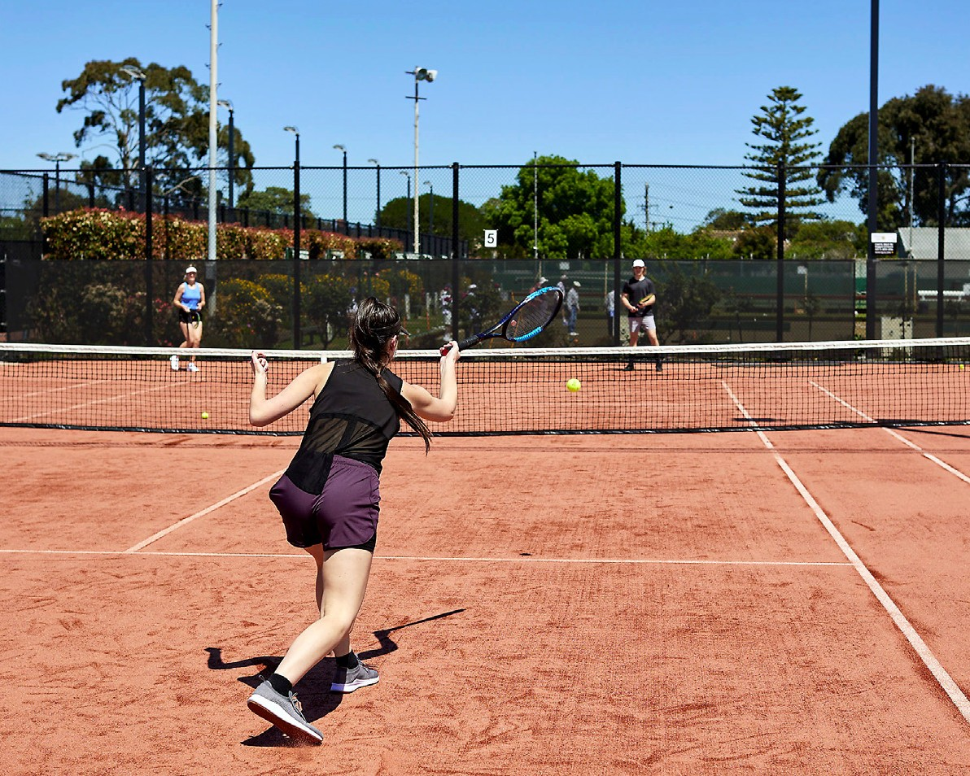

2 BARWON TENNIS STRATEGY 2024 - 2034 – POWERED BY KINETICA BARWON TENNIS STRATEGY 2024 - 2034 – POWERED BY KINETICA 3

Table of Contents
Introduction 2
Executive Summary 3
Our Approach 5
Tennis in Barwon 6
Project Overview 7
Key Stakeholder engagement findings 8
Key Stakeholder engagement key topics 9
Strategic Framework 10
Current State of Play 11
Tennis Network Performance
assessments and insights 12
Venue Performance 13
Venue Classifications 15
Recommendations 20
Colac Otway Shire 21
Golden Plains Shire 25
Greater Geelong 29
Surf Coast Shire 36
Borough of Queenscliffe 40

Our Approach

The document is structured as follows: This document provides each of these
stakeholders with a clear plan on how to optimise of the club/venue network by understanding and identifying:
The Barwon region and Tennis Perception – a summary of key
regional profile metrics and views of key stakeholders related to tennis in
the region
Tennis Supply and Demand in Barwon region – this is the fact base where
all relevant information about both the infrastructure (supply) and participation
(demand) is presented
Tennis Network Performance Assessment and Insights – analysis of the supply
and demand dynamics to determine key
relationships and insights
Recommendations – commentary and views on specific actions that should be considered at both a network level and also venue by
venue
The network coverage (by venue type)
The distribution of people and demand/ latent demand to play tennis across the region (down to the suburb level)
The performance of the network (where data is available)
Drivers for performance differentials based on a combination of venue attributes and local catchment demographic and socio- economic profiles
Each of these key inputs is combined to provide both regional and venue by venue recommendations.


APPENDIX
- Population forecast 43
- Demographic Profile 44
- Demographic Profile – Sub-regions 45
- Venue locations 46
- Venues Sizes 47
- Venue Gap Analysis 48
- Venues with lights Gap Analysis 49
- Participation and Interest 50
- Demand vs Court provision 51
- Future growth of Tennis 52
- Best Performing Venues 53
- Best Performing Models 54
- Venues with lights 55
- Best performing venue locations 56
- Venue Optimisation 57
- Colac Otway Shire Venue List 58

4 BARWON TENNIS STRATEGY 2024 - 2034 – POWERED BY KINETICA BARWON TENNIS STRATEGY 2024 - 2034 – POWERED BY KINETICA 5

Project Overview
The strategic planning process employed to complete this project is summarised below.
Stream 1: Project Set-up
Finalise scope, timings and
outputs
Project plan
Information request
Stream 2: Review & Consultation
Review of previous strategy
Sector & tennis trends
since 2015
Engagement with key
stakeholders
Stream 3: Supply & Demand Dynamics
Assessment of demand by
local area
Assessment of supply (incl.
network performance)
Venue performance analysis
Stream 4: Recommendations & Implementation
Regional plans
Venue specific
opportunities
Top-line action plan
Output: Refreshed Barwon Tennis
Strategy
On-going and regular engagement, updates, and dialogue
with the key project stakeholders
BARWON TENNIS STRATEGY 2024 - 2034 – POWERED BY KINETICA
7

Tennis in Barwon

‘The Barwon Region offers the best of regional, rural and coastal lifestyles and will see strong population growth between 2024 and 2034’
The Barwon (G21) Region has a population in excess of 360,000 people and covers an area of almost 9,000 square kilometres. The region is set to increase by approx. 85,000 people in the next 10 Years.
The Barwon (G21) Region consists of the following LGAs:
City of Greater Geelong Surf Coast Shire
Golden Plains Shire Colac Otway Shire
Borough of Queenscliff

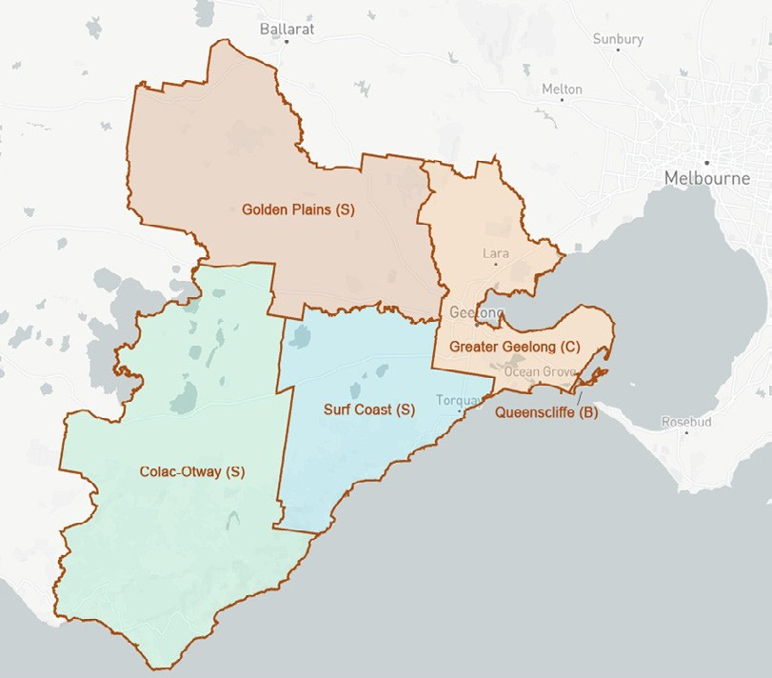

6 BARWON TENNIS STRATEGY 2024 - 2034 – POWERED BY KINETICA

Key Stakeholder engagement findings

Key Stakeholder engagement key topics

Opportunities:

More coaching/coaches in the area

More social programs to engage and connect people

More diversified offering – competition, social play, different days and times

Improve the narrative and tell Tennis’ story better

Publicly accessible regional facility and potential for multi- purpose facilities

Better understanding of where club members are travelling from to play

Challenges:

Lack of coaching/coaches in the area

Year-round access to facilities (lack of lit venues)

Utilisation of venues

Data capture for council venues

Clubs business models

Demonstrating the value of tennis

Infrastructure
Sustained investment in tennis infrastructure.
Strategic direction for facility provision. Equitable distribution.
Well maintained public courts. Contemporary delivery model.

Participation
Participation across ages and abilities. Community use and access to facilities. Remaining affordable.

Governance
United front, priorities and strong partnerships.
Strong governance at all levels.
Alignment with city policies and strategies.
Safe & inclusive, well governed, provide clear pathway, sustainable facilities.

Volunteers / Coaches
Established succession/development plan and program for volunteers.

Club Support
Support and direction for local clubs to be able to grow and maintain participation.

Investment / Sustainability
Co-investment – How can we consider
co-investment opportunities such as CORA.
Advocacy – How can we as a sport benefit from the Commonwealth Games Legacy fund.
Hockey a sport that is working well on co-investing on delivery models and advocacy.
Story telling
Data, data, data, social ROI and storytelling on the benefits of Tennis participation.
Where are club members travelling from to participate in Tennis?
Rationale and data behind the opportunity analysis.
Surf Coast Shire venues are performing well from a capacity and participation benchmarking perspective.
Colac Otway Shire– smaller shire, challenges in meeting investment and budget requirements given limited resources and finances.
Difficult for smaller councils to find budget.



8 BARWON TENNIS STRATEGY 2024 - 2034 – POWERED BY KINETICA BARWON TENNIS STRATEGY 2024 - 2034 – POWERED BY KINETICA 9

Strategic Framework Current State of Play

Ambition
Tennis thriving in the Barwon Region

Strategic Pillars
Develop business models that sustain clubs and provide support and collaborate to grow the sport
Sustainability & Growth

Provide a range of offers that meets the needs of the different playing cohorts

Play

Diverse skilled coaches and a strong volunteer network

People

A network of clubs/venues that are highly accessible to the vast majority of residents and provide a diverse range of offers

Places

Primary Activity

Identify opportunities to improve/ enhance the club network
Extend availability of court access through lighting
Improve access through technology (e.g. book a court)

Attract and train coaches to the region through increased employment opportunities
Attract, recognise and reward volunteers

Ensure tennis can be played in a variety
of formats/ offering in the region – pennant, social
competition, programs, coaching, social play
Ensure offers are available at flexible times of the week

Success Indicators

Every person in the Barwon region can
access (within 15 minutes) at least 2 different types of formats

All clubs/venues with 4 courts
or more have a qualified coach at least part time

Every person in the Barwon
region lives with 15 minutes of
a tennis venue with lights

The following insights have been garnered from key stakeholder feedback and network planning gap analysis:

Barwon region has broadly enough courts, and they are generally located in the areas where there is a density of tennis interest and participation.

The vast majority of tennis venues have less than 6 courts or less (92%) and almost half have only 1 or 2 courts. These types of venues typically don’t/can’t provide a suite of services.

In the areas expecting the most population growth (Armstrong Creek) there are currently no venues with at least 5 courts within 5km of where a significant number of people will reside in the next decade (and extending down to Torquay).

One-third of tennis venues in the Barwon region have lights. They perform significantly better than venues without lights.

Only two venues in the region have more than 13 courts (Colac Lawn Tennis Club and Geelong Lawn Tennis Club). This provides significant limitations to the regional events and tournaments.

Less than 5% of the population live further than 5km from a tennis venue. The ‘gaps’ in the network are in low density population areas. Proximity to venues with 5 or more courts (those more likely that offer a suite of tennis offerings) is more limited.

Summary based on network assessment:
Improvements can be made to the venue ‘mix’ and distribution of the network to ensure improved proximity to a range of venue types/offerings. Opportunities have been highlighted within recommendations.
Tennis Victoria and Tennis Australia believe there is significant opportunity for a venue to service all elements of tennis including regional pathways and professional events. There is a significant gap in provision in Barwon region and specifically Geelong. This is best positioned to be in Armstrong Creek growth area.
Access in the growth area around Armstrong Creek (and further south) should be considered, with a venue size of at least 6 courts (and more likely a minimum of 8)
to service local needs.
Thriving Tennis Communities framework and reporting is incredibly important to both clubs and council. It’s imperative that all clubs within the Barwon region complete assessments.

Please note in regional / rural communities of Golden Plains Shire and Colac Otway Shire, travel time success indicators may not be able to be achieved.

90% of clubs/ venues are sustainable. Complete Health in Tennis Assessments
Supporting information
- Appendix 5
- Appendix 4 & 12
- Slide 18 & Appendix 9

- Appendix 6, 10, 11, 12, 13
- Appendix 5
- Appendix 6 & 8

- Appendix 5
- Appendix 4 & 12
- Appendix 9

- Appendix 10



Work with clubs/venues to optimise their business models to ensure they’re self sustaining
Develop/ enhance a culture of growth through improved utilisation
Use data to track network performance and iterate
10 BARWON TENNIS STRATEGY 2024 - 2034 – POWERED BY KINETICA BARWON TENNIS STRATEGY 2024 - 2034 – POWERED BY KINETICA 11

Tennis Network performance assessments and insights

Venue Performance

Tennis Victoria and Australia have embarked on an ambitious data project to better understand the performance and sustainability of their venue network. To date, over 1250 venues Australia-wide have been ‘audited’ with detailed data collected on:
The physical attributes of the venue (no. courts, court type, lighting etc)
Venue operating model
Venue offering (competition, coaching, social play, programs)
Utilisation (no. visits per annum by type of visit)
Financial sustainability
Communication and marketing channels (book online, website)

In total, Kinetica was able to analyse the performance data of the venues that had been participated in the Health in Tennis audit process. When combining the rich information collected through the venue audit process with the local area demand profiles, a number of unique, compelling insights are
unearthed that provide robust rationale for the recommendations provided to optimise the tennis venue network across the region.
A strong recommendation is to continue to complete Health in Tennis Assessments using the Thriving Tennis Communities
framework and report back to councils on their performance.

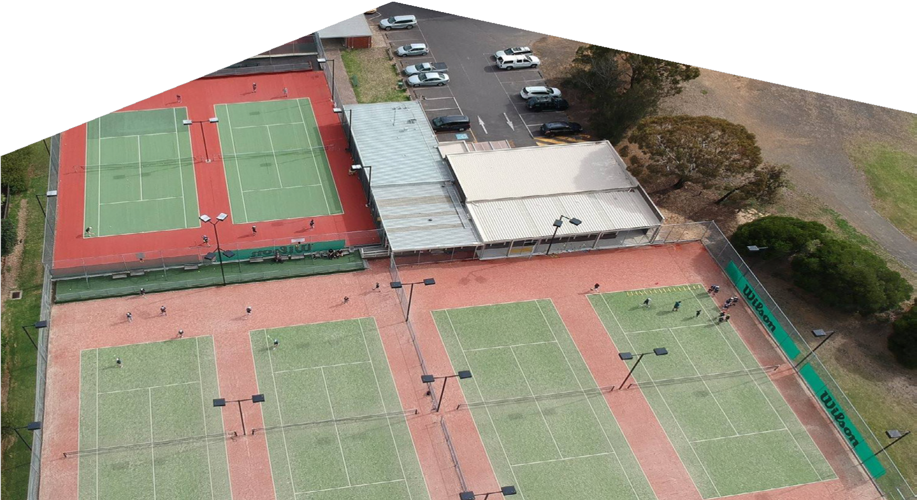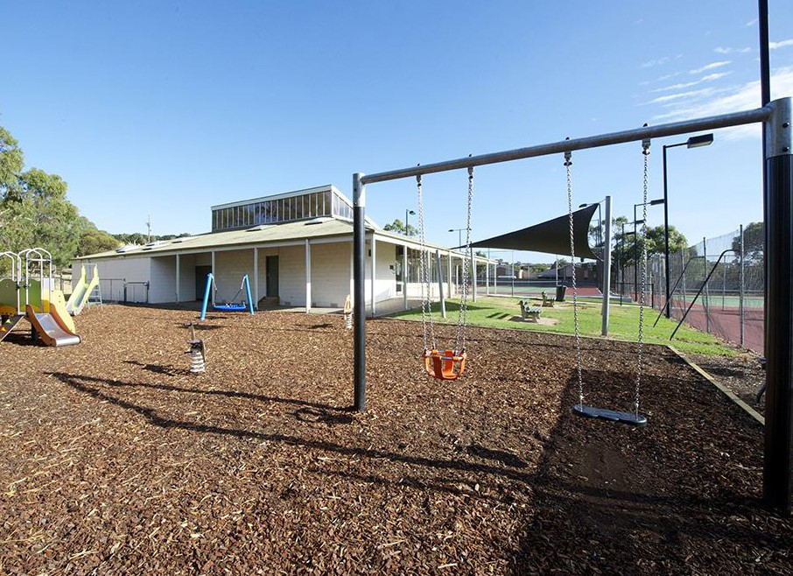

BARWON TENNIS STRATEGY 2024 - 2034 – POWERED BY KINETICA 13

Venue Performance Summary
Metrics | Explanation | Alignment to Strategic Framework
Number of courts | There is a ‘sweet spot’ in terms of the number of courts that optimise participation/utlisation (5-8 courts). Small venues (1-2 courts) play a role in providing cheap/free access, while large venues (12+) can accommodate larger scale competition and tournaments | Play – access to a range of formats/ tennis options  Sustainability & Growth – venue size is correlated to financial performance/sustainability for both small and large venues
Lights | Sustainability & Growth – for venues to be sustainable and grow, data demonstrates venues with lights are more likely to perform. | Places – not only access to a court but access at high demand times which lights provide
Competition (venue) quantum and proximity | Venues with a number of other venues nearby arguably aren’t as strategically important to the network (holding all else equal) as those that have limited nearby venues, especially if they are the same type of venues | Sustainability & Growth – a key consideration ensuring supply and demand are close to equilibrium
Population in catchment | More people living within the catchment area of a club provides a greater opportunity to engage people in the sport (holding all else equal) | Sustainability & Growth – for venues to be sustainable and grow there needs to be a critical mass of people (and demand) now and in the future  Places – ensuring equitable access in the future requires understanding of likely future population movement, and therefore future demand
Population in catchment in the future | Population growth can/will change the supply/demand dynamics over time and regions with significant population growth need to consider how to cater for increased demand.
Demand | Regions with higher demand require greater access/provision
Latent demand | Regions with a higher latent demand have greater potential for growth if the can convert interest to participation
Competition play | Venues that ensure a mix of visit types (competition play, social play, coaching and programming) will perform better. Venues with either very little or a lot of competition play won’t generally be optimising visitation | People – a diverse offering will require a combination of skilled coaches and volunteers to deliver what’s required by the community  Play – access to different formats is nearly as important as access to courts (for some user groups)

Venue Classification

The following variables have been used to create a venue classification:
- Venue size
- Lighting
- Demand in catchment
- Competition (venue numbers) in catchment
A further variable, population size (to reflect critical mass has also been used as a broad overlay to inform actions.
In total, there are 29 different venue categorisations which in turn require one of 11 actions, each of which are outlined on the following pages.

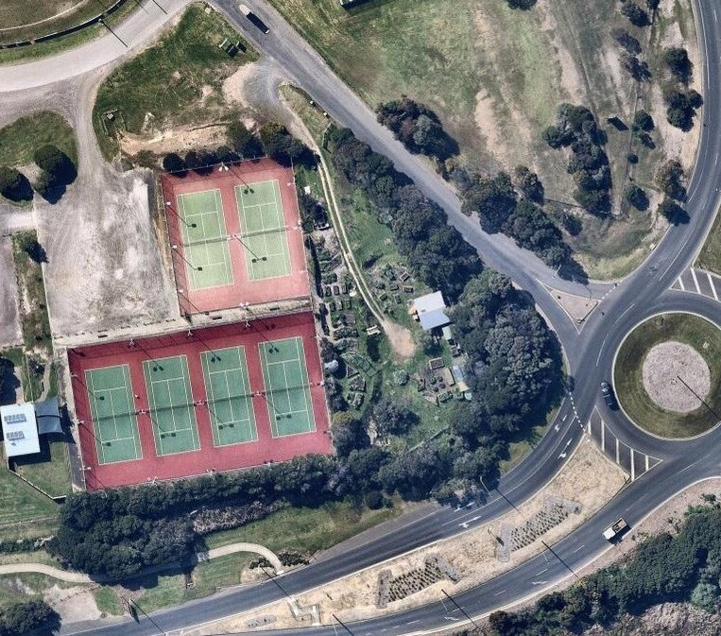

14 BARWON TENNIS STRATEGY 2024 - 2034 – POWERED BY KINETICA BARWON TENNIS STRATEGY 2024 - 2034 – POWERED BY KINETICA 15

Venue Classification

‘Using four critical data points, each venue has been classified and a strategic action developed’
Each of the 11 actions are explained below. It’s important to note that in some instances the action could be contradictory (e.g. alternate use or expansion potential). In these instances, the action for the venue will be dependent on actions for the collection of venues within close proximity (as should be the case when undertaking network planning).

Venue Classification, Explanation and Action

In total, 29 different categorisations with explanations and actions. In some instances, the explanation or action may change based on additional qualitative information provided about the venue or the community that has not/cannot be captured in the data (this is the case for only a handful of venues and are denoted with an *).
Venue classification | Explanation | Action
Small venue, Not Lit, Moderate nearby competition, Medium demand | Potential to service local social play | Maintain
Small venue, Not Lit, Moderate nearby competition, Low demand | Not of significant strategic value to the network | Maintain or alternate use
Small venue, Not Lit, Moderate nearby competition, High demand | Priority to add lights and/or expansion potential | Lights or expansion potential
Small venue, Not Lit, Limited nearby competition, Medium demand | Potential to service local social play and expansion potential | Activate and develop
Small venue, Not Lit, Limited nearby competition, Low demand | Service local demand only | Maintain
Small venue, Not Lit, Limited nearby competition, High demand | Priority to add lights and/or expansion potential | Lights or expansion potential
Small venue, Not Lit, Highly competitive, Medium demand | Moderate value to the network - potential to aggregate 2 or more venues | Alternate use potential
Small venue, Not Lit, Highly competitive, High demand | Potential to include lights | Alternate use or expansion potentail
Small venue, Lit, Moderate nearby competition, Medium demand | Service local demand | Maintain
Small venue,Lit ,Moderate nearby competition, High demand | Important to the network but requires expansion to optimise | Optimise or Potential for expansion
Small venue, Lit, Limited nearby competition, Medium demand | Important to the network but requires expansion to optimise | Optimise or Potential for expansion
Small venue, Lit, Limited nearby competition, Low demand | Valuable to the local community | Maintain
Small venue,Lit, Limited nearby competition, High demand | Critical part of the network | Optimise or Potential expansion required
Small venue, Lit, Highly competitive, Medium demand | Not of significant strategic value to the network | Maintain

Categorisation | Action explanation
Maintain | Retain the venue in its current form
Maintain or alternate use | Retain or consider an option where this venue is potentially changed to a different use but increased investment occurs at a nearby venue (consolidation and an improved offer)
Optimise | Ensure the venue is operating to its full potential
Alternate use potential | Could be considered for an alternate or complementary use to tennis
Activate and develop | Opportunity to improve the offering and increase utilisation and better service local demand
Lights or expansion potential | Opportunity to increase the number of courts and/or add lights to better service local demand
Optimise or Potential for expansion | Opportunity to increase the number of courts and/or improve/enhance offering
Lights or alternate use | Potential to add lights or could be considered for an alternate use
Expansion required | The venue requires greater capacity (more courts)
Optimise and Lights | Ensure the venue is operating to its full potential and add lights
Alternate use or expansion potential | Potential to increase the capacity of the venue or could be considered for an alternate use

16 BARWON TENNIS STRATEGY 2024 - 2034 – POWERED BY KINETICA BARWON TENNIS STRATEGY 2024 - 2034 – POWERED BY KINETICA 17

Venue Classification
Venue classification | Explanation | Action
Medium sized venue, Not Lit, Moderate nearby competition, Medium demand | Potential to play a more important role in the network | Lights or expansion potential
Medium sized venue, Not Lit, Limited nearby competition, Medium demand | Strong potential to play a more important role in the network | Lights or expansion potential
Medium sized venue, Not Lit, Highly competitive, Medium demand | Role in local area dependent on surrounding venue mix | Lights or alternate use
Medium sized venue, Lit, Moderate nearby competition, Medium demand | Important to the network | Optimise
Medium sized venue, Lit, Moderate nearby competition, Low demand | Important to the network | Maintain
Medium sized venue, Lit, Moderate nearby competition, High demand | Priority venues | Optimise
Medium sized venue, Lit, Limited nearby competition, Medium demand | Critical to the network | Optimise
Medium sized venue, Lit, Limited nearby competition, High demand | Absolutley priority venues | Optimise
Medium sized venue, Lit, Highly competitive, Medium demand | Role in local area dependent on surrounding venue mix | Maintain
Large venue, Not Lit, Moderate nearby competition, Low demand | Strategic importance given its size | Optimise and Lights
Large venue, Lit, Highly competitive, Medium demand | Strategic importance given its size | Optimise

In total, there are 29 different venue categorisations which in turn require one of 11 actions, which can then be applied to each of the venues in the Barwon region. The chart below shows the number of venues that require each of the different actions (mindful there is some overlap in the descriptions).

35

30

25

20

15

10

5

0

18 BARWON TENNIS STRATEGY 2024 - 2034 – POWERED BY KINETICA BARWON TENNIS STRATEGY 2024 - 2034 – POWERED BY KINETICA 19

Recommendations
Colac Otway Shire – Venue Categorisation and Future considerations
Of the 15 venues in Colac Otway Shire, the majority (56%) have been identified as being required in their current form or could be considered as an option to convert to another use if additional
investment can then be made into a nearby venue. It’s apparent there is a lack of lighting at facilities and this is a major focus of the recommendations.
A review of tennis assets in the Colac Otway Shire indicates that there has been a shift in the tennis landscape, with there being less teams in rural areas than there has been in years past. This has resulted in less demand for competition-standard courts in rural areas. Parallel to this has been a decline in the condition of some rural tennis courts in the Colac Otway Shire as the assets reach the end of their serviceable lives. With finite investment and maintenance support for tennis infrastructure, a considered approach toward facility investment is required.
A notable infrastructure gap within Colac itself is the access to floodlit courts. A redevelopment of the Colac Lawn Tennis Club venue would cater for the needs of the residents of Colac and provide a pathway for players from within the municipality. Further analysis is required to identify the size of the facility, surface type and associated amenities required to support this need.

Venue Categorisation and information below:

Colac Otway Shire Action Summary
Activate and develop

Optimise and Lights 6%
7%
Expansion required 6%

Maintain 25%

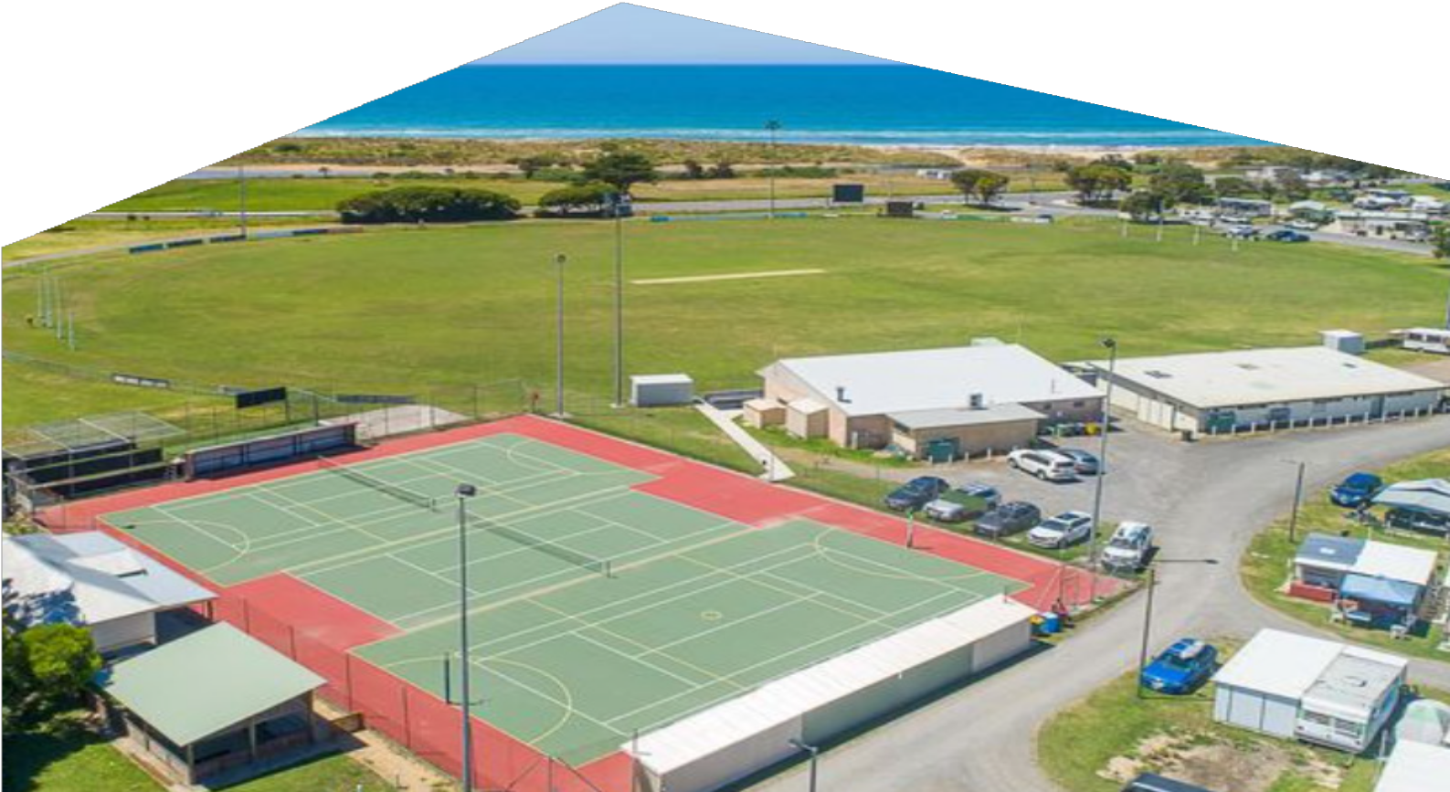

Maintain or alternate use 56%

BARWON TENNIS STRATEGY 2024 - 2034 – POWERED BY KINETICA 21
20 BARWON TENNIS STRATEGY 2024 - 2034 – POWERED BY KINETICA

Colac Otway Shire –
Venue Categorisation and Actions

Reserve Name | Club Name | Action | Categorisation | Explanation | Future Considerations
Apollo Bay Recreation Reserve | Apollo Bay Tennis Club | Small venue, Lit, Limited nearby competition, High demand | Optimise or Expansion required | Critical part of the network | Optimise, expansion not an option due to court location. Not Council owned/managed
Barongarook Hall Tennis Courts | Barongarook Community Tennis Club | Small venue, Not Lit, Moderate nearby competition, Low demand | Maintain or alternate use | Not of significant strategic value to the network | Decomission (court surface unplayable)
Barwon Downs Tennis Courts | Barwon Downs Tennis Club | Small venue, Not Lit, Moderate nearby competition, Low demand | Maintain or alternate use | Not of significant strategic value to the network | Maintain
Beeac Tennis Club | Beeac Tennis Club | Small venue, Not Lit, Moderate nearby competition, Low demand | Maintain | Service local demand only | Maintain
Birregurra Recreation Reserve | Birregurra Tennis Club | Small venue, Lit, Moderate nearby competition, Low demand | Maintain | Valuable to the local community | Maintain. Not Council owned/ managed
Central Reserve Tennis Courts | Colac Lawn Tennis Club  Polwarth & District Tennis Assoication | Small venue, Not Lit, Moderate nearby competition, Low demand | Maintain or alternate use | Not of significant strategic value to the network | Maintain court for local and overflow use
Colac Lawn Tennis Club | Colac Lawn Tennis Club | Small venue, Not Lit, Moderate nearby competition, Low demand | Optimise and Lights | Strategic importance given its size | Consider broader redevelopment of site
Cororooke Open Space Tennis Courts | Cororooke Tennis Club | Small venue, Not Lit, Moderate nearby competition, Low demand | Maintain or alternate use | Services local demand* | Maintain
Elliminyt Recreation Reserve Tennis Courts | Elliminyt Tennis Club | Small venue, Not Lit, Moderate nearby competition, Low demand | Maintain or alternate use | Services local demand* | Maintain and consider lights for optimisation
Forrest Common Tennis Courts | Forrest Tennis Club | Small venue, Not Lit, Limited nearby competition, Medium demand | Maintain | Services local demand* | Maintain
Gerangamete Tennis Courts |  | Small venue, Not Lit, Moderate nearby competition, Low demand | Maintain or alternate use | Not of significant strategic value to the network | Alternate use. Not Council owned/managed.
Kawarren Tennis Courts | Kawarren Tennis Club | Small venue, Not Lit, Limited nearby competition, Medium demand | Activate and develop | Potential to service local social play and expansion potential | Maintain or consider future activation or optimisation. Not Council owned/managed.
Kennett River Tennis Courts |  | Small venue, Not Lit, Limited nearby competition, Low demand | Maintain | Service local demand only | Maintain
Pennyroyal Tennis Club | Pennyroyal Tennis Club | Small venue, Not Lit, Moderate nearby competition, Low demand | Maintain or alternate use | Service local demand only | Maintain. Not Council owned/ managed.
Warncoort Reserve Tennis Courts | Warncoort Tennis Club | Small venue, Not Lit, Moderate nearby competition, Low demand | Maintain or alternate use | Service local demand only | Maintain
See Appendix 16 for list of venues no longer considered part of the Tennis Network in the Colac Otway Shire.

* as provided on page 17

22 BARWON TENNIS STRATEGY 2024 - 2034 – POWERED BY KINETICA BARWON TENNIS STRATEGY 2024 - 2034 – POWERED BY KINETICA 23

Golden Plains Shire – Venue Categorisation and Future considerations
Of the 17 venues in Golden Plains Shire, a large proportion (47%) have been identified as being required in their current form while there is significant opportunity to improve and expand the network through additional courts, lighting and/or ensuring venues are performing optimally given their physical and geographic attributes.
A review of tennis assets in the Golden Plains Shire indicates that the courts adequately support tennis in the region. Since initial investment in the development of tennis infrastructure, there has been a shift in population and the tennis landscape. With finite investment and maintenance support for tennis infrastructure, a considered approach toward facility investment is required.
Population continues to grow within Bannockburn the optimisation of the facilities a to cater for that community and provide a pathway the players from within the municipality.

Golden Plains Shire Action Summary

Maintain or alternate use 18%

Optimise 17%
Optimise or Potential for expansion
6%
Activate and develop
6%

Lights or expansion potential 6%

Maintain 47%

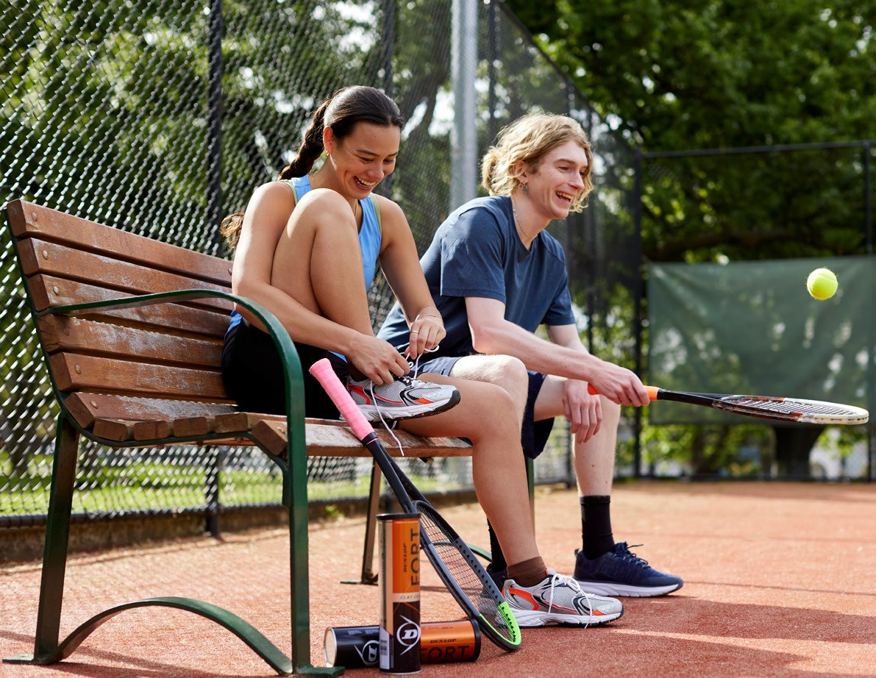

24 BARWON TENNIS STRATEGY 2024 - 2034 – POWERED BY KINETICA BARWON TENNIS STRATEGY 2024 - 2034 – POWERED BY KINETICA 25

Golden Plains Shire –
Venue Categorisation and Actions

Reserve Name | Club Name | Action |  | Categorisation | Explanation | Future Considerations
Bannockburn Recreation Reserve | Bannockburn Tennis Club | Medium sized venue, Lit, Limited nearby competition, Medium demand |  | Optimise | Critical to the network | Critical facility, optimise courts with lights
Barunah Park Tennis Courts | Barunah Park Tennis Courts | Small venue, Not Lit, Moderate nearby competition, Low demand |  | Maintain or alternate use | Not of significant strategic value to the network | Alternative use
Cape Clear Tennis Court | Cape Clear Tennis Court | Small venue, Not Lit, Limited nearby competition, Low demand |  | Maintain | Service local demand only | Service local demand only
Enfield Tennis Club | Enfield Tennis Club | Small venue, Not Lit, Moderate nearby competition, Medium demand |  | Maintain | Potential to service local social play | Maintain
Grenville Tennis Club | Grenville Tennis Club | Small venue, Not Lit, Limited nearby competition, High demand |  | Lights or expansion potential | Priority to add lights and/or expansion potential | Optimise courts with lights
Haddon Tennis Club | Haddon Tennis Club | Small venue, Not Lit, Moderate nearby competition, Low demand |  | Maintain or alternate use | Not of significant strategic value to the network | Maintain
Inverleigh Recreation Reserve | Inverleigh Tennis Club | Small venue, Not Lit, Limited nearby competition, Medium demand |  | Activate and develop | Potential to service local social play and expansion potential | Optimise courts with lights
Lethbridge Tennis Club | Lethbridge Tennis Club | Small venue, Lit, Limited nearby competition, Medium demand |  | Optimise or Potential for expansion | Important to the network but requires expansion to optimize | Optimise courts
Mannibadar Tennis Courts | Mannibadar Tennis Courts | Small venue, Not Lit, Moderate nearby competition, Low demand |  | Maintain or alternate use | Not of significant strategic value to the network | Maintain
Maude Tennis Club | Maude Tennis Club | Small venue, Not Lit, Moderate nearby competition, Medium demand |  | Maintain | Potential to service local social play | Maintain
Meredith Tennis Club | Meredith Tennis Club | Medium sized venue, Lit, Limited nearby competition, Medium demand |  | Optimise | Critical to the network | Maintain
Napoleons Tennis Courts | Napoleons Tennis Courts | Small venue, Not Lit, Moderate nearby competition, Low demand |  | Maintain or alternate use | Not of significant strategic value to the network | Maintain
Rokewood Tennis Club | Rokewood Tennis Club | Small venue, Lit, Limited nearby competition, Low demand |  | Maintain | Service local demand only | Maintain
Ross Creek Tennis Club | Ross Creek Tennis Club | Small venue, Not Lit, Moderate nearby competition, Medium demand |  | Activate and develop* | Potential to service local social play and expansion potential | Maintain
Shelford Tennis Club | Shelford Tennis Club | Small venue, Not Lit, Limited nearby competition, Medium demand |  | Maintain | Primarily service local social play | Maintain
Smythesdale Tennis Club | Smythesdale Tennis Club | Small venue, Not Lit, Limited nearby competition, Low demand |  | Maintain | Service local demand only | Maintain
Sutherlands Creek Tennis Club | Sutherlands Creek Tennis Club | Small venue, Not Lit, Limited nearby competition, Low demand |  | Maintain | Service local demand only | Maintain
Teesdale Tennis Club | Teesdale Tennis Club | Medium sized venue, Lit, Limited nearby competition, Medium demand |  | Optimise | Critical to the network | Optimise courts

26 BARWON TENNIS STRATEGY 2024 - 2034 – POWERED BY KINETICA BARWON TENNIS STRATEGY 2024 - 2034 – POWERED BY KINETICA 27

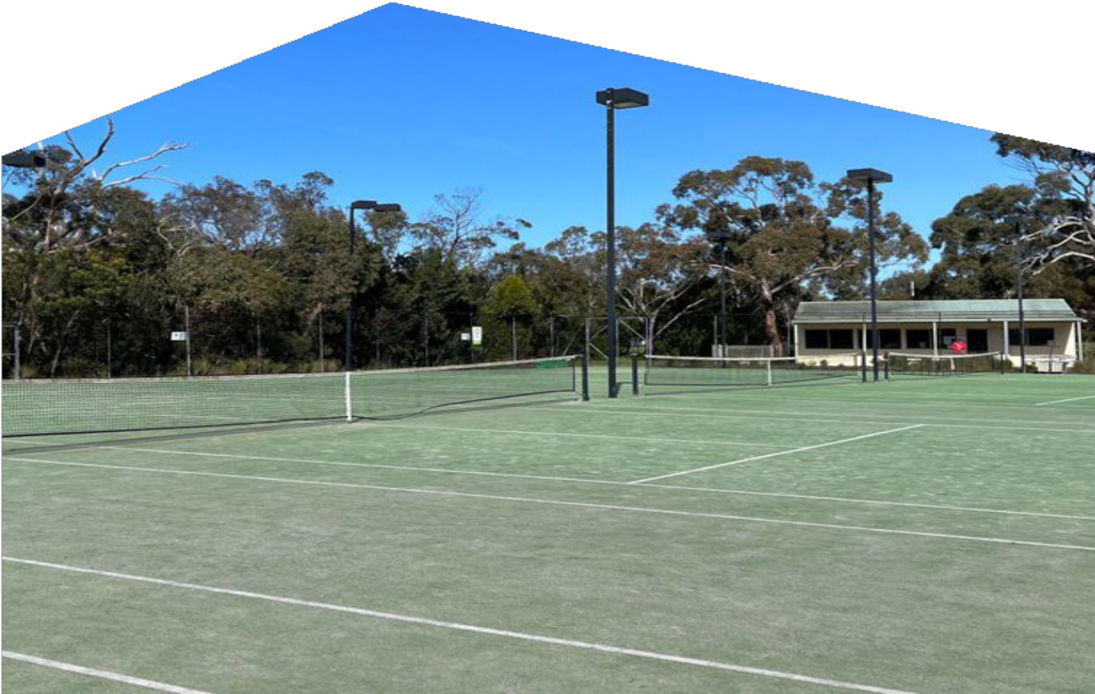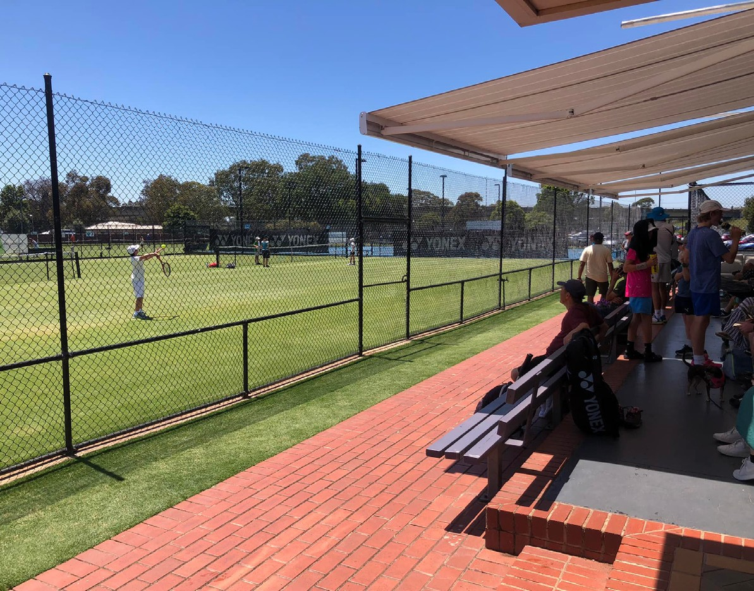

Greater Geelong – Future Considerations
There is a significant gap in tennis infrastructure in the fastest growing area within the Barwon (G21) region, around Armstrong creek. The map to the right shows a 5km radius where is currently no tennis infrastructure (not one venue). Further, there are very few venues that service the region that have 5 courts or more (venues shown on the map are only those with 5+ courts).
The region highlighted (black outline) is forecast to grow by over 30,000 people over the next 10 years. This combination of a lack of venues, and specifically a lack of larger venues that typically provide a range of services, coupled with the significant growth in population and demand to play tennis means there is a strong business case for at least one significant venue to service future demand.
The two pins located in red are sites that have been earmarked for large tennis facilities into the future (2026 and 2030+ respectively) and as part of a range of decisions to optimise the network, at least one and potentially both will be important to service residents in the region in the future.
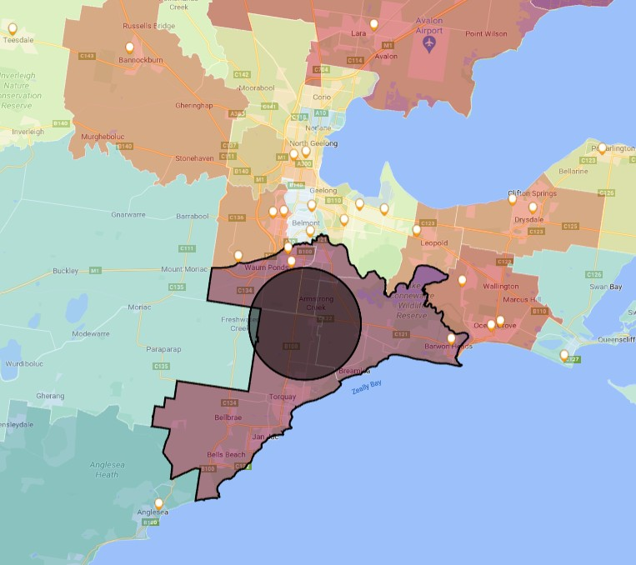

28 BARWON TENNIS STRATEGY 2024 - 2034 – POWERED BY KINETICA BARWON TENNIS STRATEGY 2024 - 2034 – POWERED BY KINETICA 29

Greater Geelong – Venue Categorisations
Of the 42 venues in Greater Geelong, one-third (33%) could be considered for an alternate or complementary use. This is due to the glut of similar type venues within close proximity of each other. These would require careful consideration and would be dependent on
Reserve Name | Club Name | Action | Categorisation | Explanation | Future Considerations
All Saints Newtown Tennis Club | All Saints Newtown Tennis Club | Small venue, Lit, Highly competitive, Medium demand | Maintain | Services local demand* | Non Council land. Maintain
Anakie Recreation Reserve | Anakie Tennis Club | Small venue, Not Lit, Limited nearby  competition, Medium  demand | Activate and develop | Potential to service local social play and expansion potential | Activate facility
Barwon Heads Villiage Park | Barwon Heads Tennis Club | Medium sized venue, Lit, Limited nearby competition, Medium demand | Optimise | Critical to the network | Optimise with lights
Myers Reserve | Bell Post Hill Tennis Courts | Small venue, Not Lit, Highly competitive, Medium demand | Alternate use potential | Moderate value to the network - potential to aggregate 2 or more venues | Maintain. Activate club
Belmont Uniting Church | Belmont Uniting Tennis Club | Small venue, Not Lit, Highly competitive, Medium demand | Alternate use potential | Moderate value to the network - potential to aggregate 2 or more venues | Non Council land. Consider venue viability
Frank Mann Reserve | Ceres Tennis Club | Small venue, Not Lit, Highly competitive, Medium demand | Maintain* | Service local demand | Maintain
Jetty Road Reserve | Clifton Springs Tennis Club | Medium sized venue, Lit, Limited nearby competition, Medium demand | Optimise | Critical to the network | Optimise with lights
Corio Community Reserve | Corio Community Reserve | Small venue, Not Lit, Moderate nearby competition, Medium demand | Maintain | Potential to service local social play | Maintain as local level facility
Drysdale Recreation Reserve | Drysdale Recreation Reserve | Small venue, Not Lit, Moderate nearby competition, Medium demand | Maintain | Potential to service local social play | Maintain to service local casual participation
Wathaurong Reserve | Drysdale Tennis Club | Medium sized venue, Lit ,Moderate nearby competition, Medium demand | Optimise | Critical to the network | Optimise

the collective set of actions (i.e. if a number of these venues were removed there would then there would be a shortage of venues in the region). Almost 20% should be optimised as they have the attributes of a venue that should be high performing.

Greater Geelong Action Summary

Activate and develop
7% Lights or expansion potential
5%

Alternate use potential 33%

Lights or alternate use 7%

Optimise 19%

Maintain 29%

30 BARWON TENNIS STRATEGY 2024 - 2034 – POWERED BY KINETICA BARWON TENNIS STRATEGY 2024 - 2034 – POWERED BY KINETICA 31

Greater Geelong –
Venue Categorisation and Actions

Reserve Name | Club Name | Action |  | Categorisation | Explanation | Future Considerations
East Geelong Tennis Club | East Geelong Tennis Club | Small venue, Not Lit, Highly competitive, Medium demand |  | Alternate use potential | Moderate value to the network - potential to aggregate 2 or more venues | Non Council land. Consider venue viability
Howard Glover Reserve | Eastern Districts Tennis Club | Small venue, Not Lit, Highly competitive, Medium demand |  | Alternate use potential | Moderate value to the network - potential to aggregate 2 or more venues | Maintain
Fyans Park Primary School | Fyans Park Tennis Club | Small venue, Not Lit, Highly competitive, Medium demand |  | Alternate use potential | Moderate value to the network - potential to aggregate 2 or more venues | Non Council land. Consider venue viability
Geelong East Uniting Church | Geelong East Uniting Church Tennis Club | Small venue, Not Lit, Highly competitive, Medium demand |  | Alternate use potential | Moderate value to the network - potential to aggregate 2 or more venues | Maintain
Geelong Lawn Tennis Club | Geelong Lawn Tennis Club | Large venue, Lit, Highly competitive, Medium demand |  | Optimise | Strategic importance given its size | Non Council venue. Optimise
Geelong West Tennis Club | Geelong West Tennis Club | Small venue, Not Lit, Highly competitive, Medium demand |  | Maintain* | Service local demand | Maintain
Burdoo Reserve | Grovedale Tennis Club | Medium sized venue, Lit, Highly competitive, Medium demand |  | Maintain | Role in local area dependent on surrounding venue mix | Maintain
Hamlyn Park Reserve | Hamlyn Park Tennis Club | Medium sized venue, Lit, Highly competitive, Medium demand |  | Maintain | Role in local area dependent on surrounding venue mix | Maintain
Highton Reserve | Highton Tennis Club | Medium sized venue, Lit, Highly competitive, Medium demand |  | Maintain | Role in local area dependent on surrounding venue mix | Maintain
Pioneer Park | Highton Tennis Club | Medium sized venue, Lit, Highly competitive, Medium demand |  | Maintain | Role in local area dependent on surrounding venue mix | Maintain
Kenwith Park | All Saints Newtown Tennis Club | Small venue, Not Lit, Highly competitive, Medium demand |  | Maintain* | Service local demand | Maintain
Lara Recreation Reserve | Lara Tennis Club | Medium sized venue, Lit, Moderate nearby competition, Low demand |  | Maintain | Important to the network | Maintain
Leopold Memorial Park | Leopold Tennis Club | Medium sized venue, Lit, Moderate nearby competition, Medium demand |  | Optimise | Important to the network | Optimise with lights
Lunan Reserve | Lunan Tennis Club | Small venue, Not Lit, Highly competitive, Medium demand |  | Maintain* | Service local demand | Maintain
Marcus Hill Reserve | Marcus Hill Reserve | Small venue ,Not Lit ,Moderate nearby competition, Medium demand |  | Maintain | Potential to service local social play | Maintain
Marshall Reserve | Marshall Reserve | Small venue, Not Lit, Highly competitive, Medium demand |  | Alternate use potential | Moderate value to the network - potential to aggregate 2 or more venues | Maintain to service local casual play
Moolap Reserve | Moolap Tennis Club | Medium sized venue, Lit, Moderate nearby competition, Medium demand |  | Optimise | Important to the network | Optimise with lights
Ervin Reserve | Newcomb Tennis Club | Medium sized venue, Not Lit, Highly competitive, Medium demand |  | Lights or alternate use | Role in local area dependent on surrounding venue mix | Optimise with lights, Consider viability of venue size
Arthur Powell Reserve | Ocean Grove Tennis Club | Medium sized venue, Lit, Moderate nearby competition, Medium demand |  | Optimise | Important to the network | Optimise with lights

32 BARWON TENNIS STRATEGY 2024 - 2034 – POWERED BY KINETICA BARWON TENNIS STRATEGY 2024 - 2034 – POWERED BY KINETICA 33

Greater Geelong –
Venue Categorisation and Actions

Reserve Name | Club Name | Action | Categorisation | Explanation | Future Considerations
Shell Rd Reserve | Ocean Grove Tennis Club | Medium sized venue, Lit, Moderate nearby competition, Medium demand | Optimise | Important to the network | Optimise with lights
Portarlington Recreation Reserve | Portarlington Tennis Club | Medium sized venue, Lit, Limited nearby competition, Medium demand | Optimise | Critical to the network | Optimise with lights
St Albans Reserve | St Albans Tennis Club | Medium sized venue, Lit, Highly competitive, Medium demand | Maintain | Role in local area dependent on surrounding venue mix | Consider viability of venue size
Lake Reserve | St Leonards - Lake Reserve | Small venue, Not Lit, Limited nearby competition, Medium demand | Maintain* | Service local demand | Maintain
Harvey Park | St Leonards Tennis Club | Small venue, Not Lit, Limited nearby competition, Medium demand | Activate and develop | Potential to service local social play and expansion potential | Non Council land, consider optimise with lights.
St Lukes Uniting Church | St Lukes Uniting Tennis Club | Small venue, Not Lit, Highly competitive, Medium demand | Alternate use potential | Moderate value to the network - potential to aggregate 2 or more venues | Non Council land. Consider venue viability
Thomspon Reserve | St Marys (Geelong) Tennis Club | Small venue, Lit, Highly competitive, Medium demand | Maintain | Services local demand* | Maintain
Francis St Reserve | St Stephens (Geelong) Tennis Club | Medium sized venue, Not Lit, Highly competitive, Medium  demand | Lights or alternate use | Role in local area dependent on surrounding venue mix | Consider activiation of a club
Wallington Reserve | Wallington Reserve | Medium sized venue, Not Lit, Moderate nearby competition, Medium demand | Lights or expansion potential | Potential to play a more important role in the network | Consider activiation of a club
Tim Hill Reserve | Wandana Heights Tennis Club | Medium sized venue, Lit, Highly competitive, Medium  demand | Maintain | Role in local area dependent on surrounding venue mix | Maintain
Waurn Ponds Reserve | Waurn Ponds Tennis Club | Medium sized venue, Not Lit, Highly competitive, Medium  demand | Lights or alternate use | Role in local area dependent on surrounding venue mix | Optimise with lights
Western Heights Uniting Church | Western Heights Uniting Tennis Club | Small venue, Not Lit, Highly competitive, Medium demand | Alternate use potential | Moderate value to the network - potential to aggregate 2 or more venues | Non Council land. Consider venue viability

34 BARWON TENNIS STRATEGY 2024 - 2034 – POWERED BY KINETICA BARWON TENNIS STRATEGY 2024 - 2034 – POWERED BY KINETICA 35

Surf Coast Shire – Venue Categorisation and Future considerations
Of the 17 venues in the Surf Coast Shire, a large proportion (42%) have been identified as being required in their current form while there is significant opportunity to improve and expand the network through additional courts, lighting and/or ensuring venues are performing optimally given their physical and geographic attributes. Given the relatively sparse distribution of venues in the region, most venues play an important role in servicing the needs of a local catchment.
Surf Coast Shire Action Summary
Alternate use or expansion potential
5% Lights or expansion potential

Optimise or Potential for expansion
21%
16%

Maintain or alternate use 5%

Optimise 5%
Maintain 48%

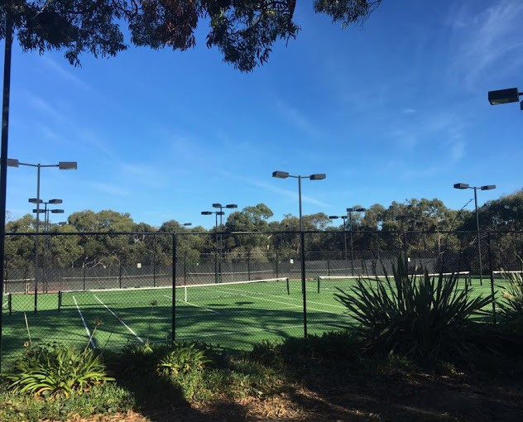

36 BARWON TENNIS STRATEGY 2024 - 2034 – POWERED BY KINETICA BARWON TENNIS STRATEGY 2024 - 2034 – POWERED BY KINETICA 37

Surf Coast Shire –
Venue Categorisation and Actions

Reserve Name | Club Name | Action |  | Categorisation | Explanation | Future Considerations
Airey’s Inlet & District Tennis Courts | Airey’s Inlet & District Tennis Club | Small venue,Lit, Limited nearby competition, Medium demand |  | Optimise or Potential for expansion | Important to the network but requires expansion to optimise | Land locked, Optimise with LED lights & BAC
Anglesea Tennis Courts | Anglesea Tennis Club | Medium sized venue, Lit, Limited nearby competition, High demand |  | Optimise | Absolute priority venues | Priority site
Bambra Tennis Courts | Bambra Tennis Club | Small venue, Lit, Limited nearby competition, Medium demand |  | Maintain | Primarily service local social play | Maintain
Bellbrae Tennis Courts - Lower |  | Small venue, Not Lit, Moderate nearby competition, Medium demand |  | Maintain or alternate use | Not of significant strategic value to the network | Consider venue viability. Alternate use.
Buckley South Tennis Courts |  | Small venue, Not Lit, Moderate nearby competition, Low demand |  | Maintain or alternate use | Not of significant strategic value to the network | Consider venue viability. Alternate use.
Connewarre Tennis Courts |  | Small venue, Not Lit, Moderate nearby competition, Medium demand |  | Maintain | Potential to service local social play | Maintain to service local casual participation
Deans Marsh Tennis Courts |  | Small venue, Not Lit, Limited nearby competition, Low demand |  | Maintain | Service local demand only | Optimise with lights and booking potential
Deep Creek Tennis Courts | Deep Creek Tennis Club | Small venue, Not Lit, Moderate nearby competition, High demand |  | Lights or expansion potential | Priority to add lights and/or expansion potential | Optimise with lights
Freshwater Creek Recreation Reserve |  | Small venue, Not Lit, Highly competitive, High demand |  | Alternate use or expansion potentail | Potential to include lights | Alternate use. Maintain one court for local play
Gnarwarre Recreation Reserve |  | Small venue, Not Lit, Moderate nearby competition, Medium demand |  | Maintain | Potential to service local social play | Maintain
Lorne Country Club | Lorne Country Club | Medium sized venue, Not Lit, Limited nearby competition, Medium demand |  | Lights or expansion potential | Strong potential to play a more important role in the network | Not Council land. Optimise with lights
Mirnee Tennis Courts |  | Small venue, Not Lit, Limited nearby competition, Low demand |  | Maintain or alternate use | Not of significant strategic value to the network | Consider venue viability. Alternate use.
Modewarre Memorial Hall |  | Small venue, Not Lit, Moderate nearby competition, Medium demand |  | Maintain | Potential to service local social play | Maintain
Newling Reserve | Moriac Tennis Club | Small venue, Lit, Moderate nearby competition, Medium demand |  | Maintain | Service local demand | Maintain
Mt Moriac Recreation Reserve | Mt Moriac Tennis Club | Small venue, Not Lit, Moderate nearby competition, Medium demand |  | Maintain | Potential to service local social play | Maintain
Spring Creek Reserve | Surf Coast Tennis Club - Torquay | Medium sized venue, Lit, Moderate nearby competition, High demand |  | Optimise or Potential for expansion | Critical to the network | Priority for expansion
Bellbrae Recreation Reserve | Surf Coast Tennis Club - Bellbrae | Small venue, Lit, Moderate nearby competition, Medium demand |  | Optimise | Important to the network but requires optimisation | Optimise
Bob Pettit Reserve | Surf Coast Tennis Club - Jan Juc | Medium sized venue, Lit, Moderate nearby competition, High demand |  | Optimise | Critical to the network | Optimise
Winchelsea Tennis Club | Winchelsea Tennis Club | Small venue, Not Lit, Limited nearby competition, High demand |  | Maintain | Service local demand only | Maintain

38 BARWON TENNIS STRATEGY 2024 - 2034 – POWERED BY KINETICA BARWON TENNIS STRATEGY 2024 - 2034 – POWERED BY KINETICA 39

Borough of Queenscliff – Venue Categorisation and Future considerations

Reserve Name | Club Name | Action |  | Categorisation | Explanation | Future Considerations
Point Lonsdale Tennis Courts | Point Lonsdale Tennis Club | Medium sized venue, Lit, Moderate nearby competition, Medium demand |  | Optimise | Important to the network | Maintain
Queenscliff Bowling, Tennis & Croquet Club | Queenscliff Tennis Club | Small venue, Lit, Limited nearby competition, Medium demand |  | Optimise or Potential for expansion | Important to the network but requires expansion to optimise | Maintain

40 BARWON TENNIS STRATEGY 2024 - 2034 – POWERED BY KINETICA BARWON TENNIS STRATEGY 2024 - 2034 – POWERED BY KINETICA 41

Appendix
- Population forecast
- Demographic Profile
- Demographic Profile – Sub-regions
- Venue locations
- Venues Sizes
- Venue Gap Analysis

Population Forecast
The Barwon (G21) region has a population in excess of 350,000 people and covers an area of almost 9,000 square kilometres.
It consists of five local government areas (LGA’s) – Colac Otway Shire, Golden Plains Shire, Greater Geelong, Borough of Queenscliffe and Surf Coast Shire. The vast majority of the population in the region is in Greater Geelong (circa 75%).

2021 LGA Population by Age Cohort

- Venues with lights Gap Analysis
- Participation and Interest
- Demand vs Court provision
- Future growth of Tennis
- Venue Performance
- Venue performance by model
- Venues with lights
- Best performing venue locations
- Venue Optimisation
- Colac Otway Shire Venue List

180,000
160,000
140,000
120,000
100,000
80,000
60,000
40,000
20,000
0

0-14 years
15-64 years
65+ years



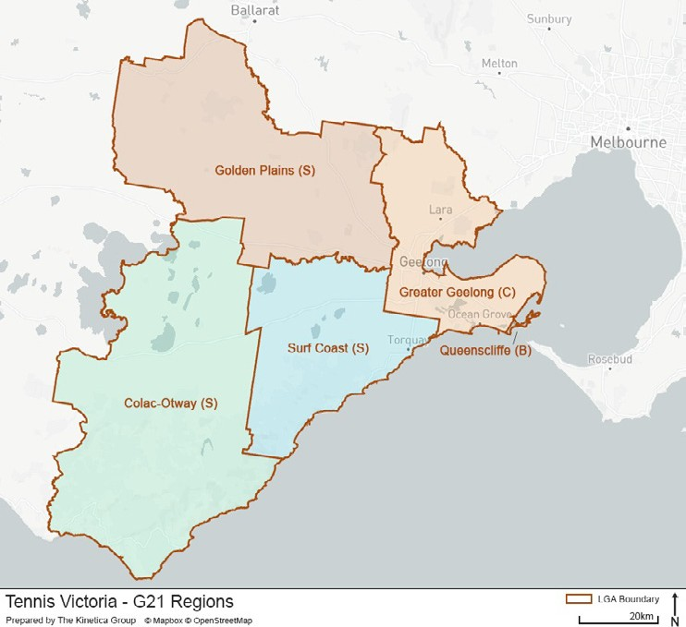

BARWON TENNIS STRATEGY 2024 - 2034 – POWERED BY KINETICA 43

Demographic Profile
The table below provides an insight into the different demographic profile of each LGA within the Barwon region. Figures highlighted in green show a higher than average proportion of this
population in the region when compared to the Victorian average, while the orange shows a lower than average number (+/-3%). The most significant differences to the State average are:
The region has more people aged over 65, with Golden Plains Shire the exception The region has a very low proportion of non-Australian born
Golden Plains Shire and the Surf Coast Shire have a high proportion of family households
Colac Otway Shire has a high proportion of low income families while Golden Plains and the Surf Coast have a higher proportion of high income
Surf Coast Shire and Borough of Queenscliffe have a high proportion of residents with a university educated

 | Population (no.) |  | Population (%) |  | % indigenous | %Aus born
Region | Kids 0-14  years | Adults 15+  years | Kids 0-14  years | Adults 65+  years | % indigenous | %Aus born
Victoria Average |  |  | 18.0% | 16.8% | 1.0% | 68.4%
Barwon Region | 65,608 | 293,209 | 18.0% | 19.9% | 1.2% | 83.2%
Colac-Otway (S) | 3,773 | 18,531 | 16.6% | 24.0% | 1.4% | 88.9%
Golden Plains (S) | 5,581 | 19,298 | 22.1% | 15.4% | 1.4% | 90.3%
Greater Geelong (C) | 48,429 | 222,347 | 17.6% | 19.6% | 1.2% | 81.5%
Queenscliff (B) | 286 | 2,949 | 9.5% | 45.1% | 0.3% | 88.4%
Surf Coast (S) | 7,539 | 30,084 | 19.7% | 19.8% | 0.6% | 87.6%

Demographic Profile, Sub-regions
The heat map to the right shows where population growth is forecast to occur within the Barwon region by SA2. The population within the Barwon region is forecast to increase by circa 70,000 people to 428,000 people in the ten years to 2031.

Average Annual LGA population Change by Age Cohort - 2021 to 2031
4.0%

3.0%

2.0%

1.0%

0.0%

-1.0%

-2.0%

0-14 years
15-64 years
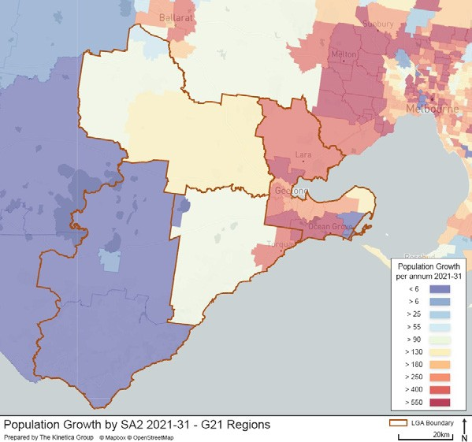
65+ years

 | %  disability | %Family household | %English only lang. | % low income | %high income | % Uni education | %  Unemployment
Region
Victoria Average | 5.8% | 70.1% | 67.2% | 12.2% | 44.3% | 22.2% | 6.6%
Barwon Region | 6.2% | 69.7% | 84.9% | 12.4% | 41.3% | 21.5% | 3.9%
Colac-Otway (S) | 6.8% | 64.3% | 87.7% | 16.9% | 30.1% | 15.7% | 2.9%
Golden Plains (S) | 5.3% | 82.0% | 92.3% | 9.7% | 47.3% | 16.6% | 3.1%
Greater Geelong (C) | 6.5% | 68.5% | 83.1% | 12.7% | 40.5% | 21.6% | 4.4%
Queenscliff (B) | 5.4% | 65.1% | 89.8% | 11.3% | 37.3% | 30.3% | 3.0%
Surf Coast (S) | 3.7% | 75.6% | 90.7% | 9.1% | 52.0% | 26.7% | 2.8%

44 BARWON TENNIS STRATEGY 2024 - 2034 – POWERED BY KINETICA BARWON TENNIS STRATEGY 2024 - 2034 – POWERED BY KINETICA 45

- Venue sizes
1-2 Courts is the most common venue size and the region only has two venues with the capacity to hold events (13+ courts).
The size of a venue is a key metric as it is a key determining factor for service provision, utilisation and sustainability. From a service provision perspective, 1-2 court venues are difficult to activate with a range of services (e.g. coaching, programs etc) due to limited space and the unit economics. These venues serve as a valuable community asset with typically a greater focus on social play
75% of courts are housed in venues with 1-6 courts
Geelong has 43% of all venues and 52% of all courts in the region. Aside from Borough of Queenscliffe, it has the largest average venue size (at 4.7 courts per venue)

No. of Venues by Venue Size No. of Courts by Venue Size
13+ courts,
- Venue locations
There are 94 Tennis Clubs/Venues in the Barwon Region and 382 Courts
Understanding the geographic coverage by venue size is key to determining how to optimise access and venue performance (utilisation):
The vast majority of venues are either 1-2 courts (39%) or 3-6 courts (44%)
Only 2 venues of the 94 have more than 13 courts (one in Colac Otway Shire and the other in Greater Geelong)
Greater Geelong has the lowest proportion of 1-2 court venues of the 5 LGA’s and the highest with 3 or more courts (excluding Borough of Queenscliffe)
One-third of all venues in the region have lighting (not necessarily every court at the venue but at least some)

7-12 courts,
7

240

200

160

120

80

40

0
2 13+ courts,
46
1-2 courts,
50
3-6 courts,
46

7-12 courts,
57

No. of Venues and Courts by LGA

1-2 courts,
92
LGA | No. of Venues in LGA by Court per Venue
LGA | 1 – 2 courts |  | 3 – 6 courts |  | 7 – 12 courts |  | 13+ courts |  | Total
LGA | No. | % of size | No. | % of size | No. | % of size | No. | % of size | No. | % of size
Colac Otway Shire (S) | 9 | 61% | 5 | 32% | 0 | 0% | 1 | 7% | 15 | 16%
Golden Plains Shire (S) | 9 | 50% | 9 | 50% | 0 | 0% | 0 | 0% | 18 | 19%
Greater Geelong (C) | 14 | 33% | 21 | 50% | 6 | 14% | 1 | 3% | 42 | 45%
Borough of Queenscliffe (B) | 0 | 0% | 2 | 100% | 0 | 0% | 0 | 0% | 2 | 2%
Surf Coast Shire (S) | 9 | 53% | 7 | 41% | 1 | 6% | 0 | 0% | 17 | 18%
Barwon Total | 41 | 44% | 44 | 47% | 7 | 7% | 2 | 2% | 94 | 100%

3-6 courts,
212

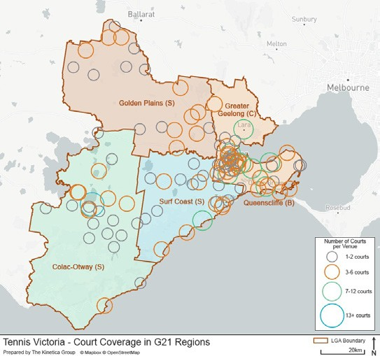
6 No. of venues No. of courts
5 Av. Courts per Venue (RHS)
4

3

2

1

0

46 BARWON TENNIS STRATEGY 2024 - 2034 – POWERED BY KINETICA BARWON TENNIS STRATEGY 2024 - 2034 – POWERED BY KINETICA 47

Venue gap analysis
This analysis is based on the proxy that living with 5km of a venue broadly provides good access to tennis (noting there are many more factors such as type of venue, service provision etc not accounted for). The analysis further in the report uses travel times to understand in detail the coverage of each venue, which is aligned to the ambition stated in the Strategic Framework.
The majority of venues are located around the population hubs of Geelong (and surrounds), Colac Otway Shire and in the northern part of the Golden Plains Shire to the south of Ballarat
As such, regions where there is no coverage within 5km of a venue account for less than 5% of the entire population (i.e. there are relatively low population densities where there are no courts). An assumption can be made there is a good provision of courts.
Relative to the entire tennis provision, outside of Greater Geelong very few 5+ court venues exist and significant gaps appear throughout the region

5km radius 5km radius – 5 court + venues
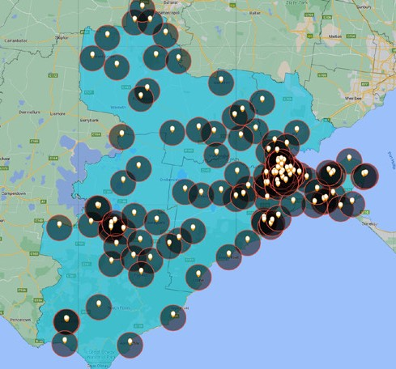
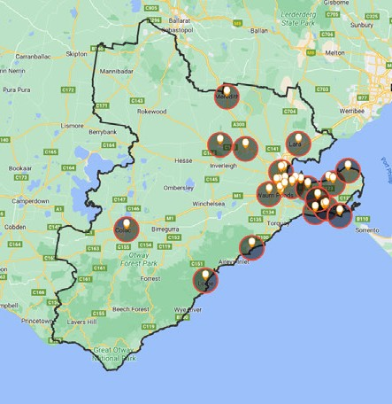

Population Density by SA2

Venues with lights gap analysis
Lights at tennis venues are important because they increase the carrying capacity (operating hours) of the venue. When thinking about how to increase the total hours of playing time available in a region, lights provide the greatest return on investment because the significant capital outlay has already been made (i.e. land, courts etc)
Similar to the larger venue network, the lit venue network skews significantly to the Greater Geelong region and significant gaps appear in the other LGA’s in the Barwon Region.

Lit venues
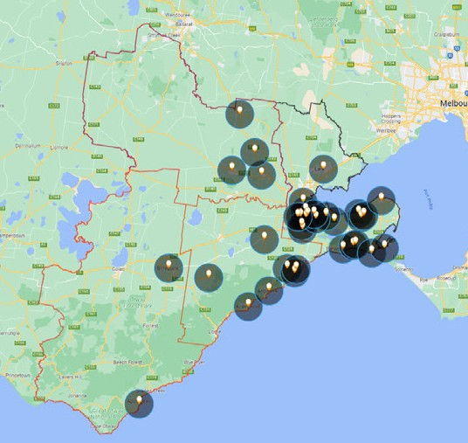

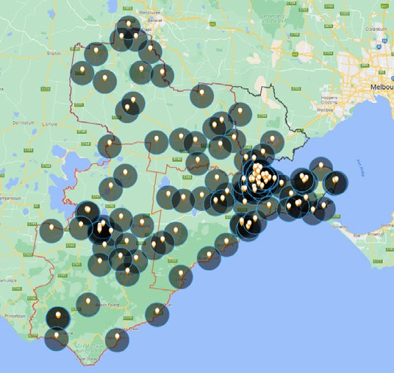
All venues

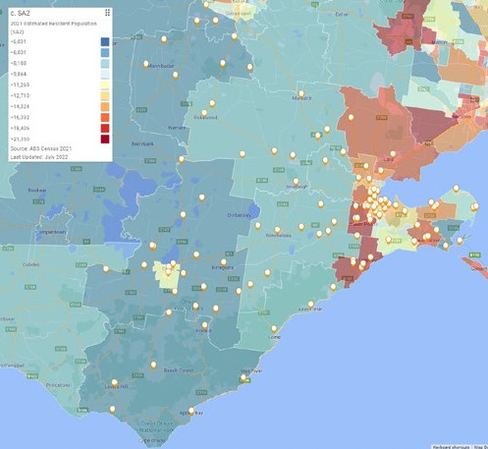

48 BARWON TENNIS STRATEGY 2024 - 2034 – POWERED BY KINETICA BARWON TENNIS STRATEGY 2024 - 2034 – POWERED BY KINETICA 49

Participation and Interest
Geelong has the highest tennis participation in the Barwon Region. However, there are high areas of interest around Torquay and the Otways.
The areas with the highest current participation are to the west and south of Geelong around the suburbs of Highton, Newtown and Grovedale and further south to Barwon Heads and Torquay while interest to play strong in these areas as well around Lara and Colac Otway.

Tennis Participation – Played last 12 months
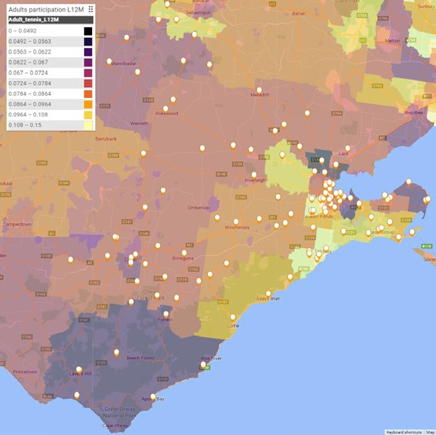

Latent Demand – Interest in playing Tennis

Demand vs Court provision
Despite Greater Geelong having more than half the courts in the region, it has three quarters of the demand in the region.
Of the 60,000 people estimated to currently play, or interested in playing tennis in the Barwon region, three-quarters of them are in the LGA of Greater Geelong
The lowest combined demand/interest to play is in Colac Otway Shire, although this still represents a significant proportion of the population (13.25)
Although Geelong has the most courts, it has by far the highest population to court ratio (i.e. compared to other regions within the Barwon region, there is relatively less courts). This is further exacerbated when looking at the ratio of tennis courts to tennis players/interested to play
This information should be used as a topline benchmark to understand at a macro level relative provision. In our view these metrics alone don’t provide enough insight, nuance or understanding of the supply and demand dynamics to determine an appropriate response. As such, all the information presented in this report will be critical in determining how best to maximise the tennis venue network.

LGA | Venues | Courts | Tennis players and interested | Total Population | % Tennis Player/ Interested to Play | Pop: Court ratio | Player/ Interest: Court ratio
Colac Otway Shire (S) | 15 | 51 | 2953 | 22304 | 13.2 | 398 | 52
Golden Plains Shire (S) | 18 | 57 | 4147 | 24879 | 16.7 | 436 | 73
Greater Geelong (C) | 42 | 208 | 45680 | 270776 | 16.9 | 1314 | 221
Borough of Queenscliffe (B) | 2 | 10 | 617 | 3235 | 19.1 | 324 | 62
Surf Coast Shire (S) | 17 | 59 | 6626 | 37623 | 17.6 | 660 | 116
Barwon Total | 94 | 385 | 60,025 | 358,817 | 16.70% | 920 | 154

Participation and Interest by LGA

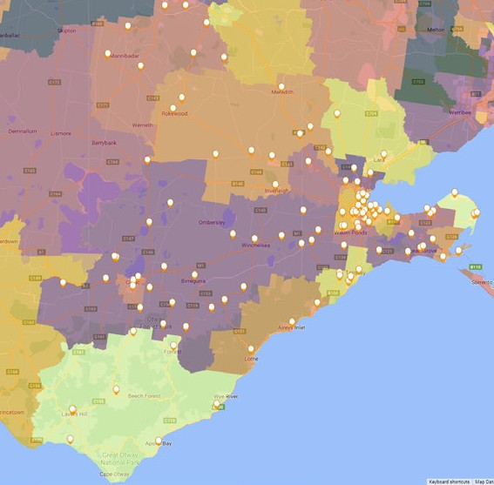
Greater Geelong (C) 45,680
Borough of Queenscliffe (B) 617
Surf Coast Shire (S) 6,627

Colac Otway Shire (S) 2,953

Golden Plains Shire (S) 4,147

50 BARWON TENNIS STRATEGY 2024 - 2034 – POWERED BY KINETICA BARWON TENNIS STRATEGY 2024 - 2034 – POWERED BY KINETICA 51

Future growth of Tennis
The vast majority of additional tennis players in the region in 2031 will be to the south of Geelong.
By 2031, there is predicted to be in excess of 5,000 more tennis players in the region, of which almost 80% will reside in Greater Geelong. The majority of the growth will be in the southern part of Geelong around Grovedale, Armstrong Creek and then further south towards Torquay.

Adult Tennis Participation by LGA | 2021 |  | 2031 |  | 21-31  Change
Adult Tennis Participation by LGA | No. | % | No. | % | 21-31  Change
Colac Otway Shire (S) | 1,253 | 6.8% | 1,233 | 6.7% | -20
Golden Plains Shire (S) | 1,614 | 8.4% | 2,033 | 8.4% | +419
Greater Geelong (C) | 17,920 | 8.1% | 21,871 | 8.1% | +3,951
Borough of Queenscliffe (B) | 273 | 9.3% | 301 | 10.3% | 28
Surf Coast Shire (S) | 3,259 | 10.8% | 3,914 | 10.7% | +655
Barwon Total | 24,320 | 8.3% | 29,353 | 8.3% | +5,033

Best performing venues
Visitation at venues with 4 or less courts is significantly lower than venues with 5 to 8 courts. This is typically due to a range of factors including:
Less likely to have lights (which limits playing time and access at high demand time (6pm-10pm) Less likely to have a coach (which limits the offering)
Less likely to promote their offering/be present online
A key consideration for venue size (number of courts) is commercial sustainability. Small venues are harder to activate given limited space to offer a range of services (which also makes them hard to attract a coach). Based on Tennis Australia benchmarks, these venues underperform other venue types. On the other hand, large venues also need to be managed carefully as the costs related to build, operate and maintain these venues requires strong, regular, on-going utilisation (which is balanced by the fact that it should be able to offer a range of services that appeal to the entire spectrum of tennis players). It’s important for all stakeholders to consider the long-term sustainability of venues as part of the long-term investment strategy (note, Kinetica did not have access to financial performance of the venues in the Barwon (G21) region and as such we can only reference this in generalisations.

Visitation by Court by Number of Courts Per Venue

2,500

2,000
Annual Visit Per Count

1,500

1,000

500

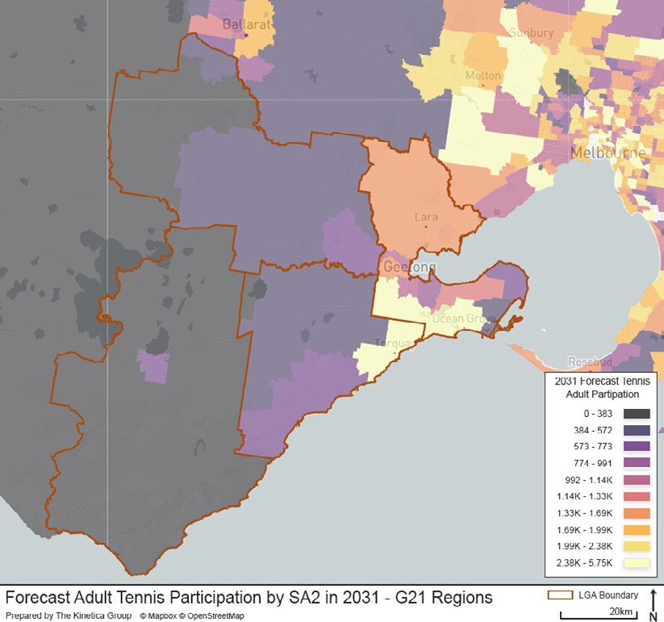
0
1 2 3 4 5

6 7 8 9 10

Courts Per Venue

52 BARWON TENNIS STRATEGY 2024 - 2034 – POWERED BY KINETICA BARWON TENNIS STRATEGY 2024 - 2034 – POWERED BY KINETICA 53

Best performing models
Venues with coaches have on average twice as many visitors per court per annum compared to those without a coach (944 vs 469)
When you include lights, utilisation at venues all increases by circa 2.5 times

Club Organisation Model and Lights

3,000
 | 1,665
 | 1,665 |  | 911
 | 944 |  | 911
 | 944 |  | 469

2,500

2,000

1,500

1,000

500
- Venue with lights
The chart shows the proportion of competition visits (x-axis) as a share of total visits per court per annum (y-axis). The critical insight from this analysis shows that very little competition (<10%) and a high proportion of competition (over 40%) significantly impacts total visitation. There is a sweet spot in between 15% and 35% of all play at a venue coming through competition. The rationale for this result is as follows:
For low level competition venues – little or no competition offer will not provide for the full suite of services sought after by tennis players and as such people will seek alternative options
For high competition venues – these venues may prioritise competition over social play, hence limiting access for some player types, they may be considered/perceived as being exclusive or requiring a certain skill level, or they may not optimise access to other forms of play and therefore not accommodate the needs of different player types.
The need for a balanced offer is critical in optimising visitation.

Share of visitation by competition

0
Club Coach

Organisation Model

Club

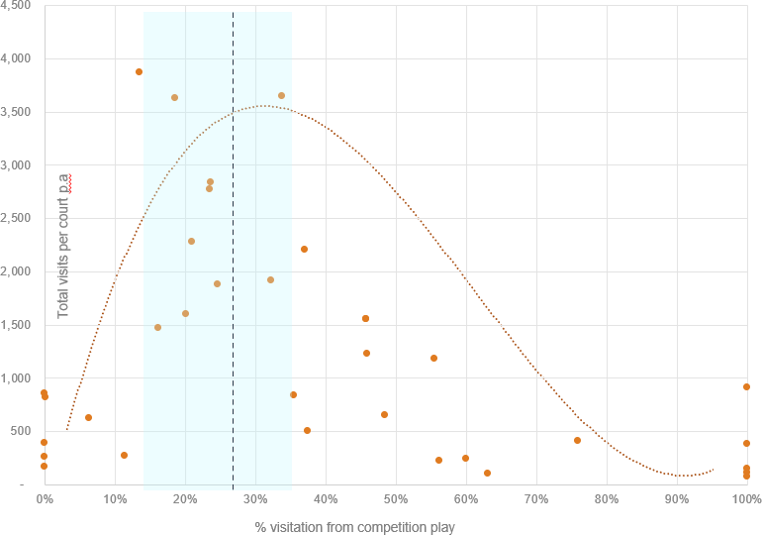
No Lights Lights

54 BARWON TENNIS STRATEGY 2024 - 2034 – POWERED BY KINETICA BARWON TENNIS STRATEGY 2024 - 2034 – POWERED BY KINETICA 55

4,000

3,500

3,000

2,500

2,000

1,500

1,000

500

Best performing venue locations

VENUES IN HIGH DEMAND REGIONS PERFORM BETTER
This is seemingly an obvious insight, however prior to access to Aura data, local area demand information did not exist. As such, this should provide Tennis Victoria and the Barwon Region Council’s substantive confidence in using local demand data as a critical input for infrastructure and venue activation planning. In the Barwon region, a 1% increase in demand in the catchment area of a venue translates to an additional 300 visits per court per annum. Every venue that is above
the trendline (expected performance) is lit, further reiterating the importance of lights to venue utilisation.

Annual Visits Per Court by SA2 Tennis Participation

Venue Optimisation

UNDERSTANDING THE AMOUNT OF ‘COMPETITION’ AROUND A VENUE IS CRITICAL IN DETERMINING HOW TO OPTIMISE THE NETWORK
Analysis has been undertaken on the amount of competition (other tennis venues) within a 10 minute drive-time catchment area of each venue. The map below shows an example of a 10-minute drive time around a venue and shows there are 4 other venues within the catchment. This determines the relative competition (or provision) within an area and across the region. Venues in low demand areas (i.e. with fewer venues around them) are, holding all else equal, more important to the network given there are less options for the local community. The table below categorises venues based on their size and whether they sit in a low, medium or highly competitive catchment, and whether their catchment has low, medium or high demand for tennis. This, combined with the other analysis, provides the basis for both network and venue by venue recommendations.

0
Jan Juc Tennis Club
All Saints Anglican
Drysdale Tennis Club
Aireys Inlet
Ocean Grove Tennis Club
Anglesea T
Leopold Tennis Club
Moriac Tennis Club

Pioneer Park Tennis Club Lara Tennis Club
Geelong Lawn Tennis Club
Lorne Country Club
Hamlyn Park Tennis Club
Waurn Ponds Tennis Club
St Stephens (Geelong) Tennis Club
elong East Uniting St Albans (Geelong East) Tennis Club
Church Tennis Club Winchelsea Tennis Club Kenwith Park Tennis Club
Newcomb Tennis Club Eastern Districts Tennis Club Ceres Tennis Club

St Leonards Tennis Club
St Leonards Tennis Club Ge Portarlington Tennis Club

rae Tennis Club
Bellb
Tennis Club

ennis Club
ub

Grovedale Tennis Cl

ennis Club

s Tennis Club
r Centre
Centre Court Indoo

Highton Tennis Club

Wandana Height

Torquay T
7% 8%

9% 10% 11% 12% 13%
Classification | Small  (1-4 courts) | Medium (5-8  courts) | Large (10+  courts) | Total
Low Competition, Low Demand (<9% adult participation) | 5 | 1 | - | 6
Low Competition, Mid Demand (<13% adult participation) | 14 | 8 | - | 22
Low Competition, High Demand  (13%+ adult participation) | 4 | 2 | - | 6
Medium Competition, Low Demand | 11 | - | 1 | 12
Medium Competition, Medium Demand | 6 | 5 | - | 11
Medium Competition, High Demand | 7 | 2 | - | 9
High Competition, Low Demand | - | - | - | -
High Competition, Medium Demand | 14 | 5 | 1 | 20
High Competition,High Demand | 4 | 4 | - | 8
Total | 65 | 27 | 2 | 94

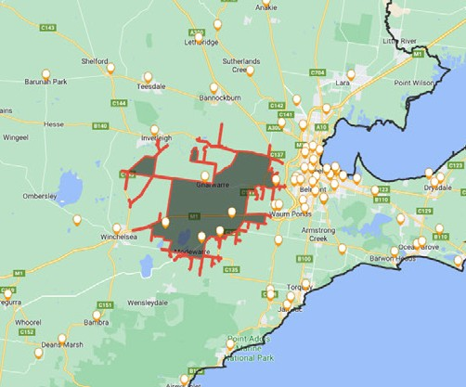
Tennis Participation by Catchment At the time of this audit, only SCS and COGG completed.

56 BARWON TENNIS STRATEGY 2024 - 2034 – POWERED BY KINETICA BARWON TENNIS STRATEGY 2024 - 2034 – POWERED BY KINETICA 57

Colac Otway Shire Venue List

VENUES NO LONGER CONSIDERED PART OF THE TENNIS NETWORK
The Venue Categorisation and Actions table within this strategy is not a complete list of tennis courts in the Colac Otway Shire. The following courts have been removed from the table because they have no active teams and/or have deteriorated to an unusable condition for tennis activities:
Carlisle River Tennis Courts
Colac Indoor Tennis Centre (privately owned)
Cressy Recreation Reserve Tennis Courts (not Council-owned) Eurack Tennis Courts
Ferguson (Beech Forest) Tennis Courts (not Council-owned)
Gellibrand Recreation Reserve Tennis Courts (not Council-owned – courts reconstructed for netball only – courts could be line marked for tennis if demand required)
Johanna Tennis Courts (not Council-owned) Larpent Tennis Courts
Lavers Hill Tennis Courts Swan Marsh Tennis Courts Yeo Tennis Courts

58 BARWON TENNIS STRATEGY 2024 - 2034 – POWERED BY KINETICA



Tennis Victoria
AAMI Park (Entrance F) Olympic Boulevard Melbourne Victoria 3000
Locked Bag 6001
Richmond Victoria 3121
T +61 8420 8420
tennis.com.au/vic
Victorian Tennis Association Incorporated ABN 29 757 304 158

