GREATER GEELONG: ECONOMY AT A

GLANCE
JUNE 2024

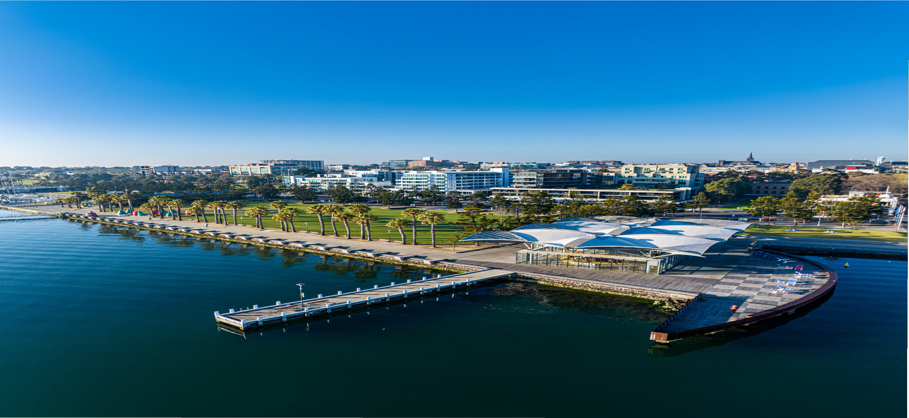





CITY OF GREATER GEELONG
Wadawurrung Country PO Box 104
Geelong VIC 3220
P: +61 3 5272 5272
E: contactus@geelongcity.vic.gov.au geelongaustralia.com.au
LATEST NEWS:
@CityofGreaterGeelong @GreaterGeelong @CityofGreaterGeelong CityofGreaterGeelong

Geelong, located on the picturesque shores of Corio Bay in Victoria, Australia, is a vibrant city known for its rich history and bustling waterfront. Recognised as a UNESCO City of Design, Geelong is emerging as a key regional hub for innovation and development.
Greater Geelong’s economy is diverse and growing rapidly. It frequently outpaces every other region in Australia in terms of growth in population, jobs and Gross Regional Product (GRP). Jobs are growing at double the pace of the population and the region has never been more attractive for its lifestyle and opportunity.

Geelong is Victoria’s second city and one of the state’s fastest growing areas.
Population: 282,800 (2023) Growth of 6,280 over last year
Growth of 36,425 over last five years
Source: ABS (2024)

TOP INDUSTRIES

Contribution to Economy ($b)
Healthcare: $2.6 (16%)
Construction: $1.9 (12%) Education and training: $1.3 (8%) Retail trade: $1.2 (8%) Manufacturing: $1.2 (8%)
Source: economy.id (2024)

Geelong has the second largest economy in Victoria.
GRP (2022-23): $19.6b
1 year growth: 5.0%
5 year average annual growth: 5.4%
Source: economy.id (2024)



Top Exporting Industries ($m)
Manufacturing: $1,857 Healthcare: $1,200 Wholesale trade: $922 Retail trade: $777
Finance and insurance: $746
Source: economy.id (2024)

Geelong is booming
$12.4b in major projects Recently completed: $961m Commenced: $4.3b
Including Nyaal Banyul Geelong
Convention and Event Centre ($456m)
Approved: $2.0b Proposed: $5.1b
Source: Geelong Data Exchange, May
2024.



Contribution to Jobs (No.)
Healthcare: 30,840 (21%)
Retail trade: 15,370 (11%)
Construction: 15,210 (11%)
Education and training: 13,840 (10%)
Accommodation and food services: 9,695 (7%)
Source: economy.id (2024)

Recently Completed Projects
Geelong Quarter (incl. Holiday Inn and Suites Geelong) ($200m)
GMHBA Stadium - Stage 5 ($142m)
Geelong Arts Centre redevelopment ($140m)
Spirit of Tasmania Terminal ($135m)
Quest Geelong Central ($70m)



Important Exporters
Viva Energy Herd Group Golden Farms Godfrey Hirst Incitec Pivot
University Hospital Geelong Deakin University
Midway

VISITOR ECONOMY AND EVENTS CREATIVE INDUSTRIES


Geelong and the Bellarine Visitation
Visitors: 6.3m Visitor nights: 4.6m
Visitor expenditure: $1.8b
Source: Tourism Research Australia (YE September 2023)

Major Events (2022-23)
Number of events: 18 Event visitors: 757,500 Economic impact: $77.5m

Economic Contribution of Visitor Economy and Events to the Geelong Economy
Direct contribution to GRP: $434m (2.7% of
total)
Direct contribution to employment: 6,270 jobs
(4.3% of total)
Source: economy.id (2024)

Geelong is Australia’s first (and only) City of Design and a member of the UNESCO Creative City Network.
The Creative Industries are an evolving mix of sectors spanning arts, culture, screen, design, publishing, advertising and a range of professional services.
Direct contribution to GRP: $755.8m (4.7% of total)
Direct contribution to employment: 7,942 jobs (5.5% of total)
Source: Lucid Economics (2024)
Geelong has world-leading innovative talent across a variety of
creative pursuits, from fashion
and the arts to engineering and production.

