
MY FAMILY AND HOUSEHOLD
EMERGENCY PLAN

Emergency risks
What emergencies could impact my family and I?

Flood | Landslide | Storm | House Fire | Bushfire
Heatwave | Health Emergency | Power Outage | Earthquake

Household details

Address:
I access my house via:
I have pet(s): | Yes/No | Type: |  |  |  | Assistance animal: | Yes/No
I use assistive technology and/or equipment (wheelchair, walking frames, hearing devices, visual aids or power reliant medical aids): |  |  |  | Yes/No | Type:
Important numbers

Police/Fire/Ambulance | 000 | Lifeline | 131 114
SES (Flood and Storm) | 132 500 | Local radio station | 774 AM
VicEmergency Hotline | 1800 226 226 | City of Greater Geelong | 5272 5272
Hearing/Speech Impaired SMS relay number | 0423 677 767
Staying informed

How will you know what is happening? I will stay informed of the situation from:
My neighbour, relative, friend or carer. | Calling the VicEmergency Hotline 1800 226 226. | Watching Sky News TV. | Listening to 774 ABC  Radio. | Monitoring VicEmergency app or website.
My family details

Name | Medicare number | Drivers licence | Car registration



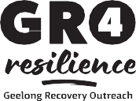
GRO4Resilience Geelong Recovery Outreach is being delivered by the City of Greater Geelong in partnership with the Victorian Government and Australian Government.

Medical needs
Medical needs are anything you and/or your household manage daily. This could include any medical conditions,
medication, specific transport needs or power dependant equipment.

Name | Medical condition/disability | Medication | Transport needs

Assistance animals or pet details
Assistance animals, household pets and companion animals are a very important part of many households and need to be included in your planning.

Name | Breed | Registration number | Microchip number
Vet details
Clinic address:

Phone number: Regular vet:

Important contacts

 | Name | Phone Number
Power of Attorney
Doctor
Dentist
Allied Health
Chemist
Specialist Practitioner
Childcare/School contact
Neighbourhood contact
Important services

Service | Company | Account number | Phone number
Electricity
Gas
Water
Phone
Internet
Other

Insurance details
List any insurance you have here.
- Ensure you have a copy of any policies in your emergency kit.
- Review your policy to ensure it is suitable for your situation.

 | Insurer | Phone Number
House insurance
Contents insurance
Car insurance
Health insurance
Pet insurance
Other

Emergency contacts
This could be family, friends, neighbours or work colleagues.
Have at least one contact who doesn’t live near you that you can call to let them know you are ok.

Name | Number | Relationship

Alternative meeting place
Being separated from your loved ones is one of the most stressful situations you can go through in an emergency. You can reduce the risk by planning and identifying an alternative meeting place.
Choose a location that everyone can meet at if you are not able to get home or if there is a communication disruption. Discuss how everyone, including children, will get there.
My agreed meeting place:

How I will get there:

Alternative accommodation
Can your current place of residence support you and your household for at least three days without services or other supports?
If you had to evacuate to a place of safety, where will you go and how will you get there?

Alternative accommodation address | How will I get there?  Car/Bus/Taxi | Can I take any pets/ assistance animals?  Yes/No
Option 1
Option 2
Option 3
If I can’t take my pets, they will stay with: | My contact number for alternative arrangements for my pet is:
Boarding Facility Family Friends Other

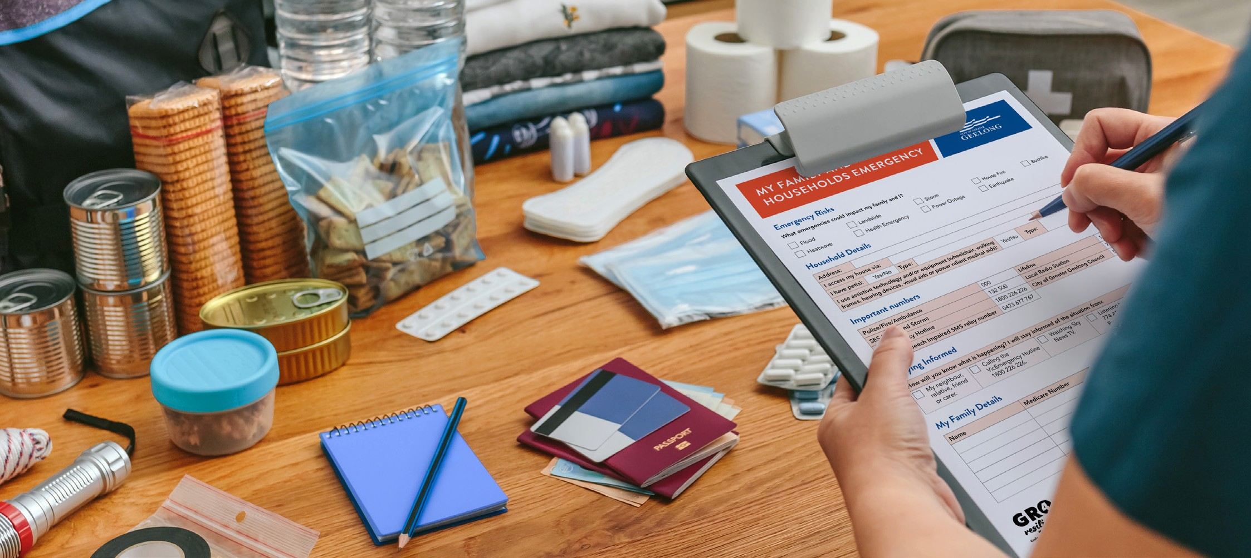

Emergency kit checklist
Prepare an emergency kit in advance with the important items you want to protect or take with you if you had to evacuate.

 | ITEM | EXAMPLE
 | Clothes | Something comfortable and warm, shoes, underwear.
 | Medication | Include a list or medication and/or scripts.
 | Pet supplies | Lead/carrier, identification, food, toys.
 | Baby/Children | Clothes, toys, nappies, bottles.
 | Toiletries | Include personal hygiene items.
 | Insurance details | A copy of any policies.
 | Family mementos | Photos, heirlooms, jewellery.
 | Battery operated torch | Include spare batteries.
 | Battery operated radio | Include spare batteries.
 | First aid kit | Band aids, pain relief.
 | Food and water | Non-perishable items.
 | Mobile phone/iPad | Include a charger.
 | Money | Small amount of cash and bank card.
 | Identification | Passport, drivers licence, Medicare card.
 | Emergency plan | Copy of this plan!


GRO4Resilience Geelong Recovery Outreach is being delivered by the City of Greater Geelong in partnership with the Victorian Government and Australian Government.

