The City Of
Greater Geelong

geelong major events

investment framework

July 2024

Contents
INVESTMENT FRAMEWORK 3
1. Geelong Major Events Strategy 3
2. Funding Application and Assessment Process 6
3. Funding Evaluation 8
4. Privacy and Confidentiality 8

INVESTMENT FRAMEWORK

Geelong Major Events Strategy
Geelong Major Events Strategy 2024 – 2029

Strategic Vision
To establish Geelong as Australia’s premier regional destination for events, where major events deliver exceptional outcomes for Geelong that elevate the region’s reputation on the national stage.

GME works to support the growth of existing events and proactively search for and acquire new events for the region.

Major Event Classifications

Events applying for funding must meet the requirements for one of the below event classifications:
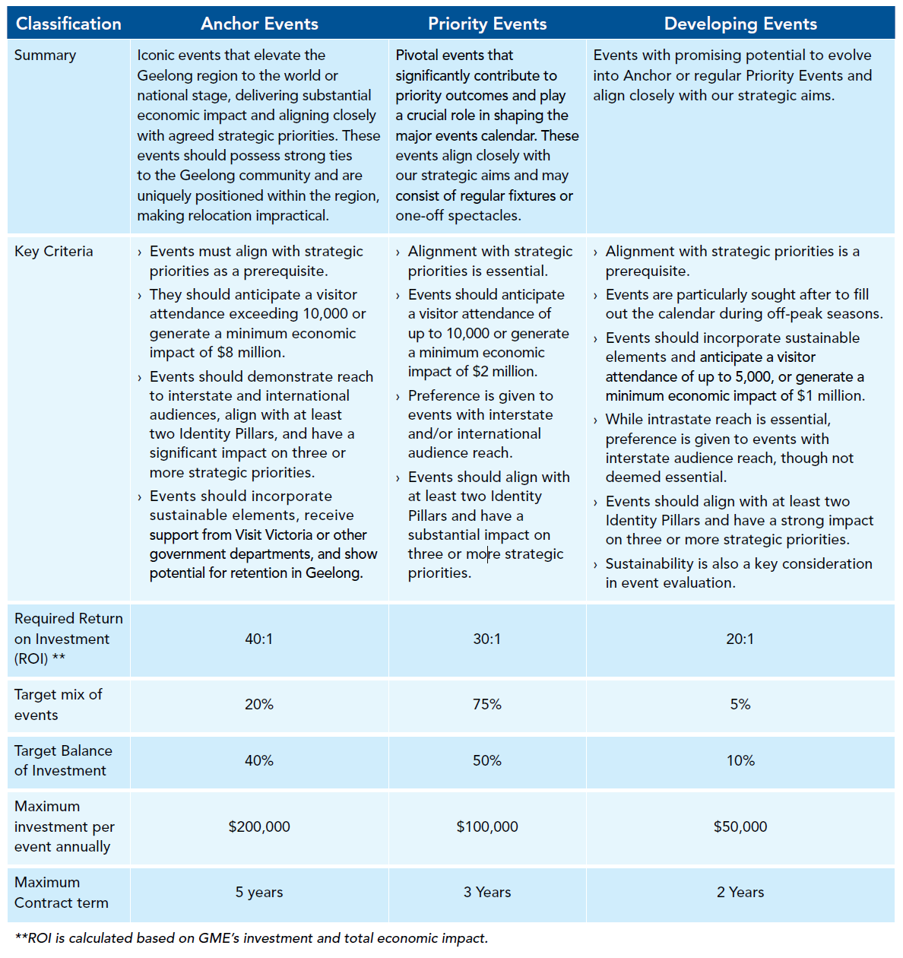

Identity Pillars
The Identity Pillars shape the selection of major events, reflecting the region’s core values and priorities. For an event to be considered for funding by GME, it must align with at least two of the identity pillars:
- Enhances livability
- Clever and Creative
- Sport and leisure recreation
- UNESCO City of Design
- Supports our key industries and heritage
- Nature and Sustainability

Strategic Priorities
Events must also have a strong or substantial impact on three or more strategic priorities:
- Audience Reach and Target Markets: Major events in Geelong aim to engage diverse demographics and geographic regions through tailored programming and targeted marketing efforts.
- Ownership: Geelong fosters a sense of community ownership and pride by involving local residents, businesses, and artists in the planning and execution of major events.
- Night-time Economy: Geelong’s major events contribute to a vibrant nighttime economy by programming evening activities and extending operating hours for local businesses and entertainment venues.
- Event Calendar Gaps: Major events in Geelong strategically supplement seasonal and thematic gaps in the event calendar providing a diverse range of experiences throughout the year that showcase the city’s unique strengths and appeal to underrepresented demographics.
- Partnerships: Geelong leverages strategic partnerships with government agencies, tourism organisations, and industry stakeholders to enhance the quality and impact of major events, along with developing place-based activations ensuring sustainable growth and community support.
- Dispersal: Major events in Geelong promote dispersal and place-based activations across different neighbourhoods and precincts, distributing economic benefits and encouraging visitors to explore diverse areas of the city beyond the event site.
- Alignment with Council and/or Victorian Government: Major events in the Geelong region are aligned to local, state and federal government strategies, such as Experience Victoria 2033, which may incentivise funding support for major events.
GME’s intention is to adopt a place-based approach to supporting our major event calendar. This strategic shift is driven by our desire to enhance the celebration of our local talents, enrich visitor experiences, foster community pride, and stimulate greater engagement among residents and visitors alike.

Major Event Outcomes
Provided events meet the minimum Identity Pillars and Strategic Outcomes requirements, the application is assessed against the Major Event Outcomes which are:
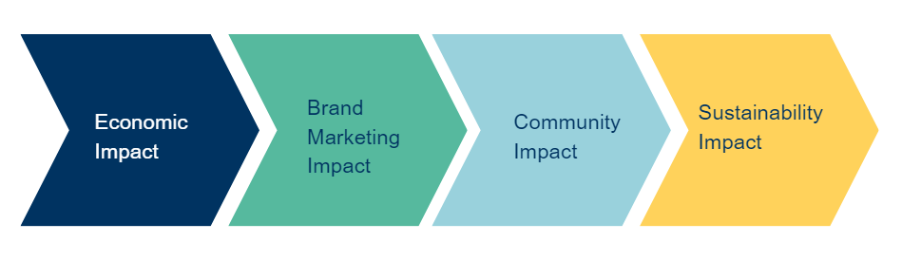
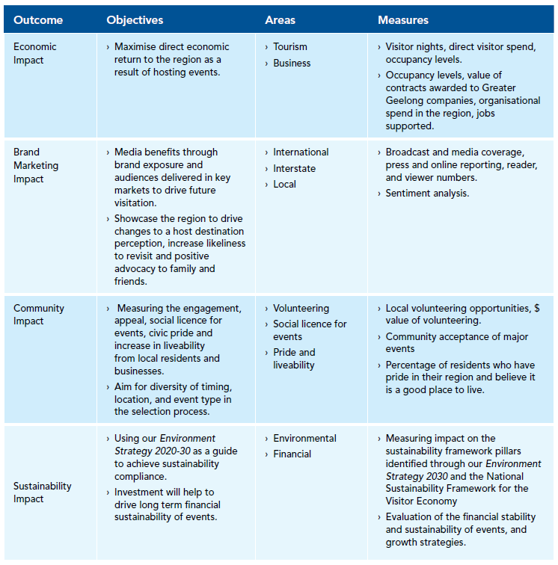

Funding Application and Assessment Process

Expression of Interest to Executive Officer
The first step in the assessment process is a discussion with the GME Executive Officer. This discussion seeks to determine eligibility for funding and to confirm that GME is the best funding program for the proposed event.

The decision for an event to progress to stage two of the assessment process (application), is based on numerous factors, primarily:
- does the event fit one of the event classifications.
- the ability of the event to deliver on the identity pillars, strategic priorities, and major event outcomes.
- the availability of funds.
- venue and location availability to support the delivery of the event.
- demonstration that the event has rigorous and comprehensive event plans

Events outside the scope of GME include community events that may receive advisory and regulatory support from the City of Greater Geelong and may be eligible for financial support through other areas of Council.
GME will not fund:
- community events
- organisations which do not have an Australian Business Number (ABN)
- capital or infrastructure works
- events of a charitable nature – GME does not provide donations
- religious, political or racial events
- events that are not open to the general public
- events not held in the municipality.

Community events, may be eligible for financial support through Council’s Community Investment & Support Fund.

As a general guide, the City of Greater Geelong does not provide operational services free of charge and this should be considered when applying for funding. GME can only provide cash sponsorship.
Therefore, services such as traffic management, road closure advertising, waste management and site reinstatement etc should always be included in your event budget, if relevant. GME cannot provide these services as in-kind support. In some cases, venue hire fees or community signage costs may have already been agreed to and provided as in-kind support by other areas of Council.
Funding is not provided to underwrite events, or to purchase assets. GME does not provide human resources to support the delivery of events.

Events to be staged on public land or roads managed by the City of Greater Geelong must also seek approval from the Event Services Unit and are subject to a separate process requiring the event organiser to, as a minimum:

- provide evidence of public liability insurance demonstrating a minimum cover of $20 million and providing a principal’s indemnity to the City of Greater Geelong.
- submit all relevant plans, including emergency management plans and risk assessments.
- participate in the Events Multi-Agency Working Group process, which is an advisory group ensuring the safe and appropriate conduct of events in the region.
Any application for funding is to be submitted a minimum of 8-12 months prior to the event date.

Contact for Expression of Interest
Hannah Sidebottom | Executive Officer, Geelong Major Events
Email: | gme@geelongcity.vic.gov.au
Telephone: | 03 5272 9045
Mailing address: | Wadawurrung Country  PO Box 104  Geelong VIC 3220

Funding Applications
The second step in the assessment process is to formally apply for funding. Each event classification has different application requirements. While the same form must be completed for each stream, more comprehensive planning is expected for anchor and priority events. GME accepts applications year-round, however, appreciates applications being received 8-12 months in advance to allow sufficient time for assessment of the proposal and for leverage opportunities to be developed and implemented:

Anchor Events | Priority Events | Developing Events
Event Application Form | Event Application Form | Event Application Form
Fully costed event budget | Fully costed event budget | Event budget
Comprehensive marketing plan | Comprehensive marketing plan | Marketing plan
Risk management plan | Risk management plan | Risk management plan

Applications are to be submitted to the GME Executive Officer (details above).

Funding Assessment

A weighted assessment is used to evaluate applications, to ensure funding is fair and equitable. The assessment ensures events meet the identity and strategic priority minimum requirements and then evaluates events based on how they contribute to the major event outcomes.
It should be noted that events must meet the minimum requirements for their specific event classification to be considered for funding. Not all applications which are eligible will be funded and discretion may be required by the GME Committee.

Funding Outcomes
Funding decisions are made at Geelong Major Events meetings which are held the third Monday of every second month. A response should be received to an application within 2-3 months of submitting the completed forms. GME meetings, like Council meetings, are open to the public. The outcome of your application will be provided to you in writing by the GME Executive Officer.

Geelong Major Events provides single year or multi-year agreements. Commitments are documented in a Funding Agreement, which is signed by your organisation before the contribution is paid. The Agreement also contains the benefits to be provided to The City of Greater Geelong and an obligation for the event to meet all operational requirements for the planning, execution and approval of your event including reaching the attendance figures provided and executing the marketing plan.
Please note that funding can only be paid in the financial year that the event will be staged. It is usually paid in instalments, with the final instalment (generally 10-20%) being paid after the event has been conducted, all obligations have been met to our satisfaction and the post-event evaluation has been submitted to Council.

If your organisation is registered to receive GST, the funding sponsorship amount will be grossed up by 10%.
The terms of a Funding Agreement are generally confidential; however Section One of the funding application, the post-event evaluation, the amount of any sponsorship provided and the period of that funding is a public record and is made available to the public on GME meeting agendas.

Funding Evaluation
Event organisers are required to regularly meet with and submit progress reports to the GME Executive Officer.

Events will be required to undertake an independent economic impact assessment using the preferred provider as stipulated by GME within the funding agreement. All events are required to provide post-event evaluations within three months of the conclusion of the event.

Privacy and Confidentiality

Privacy
The information collected on this form will be used by Geelong Major Events to determine an appropriate level of funding and may be disclosed to the general public. Should you wish to access this information or for a copy of Council’s detailed Privacy Policy, you may contact Council on 5272 5272.

Confidentiality
In accordance with the Local Government Act, Geelong Major Event’s ordinary meetings are open to the public and it is a requirement that copies of the agenda items are made available to public in attendance at meetings. However, the detailed event budget you have provided with your application will be treated as Commercial in Confidence and will not be distributed to the public attending the meeting. The budget will however be circulated to members of Geelong Major Events and relevant City of Greater Geelong officers to assist in the determination of an appropriate level of funding.

