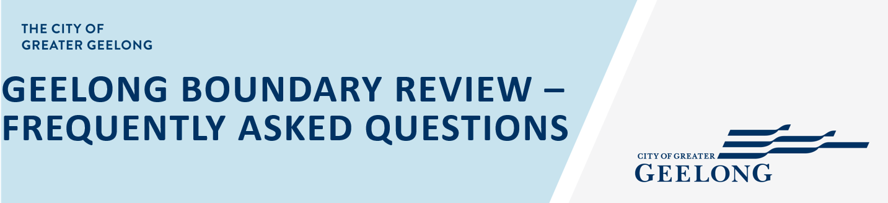

GENERAL

- When will the planning scheme amendment go on public exhibition?
It is likely exhibition will occur in early-mid 2025. Officers need to prepare the amendment documentation and receive authorisation from the Minister for Planning.
It will take some time to put together the rezoning proposals alongside the policy amendment. If this cannot progress in a timely manner the rezoning can be pursued separately post the policy amendment.
- My land was not included in the boundary as part of the Review, can I make another submission to the amendment?
Yes. You should look at the reasons your site was not included in the boundary and seek to address these as part of your submission.
- What if Council still does not support my submission?
If submissions remain unresolved an independent Planning Panel will be appointed to consider submissions and make recommendations. You can present your submission to the Panel. These will then be considered by Council and the Minister for Planning as part of the final decision making.
- When will a final decision be made?
The amendment process generally takes around 12 months.

INCLUSIONS IN THE BOUNDARY

- My site was included in the boundary, what should I do?
If you support the proposal, you can make a submission in support of the amendment. Equally, if you object to the proposal, you can make a submission outlining your objections.
- My site was included in the boundary but was not recommended for rezoning, what happens next?
You can make a submission to the amendment to outline your position on the recommendation. If you believe the site should be considered for rezoning, you should look at the reasons why rezoning was not proposed and seek to address this as part of your submission.

REZONING OPPORTUNITIES
- My site was nominated for inclusion in the boundary and potential rezoning, what happens next?
Officers will be in touch shortly to discuss the potential to look at rezoning as part of this amendment. A suite of technical reports will be required to support any rezoning, and Officers will work with landowners to coordinate this. If for any reason rezoning does not form part of this amendment, a separate proponent led amendment can be applied for in the future.
PROPOSED RURAL LIVING PRECINCT
- My land is included in the proposed Rural Living precinct, what should I do?
You can make a submission to the amendment outlining you support or objection to the proposal including any other matters you would like to raise.
- Does the state government support the Rural Living zone?
The state government raised some concerns with the Rural Living precinct in its referral comments in relation to meeting the Surf Coast Statement of Planning Policy under the Distinctive Area and Landscape declared area. Officers have sought to address these concerns as part of the proposal. The position of the state government is unknown at this stage. For this reason, Council will seek to implement the precinct into policy before commencing any detailed planning investigations.
- If the Rural Living precinct is supported, what are the next steps?
An amendment to rezone the land will need to be submitted. Fragmented land ownership means a majority of landowners need to come together to provide a coordinated development outcome and support for rezoning. In some circumstances a developer, often working with Council, will coordinate the rezoning proposal. This process can take several years.
- What is required to rezone the land?
For this area, it is likely several precincts may be identified, for example, east and west of Surf Coast Highway.
The preparation of technical reports such as bush fire assessment, tree assessment, landscape assessment, drainage assessment, traffic assessment, cultural assessment, services assessment etc. will need to be prepared to inform the planning for the area.
An overall development plan will then be prepared to ensure a coordinated approach to future development. A development contributions plan will also need to be prepared to support service and infrastructure provision.
- Are there examples of where this has occurred elsewhere in Geelong?
Rezoning of farming zoned land to the rural living zone has not occurred for many years. There are recent examples of where the rural living zone has been rezoned to a residential zone. If you are interested in this process and what was involved, you can view the amendments below:
- Central Road, Drysdale -
https://planning-schemes.app.planning.vic.gov.au/Greater%20Geelong/amendments/C363ggee
- Manzeene Avenue, Lara –
https://planning-schemes.app.planning.vic.gov.au/Greater%20Geelong/amendments/C285

