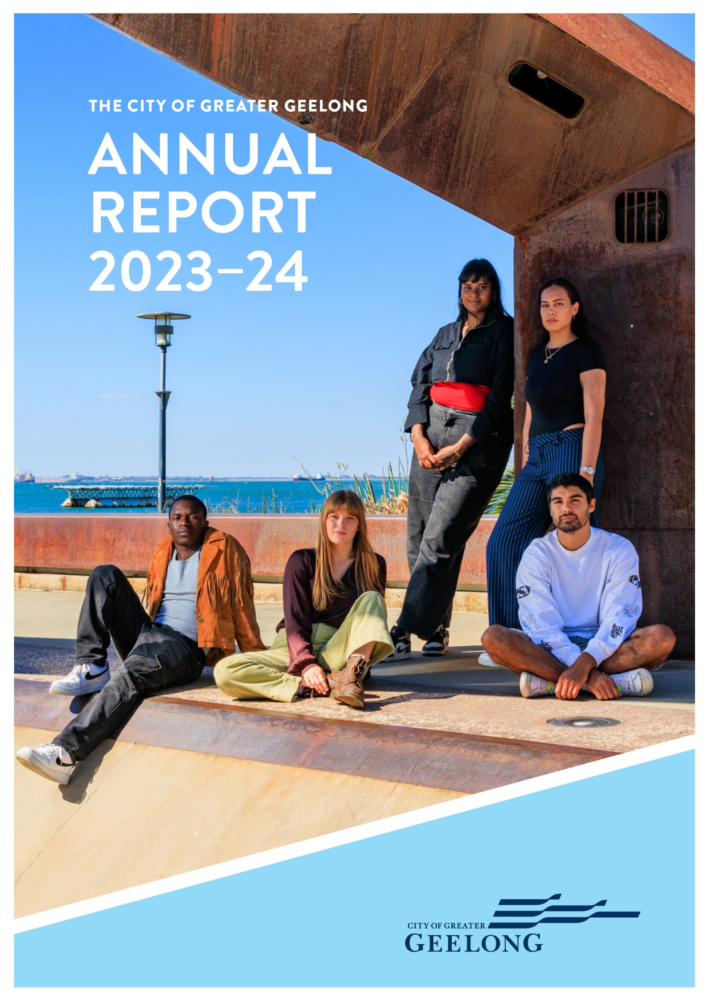
FFOn-

CONTENTS
MAYOR AND CEO MESSAGE 4
INTRODUCTION 5
OUR COMMUNITY’S VISION 7
OUR PURPOSE, VALUES AND STRATEGIC DIRECTIONS 8
THE YEAR IN REVIEW 10
OUR COMMITMENT TO HEALTH AND WELLBEING 15
FOCUS ON SUSTAINABILITY 25
KEY CAPITAL PROJECTS 26
ENGAGING WITH OUR COMMUNITY 27
GRANTS PROGRAM 29
OVERVIEW OF FINANCIAL PERFORMANCE 31
CHALLENGES IN 2023−24 36
OUR COUNCIL AND ORGANISATION 37
OUR COUNCIL 37
OUR COUNCILLORS 37
OUR ORGANISATION 40
EQUITY, INCLUSION AND DIVERSITY 46
OCCUPATIONAL HEALTH AND SAFETY 47
HOW WE PLAN 48
OUR PERFORMANCE 49
STRATEGIC DIRECTION 1: HEALTHY, CARING AND INCLUSIVE COMMUNITY 50
STRATEGIC DIRECTION 2: SUSTAINABLE GROWTH AND ENVIRONMENT 65
STRATEGIC DIRECTION 3: STRONG LOCAL ECONOMY 78
STRATEGIC DIRECTION 4: HIGH-PERFORMING COUNCIL AND ORGANISATION 87
GOVERNANCE 97
GOVERNANCE AND MANAGEMENT CHECKLIST 102
STATUTORY INFORMATION 105
DOMESTIC ANIMAL MANAGEMENT PLAN UPDATE 110
ACCESS AND INCLUSION ACTION PLAN UPDATE 112
DEVELOPMENT CONTRIBUTIONS PLAN (DCP) PROGRESS REPORT 114
ANNUAL FINANCIAL REPORT FOR THE YEAR ENDING 30 JUNE 2024 120
PERFORMANCE STATEMENT 124
Cover Photo: GRID (Grass Roots Indie Development) Series Geelong 2023-24 artists. L. to R. Baraka the Kid, Daisy Kilbourne (seated) Wild Gloriosa; LENNi and Ridzyray (seated)

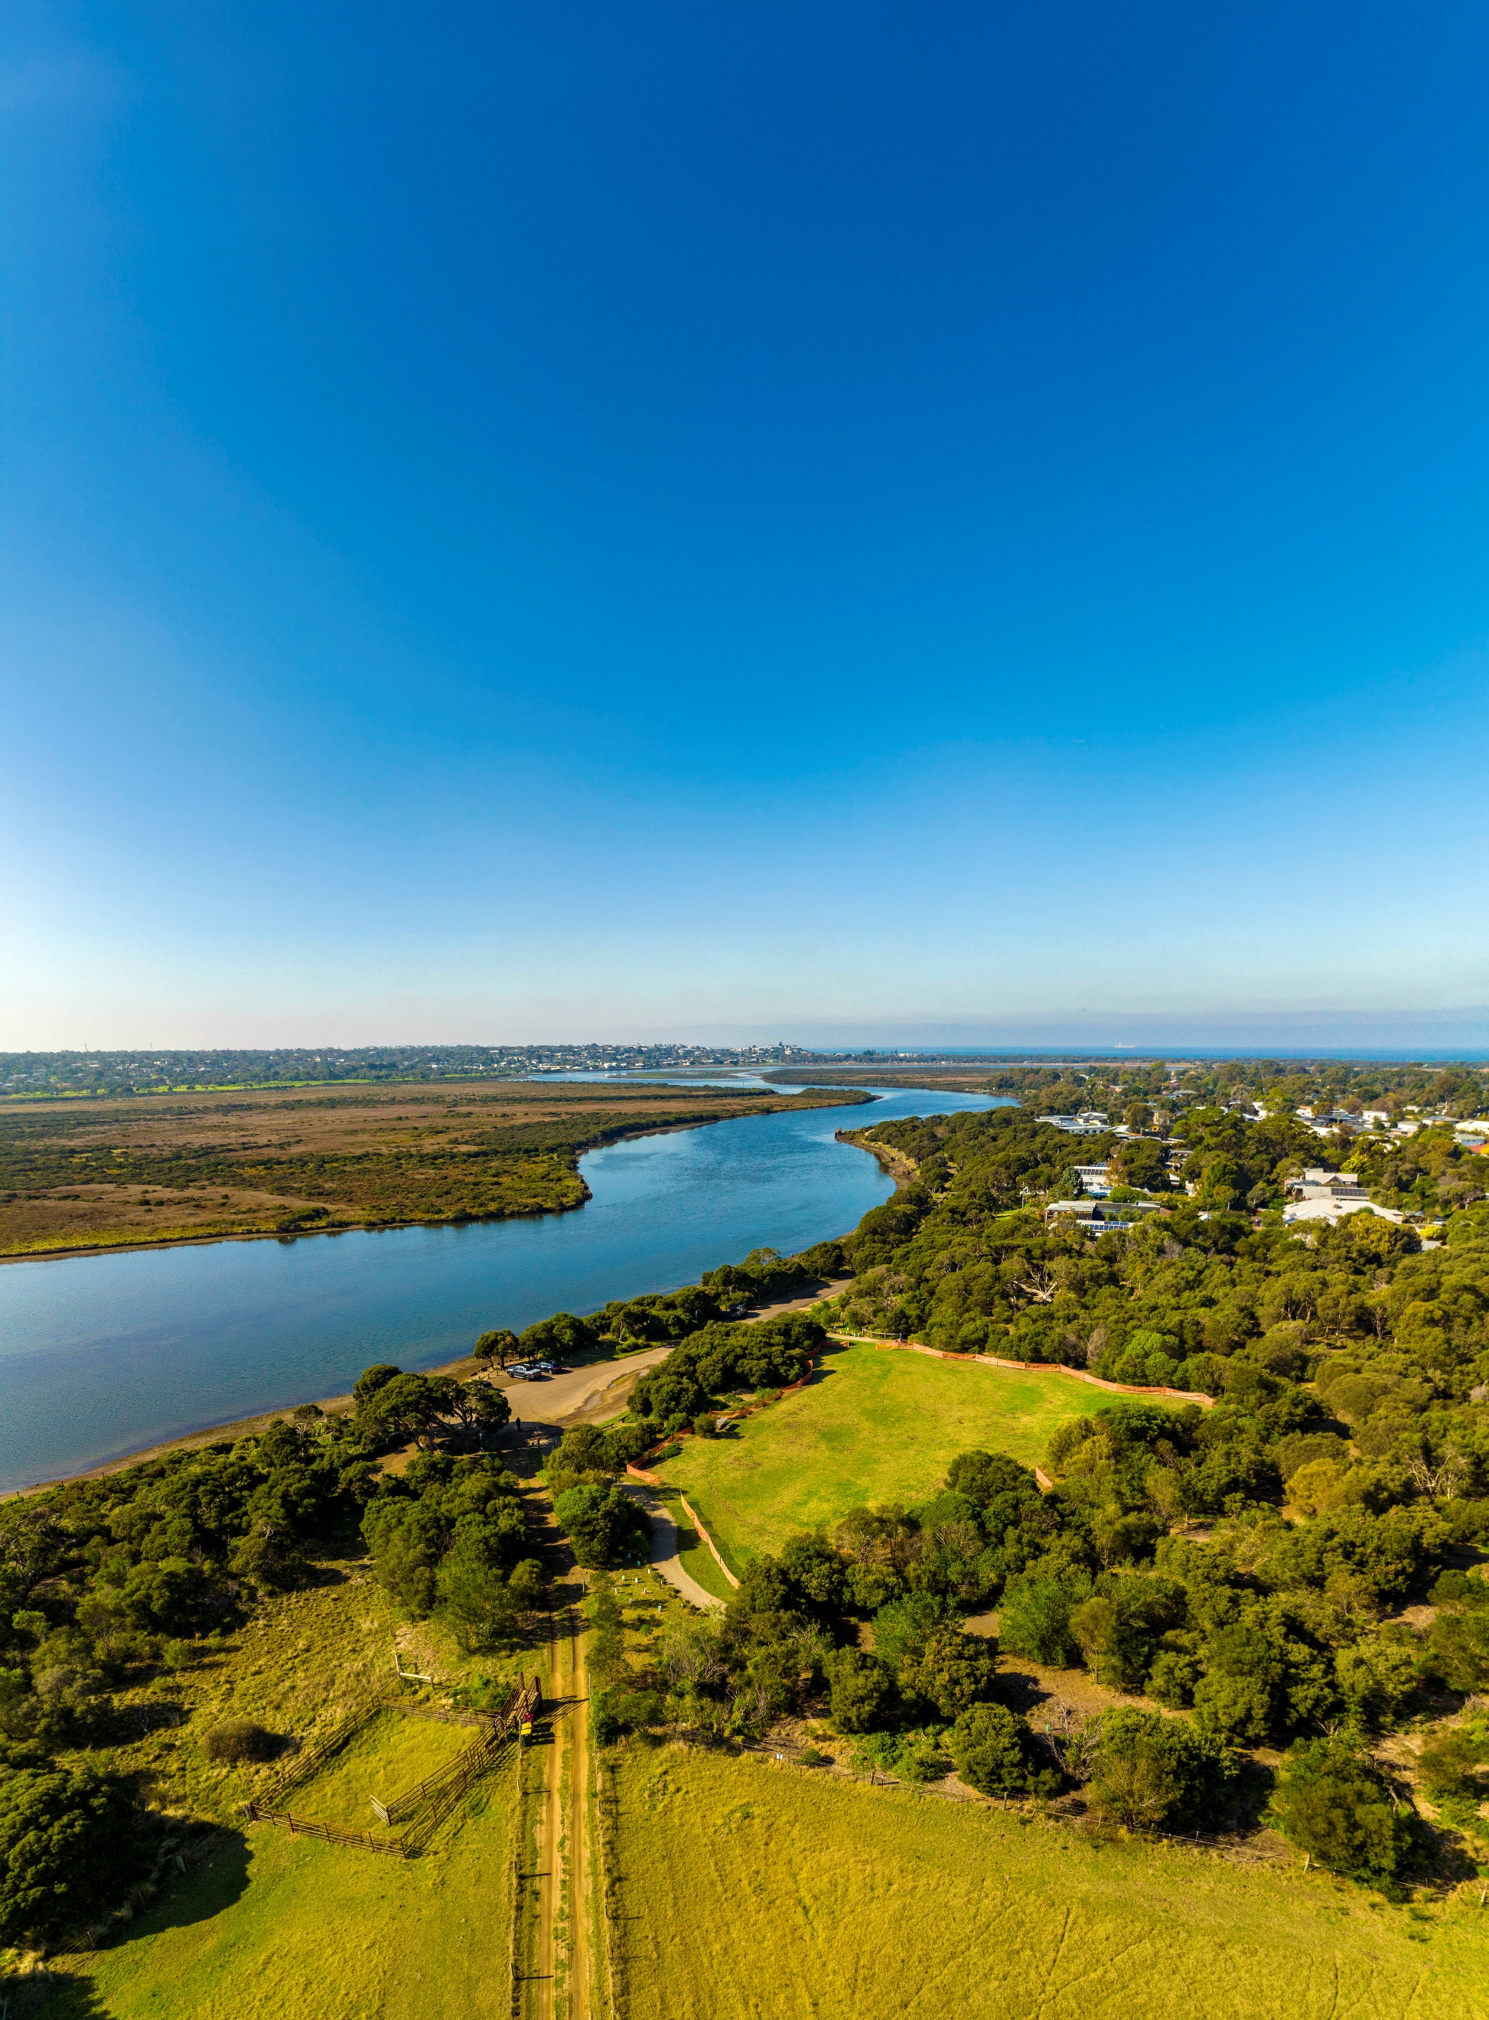
We Acknowledge the Wadawurrung People as the Traditional Owners of the Land, Waterways and Skies. We pay our respects to their Elders, past, present and emerging. We acknowledge all Aboriginal and Torres Strait Islander people who are part of our Greater Geelong community today.

Photo: Barwon River, Moonah Park Barwon Heads

MAYOR AND CEO MESSAGE

We are pleased to present the City of Greater Geelong’s Annual Report for the year ending 30 June 2024.
It has been a year of progress and change for our Council and organisation. We have continued to focus on meeting the needs of our growing community.
As the community’s elected representatives, our Council bases its decision-making on positioning Greater Geelong for an environmentally, economically and socially sustainable future.
We have sought to balance this longer-term outlook with a desire to meet the current day needs and expectations of the people they represent.
At an organisation level, the arrival of a new CEO and a new, united Executive Leadership Team, has brought stability of leadership and a fresh outlook as we approach the challenges and opportunities in front of us.
Our executive and senior leaders have been keenly focused on operating as efficiently as possible to deliver the best value to ratepayers, without compromising our core services that are so highly valued.
Against a backdrop of costs rising at a much faster rate than the income we generate, we have been financially responsible and sought to find new and better ways of doing things.
We remain committed to achieving the four strategic priorities set out in the Council’s four-year strategic document, ‘Our Community Plan 2021−25': a healthy, caring and inclusive community; sustainable growth and environment; strong local economy; and a high performing council and organisation.
The pages that follow feature countless examples of innovative and exciting projects delivered for the benefit of the Greater Geelong community. We encourage you to read this report in full.
All of these achievements are geared towards realising the community’s 30-year vision of a clever and creative future for our region.
With our Council coming to the end of its term, we thank all of our councillors for their service during this time.
We also thank our dedicated employees who take pride in their work and want the best for Greater Geelong and the people who live here.
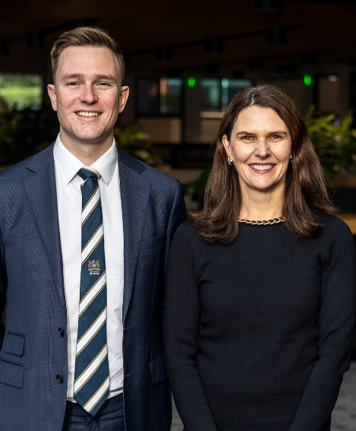
Finally, biggest thanks to our community for the input you have provided to our major projects and decisions during the past year, and the many ways in which so many of you contribute towards a healthy and thriving Greater Geelong.

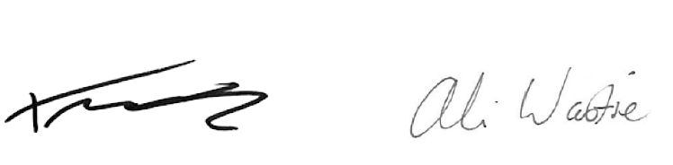

CR. TRENT SULLIVAN ALI WASTIE
Mayor Chief Executive Officer

INTRODUCTION
At the City of Greater Geelong, we are committed to working together for a thriving community.
The City of Greater Geelong Annual Report 2023−24 provides our community with a comprehensive account of our performance from 1 July 2023 to 30 June 2024.
Our City
The City of Greater Geelong is Victoria’s second-largest city, located 75 kilometres south-west of Melbourne. We are proud to be on Wadawurrung Country. Wadawurrung Country covers over 10,000 square kilometres, from the Great Dividing Range in our north, to the coast in our south, from the Werribee River in our east, and to Aireys Inlet in our west, including Geelong and Ballarat.
Our municipality stretches 1,247 square kilometres across unique urban, coastal and country areas. Our community often points to this mix of landscapes and the lifestyles they support as a key attraction for living in, working at and visiting Greater Geelong.
Greater Geelong is bound by the Moorabool Shire in our north, Wyndham City Council and the Borough of Queenscliffe in our east, Surf Coast Shire and Golden Plains Shire in our west, and Bass Strait to our south.

Community
Greater Geelong is Victoria’s most populated region outside metropolitan Melbourne, with an estimated 282,809 residents as of 30 June 2023.0F Our municipality has seen significant growth, particularly in Armstrong Creek, Lara, and the Bellarine Peninsula. By 2041, we expect our population to reach 396,388.1F
Our demographics are dynamic, with notable growth across most age groups between 2016 and 2021. Young workers and families have flocked to the region, leading to a 21 per cent increase in the 25-49 age bracket and a 20.8 per cent rise in residents over 60. The median age dropped from 40 to 39 during this period.¹
We proudly host the largest population of Aboriginal and Torres Strait Islander people in any Victorian local government area, with 3,562 residents recorded in the 2021 Census.¹ The Wadawurrung People, Traditional Owners of this land, have lived here for over 25,000 years.
Our cultural and linguistic diversity is growing, with 17.7 per cent of residents born overseas.¹ Migration has strengthened our community, with new arrivals mainly from India, the UK, the Philippines, New Zealand, Sri Lanka, and Pakistan. International students also contribute to our rich multicultural fabric.
We strive for inclusivity, respect, and belonging, delivering social, economic, and cultural initiatives that support connection, participation, innovation, and creativity. Despite our strengths, some suburbs face significant socio-economic disadvantages, which we are committed to addressing.

Lifestyle
Greater Geelong is renowned for its exceptional lifestyle, blending urban amenities with natural beauty. Our region boasts a mix of classic 'Boom Time' civic buildings, grand 18th and 19th century architecture, and revitalised modern urban areas. As Australia’s first UNESCO City of Design, we leverage creativity and innovation to build sustainable, resilient, and inclusive communities.
Our vibrant waterfront, extensive parks, and recreational reserves offer residents ample opportunities for leisure and outdoor activities. From serene bay beaches to the rugged coastline of the Great Ocean Road, our diverse landscapes cater to a wide range of recreational pursuits.

Environment
Our environment is a unique blend of urban, rural, and coastal settings. We are home to significant conservation reserves and diverse ecosystems, including the Ramsar-listed wetlands, the You Yangs, and the Barwon and Moorabool river systems. These areas support a variety of flora and fauna, including many protected species.
Geelong’s 133 kilometres of coastline, combined with our rural agricultural activities, highlight the region’s ecological and economic diversity. We face environmental challenges, such as land clearing, invasive species, climate change, and waste generation, which we address through sustainable practices and innovative solutions.

Economy
Our economy is thriving, with strengths in advanced manufacturing, professional services, creative industries, digital technology, agribusiness, health care, and the visitor economy. Our strategic location near Melbourne, combined with our infrastructure and skilled workforce, attracts global investors and new businesses.
Over the past five years, we have experienced the fastest job growth of any large Victorian regional area and have an estimated 144,568 jobs, up 9,210 jobs in the year to June 2023.2F Health care and social assistance are our largest employment sectors, followed by retail and construction. We also experienced the largest growth in business numbers, increasing the total to 22,090.³
Greater Geelong’s Gross Regional Product (GRP) grew to $19.57 billion, ³ with significant contributions from health care, accommodation, financial services, transport, and professional services. With $13 billion in major projects underway, 3F including roads, public buildings, industrial and commercial developments, and residential housing, our region is poised for continued growth and prosperity.

Thank you for being part of our journey towards a vibrant, sustainable, and thriving Greater Geelong.

OUR COMMUNITY’S VISION

‘By 2047, Greater Geelong will be internationally recognised as a clever and creative city-region that is forward looking, enterprising and adaptive and cares for its people and environment’
Between September 2016 and May 2017, over 6,000 residents and stakeholders told us what they value about the region and how they would like to see it grow and evolve. The resulting vision, Greater Geelong: A Clever and Creative Future, is a community-led blueprint for our region to be recognised regionally, nationally and internationally, as a clever and creative city-region.
At the heart of the vision are a series of aspirations focused on our region’s economy and employment, the environment, arts and culture, transport connections, tourism, efficient and equitable digital access, and good governance.
The vision is a guide for all levels of government, community organisations, businesses and anyone wanting to make a genuine contribution to the future of Greater Geelong. It has not only informed the City’s priorities but has acted as our community’s north star as we’ve collectively strived for a clever and creative future.
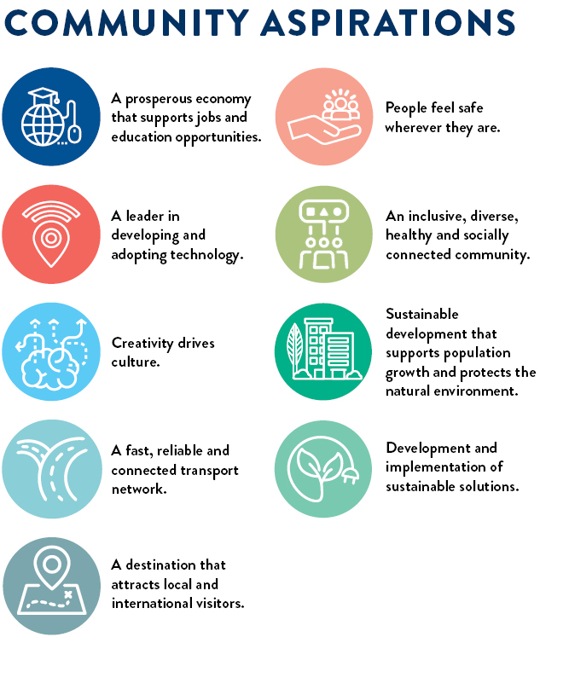
FIGURE 1: Nine aspirations of our community’s 30-year vision

OUR PURPOSE, VALUES AND STRATEGIC DIRECTIONS

Our purpose
Working together for a thriving community.

Our values
Our values represent who we are and who we aspire to be. They are the tools to create the workplace culture we want, and deliver on our purpose:
- respect and encourage each other
- create a healthy and safe environment for all
- embrace new ideas and better ways to work
- make people the centre of our business.

Our Strategic Directions
Our Community Plan 2021−25 outlines the things we will do to make Greater Geelong a clever and creative city-region. The four strategic directions our Council chose to guide us are:
- Healthy, Caring and Inclusive Community
- Sustainable Growth and Environment
- Strong Local Economy
- High Performing Council and Organisation.

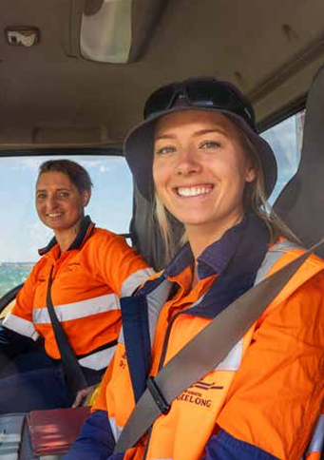
Our Organisation Strategy
If Our Community Plan 2021−25 is “what” we’ll do, our Organisation Strategy 2024−29 covers “how” we’ll do it. This document outlines our organisation’s priorities, to ensure we’re making the best decisions about how to deliver for the community efficiently and effectively. We have three commitments, each underpinned by two priorities, telling a clear story for our organisation’s future. While the focus of this report is on Council’s Strategic Directions, the Organisation Strategy is included for context on the ways we work to deliver for our community.

Photo: City Works employees

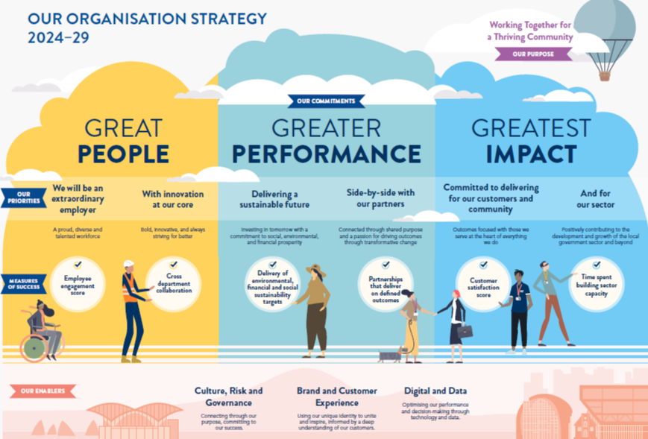

FIGURE 2: The City’s Organisation Strategy 2024–29

THE YEAR IN REVIEW

2023−24 HIGHLIGHTS
National Tree Day  The City joined forces with around 350 local residents to plant more than 3,000 trees for National Tree Day at a free City run community event in Lara on Sunday 30 July 2023.  The event, held at Lavender Drive Park in Lara, was made possible through the collaboration and support of Planet Ark, Blood Toyota, the Lions Club South Barwon and Lions Breakfast Club Drinks, dedicated volunteers and City employees who worked tirelessly to organise and coordinate the day.  Teaming Up with the Cats to Go Green  The City joined forces with Geelong Cats AFLW players and members to plant 900 native grasses, lower shrubs and some eucalypts as part of a revegetation project along the Moorabool River. The project is the first step in a new era of partnership between the Geelong Football Club and the City.  The first Planting Day gave Cats members and the Geelong community the opportunity to make a lasting impact on their local environment by restoring habitat for local wildlife.  Geelong Positive Ageing program  A performance from sixties pop icon Normie Rowe was one of more than 30 events supported by the City as part of the Geelong Positive Ageing program, launched in conjunction with the Victorian Seniors Festival. Spanning from October 2023 to March 2024, the program included activities held by community groups or organisations who received funding from our Positive Ageing Grants program designed to promote physical activity, mental health and wellbeing, social connections, and positive ageing among our senior citizens.  North Bellarine Aquatic Centre  The North Bellarine Aquatic Centre (Stage 1), with its newly constructed 50-metre heated outdoor pool, was officially opened in October 2023. The project jointly funded by the federal government ($10 million) and the City ($5.5 million), is a milestone moment for the North Bellarine community, and our many teams who have worked on this project from conception and consultation, through to completion. The City received $20 million each in funding commitments from the state and federal governments to deliver Stage 2, which will feature indoor facilities including an indoor, eight lane, 25-metre pool, a warm water pool and health and wellness facilities, including a gym and group fitness areas. A community advisory panel was established to help identify design options with a final concept design approved by Council in July 2023. Delivery is expected to take 2−3 years.  Botanic Gardens Australia and New Zealand (BGANZ) network event  The Geelong Botanic Gardens took centre stage as the venue for the Botanic Gardens Australia and New Zealand (BGANZ) network event in October 2023. We welcomed 80 national and international industry professionals hailing from more than 20 organisations, providing them with a guided tour of the 170-year-old gardens which boast more than 4,000 species across 400 genera and 100 plant families. A highlight of the tour was the Pacific Rim garden, a haven for rare plants hailing from regions in the Pacific, under threat from deforestation and climate upheavals. | Business Accelerator Program scholarships  Five local women are a step closer to achieving their business goals after being awarded Business Accelerator Scholarships with Business in Heels, valued at over $3,000 and sponsored by the City. Tamara Shaw, Nichole Chambers, Terri Wilby, Jessica Kerr and Simone Araujo Gugliandolo were selected to take part in the 12-month long Business Accelerator Program which aims to help women start trading and making sales as quickly as possible so they can become self-sustaining. Participants learn with the support of mentors to develop a business plan, turn leads into referrals, establish their small business and create social media and pricing strategies.  Waurn Ponds Skate Park redevelopment  The City unveiled the $1.94 million redevelopment of the Waurn Ponds Skate Park in September 2023. Informed by two rounds of community consultation in 2021, the skate park upgrade design retained and improved popular elements of the former skate park, while incorporating a new space to create better connections between site skate and play elements. The upgrade was jointly funded the City ($600,000) and the state government through its Sport and Recreation Victoria Community Sport Stimulus Infrastructure Grant Program ($1.34 million) and Connecting Regional Communities Program.  Geelong Nature Festival  After a huge six weeks of events attended by more than 3,000 community members, Geelong Nature Festival wrapped up in October 2023. The City, in partnership with the Geelong Field Naturalists Club, joined forces with 55 volunteer groups and organisations to deliver 70 events that celebrated, explored and nurtured Greater Geelong’s diverse natural environment. This year's theme, 'Our Backyard' was committed to inspiring local minds to engage with their surroundings, fostering a deep appreciation for nature in their own backyards. From restoring habitat on Waurn Ponds Creek and learning how to grow your own native plants to bug nights and Burrunan dolphin watching sessions, there was something on offer for all age groups, interests and passions. The festival included a major environmental art project involving primary school children from 22 schools, genU Artists, the fOrT and the Mt Dunned Men’s Shed, designed by the School of Lost Arts, culminating in the creation of major art installation at the 21st Century Garden at the Geelong Botanic Gardens. A short film capturing the installation can be seen at Geelong Nature Festival 2023. In February 2024, we delivered a presentation on the festival as part of the Victorian Biodiversity Conference held at Deakin University's Burwood campus.  Launch of Live and Local program  In October 2023, we launched our Live and Local program, designed to showcase, support and celebrate the unique mix of local musicians and bands in our region. Live and Local is a comprehensive capacity building program delivering professional development workshops, micro-music festivals and a local industry forum, presented by the City in partnership with live music advocates LiveMusic Office, and APRA AMCOS, a music rights management organisation. As part of the initiative, we are also establishing a Music Industry Register of those working in the music industry, musicians and live music venues to connect people with information about live music activities, workshops and professional development opportunities, networking and collaborative opportunities and grants.
Geelong Design Week 2023  From 19-29 October 2023, Geelong Design Week celebrated the City of Greater Geelong’s UNESCO City of Design designation. The event spanned 52 free and ticketed events across eleven days. The previous attendance record was shattered with an astounding 17,288 attendances at events, an increase of 172 per cent from 2022. The increased number of event attendees from areas outside the Geelong region, signalled the event's widening allure, with high-level estimates suggesting the impact of visitors attending Geelong Design Week events from outside Greater Geelong alone injected $1.6 million revenue into the local economy.  Poa Banyul Community Hub opening  Our $13 million state-of-the-art Poa Banyul Community Hub in Mount Duneed, was officially opened in November 2023. The hub is designed to cater to a diverse range of early years and family services, including sessional kindergarten, maternal and child health services, family support consulting rooms and versatile community spaces. Jointly funded by the City ($10.7 million) and state government ($2.25 million), the hub complements the nearby community shed, helping to create a sense of unity and support within the region.  Permanent Rainbow Crossing  In December 2023, we unveiled a permanent rainbow pedestrian crossing on Yarra Street as a symbol of pride in the diversity of the region and a celebration of the LGBTQIA+ community. Inspired by Valentino Vecchietti’s Progress Pride Flag, the chosen design is the most current and inclusive representation of LGBTQIA+ pride. It integrates not only the traditional rainbow colours but also incorporates elements of the transgender and intersex flags, as well as brown and black lines to symbolise all people of colour, including Australia’s First Nations communities. The idea was first floated in 2019 by members of the Rainbow community and supported by councillors. Initial steps were taken in 2020 with a temporary mini crossing in Little Malop Street during the launch of the Geelong Rainbow Festival. However, the COVID-19 pandemic temporarily halted plans for a permanent installation until 2022.  Recognition for Frank Costa AO  We partnered with the Costa Family, Geelong Authority member Rory Costelloe and the Geelong Cats Football Club, to commission internationally renowned sculptor Louis Laumen to create a sculptural memorial to the late Frank Costa AO, who passed away in May 2021. Unveiled in December 2023, The Newsboy (Frank Costa, aged 13), which depicts a teenage boy standing on a fruit box selling the Herald Sun newspaper, recognises the many roles Frank played in the community: a generous philanthropist, passionate Geelong Football Club president, well-known businessman and fierce advocate for our region.  Adoption of new Advocacy Framework  In March 2024, Council voted to adopt a new Advocacy Framework, which outlines the City’s approach to advocacy at a local, regional, state, national and international level over the next three years. The framework provides two new approaches for regional advocacy, with the City to renew its membership of G21 with a reduced financial contribution and work with neighbouring councils like the City of Wyndham for joint advocacy opportunities in the western growth area. The framework also considers the City’s role in the broader ecosystem of advocacy in Geelong, the approach and principles for advocacy, how advocacy priorities will be determined and how performance and outcomes will be measured.  Street upgrades near Waurn Ponds Station  A $2.1 million upgrade of Sugargum Drive and Bodega Street in Waurn Ponds was completed in May 2024, creating improved conditions for road users and pedestrians near the Waurn Ponds Station. Fully funded via the Australian Government’s Roads to Recovery program, the project produced a range of improvements between Oakwood Crescent and Rossack Drive including road pavement rehabilitation, kerb and channel upgrades, reflective pavement markers and line marking upgrades. The upgrades came in response to increasing traffic in the area, with around 11,000 vehicles now travelling along Sugargum Drive and Bodega Street each day. The project was completed on time and six weeks ahead of schedule by the City’s design, program delivery and construction teams. | City support for 16 Days of Activism against Gender Based Violence  We demonstrated our commitment to a world where everyone is respected by supporting the international campaign 16 Days of Activism against Gender-Based Violence. The campaign started on 25 November 2023, the International Day for the Elimination of Violence Against Women and finished on 10 December 2023 - Human Rights Day. In collaboration with Respect 2040, we promoted events and initiatives by other Geelong organisations and also joined local partners to light City landmarks, with the colour orange symbolising a brighter future free of violence.  Community Leadership Program  In November 2023, we celebrated the completion of the 2023 Community Leadership Program. The 17 aspiring leaders completed a nine-month interactive experience designed to equip them with personal and professional growth opportunities, as part of the City’s commitment to developing skilled and passionate leaders across the region. Throughout the course, participants developed an increased knowledge and understanding of the Geelong community, connected with like-minded peers, and were equipped with knowledge and tools across a range of topics designed to enhance their leadership capabilities.  People with Disability Awards  The City marked International Day of People with Disability in December 2023, by announcing the winners of the annual Awards for People with Disability. Attended by over 100 people, this was the fourth year the City has partnered with genU and the Barwon Disability Resource Council to present the awards. Winners of three categories were: Shannon Bowman (Achievement Award), Paige Humm (Leadership and Advocacy Award) and Tim Harte (Volunteering Award). The awards are essential to highlighting the great work accomplished by people with disability, as leaders and role models for others in the community.  Norlane ARC (Aquatic Recreation Centre)  Our brand new $65.6 million Norlane ARC (Aquatic Recreation Centre) was officially opened on 9 February 2024. Funded by the City ($48.84 million), state government ($8.5 million) and federal government ($8.26 million), the hub replaces the former Waterworld and Centenary Hall facilities. Features include a 25-metre pool, warm water pool, learn to swim pool, water play area and waterslide, as well as gym and exercise facilities, a multi-purpose hall, childcare facilities and health consulting suites. The City presented four naming options for community feedback early in 2024, based on recommendations from the facility’s Community Liaison Reference Group. Norlane ARC (Aquatic Recreation Centre) emerged as the preferred option among survey respondents and was approved by Council at its May meeting.  Co-design of the Pakington North Urban Design Framework (UDF)  In May 2024, Council adopted the Pakington North UDF which will be used to guide the future growth and development for the precinct that stretches along Pakington Street from Church Street to Waratah and Wellington Streets. In one of the City’s most extensive deliberative engagement processes, the UDF was co-designed with the Pakington Street North Community Panel, a representative sample of the Geelong West community including residents, business owners and visitors who live, work, shop and travel through the precinct. The panel participated in a series of workshops to consider and provide recommendations across a number of areas including urban design, heritage and neighbourhood character, built form, access and mobility, landscaping and open space. The UDF provides a roadmap to achieve the vision of a vibrant, people friendly and inclusive Pakington North precinct with thriving businesses, housing that is diverse and conveniently located, and quality architecture now and years into the future.
OUR COMMUNITY PLAN 2021−25

In 2023‒24, we committed to deliver 75 actions to support the achievement of our four-year priorities within Our Community Plan 2021‒25.
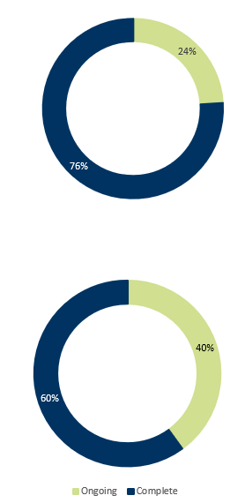
Detailed information on our progress against the Our Community Plan 2021‒25 Annual Action Plan 2023‒24 can be found in ‘Our Community Plan 2021−25 Progress Reports’ on geelongaustralia.com.au.

Overall progress
Of the 75 actions, 76 per cent (57) were complete,
and a further 24 per cent (18) are ongoing.

Major budget initiatives
Of the 75 actions, 15 are major initiatives identified in the 2023‒24 budget. Of these, 60 per cent (9) are completed and a further 40 per cent (6) are ongoing.

FIGURE 3: Our Community Plan 2021–25 Annual Action Plan progress for 2023–24

OUR COMMITMENT TO HEALTH AND WELLBEING
The health and wellbeing of our community is central to everything we do.
Under the Victorian Public Health and Wellbeing Act 2008, councils are required to prepare a four-year Municipal Public Health and Wellbeing Plan within 12 months of every Council election. The plan identifies goals for creating a local community where people can experience their best possible health and wellbeing. Acknowledging that health and wellbeing is everyone’s business, we incorporated our Municipal Public Health and Wellbeing Plan into our Council Plan to create Our Community Plan 2021‒25.

Our health and wellbeing priority areas
There are five health and wellbeing priority areas we have been focussing on since this plan began. We formed these priorities following a review of the policy context and local health data and engaging with the community and key stakeholders to identify health needs and challenges.

 |  |  |  | 
Tackling climate change and its impact on health | Increasing  healthy eating | Increasing  active living | Demonstrating and promoting gender equity practices | Improving mental wellbeing and social connection

Working with our partners
We partnered with the Barwon South West Local Public Health Unit, Bellarine Community Health and Active Geelong to submit successful grant applications to prevent vaping amongst young people and promote active transport for primary school aged children.
We also convened the Health and Wellbeing Partners Network to enable a partnership approach to health and wellbeing. Since its inception in 2021, the network has met six times. Members have mapped the work being undertaken across the municipality under the five health and wellbeing priority areas to identify gaps and opportunities for collaboration. This year, members participated in consultations for the Western Victoria Primary Health Network Community Needs Assessment and the Barwon South West Local Public Health Unit’s Catchment Plan.

Our health and wellbeing indicators
A set of 17 population level indicators in Our Community Plan 2021–25 help track the health and wellbeing of our community. Our work, along with the work of our partners and other organisations, contribute to progress in the five priority areas.

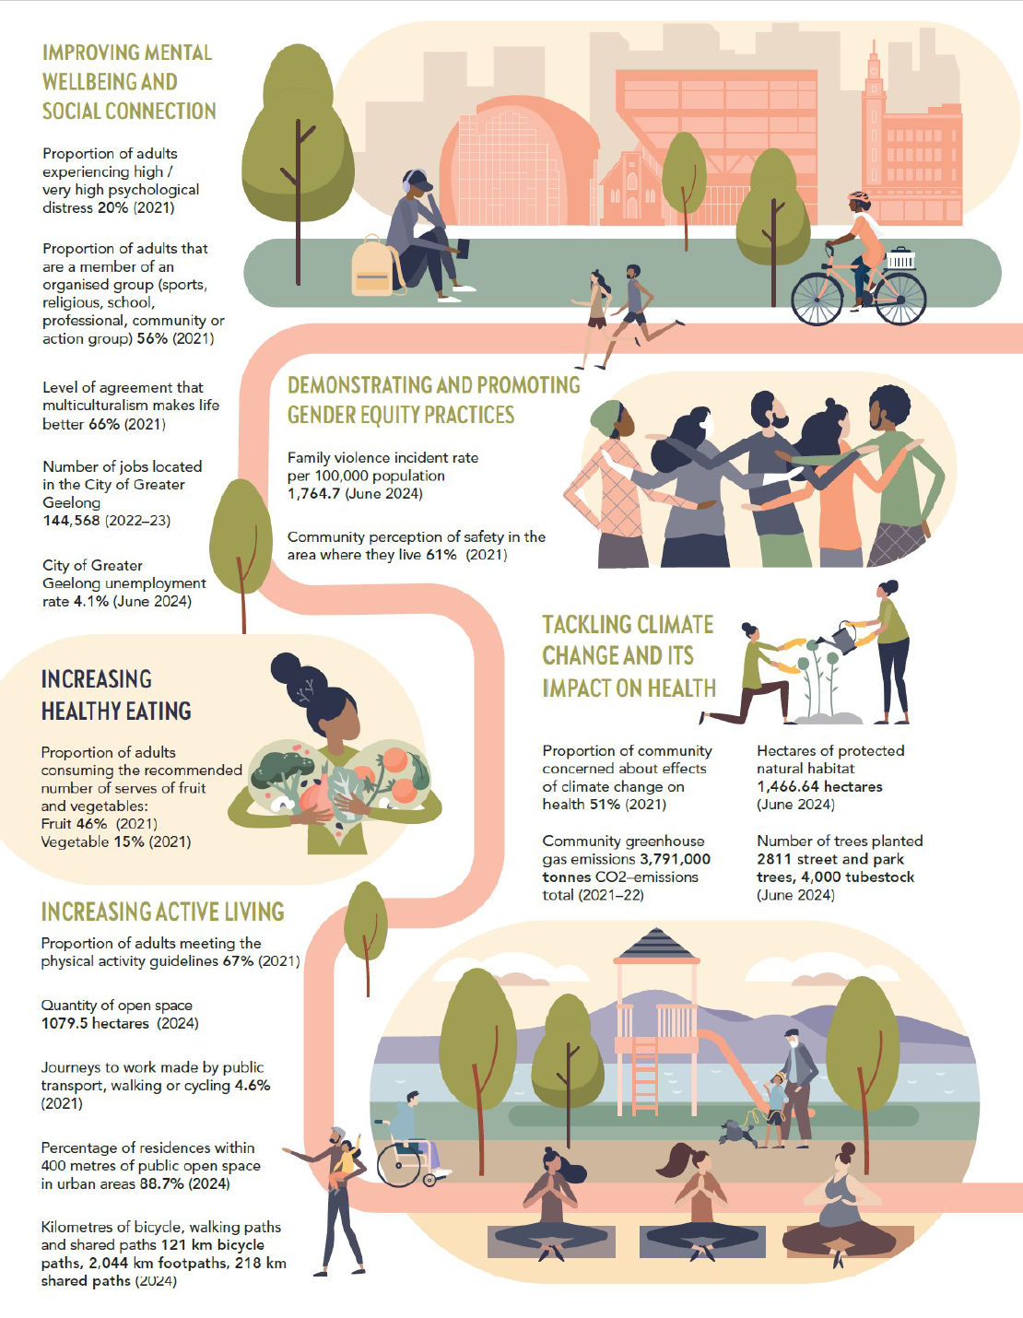
Key actions supporting health and wellbeing
FIGURE 4: Our Community Plan 2021–25 health and wellbeing indicators

In 2023‒24, we committed to deliver 36 actions to support the achievement of our five health and wellbeing priorities within Our Community Plan 2021–25 - Annual Action Plan 2023–24:
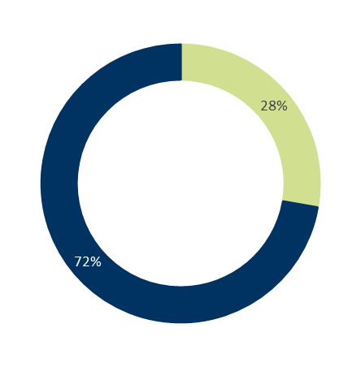
Of the 36 actions, 72 per cent (26) were complete and 28 per cent (10) were ongoing.

Progress of annual actions supporting delivery of health and wellbeing priorities

The following tables highlight some of these key actions for each health and wellbeing priority area. For more detailed information on these and other actions, please refer to the Our Community Plan 2021−25 − Quarterly Report June 2024.

Health and Wellbeing Priority 1: Tackling climate change and its impact on health
KEY ACTIONS | STATUS | COMMENT
2.4.1 Incorporate Environmentally Sustainable Design (ESD) principles into new urban growth areas including zero carbon, water efficiency, sustainable transport, urban greening and climate resilience | Complete | The City completed Creamery Road Precinct Structure Plan ESD provisions including zero emissions operational energy for new developments and completed initial engagement for the development of new ESD guidelines and templates and application checklists which will provide developers and the City with a clear and efficient process for assessment.
2.6.2 Identify new opportunities for policy or project development from the discussion paper on understanding and mitigating the health impacts of climate change | Complete | The discussion paper was finalised using feedback from internal stakeholders and subject matter experts. An internal working group meeting was held in April 2024 to prioritise opportunities arising from the December 2023 workshop. Integrating climate change and health impacts into our core work is ongoing. The City was also successful in obtaining grant funding from Sport and Recreation Victoria to implement a Kids Active Travel Program in partnership with Bellarine Community Health and Active Geelong. The program will focus on co-designing ways to improve active travel to and from school with four primary schools across Greater Geelong, improving physical activity and helping to reduce carbon emissions.
2.6.3 Facilitate partnerships to support our community to reduce emissions | Complete | The City continued to support reduction of community emissions through activities including:  - funding projects with Deakin University, Geelong Sustainability (Sustainable House Day, Electric Homes Program) and 100% Clean Bellarine via the City’s Climate Change Partnership Grant program  - participating in the Barwon South West Climate Alliance to secure a Department of Justice and Community Safety (Emergency Management Victoria) grant for Resilient Community Assets ($245,200) and more recently, another grant of $32,848 to build collaboration between registered Aboriginal Parties in the Barwon South West region in relation to climate change.  - launching the Our Climate Actions interactive site (www.geelongaustralia.com.au/sustainability) which showcases some of the work the City and community has delivered in carbon reduction and climate adaptation initiatives.  - supporting the Farm My School project in Drysdale with tonnes of compost for market gardens in schools to educate and connect communities  - conducting community information sessions about the available grants programs to reduce community emissions and build community resilience to climate change.  - presenting to Rotary East Geelong on the progress of implementation of the Climate Change Response Plan.  - partnering with Sustainability Victoria to deliver two behaviour change workshops to support community climate leaders.
Other achievements
Promoting stewardship of our natural environment
We collaborated with Outdoors Victoria to present the annual Geelong Nature Stewards program, which provides community members with the opportunity to discover more about their local native plants and animals and learn skills to help protect the places where our wildlife lives. This year, the comprehensive 10-week course provided 20 participants with a platform for exploring subjects such as geology, climate, botany, water systems, animal life, and the principles of conservation land management, including several field trips to biodiversity hotspots across Greater Geelong. The City was the first regional Victorian municipality to offer the program and after four programs has nearly 80 participants successfully graduate.

Supporting a clean energy future
Our Climate Change Partnership Grants program aims to support the Geelong community to achieve net zero community emissions and increase resilience to climate change impacts through a co-ordinated and collective response. In 2023−24, we awarded Geelong Sustainability with a $50,000 grant to deliver the Electric Homes program, aimed at promoting and assisting the community in installing renewable energy and efficient electric appliances. The program, delivered in partnership with G21 councils, focused on education and information about the various upgrades and installations available and connecting residents with trusted local installers. Over 1,500 attendees engaged in information sessions, both in-person and online, with 318 households proceeding to install products within their homes. The investment of over $2.0 million in renewable energy and efficient electric appliances is estimated to save $214,366 on energy bills ($5.3 million over 25 years) and reduce CO² emissions by 770 tonnes annually (equivalent to 183 cars off the road).
Health and Wellbeing Priority 2: Increasing healthy eating
KEY ACTIONS | STATUS | COMMENT
1.1.1 Implement the Promoting CHANGE project to encourage healthier food and drink options in council owned facilities and settings | Complete | Promoting CHANGE is a three-year project to support council-owned and operated sport and recreation facilities to shift towards healthier food and drink options in their cafes and kiosks. The six participating sites are: Barwon Valley Aquatic Centre, Leisuretime, Lara Swimming Pool, Splashdown, Leisurelink and the Norlane Aquatic and Recreation Centre. This work strengthens the implementation, monitoring and evaluation of the City’s food procurement processes, and ensures we are meeting the state government’s Healthy Choices guidelines. Most importantly, it means that environments within City facilities support community health and wellbeing, especially in the places where children and young people spend their time.  Achievements included:  - half of the participating facilities have reduced the proportion of RED (less healthy) drinks to under 20 per cent, and display GREEN (most healthy) drinks in the top 50 per cent of their fridges where they are most accessible to customers.  - all six participating facilities now registered as Vic Kids Eat Well supporter sites, and Barwon Valley Activity Centre has been awarded a $200 prize for their participation.  - a Deakin University health promotion student has been recruited to expand our implementation of the Healthy Choices Guidelines and Vic Kids Eat Well initiative with the City's three remaining sport and recreation centres.  - plans are underway to fit out storage rooms, revamp retail spaces and install new countertop refrigeration units to showcase healthy foods with equipment grants from Deakin University.  Ongoing work includes delivery of training and development opportunities to upskill facility staff and development of an online reporting platform that will help us monitor our progress in real time.
1.2.1 Develop a policy to make the region’s food system more accessible and resilient | Ongoing | The Institute of Physical Activity (IPAN) at Deakin University have been engaged to progress the development of a food systems policy and a draft discussion paper was prepared for community and stakeholder engagement planned for July 2024. We will continue to progress this action in 2024−25.
Other achievements
Collaborating to reduce waste and promote healthy eating
Through our Environmental Sustainability Grant program, we supported the Community Olive Oil project – an initiative of the Barwon Oil Barons community group. With businesses needing at least 1,000 kilograms to press oil, these local residents banded together to enable residents to have olives from their backyard or nature strip trees processed into olive oil for free, saving a total of 4.5 tonnes of olives from going to waste this year. Volunteers in Belmont, Norlane and Ocean Grove collected and weighed olives harvested by 80 residents before dropping them at Mt Moriac Olives.
The fruit was processed by Geelong Region Olives into 590 litres of healthy olive oil and then collected by participating residents using their own containers, lessening the need for new packaging. This innovative project utilises an existing resource and reduces waste, while promoting the use of healthy and local ingredients and strengthening community ties.
Creating connections through community gardening
Community gardens serve as vibrant hubs that foster a sense of belonging, promote sustainable practices, and contribute to overall well-being. They provide a gathering place where people from diverse backgrounds come together to cultivate friendships, learn new skills, and share knowledge. Additionally, these green spaces provide opportunities for individuals to grow their own nutritious produce, promoting healthier lifestyles and food security within communities.
Understanding the invaluable role these gardens play in enriching neighbourhoods and strengthening community bonds, we supported three community garden projects at Grovedale ($53,000), Chilwell ($69,300) and Murnong ($94,000), through our 2023−24 Community Infrastructure Grants program. Grants provided to these projects will enable the delivery of new and upgraded infrastructure and facilities to create more functional and inviting spaces, further enhancing engagement and participation.

Health and Wellbeing Priority 3: Increasing active living
KEY ACTIONS | STATUS | COMMENT
1.2.3 Implement Year 2 activities of the Positive Ageing Strategy 2022−2025 Action Plan | Complete | Year 2 actions from the Positive Ageing Strategy 2022−25 Action Plan implemented this year include:  - partnering with the federal government to host Live Up program resources on our website which will help older people stay at home for longer.  - supporting the Barwon Elder Abuse Primary Prevention Network to deliver the Barwon Region Knitting Project to raise awareness of ageism and elder abuse. The project included an exhibition at Geelong Regional Libraries and donation of knitted goods to Our Village (formerly Geelong Mums).  - providing 24 community groups with funding via the City's Positive Ageing Grants program with many activities occurring during the Seniors Festival.  - supporting Seniors Month (October 2023) activities including partnering with TLC Aged Care to deliver a concert for seniors.
1.7.3 Implement Stage 2 of the Lara Recreation Reserve Master Plan. | Complete | A new accessible, multi-sport and gender-neutral sports pavilion was completed with the opening scheduled for August 2024. The baseball field works are 95 per cent complete with fencing scheduled to be completed in July 2024. These enhancements aim to create a comprehensive recreational hub meeting the diverse needs of the Lara community.
1.10.1 Activate the Northern Aquatic and Community Hub with a focus on health and wellbeing, cultural engagement and community connection for people in the local community | Complete | The Norlane ARC (Aquatic Recreation Centre), formerly known as Northern Aquatic and Community Hub, was officially opened by the Deputy Prime Minister and councillors on Friday 9 February 2024, followed by a full public opening on 19 February and a community open day on Sunday 3 March. A full suite of programs is on offer to help the local community improve their physical and mental health, create social connection and experience better overall wellbeing.

Other achievements
Renewing local playgrounds
As part of the City's annual playground renewal program, and in line with the City's Geelong Play Strategy 2012−2021, we invested $570,700 to renew eight local playgrounds (Malbec Loop Reserve, Malcolm Reserve, Francis Reserve, Moolap Reserve, Gwyther Reserve, Lubeck Reserve, Pevensey Park and Barwon Valley Fun Park) and one district playground, (Breamlea Recreational Reserve) in 2023−24.
There are currently over 380 public play spaces managed and maintained by the City that are assessed annually on a monitored playground upgrade schedule. The renewal program makes sure that each of the playgrounds has somewhere for visitors to run, swing, slide and climb, as well as an update of the existing play equipment.
We were also successful in obtaining $50,000 to renew the Ceres Recreation Reserve playground through the state government’s Victorian Tiny Towns Fund which offers grants to deliver infrastructure, facilities, and capability-building projects for small communities.

Expanding our shared trails network
In April 2024 we completed construction of a new shared trail at Beacon Point, Clifton Springs. Starting at a beach access point opposite Cantata Way, the 800-metre trail runs along the cliff’s edge to Beacon Point Reserve, and then south along the eastern boundary of the reserve to finish on High Ridge Drive.
The works, jointly funded by council ($180,000) and the state government’s Regional Infrastructure Fund 2022−2023 ($360,000), also included associated facilities such as signage and trail information, park furniture, and revegetation of native and indigenous species.
The trail creates an important connection to the coastline, making it easier for the community and visitors to the Bellarine to enjoy coastal walks and bike riding with impressive views across the bay.

Health and Wellbeing Priority 4: Demonstrating and promoting gender equity practices
KEY ACTIONS | STATUS | COMMENT
1.4.1 Work with partner agencies on initiatives to prevent family violence and violence against women | Complete | The City worked with partner agencies to support initiatives to prevent family violence and deliver community programs which included:  - delivering the Respect Cup, a full day respectful relationship and consent program led by the City and Netball Victoria for 120 Year 9 students from eight different secondary schools  - supporting the 16 Days of Activism against Gender-Based Violence, an international campaign beginning on 25 November 2023, the International Day for the Elimination of Violence Against Women  - partnering with the Women in Community Life Advisory Committee in celebrating International Women’s Day by acknowledging and honouring the extraordinary contributions and leadership roles of women across the region as part of the Women in Community Life Awards.
2.3.1 Promote access to sport and physical activity for women and girls through the development of the Ocean Grove Sporting Infrastructure Plan | Ongoing | The City is reviewing the Ocean Grove Sporting Infrastructure Plan in response to the exponential increase in female sports participation and population growth, new design trends (female friendly, universal and Environmentally Sustainable Design) and development of new facility standards, strategies and policies The review is ongoing, with key stakeholders to be re-engaged to progress the plan and progress the priority development of Devlin’s Road Reserve.
Other achievements
Supporting women and girls’ participation in local sport.
In May 2024, new female friendly change facilities at the Bell Park Sports Club were officially opened following a $1.95 million upgrade jointly funded by the City ($1.7 million) and the state government ($250,000).
The new change rooms replace the previous one, which no longer met the accepted standards. The upgrade which also featured change facilities for officials, a first aid room and storage spaces, has created a more welcoming environment for female players. The new changerooms add to a $397,000 LED sports lighting upgrade completed in July last year, also jointly funded by the state government ($357,500) and the City ($39,500).

Building a culture of LGBTQIA+ inclusivity in Greater Geelong.
Reflecting Council’s commitment to create a more inclusive region, the City is developing an LGBTQIA+ Action Plan to respond to the priorities and experiences of our LGBTQIA+ community. This is scheduled to be launched in 2025.
We are using the state government's Rainbow Ready Roadmap, a set of resources designed to help regional and rural communities to progress work on LGBTQIA+ inclusion, to assess gaps and guide future priorities. Launched in May 2022, the roadmap supports Pride in our Future: Victoria’s LGBTQIA+ strategy 2022−32 and provides 15 indicators for local government. A report outlining our progress against the Rainbow Ready Roadmap indicators was made available on our website in May 2024.
In June 2024, we sponsored the national LGBTQIA+ conference ‘Better Together 2024’ held at GMHBA Stadium. More than 800 people from across Australia attended the event to explore current issues facing the LGBTQIA+ community. Run by the Equality Project, there were over 115 activities including panels, workshops and training sessions where participants came together to share ideas and experiences, listen to each other and foster greater collaboration to create change.

Health and Wellbeing Priority 5: Improving mental wellbeing and social connection
KEY ACTIONS | STATUS | COMMENT
1.5.2 Deliver priority infrastructure projects to improve all abilities access as part of our Access and Inclusion Plan 2018–2023. | Complete | Disability access ramps for the Drysdale Community Hub and the Grovedale Hall were completed.
1.7.5 Plan for the delivery of the pilot youth hub in Central Geelong | Complete | The City undertook a range of community engagement activities January to March 2024 to inform the development of the Geelong Youth Hub. Participants included advisory groups (Youth Council Advisory Committee, Gender and Sexuality Project and Rainbow Youth Advisory Group), young people, youth service providers, parents, teachers, employees and the wider community. A progress report was submitted to the Department of Families, Fairness and Housing on 28 March 2024. With planning for the infrastructure component of the pilot Youth Hub complete, planning for governance and operations of the facility will commence.
2.3.2 Partner with senior groups to create a street art mural for the Portarlington Senior Citizens Club | Complete | The City provided support and guidance and regularly liaised with the artist, senior citizens and the Portarlington Community Association. The mural titled ‘The Fish Thieves’ by local Portarlington artist Heather Duff was completed in December 2023.
3.6.1 Partner with community organisations to deliver programs that enable skills development and improved employment outcomes | Complete | The City partnered with the Geelong Chamber of Commerce to deliver the Geelong Small Business Festival from 1 to 31 August 2023. The festival saw 72 low-cost and free workshops, presentations and networking opportunities held by local businesses for community members looking to start, grow or improve their small business. Additionally, the City has implemented various programs to enhance business and professional development within our community. This included:  - sponsoring 1-2 participants and facilitating an information session to encourage participation in the Runway Incubator Program which helps participants launch their idea to the market by learning in a highly supported environment  - sponsoring 10 placements in the Business In Heels Accelerator Program which aims to help women start trading and making sales as quickly as possible so they can become self-sustaining  - providing free Business Mentoring Sessions  - the Beyond Blue NewAccess for Small Business program which offers guided self-help mental health coaching for small business owners, helping manage stress through practical problem-solving approaches over six sessions  - self-employment assistance offered through WorkForce Australia, to assist individuals in setting up, developing, and growing their own small businesses  - the Industry Growth Program, which provides advisory services to startups and small and medium enterprises engaged in innovative commercialisation and growth projects aligned with the Australian Government’s Self-Employment Assistance National Reconstruction Fund priorities.
4.2.1 Continue to provide the opportunity for in-person neighbourhood discussions with residents as part of our Neighbourhood Conversations program | Complete | The City successfully hosted a series of nine Neighbourhood Conversations across the four wards of the municipality. These sessions offered an opportunity for residents to talk to councillors and City employees about the 2024−25 budget and share their feedback on what is important to them. More ward-based Neighbourhood Conversations will be held until August 2024 to support the development of the next Council Plan and Community Vision with the incoming Council later this year.

Other achievements
Delivering vibrant public spaces
We worked with the Wadawurrung Traditional Owners Aboriginal Corporation, Norlane Community Initiatives and local stakeholders to redevelop Labuan Square in Norlane, providing a more vibrant and inclusive public space. Key highlights of the upgrade include improved safety and comfort – with new furniture, lighting, CCTV and free Wi-Fi, landscaped gardens and planter boxes, art installations and improved amenities, including a new toilet block and children’s waterplay fountain. We invested $405,000 into the project along with $326,000 from the state government through the Department of Jobs Skills Industry and Regions (DJSIR) COVID Safe Outdoor Place Activation Fund ($100,000) and the Department of Justice and Community Safety, Creating Safer Places grant ($226,000). Funding towards the digital infrastructure also came from a wider grant through the DJSIRs Connecting Regional and Communities program.

Celebrating Geelong's youth
In June 2024, we held the Geelong Youth Awards at the Geelong West Town Hall to recognise young people aged 12 – 25 making an outstanding contribution across Greater Geelong. The awards ranged across areas of leadership, innovation, cultural awareness, community work, sport, arts, music and youth development. The City’s Youth Council members were highly involved in the Youth Awards, developing the Unsung Hero Award category and participating on the judging panel as well as speaking at the awards ceremony.

FOCUS ON SUSTAINABILITY
Sustainability is a key theme of Our Community Plan 2021‒25 and a strong focus of our community’s 30-year clever and creative vision.
Sustainability refers to a continual way of thinking that focuses on the best outcomes for our community, environment and the economy, now and in the future. Our goal is to incorporate sustainable thinking into every aspect of our business to address some of the long-term challenges facing our community, including climate change, population growth, demands for community infrastructure and social inequity.
We adopted the Sustainability Framework 2020 to create a culture of sustainable practice in our organisation. The framework commits us to take action across three key priority areas of sustainability: protecting our environment; community wellbeing and social equity; and responsible and transparent business.

Major initiatives driving sustainability in 2023−24 included:
- launching the ‘Our Climate Actions’ interactive website where community members can learn about how the City and the community are working together to protect our local area and deal with the changes happening in our climate
- consulting with businesses, advocacy groups, industry bodies and our community in the development of a 10-year economic development plan – Geelong on the Rise: A Clever and Creative International City. The plan will guide our priorities to make sure we keep delivering great services and support for local businesses, and help create a sustainable, prosperous future for our community
- providing Greater Geelong’s young people with the opportunity to make valuable contributions to the discussions, decision making and actions relating to them in their communities by convening the Geelong Youth Advisory Board program
- progressing precinct structure plans for the Northern and Western Geelong Growth Areas and Marshall to meet the growing need for residential land across the municipality
- supporting community to achieve net zero community emissions and increase resilience to climate change impacts through our Climate Change Partnership Grants which in 2023−24, provided five projects a total of $126,750 in funding
- engaging with our community to develop the draft Disability Access and Inclusion Plan 2024−28 which outlines our actions to create a city that is more accessible, inclusive, welcoming and supports the full participation of people with disability
- commencing work on an integrated transport strategy that will set the long-term vision and directions for transport decision making across Greater Geelong.

KEY CAPITAL PROJECTS
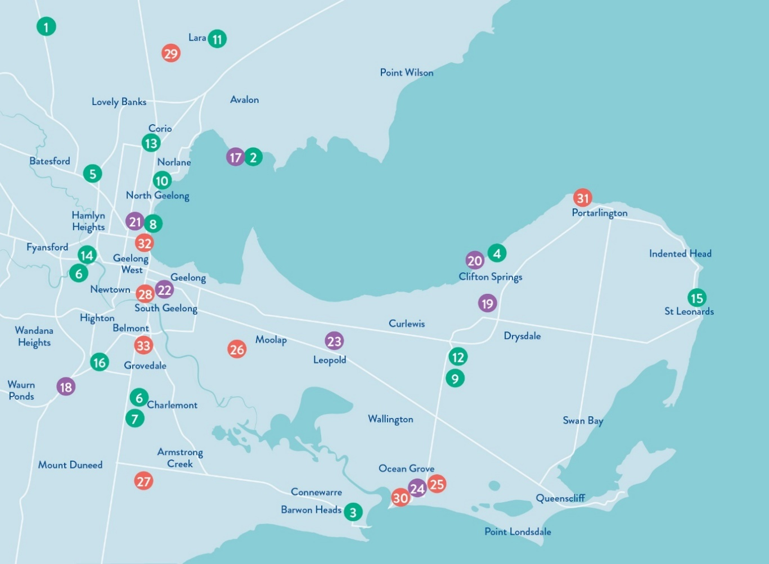
We deliver an extensive capital works program each year to create infrastructure for our community. For more information, view our Capital Works Projects dashboard.
FIGURE 5: Key Capital Projects 2023–24
PROJECTS COMPLETED  - Anakie Football Netball Club Social Room Upgrade – $2.85M  - Avalon Beach Boat Ramp Upgrade – $1.5M  - Barwon Heads Bowling Club Pavilion Upgrade – $1.2M  - Beacon Point Reserve Shared Trail, Clifton Springs – $540,000  - Bell Park Sport and Recreation Club Changeroom Upgrade – $1.95M  - Biyal-a Armstrong Creek Library, Armstrong Creek, – $21.864M  - Bus Shelter Design & Construct Program (9 bus shelters across Geelong) – $562,000  - St Helens Park Shelter and Deck – $435,000  - Drysdale Sporting Ovals Drainage Improvements – $700,000  - Labaun Square Streetscape, Norlane (including Public Toilet Replacement) – $691,000  - Lara Recreation Reserve Master Plan Stage 2 - Baseball Precinct – $5.545M  - North Bellarine Aquatic Centre, Drysdale – $15.5M  - Norlane ARC (Aquatic Recreation Centre) – $65.0M  - Queens Park Golf Club Irrigation Upgrade, Highton – $1.2M  - St Leonards Skate Park Redevelopment – $670,000  - Waurn Ponds Skate Park – Stage 2 – $1.95M | PROJECTS UNDER CONSTRUCTION  - Avalon Beach & Limeburners Boat Ramps and Carpark Upgrades – $3.5M  - Baanip Boulevard/Boundary Road intersection, Mt Duneed – $7.6M  - Barrands Lane Drainage/Flood Mitigation Works, Drysdale – $720,000  - Clifton Springs Boat Harbour Carpark Extension – $1.0M  - Geelong Arena Roof Drainage and Heating, Ventilation, and Air Conditioning Upgrade, North Geelong – $1.85M  - LED Lighting & Smart Controls delivery (across Geelong) – $13.48M  - Leopold Tennis Pavilion – $1.97M  - Ocean Grove Principal Pedestrian Network – $10.0M | PROJECTS COMMENCED DESIGN PHASE  - Bellarine Aquatic and Sports Centre Building Upgrade, Ocean Grove – $900,000  - Grinter Reserve Sports Lighting, Newcomb – $600,000  - Horseshoe Bend Community Hub, Charlemont – $19.79M  - Landy Field Pavilion Redevelopment, South Geelong – $6.0M  - Lara Golf Club - Driving Range Upgrade – $1.096M  - Ocean Grove Memorial Reserve Sports Lighting – $800,000  - Portarlington Reserve Master Plan – $3.774M  - Rippleside Inclusive Play Space & Public Toilet – $5.115M  - Winter Reserve Netball Change Room & Court Upgrade, Belmont – $1.575M

ENGAGING WITH OUR COMMUNITY
Engaging with our community ensures that we listen and make decisions based on community lived experience and in line with our community views and values.
Over the past twelve months, we continued to strengthen our community engagement practice with initiatives including:
- conducting face to face (in person) engagements
- holding regular community roadshows including attending Pako Festa, Christmas in Geelong Opening Night 2023 and holding a series of Neighbourhood Conversations in all wards
- increasing the use of deliberative engagement methods such as community panels for projects including North Pakington Street Urban Design Framework, Geelong Youth Hub, North Bellarine Aquatic Centre, the Norlane ARC (Aquatic Recreation Centre) and the Kardinia Park Concept Master Plan
* Percentages total greater than 100% as some engagements were in multiple wards

- actioning a Join Us campaign encouraging our community to sign up to the Have Your Say platform to share their ideas and opinions on projects that matter to them
- improving accessibility and inclusivity of our online Have Your Say platform by optimising font sizes and types, and colour contrasts and including a Read Speaker function which reads information written on the page.
FIGURE 6: Community engagement snapshot 2023−24
Monitoring and Reporting
We are committed to monitoring our processes, information sharing and decision making to understand the overall level of success of our engagements. Some measures of our success for the past 12 months include:

91,281 | 214,004 | 11,343 | 56 | 6,761
visitors to the Have Your Say platform | views of the Have Your Say platform | contributions received | projects on the Have Your Say platform | registered members on the Have Your Say platform
Top Have Your Say pages visited:
- Draft Market Square Quarter Master Plan (8,362 visitors)
- Armstrong Creek Library and Community Hub (3,127 visitors)
- North Bellarine Aquatic Centre (3,076 visitors)
- Integrated Transport Strategy (2,625 visitors)
- Draft Disability Access and Inclusion Plan 2024−28 (2,556 visitors).

Advisory Committees
Our advisory committees enable community members to provide community insights, share lived experience and ongoing feedback to guide our decision-making. We would like to thank each of the committee members for the time, enthusiasm, ideas and energy they’ve put into the committee meetings over the past 12 months.
Successful Projects
Community feedback influenced over 50 projects delivered in 2023−24 including:
Sparrow Park Playground Renewal  In early 2023, the community were invited to share their thoughts, ideas on proposed playground designs at Sparrow Park, Geelong West, which was being renewed as part of the City’s Playground Renewal Program. We held two in-person engagement sessions attended by over 100 people, received 625 suggestions/comments online as well as at pop-ups at the park. Feedback showed that community members strongly value Sparrow Park with many people referring to the space as a community hub. As a result of the feedback received, a number of changes were made to the design based on common themes that came through. The renewal construction is now complete with existing playground equipment replaced with new equipment, a seat installed, and additional trees planted for shade. We also partnered with Rotary International to identify existing play equipment that could be dismantled and reassembled overseas for other children to enjoy as part of their playground harvest program, Rotary Overseas Recycled Playgrounds. | Rainbow Crossing Installation  In response to community interest and suggestions, across June-August 2022 we sought feedback about the installation of a permanent Rainbow Crossing in central Geelong. More than 778 people engaged with the City on a series of possible locations, with the community identifying three most popular locations. After working through the options, we determined the best location for the crossing was Yarra Street as it addressed a range of safety concerns and was suitable for a paint product which would ensure the crossing had a long life. The City's LGBTQIA+ Advisory Committee was supportive of this option. In December 2023, the permanent rainbow pedestrian crossing on Yarra Street, under the Westfield flyover, was unveiled as a permanent symbol of pride in the diversity of the people of our region and a celebration of the LGBTQIA+ community.
Geelong Youth Hub  From January to March 2024, we undertook a range of community engagement activities with young people, youth service providers, advisory groups, parents, teachers, and the local community to understand the needs of young people when designing the spaces, services, programs and activities of the Geelong Youth Hub. More than 1,226 people, including 904 young people, engaged via a range methods/channels including an online survey, co-design workshops, information sessions, open day and in-person at community events. Feedback contributed included valuable insights and feedback regarding the space layout, desired support services, activity offerings, and ensuring accessibility and inclusivity for all youth. We also heard that young people want to be able to determine how the hub operates, what services, programs, activities, and events occur at the hub through a youth led governance model. The next phase of the co-design process will see feedback incorporated into the final plans for the hub, developing the governance and operational model and design for construction. A pilot of the hub is planned to run from January 2025 to December 2026. | Market Square Quarter Master Plan  Initial engagement to inform the development of a draft master plan occurred January-February 2023 when we held online and in person conversations with community, visitors, landowners, and occupiers on issues and opportunities regarding the revitalisation of Market Square and the surrounding area. Engagement on the resulting draft master plan was then undertaken in two stages between November 2023 and February 2024. A range of engagement tools and techniques were used to provide different types of opportunities for key stakeholders and the community to have their say including an online survey, four drop-in sessions and face to face conversations. During the engagement period more than 330 people engaged us with the have your say web page receiving 9,263 views from 6,609 visitors. Results of the survey showed majority of participants (over 66 per cent) were supportive of the draft master plan. Engagement results will be reviewed further to inform the final master plan document which will be presented to Council for consideration at a later date.

GRANTS PROGRAM
In 2023–24, our Community Grants program saw 240 grants worth $3,946,049 awarded to community groups and organisations supporting the arts, events, cultural, sporting and recreation, heritage, and environmental sustainability.
Funding ranged from small grants of $500 to assist grassroots activities, through to $350,000 to help shovel-ready community infrastructure projects. For further grants information visit our website www.geelongaustralia.com.au/grants.

TABLE 1: Community Grants program allocations 2023–24
GRANT |  | GRANT BUDGET | APPLICATIONS FUNDED | TOTAL FUNDING ALLOCATED
Arts Projects | Support to deliver arts projects in the City of Greater Geelong. | $200,000 | 19 | $179,960
Artists & Creatives Professional Development | Travel, accommodation, fees, incidentals and in some circumstances, remuneration. | $200,000 | 6 | $10,000
Clever & Creative Seed | Provide artists and creatives with small grants to initiate, explore or activate new ideas or new approaches to their work. | $200,000 | 4 | $10,000
Children’s Week | Small grants to facilitate events held during Children’s Week. | $10,000 | 20 | $9,920
Clean Economy | Projects that demonstrate clean technology and circular economy solutions. | $50,000 | 2 | $50,000
Climate Change Partnership Grants | Funding for projects and activities that will be carried out over a period of one to two financial years. | $130,000 | 5 | $126,750
Community Events | Operating expenses to run safe, moderate sized, public events that provide economic and community benefits to our region. | $180,000 | 22 | $155,300
Community Events Quick Response | Support for moderate sized events which bring our region economic benefits. | $180,000 | 3 | $25,000
Community Infrastructure | Planning for Capital Works - Costs associated with facility development planning, concept designs and detailed designs for future infrastructure projects. | $2,700,000 | 27 | $2,674,090
Community Infrastructure | Capital Works - To assist with cost of ready to go community infrastructure projects. Not applicable for the purchase of land. | $2,700,000 | 27 | $2,674,090
Environmental Sustainability | Capital Works - Small environmental capital works (for example water tanks, solar panels). | $90,000 | 14 | $79,546
Environmental Sustainability | Projects - Delivery of responsive environmental sustainability projects, programs and community activities. | $90,000 | 14 | $79,546
Environmental Sustainability | Equipment - To assist with cost of small equipment purchases that help community groups to deliver services and programs. | $90,000 | 14 | $79,546
First Nations Cultural Heritage | Projects that recognise, restore, protect and preserve both tangible and intangible Aboriginal Cultural Heritage. | $90,000 | 3 | $89,332
Geelong Heritage | Conservation Works - Building or streetscape projects that are visible to the public and focus on presentation to a street or public space and have an identified historic value. | $90,000 | 4 | $90,000
Geelong Heritage | Planning - Feasibility and investigation projects to provide technical, planning, project scoping advice for future restoration projects. | $90,000 | 4 | $90,000
Healthy & Connected Communities | Projects - Projects, programs, activities, forums or events, and equipment necessary to deliver activities (up to $10,000) that improve health and wellbeing, build community capacity and benefit the broader community. | $245,000 | 58 | $245,210
Healthy & Connected Communities | Equipment - To assist with cost of small equipment purchases (up to $2,000) that help community groups: deliver services and programs, improve health and safety outcomes or improve resources that support volunteer groups. | $245,000 | 58 | $245,210
Neighbourhood Houses | Partnership with Neighbourhood Houses for operating costs and community development projects. | $167,500 | 15 | $141,500
Neighbourhood Houses – Christmas in the Community | Support for Christmas celebrations across our municipality. | $36,000 | 11 | $35,961
Positive Ageing | Support community hosted events and experiences. This grant replaces the Geelong Seniors Festival Grants. | $24,000 | 27 | $23,480

OVERVIEW OF FINANCIAL PERFORMANCE
This is a summary of our financial results for 2023–24.
For full details, please refer to the Annual Financial Report on page 124.
- Surplus of $81.7 million – consistent with the prior year result.
- $536.7 million revenue, with 56.9 per cent coming from rates and charges.
- $454.8 million expenditure – 41.8 per cent employee costs and 27.6 per cent materials and services
- $4.8 billion in net assets – $179.9 million increase on the restated previous year, including a $98.2 million asset revaluation increment.
- $139.5 million capital expenditure – 38.1 per cent relating to land and buildings, 25.0 per cent for roads, footpaths, bike paths and drainage.
Comprehensive Income Statement
The comprehensive income statement shows how much we earned during the 2023–24 financial year. It details where we received our income and how it was spent.

Net Result
FIGURE 7: Net result 2020–21 to 2023–24 ($m)

Total Comprehensive Results
FIGURE 8: Total comprehensive results 2020–21 to 2023–24 ($m)

Recurrent Operating Results
FIGURE 9: Recurrent operating results 2020–21 to 2023–24 ($m)
The net result – that is, income minus expenditure – is shown in Figure 7.

This result can largely be attributed to:
- rates and charges increasing by $19.4 million due to a wider property base and increases in the general waste charge.
- user fees decreasing by $0.849 million as services reflect current economic climate
- grants decreasing by $29.2 million, largely due to the federal government assistance grant not received in June 2024.
- materials and services costs decreasing by $19.0 million, efficiency target was expected from materials and services, however this was delivered through other savings.
- employee costs increasing by $2.8 million.
The total comprehensive result accounts for items that will not be classified to surplus or deficit in future periods. In this case, it is the net asset revaluation of land, buildings and infrastructure which, in 2023–24, was a increase of $98.2 million.
The total surplus includes an operating recurrent deficit of $(17.6) million ($4.7 million surplus in 2022–23) and a non-recurrent surplus of $99.3 million ($149.9 million in 2022–23). The non-recurrent result includes gifted assets of $86.3 million ($91.8 million in 2022‒23).
Budget surpluses are forecast over the next four years, including a $180.3 million surplus in 2024–25. This is a critical part of our financial sustainability strategy, as it gives us the capacity to maintain our services and renew our community assets.

Balance Sheet
The balance sheet shows what we own (assets), what we owe (liabilities) and our net worth (equity).

Assets
Our assets are primarily made up of:
- cash and cash equivalents of $95.8 million – used to cover our short-term commitments including long-service leave and debt obligations.
- property, plant and equipment and infrastructure worth $4.8 billion – an increase of $188.5 million on the previous year.
These asset types make up 94.9 per cent of our total assets.
Total Assets
FIGURE 10: Total assets 2020–21 to 2023–24 ($m)

Investments
FIGURE 11: Investments 2020–21 to 2023–24 ($m)

Capital Program
We deliver an extensive capital works program – renewing, upgrading and building assets to meet community need.
As Figure 12 shows, our capital works expenditure in 2023‒24 was $ 139.5 million. This included:
- $ 75.1 million on new assets (53.9 per cent)
- $ 51.6 million on renewal works (37.0 per cent)
- $ 12.7 million on upgrade works (9.1 per cent).
FIGURE 12: Capital works expenditure 2020–21 to 2023–24 ($m)
The main categories of expenditure were:
- $ 53.2 million on land and buildings
- $ 25.4 million on roads
- $ 23.3 million on parks, open space and streetscapes
- $ 8.7 million on plant and equipment
- $ 3.4 million on drainage
- $ 6.2 million on footpaths and bike paths
- $ 2.6 million on recreational, leisure and community facilities
- $ 16.7 million on other assets.
Liabilities
Our liabilities include future commitments to suppliers, employees (for leave entitlements), loans and costs associated with providing landfill.
Total Liabilities
As Figure 13 shows, total liabilities were $ 334.3 million, an increase of 19.2 per cent on the 2022–23 balance. This increase is due to new borrowings.
FIGURE 13: Total liabilities 2020–21 to 2023–24 ($m)
Loans
Our loan balance equates to 55.3 per cent of total liabilities, which is slightly higher than 2022–23 (45.3 per cent).
The overall increase in our loan balance of $ 58.0 million is due to new loans taken in 2023−24.
FIGURE 14: Loans from 2020–21 to 2023–24 ($m)
Debt Commitment
The debt commitment ratio shows the percentage of rates required to meet loan repayments for the following 12 months.
Figure 15 shows that a low percentage of rates are being used to service loans and we have capacity to meet our debt repayments.
FIGURE 15: Debt commitment percentage 2020–21 to 2023–24 (%)

Ratepayer Equity
Ratepayer equity is represented by our net worth – that is what we own ($ 5,131 million) minus what we owe ($ 334.3 million).
As Figure 16 shows, ratepayer equity as at 30 June 2024 was $ 4,797 million – an 3.9 per cent increase on the previous year. This is due to continued growth of our fixed asset base – that is, property, plant and equipment and infrastructure and revaluation of these asset groups.
FIGURE 16: Ratepayer equity 2020–21 to 2023–24 ($m)

Assets
Across the municipality we have hundreds of thousands of physical items, and infrastructure that stretches for many kilometres.
In financial terms, these physical objects or assets are valued at approximately $4.8 billion. This includes civil infrastructure - such as roads, kerb and channel, bridges, drainage and footpaths, and social infrastructure, such as buildings, open spaces, arts and culture and recreation facilities.
With an impressive assets portfolio comes significant maintenance requirements, which grow as we invest in new facilities across the region and inherit assets such as parks, roads, drainage and footpaths in newly developed areas. Like many local governments, the City faces significant financial pressure related to maintaining and renewing its assets.

Rates and charges
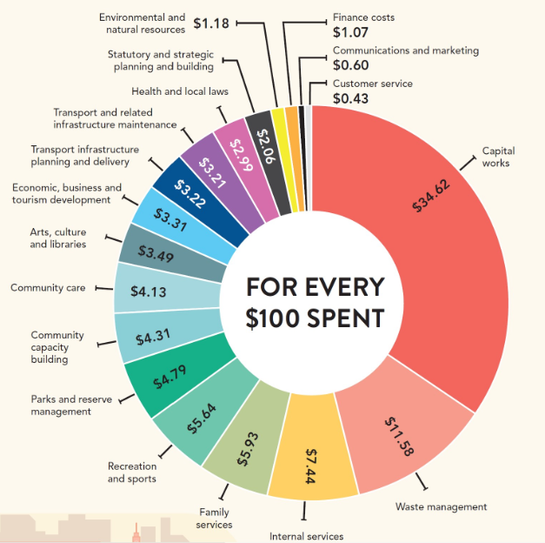
To deliver our diverse range of community and business services, we collect rates and charges from all property owners in the municipality. Here’s a breakdown showing how every $100 was spent in the 2023−24 budget:

FIGURE 17: Breakdown of 2023−24 budget
FIGURE 17: Breakdown of 2023−24 budget

CHALLENGES IN 2023−24
The following are some of the key challenges, new and ongoing, that impacted our services in 2023−24:
- prioritising projects that generate the greatest value for our community as growing pressure on financial sustainability limits our ability to invest in new services and infrastructure and provide ongoing maintenance and upgrades
- continuing to innovate and explore efficiencies to enhance overall effectiveness, improve decision-making and better align with community needs
- continuing to address the significant ongoing challenges of climate change including increased risks of flooding, bushfires, and the impact of extreme weather events, which can impact the provision of services and infrastructure
- lobbying the state government around the make-up of Geelong’s legacy facilities following the cancellation of the Commonwealth Games to ensure outcomes address our region’s growing need for social and affordable housing, and sporting facilities
- reviewing the role of the City in the delivery of aged care services in response to the federal government’s aged care reforms
- progressing a roadmap for leveraging technology to enhance organisational efficiency, drive innovation, and achieve our desired business objectives
- managing the growing logistical and environmental challenges of waste and recycling, including planning to meet state government legislative requirements to introduce food organics and glass only collection by 2030 and 2027 respectively.

FUTURE OUTLOOK
Looking ahead, plans for 2024−25 include:
- commencing upgrades to the City’s existing waste facilities to enable the introduction of Food Organics Garden Organics (FOGO) and glass kerbside collection services
- delivering a $210.5 million capital works program focussing on new and upgraded sporting facilities, community centres, parks and reserves to cater for Greater Geelong’s growing population
- working on the Innovate Reconciliation Action Plan, the second stage of the City’s Reconciliation process
- planning for a new Resource Recovery Centre and Waste Recycling Hub in the region
- developing an Integrated Transport Strategy that will set the long-term direction for transport decision making across Greater Geelong
- engaging our community to inform the development of the new 2025−29 Council Plan
- commencing a two-year pilot of the Geelong Youth Hub, to support young people to connect with each other and youth services in a safe and inclusive environment
- continuing to implement the Sparrovale-Ngubitj yoorree Wetlands Master Plan which guides us in conserving the area, managing stormwater, and creating open space
- identifying opportunities to increase the visibility, social inclusion and health and wellbeing of the LGBTQIA+ communities
- continuing to advocate and form partnerships with stakeholders across business, industry, community and government at a local, regional, state, national and international level
- engaging with the state government on draft housing capacity targets to deliver more homes in Greater Geelong.

OUR COUNCIL AND ORGANISATION

Like all local governments, the City of Greater Geelong is made up of two interdependent parts – the Council and the organisation (the City). Collectively, we work together to serve our community.
The Council sets the strategic direction for the municipality and makes decisions on behalf of the community it has been elected to represent. The organisation oversees the day-to-day delivery of all services and functions, guided by the Council, state and federal legislation and various funding agreements.

OUR COUNCIL
Our Council provides leadership for the good governance of the municipality and the local community.
This means:
- considering the diverse needs of the local community in decision-making
- establishing strategic objectives and monitoring achievements
- managing resources in a responsible and accountable manner
- advocating local community needs to other communities and governments
- giving everyone the opportunity to participate in the democratic process and decision-making that shapes our community.

OUR COUNCILLORS
On 24 October 2020, our community elected its Council for a four-year term.
The councillors work together to set the strategic direction for the municipality, which influences policy, service standards and performance across the organisation.
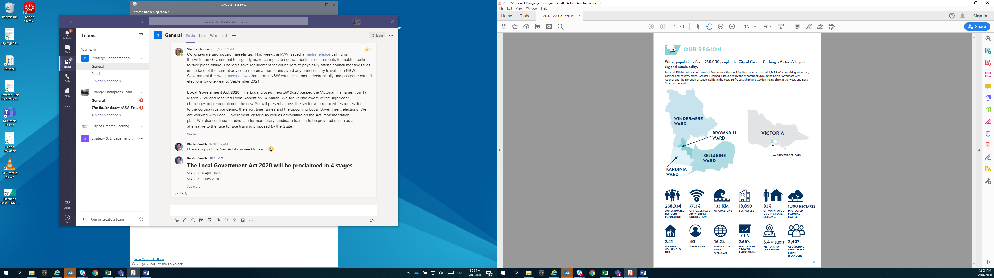
The municipality is represented by 11 elected councillors divided into four, multiple councillor wards (see Figure 18):
- Bellarine Ward: three councillors
- Brownbill Ward: three councillors
- Kardinia Ward: three councillors
- Windermere Ward: two councillors.

FIGURE 18: City of Greater Geelong wards

In 2023−24, Council included the following elected representatives. Cr Elise Wilkinson was elected as Councillor for the Bellarine Ward on 1 September 2023 as a result of the extraordinary vacancy created by the resignation of Cr Stephanie Asher on 29 July 2023:

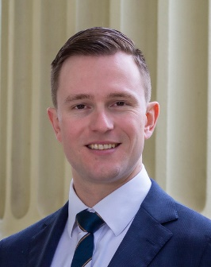 | 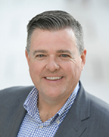 |  | 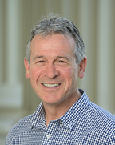
Cr Trent Sullivan  Mayor  Bellarine Ward  Portfolios  - Aboriginal and Torres Strait Islander Partnerships (Chair)  - Commonwealth Games (Chair)  c | Cr Anthony Aitken  Deputy Mayor  Windermere Ward  Portfolios  - Strong Local Economy (Chair)  - Aboriginal and Torres Strait Islander Partnerships (Deputy Chair),  - High Performing Council (Chair),  - Commonwealth Games (Deputy Chair) | Cr Melissa Cadwell  Brownbill Ward  Portfolios  - Creativity and Culture (Chair)  - City Planning and Heritage (Deputy Chair) | Cr Bruce Harwood  Kardinia Ward  Portfolios  - High Performing Council (Chair)
 | 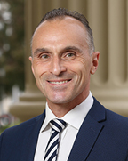 | 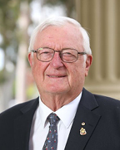 | 
Cr Sarah Hathway  Windermere Ward  Portfolios  - Inclusion and Care (Chair)  - Multicultural Geelong (Deputy Chair) | Cr Eddy Kontelj  Brownbill Ward  Portfolios  - Active Spaces (Chair),  - City Transport (Deputy Chair) | Cr Jim Manson  Bellarine Ward  Portfolios  - City Planning and Heritage (Chair)  - Strong Local Economy (Deputy Chair) | Cr Belinda Moloney  Kardinia Ward  Portfolios  - Multicultural Geelong (Chair)  - Inclusion and Care (Deputy Chair)
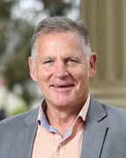 | 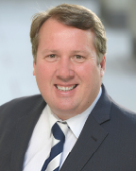 | 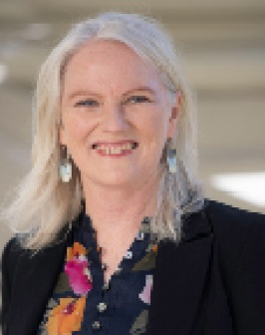
Cr Peter Murrihy  Brownbill Ward  Portfolios  - Environment and Circular Economy (Chair),  - Creativity and Culture (Deputy Chair) | Cr Ron Nelson  Kardinia Ward  Portfolios  - City Transport (Chair),  - Veterans Affairs (Deputy Chair) | Cr Elise Wilkinson  Bellarine Ward  Portfolios  - Veterans Affairs (Chair)  - Active Spaces (Deputy Chair)  - Environment and Circular Economy (Deputy Chair)

OUR ORGANISATION
We are an inclusive and flexible organisation and one of the largest employers in the region. We are responsible for:
- providing support and professional expertise to assist Council in developing policies and making decisions
- engaging with the local community and significant stakeholders to make sure Council decisions are in line with community expectations and needs
- delivering services and programs that benefit the whole community, such as waste management and roads
- delivering services and programs for specific communities, such as maternal child health and youth services
- enforcing legislation that has a local community impact, such as food safety and planning legislation
- building and maintaining infrastructure, such as local roads and community hubs
- protecting our natural environment, while supporting sustainable development
- supporting economic development that will benefit the whole community
- helping our community to plan for, and recover from, natural disasters and other emergencies.
More information about council services is included in the section on Our Performance.
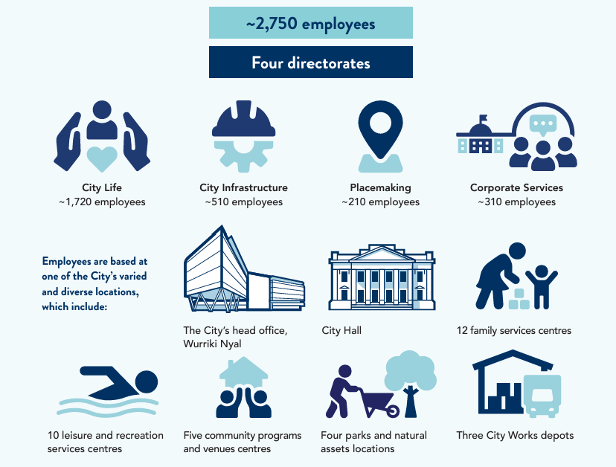
FIGURE 19: Employee location breakdown

CHANGES TO OUR ORGANISATION IN 2023−24
Following the appointment of new Chief Executive Officer Ali Wastie in August 2023, a functional alignment and validation process took place resulting in a new organisation structure. The new structure reduced the number of directorates from five to four, directly aligning with the things we need to be focused on so that we can become known as the highest performing and best local government in the country:
- Placemaking - facilitating design, investment in and delivery of extraordinary places
- City Life - providing quality and value-for-money services to the community
- City Infrastructure - maximising the value of our assets, balancing quality and experience within our financial capacity
- Corporate Services - becoming a high-performing organisation and governing ourselves with excellence.
While these changes resulted in savings without any redundancies in banded positions, several reporting line and team changes took place to get the right teams working together in common ways.
The four new Executive Director positions were advertised in mid-October 2023 and the new team announced on 6 December 2023.

MUNICIPAL MONITORS
On 24 January 2023, the Minister for Local Government appointed Ms Prue Digby and Mr Peter Dorling as municipal monitors at Greater Geelong City Council to guide the recruitment of a new Chief Executive Officer and support the City’s transition back to good governance for a period of 12 months.
The appointment, made under Section 179(1) of the Local Government Act 2020, was in response to concerns raised with the Minister for Local Government by the Chief Municipal Inspector (CMI) about the Council’s recruitment and appointment process for its ongoing Chief Executive Officer (CEO).
The final report from Ms Digby and Mr Dorling, released in April 2024, noted that although the Council has made progress, work was still required to improve its governance policies, processes and practices.
In response to this advice, on 9 April, the Minister for Local Government appointed Mr Dorling and Mr Mark Davies as municipal monitors to provide continued support and work with the City’s CEO to ensure governance improvements are fully implemented and ensure stability at the Council during the election of a new mayor following the October 2024 elections. The appointment is to 31 December 2024.

OUR LEADERSHIP TEAM
We are led by the Chief Executive Officer, who operates under the delegation of the elected Council and is responsible for our overall management and performance.
Our Executive Leadership Team, consisting of four Executive Directors and the Chief Executive Officer, are responsible for implementing council decisions and delivering sustainable and effective services, activities and infrastructure to the community.

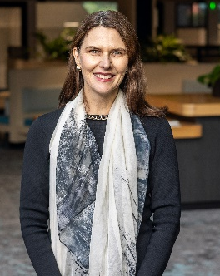 | 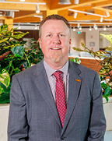 |  | 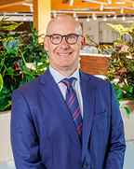 | 
Ali Wastie  Chief Executive Officer  Commenced 28 August 2023 | Anthony Basford  City Life  Commenced 19 February 2024 | Tennille Bradley  Placemaking  Commenced 22 January 2024 | Troy Edwards  Corporate Services  Commenced 22 January 2024 | James Stirton  City Infrastructure  Commenced 22 January 2024
FIGURE 20: Our leadership team as of 30 June 20244F

OUR ORGANISATIONAL STRUCTURE
Our organisation is structured around four directorates that work together to deliver a range of services, activities and infrastructure.
FIGURE 21: Our organisational structure as of 30 June 2024

OUR PEOPLE
We are proud to be an inclusive and flexible organisation that is one of the largest employers in the region.
We currently employ a total of 2,757 people, equivalent to 1,786.9 full-time employees0F5F
Our turnover6F in 2023–24 was 14.5 per cent, down from 16.9 per cent the previous year.

TABLE 2: Total full-time equivalent employees by directorate, employment condition and gender in 2023–24
EMPLOYEE TYPE – GENDER | Chief Executive | City Infrastructure | City Life | Corporate Services | Placemaking
Full Time – W | 2 | 82.5 | 266.8 | 137.2 | 97
Full Time – M | 0 | 400.6 | 94.5 | 85 | 65.8
Full Time – X | 0 | 0 | 0 | 0 | 0
Part Time – W | 0 | 7.1 | 301.1 | 43.8 | 22
Part Time – M | 0 | 1.7 | 41.2 | 3.2 | 1.2
Part Time – X | 0 | 0 | 0 | 0 | 0
Casual – W | 0 | 0.6 | 82 | 9.1 | 0.4
Casual – M | 0 | 1.9 | 38.8 | 0 | 0.6
Casual – X | 0 | 0 | 0 | 0 | 0
Total7F | 2.0 | 494.4 | 824.4 | 278.3 | 187.0
Legend: W = Women, M = Men, X = persons of self-described gender

TABLE 3: Total headcount of employees by employment classification and gender in 2023−24
EMPLOYMENT CLASSIFICATION | WOMEN | MEN | PERSONS OF SELF-DESCRIBED GENDER | TOTAL
Band 1 | 102 | 79 | 1 | 182
Band 2 | 198 | 46 |  | 244
Band 3 | 347 | 326 | 3 | 676
Band 4 | 473 | 101 | 1 | 575
Band 5 | 221 | 98 |  | 319
Band 6 | 178 | 96 |  | 274
Band 7 | 114 | 130 |  | 244
Band 8 | 62 | 51 |  | 113
MCH Nurse | 59 |  |  | 59
Senior Officer | 40 | 31 |  | 71
Total | 1,794 | 958 | 5 | 2,757

OUR VOLUNTEERS
Volunteering is integral to our operations and makes an invaluable contribution to our organisation and the community that we serve. The City currently has hundreds of volunteers working in a wide range of areas, including at the National Wool Museum, L2P mentoring program, Tourism Greater Geelong and the Bellarine, Potato Shed, Family Services, Study Geelong and Grovedale Neighbourhood House. We thank the many volunteers who provide useful – and often vital – services to people from all walks of life.
This year, the City developed a Volunteer Framework based on the National Standards for Volunteering, to further strengthen our volunteer programs across the City and implemented an online training module to support the development of our volunteers. We also held two volunteer events and delivered our first Volunteer Experience Survey with highly favourable results.

EQUITY, INCLUSION AND DIVERSITY
We believe that our people are our greatest asset. We are committed to creating an inclusive and fair organisation that encourages our employees to do their best work.
During 2023−24 we progressed key projects to support creating a safe, fair and inclusive workplace for our employees including:
- submitting our Gender Equality Progress Report to the Commission for Gender Equality in the Public Sector in February 2024. The report demonstrated improvement against key indicators including gender composition at the City, recruitment and promotion, flexible working arrangements and parental leave. It also identified key areas for improvement including how we respond to reports of sexual harassment and continually improve our gender pay gap
- implementing our Gender Equality Action Plan which is due for renewal in 2026
- integrating Gender+ Impact Assessments (GIAs) into our business planning processes, with 13 GIAs completed in 2023−24
- partnering with The Equality Institute, a global agency working to end violence against women and girls, to provide training on gender equality and the importance of GIA+ for our Mayor and councillors
- implementing a First Nations traineeship program, a commitment of our Reflect Reconciliation Action Plan, which provides four trainees the opportunity to gain qualifications and experience working at the City
- increasing our commitment to providing First Nations cultural education for City employees including monthly Cultural Education Walk and Talk tours of central Geelong by Wadawurrung Traditional Owners Aboriginal Corporation
Other plans we are using to further improve diversity and inclusion in our workplace include:
- the Access and Inclusion Action Plan 2018−2023 which outlines our actions to address barriers for people with disability, as community members, service users and employees. The plan contains a number of actions relating to employment such as the review and development of policies, procedures and checklist to establish accessible recruitment processes. Work is currently underway on a draft Disability Access and Inclusion Plan 2024−28 which will be considered by Council in late 2024
- our Inclusion and Diversity Roadmap 2021 which outlines priorities for leaders, employees and the policies, practices and processes in our organisation to improve inclusion for all current and future employees. In 2024−25, we plan to update the roadmap to establish a strategically aligned inclusion and diversity program of work and associated governance structure
- the Social Equity Framework 2022‒25 which guides the way we engage with the communities of Greater Geelong to hear their voices, recognising that we need to create opportunities for participation, support community members to have a say in decisions that affect them, and listen to community needs, to progress social equity. In 2024−25, we plan to update the framework to establish a strategically aligned inclusion and diversity program of work and associated governance structure
- our Reflect Reconciliation Action Plan which outlines how we are going to change the way we do things to better support reconciliation, both within our organisation and with the community. In 2024−25, we expect to begin work on the Innovate Reconciliation Action Plan, the second stage of the City’s Reconciliation process.

OCCUPATIONAL HEALTH AND SAFETY
Health and safety matters to us. Our safety management system, CitySafe, continues to be the source of information on health, safety and wellbeing matters. During the reporting period, the City experienced an increase in all reported categories. A strong focus remains on completing incident investigations to determine incident root cause to ensure that appropriate control measures are implemented.

TABLE 4: Occupational health and safety performance in 2023–24
 | LOST TIME INJURY FREQUENCY RATE |  | TOTAL RECORDABLE INJURY FREQUENCY RATE |  | HIGH POTENTIAL INCIDENT FREQUENCY RATE
2021–22 Results | 26.5 |  | 34.9 |  | 0.0
2022–23 Results | 22.3 |  | 29.4 |  | 2.23
2023–24 Results | 25.9 |  | 35.4 |  | 2.9
2023–24 Variation | +16.14% | X | +20.41% | X | +30.04% | X

Employee safety
In March 2024, a number of changes came into effect to modernise Victoria's WorkCover scheme. These changes were made under the Workplace Injury Rehabilitation and Compensation Act amendment. We continued to strengthen our workers compensation and injury management processes with the update of the Injury Management procedure to better support our workers who sustain an injury in the workplace. The release of the procedure was supported by face-to-face and online training sessions with people leaders across the City.
In response to the pending release of WorkSafe Victoria's Psychological Safety Regulations a working group, which was established during 2022−23, continued to meet. The development of a framework and supporting action plan for preventing and managing psychosocial hazards is underway. The framework and action plan will aim to increase knowledge and capability across the City to recognise areas of high risk, as well as develop strategies to prevent the occurrence of psychological injuries.

Health and Wellbeing
Our Health and Wellbeing team delivered a wide range of health and wellbeing initiatives including lunchtime yoga, conversation starter shirts, mental health training, our Employee Assistance Program services and presentations.
The City was recognised for our efforts to keep our community and employees active. We received a silver prize for Active Community Connections at the Active Geelong Awards in 2023, highlighting our initiatives that promote physical activity.
Other highlights included:
- introducing an online HealthHub comprising a collection of resources to further support the wellbeing of our employees
- refreshing the Wellbeing Support Officer (WSO) program, significantly increasing the number of WSO's available across the City able to provide wellbeing support to our workers. The WSO's underwent training to provide them with a range of skills to assist them in this role.

HOW WE PLAN
We have developed an integrated, long-term and transparent approach to planning, monitoring and performance reporting, aligned with our clever and creative vision.
The Local Government Act 2020 requires all councils to prepare the following documents:
- Community Vision
- Council Plan
- Financial Plan
- Asset Plan
- Budget
- Revenue and Rating Plan
- Annual Report
- Workforce Plan.
Our Integrated Strategic Planning and Reporting Framework (represented in Figure 22) demonstrates the relationship between these key planning and reporting documents. The framework helps us set goals, make decisions, prioritise our workload, allocate resources, monitor progress and adapt to changing circumstances that might challenge our progress.
In 2021, we incorporated our Municipal Public Health and Wellbeing Plan into our Council Plan to create Our Community Plan 2021‒25.
In 2022−23, we introduced an internal organisation strategy and business planning cycle to guide our budget and business planning. This process will continue to develop and enhance our strategic decision-making around priorities, performance and resource allocation.

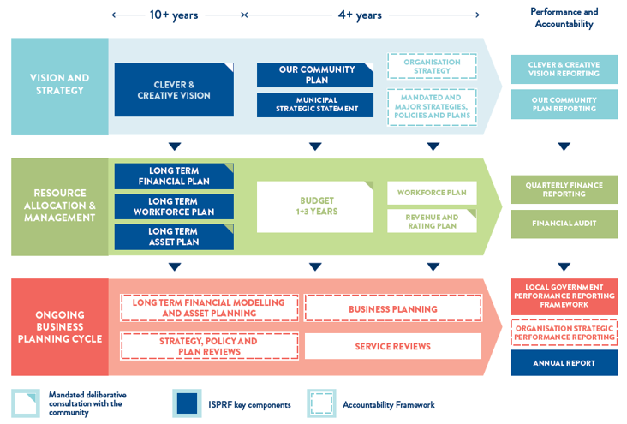
FIGURE 22: Our Integrated Strategic Planning and Reporting Framework (ISPRF)

OUR PERFORMANCE

Our Community Plan 2021‒25 outlines how we are working towards the 30-year community vision to make Greater Geelong a clever and creative city-region.
The plan tells our community what councillors are aiming to achieve during their four-year terms. It guides us on how we allocate resources, so we can deliver infrastructure, services and programs to our community to ensure the social, economic and environmental sustainability of our region.
The four strategic directions we have chosen to guide us are:
- healthy, caring and inclusive community
- sustainable growth and environment
- strong local economy
- high-performing Council and organisation.

As well as the strategic directions, the plan also outlines:
- desired outcomes ‒ the future state we’re aiming for in four years
- four-year priorities ‒ the priorities we’ll focus on to help achieve our desired outcomes
- indicators ‒ how we will monitor our progress.
Our Community Plan 2021‒25 is supported by an annual action plan and budget, highlighting the projects, initiatives and programs that will take place within the financial year to address our four-year priorities.
The following provides a high-level overview of our performance in delivering the 2023–24 annual action plan, and how we are tracking against the indicators. It also highlights other achievements supporting our strategic priorities as well as results for the prescribed service performance indicators as set out in the Local Government Performance Reporting Framework (LGPRF).
For more detailed information on the progress of the annual action plan, refer to the quarterly reports on our website (www.geelongaustralia.com.au/ourcommunityplan).

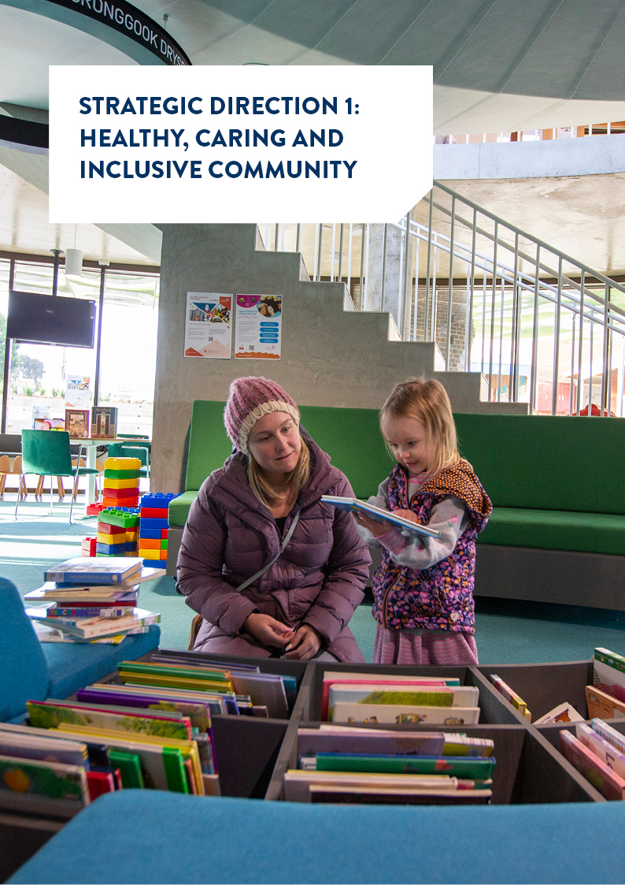
STRATEGIC DIRECTION 1: HEALTHY, CARING AND INCLUSIVE COMMUNITY

  186 learner drivers in the TAC L2P program |   49,162 meals delivered to vulnerable residents
  1,600 people provided with home maintenance and home modification services |   200+ objects added to our art and heritage collection
  12,268 participants in youth training, programs, and activities |   452 families accessed our feeding support service
  58,598 visitations to the National Wool Museum |   8,716 Webstar's Swim School members
  104 culturally and linguistically diverse families supported to engage in early years services through the CALD Outreach program | 3,574 people 65+ years supported to live at home
  46,740 dogs and cats registered |   3,016 fire hazard inspections undertaken during the fire season
  95,355 hours of early  childhood education and care delivered |   1,566 parents attending our Regional Parenting Service
  1,000+ new citizens  welcomed at Citizenship Ceremonies in 2023 |   115 performances held at the Bellarine Arts Centre – Potato Shed

LINKS TO THE CLEVER AND CREATIVE VISION
 | 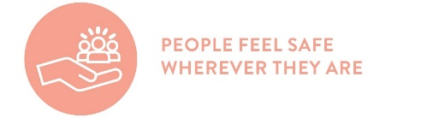 | 
Desired outcomes
- Our community feels welcome, safe and connected
- Our community has equitable access to health and social services, information and infrastructure
- Healthy behaviours and environments are promoted, supported and accessible
Four-year priorities
1.1 Help our community, recreation groups and volunteers to prosper and grow
1.2 Deliver health and community initiatives that are culturally sensitive and accessible across all life stages
1.3 Foster and embrace community connectedness
1.4 Demonstrate and promote gender equity practices
1.5 Foster an inclusive community culture
1.6 Facilitate social and affordable housing in Greater Geelong
1.7 Provide access to places, spaces and services where, and when, people need them the most
1.8 Strengthen relationships and partnerships with the Aboriginal and Torres Strait Islander communities in Greater Geelong
1.9 Support our cultural and creative life, history and heritage
1.10 Provide facilities that foster and facilitate positive health and wellbeing outcomes
1.11 Respond to the findings of the Royal Commissions into aged care and mental health
Supports health and wellbeing

PROGRESS REPORT
Indicators
Municipal Indicators |  | RESULT at 30 June 2024 | Progress comments
Proportion of adults experiencing high / very high psychological distress  Source: City of Greater Geelong Preventative Health Survey | 20% (2021)  10.3% (2017) |  | There was an increase in the proportion of our adult community experiencing high / very high psychological distress since 2017. The next survey is due to be conducted in 2024‒25.
Proportion of adults meeting the physical activity guidelines  Source: City of Greater Geelong Preventative Health Survey |  | 67% (2021)  41% (2017) | More of our adult community is reporting that they are sufficiently physically active than in 2017. The next survey is due to be conducted in 2024‒25.
Proportion of adults consuming the recommended number of serves of fruit and vegetables  Source: City of Greater Geelong Preventative Health Survey |  | Fruit  46% (2021)  53% (2017)  Vegetables  15% (2021)  10% (2017) | Since 2017, there was an increase in the proportion of our adult community consuming the recommended serves of vegetables and a decrease in the proportion consuming the recommended serves of fruit. The next survey is due to be conducted in 2024‒25.
Family violence incident rate per 100,000 population for Greater Geelong  Source: Crime Statistics Agency website www.crimestatistics.vic.gov.au |  | 1,764.7 (June 2024)  1,720.2 (June 2023)  1,586.8 (June 2022)  1,592.7 (June 2021) | For the year ending June 2024, the family incident rate for Greater Geelong was higher compared to the Victorian rate (1,418.1).
Community perception of safety in the area where they live  Source: City of Greater Geelong Preventative Health Survey |  | 61% (2021)  54% (2017) | The result comprised of 67% of males rated that they always feel safe in the area where they live compared to 56% of females. The next survey is due to be conducted in 2024‒25.
Level of agreement that multiculturalism makes life better (definitely or sometimes)  Source: City of Greater Geelong Preventative Health Survey |  | 66% (2021) | This result comprised 48% definitely and 18% sometimes. The next survey is due to be conducted in 2024‒25.
Proportion of community concerned about effects of climate change on health (very or quite concerned)  Source: City of Greater Geelong Preventative Health Survey |  | 51% (2021) | This result comprised 28% very concerned and 23% quite concerned. The next survey is due to be conducted in 2024‒25.
Proportion of adults that are a member of an organised group (sports, religious, school, professional, community or action group)  Source: City of Greater Geelong Preventative Health Survey |  | 56% (2021) | This result consisted of 28% members of a sports group. The next survey is due to be conducted in 2024‒25.

City of Greater Geelong Indicators |  | RESULT at 30 June 2024 | Progress comments
Community satisfaction with support services  Source: Local Government Community Satisfaction Survey | Family  60 (2024) 62 (2023)  64 (2022)  Elderly  57 (2024) 60 (2023)  63 (2022)  Disadvantaged  53 (2024) 58 (2023)  61 (2022) |  | While no significant change from 2023, Family Support services were rated significantly lower than the statewide (63) and comparable to the Regional Centres average (62).  While no significant change from 2023, Elderly Support services were rated significantly lower than both the statewide (63) and the Regional Centres average (62).  Disadvantaged Support services were rated significantly lower compared with the previous year. The rating was also lower than the statewide average (58) but comparable to the Regional Centres average (54).
Community satisfaction with recreational facilities  Source: Local Government Community Satisfaction Survey | 66 (2024)  69 (2023)  72 (2022) |  | There was no significant change in satisfaction compared with the previous year. Our performance continued to be well regarded by the community and was among our top three rated services. Our result was comparable to the statewide (68), however lower than the Regional Centres average (69).
Level of agreement that council infrastructure is equitable (fair access to facilities that are needed across the municipality including healthy, safe and inclusive places and spaces)  Source: Local Government Community Satisfaction Survey | 50% (2024)  44% (2023)  55% (2022) |  | There was an increase in the proportion of people who agreed or strongly agreed that council infrastructure is equitable. Comparison to statewide and Regional Centres average is unavailable as this is a tailored question for the council.
Level of agreement that council infrastructure is accessible (for all abilities, affordable and easy for people to get to)  Source: Local Government Community Satisfaction Survey | 59% (2024)  56% (2023)  63% (2022) |  | There was a slight increase in the proportion of people who agreed or strongly agreed that council infrastructure is accessible. Comparison to statewide and Regional Centres average is unavailable as this is a tailored question for the council.
Number of key community infrastructure projects completed  Source: City of Greater Geelong | 95% (2024)  89.2% (2023)  86.5% (2022)  84% (2021) |  | We have delivered 35 of the 37 key community infrastructure projects identified for delivery by 2022.
Community satisfaction with community and cultural activities  Source: Local Government Community Satisfaction Survey | 64 (2024)  66 (2023)  64 (2022)  65 (2021) |  | There was no significant change in satisfaction compared with the previous year. Our result was comparable to both statewide and Regional Centres averages (66 and 65 respectively).
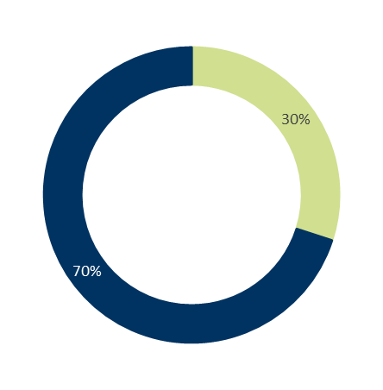
Annual Action Plan 2023‒24
We committed to 30 actions, which demonstrate how we are addressing our four-year priorities under Healthy, Caring and inclusive community.
At the end of June 2024:
- 70% (21) were ‘complete’
- 30% (nine) were ‘ongoing’

Progress of annual actions supporting delivery of Our Community Plan 2021–25

Major Budget Initiatives
Budget initiative | ACTION 2023−24 | STATUS | COMMENT
Armstrong Creek Town Centre Library & Learning Hub Design | Complete the construction phase for the Biyal-a Armstrong Creek Library | Complete | Construction of the new Biyal-a Armstrong Creek Library was completed. The facility includes library services, accessible contemporary amenities, a children's story time area, multipurpose spaces, outdoor terraces and creative places for programming. The Geelong Regional Library Corporation are currently establishing the library service in the building.
Drysdale Sporting Precinct Master Plan Implementation – Stage 2 | Implement Stage 2 of the Drysdale Sporting Precinct Master Plan | Ongoing | A Cultural Heritage Management Plan (CHPM) assessment of the activity area was completed. A significant number of artefacts discovered have been documented and registered. The City met with Traditional owners on approval of the CHMP. Discussions will continue on construction methodology to be incorporated into the CHMP. We will continue to progress this action in 2024−25.
Lara Recreation Reserve Master Plan Stage 2 | Implement Stage 2 of the Lara Recreation Reserve Master Plan | Complete | A new accessible, multi-sport and gender-neutral sports pavilion was completed with the opening scheduled for August 2024. The baseball field works are 95 per cent complete with fencing scheduled to be completed in July 2024. These enhancements aim to create a comprehensive recreational hub meeting the diverse needs of the Lara community.
Norlane Aquatic Centre and Community Hub | Activate the Norlane Aquatic and Community Hub with a focus on health and wellbeing, cultural engagement and community connection for people in the local community | Complete | The Norlane ARC (Aquatic Recreation Centre), formerly known as Northern Aquatic and Community Hub, was officially opened by the Deputy Prime Minister and councillors on Friday 9 February 2024, followed by a full public opening on 19 February and a community open day on Sunday 3 March. A full suite of programs is on offer to help the local community improve their physical and mental health, create social connection and experience better overall wellbeing.
Rippleside Inclusive Playspace | Commence construction of all abilities playspace at Rippleside Park | Ongoing | A tender for the construction of the playspace is underway with evaluation and approvals to be completed by August 2024. Construction is forecast to commence in September 2024 with completion proposed mid-2025. Once completed, the play space will be inclusive for kids of all ages and abilities, incorporating multi-sensory and nature play elements, with opportunities for physical, creative, social and passive play. We will continue to progress this action in 2024−25.

Other achievements in 2023‒24 included:
- Negotiating with the state government to ensure $250 million in redirected Commonwealth Games infrastructure funding is aligned with the City’s strategic planning priorities and best legacy outcomes are delivered for the community.
- Hosting the Meet the Women Leaders community forums in partnership with Women in Local Democracy, featuring local female speakers with diverse and rich experience in government, community development and business promoting gender equity and inclusion.
- Transforming City Hall throughout National Reconciliation Week with projections dedicated to Kurnai/Wotjobaluk artist, Cultural Educator and musician Jurrawaa Stanley.
- Collaborating with the Wadawarrung Traditional Owners Aboriginal Corporation, Wathaurong Aboriginal Co-operative and NBN Co. to showcase artwork by local First Nations people on NBN boxes at Marshall Reserve, Marshall.
- Promoting the importance of movement to maintain good physical and mental health and highlighting various healthy initiatives available in Geelong as part of the 2024 Active Geelong Showcase, held in June at the WorkSafe Victoria head office in Geelong.
- Providing use of the City’s Marveloo, a portable accessible toilet and adult change facility, at a Give Where You Live fundraiser, Beyond the Valley Festival and Pitch Festival.
- Completing a $1.95 million upgrade of the Bell Park Sports Club, including modern new female friendly change facilities, jointly funded by the City ($1.7 million) and the state government ($250,000).
- Upgrading cricket practice facilities at Grinter Reserve including brand new turf and synthetic practice nets and replacing the reserve’s existing outdated facilities.
- Partnering with Market Square’s management to open the 24-hour Yarra Street Window Gallery between Malop and Little Malop Streets which aims to attract viewers who might not typically visit traditional galleries.
- Delivering sporting facility upgrades in Barwon Heads, including court re-surfacing and the installation of LED sports lighting at the Barwon Heads Tennis Club and an upgrade to the pavilion at the Barwon Heads Bowling Club.
- Delivering improved amenities at the St Leonards Foreshore including a new open-sided shelter with accessible BBQ, accessible picnic seating, two cold water outdoor showers, two open air changerooms, new concrete path and landscaping and works.
- Awarding grants totalling $89,332 to support First Nations Cultural Heritage projects including planning for a First Nations Garden, the ‘Journey on Wadawurrung Country’ (JOWC) project and the Wathaurong Dance Group.
- Upgrading the intersection at Marshalltown Road and Bailey Street in Grovedale with works including new footpaths, roundabout, tactiles, kerb and channel improvements, street lighting upgrades, and drainage improvements.
- Convening Geelong’s Youth Council Advisory Committee (Youth Council) who provided 12 pieces of advice to Council on matters of importance for young people.
- Delivering over 130 events and activities across 65 locations as part of the Christmas in Geelong program.
- Increasing onsite visitation and program participation at the National Wool Museum, up 41 per cent on the previous year.

Awards and recognition
- The Boronggook Drysdale Library was recognised by the Australian Institute of Architects’ 2024 Victorian Architecture Awards, receiving a Public Architecture Award for its distinctive design.
- The Leisurelink Aquatic and Recreation Centre was recognised for its commitment to water safety, claiming the prestigious ‘Swim and Survive Partner of the Year award’ at the Life Saving Victoria 2023 awards.
- The National Wool Museum was an honouree in 2022−23 Victorian Collections Cataloguing ‘Best in Show’ list which celebrates excellence in cataloguing, specifically related to an ongoing commitment to catalogue improvement, accessibility and thoroughness.
- The National Wool Museum team made the shortlist for two 2023 Victorian Museums and Galleries Awards; Small project of the year: Your Museum, Geelong’s Museum and First Nations Projects of the Year: Wadawurrung Dja: Awakening Country – the Art of Deanne Gilson.
- Our teams at Splashdown, Waterworld, Leisurelink and the Bellarine Aquatic and Sports Centre were accredited with Life Saving Victoria (LSV)’s Platinum Pool award in recognition of our facilities providing outstanding levels of safety. Our teams had to undertake a rigorous series of assessments to achieve this status, ensuring LSVs criteria was met.
- We celebrated award winner Georgia Gordon, Aquatic Manager/2IC at the Norlane ARC (Aquatic Recreation Centre) and Lara Swimming Pool who took home the Emerging Leader Award at the Aquatics and Recreation Victoria (ARV) Industry Awards.

Services
The following statement provides information in relation to the services funded in the 2023−24 budget and the persons or sections of the community who are provided the service.

SERVICE AREA | DESCRIPTION OF SERVICES PROVIDED | Actual  Budget  Variance  $000
Community Strengthening Services | Creating opportunities to improve social and health equity, community connection and participation and access to programs, services and facilities, by working closely with our community and community groups, sporting clubs and volunteers. | 3,776  6,110  2,334
Community & Cultural programs | Arts, culture and heritage are integral to Geelong’s identity and the City’s sustainability. Our service contributes to the quality of life of all residents by celebrating diversity, improving cross cultural understanding and building social cohesion. | 18,941  18,685  (256)
Family Services | Responsible for planning, developing and direct service delivery of services to families with young children including maternal and child health services, contract management of the public immunisation service, early childhood education and care services, supported playgroups and parenting programs. | 7,530  6,761  (769)
Leisure & Recreation Services | Provides facilities and centres that offer a diverse range of opportunities to the community for sporting, recreational, educational, wellness and social opportunities. | 9,304  10,896  1,592
Health & Local Laws | Responsible for implementing protection and prevention programs that provide for a healthy, safe and harmonious environment for our community. | (1,873)  (2,488)  (615)
Aged Care Services | Provides a range of home care services to older people which meet and support both client’s and their carer’s needs, based on referral information received, assist older people to retain or regain skills that enable them to continue to live independently in their community, align provision of these services with program funding and guidelines. | (1,109)  678  1,787

Local Government Performance Reporting Indicators
To help measure performance across all Victorian councils in a transparent and accountable way, we report to Local Government Victoria on the following mandatory indicators:
SERVICE/INDICATOR/MEASURE | RESULTS |  |  |  | COMMENTS
SERVICE/INDICATOR/MEASURE | 2021 | 2022 | 2023 | 2024 | COMMENTS
Animal Management
Timeliness  AM1 Time taken to action animal management requests  [Number of days between receipt and first response action for all animal management requests / Number of animal management requests] | 1.00 | 1.21 | 1.26 | 1.42 | The minor increase in time taken this year compared to last year, was due to resource challenges and the complexity of nuisance investigations which make up 30% of the total requests. Of the 6,493 requests that came into the animal management team in this financial year, 90% were actioned within 2 days (48 hours).
Service standard  AM2 Animals reclaimed  [Number of animals reclaimed / Number of animals collected] x100 | 25.49% | 24.07% | 24.75% | 44.43% | Improvements in data reporting have resulted in a noticeable increase in the percentage of animals reclaimed. Previously the denominator reported all animals received at our pound from both council officers and from members of the public. In 2023−24, the denominator reported only animals received at the pound by council officers. Before the animals are impounded, we make every effort to reunite registered cats and dogs with their owners.
Service standard  AM5 Animals rehomed  [Number of unclaimed collected animals rehomed / Number of unclaimed collected animals] x100 | 61.27% | 62.37% | 48.05% | 57.42% | Improvements in data reporting have resulted in a noticeable increase in the percentage of animals rehomed. Previously the denominator reported all animals received at our pound from both council officers and from members of the public. In 2023−24, the denominator reported only animals received at the pound by council officers.
Service cost  AM6 Cost of animal management service per population  [Direct cost of the animal management service / Population] | $8.75 | $9.35 | $14.05 | $14.37 | The cost to deliver animal management services was similar to last year.
Health and safety  AM7 Animal management prosecutions  [Number of successful animal management prosecutions / Total number of animal management prosecutions] x100 | 100.00% | 100.00% | 100.00% | 100.00% | We continued to successfully prosecute all matters brought before the court, with 15 successful animal management prosecutions in 2023−24.
Aquatic Facilities
Service standard  AF2 Health inspections of aquatic facilities  [Number of authorised officer inspections of council aquatic facilities / Number of council aquatic facilities] | 1.00 | 1.00 | 1.00 | 1.00 | Annual health inspections continued to be conducted across all council leisure facilities in 2023−24.
Utilisation  AF6 Utilisation of aquatic facilities  [Number of visits to aquatic facilities / Population] | 3.32 | 4.73 | 7.21 | 7.01 | Participation at our leisure venues continued to be strong in 2023−24. The slight decrease in result was most likely due to a service disruption where Waterworld was permanently closed six months before the new Norlane ARC (Aquatic Recreation Centre) was opened.
Service cost  AF7 Cost of aquatic facilities  [Direct cost of the aquatic facilities less income received / Number of visits to aquatic facilities] | $7.53 | $5.83 | $3.31 | $3.00 | The continued decline in the direct cost of leisure facilities is attributed to efficiency initiatives, particularly moving membership management software to allow member self service activity, as well as a strong focus on internal process improvement and program growth.
Food Safety
Timeliness  FS1 Time taken to action food complaints  [Number of days between receipt and first response action for all food complaints / Number of food complaints] | 1.43 | 1.46 | 1.45 | 1.51 | A shortfall in permanent environmental health employees impacted the take time to respond to food complaints. Despite this, response times were only slightly higher than in previous years.
Service standard  FS2 Food safety assessments  [Number of registered class 1 food premises and class 2 food premises that receive an annual food safety assessment in accordance with the Food Act (Vic) 1984 / Number of registered class 1 food premises and class 2 food premises that require an annual food safety assessment in accordance with the Food Act (Vic) 1984] x100 | 35.84% | 52.17% | 59.91% | 71.02% | Despite employee turnover, the percentage of food safety assessments increased significantly from prior years due to prioritisation of assessments.
Service cost  FS3 Cost of food safety service  [Direct cost of the food safety service / Number of food premises registered or notified in accordance with the Food Act (Vic) 1984] | $469.45 | $522.07 | $502.09 | $508.47 | Food safety service costs were similar to previous years.
Food Safety
Health and safety  FS4 Critical and major non-compliance outcome notifications  [Number of critical non-compliance outcome notifications and major non-compliance notifications about a food premises followed up / Number of critical non-compliance outcome notifications and major non-compliance notifications about a food premises] x100 | 95.45% | 100% | 90.76% | 93.46% | Employee turnover and difficulties recruiting qualified officers again impeded our ability to meet program targets. We will continue to provide a prioritised response to critical and major non-compliance notifications.
Service standard  FS5 Food safety samples  [Number of food samples obtained / Required number of food samples] x100 |  |  | New indicator for 2024 | 72.11% | Difficulties recruiting qualified officers impacted our ability to meet targets.
Libraries
Resource standard  LB2 Recently purchased library collection  [Number of library collection items purchased in the last 5 years / Number of library collection items] x100 | 63.31% | 66.02% | 69.09% | 66.44% | Regular collection purchasing took place in 2023−24. The slight decrease from 2022−23 can be attributed to the opening day collection from Leopold Library, ageing out of the five-year bracket. Opening day collection purchasing for the new Biyal-a Armstrong Creek is not included in 2023−24 result.
Service cost  LB5 Cost of library service per population  [Direct cost of the library service / Population] | $36.88 | $37.71 | $39.14 | $37.82 | Cost of library service per population remained steady in 2023−24.
Libraries
Utilisation  LB6 Library loans per population  [Number of collection item loans / Population] | New indicator for 2024 |  |  | 7.27 | Given this is a new indicator for 2023−24, there are no comparative results from previous years. Drysdale Library reported a marked increase in loans in 2023−24 following the move to the new Boronggook Drysdale Library.
Participation  LB7 Library membership  [The number of registered library members / Population] x100 | New indicator for 2024 |  |  | 28.60% | Given this is a new indicator for 2023−24, there are no comparative results from previous years. Drysdale and Leopold Libraries reported increases in membership in 2023−24 showing new members are utilising the two newest facilities in the council area.
Participation  LB8 Library visits per population  [Number of library visits / Population] | New indicator for 2024 |  |  | 3.79 | Given this is a new indicator for 2023−24, there are no comparative results from previous years. Drysdale Library reported a marked increase in visits in 2023−24 following the move to the new Boronggook Drysdale Library.
Utilisation  LB1 Physical library collection usage [Number of physical library collection item loans / Number of physical library collection items] | 3.52 | 4.38 | 4.57 | Retired in 2024 | As of 1 July 2023, this indicator was replaced by LB6 Library loans per population
Participation  LB4 Active library borrowers in the  Municipality  [The sum of the number of active library borrowers in the last 3 financial years / The sum of the population in the last 3 financial years] x100 | 15.70% | 13.98% | 13.41% | Retired in 2024 | As of 1 July 2023, this indicator was replaced by LB7 Library membership
Maternal and Child Health (MCH)
Service standard  MC2 Infant enrolments in the MCH service  [Number of infants enrolled in the MCH service / Number of birth notifications received] x100 | 101.01% | 100.86% | 99.15% | 100.96% | The total number of births dropped in line with national trends. While decreasing slightly, results were within expected results.
Service cost  MC3 Cost of the MCH service  [Cost of the MCH service / Hours worked by MCH nurses] | $80.66 | $80.73 | $80.46 | $88.51 | It has been some time since the cost of the MCH service has increased, despite salary increases. Additional costs will be offset by the recent increase in funding from the Department of Health to increase the length of consultations.
Participation  MC4 Participation in the MCH service  [Number of children who attend the MCH service at least once (in a year) / Number of children enrolled in the MCH service] x100 | 72.56% | 74.40% | 73.61% | 73.88% | There were 13,260 children enrolled in the City’s MCH service of which 9,796 attended at least once in the year. This participation rate, calculated across all key age checks, reflects the gradual reduction in participation in later visits which will require innovative approaches to increase the rate of 18 month, 2 year and 3.5 year checks.
Participation  MC5 Participation in the MCH service by Aboriginal children  [Number of Aboriginal children who attend the MCH service at least once (in the year) / Number of Aboriginal children enrolled in the MCH service] x100 | 77.47% | 72.02% | 71.62% | 75.29% | There were 216 children who identify as Aboriginal or Torres Strait Islander (ATSI) enrolled in the City’s MCH service, of which 163 attended at least once in the year. The higher rate of participation by ATSI families may be a result of efforts to provide culturally safe & inclusive practice.
Satisfaction  MC6 Participation in 4-week Key Age and Stage visit  [Number of 4-week key age and stage visits / Number of birth notifications received] x100 | 94.37% | 94.02% | 94.26% | 92.32% | Despite a slight reduction in this figure, participation remains within the expected range. It is unclear whether this is an actual reduction or due to data capture where a missed four-week visit can be rebooked but recorded as an additional visit rather than a 4 week visit due to the clinical software program used in MCH.

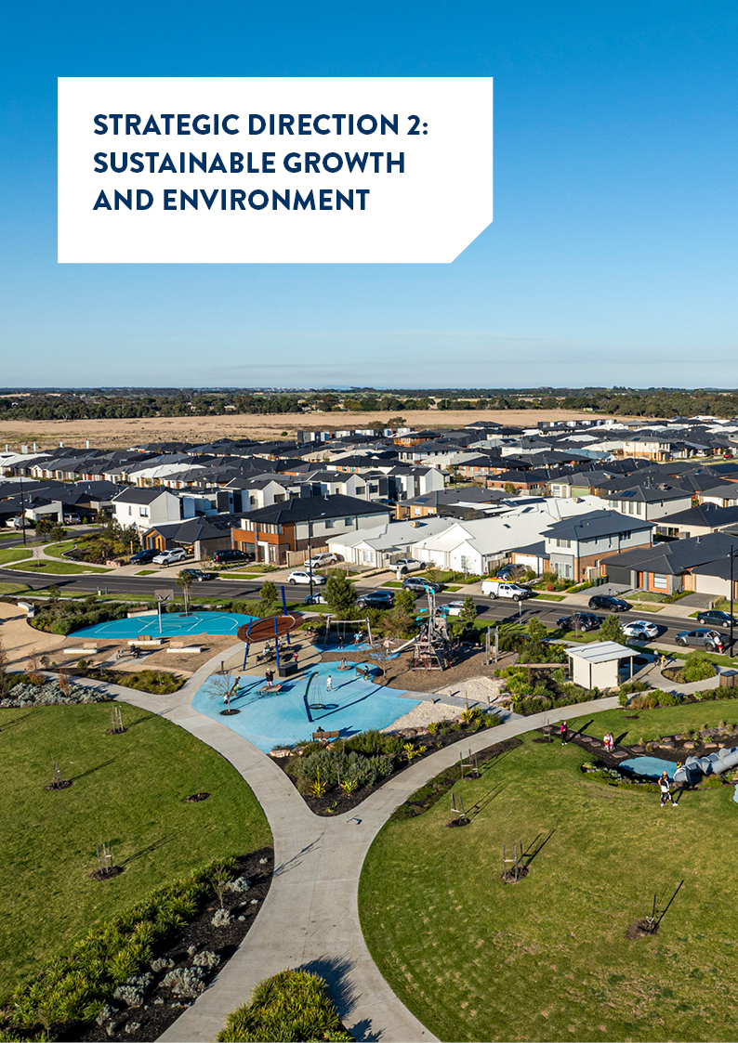
STRATEGIC DIRECTION 2: SUSTAINABLE GROWTH AND ENVIRONMENT

  10,633 mattress collection services provided |   3,243 requests for service responded to by the Parks team
  1,466 hectares of protected natural habitat managed and restored |   380 public play spaces managed
  45.5 kilometres of roads resurfaced (spray seal 24.2 km and asphalt 21.3 km) |   200,000 residential bins emptied weekly
  10 kilometres of new shared paths constructed |   $1,411 million worth of works permits issued
  12.9 kilometres of footpath replaced |   1,346 planning permit applications received
  196 tonnes of compost supplied to community gardens and not-for-profits |   628 roadside inspections and treatment for serrated tussock and woody weeds
  3,000 hectares of conservation area monitored as part of the Sparrovale Wetlands Reserve - Ngubitj yoorree |   22,489 tonnes recyclables collected
  20,000+ inspections on roads, signage, kerb and channel, storm water and furniture in the Geelong region | 5,000 requests to clear illegally dumped rubbished responded to

LINKS TO THE CLEVER AND CREATIVE VISION
 |  | 
Desired outcomes
- Delivering our vision for sustainable growth across the municipality
- A choice of housing and lifestyles to meet the diverse needs of our community
- Connected transport networks throughout that support liveability and prosperity
- Quality, vibrant public spaces
- Leading a reduction in community emissions and are increasing our resilience to climate change impacts
- Protect and restore our natural environment
- Minimise waste with good design and manage effective recovery of resources

Four-year priorities
2.1 Meet the housing needs of our future community
2.2 Meet existing and future transport needs
2.3 Create engaging places and spaces
2.4 Deliver best practice Environmentally Sustainable Design principles and vibrant neighbourhoods
2.5 Achieve carbon neutral in all City-managed operations by 2025 and manage our climate change risks
2.6 Support our community and region to reduce emissions and build resilience to climate change
2.7 Reduce the impact of waste
2.8 Support greater indigenous biodiversity
Supports health and wellbeing

PROGRESS REPORT
Indicators
Municipal Indicators | Result at 30 June 2024 |  |  | Progress comments
Residential land supply  Source: City of Greater Geelong | 20 years (April 2024)*  22 years (April 2022) |  |  | There are a range of housing choices to meet diverse community needs in both established and planned communities. Priority in the short term is the finalisation of the first Precinct Structure Plan’s in the Northern and Western Geelong Growth Areas.  *The 2024 figure is an estimate based on building activity. The next assessment will occur in late 2024.
Employment land supply  Source: City of Greater Geelong | 13 years (June 2024)*  25 years (June 2023)  26 years (June 2022)  21 years (June 2018) |  |  | There continues to be sufficient long-term industrial land supply. Priority in the short term is increasing zoned supply through the delivery of three new industrial precincts in Avalon, Armstrong Creek and Waurn Ponds.  *based on zoned supply only and not future identified precincts as part of the South West Geelong Employment Land Review in 2022
Diversity of housing supply  Source: Australian Bureau of Statistics Census of Population and Housing | 13.90% (2021)  15.10% (2020) |  |  | There was a significant decline in the share of housing growth in established areas in 2021. This type of development is typically smaller-medium density housing. No new data available.
Journeys to work made by public transport, walking or cycling  Source: Australian Bureau of Statistics Census of Population and Housing | 4.6% journeys (2021)  8.75% journeys (2016) |  |  | In 2021, this result comprised 2.0% public transport and 2.6% rode a bike or walked. Method of travel to work relates specifically to the journey to work on the morning of Census Day. The 2021 Census occurred during COVID-19 lockdowns when many occupations were required to work from home, if possible, and some industries were closed, so people did not go to work. For this reason, these categories may have increased, with corresponding declines in other methods of travel.
Percentage of residences within 400 metres of public open space in urban areas  Source: The Australian Urban Observatory Liveability Report for Geelong & City of Greater Geelong | 88.7% (2024)  81.2% (2021)  67.8% (2018) |  |  | There have been substantial changes in the methodology used to calculate public open space since 2018. As a result, changes in quality of the data set and methodology employed to undertake the analysis make it difficult to directly compare these results with previous years. Open space asset data continues to be refined.
Community greenhouse gas emissions  Source: Beyond Zero Emissions and Ironbark Sustainability, Snapshot – community climate tool (accessed 30 June 2024) | 3,791,000 tonnes CO2–emissions total (2021‒22)  3,783,000 tonnes CO2–emissions total (2020‒21)  3,856,000 tonnes CO2–emissions total (2019‒20)  3,958,000 tonnes CO2–emissions total (2018‒19) |  |  | Updated data will be available late 2024.
Diversion of waste from landfill  Source: City of Greater Geelong | 51% (2023‒24)  53.21% (2022‒23)  52.96% (2021–22)  53.87% (2020–21) |  |  | The slight decrease in diversion rate is due to a decrease in recyclables collected, resulting from introduction of Container Deposit Scheme.
City of Greater Geelong Indicators |  | RESULT at 30 June 2024 | Progress comments
Community satisfaction with planning for population growth  Source: Local Government Community Satisfaction Survey |  | 43 (2024)  49 (2023)  52 (2022)  54 (2021) | There was a significant decrease in satisfaction compared with the previous year. Our result was significantly lower than both the statewide and the Regional Centres averages (47 and 52 respectively).
Percentage housing construction within existing urban areas  Source: City of Greater Geelong and Barwon Water |  | 26% (2024)  24% (2023)  21% (2021) | Dwelling construction in new planned communities (greenfield development) continues to supply most of the housing in Greater Geelong.
Kilometres (km) of bicycle, walking paths and shared paths  Source: City of Greater Geelong |  | Bike paths  121 km (2024)  115 km (2023)  84 km (2022)  78 km (2021)  Footpaths  2,044 km (2024)  1,988 km (2023)  1,927 km (2022)  1,900 km (2021)  Shared paths  218km (2024)  208 km (2023)  181 km (2022)  169 km (2021) | Since 2021, bike paths increased 48 km, shared paths increased 144 km and footpaths increased 49 km, a total increase of 241 km in the path network.
Community satisfaction with local streets and footpaths  Source: Local Government Community Satisfaction Survey |  | 47 (2024)  52 (2023)  59 (2022)  60 (2021) | Our result decreased significantly and is significantly lower than both the statewide and Regional Centres averages (52 and 53 respectively).
Community satisfaction with sealed local roads  Source: Local Government Community Satisfaction Survey |  | 46 (2024)  53 (2023)  57 (2022)  62 (2021) | While our result decreased it is comparable to both the statewide and other Regional Centres averages (45 and 46 respectively).
Quantity of open space (civic, community parks, sports reserves and heritage open space)  Source: City of Greater Geelong |  | 1079.5 hectares − 497 sites  (June 2024)  1026.497 hectares – 485 sites (June 2023)  2,459.00 hectares – 495 sites (January 2022)  2,146.79 hectares – 495 sites (January 2021) | Open space asset data continues to be refined. Changes in quality of the data set and methodology employed to undertake the analysis make it difficult to directly compare these results with previous years.
Community satisfaction with appearance of public areas (includes local parks, gardens, reserves and nature strips)  Source: Local Government Community Satisfaction Survey |  | 64 (2024)  66 (2023)  70 (2022)  71 (2021) | There was no significant change in satisfaction from 2023. Our result is significantly lower than both the statewide and Regional Centres averages (68 and 70 respectively).
Greenhouse gas emissions generated by City-managed operations (tonnes CO2-emissions)  Source: Azility |  | 24,301 tonnes (2023−24)*  23,895 tonnes (2022−23)  23,057 tonnes (2021−22)  32,630 tonnes (2020−21)  34,429 tonnes (2019−20)  *Provisional figure as final energy invoices and landfill emissions will continue to be confirmed over coming months. | Regional population growth has contributed to higher volumes of waste going to landfill and an increase in waste emissions.  Corporate natural gas emission figures have remained stable over the past 12 months.  Our fleet emissions are reducing as we integrate low and zero emission vehicles into our fleet.
Hectares (ha) of protected natural habitat  Source: City of Greater Geelong |  | 1,466.64 ha (June 2024)  1,405 ha (June 2023)  1,335.79 ha (June 2022)  1,380.80 ha (June 2021) | There was an increase of 61.64 hectares of natural habitat managed by us in 2023–24.
Number of trees planted  Source: City of Greater Geelong |  | Street and park trees  2,811 (2023−24)  3,016 (2022−23)  Tubestock  4,000 (2023−24)  4,000 (2022−23) | In 2023‒24 we planted a total of 2,811 trees (2,543 street and 268 park trees) and removed 1,117 trees resulting in a net gain of 1,694 trees. We also planted 4,000 tubestock.
Community satisfaction with waste management  Source: Local Government Community Satisfaction Survey |  | 69 (2024)  70 (2023)  70 (2022)  69 (2021) | Our performance, unchanged from 2023, continued to be well regarded by our community with waste management among our top three rated services. Our result was comparable to the statewide (67), and significantly higher than the Regional Centres (66).

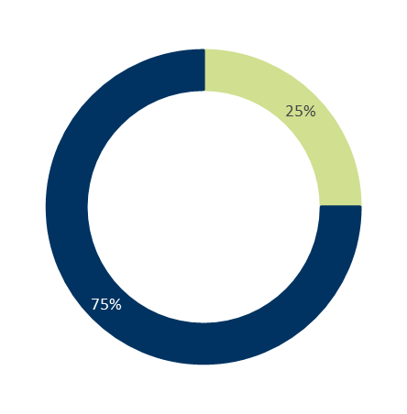
Annual Action Plan 2023‒24
We committed to 17 actions which demonstrate how we are addressing our four-year priorities under Sustainable Growth and Environment.
At the end of June 2024:
- 75% (12) were ‘complete’
- 25% (five) were ‘ongoing’

Progress of annual actions supporting delivery of Our Community Plan 2021–25

Major Budget Initiatives
Budget initiative | ACTION 2023−24 | STATUS | COMMENT
LED street lighting & smart control technology | Upgrade the LED Street Lighting & Smart Control Technology | Complete | The installation of main roads lighting progressed with 200 lights installed in Q3 2024. Stage 3 installation of decorative lights has progressed with 1,900 lights changed and an additional 150 ordered and scheduled to be delivered scheduled for changeover in September 2024. An offer for the procurement of the new Central Management System to control our new smart assets has been received from Powercor with a plan to have this implemented and operational by July 2025.
Northern and Western Geelong Growth Areas Commonwealth biodiversity approvals | Prepare the strategic assessment under the Environment Protection and Biodiversity Conservation Act and biodiversity conservation strategy for the Northern and Western Growth Areas | Ongoing | The City’s Environment Protection and Biodiversity Conservation Plan sets out a range of measures and commitments to protect biodiversity in the Northern and Western Geelong Growth Areas. We completed surveys and habitat assessment for the Victorian Grassland Earless Dragon across the growth areas and data analysis is underway. We will continue to progress this action in 2024−25. A series of workshops with key stakeholders to incorporate the habitat/survey results into the growth area framework plan are planned for late 2024. We will then seek Commonwealth environmental approval in 2025.
Northern and Western Geelong Growth Areas Precinct Structure Plan development | Deliver the Precinct Structure Planning program for the Northern and Western Geelong Growth Areas | Complete | The City continued to deliver the precinct structure plan program for the Northern and Western Geelong Growth Areas in 2023−24. This included work on drainage and transport network design for Creamery Road, work on the drainage network design for Elcho Road East Precinct Structure Plan and progressing preparation of the Monocline Master Plan.
Sparrovale Wetlands Project (Phase 1) | Establish public parkland as per phase 2 (2022−2030) of the Sparrovale Ngubitj yoorree Wetlands Master Plan | Complete | Section one of Sparrovale Wetland Reserve Ngubitj yoorree was officially opened on 23 September 2023 as part of the Geelong Nature Festival.  Phase 2 work completed includes:  - the western boundary fencing  - installation in the reserve of two naming signs and four regulations signs  - installation of a new pedestrian gate off Harriott Road  - installation of 280m of fencing along the eastern side of the open to public section  - remove rubbish from the stormwater wetland including 150 tyres and 540 meters of dilapidated fencing.

Other achievements in 2023‒24 included:
- Completing Victorian Grassland Earless Dragon surveys and habitat mapping as part of the Geelong Growth Areas Strategic Assessment process, which considers potential impacts of proposed development on biodiversity values.
- Creating high fidelity 3D building models across key precincts (Belmont, Central Geelong, Geelong West and Highton) and 3D object models for public space trees across the municipality with support of a state government Digital Planning Grant.
- Providing a free community compost giveaway day in October 2023 and free mulch pickups days in February and March 2024.
- Delivering key capital works programs including Asphalt Overlay ($5.86 million), Blackspot Road Safety ($1.45 million), Footpath Replacement ($3.69 million), Kerb & Channel Replacement ($2.43 million), Road Rehabilitation ($3.76 million), Roads to Recovery ($2.25 million) and Spray Sealing Resurfacing ($1.95 million).
- Planting over 200 low-growing, drought-tolerant native species on the median strip along the scenic waterfront entrance, boosting local biodiversity and improving the city's natural scenery and liveability.
- Supporting the community to reduce carbon emissions by partnering with the state government and other Barwon South West region councils to install 50kW Electric Vehicle (EV) fast chargers at two of our leisure centres; Leisurelink, Waurn Ponds and the North Bellarine Aquatic Centre, Drysdale.
- Partnering with Themeda Ecology Pty Ltd to protect one of the Bellarine Peninsula’s oldest living organisms, the Grasstrees of the Basin Reserve in Drysdale.
- Continuing to deliver the Restoring Rural Landscapes program which provides direction pest plant and animal control programs on City managed reserves and roadsides including the rabbit, serrated tussock and woody weed control programs.
- Adding an electric vehicle to our L2P program fleet, the first electric vehicle in the program statewide, courtesy of local businesses who jointly sponsored the vehicle.
- Partnering with the state government and the Wadawurrung Traditional Owners Aboriginal Corporation to support Revitalising Central Geelong partnership projects including the delivery of a next stage of the Green Spine (Block 3) and the start of works on the Nyaal Banyul Convention Centre.
- Securing grants from the state government’s Local Roads and Community Infrastructure Fund to support delivery of Aldershot Reserve Dog Park and the Rippleside Inclusive Playspace.
- Planting over 4,000 trees, shrubs and grasses at Red Gum Island and along the Barwon River, at Batesford on the Moorabool River, Waurn Ponds Creek, at Sparrovale and along the coast at Curlewis and Ramblers Road Foreshore.
- Hosting a student delegation from Nagoya, Japan, as part of the Geelong-Nagoya wetlands affiliation partnership - a unique opportunity for students from both cities to exchange information about our cultures, cities, and the amazing migration of shorebirds between the Ramsar wetlands in Nagoya and Geelong.
- Seeking community feedback on the draft nature strip guidelines, created to provide clear direction and suitable options for those interested in developing nature strip gardens alongside City-managed local roads.
- Securing a $3,000 grant from the state government’s Green Links Grant Program, to restore vegetation along the Waurn Ponds Creek.
- Renewing coastal and marine assets including an upgrade at the Avalon Boat Harbour and the Limeburner’s Boat Harbour, both enabled through funding support from Better Boating Victoria.

Awards and recognition
- The Dell Eco Reef project at Clifton Springs was recognised with a prestigious international award for design and sustainability, the Dezeen Award for Sustainable Design (Building Product) of the Year 2023’ in London in December 2023. The project also took out top prize at the Victorian LGPro 2024 Awards for Excellence in the ‘Special Projects Initiative’ category.
- Our sustainable bridges project at Cowies Creek in Seagull Paddock, delivered in collaboration with local manufacturer Austeng, Deakin University Carbon Nexus facility and Australian engineering company Rocla, won an Excellence in Environment & Sustainability Award at the 2024 International Public Works Conference.
- Our Parks and Gardens team was recognised by the United Nations Food and Agriculture Organisation for their work in keeping our city green with Geelong being named as a Tree City of the World for the second year. The program recognises cities committed to ensuring that their urban forests and trees are properly maintained, sustainably managed and celebrated. The Tree City accreditation coincides with two Greater Geelong trees being newly added to the National Trust of Australia register; a Moonah tree in the Foreshore Reserve, St Leonards and an Algerian Oak tree at Mont Street, Newtown.
- The City’s Modern Cloth Reusable Nappy Program was selected as a finalist at the Keep Australia Beautiful Victoria Tidy Town and Cities – Sustainability Awards. The program helps parents and carers save money and reduce their disposable nappy waste by providing educational workshops and heavily subsidised nappy packs.

Services
The following statement provides information in relation to the services funded in the 2023−24 budget and the persons or sections of the community who are provided the service.

SERVICE AREA | DESCRIPTION OF SERVICES PROVIDED | Actual  Budget  Variance  $000
Municipal Planning Services | Responsible for providing municipal planning and policy. This includes land use planning and design to deliver social and community infrastructure that meets the needs of a growing city in a sustainable way to help deliver across a range of social, environmental and economic policies. | 8,610  11,071  2,461
Municipal Emergency Management | Responsible for ensuring the City, our employees and the multiagency Municipal Emergency Management Planning Committee and its sub-committees continue to mitigate risks continues to plan for, respond to, and recover from an emergency event by planning for the three ‘phases’ of an emergency. | 744  629  (115)
City Development | Responsible for reviewing, amending and implementing the provisions of the Greater Geelong Planning Scheme, assessing and determining Planning Permits and undertaking building compliance under the Building Act 1993. | 3,299  4,176  877
Engineering Services | Responsible for management of engineering infrastructure assets, management of roads and drains, transport, parking and land development. | 5,491  8,254  2,763
Waste Services | Responsible for the delivery of waste and circular economy programs including residential waste collection services (waste, recyclables and green bins, hard waste and mattresses), public and commercial waste collection, recycling programs and initiatives, community education and advocacy, and waste site operations (landfill operations, transfer stations and green organics composting facility). | 51,715  56,492  4,777
Asset Maintenance Services | Responsible for maintenance of a diverse range of assets including civil infrastructure, public spaces, open space and horticultural assets. | 49,360  48,806  (554)
Major Projects | Responsible for the project management centre of excellence within the City. Responsible for delivering key community assets through the construction of new and renovation of existing buildings and infrastructure. | 1,155  1,434  278

Local Government Performance Reporting Indicators
To help measure performance across all Victorian councils in a transparent and accountable way, we report to Local Government Victoria on the following mandatory indicators:
SERVICE/INDICATOR/MEASURE | RESULTS |  |  |  | COMMENTS
SERVICE/INDICATOR/MEASURE | 2021 | 2022 | 2023 | 2024 | COMMENTS
Roads
Satisfaction of use  R1 Sealed local road requests  [Number of sealed local road requests / Kilometres of sealed local roads] x100 | 79.21 | 106.53 | 167.24 | 100.69 | The absence of major flood events which elevated road repair requests in 2022−23, resulted in the number of requests returning to levels more consistent with previous year’s results.
Condition  R2 Sealed local roads maintained to condition standards  [Number of kilometres of sealed local roads below the renewal intervention level set by council / Kilometres of sealed local roads] x100 | 95.26% | 94.76% | 95.59% | 96.30% | The proportion of roads maintained to condition standards increased slightly but was relatively consistent with the previous years.
Service cost  R3 Cost of sealed local road reconstruction  [Direct cost of sealed local road reconstruction / Square metres of sealed local roads reconstructed] | $124.09 | $186.13 | $150.43 | $133.02 | Projects included in this reporting period have been more economical (size, scale & material) to deliver for the organisation.
Service cost  R4 Cost of sealed local road resealing  [Direct cost of sealed local road resealing / Square metres of sealed local roads resealed] | $18.94 | $23.11 | $22.39 | $17.87 | Projects included in this reporting period have been more economical (size, scale & material) to deliver for the organisation.
Satisfaction  R5 Satisfaction with sealed local roads  [Community satisfaction rating out of 100 with how council has performed on the condition of sealed local roads] | 62 | 57 | 53 | 46.00 | While our result decreased it is comparable to both the statewide and other Regional Centres averages (45 and 46 respectively).
Waste Management
Service standard  WC2 Kerbside collection bins missed  [Number of kerbside garbage and recycling collection bins missed / Number of scheduled kerbside garbage and recycling collection bin lifts] x10,000 | 12.28 | 10.89 | 12.05 | 12.13 | The number of missed bins is consistent with previous year’s results.
Service cost  WC3 Cost of kerbside garbage bin collection service  [Direct cost of the kerbside garbage bin collection service / Number of kerbside garbage collection bins] | $108.89 | $133.19 | $141.33 | $143.02 | Our waste tonnage is similar to the previous year, however cost increased due to an increase in EPA levy and disposal cost.
Service cost  WC4 Cost of kerbside recyclables collection service  [Direct cost of the kerbside recyclables bin collection service / Number of kerbside recyclables collection bins] | $60.85 | $59.32 | $71.33 | $67.73 | The cost of our kerbside recyclable service reduced slightly due to a decrease in recyclables collected.
Waste diversion  WC5 Kerbside collection waste diverted from landfill  [Weight of recyclables and green organics collected from kerbside bins / Weight of garbage, recyclables and green organics collected from kerbside bins] x100 | 53.87% | 52.96% | 53.21% | 50.99% | The slight decrease in diversion rate is due to a decrease in the tonnage of recyclables collected following the introduction of the state government's Container Deposit Scheme.  There has also been a reduction in tonnage of green waste collected.
Satisfaction  WC1 Kerbside bin collection requests  [Number of kerbside garbage and recycling bin collection requests / Number of kerbside bin collection households] x1,000 | 276.30 | 280.64 | 238.84 | Retired in 2024 | As of 1 July 2023, this indicator was retired. The City is not required to report on this for the 2023−24 reporting year.

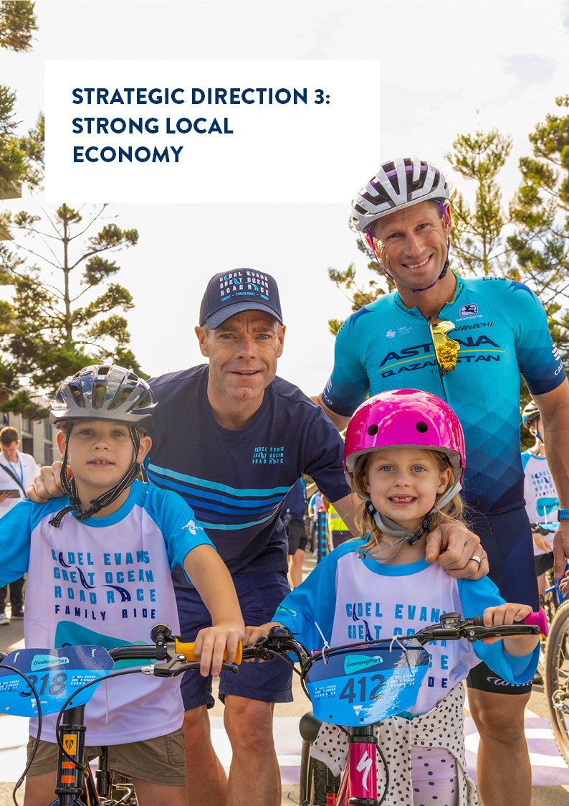
STRATEGIC DIRECTION 3: STRONG LOCAL ECONOMY

  2,127 participants in the 2023 Geelong Small Business Festival |   430 businesses supported by our Business Concierge service
  22 events supported to occur in public places |   7,500+ hours worked by 63 volunteers at visitor information centres across the region
  6.2 million visitors spent 5.8 million nights in the region |   17,288 participants in Geelong Design Week 2023
  100+ events featured in the 2024 Tastes of Greater Geelong program |   230,727 total number of Wi-Fi sessions on City-managed free public Wi-Fi
  $50,130,955 estimated economic benefit of 12 events funded by Geelong Major Events |   4 cruise ships welcomed to the region
  30+ performances as part of the ReSound Music Festival |   67 kilometres of internet fibre owned by the city and shared through agreements with others
  23 volunteer student ambassadors in the Study Geelong program |   980 tourism businesses engaged in marketing and development programs

LINKS TO THE CLEVER AND CREATIVE VISION
 | 

DESIRED OUTCOMES
- We have a global, national and local reputation as a place to do business, especially in our key sectors
- We have a diversified, future-focused and sustainable economy to drive employment and support growth
- We are an influential council that builds effective private and public partnerships, taking the lead role in advocating for future investment

Four-year priorities
3.1 Attract and facilitate public and private investment
3.2 Promote and leverage the competitive strengths and attractiveness of our region, globally, nationally and locally
3.3 Support entrepreneurs, start-ups, innovation, research and digital connectivity
3.4 Attract businesses with a carbon neutral and circular economy focus
3.5 Support local business resilience and recovery from the impacts of the COVID-19 pandemic
3.6 Attract, retain and enable participation in the workforce to meet industry needs
3.7 Address high levels of unemployment in targeted areas of our region
  - Promote our region as a trial location for innovation and new technologies
Supports health and wellbeing

PROGRESS REPORT
Indicators
Municipal Indicators | Result at 30 June 2024 |  |  | Progress comments
Number of jobs located in the City of Greater Geelong  Source: .id and National Institute of Economic and Industry Research (NIEIR) | 144,568 (2022‒23)  135,358 (2021‒22)  122,993 (2020‒21)  118,890 (2019‒20) |  |  | Greater Geelong experienced the second largest increase in jobs on record in 2022−23, with an increase of 9,210 jobs (+6.8%). The largest number of jobs created were in health care and social assistance (+3,768 jobs), professional, scientific and technical services (+928) and financial and insurance services (+771). Data for 2023−24 will be available in early 2025.
City of Greater Geelong unemployment rate  Source: Jobs and Skills Australia, Small Area Labour Markets. | 4.1% (June quarter 2024)  3.3% (June quarter 2023)  2.8% (June quarter 2022)  4.2% (June quarter 2021) |  |  | The unemployment rate increased this financial year and is now slightly above the Victorian rate of 4.0 per cent. The ten-year average unemployment rate for Greater Geelong is 5.3 per cent.
Gross Regional Product (GRP)  Source: National Institute of Economic and Industry Research (NIEIR) 2021. Compiled and presented in economy.id by .id (informed decisions) | $19.6 billion (2022‒23)  $18.6 billion (2021‒22)  $16.7 billion (2020‒21)  $16.1 billion (2019‒20) |  |  | Greater Geelong's Gross Regional Product (GRP) increased by $928 million in 2022−23 (+5.0%). The largest contributors to this growth were health care and social assistance (+$238 million), accommodation and food services (+$149 million) and financial and insurance services (+$125 million).
Value of non‒residential building approvals in City of Greater Geelong  Source: City of Greater Geelong Building Services | $1.2 billion (2023–24)  $977.1 million (2022–23)  $1.2 billion (2021‒22)  $603.2 million (2020‒21) |  |  | Non-residential building activity increased by $190.6 million or 19.5% in 2023−24.
Number of businesses  Source: Australian Bureau of Statistics, Counts of Australian Businesses, including Entries and Exits | 22,090 (2022‒23)  21,789 (2021‒22)  19,615 (2020‒21)  18,532 (2019‒20) |  |  | Greater Geelong experienced the largest growth in business numbers in the state in 2022−23 with an additional 301 businesses. Just over half the growth in the number of businesses was in professional, scientific and technical services (+166), followed by healthcare and social assistance (+138) and rental, hiring and real estate (+76).
Tourism Sentiment Index (TSI)  Source: Destination Think | 26.6 (December 2023)  24.1 (March 2023)  24 (June 2022)  22 (June 2021) |  |  | This ranking put Geelong and The Bellarine in the top 100 destinations worldwide with the highest regarded experiences in the region being dining and wineries. No new data available.
Investment in Geelong  Source: Cordell by CoreLogic | 163 projects valued at $13.0 billion (June 2024)  157 projects valued at $16.9 billion (June 2023)  137 projects valued at $13.9 billion (June 2022)  139 projects valued at $11.5 billion (June 2021) |  |  | While the value decreased, the number of major investment projects increased by six in the year to June 2024. The Geelong Major Projects dashboard summarises the investment pipeline and is updated quarterly at www.geelongdataexchange.com.au.
Visitor expenditure  Source: Tourism Research Australia’s National Visitor Survey | $1.93 billion (June 2024)  $1.6 billion (June 2023)  $876 million (June 2022)  $637 million (June 2021) |  |  | Tourism spend is up 20% compared to the previous year and 76% compared to pre COVID-19 pandemic.
City of Greater Geelong Indicators |  | Result at 30 June 2024 | Progress comments
Community satisfaction with business and community development  Source: Local Government Community Satisfaction Survey |  | 53 (2024)  59 (2023)  59 (2022)  64 (2021) | Satisfaction was significantly lower compared with the previous year. Our result is significantly lower than the statewide average (57), however comparable to the Regional Centres average (55).
Return on investment of Geelong major events  Source: Geelong Major Events Committee Annual Report |  | 54:1 (2023‒24)  50:1 (2022‒23)  24:1 (2021‒22)  28:1 (2020‒21) | The 12 major events supported via Geelong Major Events had an economic impact estimated at $50.13 million.

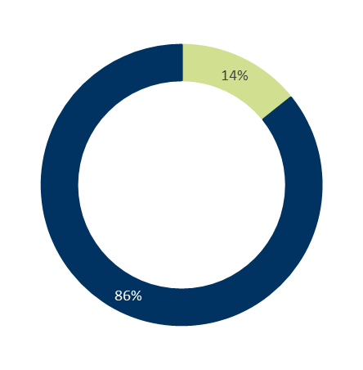
Annual Action Plan 2023‒24
We committed to 14 actions which demonstrate how we are addressing our four-year priorities under Strong Local Economy.
At the end of June 2024:
- 86% (12) were ‘complete’
- 14% (two) were ‘ongoing’.

Progress of annual actions supporting delivery of Our Community Plan 2021–25

Major Budget Initiatives
Budget initiative | ACTION 2023−24 | STATUS | COMMENT
Osbourne House works | Finalise the procurement activities related to redevelopment of the Osborne House site and complete the draft proposal of future activities for council endorsement | Ongoing | Expressions of Interest for procurement activities related to redevelopment of the Osborne House site continued to progress. The City provided the Minister with the information required and are awaiting a response. We will continue to progress this action in 2024−25.
Public Wi-Fi & enhanced broadband Geelong pilot | Deliver free public Wi-Fi and enhanced broadband across the north to address gaps in digital access and affordability (Geelong Smarter Suburbs) | Complete | Under the Geelong Smarter Suburbs initiative, we have made significant strides in delivering free public Wi-Fi and enhanced broadband access across the north, addressing digital access gaps and affordability barriers. The remaining three smart nodes were stood and commissioned as a part of the Geelong Smarter Suburbs initiative (11 nodes stood and commissioned this financial year) taking the total number of smart nodes implemented to 48 across the municipality. The smart nodes provide key services including public Wi-Fi, intelligent lighting, Internet of Things gateways, and CCTV
Commonwealth Games program | Advocate for the best community outcomes in regard to Commonwealth Games legacy funding | Ongoing | Following its decision not to proceed with hosting the Commonwealth Games in 2026, the state government committed to a $2 billion package with focusing on housing, tourism, events and sporting infrastructure.  In March, the Premier announced the housing mix for the Waurn Ponds site – with 72 of the 400 dwellings (18%) being delivered as affordable and/or social housing, less than what the City advocated for (30%).  In April, we received state government confirmation that Development Victoria will lead the delivery of three projects in Geelong: the re-development of Stead Park, Corio; new indoor sporting facilities at Armstrong Creek and a new indoor sporting complex at Waurn Ponds. The City will continue to advocate to both the state and federal government for the need for an Indoor Regional Sports and Events Centre. Discussions have been held with the Deputy Prime Minister, Member for Corangamite, Member for Geelong and relevant officials at the Department of Jobs, Skills, Industry and Regions. We also convened a round table discussion with key stakeholders including Netball Victoria, Basketball Victoria, the National Basketball League (NBL), Geelong United Basketball and Belgravia Leisure to identify deliverables which enable the City to leverage the current opportunities including a WNBL licence and possible NBL and netball licences.

Other achievements in 2023‒24 included:
- Funding two local businesses; FormFlow and Sequence Digital, to get their innovative circular economy projects off the ground through the City’s Clean Economy Grants.
- Continuing to support community members to start, manage and grow their local businesses through a range of workshops, free advice, initiatives and funding opportunities including our annual Small Business Festival, monthly one-on-one mentoring sessions and our Business Concierge service.
- Publishing the Tourism Greater Geelong and The Bellarine Sustainable Destination Master Plan.
- Engaging with the community to inform the development of a new Major Events strategy, which aims to position Geelong as a leading destination for major events, festivals, and cultural gatherings, attracting visitors from across the region, interstate, and internationally.
- Delivering the ReSound Music Festival, a program of free all-ages events presenting music and talent at a range of venues across Geelong.
- Opening the Geelong Visitor Information Centre at City Hall.
- Delivering the annual food celebration, Tastes of Greater Geelong, featuring the best in food, drink and hospitality that the Greater Geelong region has to offer.
- Launching a Geelong investment prospectus during the Future Geelong forum in March 2024, intended as a key tool in seeking and driving investment growth in the region.
- Sponsoring the Geelong Manufacturing Council’s 2024 Technology and Innovation Summit which showcased the world-leading manufacturing capabilities of the region.
- Working with Visit Victoria to host 18 familiarisation tours for international travel trade buyers and media as part of Australian Tourism Exchange.
- Partnering with the Victorian Cleantech Cluster, Regional Innovation for a Circular Economy (RICE), and ClimateKIC Australia, to bring together 140 guests and nine forward-thinking organisations, including industry leaders, researchers and trailblazers from the cleantech sector as part of the NEXUS Cleantech Innovation Festival.
- Promoting the activation of Little Malop Street with the BBQ and Beats initiative which increased foot traffic in both the precinct (+36%) and Market Square Shopping Centre (+10%) compared to any other Saturday throughout April and May 2024.
- Hosting key international delegations including 20 delegates for the Victorian Consular Corps Regional Tour, for a two-day visit highlighting Geelong's advanced manufacturing and materials, energy, engineering and cleantech sectors; and 12 delegates from the Binh Duong Provincial Government, interested in Australia-Vietnam investment opportunities.
- Live streaming a performance of "Late, Late At Night – Rick Springfield" from the Potato Shed to thousands of homes in The United States of America.
Awards and recognition
- The City was recognised for its use of smart technologies to make the region more resilient to climate change by making the annual Australian Financial Review (AFR) BOSS Most Innovative Companies list in September 2023, the only local government authority across Australia and New Zealand to be make the list.
- Our specially designed smart sensors and irrigation infrastructure in Eastern Park for protecting Gray-headed Flying Foxes won the ‘Emerging Technology category and was also highly commended in the ‘Collaboration or Partnership’ category at the Municipal Association of Victoria (MAV) Technology Awards for Excellence.
- Tourism Greater Geelong and The Bellarine’s Geelong & Bellarine Visitor Information Services team won gold at the Victorian Tourism Awards for ‘Outstanding Contribution by Volunteers’.
Services
The following statement provides information in relation to the services funded in the 2023−24 budget and the persons or sections of the community who are provided the service.

SERVICE AREA | DESCRIPTION OF SERVICES PROVIDED | Actual  Budget  Variance  $000
Economic Strengthening Services | Supporting an environment that is attractive and conducive to business and investment leading to job creation for the community. | 1,683  2,230  547
Events | Providing both a regulatory and a discretionary role in the support of events to be staged in the Geelong region. | 2,134  2,538  403
Smart City | Supporting Geelong to embrace smart technology and be innovative. | 888  1,238  350
Tourism | Growing and supporting the visitor economy through leadership, promotion and development. | 2,265  2,257  (8)

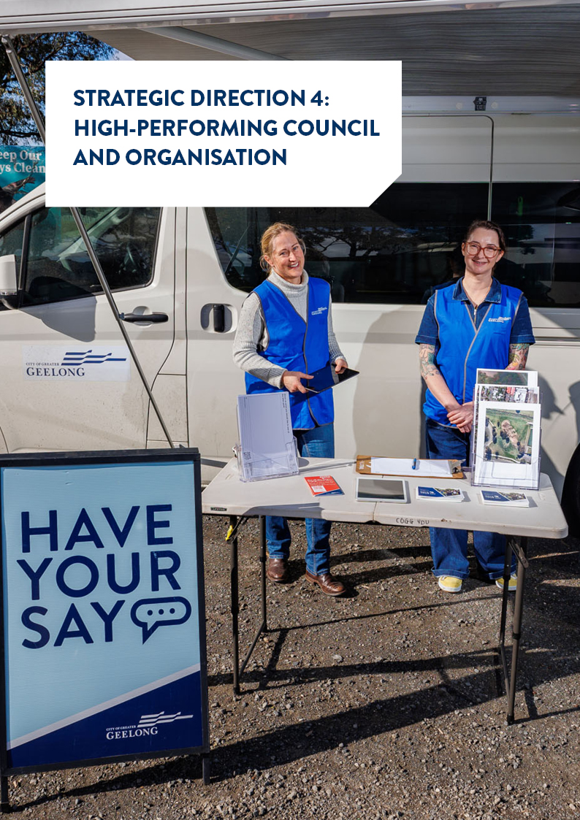

STRATEGIC DIRECTION 4: HIGH-PERFORMING COUNCIL AND ORGANISATION

  4 Council meetings held outside of City Hall |   27,512 visitors to Customer Service Centres
  9,000 subscribers to the Events Geelong e-newsletter |   171,167 visitors assisted at the Carousel
  30,171 calls/enquiries recorded by Family Services administration |   47,500 animal registration renewal notices distributed
  981 new pools/spas registered |   44,501 email enquiries handled by Customer Service Centres
  64 new lifeguards recruited | 3 arboriculture trainees graduated as qualified arborists
  57 projects shared on the City’s Have Your Say webpage | 9,073 requests for building information

DESIRED OUTCOMES
- Our services are accessible and meet the diverse needs of our community
- We are acknowledged and recognised as a leading council and organisation
- We have a healthy, safe, inclusive and diverse culture
- We are a financially sustainable and resilient organisation

Four-year priorities
4.1 Enable a customer-focused approach that delivers efficient and responsive service
4.2 Communicate and engage effectively with our community to understand their needs and advocate on their behalf
4.3 Foster excellence and equity in planning for our growing region
4.4 Continue to strengthen our workforce capabilities and culture
4.5 Create a more efficient and effective organisation
4.6 Develop a digital core of brilliant basic technology that supports better ways of working
4.7 Ensure that our employees are safe at work
4.8 Focus on economic, social and environmental sustainability
Supports health and wellbeing

PROGRESS REPORT
Indicators
City of Greater Geelong Indicators | RESULT at 30 June 2024 |  | Progress comments
Customer complaints resolution completed within 30 days  Source: City of Greater Geelong |  | 93% (2023‒24)  87% (2022‒23)  85% (April‒June 2022) | The new process for triaging complaints has seen an improvement in complaint resolution for both internal and external stakeholders. Our website now provides concise information about what a complaint is and triages customers to different request types where appropriate. The reduction in complaints has meant that departments now find their allocated complaints more manageable and complete them within the required timeline as well as providing appropriate feedback to customers.
Community satisfaction with customer service  Source: Local Government Community Satisfaction Survey |  | 70 (2024)  73 (2023)  72 (2022)  77 (2021) | Our performance, unchanged from 2023, continued to be well regarded by our community with customer service among our top three rated services. Results are comparable with the statewide and Regional Centres group averages (67 and 68 respectively).
Community satisfaction with informing the community  Source: Local Government Community Satisfaction Survey |  | 53 (2024)  56 (2023)  58 (2022)  60 (2021) | There was no significant change in satisfaction from 2023. Our result was significantly lower than the statewide average (56) but comparable to the Regional Centres average (54).
Community satisfaction with consultation and engagement  Source: Local Government Community Satisfaction Survey |  | 49 (2024)  52 (2023)  54 (2022)  57 (2021) | There was no significant change from 2023, with our score comparable with both statewide and Regional Centres averages (51 and 49 respectively).
Community satisfaction with overall council direction  Source: Local Government Community Satisfaction Survey |  | 40 (2024)  49 (2023)  52 (2022)  56 (2021) | Overall council direction was rated significantly lower compared with the previous year and is rated significantly lower than the statewide and Regional Centres group averages (45 respectively).
Community satisfaction with overall performance  Source: Local Government Community Satisfaction Survey |  | 49 (2024)  58 (2023)  63 (2022)  63 (2021) | Overall performance was rated significantly lower compared with the previous year. It is rated significantly lower than the statewide and Regional Centres group averages (54 respectively) both of which also have experienced significant declines in the past two years.
Community satisfaction with advocacy on behalf of the community  Source: Local Government Community Satisfaction Survey |  | 47 (2024)  50 (2023)  55 (2022)  57 (2021) | While there was no significant change from the previous year, satisfaction is significantly lower than both statewide and Regional Centres averages (50 respectively).
Lost Time Injury Frequency Rate (LTIFR) and Total Recordable Injury Frequency Rate (TRIFR)  Source: City of Greater Geelong |  | LTFIR  25.9 (June 2024)  22.3 (June 2023)  26.5 (June 2022)  21.4 (June 2021)  TRIFR  35.4 (June 2024)  29.4 (June 2023)  34.9 (June 2022)  24.9 (June 2021) | During the reporting period, the City experienced an increase in all reportable categories. A strong focus remains on completing incident investigations to determine the underlying cause of incidents and make sure that appropriate mitigation measures are implemented to manage and control hazards and risks.
Gender breakdown of City employees  Source: City of Greater Geelong |  | Female  65.00% (June 2024)  65.69% (June 2023)  64.32% (June 2022)  64.12% (June 2021)  Male  34.82% (June 2024)  34.13% (June 2023)  35.64% (June 2022)  35.85% (June 2021)  Self-described gender  0.18% (June 2024)  0.17% (June 2023)  0.04% (June 2022)  0.04% (June 2021) | Gender breakdown of City employees remains very consistent with last year. In 2024, the proportion of female employees declined 0.69%, the proportion of male employees increased 0.68% and the proportion of employees of self-described gender increased 0.01% on 2023 numbers.
Number of Aboriginal and Torres Strait Islander people employed at the City  Source: City of Greater Geelong |  | 21 (June 2024)  20 (June 2023)  19 (June 2022)  14 (June 2021) | We recruit, develop and retain First Nations people as an integral part of our commitment to inclusiveness, engagement and to be an employer of choice for Aboriginal and Torres Strait Islander people. The City recruited four First Nations Trainees in partnership with employment and recruitment organisation, gforce.
Employee satisfaction and engagement  Source: City of Greater Geelong Employee Experience Survey |  | 78% (2024)  76% (2022) | In 2022, the City shifted to measuring employee satisfaction and engagement using a 'Sustainable Engagement' score which has proven linkages to key performance outcomes. In March 2024, the biennial Employee Experience Survey was conducted. The response rate was 61% of the total workforce (increasing 7% since 2022), and 72% of the permanent workforce, (increasing 5% since 2022). The City’s overall sustainable engagement score was 78%, increasing 2% since 2022; a pleasing result following a year of transformation in 2023.
Recurrent surplus / deficit  Source: City of Greater Geelong |  | $(17.6) million (2023‒24)  $4.7 million (2022‒23)  $10.63 million (2021‒22) | The operating result is a deficit of $17.6 million, being $18.0 million unfavourable to budget. This is primarily driven by the timing of the Financial Assistance Grant which had an unfavourable impact of $23.9 million.
Funds from sale of assets  Source: City of Greater Geelong |  | $1.65 million (2023‒24)  $31.1 million (2022‒23)  $12.8 million (2021‒22) | Two of the City’s assets held for sale, building (151 Mercer Street) and land (Forest Road, Lara) were sold, with further asset sales in progress in 2024‒25 financial year.
Cost recovery of services and revenue growth from new sources (fees and charges)  Source: City of Greater Geelong |  | $10.3 million (2023‒24)  $9.9 million (2022‒23)  $9.4 million (2021‒22) | An increase in the rates revenue stream due to increase of 3,620 rateable properties and supplementary rates during 2023‒24 and the opening of two new aquatics centres North Bellarine and Norlane ARC (Aquatic Recreation Centre).
Efficiency target  Source: City of Greater Geelong |  | $7.1 million (2023‒24)  $3.98 million (2022‒23)  $2.965 million (2021‒22) | The budget contained an efficiency target embedded in material and services; however, this was delivered through other savings, including reducing employee costs and other expenses.
Asset renewal gap and upgrade ratio  Source: City of Greater Geelong |  | 71.0% (2023‒24)  61.8% (2022‒23)  68.9% (2021‒22)  51.9% (2020‒21) | A strong focus from council to invest in asset renewal has seen the ratio increase in 2023‒24 and will continue to increase in the forthcoming years.

Annual Action Plan 2023‒24
We committed to 14 actions which demonstrate how we are addressing our four-year priorities under High-Performing Council and organisation.
At the end of June 2024:
- 86% (12) were ‘complete’
- 14% (two) were ‘ongoing’

Progress of annual actions supporting delivery of Our Community Plan 2021–25

Major budget initiatives
Budget initiative | ACTION 2023−24 | STATUS | COMMENT
Cyber security | Protect the City’s digital landscape from cyber security threats through implementation of the Cyber Security Strategy | Ongoing | A cyber strategy is currently being drafted and will be informed by the City’s organisation strategy, alongside the new IT Strategy. Whilst work continues to develop an appropriate future state, two key cyber security initiatives were identified and endorsed to proceed to business case. To support these critical security program initiatives, a request for proposal was developed to seek submissions for a Managed Detection and Response service. Work to understand future state Identity and Access Management requirements also progressed.
Digital Innovation Program | Commence the detailed design of a digital innovation program across the organisation | Ongoing | Following extensive stakeholder engagement, we completed the IT Strategy with a roadmap for delivery of prioritised business and technology capabilities. Several initiatives are already underway, including establishing the City’s enterprise data foundations and upgrading a major Pathway product. Several other projects including a website refresh, are undergoing planning for future delivery.  Phase 1 of the larger programs of work will undergo an extensive design and planning phase for the City's larger technology investments, which includes Enterprise Asset Management, Customer Relationship Management, and a new Enterprise Integration service.
Future Ways of Working program | Deliver the City's Future Ways of Working program | Complete | The Future Ways of Working program was concluded. The Future Ways of Working program aimed to enhance how we work together and design our organisation for the future. To create a place that serves our growing Greater Geelong community in the best possible way through the implementation of an agreed Target Operating Model co-designed with our employees focusing on decision making, accountability, structure, ways of working and capabilities.  With this foundational work completed, the organisation has now moved into a period of organisation led continuous improvement to design and deliver on the benefits of our new ways of working.

Other achievements in 2023‒24 included:
- Concluding development of the City's new IT Strategy with a roadmap of business and technology capabilities which is focused on delivering our priority business and community outcomes over the next five years.
- Updating the Major Projects dashboard on the publicly accessible Geelong Data Exchange platform to feature data about capital works projects valued over $10 million outside Greater Geelong in the Borough of Queenscliffe, Surf Coast Shire, Golden Plains Shire and Colac Otway Shire.
- Delivering our International Engagement Strategy, which outlines our objectives and the guiding principles against which we’ll establish international relationships.
- Conducting the 2024 Geelong Calendar Competition which received 530 submissions and was voted on by over 15,000 unique voters.
- Completing installation of infrastructure required to provide free public Wi-Fi and enhanced broadband at Smarter Suburb sites including Leisuretime Sports Precinct, Goldsworthy Reserve and Hendy Reserve.
- Successfully securing funding through the state government’s Business Acceleration Fund for the digitisation of more than 16,000 building permits, enabling us to respond more quickly to requests for this information.
- Continuing work to simplify and improve the customer service experience through implementation of a tiered service delivery model which aims to put our customers first in enquiries, so that they can get responses easily and consistently, in ways that best suit them.
- Providing the Green Card Accredited Training Program for 18 City employees, with a total of 60 employees having completed the training to date.
- Re-entering the G21 Alliance and establishing a new partnership with Wyndham Council for regional advocacy.

Awards and recognition
- We were recognised for our efforts to keep our employees active, receiving a silver prize for ‘Active Community Connections’ at the Active Geelong Awards in November 2023.
- The City has been awarded a coveted 6-Star NABERS waste rating for the Wurriki Nyal Civic Precinct, making it the second building in Victoria and the first among local governments across Australia to achieve the market leading 6-Star waste management rating.
- We were recognised as a finalist in the 2023 Australian Financial Review BOSS Most Innovative Companies (Government, Not for Profit and Academic Category).
- Mr John Carey, one of the City’s many dedicated School Crossing Supervisors, was nominated for the prestigious School Crossing Victoria ‘Supervisor of the Year Award 2024’ for his commitment to ensuring the safety and wellbeing of children walking to school.
- Our Unlocking Data-Driven Transport Innovations project was highly commended in the ‘Data and Insights’ category at the Municipal Association of Victoria (MAV) Technology Awards for Excellence.

Services
The following statement provides information in relation to the services funded in the 2023−24 budget and the persons or sections of the community who are provided the service.

SERVICE AREA | DESCRIPTION OF SERVICES PROVIDED | Actual  Budget  Variance  $’000
Council & Organisational Services | Strategy and performance, service enablement, organisational governance and transformation. | 60,026  62,047  2,022

Local Government Performance Reporting Indicators
To help measure performance across all Victorian councils in a transparent and accountable way, we report to Local Government Victoria on the following mandatory indicators:
SERVICE/INDICATOR/MEASURE | RESULTS |  |  |  | COMMENTS
SERVICE/INDICATOR/MEASURE | 2021 | 2022 | 2023 | 2024 | COMMENTS
Governance
Transparency  G1 Council decisions made at meetings closed to the public  [Number of Council resolutions made at meetings of Council, or at meetings of a delegated committee consisting only of councillors, closed to the public / Number of Council resolutions made at meetings of Council or at meetings of a delegated committee consisting only of councillors] x100 | 8.03% | 6.55% | 14.41% | 10.42% | The number of confidential reports decreased compared to the previous year, when the CEO recruitment process increased the number of meetings closed to the public.
Consultation and engagement  G2 Satisfaction with community consultation and engagement  [Community satisfaction rating out of 100 with how council has performed on community consultation and engagement] | 57 | 54 | 52 | 49.00 | Satisfaction with consultation and engagement continued to decline. This trend is on par with regional centres, but lower than metro councils' decline. While there are broader factors negatively influencing people’s satisfaction with council (financial sustainability, population growth, cost of living), we will focus on expanding feedback channels, and implementing more outreach initiatives to foster greater community involvement and build trust.
Attendance  G3 Councillor attendance at council meetings  [The sum of the number of councillors who attended each council meeting / (Number of council meetings) × (Number of councillors elected at the last Council general election)] x100 | 96.97% | 98.70% | 90.40% | 95.15% | An increase in attendance numbers from the previous year was a result of resignations and the time required to fill vacancies.
Service cost  G4 Cost of elected representation  [Direct cost of the governance service / Number of councillors elected at the last council general election] | $45,711.91 | $47,697.36 | $60,073.35 | $52,495.45 | The cost of elected representatives was similar to previous years with the exception of 2022−23 which saw an increase in the costs incurred as part of the CEO recruitment process.
Satisfaction  G5 Satisfaction with council decisions  [Community satisfaction rating out of 100 with how council has performed in making decisions in the interest of the community] | 59 | 56 | 52 | 46.00 | While there was a decrease in the score for council decisions for Geelong, Regional Centres and statewide also saw a decline. We will continue to engage with the community to raise awareness and provide transparency on decision making.
Statutory Planning
Timeliness  SP1 Time taken to decide planning applications  [The median number of days between receipt of a planning application and a decision on the application] | 78.00 | 80.00 | 91.00 | 91.00 | The time taken to decide planning applications was unchanged from the previous year where the complexity in planning applications and the recurring employee shortages resulted in an increase in the median processing days.
Service standard  SP2 Planning applications decided within required time frames  [Number of planning application decisions made within 60 days for regular permits and 10 days for VicSmart permits / Number of planning application decisions made] x100 | 80.90% | 78.70% | 75.05% | 78.60% | There has been an improvement in the processing times based on the reduction in the overall planning permit applications received and the increased processing efficiencies of employees.
Service cost  SP3 Cost of statutory planning service  [Direct cost of the statutory planning service / Number of planning applications received] | $2,304.98 | $2,260.19 | $3,250.96 | $4,026.43 | An increase in the cost of the service is mostly due to the decrease in the number of planning applications received this financial year, which includes a reduction in the number of significant complex applications.
Decision making  SP4 Council planning decisions upheld at VCAT  [Number of VCAT decisions that did not set aside council's decision in relation to a planning application / Number of VCAT decisions in relation to planning applications] x100 | 71.79% | 72.41% | 64.00% | 58.33% | The number of Council decisions affirmed is consistent with the previous year. It is also noted that Council had a further 20 decisions determined by consent orders at VCAT and 5 decisions were withdrawn.

GOVERNANCE

The Local Government Act 2020 (the Act) requires all councils to provide good governance in its municipal district for the benefit and wellbeing of the community.
Good governance includes giving effect to the overarching governance principles:
- Council decisions are to be made and actions taken in accordance with the relevant law
- priority is to be given to achieving the best outcomes for the municipal community, including future generations
- the economic, social and environmental sustainability of the municipal district, including mitigation and planning for climate change risks, is to be promoted
- the municipal community is to be engaged in strategic planning and strategic decision-making
- innovation and continuous improvement is to be pursued
- collaboration with other councils and governments and statutory bodies is to be sought
- the ongoing financial viability of the Council is to be ensured
- regional, state and national plans and policies are to be considered in strategic planning and decision-making
- the transparency of Council decisions, actions and information is to be ensured.

In giving effect to the overarching governance principles, a Council must consider the following supporting principles:
- the community engagement principles
- the public transparency principles
- the strategic planning principles
- the financial management principles
- the service performance principles.

Council Meetings
The Governance Rules describe the way Council will conduct meetings and make decisions.
The formal decision-making process of a Council occurs via Council Meetings, which councillors are required to attend. The Chief Executive Officer and members of our Executive Leadership Team also attend the meetings to provide information or advice when called upon by the Mayor. Ordinary meetings of Council are generally held on the fourth Tuesday of each month except in January, September and December. Public attendance at Council meetings is welcome and meetings continue to be live streamed.
On occasion Council may also call for a meeting not fixed by Council, these are also known as special Council meetings and occur to deal with urgent items that cannot wait until the next Ordinary Council meeting.
TABLE 5: Council meetings in 2023–24
Meeting type | Number held | Held at
Council Meetings | 12 | 8 meetings conducted at City Hall  4 meetings conducted offsite
Meetings not fixed by Council | 3 | Meetings were held to consider Urgent or Confidential matters and the Annual Report

TABLE 6: Councillor attendance for 2023–24*
Councillor | Leave of  Absence * | Apology | Council Meeting Attendance
Cr Anthony Aitken (Deputy Mayor) | - | - | 15
Cr Stephanie Asher (resigned 29 July 2023) | - | - | 1
Cr Melissa Cadwell | - | - | 15
Cr Bruce Harwood | 1 | - | 15
Cr Sarah Hathway | - | - | 15
Cr Eddy Kontelj | 2 | 1 | 14
Cr Jim Mason | 2 | - | 15
Cr Belinda Moloney | - | 2 | 13
Cr Peter Murrihy | - | - | 15
Cr Ron Nelson | 1 | 3 | 12
Cr Trent Sullivan (Mayor) | - | - | 15
Cr Elise Wilkinson (Affirmation of Office 1 September 2023)^ | - | 1 | 12

*In line with the Local Government Better Practice Guide, Annual Report Performance Reporting Indicator Guide a councillor is counted as having attended a council meeting where a councillor is on an approved leave of absence.
^Elise Wilkinson was declared elected to fill an extraordinary vacancy in the Bellarine Ward within the Greater Geelong City Council by the VEC’s Notice of Result and Countback distribution report on 31 August 2023.

Committees
Council has a variety of working groups, advisory and planning committees to meet its legislative obligations, enhance its involvement in community activities and to advocate on behalf of the community.

TABLE 7: Committees in 2023−24
Committee | COUNCILLORS APPOINTED
Access and Inclusion Advisory | Cr Anthony Aitken
Ageing-Well Advisory | Cr Belinda Moloney (Chair)
Association of Bayside Municipalities | Cr Jim Mason, Cr Belinda Moloney
Audit and Risk | Cr Trent Sullivan, Cr Ron Nelson
CEO Employment and Remuneration | Cr Trent Sullivan, Cr Anthony Aitken, Cr Melissa Cadwell, Cr Jim Mason, Cr Elise Wilkinson, Cr Peter Murrihy
G21 Pillar – Health and Wellbeing | Cr Peter Murrihy
G21 Pillar – Cultural and Economic Development | Cr Melissa Cadwell
G21 Pillar − Sustainability | Cr Peter Murrihy, Cr Bruce Harwood (agreed delegate)
G21 Managing Growth Advisory Group | Cr Jim Mason, Cr Melissa Cadwell (agreed delegate)
Geelong Art Gallery | Cr Melissa Cadwell
Geelong Heritage Advisory | Cr Jim Mason (Chair), Cr Melissa Cadwell
Geelong Regional Library Corporation | Cr Trent Sullivan, Cr Anthony Aitken, Cr Melissa Cadwell, Cr Belinda Moloney
Kilangiti Aboriginal Advisory | Cr Trent Sullivan (Chair)
LGBTQIA+ Advisory Committee | Cr Sarah Hathway (Chair)
Municipal Association of Victoria delegate | Cr Belinda Moloney  Cr Jim Mason (agreed delegate)
Multicultural Action Plan | Cr Belinda Moloney
Regional Cities Victoria | Cr Trent Sullivan
Regional Capitals Australia | Cr Trent Sullivan
Rural and Peri-Urban Advisory | Cr Jim Mason (Chair), Cr Anthony Aitken
Submissions Review Panel | Cr Bruce Harwood (Chair), Cr Trent Sullivan, Cr Anthony Aitken (Alt), Cr Melissa Cadwell, Cr Sarah Hathway, Cr Eddy Kontelj, Cr Jim Mason, Cr Belinda Moloney, Cr Peter Murrihy, Cr Ron Nelson, Cr Elise Wilkinson
Sustainability Advisory | Cr Peter Murrihy (Chair), Cr Bruce Harwood
Tourism Greater Geelong and The Bellarine Inc | Cr Trent Sullivan
Women in Community Life Advisory | Cr Melissa Cadwell (Chair)

Delegated Committees
TABLE 8: s 63 & s 65 Delegated and Community Asset Committee Committees in 2023−24
Committee |  | Purpose and Appointment | APPOINTED COUNCILLOR(S)
Geelong Major Events Delegated Committee |  | Appointed under section 63 of the Act  To coordinate how we attract, assist and fund events. | Cr Anthony Aitken (Chair), Cr Melissa Cadwell, Cr Jim Mason, Cr Ron Nelson
Bellarine Arts Centre (Potato Shed) Community Asset Committee |  | Appointed under section 65 of the Act  To support the long-term management and promotion of the Potato Shed - Bellarine Arts Centre. | Cr Jim Mason (Chair)
Planning Committee |  | Appointed under section 63 of the Act  To consider and determine planning permit applications that have been called in by a councillor. | Cr Jim Mason (Chair), Cr Trent Sullivan, Cr Anthony Aitken, Cr Melissa Cadwell (Alt), Cr Sarah Hathway, Cr Bruce Harwood, Cr Eddy Kontelj, Cr Belinda Moloney, Cr Peter Murrihy, Cr Ron Nelson, Cr Elise Wilkinson

Code of conduct
In accordance with the Local Government Act 2020, all councils are required to develop and approve a Councillor Code of Conduct. The Local Government (Governance and Integrity) Regulations 2020 prescribe the five standards of conduct that must be observed by every councillor:
- treatment of others
- performing the role of a councillor
- compliance with good governance measures
- councillor must not discredit or mislead Council or public
- standards do not limit robust political debate.

Councillor allowances
All councillors are entitled to an allowance while performing their duty. Under section 39 of the Act, allowances are set by a Determination of the Victorian Independent Remuneration Tribunal.
On 30 June 2023, in accordance with section 23B (1) of the Victorian Independent Remuneration Tribunal and Improving Parliament Standards Act 2019 (Vic) (VIRTIPS Act), the Tribunal made the Allowance payable to Mayors, Deputy Mayors and Councillors (Victoria) Annual Adjustment Determination 2023. The Determination, which applies to all Mayors, Deputy Mayors and Councillors (Council members) in all Victorian Councils, took effect from 1 July 2023. The Tribunal determined the City of Greater Geelong as a Category 3 Council.

TABLE 9: Current annual allowance from 1 July 2023 – 30 June 2024
 | Allowance ($)
 | 1 JULY 2023 – 17 December 2023 | 18 December 2023 – 30 JUne 2024
Councillor | 38,316 | 39,390
Deputy Mayor | 63,480 | 65,195
Mayor | 126,958 | 130,390

Councillor expenses
Councillors must be reimbursed for expenses incurred while performing their duties. Council has adopted a policy to determine what will be reimbursed, as well as other resources, facilities and support needed to help the mayor and councillors discharge their duties.
TABLE 10: Details of reimbursements and expenses paid 1 July 2023 – 30 June 2024
COUNCILLOR EXPENDITURE
NAME | TRAVEL  ($*) | PROFESSIONAL DEVELOPMENT ($) | EXPENSES TO SUPPORT THE PERFORMANCE OF THE ROLE  ($^) | ALLOWANCES  ($) | GRAND TOTAL  ($)
Cr Anthony Aitken | - | - | 402 | 64,402 | 64,804
Cr Belinda Moloney | - | - | 356 | 38,893 | 39,249
Cr Bruce Harwood | (21) | - | 381 | 38,893 | 39,254
Cr Eddy Kontelj | - | - | 1,343 | 38,893 | 40,236
Cr Jim Mason | 4,124 | - | 521 | 38,893 | 43,539
Cr Kylie Grzybek | - | - | (97) | - | -97
Cr Melissa Cadwell | 1,003 | - | 1,107 | 38,893 | 41,004
Cr Peter Murrihy | - | - | 627 | 38,893 | 39,520
Cr Ron Nelson | (87) | - | 515 | 38,893 | 39,321
Cr Sarah Hathway | - | - | 623 | 39,206 | 39,830
Cr Stephanie Asher | - | - | 106 | 2,987 | 3,093
Cr Elise Wilkinson | - | 454 | 484 | 32,507 | 33,445
Cr Trent Sullivan | 22,259 | 1,436 | 1,753 | 128,803 | 154,251
Total Councillor Expenses | 27,278 | 1,890 | 8,121 | 540,160 | 577,450
*including mileage
^including Information Technology and Communication

GOVERNANCE AND MANAGEMENT CHECKLIST
The following are the results in the prescribed form of council’s assessment against the prescribed governance and management checklist, as of 30 June 2024.
GOVERNANCE AND MANAGEMENT ITEMS |  | ASSESSMENT
GC1 | Community engagement policy  (Under section 55 of the Act outlining Council's commitment to engaging with the community on matters of public interest) | Adopted in accordance with section 55 of the Act  Date of adoption: 23 February 2021
GC2 | Community engagement guidelines  (Guidelines to assist staff to determine when and how to engage with the community) | Guidelines  Date of commencement of current guidelines: 18 May 2021  Quarterly reviews conducted in 2023.
GC3 | Financial Plan  (Under section 91 of the Act outlining the financial and non-financial resources required for at least the next 10 financial years) | Adopted in accordance with section 91 of the Act  Date of adoption: 26 October 2021
GC4 | Asset Plan  (Under section 92 of the Act setting out the asset maintenance and renewal needs for key infrastructure asset classes for at least the next 10 years) | Adopted in accordance with section 92 of the Act  Date of adoption: 28 June 2022
GC5 | Revenue and Rating Plan  (Under section 93 of the Act setting out the rating structure of Council to levy rates and charges) | Adopted in accordance with section 93 of the Act  Date of adoption: 25 June 2024
GC6 | Annual budget  (Under section 94 of the Act setting out the services to be provided and initiatives to be undertaken during the budget year and the funding and other resources required) | Adopted in accordance with section 94 of the Act  Date of adoption: 25 June 2024
GC7 | Risk policy  (Outlining council's commitment and approach to minimising the risks to council operations) | Policy  Date of commencement of current policy: 20 November 2019  Has been reviewed and is to be presented to the Audit and Risk Committee in August 2024.
GC8 | Fraud policy  (Outlining Council's commitment and approach to minimising the risk to council operations) | Policy  Date of commencement of current policy: 17 February 2021  We will review the policy in 2024‒25 as part of our overall risk management framework.
GC9 | Municipal emergency management planning  (Participation in meetings of the Municipal Emergency Management Planning Committee (MEMPC).) | Undertake chair duties and attend MEMPC meetings  Dates of the MEMPC meetings attended:  - 10/08/23  - 09/11/23  - 08/02/24  - 09/05/24
GC10 | Procurement policy  (Under section 108 of the Act outlining the principles, processes and procedures that will apply to the purchase of goods and services by the Council) | Adopted in accordance with section 108 of the Act  Date of adoption: 27 February 2024
GC11 | Business continuity plan  (Setting out the actions that will be undertaken to ensure that key services continue to operate in the event of a disaster) | Plans  Date of commencement of current plans: 2023/2024  The Business Continuity Plans were established in FY 2023−2024.
GC12 | Disaster recovery plan  (Setting out the actions that will be undertaken to recover and restore business capability in the event of a disaster) | Plan  Date of commencement of current plan: 1 July 2020
GC13 | Complaint policy  (Under section 107 of the Act outlining Council’s commitment and approach to managing complaints.) | Adopted in accordance with section 108 of the Act  Date of adoption: 31 October 2022
GC14 | Workforce Plan  (outlining Council’s commitment and approach to planning the current and future workforce requirements of the organisation.) | Adopted in accordance with section 46 of the Act  Date of adoption: 24 November 2021
GC15 | Payment of rates and charges hardship policy  (outlining Council’s commitment and approach to assisting ratepayers experiencing financial hardship or difficulty paying their rates.) | Policy  Date of commencement of current policy: 23 November 2021
GC16 | Risk management framework  (Outlining council's approach to managing risks to the council operations) | Framework  Date of commencement of current framework: 21 October 2021.  Currently under review.
GC17 | Audit and Risk Committee  (See sections 53 and 54 of the Act) | Established in accordance with section 53 of the Act  Date of establishment: 1 September 2020
GC18 | Internal audit  (Independent accounting professionals engaged by the City to provide analyses and recommendations aimed at improving our governance, risk and management controls) | Engaged  Date of engagement of current provider: 1 January 2022
GC19 | Performance reporting framework  (A set of indicators measuring financial and non-financial performance, including the performance indicators referred to in section 98 of the Act) | Framework  Date of adoption of current framework: 20 May 2020  We reviewed and updated the framework in 2022‒23 in line with the Local Government Act 2020 and Local Government (Planning and Reporting) Regulations 2020.
GC20 | Council Plan report  (Reviewing the performance of the council against the Council Plan, including the results in relation to the strategic indicators, for the first six months of the financial year) | Report  Date of report: 12 December 2023, 26 March 2024, 25 June 2024  We provide quarterly reports on the progress of our Council Plan including a six-monthly update on the progress of the strategic indicators as per section 98 of Local Government Act 2020.
GC21 | Quarterly budget reports  (Quarterly statements to Council under section 97(1) of the Local Government Act 2020, comparing actual and budgeted results and an explanation of any material variations) | Reports presented to Council in accordance with section 97(1) of the Act  Dates reports presented: 28 November 2023, 27 February 2024, 25 June 2024
GC22 | Risk reports  (Six-monthly reports of strategic risks to our operations, the likelihood and consequences of occurring and risk minimisation strategies) | Reports  Dates of reports: 30 August 2023, 6 December 2023, 7 March 2024 and 6 June 2024  Risk reports are provided to the Executive Leadership Team and Audit and Risk Committee. A Strategic Risk Review is provided every six months as part of this report.
GC23 | Performance reports  (Six-monthly reports of indicators measuring financial and non-financial performance, including the performance indicators referred to in section 98 of the Act) | Report  Dates of reports: 24 October 2023 and 26 February 2024  We report every six months on financial performance indicators and annually against non-financial performance indicators referred to in section 98 of Local Government Act 2020.
GC24 | Annual Report  (Under sections 98 and 99 of the Act containing a report of operations and audited financial and performance statements) | Presented at a meeting of the Council in accordance with section 100 of the Act  Date of presentation: 24 October 2023
GC25 | Councillor Code of Conduct  (Code under section 139 of the Act setting out the standards of conduct to be followed by councillors and other matters) | Reviewed and adopted in accordance with section 139 of the Act  Date reviewed and adopted: 23 February 2021
CG26 | Delegations  (Documents setting out the powers, duties and functions of Council and the Chief Executive Officer that have been delegated to members of staff, in accordance with sections 11 and 47 of the Act) | Reviewed in accordance with section 11(7) of the Act and a register kept in accordance with sections 11(8) and 47(7) of the Act  Council to CEO section 11(1)(b): reviewed 28 March 2023  CEO to Staff sub delegation section 47(1): reviewed 20 May 2024
GC27 | Meeting procedures  (Governance Rules under section 60 of the Act governing the conduct of meetings of Council and delegated committees) | Governance Rules adopted in accordance with section 60 of the Act  Date Governance Rules adopted: 23 August 2022

CERTIFICATION OF THE GOVERNANCE AND MANAGEMENT CHECKLIST
We certify that this information presents fairly the status of council’s governance and management arrangements.
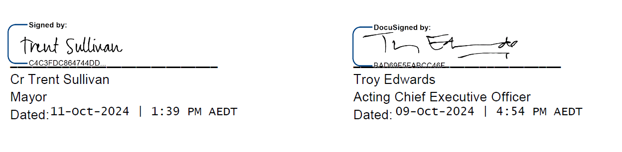

STATUTORY INFORMATION

The following information is provided in accordance with legislative and other requirements applying to Council.

Public Transparency Policy
This policy describes the ways in which Council information is to be made publicly available and give effect to the public transparency principles prescribed in section 58 of the Act.

Publicly available information
Under the Act (and, in some cases the Local Government Act 1989), certain information must be made publicly available, namely:

- Register of Delegations made by Council
- Council and Delegated Committees meeting minutes
- Local Laws and any documents incorporated
- Council Plan
- Strategic Resource Plan
- Budget
- Annual Report
- Councillor Code of Conduct
- Procurement Policy
- Register of interests
- Reappointment of Chief Executive Officer (CEO) without advertisement
- Differential Rates
- Summary of Campaign Donation Returns.

The following information will also be made publicly available to ensure our community is informed, and can benefit from, access to information regarding Council’s functions and operations:

- All adopted Council policies, plans and strategies
- Governance Rules
- Composition, Terms of Reference, Agendas and Minutes of Council Meetings, Committees and Groups
- Code of Conduct for Council employees
- Register of Delegations made by the CEO
- Register of Authorised Officers
- Register of Interstate and Overseas Travel by councillors and employees
- Register of Land Leases entered into by Council
- Register of Donations and Grants made by Council
- Register of Contracts Awarded by Council
- Details of any Council Land proposed for Sale or Exchange.

Under various other Acts administered by Council, the following information will be made publicly available:

- Register of Planning Permits
- Register of Planning Applications on Advertising
- Copy of Planning Permits and Endorsed Plans (by application, charges will apply)
- Register of Building Permits, Occupancy Permits and Temporary Approvals
- Copies of Building Permits, plans and documentation (by application, charges will apply)
- Register of Animal Registrations
- Register of Public Roads
- Freedom of Information (FOI) Part II Statement.

Access to information
The Freedom of Information Act 1982 (FOI Act) gives you the right to apply for access to documents held by the City. We are committed to, where possible, proactive and informal release of information in accordance with the Freedom of Information Professional Standards issued by the Victorian Information Commissioner.
A list of available information is provided in the Part II Statement (Statement) published on our website in accordance the FOI Act. This Statement requires government agencies and local councils to publish a number of statements designed to assist members of the public in accessing the information it holds.

Information privacy
We are committed to protecting people's right to privacy and the responsible and fair handling of personal information, consistent with the Privacy and Data Protection Act (Vic) 2014 and Health Records Act (Vic) 2001.
Our policies set out our requirements for the managing and handling of personal information. The policies are public documents which are available on request, or via our website.

Freedom of Information
In accordance with section 7(4AA)(a) and 7(4AA)(b) of the FOI Act, we are required to publish certain statements in the Annual Report or separately, such as on our website, concerning our functions and information available. We have chosen to publish the statements separately; however, the following summarises the application and operation of the FOI Act.
Access to documents that are not publicly available may be obtained through written request to the Freedom of Information Officer, as detailed in section 17 of the FOI Act and in summary as follows:
- it should be in writing
- it should identify the document being requested as clearly as possible
- it should be accompanied by the appropriate application fee (the fee may be waived in certain circumstances).
Requests can also be lodged online, or by email.
Access charges may also apply once documents have been processed and a decision on access has been made, for example, photocopying, and search and retrieval charges.
Further information regarding freedom of information can be found at ovic.vic.gov.au/freedom-of-information and on our website (www.geelongaustralia.com.au/governance).

Public interest disclosure procedures
In accordance with section 69 of the Public Interest Disclosure Act 2012 (the Act), our website (www.geelongaustralia.com.au/governance) provides information about making a public interest disclosure.
The Act aims to ensure openness and accountability in government by encouraging people to disclose improper conduct within the public sector and provide protection for people who make disclosures.

Contracts
During 2023–24, the following contracts entered into by Council were valued above the contract value at which the Council must invite a tender or seek an expression of interest under its Procurement Policy.
TABLE 11: List of contracts entered into by Council valued above the contract value at which the Council must invite a tender or seek an expression of interest under its Procurement Policy
Contract No | Contract Title | Contract No | Contract Title
C2400092 | Geelong Preventative Health Survey | C2300109 | Event Producer Surround Sounds 2024
C2400087 | Geelong Cricket Ground Kardinia Park | C2300136 | The Basin Boardwalk Project
C2400084 | Enterprise Storage Solution | C2300134 | Hard surface Program Contractor Panel
C2400077 | Supply and Delivery of Janitorial & Cleaning Products | C2300132 | Mobile Garbage Bin Cleaning
C2400066 | Geelong Youth Hub Construction | C2300131 | Bell Park Changerooms Redevelopment
C2400062 | Early Intervention Program | C2300129 | Poppy Kettle Playground Upgrade
C2400059 | New Drysdale Depot Sheds Project | C2300133 | Provision of General Maintenance to Council Owned Buildings
C2400058 | Eastern Beach Promenade Pile Wrapping | C2300125 | Street Sweeper Waste Disposal
C2400061 | Road Condition Data Capture | C2300124 | Baanip Boulevard Boundary Road Intersection - Construction Services
C2400055 | Wallington Reserve Cricket Practice Redevelopment | C2300123 | Flood Assessment Support
C2400054 | Seawall Renewal - Bob McGovern Path, Geelong | C2300120 | Tree Maintenance Services
C2400053 | Landy Field Track Replacement | C2300119 | Tree Planting and Establishment
C2400052 | Recycled Asphalt Crushing | C2300118 | Norlane Bowling Club -Bowling Green Remediation Project
C2400047 | Integrated Planning and Performance Reporting Software | C2300117 | Central Geelong Stormwater Management Strategy
C2400051 | Server Hardware | C2300121 | Provision of Laboratory and Analytical Services
C2400046 | Family Services Review & Strategic Workforce Planning | C2300116 | Grinding and Decontamination Services
C2400045 | Old Court House - Passenger Lift Replacement | C2300115 | Leopold Tennis Pavilion Design and Construct Project
C2400048 | Open Space – Fencing | C2300111 | Geelong Arena - HVAC Works
C2400044 | St Helens Park Shelter Upgrade | C2300110 | Geelong Arena Roof Drainage Works
C2400043 | South Geelong Stormwater Management Strategy | C2300108 | Lara Recreation Reserve - Baseball Field Construction Services
C2400042 | Quantity Surveying - Horseshoe Bend Hub | C2300107 | St Leonards Foreshore Pavilion & Public Toilet
C2400041 | Design Services - Horseshoe Bend Community Hub | C2300105 | Kevin Hoffman Walk Boardwalk Construction
C2400040 | Grinter Reserve Cricket Practice Redevelopment | C2300101 | Temporary Disposal of Green Waste
C2400038 | Geelong Resource Recovery Centre & Transfer Station | C2300100 | Lookout Road Construction Works, Ocean Grove
C2400036 | Accessibility Improvements - Grovedale Hall | C2300095 | Integrated Planning and Performance Reporting Software
C2400037 | Anakie Reserve Netball Court and Sports Lighting Construction | C2300094 | Steampacket Gardens Public Lighting
C2400032 | Open Drain Condition Data Capture | C2300092 | Cricket Practice Net Construction – Osborne Park and Hurst Reserve
C2400031 | Executive Recruitment Services | C2300093 | Shared Path Construction - Edge Water Drive / Beacon Point Reserve, Clifton Springs
C2400030 | Provision of Debt Collection Services | C2300091 | Provision of Cleaning Services for Geelong Library & Heritage Centre
C2400026 | Geelong Arena Electrical Upgrade | C2300090 | Cleaning Services for Leisure Centres, Outdoor Pools and The Arena
C2400024 | Lift Maintenance | C2300087 | Collins Street Kerb & Channel and Footpath, Drysdale
C2400023 | Elcho Road East Precinct Structure Plan Trans Network | C2300086 | Tower Road Construction, Portarlington
C2400022 | Gravel Resheeting Trials 23/24 | C2300077 | Cricket Practice Net Construction - St Leonards Lake Reserve
C2400014 | 100783 - Grovedale Sports Club - LED Scoreboard | C2300079 | Barrands Lane Drainage Flood Mitigation, Drysdale
C2400013 | Graffiti Removal | C2300078 | Stephenson Street, Lara - Road Construction
C2400028 | 23−24 Bus Shelter Program - Design and Construct | C2300073 | Business Case - Regional Livestock and Rural Info Exchange Hub
C2400008 | 2023 Dust Suppression Program | C2300070 | Public Lighting Electrical Services
C2400004 | Annual Supply of Bituminous Spray Sealing Works | C2300063 | Sparrow Park Playground Renewal
C2400003 | Floating Christmas Tree - Lighting and Music Services | C2300064 | Skate Park Facility Repair Project
C2400002 | High Street and Barrands Lane Drainage Works, Drysdale | C2300061 | Provision of Fleet Telematics Services
C2400001 | Drysdale Sports Precinct Drainage | C2300057 | Lara to You Yangs Shared Trail
C2400005 | Building HVAC Maintenance | C2300055 | Seagull Paddock Footbridge Replacement - Design and Construct
C2300017 | St Leonards Skate Park - Construction Works | C2300047 | Request for Proposal - Aquatic Concourse Solution
C2300028 | Surround Sounds 2023 | C2300046 | Anakie Reserve Netball Court and Sports Lighting Construction
C2300027 | Supply & Installation of Gymnasium Equipment for Leisure Centres | C2300039 | Bell Park Sports Club (Pitch 2) - Lights and Electrical Upgrade
C2300031 | Aphrasia Street, Newtown Directional Drilling | C2300032 | Hard surface Program Contractor Panel
C2300023 | 100113 - Grovedale Kinder Upgrade | C2300045 | Provision of Laboratory Sampling and Analytical Services
C2300022 | Destination Charging Across Victoria Electric Vehicle Charger Stations - Electrical installation | C2300024 | Chilwell Library Upgrade

In addition, the following contracts are those that met the criteria for competitive processes but were signed off as exempt (sole source):
TABLE 12: Contracts that met the criteria for competitive processes but were signed off as exempt (sole source)
Contract No: | Description
T2400094 | Delivered Meals

Food Act Ministerial directions
In accordance with section 7E of the Food Act (Vic) 1984, we are required to publish a summary of any Ministerial Directions received during the financial year in our Annual Report, however we did not receive any in 2023–24.

Road Management Act Ministerial direction
In accordance with section 22 of the Road Management Act (Vic) 2004, a council must publish a copy or summary of any Ministerial direction in its Annual Report. No such ministerial directions were received during the financial year.

Charter of Human Rights and Responsibilities
In June 2006, the Victorian Parliament passed the Charter of Human Rights and Responsibilities Act (Vic) 2006 (the Charter). The Charter came into effect on 1 January 2008.
The Charter enshrines civil and political rights, and some cultural rights, into Victorian law, while promoting and protecting principles of freedom, respect, equality and dignity.
We consider the 20 human rights established by the Charter when delivering our services, developing our policies, or implementing our plans.

Local Laws
The following local laws remain current:
Neighbourhood Amenity Local Law 2014
This local law regulates activities of people and provides standards and conditions for specified activities to protect people in, or the environment of, the municipal district. The local law aims to achieve the following objectives that align with our overall objectives and strategies:
- to secure community safety
- to protect public assets
- to enhance neighbourhood amenity.
Council Meeting Procedures Local Law 2017
This local law regulates the use of the Common Seal and offence provisions relating to the conduct of Council and Delegated Committee meetings.

DOMESTIC ANIMAL MANAGEMENT PLAN UPDATE
Greater Geelong has one of the largest dog and cat populations of any Victorian municipality, with 35,909 registered dogs and 10,831 registered cats.
We have a legal obligation under the Domestic Animals Act (Vic) 1994 to prepare a four-year plan outlining how we will manage dogs and cats within our municipal boundaries and evaluate the progress of our plan in our Annual Report. Our Domestic Animal Management Plan (DAMP) identifies how council will:
- help pets, pet owners and the general community to live together
- protect the environment and local wildlife from the negative impacts of dogs and cats
- balance the needs of those who own pets with those who do not
- address animal management welfare and legal issues
- promote responsible pet ownership
- improve the experience of animal ownership.
The plan not only outlines our role in animal management, but is also intended to have an educational focus, encouraging and teaching community members that it is every owner’s responsibility to take care of their pets.
Council adopted the Domestic Animal Management Plan 2022–25 on 23 November 2021. Activities we have undertaken in the last 12 months in support of the plan include:
- Completing a review of the Dog Controls in Public Places Policy. New Dog Control Orders endorsed by Council on 22 August 2023 with changes made to eight locations in the municipality aimed at fairer access to public open spaces for the entire community with consideration to usage and safety.
- Completing a comprehensive review of cat confinement, following robust community consultation. A 24-hour confinement order was recommended however was not supported by Council. This project is now complete.
- Expanding our discount cat desexing program delivered from Geelong Animal Welfare Society (GAWS) including removing concession requirements and extending timeframes to ensure greater participation and support during a feline vaccine shortage.
- Commencing construction of a new dog park at Aldershot Reserve in St Albans Park, due for completion in July 2024. We also received state government funding for the development of a dog park in Sparrovale Reserve, Charlemont.
- Completing a redesign of all marketing material to ensure up to date, best practice information is readily available through all of our customer service centres and via our website.
- Participating in skill development activities to ensure capacity and capability of our Animal Management team members to support residents and their pets during and following emergencies. Team members joined the Building Resources and Capacity for Emergencies (BRACE) team to undertake training including Introduction to Emergency Management, Working in an Emergency Relief Centre, and Introduction to Psychological First Aid (Personal Support).
- Participating in an ERC training exercise to test our recently endorsed Animal Emergency Welfare Plan and ensure preparedness in the event of a municipal emergency.
- Participating in an on-call emergency response roster when extreme weather events were forecast.
- Completing the transfer to a digital platform for the impounding of animals at GAWS.
- Maintaining and updating an interactive dog walking map on our website to allow for the most up-to-date and informative relay of dog accessibility information to our community.
- Renewing our safety equipment for animal management employees and fleet.
- Embedding the use of safety lighting and variable scrolling messaging signs for our animal management fleet.
- Rebranding our animal management fleet, aligning messaging on the rear of all vehicles to reflect key ‘on leash’ messaging.
- Maintaining the use of a Patrol Survey for our employees to complete upon conclusion of each patrol, allowing for greater data collection and analysis.
- Refining the operations and use of noise monitoring devices in barking dog investigations.
- Completing a review and designing new signage in support of finalised dog control orders on land managed by Barwon Coast Committee of Management.
- Using both cat and dog mascot costumes at internal and community facing events, to garner greater engagement and interest, equally representing the domestic animal breeds we manage.
- Developing an annual marketing plan outlining key messages and projects to be promoted each month of the year through multiple media channels. These messages are planned to align with key dates in animal management such as annual registration, seasonal dog control orders changes and cat desexing promotions.
- Attending animal related and City run community events to promote responsible pet ownership.
- Renewing the authorisation of our Senior Animal Management employees for the administration of POCTA (Prevention of Cruelty to Animals) legislation.
- Participating in early career expos for City employees to promote employment pathways.
- Participating in information sessions for new immigrants to support their understanding of animal legislation and responsible pet ownership in Australia.
- Continuing development of relationships with community-based organisations for the welfare of animals in crisis situations.
- Ensuring the continued delivery of pound services through partnership with GAWS.
- Supporting the introduction of the Very Important Pooch Program, an initiative aimed at encouraging greater office attendance by City employees; recognising the health and wellbeing benefits dogs can bring to an office environment.
- Maintaining delivery of a 24-hour, seven day a week service to the community, despite population growth and resource challenges.
- Successfully prosecuting all animal management matters presented to the Magistrates Court.
- Commencing planning for community engagement in preparation for our next DAMP.

ACCESS AND INCLUSION ACTION PLAN UPDATE
We have a legal obligation under the Disability Act (Vic) 2006 to produce a disability action plan and evaluate its progress in the Annual Report.
Our Access and Inclusion Action Plan 2018–23 provides information on ways the City continues to work on building an accessible and inclusive community for all.
The plan, which was extended to 2023, aligns to the community’s 30-year vision, which includes the aspiration of being ‘An inclusive, diverse, healthy and socially connected community’. It also contributes to and supports Geelong’s UNESCO City of Design designation.
A final report, which outlines our progress against the goals and measures across the five years of the plan is available on the City of Greater Geelong website.
In 2023, the City conducted extensive community engagement to develop the next action plan. A draft Disability Access and Inclusion Plan 2024−28 was made available for public exhibition during June−July 2024.

TABLE 13: Key projects undertaken in 2023–24
KEY AREA | EXAMPLES OF 2023–24 ACTIONS
ACCESS  Improving access to places and spaces | Construction of the Norlane ARC (Aquatic Recreation Centre) which includes a Changing Places facility, accessible lifts to the performance stage, ramp access and hoist access to pools.  Completed accessibility upgrades at Drysdale Community Hub, St Stephens Tennis/Croquet Club, Anakie Reserve Social Room and Shell Reserve Changerooms.  Completed new accessible parking bays at Thomson Street (Belmont), The Terrace (Ocean Grove) and Shell Road (Ocean Grove).  Progressed planning for the new Rippleside Inclusive Playspace to the detailed design and tender stage.  Provided the Marveloo, a mobile accessible changing places facility, for use at a Give Where You Live fundraiser, Beyond the Valley Festival and Pitch Festival.
INCLUSION  Promoting inclusion and participation | Convened six meetings of our Access and Inclusion Advisory Committee with a quorum in attendance. Members have a lived experience of disability and advise us on our strategies and policies, projects and facility upgrades.  Engaged Access and Inclusion Advisory Committee members in 10 consultations including the Geelong Youth Hub, Horseshoe Bend Community Hub, Geelong Conference Centre and Eastern Beach Conservation Plan.  Developed and piloted an Accessible Events Checklist for City-run events.  Established sensory quiet time at Leisurelink.  Promoted and delivered the Sport4All Program, designed to help sporting clubs and schools become more accessible and inclusive to people with disability.  Conducted extensive community engagement to inform the development of the draft Disability Access and Inclusion Plan 2024−28. A total of 226 responses were received via online and hard copy surveys, community workshops and interviews. Of the 128 survey respondents, 48 per cent identified as people with disability, 39 per cent were carers or family members of people with disability, and 25 per cent worked in the disability sector. The Access and Inclusion Advisory Committee provided advice through this process.  Developed the new Reasonable Adjustment and Support Guide for community engagement to provide a consistent approach to accessible engagement and removing barriers to participation.
EMPLOYMENT  Reducing barriers to obtaining and maintaining employment | Offered employees e-learning on Disability Awareness and Creating Value through Inclusion & Diversity.  Initiated a new Access and Inclusion Employee Network.  Embedded reasonable adjustment provisions in employee onboarding.
INCLUSIVE ATTITUDES  Achieving tangible changes in attitudes and practices that discriminate against persons with a disability | Delivered an International Day of People with Disability event at the Geelong Library & Heritage Centre which included presentation of the 2023 Geelong Awards for People with Disability. Attended by more than 100 people, award categories included Achievement, Volunteering, and Leadership and Advocacy.  Conducted engagement and awareness raising activities for the development of the Disability Access and Inclusion Plan 2024−28.

DEVELOPMENT CONTRIBUTIONS PLAN (DCP) PROGRESS REPORT
In accordance with sections 46GM and 46QM of the Planning and Environment Act 1987, we must prepare and give a report to the Minister for Planning on infrastructure (not applicable to us) and development contributions including levies and works-in-kind that is published in our Annual Report.
Development contributions are payments or works-in-kind towards the provision of infrastructure made by the proponent of a new development.
For 2023–24, the following information about infrastructure and development contributions has been disclosed.

Development contributions
TABLE 14: Total DCP levies received in 2023–24
DCP NAME | YEAR  APPROVED | LEVIES RECEIVED IN 2023–24  FINANCIAL YEAR  ($)
DCP01 Armstrong Creek North East Industrial | 2010 | $0.00
DCP02 Jetty Road Urban Growth Area Stage 1 | 2012 | $0.00
DCP03 Armstrong Creek East Precinct | 2012 | $7,688,002.65
DCP04 Armstrong Creek West Precinct | 2013 | $507,306.27
DCP05 Armstrong Creek Horseshoe Bend Precinct | 2014 | $7,446,518.75
DCP06 Armstrong Creek Town Centre Precinct | 2014 | $0.00
DCP07 Lara West Urban Growth Area | 2014 | $6,760,174.75
DCP08 Central Road Drysdale | 2022 | $0.00
Total |  | $22,402,002.42

TABLE 15: DCP land, works, services or facilities accepted in-kind in 2023–24
DCP name and year approved | Project ID | Project description | Item purpose | Project value ($)
DCP03 Armstrong Creek East Precinct 2012 | DI_DR_1 | Armstrong Creek Drainage and Waterway Improvement Works - Section 1 (Barwon Heads Road to precinct boundary) | Drainage | $6,355,408.35
DCP03 Armstrong Creek East Precinct 2012 | DI_TR_1 | Off-road shared trail network | Trails | $211,764.87
DCP03 Armstrong Creek East Precinct 2012 | DI_TR_1 | Off-road shared trail network | Trails | $80,518.99
DCP03 Armstrong Creek East Precinct 2012 | DI_TR_1 | Off-road shared trail network | Trails | $118,424.98
DCP03 Armstrong Creek East Precinct 2012 | DI_TR_1 | Off-road shared trail network | Trails | $302,187.89
DCP03 Armstrong Creek East Precinct 2012 | DI_TR_1 | Off-road shared trail network | Trails | $77,588.78
DCP05 Armstrong Creek Horseshoe Bend Precinct 2014 | DI_DR_01b | Drainage Works - Boundary Road Pipeline to the crossing of the Transit Corridor - Construction of Pipeline | Drainage | $640,165.00
DCP05 Armstrong Creek Horseshoe Bend Precinct 2014 | DI_DR_01b | Drainage Works - Boundary Road Pipeline to the crossing of the Transit Corridor - Construction of Pipeline | Drainage | $1,259,679.52
DCP05 Armstrong Creek Horseshoe Bend Precinct 2014 | DI_LA_11 | Community Complex - NAC - Land | Land | $1,375,000.00
DCP05 Armstrong Creek Horseshoe Bend Precinct 2014 | DI_OS_5 | Playground Equipment - Local Parks x 6 | Open Space | $168,115.08
DCP05 Armstrong Creek Horseshoe Bend Precinct 2014 | DI_TR_1 | Shared Path Network - Off Road | Trails | $15,973.56
DCP05 Armstrong Creek Horseshoe Bend Precinct 2014 | DI_TR_1 | Shared Path Network - Off Road | Trails | $89,925.22
DCP05 Armstrong Creek Horseshoe Bend Precinct 2014 | DI_TR_1 | Shared Path Network - Off Road | Trails | $43,187.77
DCP04 Armstrong Creek West Precinct 2013 | DI_DR_07 | Drainage Works - Wetland retarding Basins (WLRB1) - construction | Drainage | $2,903,628.61
DCP04 Armstrong Creek West Precinct 2013 | DI_OS_6 | Playground Equipment - Local parks (5 no.) | Open Space | $146,794.87
DCP04 Armstrong Creek West Precinct 2013 | DI_TR_2 | Shared Path network - Offroad | Trails | $46,703.36
DCP04 Armstrong Creek West Precinct 2013 | DI_TR_2 | Shared Path network - Offroad | Trails | $58,802.00
DCP04 Armstrong Creek West Precinct 2013 | DI_TR_2 | Shared Path network - Offroad | Trails | $52,297.35
Total |  |  |  | $13,946,166.20

TABLE 16: Total DCP contributions received and expended to date (for DCPs approved after 1 June 2016)
DCP NAME  (YEAR APPROVED) | TOTAL LEVIES  RECEIVED  ($) | TOTAL LEVIES  EXPENDED  ($) | TOTAL WORKS-IN-KIND ACCEPTED  ($) | TOTAL DCP CONTRIBUTIONS RECEIVED (LEVIES AND WORKS-IN-KIND)  ($)
DCP08 Central Road Drysdale 2022 | $0.00 | $1,276,095.64 | $0.00 | $0.00
Total | $0.00 | $1,276,095.64 | $0.00 | $0.00

TABLE 17: Land, works, services or facilities delivered in 2023–24 from DCP levies collected
Project description | Project ID | DCP name and year approved | DCP fund expended ($) | Works-in-kind accepted ($) | Council's contribution ($) | Other contributions ($) | Total project expenditure ($) | Percentage of item delivered
Community Complex - NAC - Construction | DI_C_1 | DCP05 Armstrong Creek Horseshoe Bend Precinct 2014 | $225,359.70 |  |  |  | $225,359.70 | 1.11%
Sparrovale Wetlands - Management Plan | DI_DR_13 | DCP05 Armstrong Creek Horseshoe Bend Precinct 2014 | $377,023.29 |  |  |  | $377,023.29 | 5.72%
Land Acquisition - Horseshoe bend Road Section 3 (Boundary Road - Catholic school northern limit) | DI_LA_06 | DCP05 Armstrong Creek Horseshoe Bend Precinct 2014 | $505.12 |  |  |  | $505.12 | 0.07%
Drainage Works - Barwon Heads Road South Retarding Basin - Land | DI_LA_17 | DCP05 Armstrong Creek Horseshoe Bend Precinct 2014 | $1,453,393.58 |  |  |  | $1,453,393.58 | 71.80%
Drainage Works - Barwon Heads Road to Harriot Road - Land | DI_LA_18 | DCP05 Armstrong Creek Horseshoe Bend Precinct 2014 | $267,721.48 |  |  |  | $267,721.48 | 9.81%
Sparrovale Wetlands - Land (1 - 87 Grove Road, Armstrong Creek) | DI_LA_22 | DCP05 Armstrong Creek Horseshoe Bend Precinct 2014 | $194,843.46 |  |  |  | $194,843.46 | 9.02%
Land Acquisition - Boundary Road (Surf Coast Highway to Barwarre Road) - 412 Torquay Road | DI_LA_09a | DCP05 Armstrong Creek Horseshoe Bend Precinct 2014 | $44,519.09 |  |  |  | $44,519.09 | 7.77%
Sparrovale Wetlands - Land (109 - 215 Sparrovale Road Charlemont) | DI_LA_23 | DCP05 Armstrong Creek Horseshoe Bend Precinct 2014 | $358,801.50 |  |  |  | $358,801.50 | 4.29%
Library - Construction (contribution) | CI_CF_1 | DCP06 Armstrong Creek Town Centre Precinct 2014 | $14,151,667.51 |  |  |  | $14,151,667.51 | 69.69%
Land Acquisition - Boundary Road - 412 Torquay Road Armstrong Creek | DI_LA_3a | DCP06 Armstrong Creek Town Centre Precinct 2014 | $44,519.09 |  |  |  | $44,519.09 | 13.80%
Intersection - Surf Coast Highway and Boundary Road | DI_RO_01 | DCP06 Armstrong Creek Town Centre Precinct 2014 | $83,760.33 |  |  |  | $83,760.33 | 6.77%
Community Complex - NAC - Construction | DI_C_1 | DCP04 Armstrong Creek West Precinct 2013 | -$839,870.49 |  |  | $900,000.00 | -$839,870.49 | 0.00%
Intersection - GRR-4c and Connector (west of Airport Road) | DI_RO_01 | DCP04 Armstrong Creek West Precinct 2013 | $1,607,374.44 |  | $1,012,831.74 |  | $2,620,206.18 | 33.83%
Regional Community and Learning Hub | CI_CF_01 | DCP08 Central Road Drysdale 2022 | $20,372.64 |  |  |  | $20,372.64 | 3.92%
Regional Community and Learning Hub | C003 | DCP02 Jetty Road Urban Growth Area Stage 1 2012 | $133,591.07 |  | $180,013.96 |  | $313,605.03 | 3.92%
Library - Construction | CI_C_1 | DCP07 Lara West Urban Growth Area 2014 | $6,200.00 |  |  |  | $6,200.00 | 0.02%
Patullos Road (east) - road widening | DI_RO_7 | DCP07 Lara West Urban Growth Area 2014 | $714,439.25 |  |  |  | $714,439.25 | 14.36%
Armstrong Creek Drainage and Waterway Improvement Works - Section 1 (Barwon Heads Road to precinct boundary) | DI_DR_1 | DCP03 Armstrong Creek East Precinct 2012 |  | $6,355,408.35 |  |  | $6,355,408.35 | 75.23%
Off-road shared trail network | DI_TR_1 | DCP03 Armstrong Creek East Precinct 2012 |  | $211,764.87 |  |  | $211,764.87 | 3.63%
Off-road shared trail network | DI_TR_1 | DCP03 Armstrong Creek East Precinct 2012 |  | $80,518.99 |  |  | $80,518.99 | 1.58%
Off-road shared trail network | DI_TR_1 | DCP03 Armstrong Creek East Precinct 2012 |  | $118,424.98 |  |  | $118,424.98 | 2.03%
Off-road shared trail network | DI_TR_1 | DCP03 Armstrong Creek East Precinct 2012 |  | $302,187.89 |  |  | $302,187.89 | 5.18%
Off-road shared trail network | DI_TR_1 | DCP03 Armstrong Creek East Precinct 2012 |  | $77,588.78 |  |  | $77,588.78 | 1.33%
Drainage Works - Boundary Road Pipeline to the crossing of the Transit Corridor - Construction of Pipeline | DI_DR_01b | DCP05 Armstrong Creek Horseshoe Bend Precinct 2014 |  | $640,165.00 |  |  | $640,165.00 | 31.00%
Drainage Works - Boundary Road Pipeline to the crossing of the Transit Corridor - Construction of Pipeline | DI_DR_01b | DCP05 Armstrong Creek Horseshoe Bend Precinct 2014 |  | $1,259,679.52 |  |  | $1,259,679.52 | 61.00%
Community Complex - NAC - Land | DI_LA_11 | DCP05 Armstrong Creek Horseshoe Bend Precinct 2014 |  | $1,375,000.00 |  |  | $1,375,000.00 | 100.00%
Playground Equipment - Local Parks x 6 | DI_OS_5 | DCP05 Armstrong Creek Horseshoe Bend Precinct 2014 |  | $168,115.08 |  |  | $168,115.08 | 16.67%
Shared Path Network - Off Road | DI_TR_1 | DCP05 Armstrong Creek Horseshoe Bend Precinct 2014 |  | $15,973.56 |  |  | $15,973.56 | 0.27%
Shared Path Network - Off Road | DI_TR_1 | DCP05 Armstrong Creek Horseshoe Bend Precinct 2014 |  | $89,925.22 |  |  | $89,925.22 | 1.52%
Shared Path Network - Off Road | DI_TR_1 | DCP05 Armstrong Creek Horseshoe Bend Precinct 2014 |  | $43,187.77 |  |  | $43,187.77 | 0.73%
Drainage Works - Wetland retarding Basins (WLRB1) - construction | DI_DR_07 | DCP04 Armstrong Creek West Precinct 2013 |  | $2,903,628.61 |  |  | $2,903,628.61 | 77.59%
Playground Equipment - Local parks (5 no.) | DI_OS_6 | DCP04 Armstrong Creek West Precinct 2013 |  | $146,794.87 |  |  | $146,794.87 | 20.00%
Shared Path network - Offroad | DI_TR_2 | DCP04 Armstrong Creek West Precinct 2013 |  | $46,703.36 |  |  | $46,703.36 | 1.82%
Shared Path network - Offroad | DI_TR_2 | DCP04 Armstrong Creek West Precinct 2013 |  | $58,802.00 |  |  | $58,802.00 | 2.26%
Shared Path network - Offroad | DI_TR_2 | DCP04 Armstrong Creek West Precinct 2013 |  | $52,297.35 |  |  | $52,297.35 | 2.01%
Total |  |  | $18,844,221.06 | $13,946,166.20 | $1,192,845.71 | $900,000.00 | $33,983,232.97

ANNUAL FINANCIAL REPORT FOR THE YEAR ENDING 30 JUNE 2024

Our Financial Report and Performance Statement are prepared in accordance with the Australian Accounting Standards, the Local Government Act 2020 and Local Government Victoria’s model accounts.
The Financial Report and Performance Statement are audited by the Victorian Auditor-General’s agent and are approved in principle by both the Audit and Risk Committee and by Council. The reports are then forwarded to the Victorian Auditor-General’s Office for finalisation and an independent opinion.

Understanding the Financial Report and Financial Statements
The financial report consists of five financial statements, explanatory notes supporting the reports and endorsement from the Council and the Victorian Auditor-General.
The five financial statements are:
- a comprehensive income statement,
- a balance sheet,
- a statement of changes in equity,
- a cash flow statement, and
- a statement of capital works.
The explanatory notes detail the accounting policies applied and the make-up of the values contained in the statements.

Comprehensive income statement
The comprehensive income statement measures performance over the year.
It lists revenue sources under various income headings, as well as the expenses incurred during the year. The expenses relate only to the operations and do not include the cost associated with the purchase or building of assets. Expenses include an item for depreciation, which is the value of the assets depleted during the year.

Balance sheet
The balance sheet shows the assets owned and what is owed (liabilities) as of 30 June 2024.
The bottom line of the balance sheet is net assets, which is the net worth built up over time.
Assets and liabilities are separated into current and non-current. Current refers to assets or liabilities falling due within the next 12 months (except long service leave – refer to note 5.5 within the notes to the accounts section of this report).

Statement of changes in equity
The statement of changes in equity summarises the change in value of total ratepayer equity. The value of equity can only change as a result of:
- profit or loss from operations, described as surplus or deficit in the income statement,
- use of monies from reserves, and
- a change in the value of non-current assets, resulting from a revaluation of these assets.

Cash flow statement
The cash flow statement summarises cash payments and receipts for the year, as well as the level of cash at the end of the financial year.
Cash in this statement refers to bank deposits and investments which can be quickly converted to cash.
Cash arises from, and is used in, three main areas:
- Cash flows from operating activities summarises all income and expenses relating to operations, including service delivery and maintenance,
- Cash flows from investing activities relates to capital works payments recorded as assets in the balance sheet, as well as receipts for the sale of assets, and
- Cash flows from financing activities represents repayments of and receipts from loans.

Statement of capital works
This statement provides detail of capital expenditure by asset type and distinguishes renewal, upgrade, and new capital expenditure.

Notes to the accounts
The notes to the accounts enable the user to understand the basis on which the values shown in the accounts are established. The notes also advise if there has been any change to the accounting standards, policy or legislation which has impacted on how the standards were prepared.
Within the five financial statements, there is a note column indicating additional information. This is particularly useful where there has been a significant change from the previous year’s comparative figure.

Statements by the Principal Accounting Officer, Chief Executive Officer and councillors
The Financial Statements and the Performance Statement require certification under the Local Government Act 2020. The certifications are made by a combination of the Principal Accounting Officer, the Chief Executive Officer and two councillors, on behalf of the Council, as a written undertaking to the statements being correct and not misleading.

Victorian Auditor-General’s report
This document provides a written undertaking of the accuracy, fairness, and completeness of the accounts.
The audit report from the Victorian Auditor-General provides an independent view of the statements and advises the reader if there are any issues of concern.

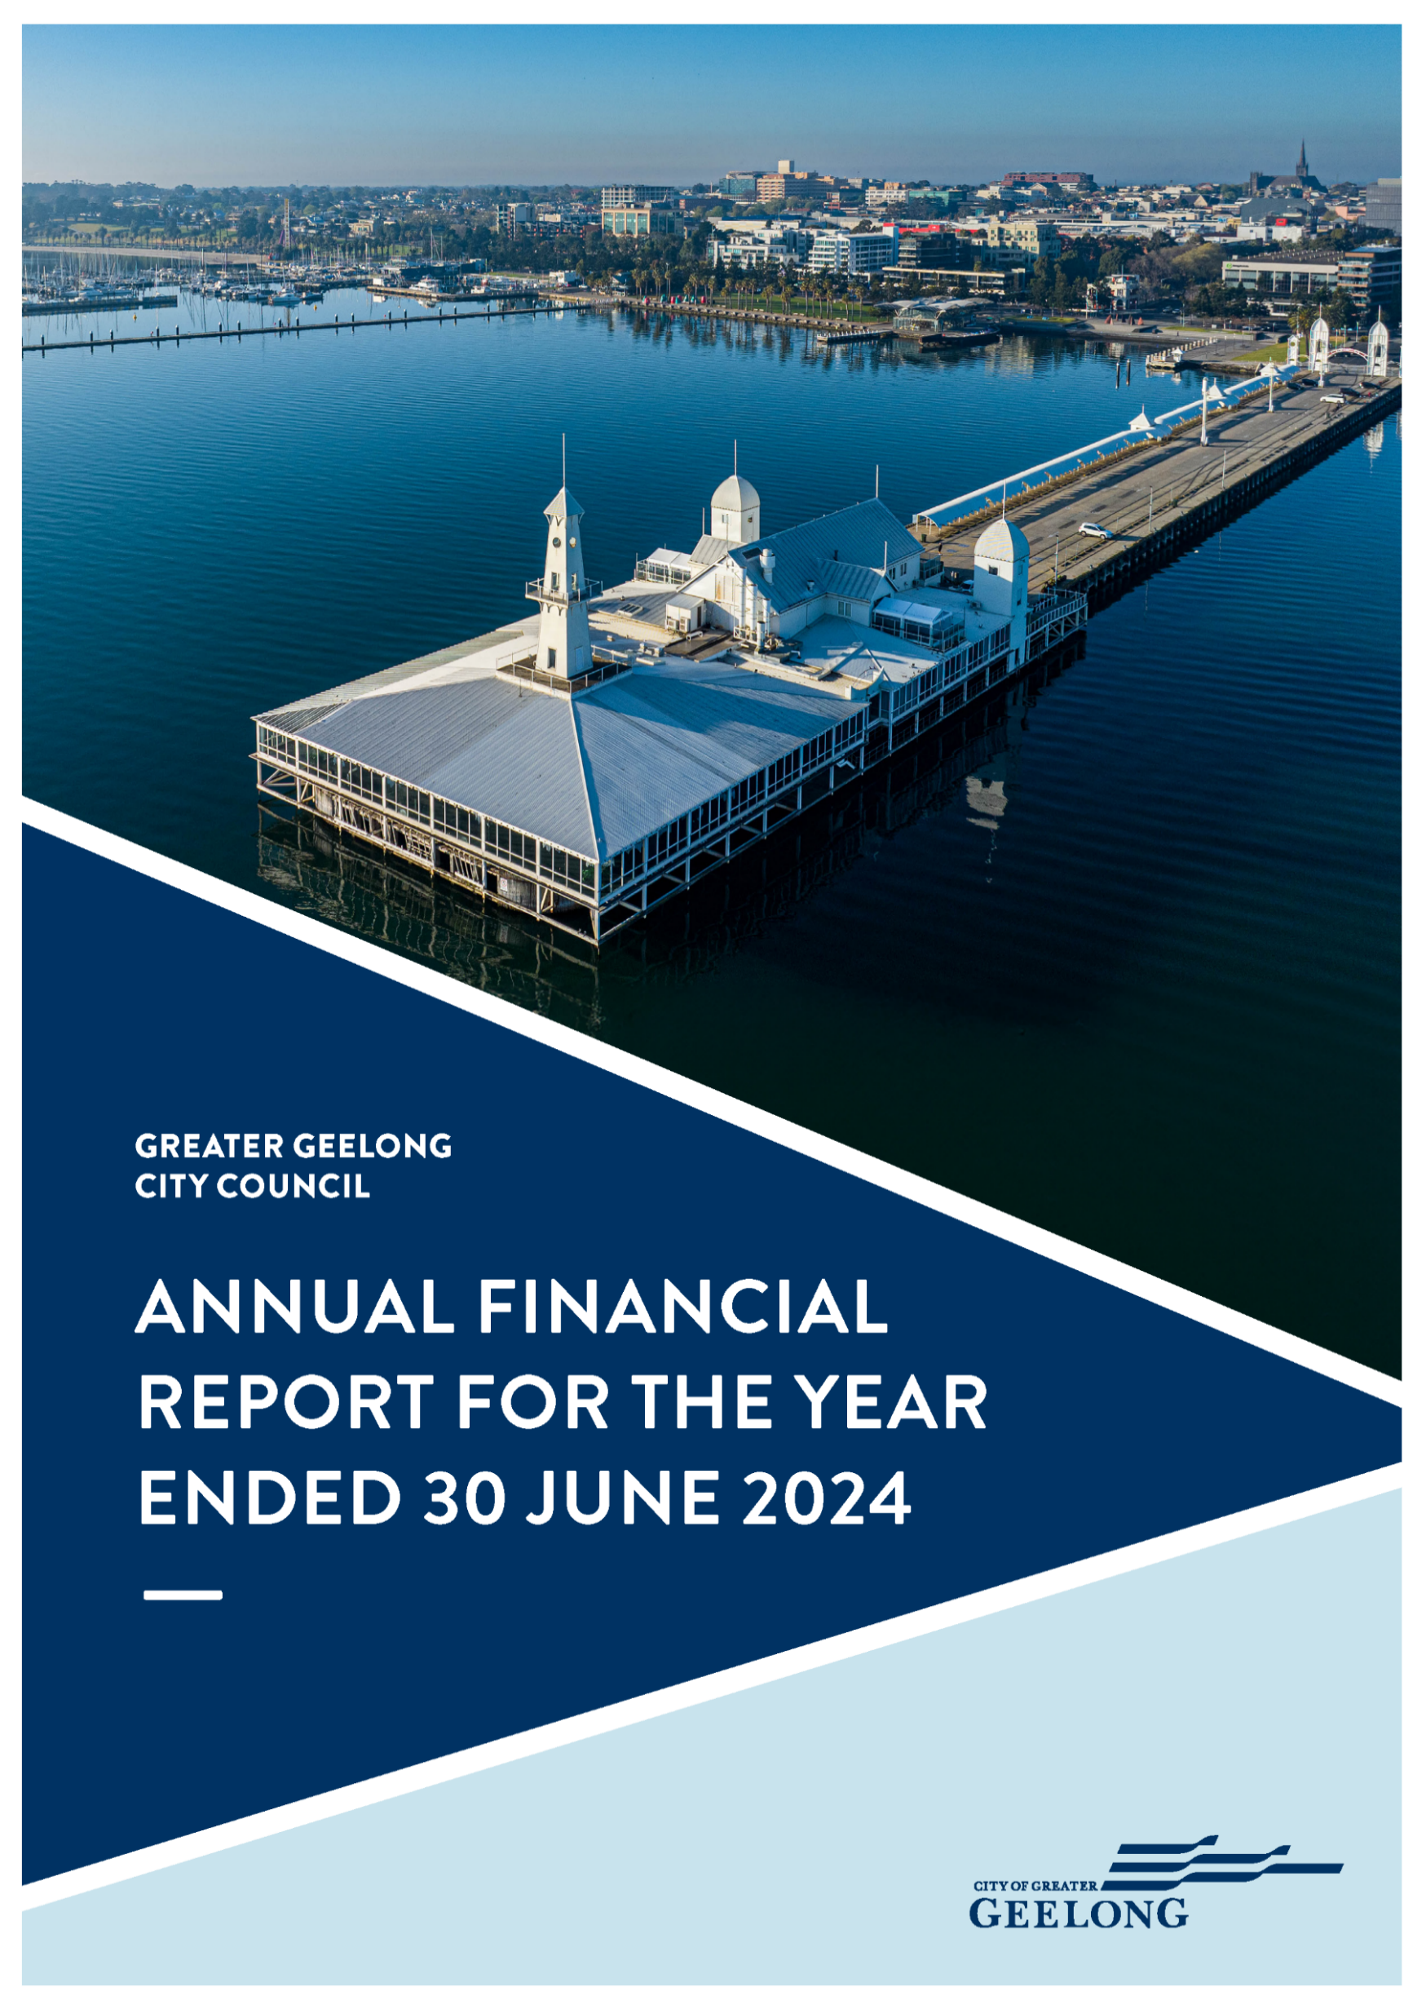

For a full copy of the Annual Financial Report, refer to The City of Greater Geelong Annual Report 2023-24 Part 2 – Financial Report located on geelongaustralia.com.au/annualreport



PERFORMANCE STATEMENT
THE GREATER GEELONG CITY COUNCIL
PERFORMANCE STATEMENT
For the year ended 30 June 2024

CONTENTS

Section 1. Description of municipality 126
Section 2. Sustainable Capacity Indicators 127
Section 3. Service Performance Indicators 129
Section 4. Financial Performance Indicators 133
Section 5. Notes to the accounts 138
5.1 Basis for preparation 138
5.2 Definitions 138
5.3 Other Matters 140
CERTIFICATION OF THE PERFORMANCE STATEMENT 141
INDEPENDENT AUDITOR’S REPORT OF THE PERFORMANCE STATEMENT 2023–24 142

Section 1. Description of municipality
For the year ended 30 June 2024
The City of Greater Geelong, Victoria’s largest regional municipality, is located 75 kilometres southwest of Melbourne and is bound by the Moorabool Shire in our north, Wyndham City Council and the Borough of Queenscliffe in our east, Surf Coast Shire and Golden Plains Shire in our west, and Bass Strait to our south.
Covering an area of 1,247 square kilometres, the region is characterised by the multi-award winning Waterfront overlooking Corio Bay, the picturesque Bellarine Peninsula, the Barwon River, You Yangs Regional Park, wetlands, beautiful parklands and wildlife sanctuaries. Geelong is also the gateway to the world-renowned coastline of south-west Victoria via the Great Ocean Road. With over 282,000 people, the population is forecast to grow to more than 396,000 by 2041 – an increase of over 35 per cent8F.

Section 2. Sustainable Capacity Indicators
For the year ended 30 June 2024
INDICATOR/MEASURE | RESULTS |  |  |  | COMMENTS
INDICATOR/MEASURE | 2021 | 2022 | 2023 | 2024 | COMMENTS
Population
C1  Expenses per head of population  [Total expenses / Population] | $1,504.49 | $1,578.97 | $1,682.45 | $1,763.19 | There are ongoing business as usual impacts from the COVID-19 period which have resulted in increased costs for the city.
C2  Infrastructure per head of population  [Value of infrastructure / Population] | $8,596.71 | $11,311.66 | $12,719.95 | $13,295.91 | There are ongoing business as usual impacts from the COVID-19 period which have resulted in increased costs for the city.
C3  Population density per length of road  [Population / Kilometres of local roads] | 112.57 | 114.13 | 116.46 | 116.19 | In 2023−24, the increase in length of local roads was marginally higher than the increase in population.
Own-source revenue
C4  Own-source revenue per head of population  [Own source revenue / Population] | $1,197.71 | $1,290.16 | $1,407.78 | $1,392.30 | There are ongoing business as usual impacts from the COVID-19 period which has resulted in revenue for the city.
Recurrent grants
C5  Recurrent grants per head of population  [Recurrent grants / Population] | $239.27 | $291.32 | $289.54 | $166.35 | Budgeted grant funding was received in July 2024 and not June 2024.
Disadvantage
C6  Relative Socio-Economic Disadvantage  [Index of Relative Socio-Economic Disadvantage by decile] | 6.00 | 6.00 | 6.00 | 6.00 | Greater Geelong's Relative Socio-Economic Disadvantage Index from the 2021 Census was in the sixth decile. The first decile indicates the most disadvantaged and the tenth decile indicates the least disadvantaged. We acknowledge that there are areas experiencing significant disadvantage and others with low disadvantage within the municipality.
Workforce turnover
C7  Percentage of staff turnover  [Number of permanent staff resignations and terminations / Average number of permanent staff for the financial year] x100 | 11.08% | 15.77% | 14.73% | 12.78% | Employee turnover at the City continues to trend towards pre-pandemic rates, reflecting broader economic and job market conditions. This improvement also highlights the organisation’s recent focus on being the best local government employer in Australia. Notably, the City’s turnover rate remains well below the Victorian Public Sector average of 18.1% in 2023.

Section 3. Service Performance Indicators
For the year ended 30 June 2024
INDICATOR/MEASURE | RESULTS |  |  |  |  | COMMENTS
INDICATOR/MEASURE | 2021 | 2022 | 2023 | 2024 |  | COMMENTS
INDICATOR/MEASURE | Actual | Actual | Actual | Target as per budget | Actual | COMMENTS
Aquatic Facilities
AF6  Utilisation  Utilisation of aquatic facilities  [Number of visits to aquatic facilities / Population] | 3.32 | 4.73 | 7.21 | Not applicable | 7.01 | Participation at our leisure venues continued to be strong in 2023−24. The slight decrease in result was most likely due to a service disruption where Waterworld was permanently closed six months before the new Norlane ARC (Aquatic Recreation Centre) was opened.
Animal Management
AM7  Health and safety  Animal management prosecutions  [Number of successful animal management prosecutions / Number of animal management prosecutions] x100 | 100.00% | 100.00% | 100.00% | Not applicable | 100% | We continued to successfully prosecute all matters brought before the court, with 15 successful animal management prosecutions in 2023−24.
Food Safety
FS4  Health and safety  Critical and major non-compliance outcome notifications  [Number of critical non-compliance outcome notifications and major non-compliance notifications about a food premises followed up / Number of critical non-compliance outcome notifications and major non-compliance notifications about a food premises] x100 | 95.45% | 100.00% | 90.76% | Not applicable | 93.46% | Employee turnover and difficulties recruiting qualified officers again impeded our ability to meet program targets. We will continue to provide a prioritised response to critical and major non-compliance notifications.
Governance
G2  Satisfaction  Satisfaction with community consultation and engagement  [Community satisfaction rating out of 100 with how council has performed on community consultation and engagement] | 57 | 54 | 52 | 55 | 49 | Satisfaction with consultation and engagement continued to decline. This trend is on par with regional centres, but lower than metro councils' decline. While there are broader factors negatively influencing people’s satisfaction with council (financial sustainability, population growth, cost of living), we will focus on expanding feedback channels, and implementing more outreach initiatives to foster greater community involvement and build trust.
Libraries
LB7  Participation  Library membership  [The number of registered library members / Population] x100 | New for 2024 |  |  | Not applicable | 28.60% | Given this is a new indicator for 2023−24, there are no comparative results from previous years. Drysdale and Leopold Libraries reported increases in membership in 2023−24 showing new members are utilising the two newest facilities in the council area.
Maternal and Child Health (MCH)
MC4  Participation  Participation in the MCH service  [Number of children who attend the MCH service at least once (in the year) / Number of children enrolled in the MCH service] x100 | 72.56% | 74.40% | 73.61% | Not applicable | 73.88% | There were 13,260 children enrolled in the City’s MCH service of which 9,796 attended at least once in the year. This participation rate, calculated across all key age checks, reflects the gradual reduction in participation in later visits which will require innovative approaches to increase the rate of 18 month, 2 year and 3.5 year checks.
MC5  Participation  Participation in the MCH service by Aboriginal children  [Number of Aboriginal children who attend the MCH service at least once (in the year) / Number of Aboriginal children enrolled in the MCH service] x100 | 77.47 | 72.02% | 71.62% | Not applicable | 75.29% | There were 216 children who identify as Aboriginal or Torres Strait Islander (ATSI) enrolled in the City’s MCH service, of which 163 attended at least once in the year. The higher rate of participation by ATSI families may be a result of efforts to provide culturally safe & inclusive practice.
Roads
R2  Condition  Sealed local roads maintained to condition standards  [Number of kilometres of sealed local roads below the renewal intervention level set by / Kilometres of sealed local roads] x100 | 95.26% | 94.76% | 95.59% | 94.73% | 96.30% | The proportion of roads maintained to condition standards increased slightly but was relatively consistent with the previous years.
Statutory Planning
SP2  Service standard  Planning applications decided within required time frames  [Number of planning application decisions made within 60 days for regular permits and 10 days for VicSmart permits / Number of planning application decisions made] x100 | 80.90% | 78.70% | 75.05% | 70.00% | 78.60% | There has been an improvement in the processing times based on the reduction in the overall planning permit applications received and the increased processing efficiencies of employees.
Waste Collection
WC5  Waste diversion  Kerbside collection waste diverted from landfill  [Weight of recyclables and green organics collected from kerbside bins / Weight of garbage, recyclables and green organics collected from kerbside bins] x100 | 53.87% | 52.96% | 53.21% | 52.32% | 50.99% | The slight decrease in diversion rate is due to a decrease in the tonnage of recyclables collected following the introduction of the state government's Container Deposit Scheme.  There has also been a reduction in tonnage of green waste collected.

Section 4. Financial Performance Indicators
For the year ended 30 June 2024
INDICATOR/MEASURE | RESULTS |  |  |  |  |  |  |  |  | COMMENTS
INDICATOR/MEASURE | 2021 | 2022 | 2023 | 2024 |  | 2025 | 2026 | 2027 | 2028 | COMMENTS
INDICATOR/MEASURE | Actual | Actual | Actual | Target  as per budget | Actual | Forecast | Forecast | Forecast | Forecast | COMMENTS
Efficiency
E2 Expenditure level  Expenses per property assessment  [Total expenses / Number of property assessments] | $3,088.94 | $3,199.59 | $3,339.68 | $3,294 | $3,511.60 | $3,387.51 | $3,518.34 | $3,630.97 | $3,735.88 | The financial performance for FY2024 has improved with several initiatives implemented. Expense per property assessment is due to the growth in the number of rateable properties.
E4 Revenue level  Average rate per property  [Total rate revenue / Number of property assessments] | $1,639.93 | $1,661.65 | $1,660.37 |  | $1,728.27 | $2,229.88 | $2,329.34 | $2,407.38 | $2,494.58 | The average rate per property is likely to grow in line with the forecast annual rate cap
Liquidity
L1 Working capital  Current assets compared to current liabilities  [Current assets / Current liabilities] x100 | 140.29% | 148.04% | 134.85% | 136.16% | 162.78% | 136.98% | 138.15% | 107.80% | 123.54% | To support the City's requirement for strong liquidity, it holds close to $100 million in cash and cash equivalents (term deposits). The City's financial position is forecast to be maintained at its current level into FY2025.
L2 Unrestricted cash  Unrestricted cash compared to current liabilities  [Unrestricted cash / Current liabilities] x100 | 97.96% | 48.08% | 33.34% |  | 29.58% | 63.02% | 60.35% | 44.09% | 54.81% | To support the City's requirement for strong liquidity, it holds close to $100million in cash and cash equivalents (term deposits)
Obligations
O2 Loans and borrowings  Loans and borrowings compared to rates  [Interest bearing loans and borrowings / Rate revenue] x100 | 45.94% | 51.85% | 44.41% |  | 60.56% | 58.43% | 56.64% | 54.12% | 52.00% | On an own revenue basis this is below 60% which is an important covenant for the City's borrowings. Borrowings increased as outlined in the budget to deliver the infrastructure the City needs.
O3 Loans and borrowings  Loans and borrowings repayments compared to rates  [Interest and principal repayments on interest bearing loans and borrowings / Rate revenue] x100 | 5.29% | 4.46% | 5.39% |  | 4.36% | 5.42% | 7.84% | 5.28% | 5.42% | The majority of existing loans with banks are on a principal and interest basis, the new Treasury Corporation Victoria loans are on interest only.
O4 Indebtedness  Non-current liabilities compared to own source revenue  [Non-current liabilities / Own source revenue] x100 | 39.46% | 41.81% | 35.72% |  | 51.23% | 48.86% | 49.25% | 46.84% | 44.78% | The majority of existing loans with banks are on a principal and interest basis, the new Treasury Corporation Victoria loans are on interest only.
O5 Asset renewal and upgrade  Asset renewal and upgrade expense compared to depreciation  [Asset renewal and asset upgrade expenditure / Asset depreciation] x100 | 57.65% | 68.94% | 65.72% | 76.26% | 71.00% | 97.68% | 88.97% | 57.25% | 51.48% | A number of new assets have come online in 2023−24, increasing depreciation but not requiring renewal.
Operating Position
OP1 Adjusted underlying result  Adjusted underlying surplus (or deficit)  [Adjusted underlying surplus (or deficit) / Adjusted underlying revenue] x100 | 5.61% | 9.33% | 8.33% |  | -12.85% | 4.85% | 6.53% | 6.16% | 1.55% | Financial performance in FY2024 has improved with several initiatives implemented resulting an increased forecast surplus of $2.793million, however, a deficit of $17.658million was the result due to budgeted grant funded being received in July 2024 not June 2024. On an adjusted basis a small surplus would have been achieved for FY2024. It was noted in preparing the FY2024 funding from the Federal Government which had been received early in prior years did transfer some risk into FY2024.
Stability
S1 Rates concentration  Rates compared to adjusted underlying revenue  [Rate revenue / Adjusted underlying revenue] x100 | 60.37% | 57.58% | 56.45% | 66.82% | 69.16% | 62.63% | 61.88% | 62.22% | 65.74% | The rate cap for FY2024 was 3.5%, revenue from other sources grew at a slower rate.
S2 Rates effort  Rates compared to property values  [Rate revenue / Capital improved value of rateable properties in the municipality] x100 | 0.33% | 0.33% | 0.27% |  | 0.26% | 0.27% | 0.28% | 0.29% | 0.31% | Rates revenue and Capital Improved Value increases are likely to remain stable.

Section 5. Notes to the accounts

Basis for preparation
Council is required to prepare and include a performance statement within its Annual Report. The performance statement includes the results of the prescribed sustainable capacity, service performance, and financial performance indicators and measures, together with a description of the municipal district and an explanation of material variations in the results. This statement has been prepared to meet the requirements of the Local Government Act 2020 and Local Government (Planning and Reporting) Regulations 2020.
Where applicable, the results in the performance statement have been prepared on accounting bases consistent with those reported in the Financial Statements. The other results are based on information drawn from our information systems, or from third parties, such as the Australian Bureau of Statistics (ABS).
The performance statement presents the actual results for the current year and for the prescribed financial performance indicators and measures, the results forecast by the council’s strategic resource plan. The Local Government (Planning and Reporting) Regulations 2020 requires explanation of any material variations in the results contained in the performance statement. Council applied a materiality threshold to all indicators and provided commentary for all indicators regardless of whether the variance was considered to be material.
The forecast figures included in the performance statement are those adopted by Council in its 2024−25 budget on 25 June 2024. The annual budget includes estimates based on key assumptions about the future that were relevant at the time of adoption and aimed at achieving sustainability over the long-term. Detailed information on the actual financial results is contained in the General Purpose Financial Statements. The annual budget and long-term financial plan are available on the City’s website or on request.

Definitions
Key term | Definition
Adjusted underlying revenue | means total income other than:  (a) non-recurrent grants used to fund capital expenditure; and  (b) non-monetary asset contributions; and  (c) contributions to fund capital expenditure from sources other than those referred to above
Infrastructure | means non-current property, plant and equipment excluding land
Local road | means a sealed or unsealed road for which the council is the responsible road authority under the Road Management Act 2004
Population | means the resident population estimated by council
Own-source revenue) | means adjusted underlying revenue other than revenue that is not under the control of council (including government grants)
Relative socio-economic disadvantage | in relation to a municipality, means the relative socio-economic disadvantage, expressed as a decile for the relevant financial year, of the area in which the municipality is located according to the Index of Relative Socio-Economic Disadvantage (Catalogue Number 2033.0.55.001) of SEIFA
SEIFA | means the Socio-Economic Indexes for Areas published from time to time by the Australian Bureau of Statistics on its website
Unrestricted cash | means all cash and cash equivalents other than restricted cash
Aboriginal child | means a child who is an Aboriginal person
Aboriginal person | has the same meaning as in the Aboriginal Heritage Act 2006
Active library borrower | means a member of a library who has borrowed a book from the library
Annual Report | means an Annual Report prepared by a council under section 98 of the Act
‘Class 1 food premises’ | means food premises, within the meaning of the Food Act 1984, that have been declared as class 1 food premises under section 19C of that Act
‘Class 2 food premises’ | means food premises, within the meaning of the Food Act 1984, that have been declared as class 2 food premises under section 19C of that Act
Critical non-compliance outcome notification | means a notification received by council under section 19N(3) or (4) of the Food Act 1984, or advice given to council by an authorised officer under that Act, of a deficiency that poses an immediate serious threat to public health
Food premises | has the same meaning as in the Food Act 1984
‘Local road’ | means a sealed or unsealed road for which the council is the responsible road authority under the Road Management Act 2004
Major non-compliance outcome notification | means a notification received by a council under section 19N(3) or (4) of the Food Act 1984, or advice given to council by an authorised officer under that Act, or a deficiency that does not pose an immediate serious threat to public health but may do so if no remedial action is taken
MCH | means the Maternal and Child Health Service provided by a council to support the health and development of children within the municipality from birth until school age
Population | means the resident population estimated by council
Adjusted underlying revenue | means total income other than:  (a) non-recurrent grants used to fund capital expenditure and  (b) non-monetary asset contributions and  (c) contributions to fund capital expenditure from sources other than those referred to above
Adjusted underlying surplus (or deficit) | means adjusted underlying revenue less total expenditure
Asset renewal expenditure | means expenditure on an existing asset or on replacing an existing asset that returns the service capability of the asset to its original capability
Current assets | has the same meaning as in the AAS
Current liabilities | has the same meaning as in the AAS
Non-current assets | means all assets other than current assets
Non-current liabilities | means all liabilities other than current liabilities
Non-recurrent grant | means a grant obtained on the condition that it be expended in a specified manner, and is not expected to be received again during the period covered by a council's strategic resource plan
Own-source revenue | means adjusted underlying revenue other than revenue that is not under the control of council (including government grants)
Population | means the resident population estimated by council
Rate revenue | means revenue from general rates, municipal charges, service rates and service charges
Recurrent grant | means a grant other than a non-recurrent grant
Residential rates | means revenue from general rates, municipal charges, service rates and service charges levied on residential properties
Restricted cash | means cash and cash equivalents, within the meaning of the AAS, that are not available for use other than for a purpose for which it is restricted, and includes cash to be used to fund capital works expenditure from the previous financial year
Unrestricted cash | means all cash and cash equivalents other than restricted cash

Other Matters
Overview of the year
Like many other governments and organisations, the City of Greater Geelong is feeling the impacts of inflation and rising costs. Our projects and services are under continuous financial pressure, meaning the development of our 2023−24 budget was challenging. To set ourselves up for long-term financial sustainability, we looked closely at our corporate expenses, external grants, sponsorships and funding to find savings and free up funds to invest back into the community. We also had to be realistic about what we could deliver in the short-term. While we did not reduce our capital projects budget, we couldn’t afford to deliver as many projects in total resulting in a number of projects being placed on hold until alternate funding sources can be identified.
Despite these challenges, in 2023−24 we continued to deliver new facilities and infrastructure and upgrade our existing assets to meet the needs of our growing municipality. We delivered a $139.5 million capital projects program including the new state-of-the-art Norlane ARC (Aquatic and Recreation Centre), Stage 1 of the North Bellarine Aquatic Centre and an upgrade to the Waurn Ponds Skate Park.

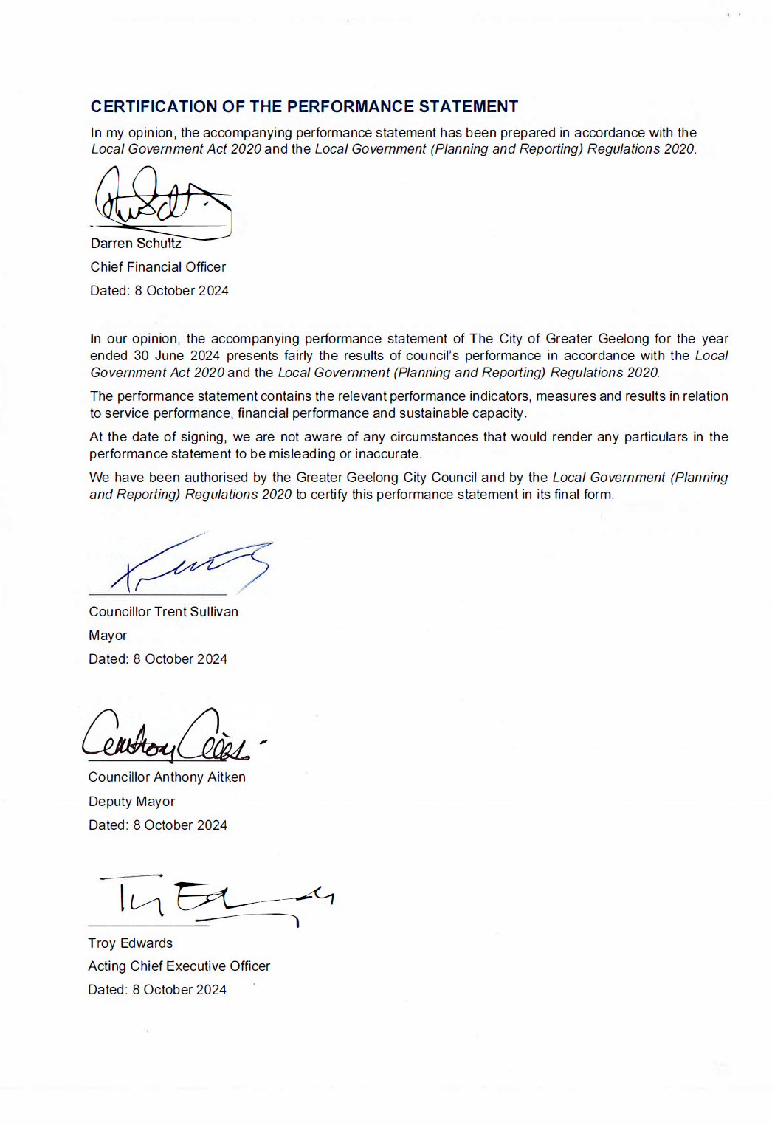
CERTIFICATION OF THE PERFORMANCE STATEMENT
In my opinion, the accompanying performance statement has been prepared in accordance with the Local Government Act 2020 and the Local Government (Planning and Reporting) Regulations 2020.

__________________
Darren Schultz
Chief Financial Officer
Dated: 08 October 2024

In our opinion, the accompanying performance statement of The City of Greater Geelong for the year ended 30 June 2024 presents fairly the results of council’s performance in accordance with the Local Government Act 2020 and the Local Government (Planning and Reporting) Regulations 2020.
The performance statement contains the relevant performance indicators, measures and results in relation to service performance, financial performance and sustainable capacity.
At the date of signing, we are not aware of any circumstances that would render any particulars in the performance statement to be misleading or inaccurate.
We have been authorised by the Greater Geelong City Council and by the Local Government (Planning and Reporting) Regulations 2020 to certify this performance statement in its final form.

__________________
Councillor Trent Sullivan
Mayor
Dated: 08 October 2024

__________________
Councillor Anthony Aitken
Deputy Mayor
Dated: 08 October 2024

__________________
Troy Edwards
Acting Chief Executive Officer
Dated: 08 October 2024

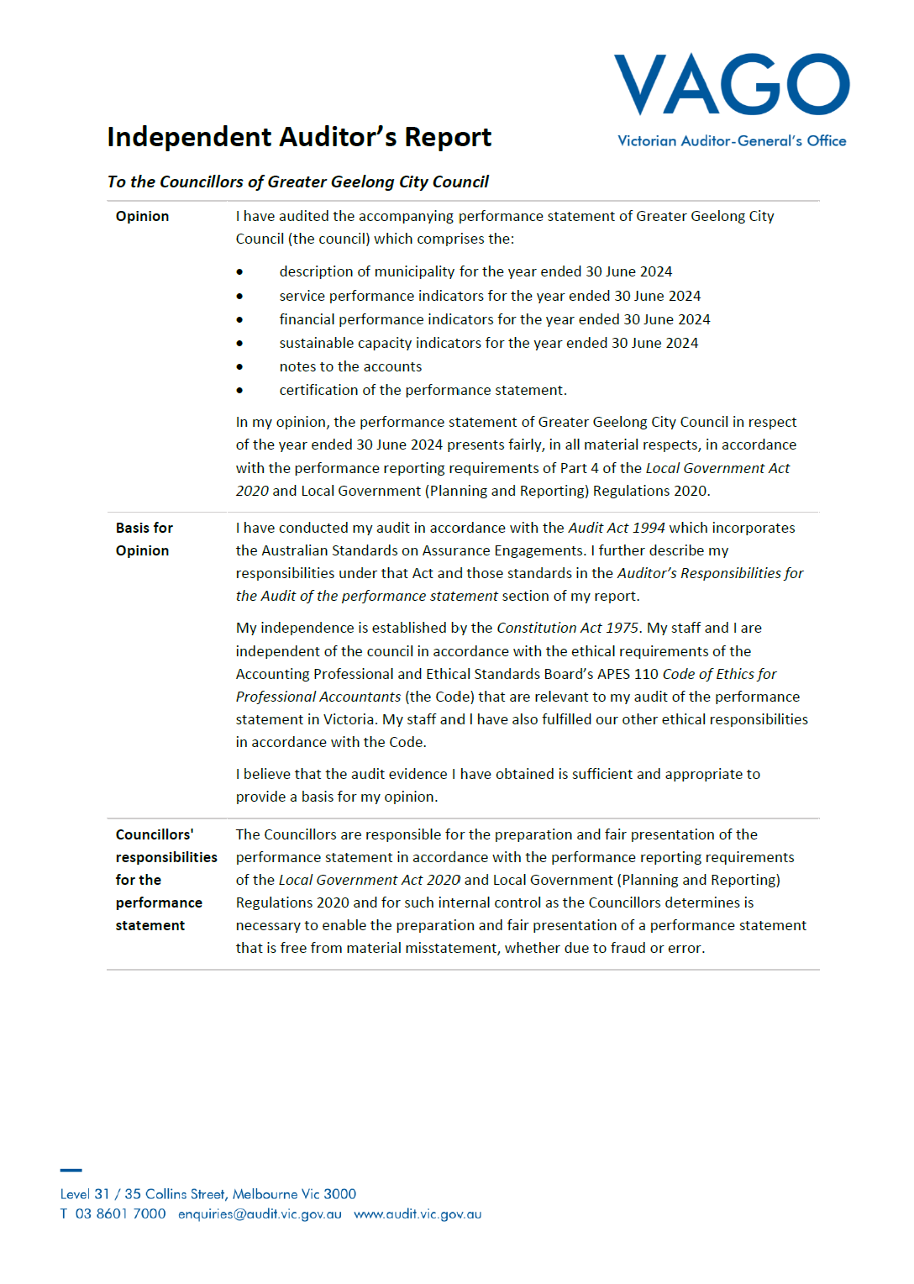
INDEPENDENT AUDITOR’S REPORT OF THE PERFORMANCE STATEMENT 2023–24

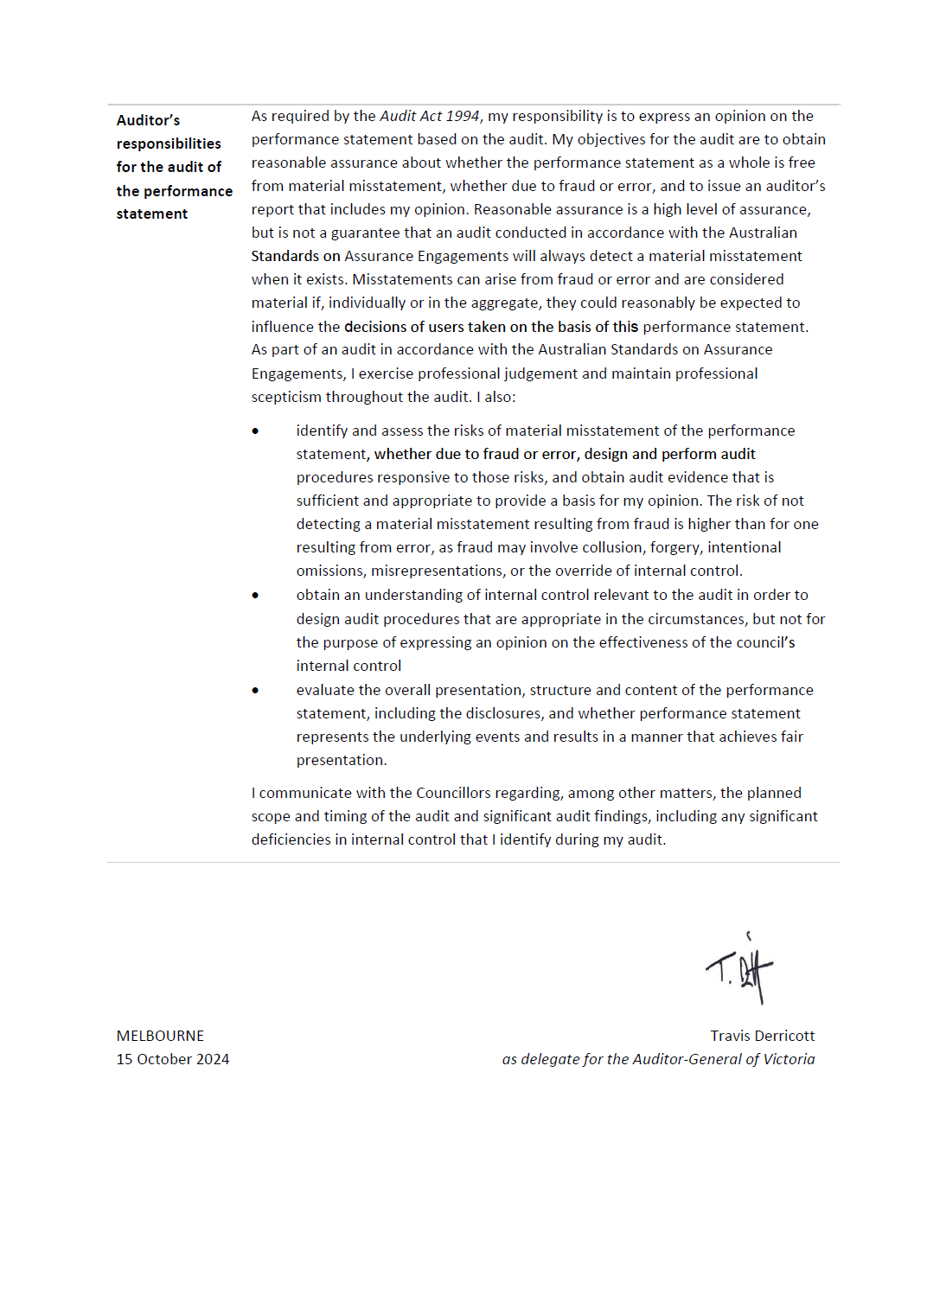



Australian Bureau of Statistics, Census of Population and Housing 2016 and 2021. Compiled and presented by .id (informed decisions).
Population and household forecasts, 2021 to 2041, prepared by .id (informed decisions), January 2023.
National Institute of Economics and Industry Research (NIEIR) 2024. Complied and presented in economy.id by .id (informed decisions).
City of Greater Geelong, Geelong Data Exchange, www.geelongdataexchange.com.au/pages/projectsv2/ (June 2024).
David Greaves held the position of Acting Executive Director City Infrastructure 1 July 2023 - 21 January 2024. Kaarina Phyland held the positions of Acting Chief Executive Officer from 1 July - 27 August 2023 and Executive Director Strategy, People and Performance from 28 August - 5 September 2023. Bryce Prosser held the position of Acting Executive Director Customer, Community and Economy till 1 July - 18 September 2023. Tennille Bradley held the position of Acting Executive Director Customer, Community and Economy from 18 September 2023 to 21 January 2024. Gareth Smith held the position of Executive Director Planning & Design 1 July – 11 November 2023. Robyn Stevens held the position of Executive Director Community Service Delivery 1 July - 8 December 2023.
As of 30 June 2024
Excludes casual employees
Total includes 1.3 Full-Time equivalent of self-described gender not captured in the individual breakdown
Source: Population and household forecasts, 2021 to 2041, prepared by .id (informed decisions), January 2023.

