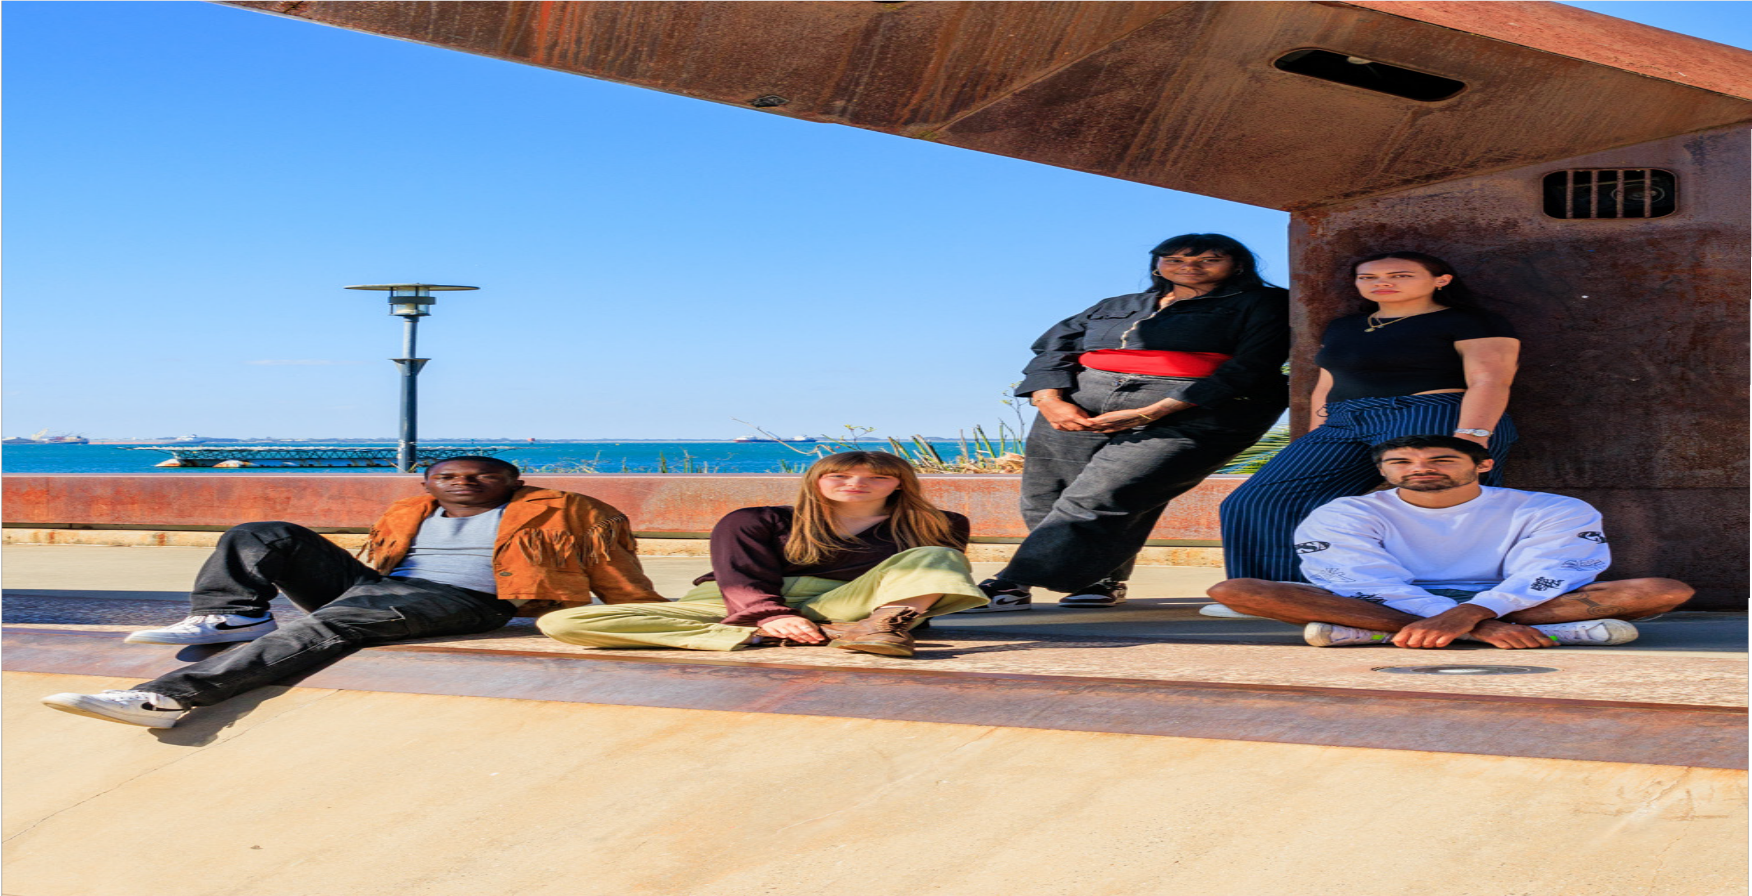

THE CITY OF GREATER GEELONG

ANNUAL REPORT
THE CITY OF GREATER GEELONG

SUMMARY 2023–24

We Acknowledge the Wadawurrung People as the Traditional Owners of the Land, Waterways and Skies. We pay our respects to their Elders, past, present and emerging. We Acknowledge all Aboriginal and Torres Strait Islander people who are part of our Greater Geelong community today.

Photo: Barwon River, Moonah Park Barwon Heads

2.

CONTENTS

MAYOR AND CEO MESSAGE 4
INTRODUCTION 5
OUR COMMUNITY’S VISION 7
OUR PURPOSE, VALUES AND STRATEGIC DIRECTIONS 8
THE YEAR IN REVIEW 10
OUR COMMITMENT TO HEALTH AND WELLBEING 16
FOCUS ON SUSTAINABILITY 20
KEY CAPITAL PROJECTS 21
ENGAGING WITH OUR COMMUNITY 23
GRANTS PROGRAM 24
CHALLENGES AND FUTURE OUTLOOK 26
OUR COUNCIL AND ORGANISATION 27
HOW WE PLAN 34
OUR PERFORMANCE 35
OVERVIEW OF FINANCIAL PERFORMANCE 44

ABOUT THIS SUMMARY
This is a summary of The City of Greater Geelong Annual Report 2023–24. It gives a broad overview of:
- our municipality
- our organisation and people
- how we plan and what influences us
- what we’ve achieved in 2023–24, as it applies to our council plan strategic priorities.
For the full details of our 2023–24 performance, download the complete annual report at geelongaustralia.com.au/annualreport

3.

MAYOR AND CEO MESSAGE

We are pleased to present this summary of the City of Greater Geelong’s Annual Report for the year ending 30 June 2024.

It has been a year of progress and change for our Council and organisation. We have continued to focus on meeting the needs of our growing community.
As the community’s elected representatives, our Council bases its decision-making on positioning Greater Geelong for an environmentally, economically and socially sustainable future.
We have sought to balance this longer-term outlook with a desire to meet the current day needs and expectations of the people they represent.
At an organisation level, the arrival of a new CEO and a new, united Executive Leadership Team, has brought stability of leadership and a fresh outlook as
we approach the challenges and opportunities in front of us.
Our executive and senior leaders have been keenly focused on operating as efficiently as possible
to deliver the best value to ratepayers, without compromising our core services that are so highly valued.
Against a backdrop of costs rising at a much faster rate than the income we generate, we have been financially responsible and sought to find new and better ways of doing things.
We remain committed to achieving the four strategic priorities set out in the Council’s four-year strategic document, ‘Our Community Plan 2021−25’: A Healthy, Caring and Inclusive Community, Sustainable Growth and Environment, Strong Local Economy, and a High Performing Council and Organisation.
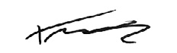
This summary will give you a snapshot of the projects and initiatives delivered for the benefit of the community during the financial year. We also encourage you to read our Annual Report in full.
All of these achievements are geared towards
We also thank our dedicated employees who take pride in their work and want the best for Greater Geelong and the people who live here.
Finally, biggest thanks to our community for the input you have provided to our major projects and decisions during the past year, and the many ways in which so many of you contribute towards a healthy and thriving Greater Geelong.

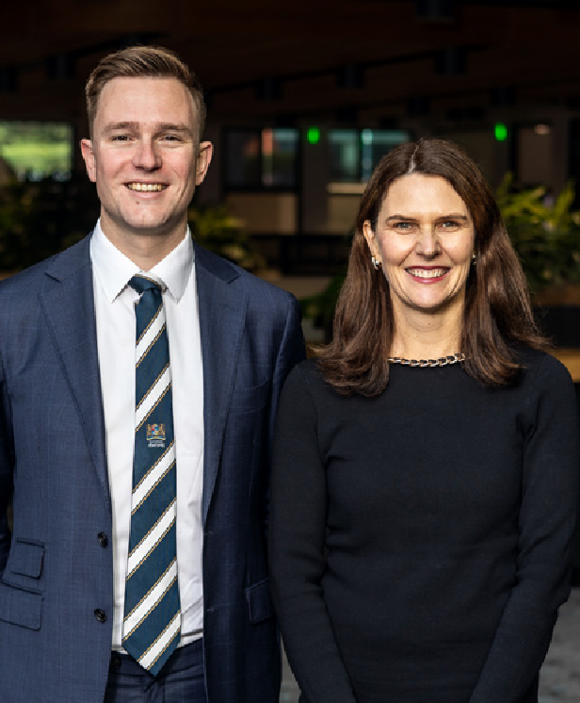
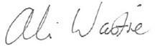

realising the community’s 30-year vision of a clever and creative future for our region.
With our Council coming to the end of its term, we thank all of our councillors for their service during this time.
CR TRENT SULLIVAN MAYOR
ALI WASTIE
CHIEF EXECUTIVE OFFICER

This report has been prepared in accordance with the relevant requirements of the Local Government Act 2020.

4.

INTRODUCTION

OUR CITY
The City of Greater Geelong is Victoria’s second-largest city, located 75 kilometres south-west of Melbourne.
We are proud to be on Wadawurrung Country. Wadawurrung Country covers over 10,000 square kilometres, from the Great Dividing Range in our north, to the coast in our south, from the Werribee River in our east, and to Aireys Inlet in our west, including Geelong and Ballarat.
Our municipality stretches 1,247 square kilometres across unique urban, coastal and country areas. Our community often points to this mix of landscapes and the lifestyles they support as a key attraction for living in, working at and visiting Greater Geelong.
Greater Geelong is bound by the Moorabool Shire in our north, Wyndham City Council and the Borough of Queenscliffe in our east, Surf Coast Shire and Golden Plains Shire in our west, and Bass Strait to our south.
COMMUNITY
Greater Geelong is Victoria’s most populated region outside metropolitan Melbourne, with an estimated 282,809 residents as of 30 June 2023.1 Our municipality has seen significant growth, particularly in Armstrong Creek, Lara, and the Bellarine Peninsula. By 2041, we expect our population to reach 396,388.2
Our demographics are dynamic, with notable growth across most age groups between 2016 and 2021.
Young workers and families have flocked to the region, leading to a 21 per cent increase in the 25-49 age bracket and a 20.8 per cent rise in residents over 60. The median age dropped from 40 to 39 during this period.1
We proudly host the largest population of Aboriginal and Torres Strait Islander people in any Victorian local government area, with 3,562 residents recorded in the 2021 Census.1 The Wadawurrung People, Traditional Owners of this land, have lived here for over 25,000 years.
Our cultural and linguistic diversity is growing, with
17.7 per cent of residents born overseas.1 Migration has strengthened our community, with new arrivals mainly from India, the UK, the Philippines, New Zealand, Sri Lanka, and Pakistan. International students also contribute to our rich multicultural fabric.
We strive for inclusivity, respect, and belonging, delivering social, economic, and cultural initiatives that support connection, participation, innovation, and creativity. Despite our strengths, some suburbs face significant socio-economic disadvantages, which we are committed to addressing.
LIFESTYLE
Greater Geelong is renowned for its exceptional lifestyle, blending urban amenities with natural beauty. Our region boasts a mix of classic ‘Boom Time’ civic buildings, grand 18th and 19th century architecture,
and revitalised modern urban areas. As Australia’s first UNESCO City of Design, we leverage creativity and innovation to build sustainable, resilient, and inclusive communities.
Our vibrant waterfront, extensive parks, and recreational reserves offer residents ample opportunities for leisure and outdoor activities. From serene bay beaches to
the rugged coastline of the Great Ocean Road, our diverse landscapes cater to a wide range of recreational pursuits.
ENVIRONMENT
Our environment is a unique blend of urban, rural, and coastal settings. We are home to significant conservation reserves and diverse ecosystems, including the Ramsar-listed wetlands, the You Yangs, and the Barwon and Moorabool river systems. These areas support a variety of flora and fauna, including many protected species.
Geelong’s 133 kilometres of coastline, combined with our rural agricultural activities, highlight the region’s ecological and economic diversity. We face environmental challenges, such as land clearing, invasive species, climate change, and waste generation, which we address through sustainable practices and innovative solutions.

- Australian Bureau of Statistics, Census of Population and Housing 2016 and 2021. Compiled and presented by .id (informed decisions).
- Population and household forecasts, 2021 to 2041, prepared by .id (informed decisions), January 2023.

5.

ECONOMY
Our economy is thriving, with strengths in advanced manufacturing, professional services, creative industries, digital technology, agribusiness, health care, and the visitor economy. Our strategic location near Melbourne, combined with our infrastructure and skilled workforce, attracts global investors and new businesses.
Over the past five years, we have experienced the fastest job growth of any large Victorian regional area and have an estimated 144,568 jobs, up 9,210 jobs in the year to June 2023.3 Health care and social assistance are our largest employment
sectors, followed by retail and construction. We also experienced the largest growth in business numbers, increasing the total to 22,090.3
Greater Geelong’s Gross Regional Product (GRP) grew to $19.57 billion, 4 with significant contributions from health care, accommodation, financial services, transport, and professional services. With $13 billion in major projects underway,4 including roads, public buildings, industrial and commercial developments, and residential housing, our region is poised for continued growth and prosperity.
Thank you for being part of our journey towards a vibrant, sustainable, and thriving Greater Geelong.

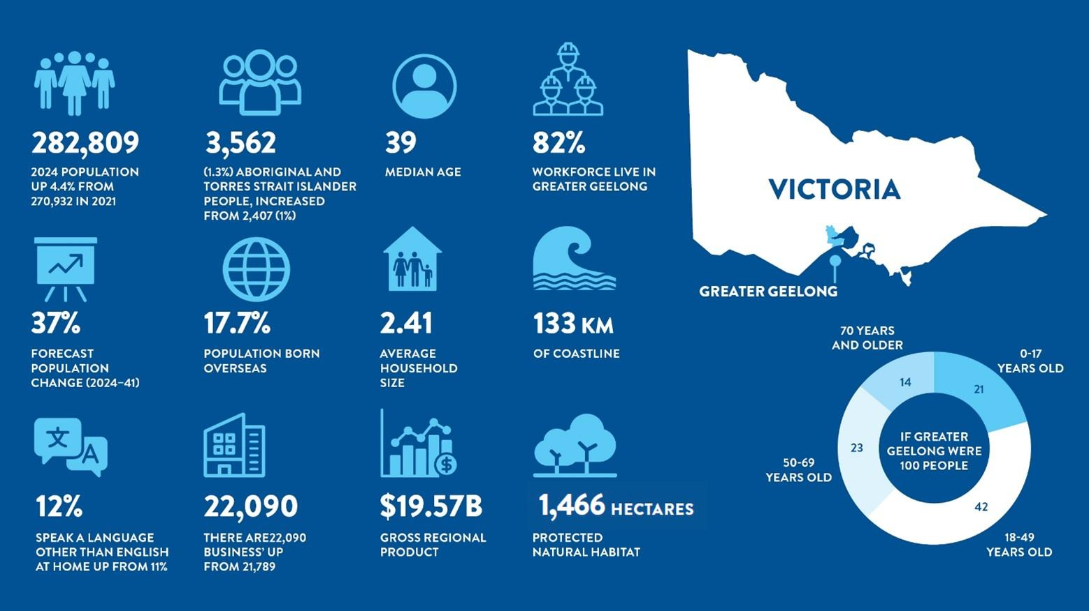

- National Institute of Economics and Industry Research (NIEIR) 2024. Complied and presented in economy.id by .id (informed decisions).
- City of Greater Geelong, Geelong Data Exchange, www.geelongdataexchange.com.au/pages/projectsv2/ (June 2024).
6.

OUR COMMUNITY’S VISION

By 2047, Greater Geelong will be internationally recognised as a clever and creative city-
region that is forward looking, enterprising and adaptive, and cares for its people and environment.
Between September 2016 and May 2017, over 16,000 residents and stakeholders told us what they value about the region and how they would like to see it grow and evolve. The resulting vision, Greater Geelong: A Clever and Creative Future, is a community-led blueprint for our region to be recognised regionally, nationally and internationally, as a clever and creative city-region.
At the heart of the vision are a series of aspirations focused on our region’s economy and employment, the environment, arts and culture, transport connections, tourism, efficient and equitable digital access, and good governance.
The vision is a guide for all levels of government, community organisations, businesses and anyone wanting to make a genuine contribution to the future of Greater Geelong. It has not only informed the City’s priorities but has acted as our community’s north star as we’ve collectively strived for a clever and creative future.

COMMUNITY ASPIRATIONS


A prosperous economy that supports jobs and education opportunities.
People feel safe wherever they are.
A leader in developing and adopting technology.

Creativity drives culture.
A fast, reliable and connected transport network.
A destination that attracts local and international visitors.


An inclusive, diverse, healthy and socially connected community.
Sustainable development that supports population growth and protects the natural environment.
Development and implementation of sustainable solutions.


Figure 2: Nine aspirations of our community’s 30-year vision

7.

OUR PURPOSE, VALUES AND STRATEGIC DIRECTIONS

OUR PURPOSE
Working together for a thriving community.

OUR VALUES
Our values represent who we are and who we aspire to be. They are the tools to create the workplace culture we want, and deliver on our purpose:
- respect and encourage each other
- create a healthy and safe environment for all
- embrace new ideas and better ways to work
- make people the centre of our business.
OUR STRATEGIC DIRECTIONS
Our Community Plan 2021−25 outlines the things we will do to make Greater Geelong a clever and creative city-region. The four strategic directions our Council chose to guide us are:
- Healthy, Caring and Inclusive Community
- Sustainable Growth and Environment
- Strong Local Economy
- High Performing Council and Organisation.

OUR ORGANISATION STRATEGY
If Our Community Plan 2021−25 is “what” we’ll do, our Organisation Strategy 2024−29 covers “how” we’ll do it. This document outlines our organisation’s priorities, to ensure we’re making the best decisions about how to deliver for the community efficiently and effectively. We have three commitments, each underpinned by two priorities, telling a clear story for our organisation’s future. While the focus of
this report is on Council’s Strategic Directions, the Organisation Strategy is included for context on the ways we work to deliver for our community.










OUR ORGANISATION STRATEGY 2024-29

Working Together for a Thriving Community
OUR PURPOSE

GREAT

PEOPLE
OUR COMMITMENTS
GREATER

PERFORMANCE
GREATEST

IMPACT

OUR PRIORITIES
We will be an extraordinary employer
A proud, diverse and talented workforce

With innovation at our core

Bold, innovative, and always striving for better

Delivering a sustainable future

Investing in tomorrow with a commitment to social, environmental, and financial prosperity

Side-by-side with our partners

Connected through shared purpose and a passion for driving outcomes through transformative change
Committed to delivering for our customers and community
Outcomes focused with those we serve at the heart of everything we do

And for our sector

Positively contributing to the development and growth of the local government sector and beyond

MEASURES OF SUCCESS

Employee engagement score

Cross department collaboration
Delivery of environmental, financial and social sustainability targets

Partnerships that deliver on defined outcomes

Customer satisfaction score

Time spent building sector capacity

OUR ENABLERS Culture, Risk and
Governance
Connecting through our purpose, committing to our success
Brand and Customer Experience
Figure 3: City of Greater Geelong Organisation Strategy 2024–29

Using our unique identity to unite and inspire, informed by a deep understanding of our customers
Digital and Data
Optimising our performance and decision-making through technology and data

THE YEAR IN REVIEW 2023−24 HIGHLIGHTS

National Tree Day  The City joined forces with around 350 local residents to plant more than 3,000 trees for National Tree Day at a free City run community event in Lara on Sunday 30 July 2023.  The event, held at Lavender Drive Park in Lara, was made possible through the collaboration and support of Planet Ark, Blood Toyota, the Lions Club South Barwon and Lions Breakfast Club Drinks, dedicated volunteers and City employees who worked tirelessly to organise and coordinate the day.  Teaming Up with the Cats to Go Green  The City joined forces with Geelong Cats AFLW players and members to plant 900 native grasses, lower shrubs and some eucalypts as part of a revegetation project along the Moorabool River. The project is the first step in a new era of partnership between the Geelong Football Club and the City.  The first Planting Day gave Cats members and the Geelong community the opportunity to make a lasting impact on their local environment by restoring habitat for local wildlife.  Geelong Positive Ageing program  A performance from sixties pop icon Normie Rowe was one of more than 30 events supported by the City as part of the Geelong Positive Ageing program, launched in conjunction with the Victorian Seniors Festival. Spanning from October 2023 to March 2024, the program included activities held by community groups or organisations who received funding from our Positive Ageing Grants program designed to promote physical activity, mental health and wellbeing, social connections, and positive ageing among our senior citizens.  North Bellarine Aquatic Centre  The North Bellarine Aquatic Centre (Stage 1), with its newly constructed 50-metre heated outdoor pool, was officially opened in October 2023. The project jointly funded by the federal government ($10 million) and the City ($5.5 million), is a milestone moment for the North Bellarine community, and our many teams who have worked on this project from conception and consultation, through to completion. The City received $20 million each in funding commitments from the state and federal governments to deliver Stage 2, which will feature indoor facilities including an indoor, eight lane, 25-metre pool, a warm water pool and health and wellness facilities, including a gym and group fitness areas. A community advisory panel was established to help identify design options with a final concept design approved by Council in July 2023. Delivery is expected to take 2−3 years.  Botanic Gardens Australia and New Zealand (BGANZ) network event  The Geelong Botanic Gardens took centre stage as the venue for the Botanic Gardens Australia and New Zealand (BGANZ) network event in October 2023. We welcomed 80 national and international industry professionals hailing from more than 20 organisations, providing them with a guided tour of the 170-year-old gardens which boast more than 4,000 species across 400 genera and 100 plant families. A highlight of the tour was the Pacific Rim garden, a haven for rare plants hailing from regions in the Pacific, under threat from deforestation and climate upheavals. | Business Accelerator Program scholarships  Five local women are a step closer to achieving their business goals after being awarded Business Accelerator Scholarships with Business in Heels, valued at over $3,000 and sponsored by the City. Tamara Shaw, Nichole Chambers, Terri Wilby, Jessica Kerr and Simone Araujo Gugliandolo were selected to take part in the 12-month long Business Accelerator Program which aims to help women start trading and making sales as quickly as possible so they can become self-sustaining. Participants learn with the support of mentors to develop a business plan, turn leads into referrals, establish their small business and create social media and pricing strategies.  Waurn Ponds Skate Park redevelopment  The City unveiled the $1.94 million redevelopment of the Waurn Ponds Skate Park in September 2023. Informed by two rounds of community consultation in 2021, the skate park upgrade design retained and improved popular elements of the former skate park, while incorporating a new space to create better connections between site skate and play elements. The upgrade was jointly funded the City ($600,000) and the state government through its Sport and Recreation Victoria Community Sport Stimulus Infrastructure Grant Program ($1.34 million) and Connecting Regional Communities Program.  Geelong Nature Festival  After a huge six weeks of events attended by more than 3,000 community members, Geelong Nature Festival wrapped up in October 2023. The City, in partnership with the Geelong Field Naturalists Club, joined forces with 55 volunteer groups and organisations to deliver 70 events that celebrated, explored and nurtured Greater Geelong’s diverse natural environment. This year's theme, 'Our Backyard' was committed to inspiring local minds to engage with their surroundings, fostering a deep appreciation for nature in their own backyards. From restoring habitat on Waurn Ponds Creek and learning how to grow your own native plants to bug nights and Burrunan dolphin watching sessions, there was something on offer for all age groups, interests and passions. The festival included a major environmental art project involving primary school children from 22 schools, genU Artists, the fOrT and the Mt Dunned Men’s Shed, designed by the School of Lost Arts, culminating in the creation of major art installation at the 21st Century Garden at the Geelong Botanic Gardens. A short film capturing the installation can be seen at Geelong Nature Festival 2023. In February 2024, we delivered a presentation on the festival as part of the Victorian Biodiversity Conference held at Deakin University's Burwood campus.  Launch of Live and Local program  In October 2023, we launched our Live and Local program, designed to showcase, support and celebrate the unique mix of local musicians and bands in our region. Live and Local is a comprehensive capacity building program delivering professional development workshops, micro-music festivals and a local industry forum, presented by the City in partnership with live music advocates LiveMusic Office, and APRA AMCOS, a music rights management organisation. As part of the initiative, we are also establishing a Music Industry Register of those working in the music industry, musicians and live music venues to connect people with information about live music activities, workshops and professional development opportunities, networking and collaborative opportunities and grants.
Geelong Design Week 2023  From 19-29 October 2023, Geelong Design Week celebrated the City of Greater Geelong’s UNESCO City of Design designation. The event spanned 52 free and ticketed events across eleven days. The previous attendance record was shattered with an astounding 17,288 attendances at events, an increase of 172 per cent from 2022. The increased number of event attendees from areas outside the Geelong region, signalled the event's widening allure, with high-level estimates suggesting the impact of visitors attending Geelong Design Week events from outside Greater Geelong alone injected $1.6 million revenue into the local economy.  Poa Banyul Community Hub opening  Our $13 million state-of-the-art Poa Banyul Community Hub in Mount Duneed, was officially opened in November 2023. The hub is designed to cater to a diverse range of early years and family services, including sessional kindergarten, maternal and child health services, family support consulting rooms and versatile community spaces. Jointly funded by the City ($10.7 million) and state government ($2.25 million), the hub complements the nearby community shed, helping to create a sense of unity and support within the region.  Permanent Rainbow Crossing  In December 2023, we unveiled a permanent rainbow pedestrian crossing on Yarra Street as a symbol of pride in the diversity of the region and a celebration of the LGBTQIA+ community. Inspired by Valentino Vecchietti’s Progress Pride Flag, the chosen design is the most current and inclusive representation of LGBTQIA+ pride. It integrates not only the traditional rainbow colours but also incorporates elements of the transgender and intersex flags, as well as brown and black lines to symbolise all people of colour, including Australia’s First Nations communities. The idea was first floated in 2019 by members of the Rainbow community and supported by councillors. Initial steps were taken in 2020 with a temporary mini crossing in Little Malop Street during the launch of the Geelong Rainbow Festival. However, the COVID-19 pandemic temporarily halted plans for a permanent installation until 2022.  Recognition for Frank Costa AO  We partnered with the Costa Family, Geelong Authority member Rory Costelloe and the Geelong Cats Football Club, to commission internationally renowned sculptor Louis Laumen to create a sculptural memorial to the late Frank Costa AO, who passed away in May 2021. Unveiled in December 2023, The Newsboy (Frank Costa, aged 13), which depicts a teenage boy standing on a fruit box selling the Herald Sun newspaper, recognises the many roles Frank played in the community: a generous philanthropist, passionate Geelong Football Club president, well-known businessman and fierce advocate for our region.  Adoption of new Advocacy Framework  In March 2024, Council voted to adopt a new Advocacy Framework, which outlines the City’s approach to advocacy at a local, regional, state, national and international level over the next three years. The framework provides two new approaches for regional advocacy, with the City to renew its membership of G21 with a reduced financial contribution and work with neighbouring councils like the City of Wyndham for joint advocacy opportunities in the western growth area. The framework also considers the City’s role in the broader ecosystem of advocacy in Geelong, the approach and principles for advocacy, how advocacy priorities will be determined and how performance and outcomes will be measured.  Street upgrades near Waurn Ponds Station  A $2.1 million upgrade of Sugargum Drive and Bodega Street in Waurn Ponds was completed in May 2024, creating improved conditions for road users and pedestrians near the Waurn Ponds Station. Fully funded via the Australian Government’s Roads to Recovery program, the project produced a range of improvements between Oakwood Crescent and Rossack Drive including road pavement rehabilitation, kerb and channel upgrades, reflective pavement markers and line marking upgrades. The upgrades came in response to increasing traffic in the area, with around 11,000 vehicles now travelling along Sugargum Drive and Bodega Street each day. The project was completed on time and six weeks ahead of schedule by the City’s design, program delivery and construction teams. | City support for 16 Days of Activism against Gender Based Violence  We demonstrated our commitment to a world where everyone is respected by supporting the international campaign 16 Days of Activism against Gender-Based Violence. The campaign started on 25 November 2023, the International Day for the Elimination of Violence Against Women and finished on 10 December 2023 - Human Rights Day. In collaboration with Respect 2040, we promoted events and initiatives by other Geelong organisations and also joined local partners to light City landmarks, with the colour orange symbolising a brighter future free of violence.  Community Leadership Program  In November 2023, we celebrated the completion of the 2023 Community Leadership Program. The 17 aspiring leaders completed a nine-month interactive experience designed to equip them with personal and professional growth opportunities, as part of the City’s commitment to developing skilled and passionate leaders across the region. Throughout the course, participants developed an increased knowledge and understanding of the Geelong community, connected with like-minded peers, and were equipped with knowledge and tools across a range of topics designed to enhance their leadership capabilities.  People with Disability Awards  The City marked International Day of People with Disability in December 2023, by announcing the winners of the annual Awards for People with Disability. Attended by over 100 people, this was the fourth year the City has partnered with genU and the Barwon Disability Resource Council to present the awards. Winners of three categories were: Shannon Bowman (Achievement Award), Paige Humm (Leadership and Advocacy Award) and Tim Harte (Volunteering Award). The awards are essential to highlighting the great work accomplished by people with disability, as leaders and role models for others in the community.  Norlane ARC (Aquatic Recreation Centre)  Our brand new $65.6 million Norlane ARC (Aquatic Recreation Centre) was officially opened on 9 February 2024. Funded by the City ($48.84 million), state government ($8.5 million) and federal government ($8.26 million), the hub replaces the former Waterworld and Centenary Hall facilities. Features include a 25-metre pool, warm water pool, learn to swim pool, water play area and waterslide, as well as gym and exercise facilities, a multi-purpose hall, childcare facilities and health consulting suites. The City presented four naming options for community feedback early in 2024, based on recommendations from the facility’s Community Liaison Reference Group. Norlane ARC (Aquatic Recreation Centre) emerged as the preferred option among survey respondents and was approved by Council at its May meeting.  Co-design of the Pakington North Urban Design Framework (UDF)  In May 2024, Council adopted the Pakington North UDF which will be used to guide the future growth and development for the precinct that stretches along Pakington Street from Church Street to Waratah and Wellington Streets. In one of the City’s most extensive deliberative engagement processes, the UDF was co-designed with the Pakington Street North Community Panel, a representative sample of the Geelong West community including residents, business owners and visitors who live, work, shop and travel through the precinct. The panel participated in a series of workshops to consider and provide recommendations across a number of areas including urban design, heritage and neighbourhood character, built form, access and mobility, landscaping and open space. The UDF provides a roadmap to achieve the vision of a vibrant, people friendly and inclusive Pakington North precinct with thriving businesses, housing that is diverse and conveniently located, and quality architecture now and years into the future.

OUR COMMITMENT TO HEALTH AND WELLBEING

The health and wellbeing of our community is central to everything we do.
Under the Victorian Public Health and Wellbeing Act 2008, councils are required to prepare a four-year Municipal Public Health and Wellbeing Plan within 12 months of every Council election. The plan identifies goals for creating a local community where people can experience their best possible health and wellbeing. Acknowledging that health and wellbeing is everyone’s business, we incorporated our Municipal Public Health and Wellbeing Plan into our council plan to create Our Community Plan 2021–25.

OUR HEALTH AND WELLBEING PRIORITY AREAS
There are five health and wellbeing priority areas we have been focussing on since this plan began. We formed these priorities following a review of the policy context and local health data and engaging
with the community and key stakeholders to identify health needs and challenges:
- tackling climate change and its impact on health
- increasing healthy eating
- increasing active living
- demonstrating and promoting gender equity practices
- improving mental wellbeing and social connection.
WORKING WITH OUR PARTNERS
We partnered with the Barwon South West Local Public Health Unit, Bellarine Community Health and Active Geelong to submit successful grant
applications to prevent vaping amongst young people and promote active transport for primary school aged children.
We also convened the Health and Wellbeing Partners Network to enable a partnership approach to health and wellbeing. Since its inception in 2021, the network has met six times. Members have mapped the work being undertaken across the municipality under the five health and wellbeing priority areas to identify gaps and opportunities for collaboration. This year, members participated in consultations for the Western Victoria Primary Health Network Community Needs Assessment and the Barwon South West Local Public Health Unit’s Catchment Plan.

OUR HEALTH AND WELLBEING INDICATORS
A set of 17 population level indicators in Our Community Plan 2021–25 help track the health and wellbeing of our community. Our work, along with the work of our partners and other organisations, contribute to progress in the five priority areas.

IMPROVING MENTAL WELLBEING AND SOCIAL CONNECTION
Proportion of adults experiencing high / very high psychological distress 20% (2021)

Proportion of adults that are a member of an organised group (sports, religious, school, professional, community or action group) 56% (2021)

Level of agreement that multiculturalism makes life better 66% (2021)

Number of jobs located in the City of Greater Geelong
144,568 (2022–23)

City of Greater
Geelong unemployment rate 4.1% (June 2024)

INCREASING HEALTHY EATING
Proportion of adults consuming the recommended number of serves of fruit
and vegetables:
Fruit 46% (2021)
Vegetable 15% (2021)

INCREASING ACTIVE LIVING
Proportion of adults meeting the

DEMONSTRATING AND PROMOTING GENDER EQUITY PRACTICES
Family violence incident rate per 100,000 population
1,764.7 (June 2024)

Community perception of safety in the area where they live 61% (2021)

TACKLING CLIMATE CHANGE AND ITS IMPACT ON HEALTH

Proportion of community concerned about effects of climate change on health 51% (2021)

Community greenhouse gas emissions 3,791,000 tonnes CO2–emissions total (2021–22)

Hectares of protected natural habitat 1,466.64 hectares
(June 2024)

Number of trees planted 2811 street and park trees, 4,000 tubestock
(June 2024)

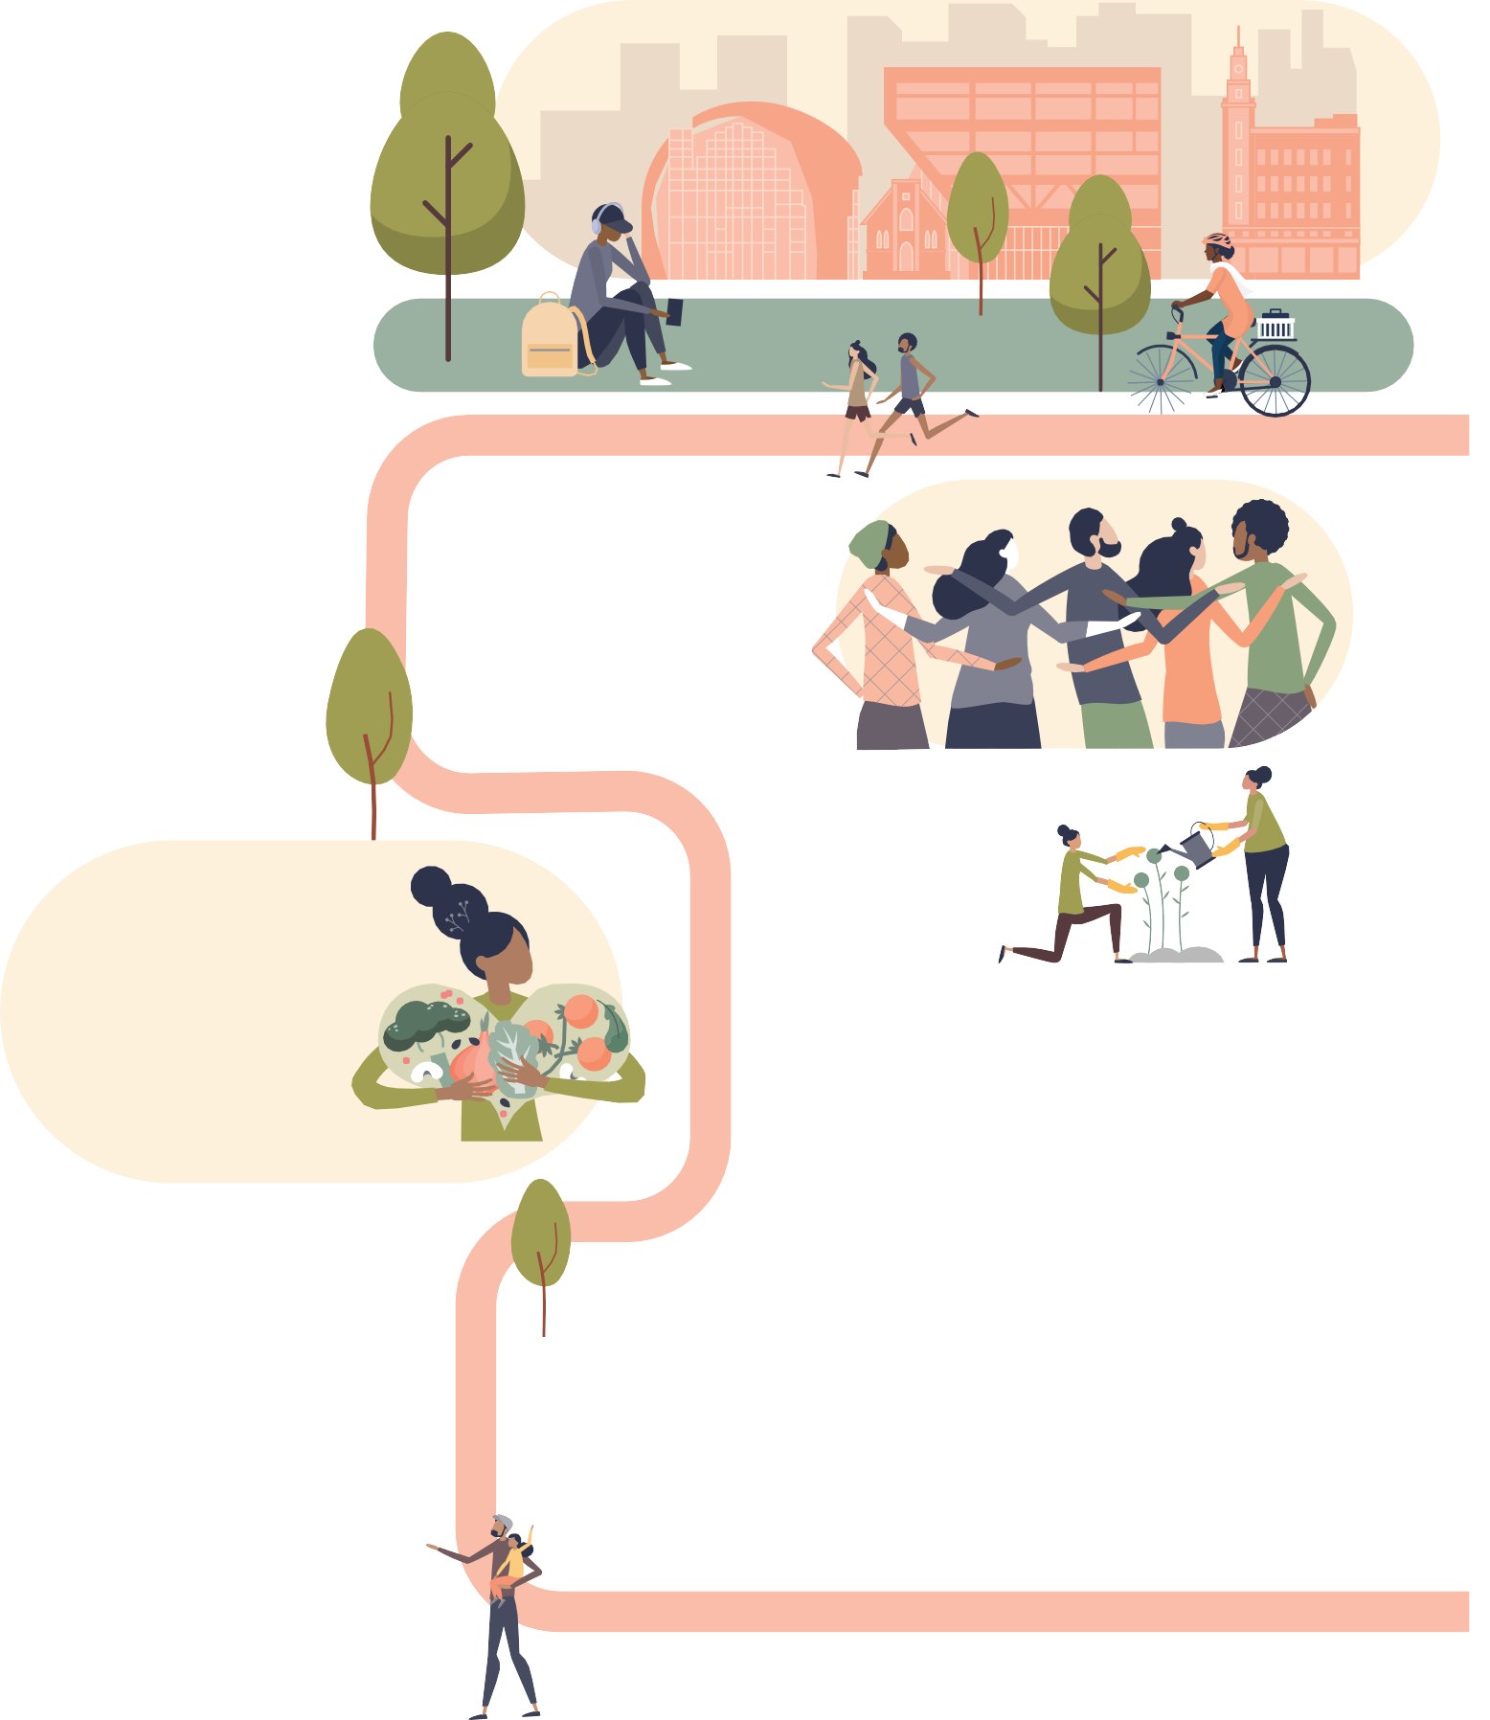







physical activity guidelines 67% (2021)

Quantity of open space
1079.5 hectares (2024)

Journeys to work made by public transport, walking or cycling 4.6% (2021)

Percentage of residences within 400 metres of public open space in urban areas 88.7% (2024)

Kilometres of bicycle, walking paths and shared paths 121 km bicycle paths, 2,044 km footpaths, 218 km
shared paths (2024)
Figure 4: Our Community Plan 2021–25 health and wellbeing indicators

KEY ACTIONS SUPPORTING HEALTH AND WELLBEING
In 2023–24, we committed to deliver 36 actions to support the achievement of our five health and wellbeing priorities within Our Community Plan 2021–25 - Annual Action Plan 2023–24. Of the 36 actions, 72 per cent (26) were complete and 28 per cent (10) were ongoing. The following highlights some of these key actions for each health and wellbeing priority area. For more detailed information on these and other actions, please refer to the Our Community Plan 2021−25 − Quarterly Report June 2024.

Health and Wellbeing Priority 1: Tackling climate change and its impact on health

KEY ACTIONS AND RELATED STRATEGIC DIRECTION
Incorporate Environmentally Sustainable Design (ESD) principles into new urban growth areas including zero carbon, water efficiency, sustainable transport, urban greening and climate resilience | 2 | Complete
Identify new opportunities for policy or project development from the discussion paper on understanding and mitigating the health impacts of climate change | 2 | Complete
Facilitate partnerships to support our community to reduce emissions | 2 | Complete
Health Priority 2: Increasing healthy eating

KEY ACTIONS AND RELATED STRATEGIC DIRECTION
Implement the Promoting CHANGE project to encourage healthier food and drink options in Council owned facilities and settings | 1 | Complete
Develop a policy to make the region’s food system more accessible and resilient | 1 | Ongoing

Health Priority 3: Increasing active living

KEY ACTIONS AND RELATED STRATEGIC DIRECTION
Implement Year 2 activities of the Positive Ageing Strategy 2022−2025 Action Plan | 1 | Complete
Implement Stage 2 of the Lara Recreation Reserve Master Plan. | 1 | Complete
Activate the Northern Aquatic and Community Hub with a focus on health and wellbeing, cultural engagement and community connection for people in the local community | 1 | Complete
Progress of annual actions supporting delivery of health and wellbeing priorities

28%

72%

On going Complete

ACHIEVEMENT: Collaborating with Outdoors Victoria to present the fourth annual Geelong Nature Stewards program, a 10-week course which provides community members with the opportunity to discover more about their local native plants and animals and learn skills to help protect the places where our wildlife lives.

ACHIEVEMENT: Funding three community garden projects at Grovedale, Chilwell and Murnong through our 2023−24 Community Infrastructure Grants program. Grants provided will enable the delivery of new and upgraded infrastructure and facilities to create more functional and inviting spaces, further enhancing engagement and participation.

Health Priority 4: Demonstrating and promoting gender equity practices

KEY ACTIONS AND RELATED STRATEGIC DIRECTION
Work with partner agencies on initiatives to prevent family violence and violence against women | 1 | Complete
Promote access to sport and physical activity for women and girls through the development of the Ocean Grove Sporting Infrastructure Plan | 2 | Ongoing

ACHIEVEMENT: Delivering new female friendly change facilities at the Bell Park Sports Club following a $1.95 million upgrade jointly funded by the City and state government. The upgrade also delivered change facilities for officials, a first aid room and storage spaces.

ACHIEVEMENT: Expanding our shared trails network with completion of a new trail at Beacon Point, Clifton Springs. The trail creates an important connection to the coastline, making it easier for the community and visitors to the Bellarine to enjoy coastal walks and bike riding with impressive views across the bay.

ACHIEVEMENT: Recognising the outstanding contributions young people aged 12–25 years are making across Greater Geelong as part of the Geelong Youth Awards 2023−24.

Health Priority 5: Improving mental wellbeing and social connections

KEY ACTIONS AND RELATED STRATEGIC DIRECTION
Deliver priority infrastructure projects to improve all abilities access as part of our Access and Inclusion Plan 2018–2023. | 1 | Complete
Plan for the delivery of the pilot youth hub in Central Geelong | 1 | Complete
Partner with senior groups to create a street art mural for the Portarlington Senior Citizens Club | 2 | Complete
Partner with community organisations to deliver programs that enable skills  development and improved employment outcomes | 3 | Complete
Continue to provide the opportunity for in-person neighbourhood discussions with residents as part of our Neighbourhood Conversations program | 4 | Complete

FOCUS ON SUSTAINABILITY
Sustainability is a key theme of Our Community Plan 2021–25 and a strong focus of our community’s 30-year clever and creative vision.

Sustainability refers to a continual way of thinking that focuses on the best outcomes for our community, environment and the economy, now and in the future. Our goal is to incorporate sustainable thinking into every aspect of our business to address some of the long-term challenges facing our community, including climate change, population growth, demands for community infrastructure and social inequity.
We adopted the Sustainability Framework 2020 to create a culture of sustainable practice in our organisation. The framework commits us to take
action across three key priority areas of sustainability: protecting our environment; community wellbeing and social equity; and responsible and transparent business.
Major initiatives driving sustainability in 2023−24 included:
- launching the ‘Our Climate Actions’ interactive website where community members can learn about how the City and the community are working together to protect our local area and deal with the changes happening in our climate
- consulting with businesses, advocacy groups, industry bodies and our community in the development of a 10-year economic development plan – Geelong on the Rise: A Clever and Creative International City. The plan will guide our priorities
to make sure we keep delivering great services and support for local businesses, and help create a sustainable, prosperous future for our community
- providing Greater Geelong’s young people with the opportunity to make valuable contributions to the discussions, decision making and actions
relating to them in their communities by convening the Geelong Youth Advisory Board program
- progressing precinct structure plans for the Northern and Western Geelong Growth Areas (NWGGA) and Marshall to meet the growing need for residential land across the municipality
- supporting community to achieve net zero community emissions and increase resilience to climate change impacts through our Climate Change Partnership Grants which in 2023−24, provided five projects a total of $126,750 in funding
- engaging with our community to develop the draft Access and Inclusion Plan 2024−28 which outlines our actions to create a city that is more accessible, inclusive, welcoming and supports the full participation of people with disability
- commencing work on an integrated transport strategy that will set the long-term vision and directions for transport decision making across Greater Geelong.

20.

KEY CAPITAL PROJECTS
We deliver an extensive capital works program each year to create infrastructure for our community. For more information, visit our Capital Works Projects dashboard.
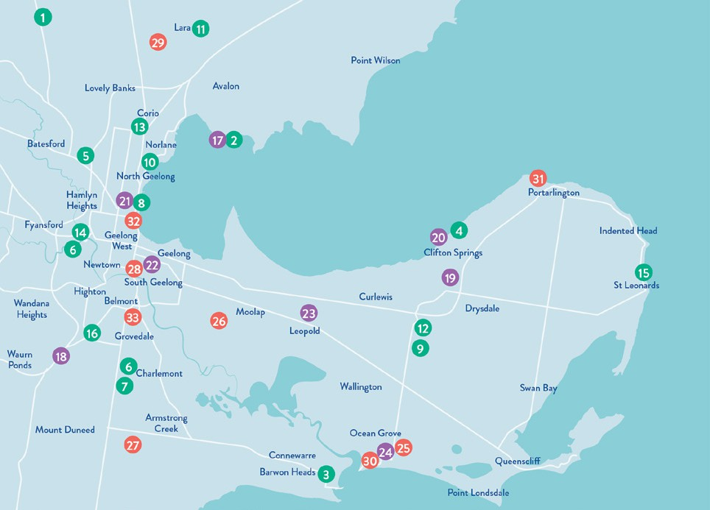
Figure 5: Key Capital Projects 2023–24

PROJECTS COMPLETED PROJECTS UNDER CONSTRUCTION

Anakie Football Netball Club Social Room Upgrade – $2.85M
1
Avalon Beach Boat Ramp Upgrade – $1.5M
2
Barwon Heads Bowling Club Pavilion Upgrade –
3
$1.2M
Beacon Point Reserve Shared Trail, Clifton Springs – $540,000
4
Bell Park Sport and
5
Drysdale Sporting Ovals Drainage Improvements – $700,000
Labaun Square Streetscape, Norlane (including Public Toilet Replacement) – $691,000
9
10
Lara Recreation Reserve Master Plan Stage
11
2 - Baseball Precinct –
$5.545M
North Bellarine Aquatic
12
Avalon Beach & Limeburners Boat Ramps and Carpark Upgrades – $3.5M
Baanip Boulevard/Boundary Road intersection, Mt Duneed – $7.6M
17
18
Barrands Lane Drainage/ Flood Mitigation Works, Drysdale – $720,000
19
Clifton Springs Boat Harbour Carpark Extension – $1.0M
20
Geelong Arena Roof Drainage and Heating, Ventilation, and Air Conditioning Upgrade, North Geelong – $1.85M
LED Lighting & Smart Controls delivery (across Geelong) – $13.48M
21
22
Leopold Tennis Pavilion –
23
$1.97M
Ocean Grove Principal Pedestrian Network – $10.0M
24

Recreation Club
Centre, Drysdale –
PROJECTS COMMENCED DESIGN PHASE

Changeroom Upgrade –
$1.95M
Biyal-a Armstrong Creek Library, Armstrong Creek, – $21.864M
6
Bus Shelter Design & Construct Program (9 bus shelters across Geelong) – $562,000
7
St Helens Park Shelter and Deck – $435,000
8
$15.5M
Norlane ARC (Aquatic Recreation Centre) –
13
$65.0M
14
Queens Park Golf Club Irrigation Upgrade, Highton – $1.2M
15
St Leonards Skate Park Redevelopment –
$670,000
16
Waurn Ponds Skate Park, Stage 2 – $1.95M
Bellarine Aquatic and Sports Centre Building Upgrade, Ocean Grove – $900,000
Horseshoe Bend Community Hub, Charlemont – $19.79M
25
26
Horseshoe Bend Community Hub, Charlemont – $19.79M
27
Landy Field Pavilion Redevelopment, South Geelong – $6.0M
28
Lara Golf Club - Driving Range Upgrade – $1.096M
29
Ocean Grove Memorial Reserve Sports Lighting –
$800,000
30
31
Portarlington Reserve Master Plan – $3.774M
32
Rippleside Inclusive Play Space & Public Toilet –
$5.115M
33
Winter Reserve Netball Change Room & Court Upgrade, Belmont –
$1.575M

ENGAGING WITH OUR COMMUNITY
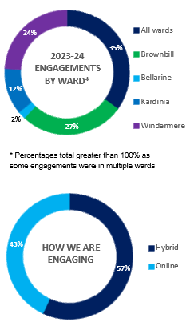

Engaging with our community ensures that we listen and make decisions based on community lived experience and in line with our community views and values.
Over the past twelve months, we continued to strengthen our community engagement practice with initiatives including:
- conducting face to face (in person) engagements
- holding regular community roadshows including attending Pako Festa, Christmas in Geelong Opening Night 2023 and holding a series of Neighbourhood Conversations in all wards
- increasing the use of deliberative engagement methods such as community panels for projects including North Pakington Street Urban
Design Framework, Geelong Youth Hub, North Bellarine Aquatic Centre, the Norlane ARC (Aquatic Recreation Centre) and the Kardinia Park Concept Master Plan
- actioning a Join Us campaign encouraging our community to sign up to the Have Your Say

Figure 6: Engagement snapshot 2023-24

Advisory Committees

platform to share their ideas and opinions on projects that matter to them
- improving accessibility and inclusivity of our online Have Your Say platform by optimising font sizes and types, and colour contrasts and including a Read Speaker function which reads information written on the page.
Our advisory committees enable community members to provide community insights, share lived experience and ongoing feedback to guide our decision-making. We would like to thank each of the committee members for the time, enthusiasm, ideas and energy they’ve put into the committee meetings over the past 12 months.

MONITORING AND REPORTING
We are committed to monitoring our processes, information sharing and decision making to understand the overall level of success of our engagements. Some measures of our success for the past 12 months include:
TOP HAVE YOUR SAY PAGES
•

•

•
•
•
Draft Market Square Quarter Master Plan (8,362 visitors)
Armstrong Creek Library and Community Hub (3,127 visitors)
North Bellarine Aquatic Centre (3,076 visitors)
Integrated Transport Strategy (2,625 visitors)
Draft Disability Access and Inclusion Plan 2024−2028 (2,556 visitors)
91,281
visitors to the Have
Your Say platform
214,004
views of the
Have Your Say platform
11,343
contributions
received
56
projects on the
platform
6,761
registered members on the Have Your Say platform

GRANTS PROGRAM

In 2023–24, our Community Grants program saw 240 grants worth $3,946,049 awarded to community groups and organisations supporting the arts, events, cultural, sporting and recreation, heritage, and environmental sustainability.
Funding ranged from small grants of $500 to assist grassroots activities, through to $350,000 to help shovel-ready community infrastructure projects. For further grants information visit our website www.geelongaustralia.com.au/grants.

Table 1: Community Grants program allocations 2023–24.
GRANT |  | GRANT BUDGET | APPLICATIONS FUNDED | TOTAL FUNDING ALLOCATED
Arts Projects | Support to deliver arts projects in the City of Greater Geelong. | $200,000 | 19 | $179,960
Artists & Creatives Professional Development | Travel, accommodation, fees, incidentals and in some circumstances, remuneration. | $200,000 | 6 | $10,000
Clever & Creative Seed | Provide artists and creatives with small grants to initiate, explore or activate new ideas or new approaches to their work. | $200,000 | 4 | $10,000
Children’s Week | Small grants to facilitate events held during Children’s Week. | $10,000 | 20 | $9,920
Clean Economy | Projects that demonstrate clean technology and circular economy solutions. | $50,000 | 2 | $50,000
Climate Change Partnership Grants | Funding for projects and activities that will be carried out over a period of one to two financial years. | $130,000 | 5 | $126,750
Community Events | Operating expenses to run safe, moderate sized, public events that provide economic and community benefits to our region. | $180,000 | 22 | $155,300
Community Events Quick Response | Support for moderate sized events which bring our region economic benefits. | $180,000 | 3 | $25,000
Community Infrastructure | Planning for Capital Works - Costs associated with facility development planning, concept designs and detailed designs for future infrastructure projects. | $2,700,000 | 27 | $2,674,090
 | Capital Works - To assist with cost of ready to go community infrastructure projects. Not applicable for the purchase of land.
Environmental Sustainability | Capital Works - Small environmental capital works (for example water tanks, solar panels). | $90,000 | 14 | $79,546
 | Projects - Delivery of responsive environmental sustainability projects, programs and community activities.
 | Equipment - To assist with cost of small equipment purchases that help community groups to deliver services and programs.

24.

GRANT |  | GRANT BUDGET | APPLICATIONS FUNDED | TOTAL FUNDING ALLOCATED
First Nations Cultural Heritage | Projects that recognise, restore, protect and preserve both tangible and intangible Aboriginal Cultural Heritage. | $90,000 | 3 | $89,332
Geelong Heritage | Conservation Works - Building or streetscape projects that are visible to the public and focus on presentation to a street or public space and have an identified historic value. | $90,000 | 4 | $90,000
 | Planning - Feasibility and investigation projects to provide technical, planning, project scoping advice for future restoration projects.
Healthy & Connected Communities | Projects - Projects, programs, activities, forums or events, and equipment necessary to deliver activities (up to $10,000) that improve health and  wellbeing, build community capacity and benefit the broader community. | $245,000 | 58 | $245,210
 | Equipment - To assist with cost of small equipment purchases (up to $2,000) that help community groups: deliver services and programs, improve health and safety outcomes or improve resources that support volunteer groups.
Neighbourhood Houses | Partnership with Neighbourhood Houses for operating costs and community development projects. | $167,500 | 15 | $141,500
Neighbourhood Houses – Christmas in the Community | Support for Christmas celebrations across our municipality. | $36,000 | 11 | $35,961
Positive Ageing | Support community hosted events and experiences. This grant replaces the Geelong Seniors Festival Grants. | $24,000 | 27 | $23,480

25.

CHALLENGES IN 2023−24

The following are some of the key challenges, new and ongoing, that impacted our services in 2023−24:
- prioritising projects that generate the greatest value for our community as growing pressure on financial sustainability limits our ability to invest in new services and infrastructure and provide ongoing maintenance and upgrades
- continuing to innovate and explore efficiencies to enhance overall effectiveness, improve decision- making and better align with community needs
- continuing to address the significant ongoing challenges of climate change including increased risks of flooding, bushfires, and the impact of extreme weather events, which can impact the provision of services and infrastructure
- lobbying the state government around the make- up of Geelong’s legacy facilities following the cancellation of the Commonwealth Games to ensure outcomes address our region’s growing need for social and affordable housing, and sporting facilities
- reviewing the role of the City in the delivery of aged care services in response to the federal government’s aged care reforms
- progressing a roadmap for leveraging technology to enhance organisational efficiency, drive innovation, and achieve our desired business objectives
- managing the growing logistical and environmental challenges of waste and recycling, including planning to meet state government legislative requirements to introduce food organics and glass only collection by 2030 and 2027 respectively.

FUTURE OUTLOOK

Looking ahead, plans for 2024−25 include:
  - commencing upgrades to the City’s existing waste facilities to enable the introduction of Food Organics Garden Organics (FOGO) and glass kerbside collection services
  - delivering a $210.5 million capital works program focussing on new and upgraded sporting facilities, community centres, parks and reserves to cater for Greater Geelong’s growing population
  - working on the Innovate Reconciliation Action Plan, the second stage of the City’s Reconciliation process
  - planning for a new Resource Recovery Centre and Waste Recycling Hub in the region
  - developing an Integrated Transport Strategy that will set the long-term direction for transport decision making across Greater Geelong
- engaging our community to inform the development of the new 2025−29 Council Plan
- commencing a two-year pilot of the Geelong Youth Hub, to support young people to connect with each other and youth services in a safe and inclusive environment
- continuing to implement the Sparrovale-Ngubitj yoorree Wetlands Master Plan which guides us in conserving the area, managing stormwater, and creating open space
- identifying opportunities to increase the visibility, social inclusion and health and wellbeing of the LGBTQIA+ communities
- continuing to advocate and form partnerships with stakeholders across business, industry, community and government at a local, regional, state, national and international level
- engaging with the state government on draft housing capacity targets to deliver more homes in Greater Geelong.

26.

OUR COUNCIL AND ORGANISATION

Like all local governments, the City of Greater Geelong is made up of two interdependent parts – the Council and the organisation. Collectively, we work together to serve our community.
The Council sets the strategic direction for the municipality and makes decisions on behalf of the community it has been elected to represent. The organisation oversees the day-to-day delivery of all services and functions, guided by the Council, state and federal legislation and various funding agreements.
OUR COUNCIL
Our council provides leadership for the good governance of the municipality and the local community. This means:
- considering the diverse needs of the local community in decision-making
- establishing strategic objectives and monitoring achievements
- managing resources in a responsible and accountable manner
- advocating local community needs to other communities and governments
- giving everyone the opportunity to participate in the democratic process and decision-making that shapes our community.

27.

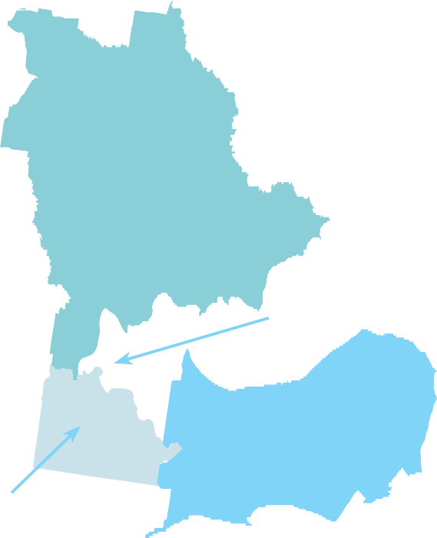
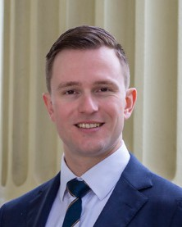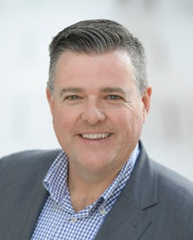
OUR COUNCILLORS
On 24 October 2020, our community elected its Council for a four-year term.
The councillors work together to set the strategic direction for the municipality, which influences policy, service standards and performance across the organisation.
The municipality is divided into four, multiple-councillor wards (see Figure 7):
- Bellarine Ward: three councillors
- Brownbill Ward: three councillors
- Kardinia Ward: three councillors
- Windermere Ward: two councillors
Cr Elise Wilkinson was elected as Councillor for the Bellarine Ward on 1 September 2023 as a result of the extraordinary vacancy created by the
resignation of Cr Stephanie Asher on 29 July 2023.
Figure 7: Ward map of the City of Greater
Geelong
WINDERMERE WARD
BROWNBILL WARD
BELLARINE WARD
KARDINIA WARD
28.

CR TRENT SULLIVAN
Mayor Bellarine Ward
PORTFOLIOS:
- Aboriginal and Torres Strait Islander (ATSI) Partnerships (Chair)
- Commonwealth Games (Chair)
CR ANTHONY AITKEN
Deputy Mayor Windermere Ward
PORTFOLIOS:
- Strong Local Economy (Chair)
- Aboriginal and Torres Strait Islander (ATSI) Partnerships (Deputy Chair)
- High Performing Council (Deputy Chair)
- Commonwealth Games (Deputy Chair)

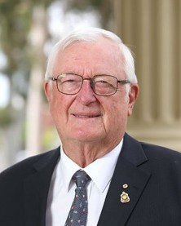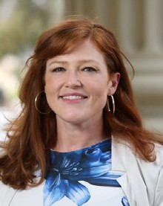

CR JIM MASON AM
Bellarine Ward

PORTFOLIOS:
  - City Planning and Heritage (Chair)
  - Strong Local Economy (Deputy Chair)
CR BELINDA MOLONEY
Kardinia Ward

PORTFOLIOS:
- Multicultural Geelong (Chair)
- Inclusion and Care (Deputy Chair)

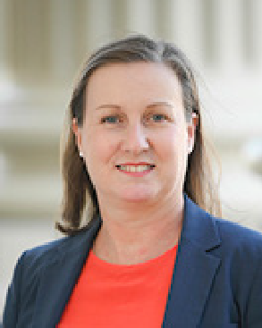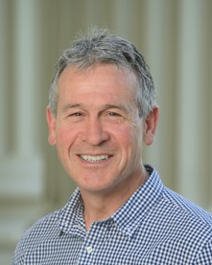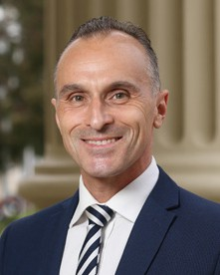

CR MELISSA CADWELL
Brownbill Ward
PORTFOLIOS:
  - Creativity and Culture (Chair)
  - City Planning and Heritage (Deputy Chair)
CR BRUCE HARWOOD
Kardinia Ward
PORTFOLIOS:
- High Performing Council (Chair)
CR SARAH HATHWAY
Windermere Ward
PORTFOLIOS:
- Inclusion and Care (Chair)
- Multicultural Geelong (Deputy Chair)
CR EDDY KONTELJ
Brownbill Ward
PORTFOLIOS:
- Active Spaces (Chair)
- City Transport (Deputy Chair)

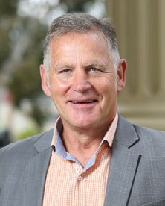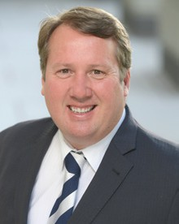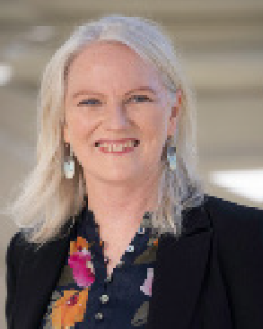

CR PETER MURRIHY
Brownbill Ward
PORTFOLIOS:
  - Environment and Circular Economy (Chair)
  - Creativity and Culture (Deputy Chair)
CR RON NELSON
Kardinia Ward
PORTFOLIOS:
- City Transport (Chair)
- Veteran Affairs (Deputy Chair)
CR ELISE WILKINSON
Bellarine Ward

PORTFOLIOS:
- Veterans Affairs (Chair)
- Active Spaces (Deputy Chair)
- Environment and Circular Economy (Deputy Chair)

29.

OUR ORGANISATION

We are an inclusive and flexible organisation and one of the largest employers in the region. We are responsible for:
  - providing support and professional expertise to assist Council in developing policies and making decisions
  - engaging with the local community and significant stakeholders to make sure Council decisions are in line with community expectations and needs
  - delivering services and programs that benefit the whole community, such as waste management and roads
  - delivering services and programs for specific communities, such as maternal child health and youth services
- enforcing legislation that has a local community impact, such as food safety and planning legislation
- building and maintaining infrastructure, such as local roads and community hubs
- protecting our natural environment, while supporting sustainable development
- supporting economic development that will benefit the whole community
- helping our community to plan for, and recover from, natural disasters and other emergencies.

Figure 8: Employee location breakdown

~2,750 employees

Four directorates






City Life
~1,720 employees
City Infrastructure
~510 employees
Placemaking
~210 employees
Corporate Services
~310 employees

Employees are based at one of the City’s varied and diverse locations, which include:

10 leisure and recreation services centres


The City’s head office, Wurriki Nyal


Five community programs and venues centres

City Hall

Four parks and natural assets locations


12 family services centres

Three City Works depots

30.

OUR LEADERSHIP TEAM
We are led by the Chief Executive Officer, who operates under the delegation of the elected Council and is responsible for our overall management and performance.
Our Executive Leadership Team, consisting of four Executive Directors and the Chief Executive Officer, are responsible for implementing council decisions and delivering sustainable and effective services, activities and infrastructure to the community.


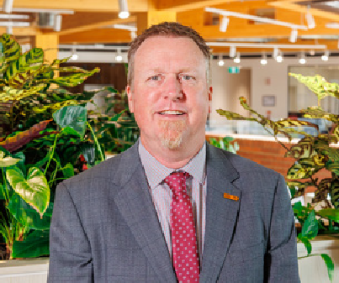
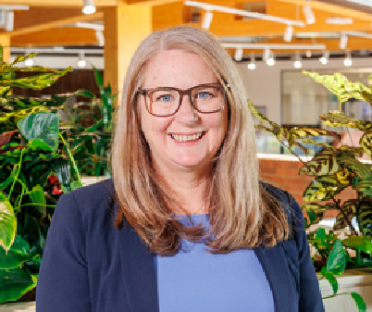

ALI WASTIE
Chief Executive Officer
Commenced 28 August 2023

ANTHONY BASFORD
City Life
Commenced 19 February 2024

TENNILLE BRADLEY
Placemaking
Commenced 22 January 2024

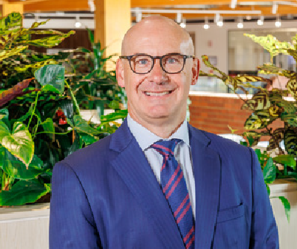
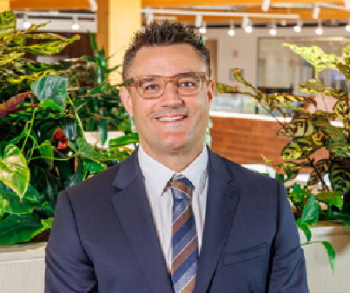

TROY EDWARDS
Corporate Services
Commenced 22 January 2024

JAMES STIRTON
City Infrastructure
Commenced 22 January 2024

Figure 9: Our leadership team as at 30 June 2024.5

- David Greaves held the position of Acting Executive Director City Infrastructure 1 July 2023 - 21 January 2024.
Kaarina Phyland held the positions of Acting Chief Executive Officer from 1 July - 27 August 2023 and Executive Director Strategy, People and Performance from 28 August - 5 September 2023.
Bryce Prosser held the position of Acting Executive Director Customer, Community and Economy till 1 July - 18 September 2023. Tennille Bradley held the position of Acting Executive Director Customer, Community and Economy from 18 September 2023 to 21 January 2024.
Gareth Smith held the position of Executive Director Planning & Design 1 July – 11 November 2023
Robyn Stevens held the position of Executive Director Community Service Delivery 1 July - 8 December 2023

31.

OUR PEOPLE
We are proud to be an inclusive and flexible organisation that is one of the largest employers in the region.
We currently employ a total of 2,757 people, equivalent to 1,786.9 full-time employees6. Our turnover7 in 2023–24 was 14.5 per cent, down from 16.9 per cent the previous year.
Table 2: Total full-time equivalent employees by directorate, employment condition and gender in 2023–24

EMPLOYEE TYPE – GENDER | CHIEF EXECUTIVE | CITY INFRASTRUCTURE | CITY LIFE | CORPORATE SERVICES | PLACEMAKING
Full Time – W | 2 | 82.5 | 266.8 | 137.2 | 97
Full Time – M | 0 | 400.6 | 94.5 | 85 | 65.8
Full Time – X | 0 | 0 | 0 | 0 | 0
Part Time – W | 0 | 7.1 | 301.1 | 43.8 | 22
Part Time – M | 0 | 1.7 | 41.2 | 3.2 | 1.2
Part Time – X | 0 | 0 | 0 | 0 | 0
Casual – W | 0 | 0.6 | 82 | 9.1 | 0.4
Casual – M | 0 | 1.9 | 38.8 | 0 | 0.6
Casual – X | 0 | 0 | 0 | 0 | 0
Total8 | 2.0 | 494.4 | 825.7 | 278.3 | 187.0
Legend: W = Women, M = Men, X = Persons of self-described gender

Table 3: Total headcount of employees by employment classification and gender in 2023–24

EMPLOYMENT CLASSIFICATION | WOMEN | MEN | PERSONS OF SELF- DESCRIBED GENDER | TOTAL
Band 1 | 102 | 79 | 1 | 182
Band 2 | 198 | 46 |  | 244
Band 3 | 347 | 326 | 3 | 676
Band 4 | 473 | 101 | 1 | 575
Band 5 | 221 | 98 |  | 319
Band 6 | 178 | 96 |  | 274
Band 7 | 114 | 130 |  | 244
Band 8 | 62 | 51 |  | 113
MCH Nurse | 59 |  |  | 59
Senior Officer | 40 | 31 |  | 71
Total | 1,794 | 958 | 5 | 2757

- As at 30 June 2024
- Excludes casual employees
- Total includes 1.3 Full-Time equivalent of self-described gender not captured in the individual breakdown

OUR VOLUNTEERS
Volunteering is integral to our operations and makes an invaluable contribution to our organisation and the community that we serve.
The City currently has hundreds of volunteers working in a wide range of areas, including at the National Wool Museum, L2P mentoring program, Tourism Greater Geelong and the Bellarine, Potato Shed, Family Services, Study Geelong and Grovedale Neighbourhood House. We thank the many volunteers who provide useful – and often vital – services to people from all walks of life.
This year, the City developed a Volunteer Framework based on the National Standards for Volunteering, to further strengthen our volunteer programs and implemented an online training module to support the development of our volunteers. We also held two volunteer events and delivered our first Volunteer Experience Survey with highly favourable results.

Photo: Thanking our volunteers at a special event at the Carousel, Geelong.
33.

HOW WE PLAN

We have developed an integrated, long-term and transparent approach to planning, monitoring and performance reporting that is aligned with our clever and creative vision.

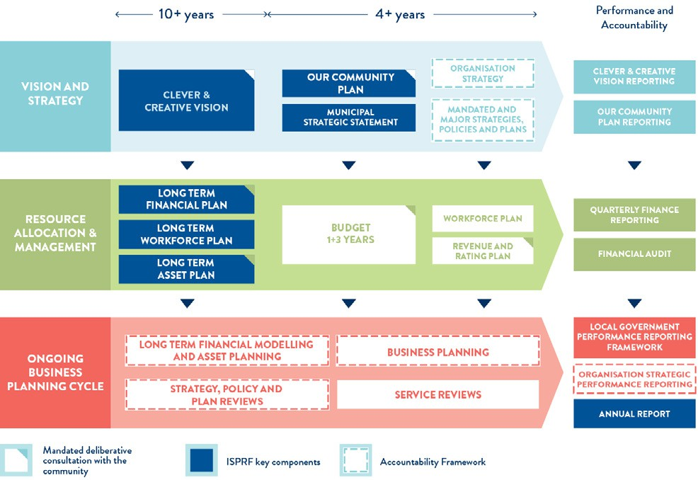
Figure 10: Our Integrated Strategic Planning and Reporting Framework (ISPRF)

The Local Government Act 2020 requires all councils to prepare the following documents:
- Community Vision
- Council Plan
- Financial Plan
- Asset Plan
- Budget
- Revenue and Rating Plan
- Annual Report
- Workforce Plan.
Our Integrated Strategic Planning and Reporting Framework (represented in Figure 10) demonstrates the relationship between these key planning and
reporting documents. The framework helps us set goals, make decisions, prioritise our workload, allocate resources, monitor progress and adapt to changing circumstances that might challenge our progress.
In 2021, we incorporated our Municipal Public Health and Wellbeing Plan into our Council Plan to create Our Community Plan 2021–25.
In 2022−23, we introduced an internal organisation strategy and business planning cycle to guide our budget and business planning. This process will continue to develop and enhance our strategic decision-making around priorities, performance and resource allocation.

OUR PERFORMANCE

Our Community Plan 2021–25 outlines how we are working towards the 30-year community vision to make Greater Geelong a clever and creative city-region.
OVERALL PROGRESS
Of the 75 actions, 76 per cent (57) were complete, and a further 24 per cent (18) are ongoing.
24%%
76%%
Ongoing Complete
The plan tells our community what councillors are aiming to achieve during their four-year terms. It guides us on how we allocate resources, so we can deliver infrastructure, services and programs to our community to ensure the social, economic and environmental sustainability of our region.
The four strategic directions we have chosen to guide us are:
- healthy, caring and inclusive community
- sustainable growth and environment
- strong local economy
- high-performing Council and organisation.
As well as the strategic directions, the plan also outlines:
- desired outcomes – the future state we’re aiming for in four years
MAJOR BUDGET INITIATIVES
Of the 75 actions, 15 are major initiatives identified in the 2023–24 budget. Of these, 60 per cent (9) are completed and a further 40 per cent (6) are ongoing.
40%%
60%%
Ongoing Complete
- four-year priorities – the priorities we’ll focus on to help achieve our desired outcomes
- indicators – how we will monitor our progress.
Our Community Plan 2021–25 is supported by an annual action plan and budget, highlighting the projects, initiatives and programs that will take place within the financial year to address our four-year priorities.
The following provides a high-level overview of our performance in delivering the 2023–24 annual action plan, and how we are tracking against the indicators. It also highlights our major budget initiatives supporting our strategic priorities.
For more detailed information on the progress of the annual action plan, refer to the quarterly reports on our website geelongaustralia.com.au/ourcommunityplan

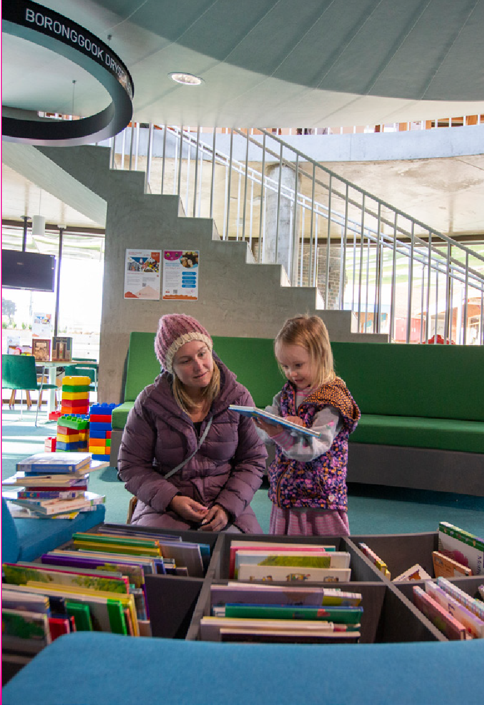


STRATEGIC DIRECTION 1:
HEALTHY, CARING AND INCLUSIVE COMMUNITY

LINKS TO CLEVER AND CREATIVE VISION:
People feel safe wherever they are

Creativity drives culture

An inclusive, diverse, healthy and socially connected community

ANNUAL ACTION PLAN 2023–24
We committed to 30 actions, which demonstrate how we are addressing our four-year priorities under Healthy, Caring and Inclusive community.
At the end of June 2024,
- 70% (21) were ‘complete’
- 30% (nine) were ‘ongoing’

30%
70%

Progress of annual actions supporting delivery of Our Community Plan 2021–25

Ongoing Complete

Photo: Boronggook Drysdale Library.

MAJOR BUDGET INITIATIVES

BUDGET INITIATIVE | ACTION 2023−24 | STATUS
Armstrong Creek Town Centre Library & Learning Hub Design | Complete the construction phase for the Biyal-a Armstrong Creek Library | Complete
Drysdale Sporting Precinct Master Plan Implementation – Stage 2 | Implement Stage 2 of the Drysdale Sporting Precinct Master Plan | Ongoing
Lara Recreation Reserve Master Plan Stage 2 | Implement Stage 2 of the Lara Recreation Reserve Master Plan | Complete
Norlane Aquatic Centre and Community Hub | Activate the Norlane Aquatic and Community Hub with a focus on health and wellbeing, cultural engagement and community connection for people in the local community | Complete
Rippleside Inclusive Playspace | Commence construction of all abilities playspace at Rippleside Park | Ongoing

PROGRESS REPORT

INDICATORS | RESULT AT 30 JUNE 2024 | PROGRESS COMMENTS
MUNICIPAL
Proportion of adults experiencing | 20% (2021) / | There was an increase in the proportion of our adult community
high / very high psychological distress | 10.3% (2017) | experiencing high / very high psychological distress since 2017. The
 |  | next survey is due to be conducted in 2024–25.
Proportion of adults meeting the | 67% (2021) / | More of our adult community is reporting that they are sufficiently
physical activity guidelines | 41% (2017) | physically active than in 2017. The next survey is due to be
 |  | conducted in 2024–25.
Proportion of adults consuming the recommended number of serves of fruit and vegetables | Fruit 46% (2021) /  53% (2017)  Vegetable 15% (2021) /  10% (2017) | Since 2017, there was an increase in the proportion of our adult community consuming the recommended serves of vegetables and a decrease in the proportion consuming the recommended serves of fruit. The next survey is due to be conducted in 2024–25.
Family violence incident rate per 100,000 population for Greater Geelong | 1,764.7 (June 2024) /  1,720.2 (June 2023) | For the year ending June 2024, the family incident rate for Greater Geelong was higher compared to the Victorian rate (1,418.1).
Community perception of safety in | 61% (2021) / | The result comprised of 67% of males rated that they always feel
the area where they live | 54% (2017) | safe in the area where they live compared to 56% of females. The
 |  | next survey is due to be conducted in 2024–25.
Level of agreement that multiculturalism makes life better (definitely or sometimes) | 66% (2021) | This result comprised 48% definitely and 18% sometimes. The next survey is due to be conducted in 2024–25.
Proportion of community concerned about effects of climate change on health (very or quite concerned) | 51% (2021) | This result comprised 28% very concerned and 23% quite concerned. The next survey is due to be conducted in 2024–25.
Proportion of adults that are a member of an organised group (sports, religious, school, professional, community or action group) | 56% (2021) | This result consisted of 28% members of a sports group. The next survey is due to be conducted in 2024–25.
CITY OF GREATER GEELONG
Community satisfaction with support services | Family 60 (2024) / 62 (2023)  Elderly 57 (2024) / 60 (2023)  Disadvantaged 53 (2024) /  58 (2023) | While no significant change from 2023, Family Support services were rated significantly lower than the statewide (63) and comparable to the Regional Centres average (62).  While no significant change from 2023, Elderly Support services were rated significantly lower than both the statewide (63) and the Regional Centres average (62).
 |  | Disadvantaged Support services were rated significantly lower compared with the previous year. The rating was also lower than the statewide average (58) but comparable to the Regional Centres average (54).
Community satisfaction with | 66 (2024) / | There was no significant change in satisfaction compared with the
recreational facilities | 69 (2023) | previous year. Our result was comparable to the statewide (68), however lower than the Regional Centres average (69).
Level of agreement that council infrastructure is equitable (fair access to facilities that are needed across the municipality including healthy, safe and inclusive places and spaces) | 50% (2024) /  44% (2023) | There was an increase in the proportion of people who agreed or strongly agreed that council infrastructure is equitable. Comparison to statewide and Regional Centres average is unavailable as this is a tailored question for the council.
Level of agreement that council infrastructure is accessible (for all abilities, affordable and easy for people to get to) | 59% (2024) /  56% (2023) | There was a slight increase in the proportion of people who agreed or strongly agreed that council infrastructure is accessible. Comparison to statewide and Regional Centres average is unavailable as this is a tailored question for the council.
Number of key community | 95% (2024) / | We have delivered 35 of the 37 key community infrastructure
infrastructure projects completed | 89.2% (2023) | projects identified for delivery by 2022.
Community satisfaction with community and cultural activities | 64 (2024) / 66 (2023) | There was no significant change in satisfaction compared with the previous year. Our result was comparable to both statewide and Regional Centres averages (66 and 65 respectively).

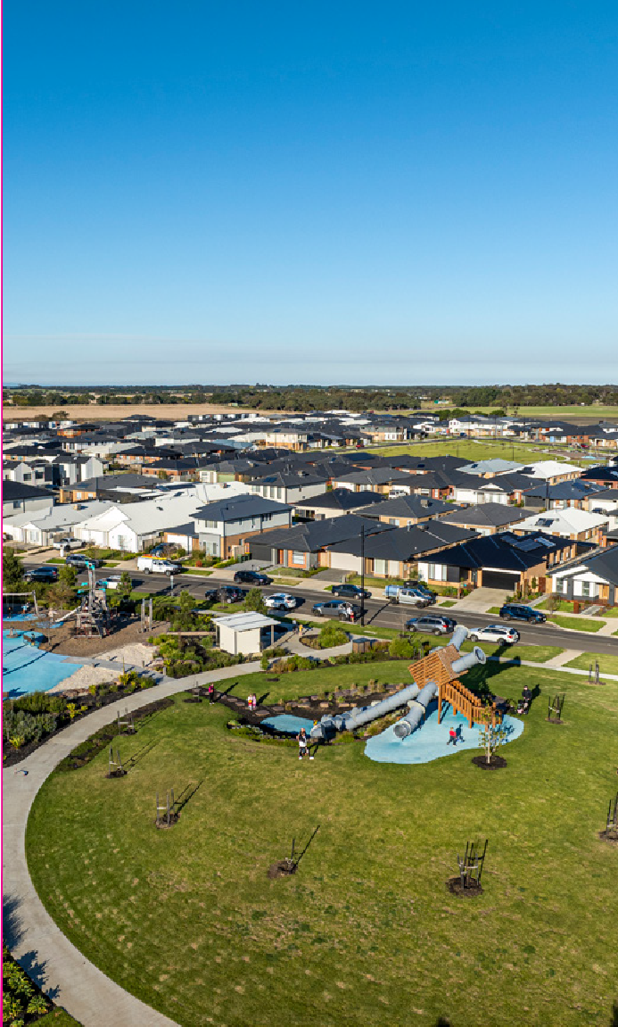



STRATEGIC DIRECTION 2: SUSTAINABLE GROWTH AND ENVIRONMENT

LINKS TO CLEVER AND CREATIVE VISION:
People feel safe wherever they are

A fast, reliable and connected transport network
Photo: Armstrong Creek growth area.

Development and implementation of sustainable solutions
Creativity drives culture

Sustainable development that supports population growth and protects the natural environment

ANNUAL ACTION PLAN 2023–24
We committed to 17 actions which demonstrate how we are addressing our four-year priorities under Sustainable Growth and Environment.
At the end of June 2024:

- 75% (12) were ‘complete’
- 25% (five) were ‘ongoing’

Progress of annual actions supporting delivery of Our Community Plan 2021–25
25%

75%

Ongoing Complete

MAJOR BUDGET INITIATIVES

BUDGET INITIATIVE | ACTION 2023−24 | STATUS
LED street lighting & smart control technology | Upgrade the LED Street Lighting & Smart Control Technology | Complete
Northern and Western Geelong Growth Areas Commonwealth biodiversity approvals | Prepare the strategic assessment under the Environment Protection and Biodiversity Conservation Act and biodiversity conservation strategy for the Northern and Western Growth Areas | Ongoing
Northern and Western Geelong Growth Areas Precinct Structure Plan development | Deliver the Precinct Structure Planning program for the Northern and Western Geelong Growth Areas | Complete
Sparrovale Wetlands Project (Phase 1) | Establish public parkland as per phase 2 (2022−2030) of the Sparrovale Ngubitj yoorree Wetlands Master Plan | Complete

PROGRESS REPORT

INDICATORS | RESULT AT 30 JUNE 2024 | PROGRESS COMMENTS
MUNICIPAL
Residential land supply | 20 years (April 2024)* / 22 years (April 2022)  *estimate based on building activity. The next  assessment will occur in late 2024. | There are a range of housing choices to meet diverse community needs. Priority in the short term is the finalisation of the first Precinct Structure Plan’s in the Northern and Western Geelong Growth Areas.
Employment land supply | 13 years (June 2024) / 25 years (June 2023)  *based on zoned supply only and not future identified precincts as part of the South West Geelong Employment Land Review in 2022. | There continues to be sufficient long-term industrial land supply. Priority in the short term is increasing zoned supply through the delivery of three new industrial precincts in Avalon, Armstrong Creek and Waurn Ponds.
Diversity of housing supply | 13.90% (2021) / 15.10% (2020) | There was a significant decline in the share of housing growth in established areas in 2021. This type of development is typically smaller-medium density housing. No new data available.
Journeys to work made by public transport, walking or cycling | 4.6% journeys (2021) /  8.75% journeys (2016) | In 2021, journeys to work were significantly impacted by COVID-19 lockdowns.
Percentage of residences within 400 metres of public open space in urban areas | 88.7% (2024) /  81.2% (2021) /  67.8% (2018) | There have been substantial changes in the methodology used to calculate public open space since 2018. As a result, changes in quality of the data set and methodology employed to undertake  the analysis make it difficult to directly compare these results with previous years. Open space asset data continues to be refined.
Community greenhouse gas emission | Tonnes CO2–emissions total  3,791,000 (2021–22) / 3,783,000 (2020–21) | Updated data will be available late 2024.
Diversion of waste from landfill | 51% (2023–24) / 53.21% (2022–23) | The slight decrease in diversion rate is due to a decrease in recyclables collected, resulting from introduction of the Container Deposit Scheme.
CITY OF GREATER GEELONG
Community satisfaction with planning for population growth | 43 (2024) / 49 (2023) | There was a significant decrease in satisfaction compared with the previous year. Our result was significantly lower than both the statewide and the Regional Centres averages (47 and 52 respectively).
Percentage housing construction within existing urban areas | 26% (2024) / 24% (2023) | Greenfield development continues to supply most of the housing in Greater Geelong.
Kilometres (km) of bicycle, walking paths and shared paths | Bike paths: 121 km (+6km from 2023) Footpaths: 2,044 km (+56km from 2023) Shared paths: 218km (+10 km from 2023) | There was a total increase of 72km in the path network in 2023-24.
Community satisfaction with local streets and footpaths | 47 (2024) / 52 (2023) / 59 (2022) | Our result decreased significantly and is lower than both the statewide and Regional Centres averages (52 and 53 respectively).
Community satisfaction with sealed local roads | 46 (2024) / 53 (2023) / 57 (2022) | While our result decreased it is comparable to both the statewide and other Regional Centres averages (45 and 46 respectively).
Quantity of open space (civic, community parks, sports reserves and heritage open space) | 1,079.5 ha – 497 sites (June 2024) /  1,026.497 ha – 485 sites (June 2023) | Changes in quality of the data set and methodology employed to undertake the analysis make it difficult to directly compare these results with previous years. Open space asset data continues to be refined.
Community satisfaction with appearance of public areas (includes local parks, gardens, reserves and nature strips) | 64 (2024) / 66 (2023) / 70 (2022) | There was no significant change in satisfaction from 2023. Our result is significantly lower than both the statewide and Regional Centres averages (68 and 70 respectively).
Greenhouse gas emissions generated by City-managed operations (tonnes CO2- emissions) | 24,301 tonnes (2023–24)* /  23,895 tonnes (2022–23)  *provisional figure to be finalised. | Regional population growth has contributed to higher volumes of waste going to landfill and an increase in waste emissions. While corporate natural gas emission figures have remained stable, our fleet emissions are reducing as we integrate low and zero emission vehicles into our fleet.
Hectares (ha) of protected natural habitat | 1,466.64 ha (June 2024) /  1,405 ha (June 2023) | There was an increase of 61.64 hectares of natural habitat managed by us in 2023–24.
Number of trees planted | Street and park trees:  2,811 (2023−24) / 3,016 (2022−23)  Tubestock: 4,000 (2023−24) /  4,000 (2022−23) | We planted 2,543 street and 268 park trees and removed 1,117 trees resulting in a net gain of 1,694 trees.
Community satisfaction with waste management | 69 (2024) / 70 (2023) / 70 (2022) | Our performance, unchanged from 2023, was comparable to the statewide (67), and significantly higher than the Regional Centres (66).

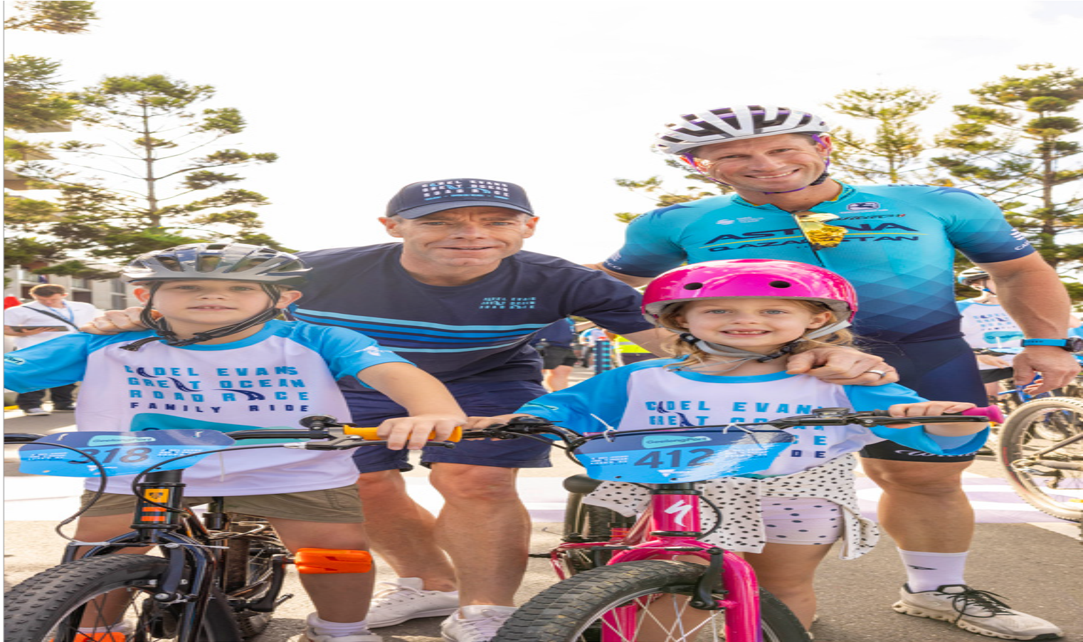




STRATEGIC DIRECTION 3:
STRONG LOCAL ECONOMY

LINKS TO CLEVER AND CREATIVE VISION:
Photo: 2023 Cadel Evans Family Ride, Geelong.

A destination that attracts local and international visitors
A leader in developing and adopting technology

Creativity drives culture
A prosperous economy that supports jobs and education opportunities

ANNUAL ACTION PLAN 2023–24
We committed to 14 actions which demonstrate how we are addressing our four-year priorities under Strong Local Economy.
At the end of June 2024:
- 86% (12) were ‘complete’
- 14% (two) were ‘ongoing’.
14%

Progress of annual actions supporting delivery of Our Community Plan 2021–25
86%

Ongoing Complete

MAJOR BUDGET INITIATIVES

BUDGET INITIATIVE | ACTION 2023−24 | STATUS
Osbourne House works | Finalise the procurement activities related to redevelopment of the Osborne House site and complete the draft proposal of future activities for council endorsement | Ongoing
Public Wi-fi & enhanced broadband Geelong pilot | Deliver free public Wi-Fi and enhanced broadband across the north to address gaps in digital access and affordability (Geelong Smarter Suburbs) | Complete
Commonwealth Games program | Advocate for the best community outcomes in regard to Commonwealth Games legacy funding | Ongoing

PROGRESS REPORT

INDICATORS | RESULT AT 30 JUNE 2024 | PROGRESS COMMENTS
MUNICIPAL
Number of jobs located in the City of Greater Geelong | 144,568 (2022–23) /  135,358 (2021–22) | Greater Geelong experienced the second largest increase in jobs on record in 2022−23, with an increase of 9,210 jobs (+6.8%). The largest number of jobs created were in  health care and social assistance (+3,768 jobs), professional, scientific and technical services (+928) and financial and insurance services (+771). Data for 2023−24 will be available in early 2025.
City of Greater Geelong unemployment rate | 4.1% (June quarter 2024) /  3.3% (June quarter 2023) | The unemployment rate increased this financial year and is now slightly above the Victorian rate of 4.0 per cent. The ten-year average unemployment rate for Greater Geelong is  5.3 per cent.
Gross Regional Product (GRP) | $19.6 billion (2022–23) /  $18.6 billion (2021–22) | Greater Geelong's GRP increased by $928 million in 2022−23 (+5.0%). The largest contributors to this growth were health care and social assistance (+$238 million), accommodation and food services (+$149 million) and financial and insurance services (+$125 million).
Value of non-residential building approvals in City of Greater Geelong | $1.2 billion (2023–24) /  $977.1 million (2022–23) | Non-residential building activity increased by $190.6 million or 19.5% in 2023-24.
Number of businesses | 22,090 (2022–23) /  21,789 (2021–22) | Greater Geelong experienced the largest growth in business numbers in the state in 2022−23 with an additional 301 businesses. Just over half the growth in the number of businesses was in professional, scientific and technical services (+166), followed by healthcare and social assistance (+138) and rental, hiring and real estate (+76).
Tourism Sentiment Index (TSI) | 26.6 (December 2023) /  24.1 (March 2023) | Geelong and The Bellarine ranked in the top 100 destinations worldwide with the highest regarded experiences in the region being dining and wineries.
Investment in Geelong | 163 projects valued at  $13 billion (June 2024)  157 projects valued at  $16.9 billion (June 2023) | While the value decreased, the number of major investment projects increased by six in the year to June 2024.
Visitor expenditure | $1.93 billion (June 2024) /  $1.6 billion (June 2023) | Tourism spend is up 20% compared to the previous year and 76% compared to pre-Covid.
CITY OF GREATER GEELONG
Community satisfaction with business and community development | 53 (2024) / 59 (2023) /  59 (2022) | Satisfaction was significantly lower compared with the previous year. Our result is significantly lower than the statewide average (57), however comparable to the Regional Centres average (55).
Return on investment of Geelong major events | 54:1 (2023–24) /  50:1 (2022–23) | The 12 major events supported via Geelong Major Events had an economic impact estimated at $50.13 million.

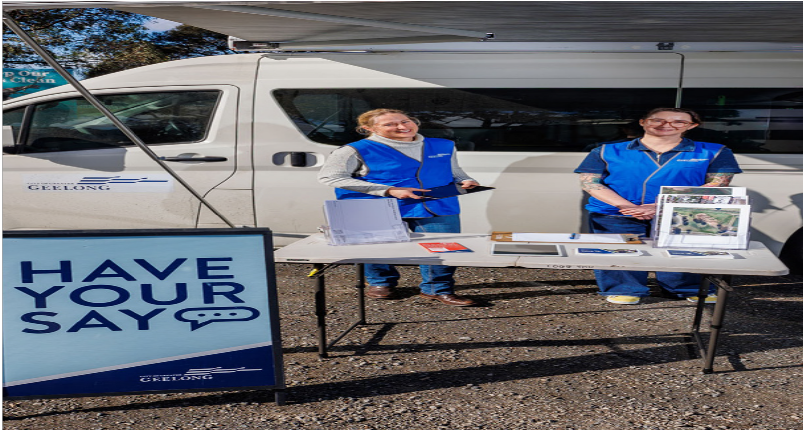

STRATEGIC DIRECTION 4:
HIGH-PERFORMING COUNCIL AND ORGANISATION

ANNUAL ACTION PLAN 2023–24
We committed to 14 actions which demonstrate how we are addressing our four-year priorities under High-performing Council and Organisation.
At the end of June 2024:
- 86% (12) were ‘complete’
- 14% (two) were ‘ongoing’.

14%

86%

Ongoing Complete

Progress of annual actions supporting delivery of Our Community Plan 2021–25

Photo: Face-to-face engagement activities for the Geelong Mountain Bike Facilities Renewal Project.

MAJOR BUDGET INITIATIVES

BUDGET INITIATIVE | ACTION 2023−24 | STATUS
Cyber security | Protect the City’s digital landscape from cyber security threats through implementation of the Cyber Security Strategy | Ongoing
Digital Innovation program | Commence the detailed design of a digital innovation program across the organisation | Ongoing
Future Ways of Working program | Deliver the City's Future Ways of Working program | Complete

PROGRESS REPORT
INDICATORS | RESULT AT 30 JUNE 2024 | PROGRESS COMMENTS
CITY OF GREATER GEELONG
Customer complaints resolution completed within 30 days | 93% (2023–24) /  87% (2022–23) | The new process for triaging complaints has seen an improvement in complaint resolution for both internal and external stakeholders.
Community satisfaction with customer service | 70 (2024) / 73 (2023) | There was no significant change in satisfaction from 2023. Our result was comparable with the statewide and Regional Centres group averages (67 and 68 respectively).
Community satisfaction with informing the community | 53 (2024) / 52 (2023) | While there was no significant change in satisfaction from 2023. Our result was significantly lower than the statewide average (56) but comparable to the Regional Centres average (54).
Community satisfaction with consultation and engagement | 49 (2024) / 52 (2023) | While there was no significant change in satisfaction from 2023. Our score was comparable with both statewide and Regional Centres averages (51 and 49 respectively).
Community satisfaction with overall council direction | 40 (2024) / 49 (2023) | Satisfaction was rated significantly lower compared with the previous year and is rated significantly lower than the statewide and Regional Centres group averages (45 respectively).
Community satisfaction with overall performance | 49 (2024) / 58 (2023) | Satisfaction was rated significantly lower compared with the previous year and is rated significantly lower than the statewide and Regional Centres group averages (54 respectively).
Community satisfaction with advocacy on behalf of the community | 47 (2024) / 50 (2023) | While there was no significant change from the previous year, satisfaction is significantly lower than both statewide and Regional Centres averages (50 respectively).
Lost Time Injury Frequency Rate (LTIFR) and Total Recordable Injury Frequency Rate (TRIFR) | 25.9 LTIFR (June 2024) /  22.3 LTIFR (June 2023)  35.4 TRIFR (June 2024) /  29.4 TRIFR (June 2023) | There was an increase in all reportable categories. A strong focus remains on completing incident investigations to determine the underlying cause of incidents and make sure that appropriate mitigation measures are implemented to manage and control hazards and risks.
Gender breakdown of City employees | 65.00% – female (June 2024)  65.69% – female (June 2023)  34.82% – male (June 2024)  34.13% – male (June 2023) 0.18% – self-described gender (June 2024)  0.17% – self-described gender (June 2023) | Gender breakdown of City employees remains very consistent with last year.
Number of Aboriginal and Torres Strait Islander people employed at the City | 21 (June 2024) / 20 (June  2023) | We recruit, develop and retain First Nations people as an integral part of our commitment to inclusiveness, engagement and to be an employer of choice for Aboriginal and Torres Strait Islander people.
Employee satisfaction and engagement | 78% (2024) / 76% (2022) | The City’s overall sustainable engagement score was 78%, increasing 2% since 2022.
Recurrent surplus / deficit | $(17.6) million (2023–24) /  $4.7 million (2022–23) | The operating result is a deficit of $17.6 million, being $18.0 million unfavourable to budget. This is primarily driven by the timing of the Financial Assistance Grant which had an unfavourable impact of  $23.9 million.
Funds from sale of assets | $1.65 million (2023–24) /  $31.1 million (2022–23) | Two of the City’s assets held for sale, building (151 Mercer Street) and land (Forest Road, Lara) were sold, with further asset sales in progress in 2024–25 financial year.
Cost recovery of services and revenue growth from new sources (fees and charges) | $10.3 million (2023–24) /  $9.9 million (2022–23) | An increase in the rates revenue stream due to increase of 3,620 rateable properties and supplementary rates during 2023–24 and the opening of two new aquatics centres North Bellarine and Norlane ARC (Aquatic Recreation Centre).
Efficiency target | $7.1 million (2023–24) /  $3.98 million (2022–23) | The budget contained an efficiency target embedded in material and services; however, this was delivered through other savings, including reducing employee costs and other expenses.
Asset renewal gap and upgrade ratio | 71.0% (2023–24) /  61.8% (2022–23) | A strong focus from council to invest in asset renewal has seen the ratio increase in 2023–24 and will continue to increase in the forthcoming years.

OVERVIEW OF
FINANCIAL PERFORMANCE
This is a summary of our financial results for 2023–24. For the full
details of our 2023–24 performance, download the complete annual report at geelongaustralia.com.au/annualreport

SURPLUS OF
$81.7 MILLION
Consistent with the prior year result.

$536.7 MILLION REVENUE
with 56.9 per cent coming from rates and charges.

$454.8 MILLION EXPENDITURE
41.8 per cent employee costs and 27.6 per cent materials and services.

$4.8 BILLION IN NET ASSETS
$179.9 million increase on the previous year, including a $98.2 million asset revaluation increment.

$139.5 MILLION CAPITAL
EXPENDITURE
38.1 per cent relating to land and buildings,
25.0 per cent for roads, footpaths, bike paths and drainage.

44.

COMPREHENSIVE INCOME STATEMENT

The comprehensive income statement shows how much we earned during the 2023–24 financial year. It details where we received our income and how it was spent.

NET RESULT

184.6

141.6
2020–21

2021–2021–22
*restated

81.7

2022–23 2023–24

154.6
The net result – that is, income minus expenditure – is shown in Figure 11.
This result can largely be attributed to:
- rates and charges increasing by $19.4 million due to a wider property base and increases in the general waste charge.
- user fees decreasing by $0.849 million as services reflect current economic climate

Figure 11: Net result 2020–21 to 2023–24 ($m)

TOTAL COMPREHENSIVE RESULTS

1,037.5

373.6

350.3

179.9
- grants decreasing by $29.2 million, largely due to the federal government assistance grant not received in June 2024.
- materials and services costs decreasing by $19.0 million Mainly efficiency target was expected from materials and services, however this was delivered through other savings.
- employee costs increasing by $2.8 million.
The total comprehensive result accounts for items that will not be classified to surplus or deficit in future periods. In this case, it is the net asset revaluation of land, buildings and infrastructure which, in 2023–24, was an increase of $98.2 million.

2020–21
2021–22
*restated
2022–23
2023–24
The total surplus includes an operating recurrent deficit of $(17.6) million ($4.7 million surplus in

Figure 12: Total comprehensive results 2020–21 to 2023–24 ($m)

RECURRENT OPERATING RESULTS

10.6

4.7
(17.6)
(9.4)
2022–23) and a non-recurrent surplus of $99.3 million ($149.9 million in 2022–23). The non-recurrent result includes gifted assets of $86.3 million ($91.8 million in 2022–23).
Budget surpluses are forecast over the next four years, including a $180.3 million surplus in 2024–25. This is a critical part of our financial sustainability strategy, as it gives us the capacity to maintain our services and renew our community assets.

2020–21
2021–22
*restated
2022–23
2023–24

Figure 13: Recurrent operating results 2020–21 to 2023–24 ($m)

BALANCE SHEET

The balance sheet shows what we own (assets), what we owe (liabilities) and our net worth (equity).
ASSETS
Our assets are primarily made up of:
- cash and cash equivalents of $95.8 million – used to cover our short-term commitments including long-service leave and debt obligations.
- property, plant and equipment and infrastructure worth $4.8 billion – an increase of $188.5 million on the previous year.
These asset types make up 94.9 per cent of our total assets.

CAPITAL PROGRAM

We deliver an extensive capital works program – renewing, upgrading and building assets to meet community need.
As Figure 16 shows, our capital works expenditure in 2023–24 was $ 139.5 million. This included:
- $75.1 million on new assets (53.9 per cent)
- $51.6 million on renewal works (37.0 per cent)
- $12.7 million on upgrade works (9.1 per cent).

2020–21

121.2

139.5

174.2

195.7
2021–22
2022–23
2023–24

TOTAL ASSETS Figure 16: Total liabilities 2020–21 to 2023–24 ($m)

5,131.1

4,554.5

4.897.2

3,354.7

2020–21

2021–22
*restated

2022–23
*restated

2023–24
The main categories of expenditure were:
- $53.2 million on land and buildings
- $25.4 million on roads
- $23.3 million on parks, open space and streetscapes
- $8.7 million on plant and equipment

Figure 14: Total assets 2020–21 to 2023–24 ($m)

171.5
INVESTMENTS
$3.4 million on drainage

138.1

145.6

144.0
  - $6.2 million on footpaths and bike paths
  - $2.6 million on recreational, leisure and community facilities
  - $16.7 million on other assets.

2020–21
2021–22 2022–23
2023–24

Figure 15: Investments 2020–21 to 2023–24 ($m)

46.

LIABILITES

Our liabilities include future commitments to suppliers, employees (for leave entitlements), loans and costs associated with providing landfill.
TOTAL LIABILITIES
As Figure 17 shows, total liabilities were $334.3 million, an increase of 19.2 per cent on the 2022–23 balance. This increase is due to new borrowings.

DEBT COMMITMENT
The debt commitment ratio shows the percentage of rates required to meet loan repayments for the following 12 months.
Figure 19 shows that a low percentage of rates are being used to service loans and we have capacity to meet our debt repayments.

6.9

2020–21

243.2

280.3

277.5

334.3

4.57

4.84

5.29
2021–22
2022–23
2023–24

2020–21

2021–22

2022–23
*restated

2023–24
Figure 19: Debt commitment percentage 2020–21 to 2023–24 (%)

RATEPAYER EQUITY

Figure 17: Total liabilities 2020–21 to 2023–24 ($m)

LOANS
Our loan balance equates to 55.3 per cent of total liabilities, which is slightly higher than 2022–23 (45.3 per cent).
The overall increase in our loan balance of $ 58.0 million is due to new loans taken in 2023−24.
Ratepayer equity is represented by our net worth – that is what we own ($ 5,131 million) minus what we owe ($ 334.3 million).
As Figure 20 shows, ratepayer equity as at 30 June 2024 was $ 4,797 million – an 3.9 per cent increase on the previous year. This is due to continued growth of our fixed asset base – that is, property, plant and
equipment and infrastructure and revaluation of these asset groups.
.

4,796.8

3,074.1

4,276.9

4,616.9

2020–21

117.1

127.0

140.1

185.0
2021–22
*restated
2022–23
*restated
2023–24

2020–21
2021–22
2022–23
2023–24
Figure 20: Ratepayer equity 2020–21 to 2023–24 ($m)

Figure 18: Loans from 2020–21 to 2023–24 ($m)

ASSETS
Across the municipality we have hundreds of thousands of physical items, and infrastructure that stretches for many kilometres.
In financial terms, these physical objects or assets are valued at approximately $4.8 billion. This includes civil infrastructure - such as roads, kerb and channel, bridges, drainage and footpaths, and social infrastructure, such as buildings, open spaces, arts and culture and recreation facilities.
With an impressive assets portfolio comes significant maintenance requirements, which grow as we invest in new facilities across the region and inherit assets such as parks, roads, drainage and footpaths in newly developed areas. Like many local governments, the City faces significant financial pressure related to maintaining and renewing its assets.

RATES AND CHARGES
To deliver our diverse range of community and business services, we collect rates and charges from all property owners in the municipality.
Figure 21 shows how every $100 was spent in the 2023–24 budget.

Environmental and natural resources
$1.18
Finance costs
$1.07

Statutory and strategic planning and building

Health and local laws
Transport and related infrastructure maintenance

Transport infrastructure planning and delivery
$3.21

Economic, business and tourism development
$3.31
$3.22
Communications and marketing
$0.60
Customer service
$0.43
$2.99
$2.06

Capital works
$34.62

Arts, culture and libraries

Community care

Community capacity building
$4.79

FOR EVERY
$3.49
$100 SPENT
$4.13
$4.31

Parks and reserve management
$11.58
$5.64

48.

Figure 21: Breakdown
$5.93
2023–24 Budget
Recreation and sports

Family services

Internal services

Waste management
$7.44







This document contains important information about the City of Greater Geelong. Please contact us if you have any questions or would like to request a hard copy of the report.

CITY OF GREATER GEELONG
Wadawurrung Country PO Box 104
Geelong VIC 3220
P: 5272 5272
E: contactus@geelongcity.vic.gov.au www.geelongaustralia.com.au

© City of Greater Geelong 2024 ISSN: 2209–8828

LATEST NEWS:
@CityofGreaterGeelong @GreaterGeelong @CityofGreaterGeelong CityofGreaterGeelong

