
gravel roads

2025 Resheeting Program

Our annual gravel road resheeting program aims to support residents living on unsealed roads by using the best available gravel that provides a good driving surface which lasts.
New gravel will be placed on your road as part of our 2025 program.
Drivers may experience short delays while we are undertaking works onsite.

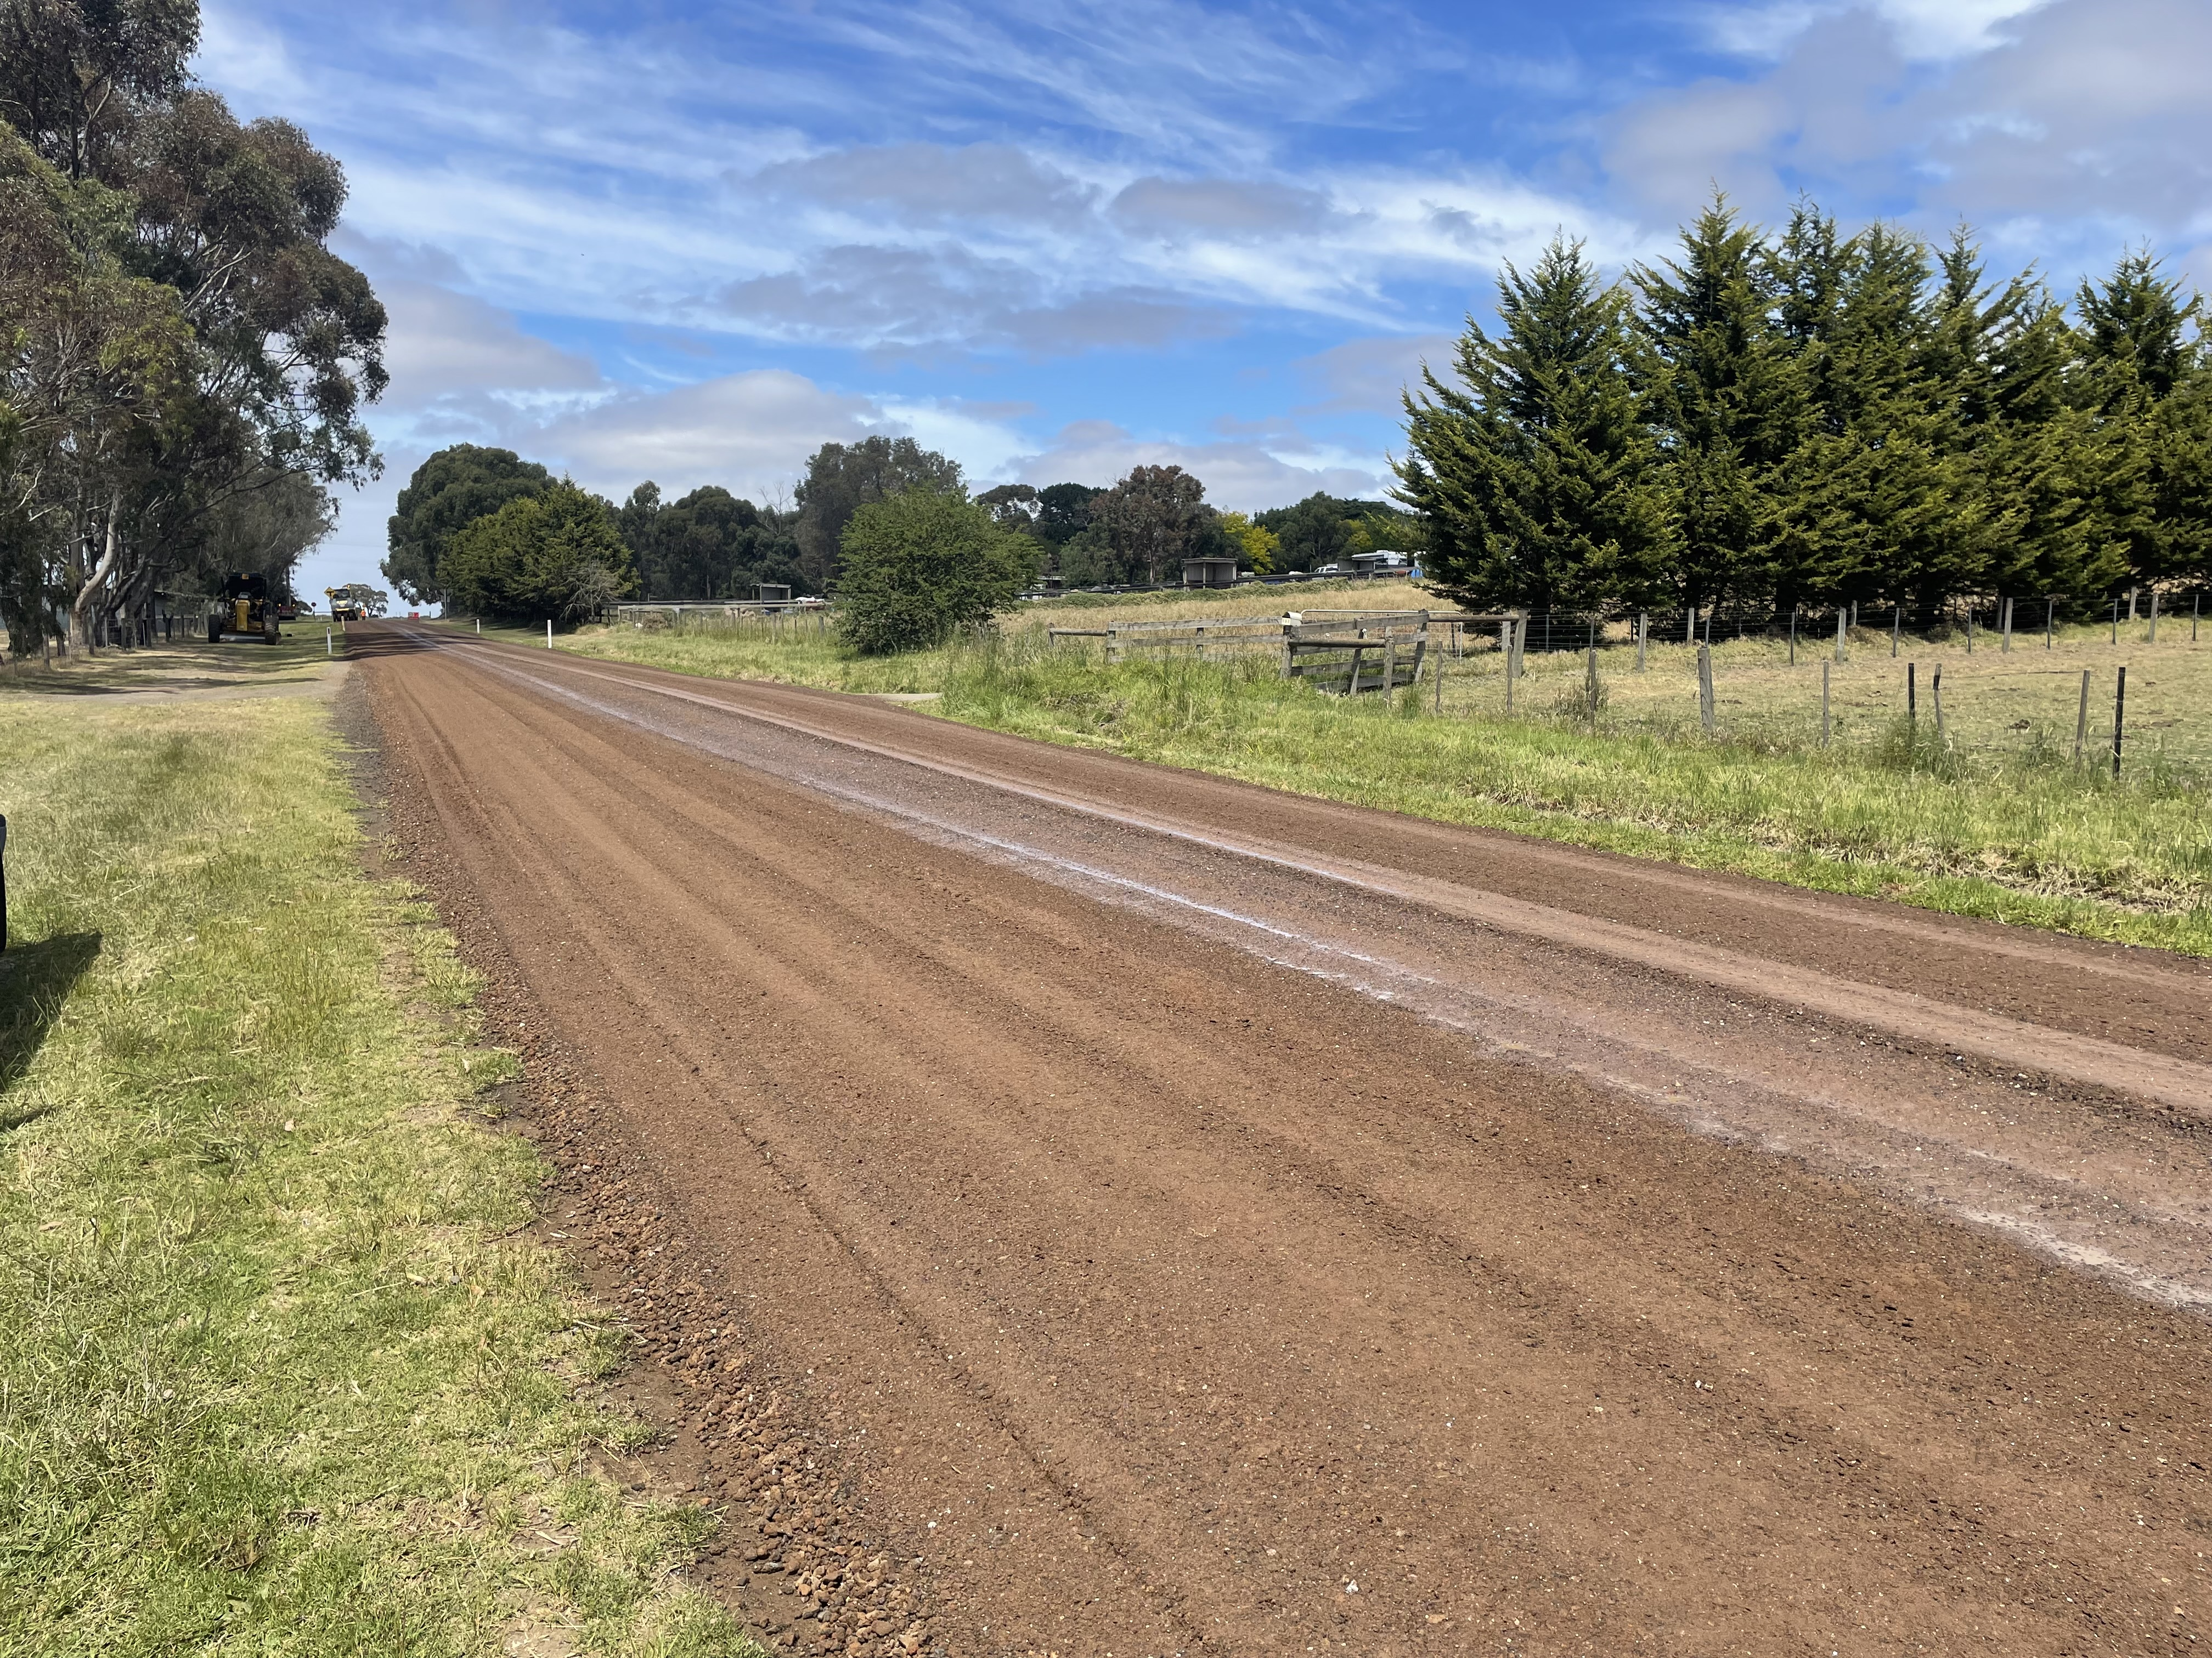
CoGG8 resheeted road
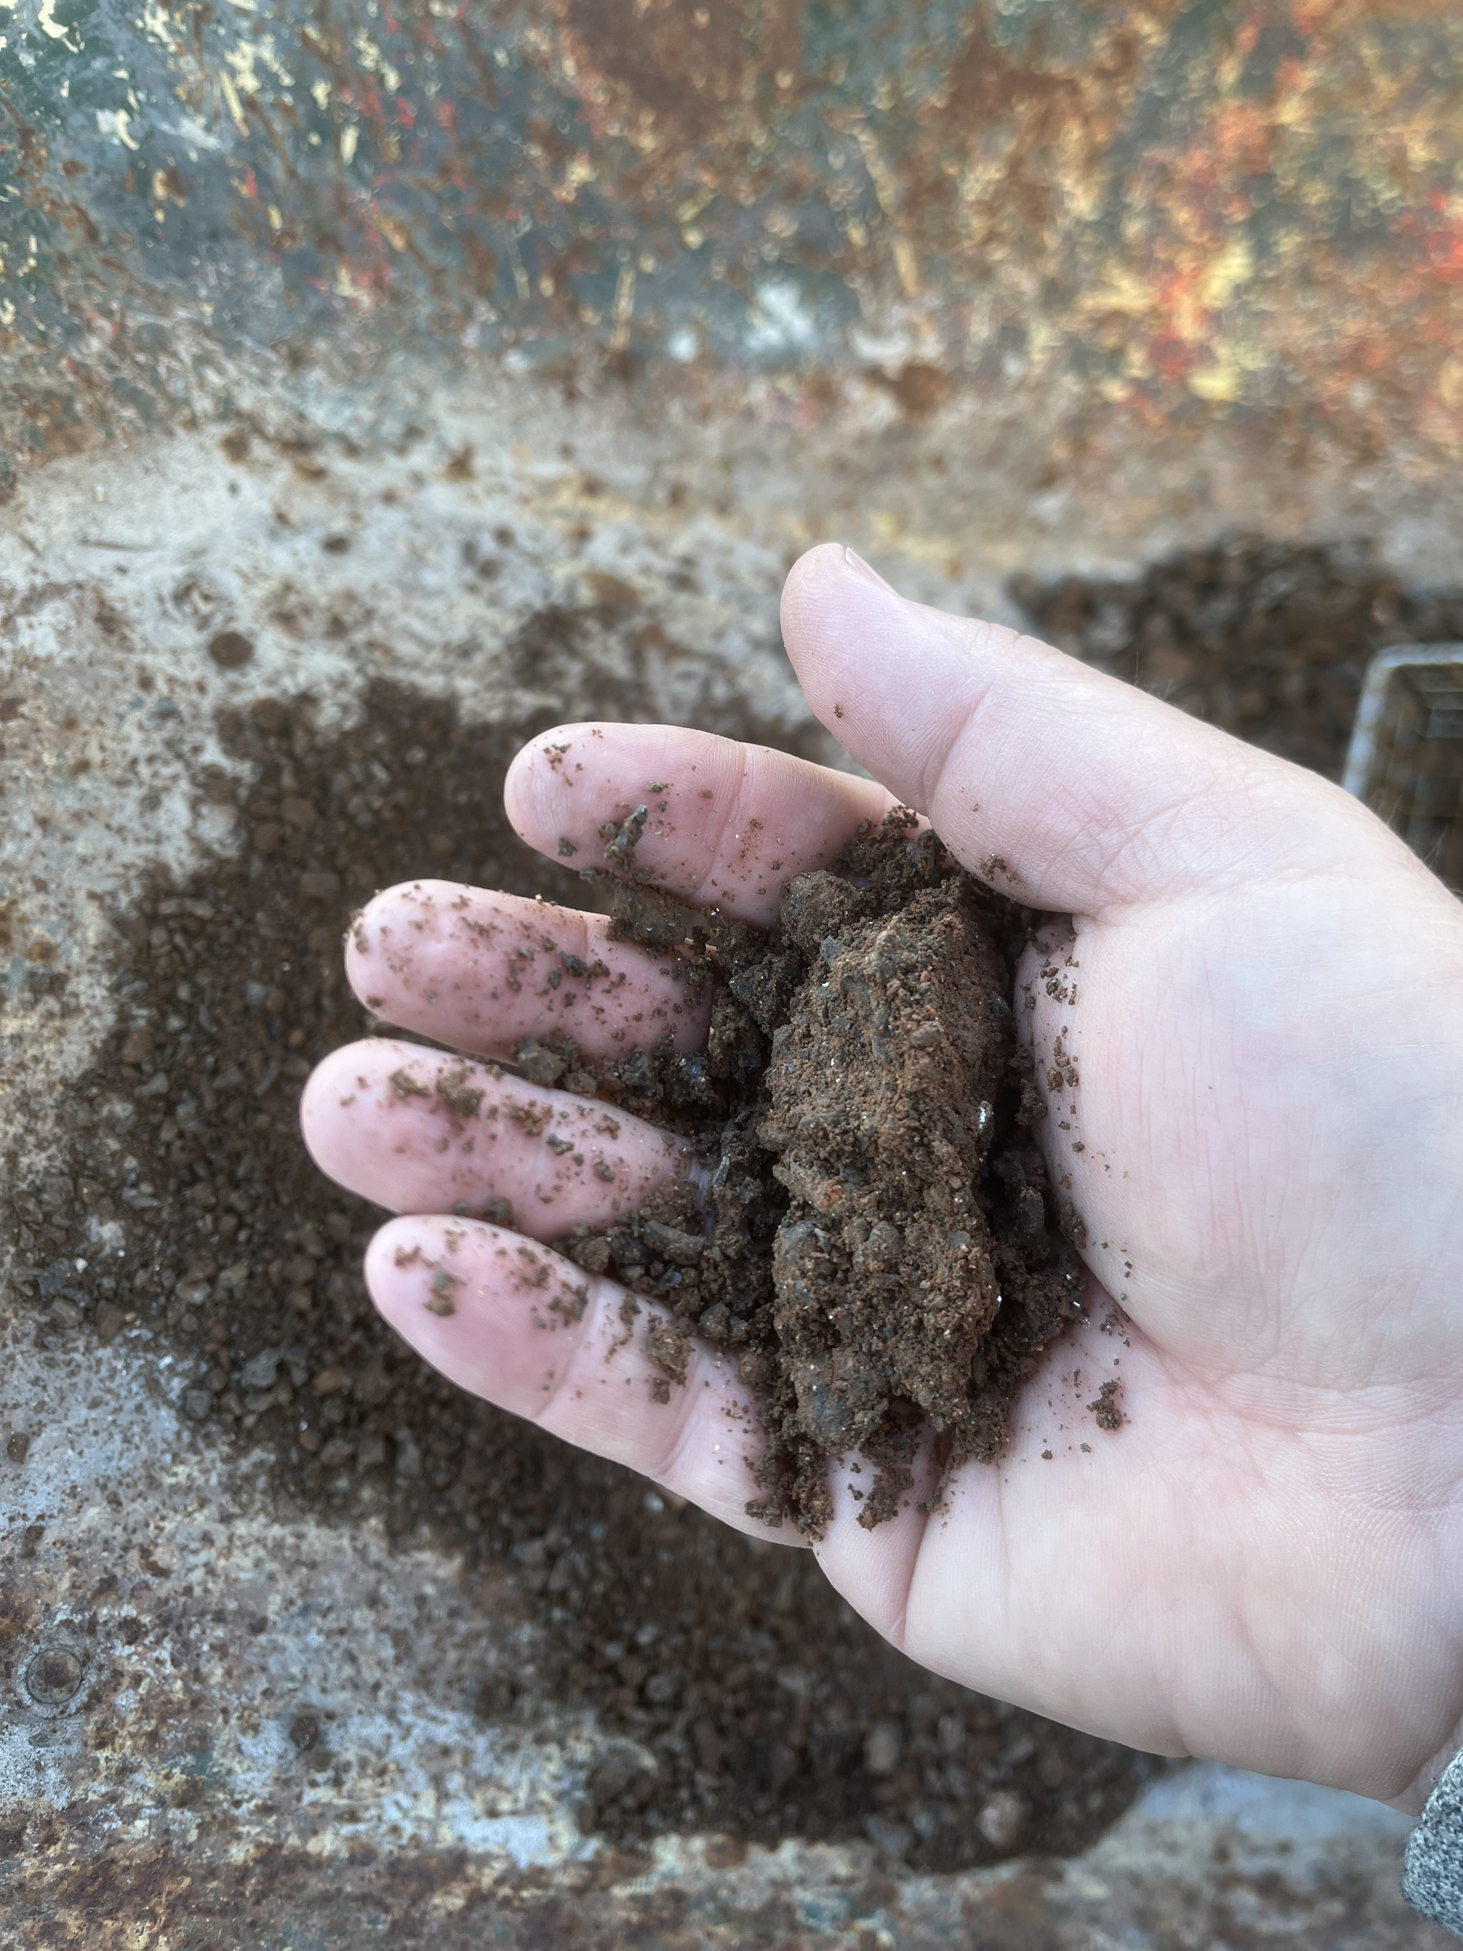
CoGG8 material

In this year’s resheeting program, CoGG8 gravel blend material will be placed on roads included in the program. The gravel is produced locally and has a slightly lower clay content than other local gravel products. Gravel roads produce more dust during dry weather and the CoGG8 blend is no different – however, it performs better in wet weather due to the lower clay content. We do not provide dust suppression as a service standard for any road which has been resheeted.

Independent testing confirmed that:
- the CoGG8 gravel meets our gravel road standards
- crystalline silica was not detected in the samples
- respirable dust (not visible to the naked eye) was below safe exposure limits for a residential area

When resheeting, where there are no native vegetation restrictions, we will reshape swale drains along the road to restore drainage.


Further information on gravel roads can be found by using the QR code, or by heading to our website -https://www.geelongaustralia.com.au/roads/default.aspx

