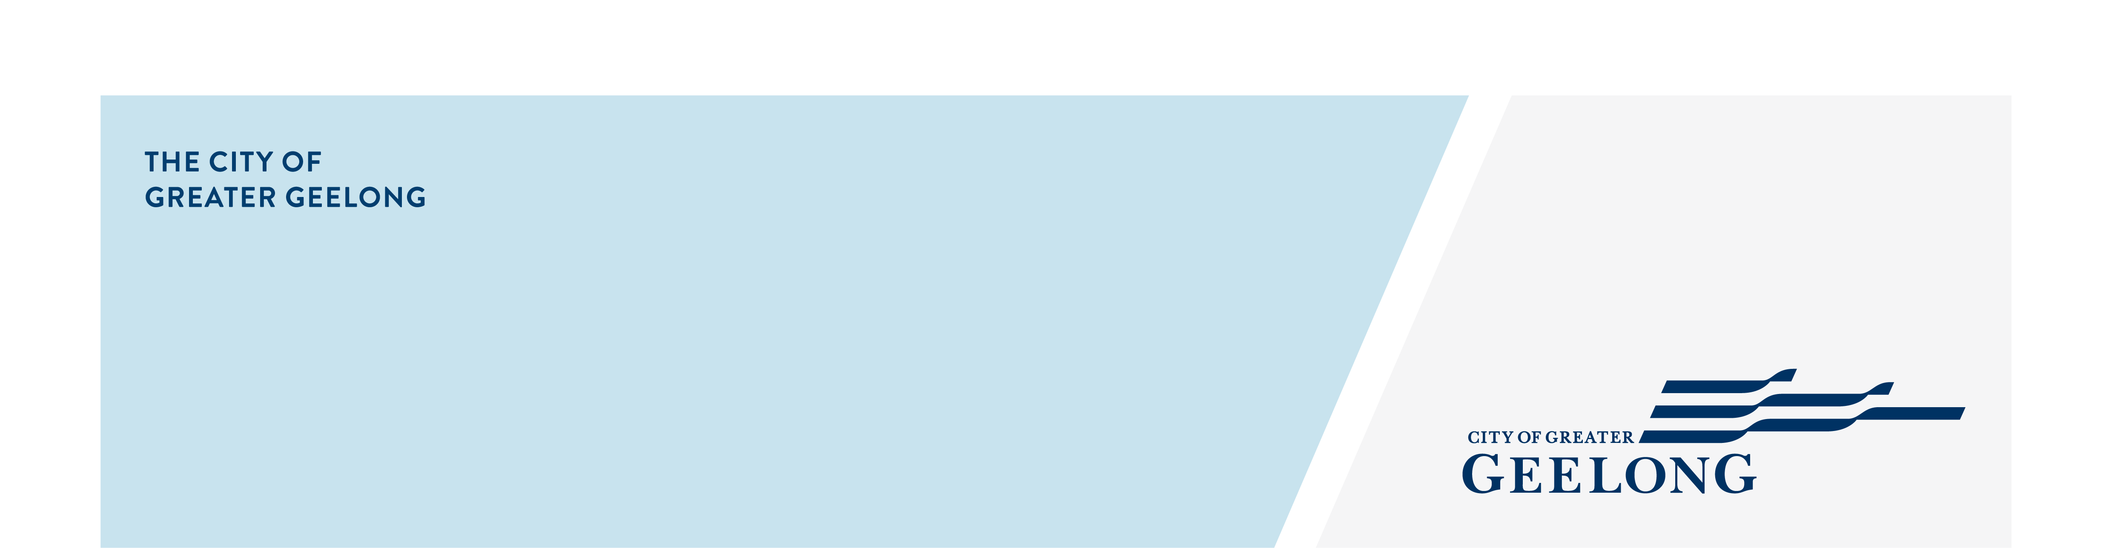
Agenda

caos network meeting

tuesday 16 july, 10:00am, geelong library, 51 little malop street geelong

Attendees
Lisa Sitlington (chair)

- Welcome, Minutes of previous meeting –
Welcome Everyone
- Acknowledgement of Country

- Dana Vickers – Community Engagement – City of Greater Geelong
Present the Community Engagement Policy

- Melissa Bird – Geelong Library

- Around the Room Discussion
Service and Program update from attendees.

- Emerging Issues
Discuss any emerging issues that attendees are finding within their community groups.

- Next Meeting – September 2025
In person

