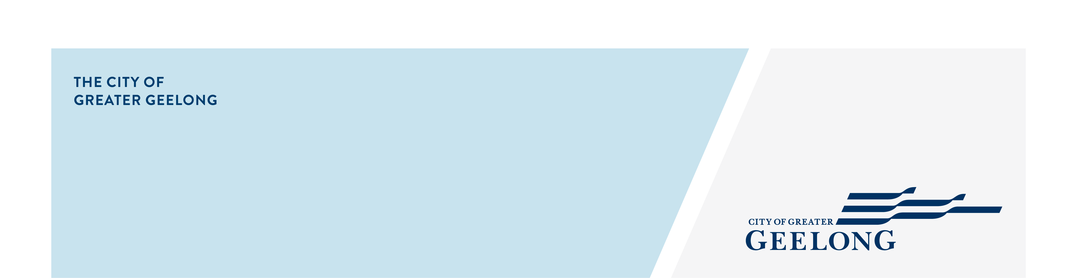
minutes

caos network meeting

27 may 2025, 10:00am-11:30am, wurriki nyal

Attendees
Lisa Sitlington (chair), Chris Swain, Amy Bellia, Narelle Arthur, Eleisha Casanas, Melissa Bird, Sheldan Alexander, Louise Xerri, Helen Gane, Monique Jacques

Apologies
Tanya Kane
- Welcome
Lisa Sitlington completed Acknowledgement of Country

Welcomed everyone to the meeting and introduced the speaker for the meeting.

- City of Greater Geelong – Sheldan Alexander – Social Inclusion Action Group (SIAG)
- Session presentation.
- Expressions of Interest will open end of June 2025.
- For more information contact Sheldan.Alexander@geelongcity.vic.gov.au
https://www.health.vic.gov.au/mental-health-wellbeing-reform/social-inclusion-action-groups

- Around the Room Discussion
Chris Swain – Place Based Manager – Drummond Street
- Full funding and staffing approval has been granted for the QHub.
- QHub is running the following programs:
  - Under 12’s
  - Teens 12 – 18 years after school (GASP)
  - 18+ groups
  - Parents Group
  - Family Services Programs for Term 3 are in planning.
- Talking Sexual Health Workshop – Monday 30 June, 6pm-8pm.
Register: https://events.humanitix.com/talking-sexual-health-workshop
- To be on the newsletter mailing list, email: Christopher.swain@ds.org.au
- Visit website for more programs https://ds.org.au/

Louise Xerri – Youth Services – Salvation Army
- Manages young (single) mums 16-25 years.
- Receive referrals from MELI – Young Persons
- Work with the young mums with a housing program, work/education plan and childcare.
- Work closely with organisations - SAFV and Orange Door.
- Wanting to build a wider network of services to work with in helping these young people.

Monique Jacques –Manager – Rosewall Community Centre
- Providing many programs for their community:
  - Cultural Cooking Classes
  - Café is providing $6 lunches Monday & Tuesday
  - Youth Program 12-18 years
  - WestVic provides a free legal service.
  - Pottery / Screen printing / Hair Beauty Classes
  - Empowerment Challenge for young parents
  - Plus, many more.

Amy Bellia – Strategic Partnerships Officer – Open Door
- WCIG has had a name change to Opendoor.
- Work with people with disabilities and the disengaged in helping them find employment.
- Collaborate with many organisations and schools that offer sustainable employment outcomes.
- Work with 15–24 years to help them transition to work.
- Working on an Expo in November at Rosewall Community Centre, more information to come.
- Open for referrals.
https://opendoor.org.au/

Melissa Bird – Community Development – Geelong Regional Libraries
- Geelong Regional Libraires provide 20,000 programs a year.
- Exploring partnerships and identifying barriers to address program gaps.
- Identify and connect with local services that are currently being missed.
- A gap analysis revealed low engagement among youth and the CALD community.

Eleisha Casanas – Community Education Manager – Friends for Good
- Friends for Good is a volunteer driven not-for-profit organisation.
- Bloom & Connect is a free 6-week facilitated program for expectant mums in the Geelong region.
  - Designed to support social connection and emotional wellbeing during pregnancy.
  - Starting 14 June – 27 September, 10am-12pm at Grovedale Community Hub.
Register: Bloom and Connect
- Free Phone Service supported by volunteer staff for people that have no social connection or are feeling isolated. There is a wait list of 700 people.
- An Arabic Phone Service is being looked at due to data research.
- Mateline is a support line for Australian veterans.
- TeleHealth service – paid fee of $50

Helen Gane – Traineeship Services – gForce
- Offer a full service of employment and recruitment.
- Provide 2-year traineeships with paid placements.
- Referrals accepted.

Narelle Arthur – Global Sisters
- Global Sisters Geelong Launch – Wednesday 11 June. 11:30am-1:30pm at the Murran Hub. The launch will consist of a market displaying women’s businesses and a panel event.
RSVP: geelong@globalsisters.org
- Free online coaching / supports for women in micro or small business with a no end date.
- Safe at Home project where you can explore business ideas.
- Little Green Houses – a pathway to home ownership for women
https://globalsisters.org/

Lisa Sitlington – Community Inclusion – Community Development Project Officer
- On 22 April 2025 Council voted to move forward with Stage 2 of our engagement process. This stage is all about gathering your feedback and input on the City’s first draft of the Rainbow Action Plan 2025-29. This draft plan is designed to address actions and issues that specifically impact the LGBTQIA+ community.
We are seeking your feedback on the work included in this draft Rainbow Action Plan. We want to ensure it reflects the priorities and concerns of the LGBTQIA+ community and helps identify valuable activities and any areas for improvement.
Rainbow Action Plan Survey

- Next Meetings
CAOS Network Meeting – July 2025
Venue: TBA

