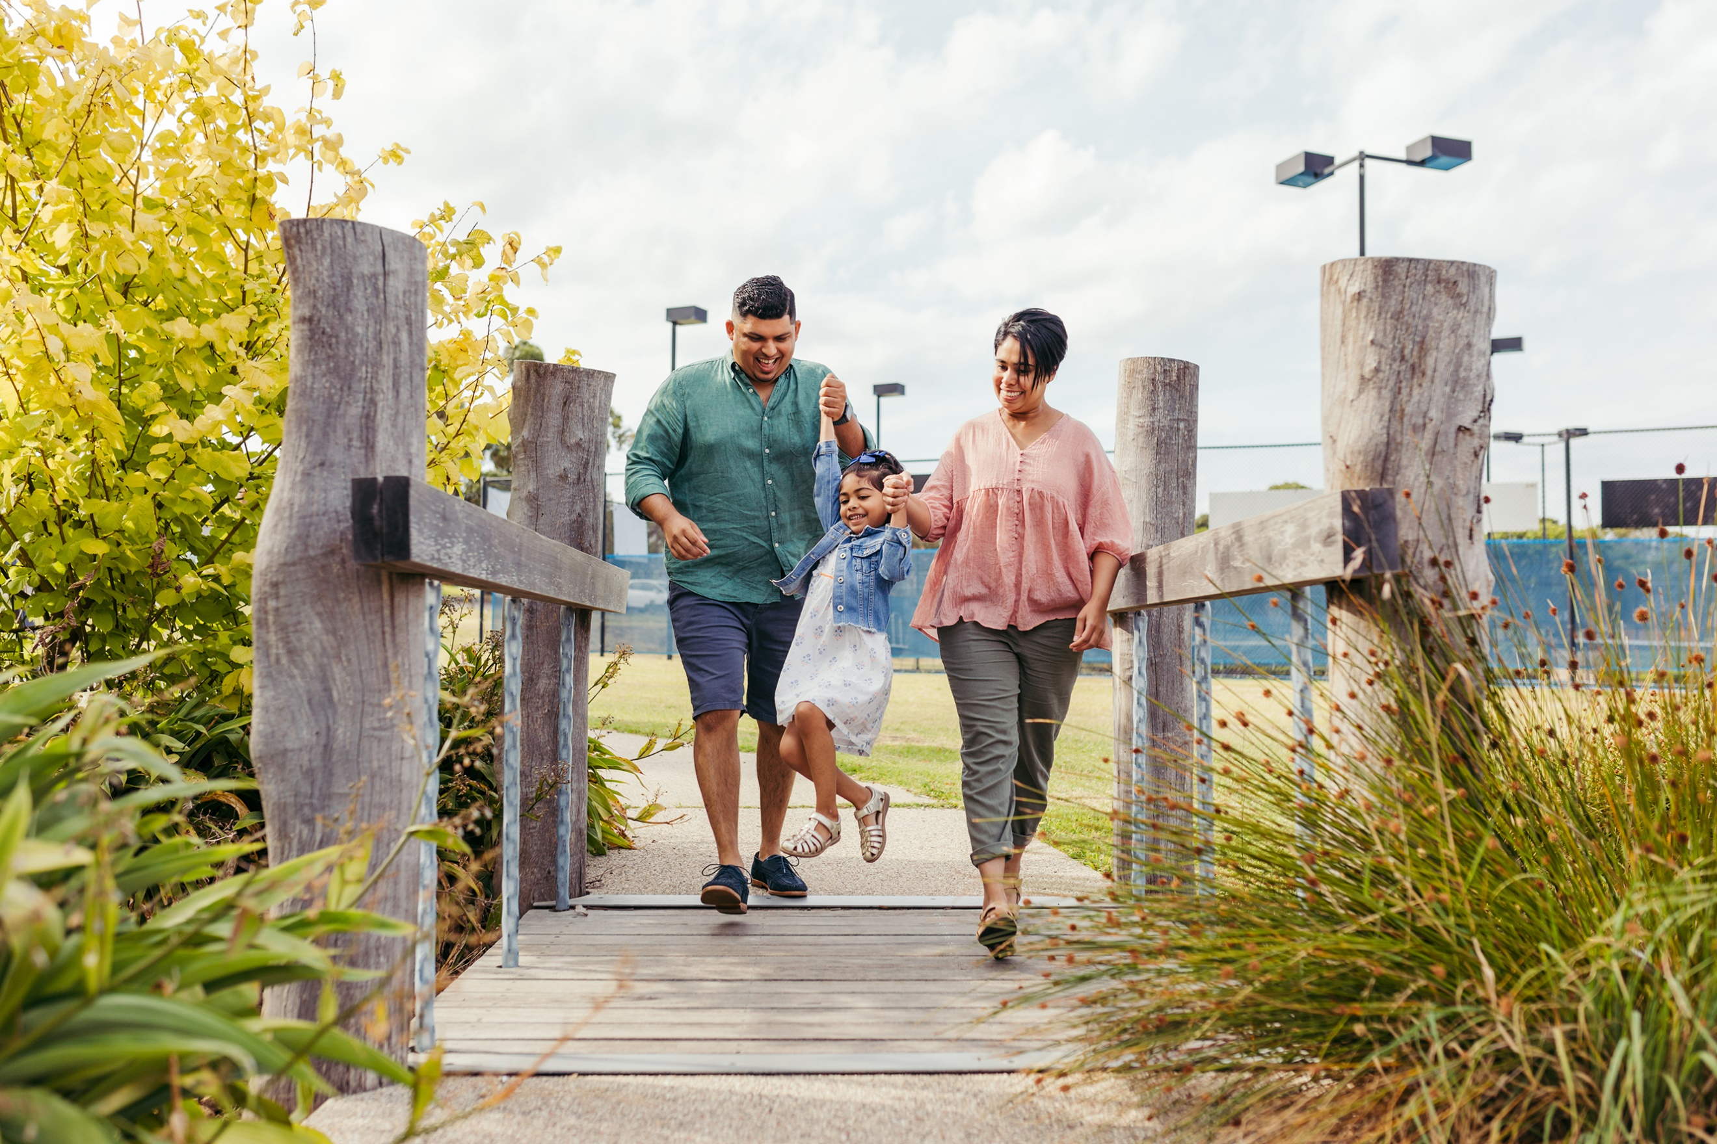


THE CITY OF
GREATER GEELONG

our community
PLAN 2021–25

annual ACTION PLAN
2021–22

INTRODUCTION

Our Community Plan 2021-25 – A Proud, Safe and Healthy Community outlines how we are working towards the City’s 30-year community vision to make Greater Geelong a clever and creative city-region.
The plan tells the community what the councillors are aiming to achieve during their four-year term, and guides how we allocate resources so we can deliver infrastructure, services and programs to the community to ensure the social, economic and environmental sustainability of our region.
The four strategic directions we’ve chosen to guide us are as follows:
- Healthy, caring and inclusive community
- Sustainable growth and environment
- Strong local economy
- High-performing Council and organisation.
With the health and wellbeing of our community being one of the council’s key priorities, this year we’re bringing the council plan and municipal public health and wellbeing plan together into one document. This will create a more focused agenda for our work and make it easier for our community to track our progress.
Health and wellbeing is embedded throughout the plan, supporting each strategic direction, and the outcomes, four-year priorities, actions and indicators. The areas with a link to health and wellbeing are identified with a symbol.
ANNUAL ACTION PLAN
The Annual Action Plan 2021-22 highlights the projects, initiatives and programs that will take place in the next financial year to address our four-year priorities and provides a detailed breakdown of the 86 actions.
We will report on the progress of the annual action plan quarterly, while the annual report will provide an end of year overview of the City’s performance including how we’re tracking against the indicators.
Status | Symbol | Number of actions | Comments
On track | 
Needs improvement
Off track | 
Off track COVID-19
Not yet available
Complete

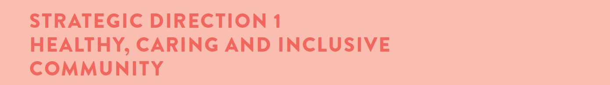
Desired outcomes
- Our community feels welcome, safe and connected
- Our community has equitable access to health and social services, information and infrastructure
- Healthy behaviours and environments are promoted, supported and accessible
Four-year priorities
  - Help our community, recreation groups and volunteers to prosper and grow
  - Deliver health and community initiatives that are culturally sensitive and accessible across all life stages
  - Foster and embrace community connectedness
  - Demonstrate and promote gender equity practices
  - Foster an inclusive community culture
  - Facilitate social and affordable housing in Greater Geelong
  - Provide access to places, spaces and services where and when people need them the most
  - Strengthen relationships and partnerships with the Aboriginal and Torres Strait Islander communities in Greater Geelong
  - Support the City’s cultural and creative life, history and heritage
  - Provide facilities that foster and facilitate positive health and wellbeing outcomes
  - Respond to the findings of the Royal Commissions into aged care and mental health

Four-year priority | 2021-22 actions
1.1.1 | Develop opportunities for community, groups, clubs and volunteers that builds capacity and capability in governance, leadership and sustainability
1.2.1 | Develop a nutrition toolkit for infants to older adults including a focus on First Nations and culturally and linguistically diverse communities
1.2.2 | Partner with G21 to implement the G21 Healthy Eating and Active Living (HEAL) priority 2021-2025 Regional Plan
1.2.3 | Adopt and implement the City’s first Positive Ageing Strategy and co-design an action plan with the community
1.2.4 | Deliver programs and services that improve health and wellbeing outcomes across all life stages in our leisure services
1.2.5 | Develop the 2022-2025 Municipal Early Years Plan to support the wellbeing and development of children and families
1.3.1 | Partner with key stakeholders and community safety networks to develop a community safety framework
1.3.2 | Partner with the Victorian Equal Opportunity and Human Rights Commission to deliver the Reducing Racism Project in response to the increase in racism towards our culturally and linguistically diverse communities through the COVID-19 pandemic
1.4.1 | Partner with Women's Health and Wellbeing Barwon South West and G21 to develop the G21 Respect 2040 plan that will provide a shared vision to address gender equity and the prevention of violence against women
1.4.2 | Implement the Gender Impact Analysis tool across a range of community focused services

Supports health and wellbeing
Four-year priority | 2021-22 actions
1.5.1 | Implement and report on the fourth year of the Access and Inclusion Action Plan 2018-22 to inform new direction priorities
1.5.2 | Implement an inclusive events tool that promotes inclusive practices for people with a lived experience of a disability and considers all ages, abilities and backgrounds
1.5.3 | Explore a range of opportunities to embed the City's social equity principles across a range of community focused services
1.5.4 | Review the Multicultural Action Plan in partnership with the Multicultural Advisory Committee and key stakeholders
1.6.1 | Implement the City's Social Housing Plan 2020-2041
1.7.1 | Develop agreed policy and standards to guide the delivery of all social infrastructure in a manner consistent with our social equity and sustainability principles
1.7.2 | Implement recommendations from the Vital Communities Social Research Project and Gender COVID Impact Analysis
1.7.3 | Continue to advocate for funding to deliver the Northern Aquatic and Community Hub
1.8.1 | Evaluate and report on the Reflect Reconciliation Action Plan and commence development of the Innovate Reconciliation Action Plan
1.8.2 | Partner with Wathaurong Aboriginal Cooperative to review the Closing the Gap agreement and  targets
1.9.1 | Progress business cases for the improvement and transformation of three of the City's cultural venues - the Potato Shed, National Wool Museum and Geelong Gallery
1.9.2 | Prepare a First Nations Heritage Grant program to fund the identification, conservation and promotion of Aboriginal heritage places
1.10.1 | Progress the design and construction of the Armstrong Creek West Child and Community Hub
1.10.2 | Progress the design and construction of the Northern Bellarine Aquatic Centre
1.10.3 | Review and update the Social Infrastructure Plan, with particular regard to the needs of young people and early years services
1.10.4 | Upgrade an existing fenced dog park located at Stead Park, Corio and deliver a new fenced dog park located in Rennie Street, Lara
1.11.1 | Provide a briefing on the impact of Federal government response to the findings of the Aged Care Royal Commission and next steps for the role of local government
1.11.2 | Provide a briefing on the impact of State government response to the findings of the Mental Health Royal Commission and next steps for the role of local government

LINKS TO THE CLEVER CREATIVE VISION
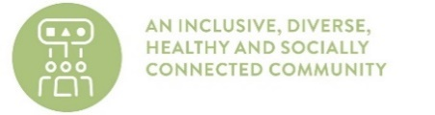 | 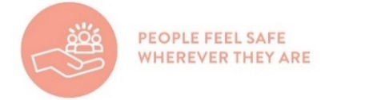 | 

Supports health and wellbeing
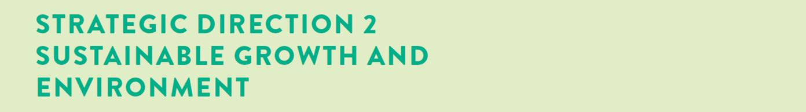
Desired outcomes
- We are delivering our vision for sustainable growth across the municipality
- We have a choice of housing and lifestyles to meet the diverse needs of our community
- There are connected transport networks throughout the region that support liveability and prosperity
- Greater Geelong has quality, vibrant public spaces
- We are leading a reduction in community emissions and are increasing the City’s resilience to climate change impacts
- We protect and restore our natural environment
- We minimise waste with good design and manage effective recovery of resources
Four-year priorities
  - Meet the housing needs of our future community
  - Meet existing and future transport needs
  - Create engaging places and spaces
  - Deliver best practice Environmentally Sustainable Design principles and vibrant neighbourhoods
  - Achieve carbon neutral in all City-managed operations by 2025 and manage our climate change risks
  - Support our community and region to reduce emissions and build resilience to climate change
  - Reduce the impact of waste
  - Support greater indigenous biodiversity

Four-year priority | 2021-22 actions
2.1.1 | Prepare the Elcho Road East and Creamery Road Precinct Structure Plans
2.1.2 | Adopt an updated Municipal Heritage Strategy
2.1.3 | Deliver program of Structure Plans and Urban Design Frameworks to facilitate housing supply
2.1.4 | Finalise a long-term settlement boundary for urban Geelong
2.2.1 | Complete improvement works and address trail and network gaps as identified by the Shared Trails Masterplan
2.2.2 | Build the Better Bike Connections - Southern Link stages 1 and 2 to link Waurn Ponds to Central  Geelong
2.2.3 | Engage with key stakeholders in the development of the draft Integrated Transport Plan, to improve integration of all modes of transport including active transport
2.2.4 | Adopt the Central Geelong Parking Strategy
2.2.5 | Implement the Armstrong Creek Land Acquisition Program
2.3.1 | Commission new public art assets to develop the City's outdoor collection
2.3.2 | Plant more trees through the Urban Forest Strategy and create opportunities for community planting
2.3.3 | Work with the Department of Environment, Land, Water and Planning to deliver the Central Geelong Framework Plan
2.3.4 | Landscape the public space on the corner of Gheringhap and Malop Streets as part of the Revitalising Central Geelong Action Plan Green Spine project

Supports health and wellbeing
Four-year priority | 2021-22 actions
2.4.1 | Develop best practice Environmentally Sustainable Design Action Plans for the first two precincts in the Northern and Western Geelong Growth Areas
2.4.2 | Review the City’s Sustainable Building Policy to ensure best practice standards for new buildings, renovations and retrofitting, and maintenance and minor works
2.4.3 | Review the Environmentally Sustainable Design Local Planning Policy for new developments for opportunities to strengthen the breadth of the application of the policy
2.5.1 | Identify actions to achieve the City’s emissions reduction targets and manage climate-related risks through development of the Climate Change Response Plan
2.6.1 | Outline how the City will support the community and business to reduce the risks that climate change poses to community health and wellbeing and infrastructure through the Climate Change Response  Plan
2.6.2 | Design a framework for the community climate action strategic partnerships funding
2.6.3 | Upgrade to LED street lighting with smart control technology
2.6.4 | Deliver a regional Integrated Water Management Strategy with key stakeholders including Barwon Water and Corangamite Catchment Management Authority
2.7.1 | Implement a pilot food waste collection service for residents
2.7.2 | Collaborate with Barwon Water, G21 councils and Wyndham City Council to develop an organic waste processing facility to support the circular economy
2.8.1 | Adopt a Biodiversity Strategy to protect and restore the natural environment
2.8.2 | Adopt and commence implementation of a master plan to protect and restore the Sparrovale Wetlands Reserve
2.8.3 | Work with the Federal and State Governments to deliver the Biodiversity Conservation Strategy for the Northern and Western Geelong Growth Areas

LINKS TO THE CLEVER CREATIVE VISION
 | 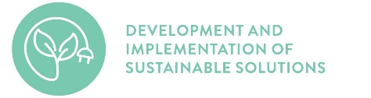 | 

Supports health and wellbeing
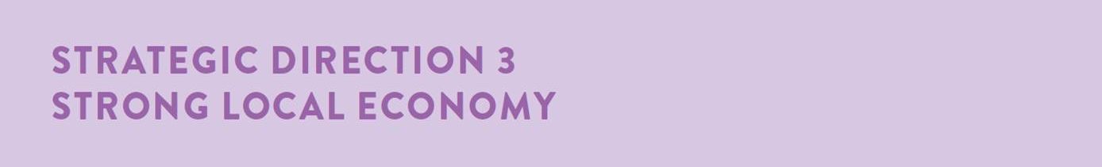
Desired outcomes
- We have a global, national and local reputation as a place to do business – especially in our key sectors
- We have a diversified, future-focused and sustainable economy to drive employment and support growth
- We are an influential Council that builds effective private and public partnerships, taking the lead role in advocating for future investment
Four-year priorities
  - Attract and facilitate public and private investment
  - Promote and leverage the competitive strengths and attractiveness of our region, globally, nationally and locally
  - Support entrepreneurs, start-ups, innovation, research and digital connectivity
  - Attract businesses with a carbon neutral and circular economy focus
  - Support local business resilience and recovery from the impacts of the COVID-19 pandemic
  - Attract, retain and enable participation in the workforce to meet industry needs
  - Address high levels of unemployment in targeted areas of our region
  - Promote our region as a trial location for innovation and new technologies

Four-year priority | 2021-22 actions
3.1.1 | Develop and implement an advocacy plan for major infrastructure investment with our stakeholders
3.1.2 | Ensure there is diversity of employment land to meet forecast growth and attract investment
3.1.3 | Prepare the Moolap Coastal Strategic Framework Plan
3.2.1 | Develop the City's 10-Year Economic Development Plan to support the ongoing socio-economic prosperity of the region
3.2.2 | Lead Geelong’s UNESCO City of Design Designation and implement actions that support our commitment to the UNESCO's Creative Cities Network
3.2.3 | Implement the Geelong Major Events Strategy to ensure Geelong is positively recognised globally for hosting accessible and inclusive major events of an international standard
3.2.4 | Adopt and commence implementation of the Arts and Cultural Strategy to support our creative industries
3.2.5 | Adopt a tourism destination masterplan focused on a ten-year planning horizon to update the Tourism Development Plan in partnership with the Tourism industry (Tourism Greater Geelong and the Bellarine)
3.2.6 | Provide publicly accessible external urban space around the site of the proposed Geelong Convention and Exhibition Centre which is safe, attractive and designed considering the needs of people of all ages, abilities and backgrounds
3.2.7 | Partner with the Vision Partners to develop and implement a place brand for the region
3.3.1 | Implement the Smart Cities Framework to support the City's objectives in business support innovation, research and digital connectivity and consideration of community connectivity, particularly in the northern suburbs
3.4.1 | Develop and implement business programs to support the circular economy in partnership with state government

Supports health and wellbeing
Four-year priority | 2021-22 actions
3.5.1 | Deliver support programs to our business community to assist recovery and adapt to the effects of the COVID-19 pandemic
3.5.2 | Implement second hour free parking in 2P parking zones in central Geelong
3.6.1 | Implement actions from the Vital Communities (including Regional Industry Sector Employment) program that support employment pathways to address Geelong’s disadvantaged areas
3.7.1 | Develop a structured program and process to enable innovative ideas and solutions, for Council consideration and action
LINKS TO THE CLEVER CREATIVE VISION
 | 


Supports health and wellbeing
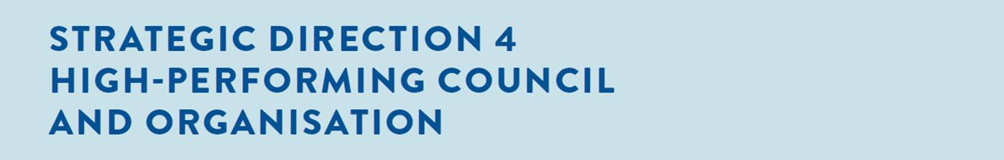
Desired outcomes
- Our services are accessible and meet the diverse needs of our community
- We are acknowledged and recognised as a leading council and organisation
- We have a healthy, safe, inclusive and diverse culture
- We are a financially sustainable and resilient organisation
Four-year priorities
  - Enable a customer-focused approach that delivers efficient and responsive service
  - Communicate and engage effectively with our community to understand their needs and advocate on their behalf
  - Deliver on our community’s most important needs for infrastructure and services
  - Continue to strengthen our workplace culture
  - Create a more efficient and effective organisation
  - Ensure that our employees are safe at work
  - Focus on financial sustainability

Four-year priority | 2021-22 actions
4.1.1 | Implement the City's Customer Experience Strategy
4.1.2 | Implement the City's Digital Modernisation Project to improve our digital capability
4.2.1 | Implement the City's Community Engagement Policy with a focus on hard to reach communities
4.2.2 | Continue to embed Youth Council and the Councillor Connect Mentoring Program as an opportunity for the voice of Geelong’s youth to be considered in decision-making of the Council
4.3.1 | Advocate on behalf of the community to secure funding and policy change to deliver on key / priority infrastructure and services
4.3.2 | Divest surplus assets to invest in the development and renewal of community infrastructure
4.3.3 | Review the City’s services to ensure they meet existing and emerging community needs in line with our organisational strategy
4.4.1 | Implement the Diversity and Inclusion Road Map with the City's social equity principles embedded
4.4.2 | Transform our workplace culture through delivery of our Working Better Together program
4.4.3 | Implement a campaign for employees aimed at increasing awareness and uptake of volunteering in the local community
4.5.1 | Deliver the City's new civic precinct, Wurriki Nyal
4.5.2 | Deliver the City's Future Ways of Working program
4.5.3 | Implement the City's Sustainability Framework to create a culture of sustainable practice in our organisation
4.6.1 | Deliver the City's organisation wide risk register
4.6.2 | Increase employee engagement and communication messages on physical and mental health, and safety in the workplace
4.7.1 | Deliver on efficiency targets and identify areas for investment in sustainable cost savings considering total cost of ownership

Supports health and wellbeing

