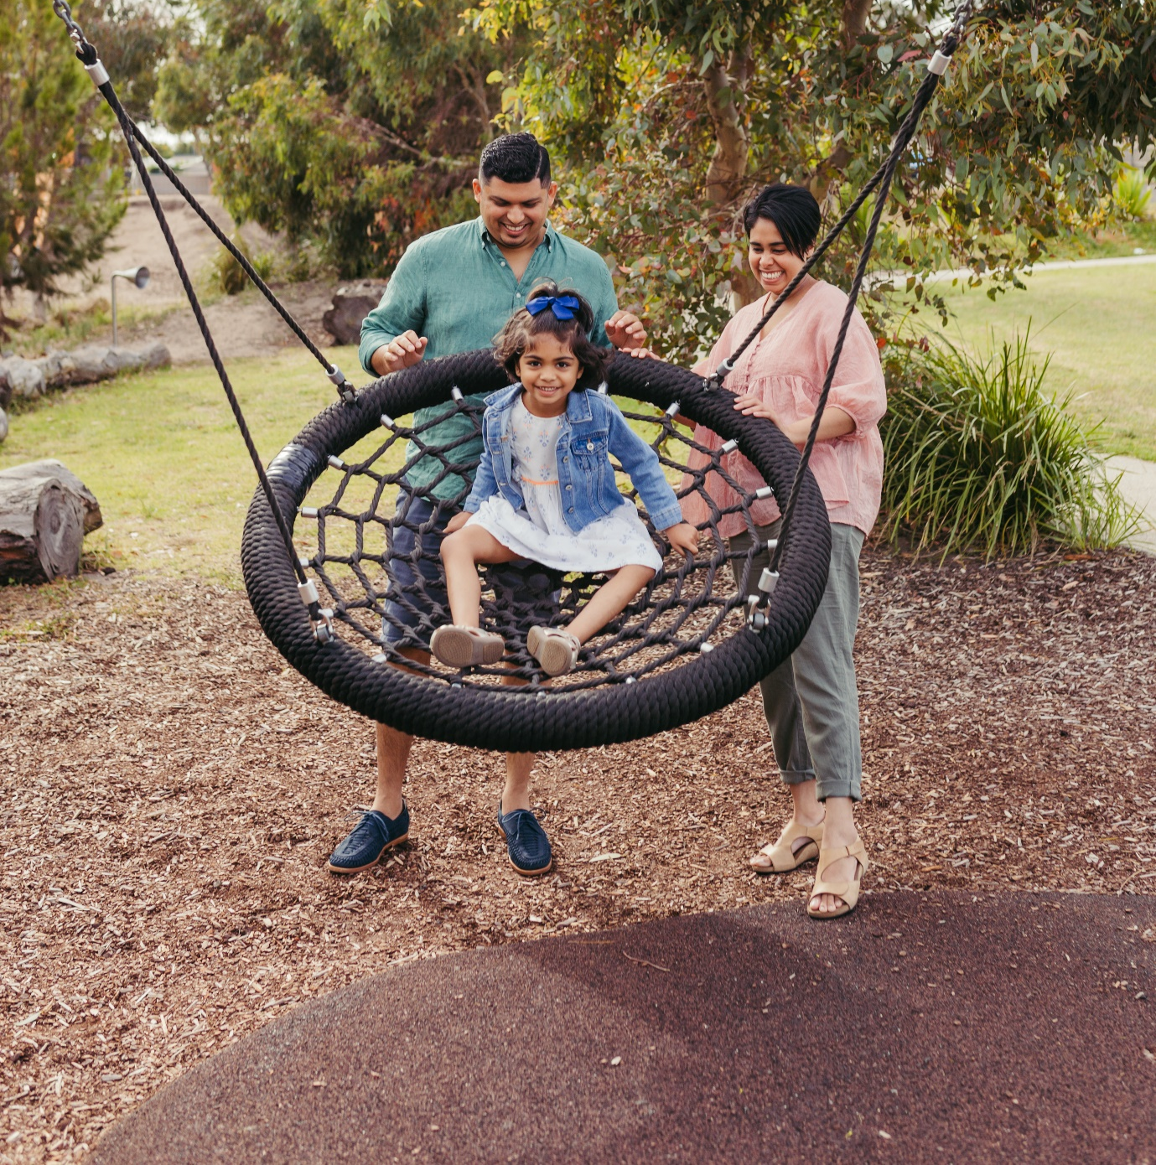


THE CITY OF
GREATER GEELONG

our community
PLAN 2021–25

annual ACTION PLAN
2022–23

INTRODUCTION

Our Community Plan 2021-25 – A Proud, Safe and Healthy Community outlines how we are working towards the City’s 30-year community vision to make Greater Geelong a clever and creative city-region.
The plan tells the community what the councillors are aiming to achieve during their four-year term, and guides how we allocate resources so we can deliver infrastructure, services and programs to the community to ensure the social, economic and environmental sustainability of our region.
The four strategic directions we’ve chosen to guide us are as follows:
- Healthy, caring and inclusive community
- Sustainable growth and environment
- Strong local economy
- High-performing Council and organisation.
With the health and wellbeing of our community being one of the council’s key priorities, we have integrated the council plan and municipal public health and wellbeing plan together into one document. This will create a more focused agenda for our work and make it easier for our community to track our progress.
Health and wellbeing is embedded throughout the plan, supporting each strategic direction, and the outcomes, four-year priorities, actions and indicators. The areas with a link to health and wellbeing are identified with a symbol.
The five health and wellbeing priorities are:
- Tackling climate change and its impact on health
- Increasing healthy eating
- Increasing active living
- Demonstrating and promoting gender equity practices
- Improving mental wellbeing and social connection.
ANNUAL ACTION PLAN
The Annual Action Plan 2022-23 highlights the projects, initiatives and programs that will take place in the next financial year to address our four-year priorities and provides a detailed breakdown of the 64 actions.
We will report on the progress of the annual action plan quarterly, while the annual report will provide an end of year overview of the City’s performance including how we’re tracking against the indicators.
Status | Symbol
On track | OnT
Needs improvement | NI
Off track | OffT
Off track COVID-19 | OffTC
Not yet available | NA
Complete | C

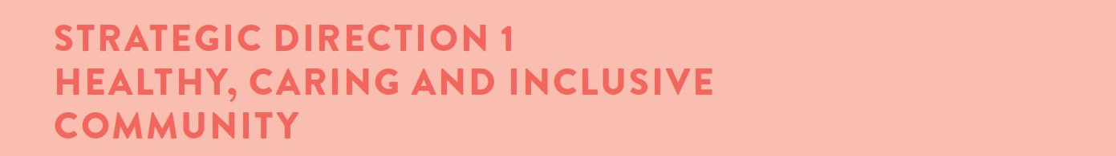
Desired outcomes
- Our community feels welcome, safe and connected
- Our community has equitable access to health and social services, information and infrastructure
- Healthy behaviours and environments are promoted, supported and accessible
Four-year priorities
  - Help our community, recreation groups and volunteers to prosper and grow
  - Deliver health and community initiatives that are culturally sensitive and accessible across all life stages
  - Foster and embrace community connectedness
  - Demonstrate and promote gender equity practices
  - Foster an inclusive community culture
  - Facilitate social and affordable housing in Greater Geelong
  - Provide access to places, spaces and services where and when people need them the most
  - Strengthen relationships and partnerships with the Aboriginal and Torres Strait Islander communities in Greater Geelong
  - Support the City’s cultural and creative life, history and heritage
  - Provide facilities that foster and facilitate positive health and wellbeing outcomes
  - Respond to the findings of the Royal Commissions into aged care and mental health

Four-year priority | 2022-23 actions
1.2.1 | Implement the Municipal Early Years Plan 2022-25
1.2.2 | Undertake a review of the Livewell Program to ensure it is sustainable and meets the health and wellbeing needs of people aged over 55
1.2.3 | Update Council's Healthy Food Policy
1.3.1 | Develop an annual action plan for the Vital Communities project
1.3.2 | Identify the key safety concerns of the community and articulate the City's role in facilitating a safe Geelong community
1.4.1 | Develop an annual Ba-gurrk Gender Equity Framework action plan, incorporating actions from the Gender COVID-19 research
1.4.2 | Commence detailed design of gender neutral facilities at the Leopold Tennis Club
1.5.1 | Finalise the new Access and Inclusion Action Plan which outlines actions the City will take to reduce discrimination and promote inclusion of people with disabilities
1.5.2 | Develop an annual Multicultural Action Plan which will guide how the City plans for and supports our multicultural community
1.5.3 | Commence construction of a new inclusive play space at Rippleside Park
1.6.1 | Increase the amount of social housing by evaluating Council owned land available for development
1.7.1 | Complete a feasibility study for a program that makes recommendations on how to deliver a safe and inclusive space for young people within central Geelong
1.7.2 | Expand our Drop In Feeding support service (0-3 months of age) to include the Bellarine

Supports the health and wellbeing priorities
Four-year priority | 2022-23 actions
1.8.1 | Commence working with community on the next Innovate Reconciliation Action Plan
1.8.2 | Deliver a training and education program in partnership with Wadawurrung Traditional Owners Aboriginal Corporation with a focus on tourism development and cultural awareness strengthening cultural tourism in the region
1.8.3 | Partner with Wathaurong Aboriginal Co-operative for local actions around Closing The Gap, an initiative which aims to achieve health and life expectation equality for Australia's Aboriginal and Torres Strait Islander peoples
1.9.1 | Collaborate with Wadawurrung Traditional Owners to conserve, digitise and interpret artworks and artefacts of regional importance from across Council's arts and heritage collections
1.10.1 | Commence construction of the Northern Aquatic and Community Hub
1.10.2 | Enhance the City Safe Camera Network (CCTV) across priority neighbourhoods and suburbs
1.10.3 | Complete final concept Stage 2 design of the North Bellarine Aquatic Centre
1.11.1 | Prepare Council to make an informed decision about its future in the delivery of in home and community care (under 65s) and aged care (over 65s) services

LINKS TO THE CLEVER CREATIVE VISION
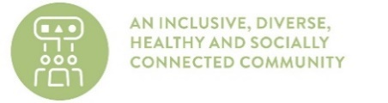 | 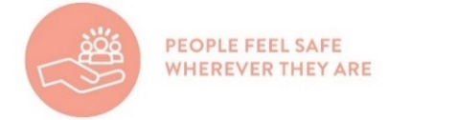 | 

Supports the health and wellbeing priorities
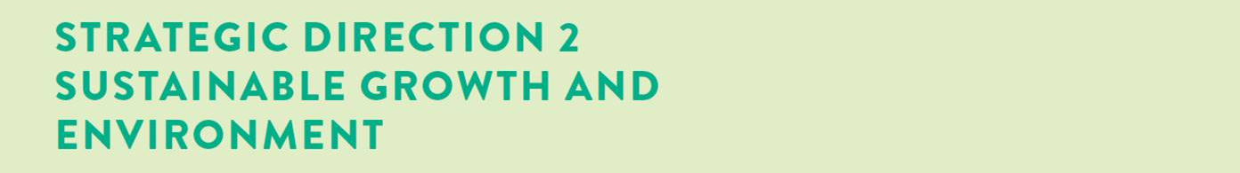
Desired outcomes
- We are delivering our vision for sustainable growth across the municipality
- We have a choice of housing and lifestyles to meet the diverse needs of our community
- There are connected transport networks throughout the region that support liveability and prosperity
- Greater Geelong has quality, vibrant public spaces
- We are leading a reduction in community emissions and are increasing the City’s resilience to climate change impacts
- We protect and restore our natural environment
- We minimise waste with good design and manage effective recovery of resources
Four-year priorities
  - Meet the housing needs of our future community
  - Meet existing and future transport needs
  - Create engaging places and spaces
  - Deliver best practice Environmentally Sustainable Design principles and vibrant neighbourhoods
  - Achieve carbon neutral in all City-managed operations by 2025 and manage our climate change risks
  - Support our community and region to reduce emissions and build resilience to climate change
  - Reduce the impact of waste
  - Support greater indigenous biodiversity

Four-year priority | 2022-23 actions
2.1.1 | Commence planning for a new residential strategy for Central Geelong
2.2.1 | Commence development of a draft Integrated Transport Plan
2.2.2 | Construct the Building Better Bike Connections Southern Link Stage 2
2.3.1 | Develop a new Open Space Policy and Strategy to facilitate equitable access to open space across the municipality
2.4.1 | Prepare the Creamery Road and Elcho Road East precinct structure plan and development contributions plans including environmentally sustainable design initiatives
2.4.2 | Review the local planning policy framework in the Greater Geelong Planning Scheme to implement key strategies into the planning scheme
2.4.3 | Engage key stakeholders in setting a future vision and direction ways to connect building occupants to the natural environment (biophilic design principles) and how to embed this in planning and urban design
2.5.1 | Develop a plan to transition to low emissions light fleet vehicles
2.5.2 | Commence implementation of the new Sustainable Building Policy
2.5.3 | Undertake an assessment of City owned gas using infrastructure to support a transition to gas-free operations
2.6.1 | Develop a community campaign to raise awareness of the region’s climate risks, impacts and responses
2.6.2 | Prepare a discussion paper to increase understanding of the health impacts of climate change and the health co-benefits of mitigation and adaptation strategies
2.6.3 | Upgrade to LED street lighting with smart control technology

Supports the health and wellbeing priorities
Four-year priority | 2022-23 actions
2.7.1 | Collaborate with Barwon Water and G21 councils to develop the Regional Renewable Organics Network facility to process the City's organic waste
2.7.2 | Collaborate with metro Melbourne councils to deliver the Best Waste Practices in Multi Unit Dwellings project to improve recycling in multi-unit developments
2.8.1 | Implement the Sparrovale Master Plan phase 1
2.8.2 | Develop a 10-year Biodiversity Strategy
2.8.3 | Develop the Southeast Bellarine Coastal Strategy

LINKS TO THE CLEVER CREATIVE VISION
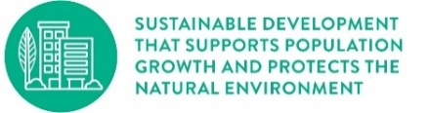 | 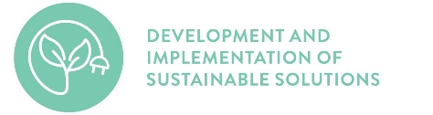 | 

Supports the health and wellbeing priorities
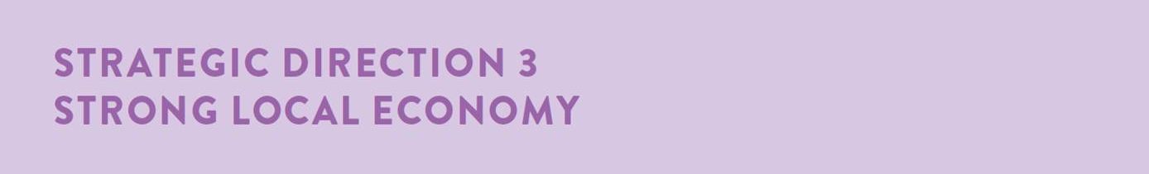
Desired outcomes
- We have a global, national and local reputation as a place to do business – especially in our key sectors
- We have a diversified, future-focused and sustainable economy to drive employment and support growth
- We are an influential Council that builds effective private and public partnerships, taking the lead role in advocating for future investment
Four-year priorities
  - Attract and facilitate public and private investment
  - Promote and leverage the competitive strengths and attractiveness of our region, globally, nationally and locally
  - Support entrepreneurs, start-ups, innovation, research and digital connectivity
  - Attract businesses with a carbon neutral and circular economy focus
  - Support local business resilience and recovery from the impacts of the COVID-19 pandemic
  - Attract, retain and enable participation in the workforce to meet industry needs
  - Address high levels of unemployment in targeted areas of our region
  - Promote our region as a trial location for innovation and new technologies

Four-year priority | 2022-23 actions
3.1.1 | Finalise the City of Greater Geelong 10-year Economic Development Plan to guide and foster economic growth opportunities for the City
3.1.2 | Facilitate employment precinct land development to maintain a diversity of employment areas
3.2.1 | Deliver Geelong Design Week 2023 showcasing local designers, creatives and innovators and celebrate Geelong's global recognition as Australia's only UNESCO Creative City of Design
3.2.2 | Develop and implement Business Events Geelong marketing program to represent, showcase and promote the region as a business events destination
3.3.1 | Deliver the Fibre in the North project to enable a high-speed optical fibre network, providing community facilities and public spaces with access to ultra-high-speed internet
3.3.2 | Deliver free public Wi-Fi and enhanced broadband to address gaps in digital access and affordability (Geelong Smarter Suburbs)
3.4.1 | Commence delivery of demonstration projects to stimulate demand for Cleantech and Circular Economy solutions
3.5.1 | Launch a major annual live music program in support of day and night economic activation
3.6.1 | Implement the Regional Industry Sector Employment program that supports employment pathways to address Geelong’s disadvantaged areas
3.8.1 | Identify innovative cleantech solutions through Procurement for Innovation projects
3.8.2 | Undertake a review of the City’s digital 3D model and develop a roadmap for ongoing management and enhancement to support a Geelong Digital Twin

Supports the health and wellbeing priorities
LINKS TO THE CLEVER CREATIVE VISION
 | 


Supports the health and wellbeing priorities

Desired outcomes
- Our services are accessible and meet the diverse needs of our community
- We are acknowledged and recognised as a leading council and organisation
- We have a healthy, safe, inclusive and diverse culture
- We are a financially sustainable and resilient organisation
Four-year priorities
  - Enable a customer-focused approach that delivers efficient and responsive service
  - Communicate and engage effectively with our community to understand their needs and advocate on their behalf
  - Foster excellence and equity in planning for our growing region
  - Continue to strengthen our workforce capabilities and culture
  - Create a more efficient and effective organisation
  - Develop a digital core of brilliant basic technology that supports better ways of working
  - Ensure that our employees are safe at work
  - Focus on economic, social and environmental sustainability

Four-year priority | 2022-23 actions
4.1.1 | Build a new website to make information and services more convenient and efficient for our community
4.1.2 | Protect the City's digital landscape against cyber security threats by establishing a Risk Management Framework and overarching Cyber Policy
4.1.3 | Provide the community with an online portal to lodge valuation objections
4.2.1 | Ensure Council’s Priority Projects are current, communicated to key stakeholders and decision makers and ensure active community engagement in the delivery of these projects
4.3.1 | Develop an impact evaluation framework to monitor the contribution of investment in social infrastructure to community health and wellbeing
4.3.2 | Implement the City’s approach to deliver integrated strategic planning and reporting activities for the municipality (Integrated Municipal Planning Framework)
4.4.1 | Deliver new leadership and culture development programs, coaching and performance improvement, learning resources and events
4.5.1 | Develop the City’s approach to addressing customer requests and queries
4.5.2 | Complete Target Operating Models for Enterprise Program Management Office, Municipal Planning, and Customer and Community
4.5.3 | Develop the City's approach for reviewing the delivery of services
4.6.1 | Continue upgrading and modernising the City’s digital capabilities
4.7.1 | Develop a formal and centralised health, safety and wellbeing audit program
4.8.1 | Review and update the Long-term Financial Plan 2021-31
4.8.2 | Develop a partnerships model that supports the organisation to develop stronger and effective relationships with community and key stakeholders

Supports the health and wellbeing priorities

