

2024 GEELONG PREVENTATIVE HEALTH SURVEY
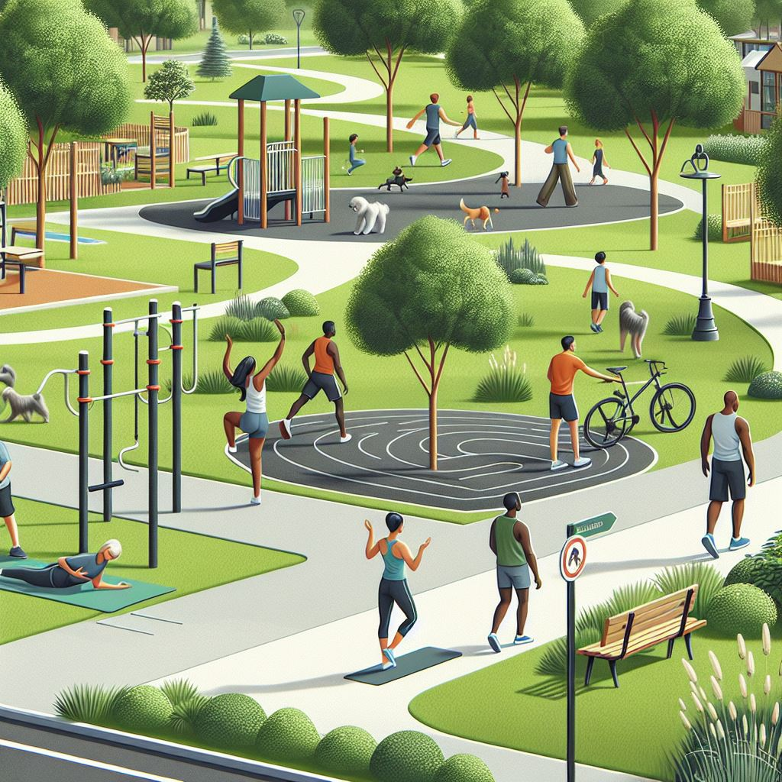

We Acknowledge the Wadawurrung People as the Traditional Owners of the Land, Waterways and Skies. We pay our respects to their Elders, past, present and emerging. We Acknowledge all Aboriginal and Torres Strait Islander people who are part of our Greater Geelong community today.

Contents

Introduction 4
Summary Findings 6
Key Findings Overview 7
Key Findings by Demographics and Priority Populations 11
Key Findings by Planning Area 16
Key Indicators 22

The Geelong Preventative Health Survey is undertaken every four years to help us better understand the health status of the Greater Geelong population and inform evidence-based planning and decision making across the municipality.
The last survey was undertaken in 2021, and the 2024 survey provides updated data as well as data for new indicators.
www.geelongaustralia.com.au/gphs

Introduction
The Geelong Preventative Health Survey (GPHS) provides an important source of local data about health behaviours and other factors that influence community health and wellbeing. It is currently the only robust, statistically significant, local health and wellbeing survey which provides sub-LGA level data in Geelong and the Bellarine.
The GPHS focuses on key modifiable risk factors for health including healthy eating, physical activity, and psychological distress, as well as other determinants of health such as food security, safety, and climate change. In addition to this booklet, data is available at an LGA level on the Geelong Data Exchange, and sub-LGA data is available upon request.
The survey sample size is statistically significant for the municipality and enables the City to identify emerging issues and trends for the comparison of repeated health and wellbeing indicators over time. It provides a common evidence base to inform planning, with data collected to align with the 15 planning areas as outlined in the Social Infrastructure Plan (refer to Appendix 2).
The GPHS was first conducted in 2017 and again in 2021. With the 2021 survey heavily influenced by COVID-19 (both in the questions asked and responses provided), the 2024 iteration provides a more current dataset that reflects the health and wellbeing needs of our community today.
Despite the availability of health and wellbeing data at a local LGA level from other sources such as the Victorian Population Health Survey (undertaken every three years), there is a lack of data available at suburb level. This is important because there are health disparities at suburb level between different parts of the municipality (e.g., more residents in Planning Area 13 (Corio, Norlane, and North Shore) experience moderate to severe psychological distress (27%) compared to the residents of Planning Area 2 (Barwon Heads, Ocean Grove, Point Lonsdale, 3%). In addition, most data are point in time measures, and with sample sizes not statistically significant, and inconsistencies in questions and collection methods from year to year, data is not comparable over time. In the past, the City has relied on other data sources which are then subject to change, or even discontinued.
The City of Greater Geelong has invested in the Geelong Preventative Health Survey to address these inconsistencies and to provide access to the best possible local evidence to inform decision making. It will also provide direction about where to focus our efforts to improve the health and wellbeing of the community and will assist in identifying target population groups for our initiatives.
The evidence provided by this survey suggests the following areas of focus to improve community health and wellbeing:
- Increasing fruit and vegetable intake.
- Reducing lifetime harm from alcohol.
- Addressing the uptake of vaping in young people.
- Reducing loneliness and improving community connection, social inclusion, and mental wellbeing.
- Encouraging more physical activity amongst those who are sedentary.
- Addressing food insecurity and introducing measures to reduce cost of living pressures.
The following indicators demonstrate the health disparities between different geographical locations within the municipality, and we can use this data to inform our interventions:
- More residents in planning areas 6 and 13 smoke (16%) when compared to planning areas 3 and 14 (5%)
- More smokers in planning area 3 (42%) and 13 (31%) use vapes when compared to planning area 14 (8%)
- More residents in planning areas 13 (46%), 1 (42%) and 11 (39%) are lonely when compared to the Greater Geelong average (25%) and this could be for a variety of reasons due to age, ability, socio economic status or geographic isolation.
- 30% of residents in planning area 13 worried they would run out of food in the previous 12 months compared to 3% in planning area 12.

Summary Findings

Indicator | 2024 Result
Self-reported health excellent / very good | 51%
Satisfaction with life (7-10/10) | 78%
High to very high psychological distress | 13%
Sought help for mental health | 24%
Lonely | 25%
Drink 8+ glasses water a day | 42%
Consume sugar sweetened drinks >weekly | 29%
Eat takeaway more than weekly | 16%
Met fruit guidelines | 50%
Met veg guidelines | 14%
Met physical activity guidelines | 65%
Walk for exercise weekly | 78%
Walk for exercise daily | 32%
Cycle for exercise weekly | 17%
Classified as obese | 28%
Classified as sedentary | 20%
Alcohol – long term risk | 17%
Alcohol – short term risk | 11%
Smoke cigarettes or vaper | 10%
Young adults (18-24) who vape* | 10%
Can call on someone in emergency | 84%
Can raise $2,000 in two days | 80%
Ran out of food and couldn’t afford to buy more | 8%
Worried about running out of food | 20%
Experience uncomfortable home temperatures | 46%
Feel safe in their area | 82%
Feel their area is safer than others | 42%
Multiculturalism makes life better | 43%
Experienced discrimination | 16%
Very concerned about climate change | 28%
*Interpret with caution due to low sample size

Key Findings Overview
This report presents the findings of the 2024 Geelong Preventative Health Survey. This research was designed to collect data on a range of topics relating to the health and wellbeing of the community, to help inform the City’s planning.
The research used a mixed mode methodology, with 31% of the sample sourced through phone surveys (for methodological consistency with previous years) and then the remainder sourced through random representative rates database sampling methodology, with invitations sent to households via email (to an online version), or paper form in the mail. The research was in field from August to early September 2024 and achieved a sample size of n=2,282.
The following section presents the key findings. To access the full report, visit www.geelongaustralia.com.au/gphs

Health and wellbeing
A range of measures assist in tracking the general wellbeing of the community, to help identify any cohorts that may need additional support to maintain healthy lifestyles. Findings suggest that whilst we perform better than the state average for some indicators, in general, self-reported health and wellbeing is decreasing amongst the Greater Geelong community.
- The incidence of residents self-reporting good health has been declining over time (59% in 2017 down to 51% in 2024).
- The incidence of residents providing high satisfaction ratings with life as a whole was lower in 2024 than previous years (78%, 86% in 2017).
- Areas of wellbeing that were contributing most to lower levels of satisfaction with life were feeling part of the community, future security and physical health.

Mental health
- Fewer residents are experiencing high to very high psychological distress (13%) after an increase during COVID (20% in 2021). This may in part be due to a higher proportion seeking professional help for their mental health (24%, 20% in 2021).
- A quarter of the community (25%) is experiencing loneliness.

Healthy eating
Healthy eating, coupled with exercise, can help improve the general wellbeing of the community, and reduce instances of illness and/or injury. There have been some promising improvements in some indicators for healthy eating since 2021, whilst others remain unchanged.
- Findings suggest that over time the proportion of the population drinking 8+ glasses of water a day is increasing, sitting at 42% in 2024.
- There has also been a decrease in consumption of sugar-sweetened drinks, with 2024 data showing 29% of respondents are drinking them more than once a week, compared to 37% in 2021.
- Take away consumption habits appear to be returning to pre-COVID levels, with 16% eating it more than weekly, down from 20% in 2021 (14% in 2017).
- The incidence of meeting fruit and vegetable consumption guidelines remains relatively unchanged over time, with around half meeting fruit consumption guidelines (2 pieces a day) and only 14% meeting vegetable consumption guidelines (5+ serves a day). Not meeting guidelines is primarily due to personal preference and lack of time, although in 2024 cost has emerged as having more of an impact on people not meeting guidelines (12%, 3% in 2021).

Active living
Coupled with healthy eating, active living is an important aspect of life to help improve health and wellbeing and reduce the incidence of chronic disease.
- Greater Geelong residents are fairly active, with almost two thirds of residents (65%) meeting physical activity guidelines, which is relatively similar to that recorded in 2021 (67%).
- Walking is a popular form of exercise with most residents walking for exercise more than once a week (78%), and a third doing so daily (32% 7+ times a week). The incidence of walking 7+ times a week has remained relatively consistent over time.
- Cycling for exercise is not as popular, with less than one in five residents cycling for more than 10 minutes for exercise at least once a week (17%). This is a similar level to that recorded in 2021 (19%).
- There are fewer people classified as obese (28%) than in 2021 (31%), although the rate still remains higher than in 2017 (21%) and higher than the Victorian average (23%).
- One in five respondents were classified as sedentary (20%).

Alcohol harm
Excessive alcohol consumption can both increase the risk of illness and disease in the future (lifetime harm) as well as harm at the time of drinking due to reduced capacity (short term harm). The proportion of residents at risk of lifetime harm has increased, but those at risk of short term harm has decreased.
- One in ten are at risk of short term harm from their alcohol consumption (11%) down from 14% in 2021.
- Almost one in five are at risk of lifetime harm from alcohol consumption (17%), up from 11% in 2021.

Smoking/vaping
Smoking of cigarettes can cause diseases later in life, and the recent introduction of vapes has also raised concerns about potential future health impacts of this activity. The smoking questions were expanded in 2024 to better understand these behaviours.
- Fewer residents in Greater Geelong smoke (just over 10%) when compared to the Victorian average (19%). Findings suggest that the overall rate of smoking (cigarettes or vapes) has not changed over time.
- The mix of smoking type for current smokers is 69% cigarettes and 34% vapes (some use both).
- 10% of 18 to 24 year olds smoke vapes. Vapes are predominantly used amongst those aged under 45, with most using vapes with nicotine in them (64% always, 15% sometimes).

Resilience
The ability for people to source assistance in an emergency and/or navigate times of financial hardship can impact greatly on overall wellbeing.
- Most residents in Greater Geelong (84%) can call on someone outside their home in an emergency (similar level to 2021, 89%).
- Findings suggest that the cost of living may be influencing resilience for some, with a slight decline in the proportion of those who said they could raise $2,000 in two days in an emergency (80%, down from 85% in 2021).
- Almost one in ten (8%) said they had experienced a situation where they had run out of food and couldn’t afford to buy more in the previous 12 months. This has doubled from a rate of 4.3% in 2017. The cost of living is also a concern for the one in five (20%) who said they had experienced a situation where they were worried about running out of money to buy food.
- Impacting resilience from extreme weather events, almost half said they were living in a house where the temperature was uncomfortable all the time (7%) or some of the time (39%).

Safety
Perceptions of safety can impact on an individual’s participation in activities that can improve their health and wellbeing.
- Most residents (82%) said they feel very safe or safe in the area where they live.
- Those who said they felt unsafe mostly indicated this being due to personal experience (56%) and/or things in the media (50%).
- 42% indicated that they felt their area was more safe than other parts of Greater Geelong.

Multiculturalism
With an increasingly multicultural community, it is important to track perceptions of the benefits of multiculturalism and experiences of discrimination, to identify and address any risks of community unrest.
- Only two in five (43%) indicated that they felt multiculturalism definitely makes life in their suburb better. Further waves of research are necessary to identify if this is increasing or decreasing.
- 16% of respondents indicated they had experienced discrimination. The most common forms of discrimination are related to disability, socio economic status, Aboriginal and Torres Strait Islander status and older age.

Climate Change
As the impacts of climate change are becoming more common, the survey seeks to understand the extent to which the community is recognising the impact of climate change, and their concern for the future.
- 28% said they are very concerned about the impacts of climate change. This hasn’t changed since 2021 (28%). Concerns are primarily for future generations and the increase in extreme weather events.
- 22% think that climate change will harm the health of Victorians a great deal (similar to 2021, 23%).
The table on the next page shows a summary of the key indicators broken down by planning area, gender and age.

Key Findings by Demographics and Priority Populations

The following section summarises the items where respondents of that demographic or location showed notably higher instances of providing each specified survey response. This helps understand the unique circumstances and experiences of different population cohorts.

Females
- 55% Self-reported good health (excellent or very good) (49% males).
- 14% classified as being in severe or moderate psychological distress (10% males).
- 32% sought professional help for a mental health related problem (16% males).
- 8% member of a school group (4% males).
- 9% live in a home where the temperature is always uncomfortable (5% males).
- 9% feel unsafe in the area where they live (3% males).
- 17% had experienced discrimination (14% males). Of these, 38% said it was due to their gender.
- 34% very concerned about the impacts of climate change on human health and wellbeing (22% males).
- 31% think climate change will harm the health of Victorians a great deal (13% males).

Males
- 51% self-reported lower levels of health (good, fair or poor) (45% females).
- 16% had sought professional help for a mental health related problem (32% females).
- 33% member of a sports group (23% females).
- 22% eat fast food more than once a week (10% females).
- 50% meet water consumption guidelines (8+ glasses a day) (35% females).
- 37% consume sugar sweetened drinks more than once a week (23% females).
- 35% walk continuously for more than 10 minutes 7+ times a week (30% females).
- 24% cycle continuously for more than 10 minutes at least once a week (11% females).
- 23% lifetime risk of alcohol harm (12% females).
- 17% at risk of short term alcohol harm (6% females).
- 12% smoke (7% females).
- 84% could raise $2,000 in a week in an emergency (78% females).
- 39% feel very safe in the area they live (29% females).

Single parents with child/ren under 15
- 28% classified as being in severe or moderate psychological distress (9% couple no children).
- 53%% sought professional help for a mental health related problem (19% couple no children).
- 57% classified as lonely (17% couple no kids).
- 45% classified as obese (26% single households).
- 18% at risk of short term alcohol harm (9% couples child/ren all 15+).
- 24% smoke (5% couples no children).
- Lower instance of having someone outside the household they can rely on in an emergency (70%, 87% couples).
- Lower instance of being able to raise $2,000 in an emergency (49%, 88% couple no children).
- 45% had run out of food and couldn’t afford to buy more (7% couple no children).
- 27% live in a home where the temperature is always uncomfortable (5% couples with child/ren under 15).
- 19% rated the area where they live as more unsafe than other areas of Greater Geelong (8% single person).
- 30% had experienced discrimination (16% couples no children). Of these 55% said it was due to their marital status.

Youth (18-24 year olds)*
- 58% self-reported health as excellent or very good (31% 75+ year olds).
- 37% eat fast food more than once a week (17% 55+).
- 55% meet water consumption guidelines (8+ glasses a day) (23% 55+).
- 48% normal weight as per their BMI (26% 55-74 year olds).
- 88% met physical activity guidelines (42% 75+).
- 43% abstain from drinking alcohol (20% 25-34 year olds).
- 90% never smoked nor vaped (58-62% 25-74 year olds). Of the 10% who had, they had only vaped.
- 18% in severe psychological distress (Kessler 10) (8% or less for other age categories).
- 60% classified as lonely (<30% for other age categories).
- 20% don’t have someone outside of their household they can call on in an emergency (6% 25-34 year olds).
- 21% had run out of food and couldn’t afford to buy more (11% or less for other age categories).
- 20% had worried about running out of food (3% 65+).
- 7% felt very unsafe where they live (2% or less for other age categories).
- 20% felt more unsafe in the area where they live than other areas of Greater Geelong (4% 65+).
- 26% think multiculturalism in their suburb definitely makes life better (54% 25-34 year olds).
- 27% had experienced discrimination (9% 65+ year olds).
- 26% not very concerned about climate change (11% 25-34 year olds).
- 82% of those who were concerned about climate change said they were concerned about their quality of life (27% 75+).
- 30% didn’t think climate change would harm the health of Victorians in the next 10 years at all (7% 25-34 year olds).
*Please interpret with caution due to low sample size

Young adults (18-35 year olds)
- 60% Self-reported good health (excellent or very good) (38% 65+ year olds).
- 18% classified as being in severe or moderate psychological distress (8% 55+).
- 35% sought professional help for a mental health related problem (14% 55+).
- 31% classified as lonely (22% 55+ year olds).
- 16% member of a professional group or academic society (8% 55+).
- 22% eat fast food more than once a week (17% 55+).
- 57% meet water consumption guidelines (8+ glasses a day) (23% 55+).
- 39% consume sugar sweetened drinks more than once a week (21% 55+).
- Lower instance of meeting physical activity guidelines (7%, 60% 55+).
- 39% walk continuously for more than 10 minutes 7+ times a week (27% 55+).
- 23% sedentary (13% 35-54).
- 17% at risk of short term alcohol harm (7% 55+).
- Fewer smoke (8%, 13% 35-54).
- 6% vape (<1% 55+).
- 91% have someone outside the household they can rely on in an emergency (84% 55+).
- 83% could raise $2,000 in a week in an emergency (76% 35-54).
- 9% had run out of food and couldn’t afford to buy more (4% 55+).
- 12% live in a home where the temperature is always uncomfortable (3% 55+).
- 10% feel unsafe in the area where they live (4% 35-54).
- 13% rated the area where they live as more unsafe than other areas of Greater Geelong (5% 55+).
- 51% said they ‘definitely’ think multiculturalism makes life in their suburb better (35% 55+).
- 18% had experienced discrimination (13% 55+).

Older adults (55+ year olds)
- 59% self-reported lower levels of health (good, fair or poor) (42% <55).
- 13% member of a religious group (8% <35).
- 21% sedentary (13% 35-54).
- 31% classified as obese (22% <35).
- 20% lifetime risk of alcohol harm (13% <35).
- Fewer smoke (8%, 13% 35-54).
- 37% feel very safe in the area they live (30% <35).
- 55% of those who had experienced discrimination (n=192) said it was due to their age.
- 15% not at all concerned about the impacts of climate change on human health and wellbeing (10% <35).
- 24% think climate change will harm the health of Victorians a great deal (17% 35-54).

Those who speak a language other than English
- Less often sought professional help for a mental health related problem (18%, 25% English only).
- Less often member of a sports group (15%, 29% English only).
- 22% member of a religious group (10% English only).
- Lower instance of meeting physical activity guidelines (16%, 23% English only).
- Less often lifetime risk of alcohol harm (10%, 18% English only).
- Lower instance of having someone outside the household they can rely on in an emergency (75%, 86% English only).
- Lower instance of feeling very safe in the area they live (24%, 35% English only).
- Lower instance of rating the area where they live as more unsafe than other areas of Greater Geelong (2%, 9% English only).
- 56% said they ‘definitely’ think multiculturalism makes life in their suburb better (42% English only).
- 24% had experienced discrimination (15% English only). Of these 11% said it was due to the language they speak.

LGBTQIA+
- 65% self-reported lower levels of health (good, fair or poor) (47% non-LGBTQIA+).
- 32% provided life satisfaction ratings of 0-6 out of 10 (20% non-LGBTQIA+).
- 33% classified as being in severe or moderate psychological distress (11% non-LGBTQIA+).
- 47% % sought professional help for a mental health related problem (23% non-LGBTQIA+).
- 39% classified as lonely (25% non-LGBTQIA+).
- Less often member of a sports group (15%, 29% non-LGBTQIA+).
- 26% member of a professional group or academic society (14% non-LGBTQIA+).
- 43% walk continuously for more than 10 minutes 7+ times a week (32% non-LGBTQIA+).
- Less often sedentary (10%, 20% non-LGBTQIA+).
- 19% smoke (9% non-LGBTQIA+).
- Lower instance of having someone outside the household they can rely on in an emergency (75%, 86% non-LGBTQIA+).
- Lower instance of being able to raise $2,000 in a week in an emergency (71%, 82% non-LGBTQIA+).
- 17% had run out of food and couldn’t afford to buy more (7% non-LGBTQIA+).
- 18% live in a home where the temperature is always uncomfortable (6% non-LGBTQIA+).
- 14% feel unsafe in the area where they live (5% non-LGBTQIA+).
- 22% rated the area where they live as more unsafe than other areas of Greater Geelong (8% non-LGBTQIA+).
- 62% said they ‘definitely’ think multiculturalism makes life in their suburb better (43% non-LGBTQIA+).
- 32% had experienced discrimination (15% non-LGBTQIA+). Of these 29% said it was due to their sexual orientation.
- 53% very concerned about the impacts of climate change on human health and wellbeing (27% non-LGBTQIA+).
- 45% think climate change will harm the health of Victorians a great deal (21% non-LGBTQIA+).

People with a disability
- 92% self-reported lower levels of health (good, fair or poor) (42% no disability).
- 57% provided life satisfaction ratings of 0-6 out of 10 (19% no disability).
- 44% classified as being in severe or moderate psychological distress (10% no disability).
- 37% sought professional help for a mental health related problem (34% no disability).
- 61% classified as lonely (23% no disability).
- 43% meet water consumption guidelines (8+ glasses a day) (31% no disability).
- 40% consume sugar sweetened drinks more than once a week (28% no disability).
- 40% classified as obese (27% no disability).
- Lower instance of having someone outside the household they can rely on in an emergency (72%, 86% no disability).
- 24% had run out of food and couldn’t afford to buy more (6% no disability).
- 16% live in a home where the temperature is always uncomfortable (6% no disability).
- Lower instance of feeling very safe in the area they live (24%, 35% no disability).
- 17% feel unsafe in the area where they live (5% no disability).
- 19% rated the area where they live as more unsafe than other areas of Greater Geelong (7% no disability).
- 45% had experienced discrimination (13% no disability). Of these 78% said it was due to their disability.
- 39% think climate change will harm the health of Victorians a great deal (21% no disability).

Renters
- 30% sought professional help for a mental health related problem (13% own outright).
- 39% classified as lonely (22% own home).
- 56% meet water consumption guidelines (8+ glasses a day) (28% own outright).
- 23% cycle continuously for more than 10 minutes at least once a week (15% own with mortgage).
- 25% sedentary (18% own with mortgage).
- 15% smoke (7% own outright).
- 17% had run out of food and couldn’t afford to buy more (2% own outright).
- 13% live in a home where the temperature is always uncomfortable (3% own outright).
- 12% rated the area where they live as more unsafe than other areas of Greater Geelong (5% own with mortgage).
- 20% had experienced discrimination (12% own outright).

Key Findings by Planning Area
This section highlights key indicators for each planning area. All indicators are available in the table on pages 22 and 23.

Planning Area 1
- 57% self-reported health as good, fair or poor.
- 17% classified as being in severe or moderate psychological distress.
- 42% sought professional help for a mental health related problem.
- 42% classified as lonely.
- 30% eat fast food more than once a week.
- 36% consume sugar sweetened drinks more than once a week.
- 28% cycle continuously for more than 10 minutes at least once a week.
- 14% risk of short term harm from alcohol.
- 59% said they ‘definitely’ think multiculturalism makes life in their suburb better.

Planning Area 2
- 66% self-reported excellent or very good health
- 88% provided good life satisfaction rating of 7-10 out of 10
- 42% member of a sports group.
- 45% walk continuously for more than 10 minutes 7+ times a week.
- 25% lifetime risk of alcohol harm.
- 92% have someone outside the household they can rely on in an emergency.
- 91% could raise $2,000 in a week in an emergency.
- 53% feel very safe in the area where they live.

Planning Area 3
- 42% member of a sports group.
- 41% consume sugar sweetened drinks more than once a week.
- Low 20% walk continuously for more than 10 minutes 7+ times a week.
- 26% sedentary.
- 29% lifetime risk of alcohol harm.
- 24% risk of short term harm from alcohol.
- 47% feel very safe in the area where they live.

Planning Area 4
- 90% could raise $2,000 in a week in an emergency.
- 45% feel very safe in the area where they live.

Planning Area 5
- 24% sedentary.
- 16% risk of short term harm from alcohol.

Planning Area 6
- 64% self-reported health as good, fair or poor.
- Overall low life satisfaction score (69.5/100) due to low ratings for physical health and feeling part of the community.
- 60% not a member of any group.
- 12% had run out of food and couldn’t afford to buy more.
- 16% feel unsafe in the area where they live.
- 23% rated the area where they live as more unsafe than other areas of Greater Geelong.

Planning Area 7
- 17% risk of short term harm from alcohol.
- Low 32% said they ‘definitely’ think multiculturalism makes life in their suburb better.

Planning Area 8
- A low 1% % rated the area where they live as more unsafe than other areas of Greater Geelong.

Planning Area 9
- 24% member of a professional or academic society.

Planning Area 10
- 26% lifetime risk of alcohol harm.
- 19% risk of short term harm from alcohol.
- 89% could raise $2,000 in a week in an emergency.
- 51% said they ‘definitely’ think multiculturalism makes life in their suburb better.

Planning Area 11
- 57% self-reported health as good, fair or poor.
- 39% classified as lonely.
- Low 38% eat recommended amount of fruit daily.
- 22% eat fast food more than once a week.
- 36% sedentary.
- 15% live in a home where the temperature is always uncomfortable.
- 54% said they ‘definitely’ think multiculturalism makes life in their suburb better.

Planning Area 12
- 88% provided good life satisfaction rating of 7-10 out of 10.
- 28% sedentary.

Planning Area 13
- 70% self-reported health as good, fair or poor.
- 41% provided poor life satisfaction rating of 0-6 out of 10.
- Low overall subjective wellbeing score (64.2/100) due to low ratings for future security, standard of living, what they are achieving in life, perceptions of safety.
- 28% classified as being in severe or moderate psychological distress.
- 38% sought professional help for a mental health related problem.
- 46% classified as lonely.
- 66% not a member of any group.
- Low 37% eat recommended amount of fruit daily.
- 23% eat fast food more than once a week.
- 43% consume sugar sweetened drinks more than once a week.
- Low 12% cycle continuously for more than 10 minutes at least once a week.
- 29% sedentary.
- 41%% classified as obese.
- Low 55% could raise $2,000 in a week in an emergency.
- 23% had run out of food and couldn’t afford to buy more.
- 42% were worried they might run out of food.
- 16% live in a home where the temperature is always uncomfortable.
- 17% feel unsafe in the area where they live.
- 76% of those who felt unsafe said it was due to a personal experience.
- 41% rated the area where they live as more unsafe than other areas of Greater Geelong.
- 52% of those who said they had experienced discrimination said it was due to the suburb where they live (70% in Norlane and 42% in Corio).

Planning Area 14
- Low 40% eat recommended amount of fruit daily.
- 21% eat fast food more than once a week.
- Low 10% cycle continuously for more than 10 minutes at least once a week.
- Low 33% said they ‘definitely’ think multiculturalism makes life in their suburb better.

Planning Area 15
- Low overall subjective wellbeing score (71.3/100) due to low ratings for perceptions of safety, feeling part of the community.
- 11% feel unsafe in the area where they live.

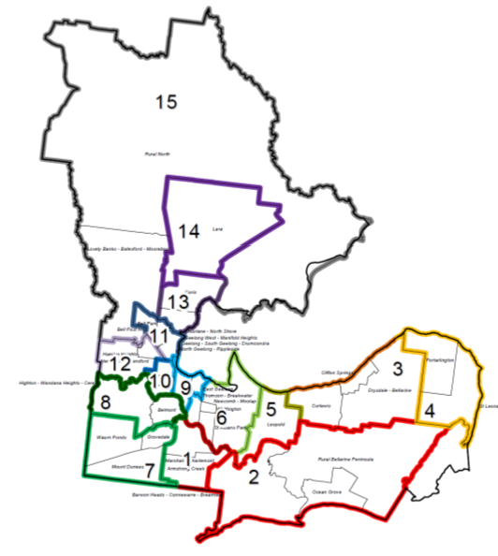
1 | Armstrong Creek
1 | Charlemont
1 | Marshall
2 | Barwon Heads
2 | Breamlea
2 | Connewarre
2 | Mannerim
2 | Marcus Hill
2 | Ocean Grove
2 | Point Lonsdale
2 | Swan Bay
2 | Wallington
3 | Bellarine
3 | Clifton Springs
3 | Curlewis
3 | Drysdale
4 | Indented Head
4 | Portarlington
4 | St Leonards
5 | Leopold
6 | Breakwater
6 | Moolap
6 | Newcomb
6 | St Albans Park
6 | Thomson
6 | Whittington
7 | Grovedale
7 | Mount Duneed
7 | Waurn Ponds
8 | Belmont
8 | Ceres
8 | Highton
8 | Wandana Heights
9 | Drumcondra
9 | East Geelong
9 | Geelong
9 | South Geelong
10 | Geelong West
10 | Manifold Heights
10 | Newtown
11 | Bell Park
11 | Bell Post Hill
11 | North Geelong
11 | Rippleside
12 | Fyansford
12 | Hamlyn Heights
12 | Herne Hill
13 | Corio
13 | Norlane
13 | North Shore
14 | Lara
15 | Anakie
15 | Avalon
15 | Balliang
15 | Batesford
15 | Little River
15 | Lovely Banks
15 | Moorabool
15 | Staughton Vale

Key Indicators
In the following tables the key indicators are shown by demographics and Planning Area. Darker teal cells show a result that is statistically higher when compared to the corresponding red cell within each demographic category (e.g., a higher proportion of females (55%) compared to males (49%)).
Indicator | 2021 |  | 2024 | Trend | M | F | <35 | 35-54 |  | 55+ |  | 1 |  | 2 |  |  | 3 |  | 4 |  | 5 |  | 6 |  | 7 |  | 8 |  | 9 |  | 10 |  | 11 |  | 12 |  | 13 |  | 14 | 15
Self-reported health excellent / very good | 54% |  | 51% |  | 49% | 55% | 60% | 57% |  | 41% |  | 43% |  | 66% |  |  | 49% |  | 49% |  | 51% |  | 36% |  | 55% |  | 56% |  | 58% |  | 66% |  | 43% |  | 56% |  | 30% |  | 56% | 40%
Satisfaction with life (7-10/10) | 85% |  | 78% |  | 78% | 80% | 81% | 76% |  | 79% |  | 74% |  | 88% |  |  | 82% |  | 81% |  | 73% |  | 71% |  | 83% |  | 82% |  | 82% |  | 77% |  | 73% |  | 88% |  | 59% |  | 80% | 80%
High to very high psychological distress | 20% |  | 13% |  | 10% | 14% | 16% | 14% |  | 8% |  | 17% |  | 3% |  |  | 12% |  | 8% |  | 11% |  | 12% |  | 13% |  | 11% |  | 13% |  | 9% |  | 19% |  | 6% |  | 28% |  | 11% | 12%
Sought help for mental health | 20% |  | 24% |  | 16% | 32% | 35% | 26% |  | 14% |  | 42% |  | 18% |  |  | 19% |  | 16% |  | 23% |  | 32% |  | 17% |  | 26% |  | 18% |  | 19% |  | 24% |  | 20% |  | 38% |  | 22% | 23%
Lonely |  |  | 25% | New | 25% | 26% | 31% | 24% |  | 22% |  | 42% |  | 15% |  |  | 21% |  | 22% |  | 20% |  | 26% |  | 21% |  | 18% |  | 27% |  | 23% |  | 39% |  | 24% |  | 46% |  | 22% | 17%
Not a member of any group | 43% |  | 45% |  | 45% | 46% | 47% | 43% |  | 46% |  | 33% |  | 30% |  |  | 39% |  | 41% |  | 50% |  | 60% |  | 44% |  | 41% |  | 50% |  | 47% |  | 48% |  | 46% |  | 66% |  | 45% | 52%
Met veg guidelines | 15% |  | 14% |  | 12% | 17% | 13% | 12% |  | 15% |  | 8% |  | 17% |  |  | 13% |  | 9% |  | 14% |  | 11% |  | 17% |  | 18% |  | 20% |  | 20% |  | 13% |  | 15% |  | 13% |  | 8% | 6%
Met fruit guidelines | 46% |  | 50% |  | 48% | 51% | 47% | 50% |  | 53% |  | 55% |  | 55% |  |  | 66% |  | 43% |  | 51% |  | 43% |  | 46% |  | 51% |  | 58% |  | 63% |  | 38% |  | 47% |  | 37% |  | 40% | 44%
Eat fast food weekly | 43% |  | 44% |  | 51% | 38% | 60% | 46% |  | 27% |  | 60% |  | 30% |  |  | 49% |  | 23% |  | 50% |  | 53% |  | 51% |  | 36% |  | 35% |  | 35% |  | 47% |  | 50% |  | 55% |  | 45% | 43%
Drink 8+ glasses water a day | 42% |  | 42% |  | 50% | 35% | 57% | 45% |  | 23% |  | 41% |  | 46% |  |  | 47% |  | 30% |  | 40% |  | 31% |  | 47% |  | 43% |  | 39% |  | 46% |  | 38% |  | 41% |  | 41% |  | 45% | 51%
Consume sugar sweetened drinks >weekly | 37% |  | 29% |  | 37% | 23% | 39% | 22% |  | 21% |  | 36% |  | 27% |  |  | 41% |  | 22% |  | 33% |  | 28% |  | 33% |  | 20% |  | 15% |  | 19% |  | 28% |  | 26% |  | 43% |  | 34% | 26%
Met physical activity guidelines | 67% | 66% |  |  | 66% | 68% | 68% |  | 75% |  | 60% |  | 70% |  | 75% | 60% |  | 66% |  | 61% |  | 65% |  | 74% |  | 64% |  | 75% |  | 72% |  | 50% |  | 59% |  | 62% |  | 71% |  | 60%
BMI Obese | 31% | 28% |  |  | 28% | 29% | 22% |  | 25% |  | 31% |  | 32% |  | 19% | 28% |  | 26% |  | 37% |  | 34% |  | 27% |  | 24% |  | 13% |  | 23% |  | 31% |  | 28% |  | 41% |  | 33% |  | 36%
Alcohol – long term risk | 11% | 18% |  |  | 23% | 12% | 13% |  | 20% |  | 21% |  | 8% |  | 25% | 29% |  | 24% |  | 20% |  | 21% |  | 18% |  | 13% |  | 12% |  | 26% |  | 13% |  | 16% |  | 10% |  | 15% |  | 17%
Alcohol – short term risk | 14% | 11% |  |  | 17% | 6% | 17% |  | 10% |  | 7% |  | 14% |  | 8% | 24% |  | 7% |  | 16% |  | 12% |  | 17% |  | 3% |  | 7% |  | 19% |  | 3% |  | 8% |  | 11% |  | 9% |  | 11%
Smoker | 14% | 10% |  | ** | 12% | 7% | 8% |  | 13% |  | 8% |  | 6% |  | 10% | 5% |  | 9% |  | 11% |  | 16% |  | 12% |  | 9% |  | 9% |  | 8% |  | 6% |  | 13% |  | 16% |  | 5% |  | 9%
Have someone to rely on in emergency | 89% | 84% |  |  | 84% | 86% | 91% |  | 79% |  | 84% |  | 83% |  | 92% | 85% |  | 74% |  | 85% |  | 81% |  | 89% |  | 81% |  | 88% |  | 90% |  | 84% |  | 90% |  | 81% |  | 80% |  | 71%
Could source $2k in 2 days | 85% | 80% |  |  | 84% | 78% | 83% |  | 76% |  | 82% |  | 86% |  | 91% | 83% |  | 90% |  | 85% |  | 72% |  | 76% |  | 78% |  | 87% |  | 89% |  | 81% |  | 88% |  | 55% |  | 81% |  | 76%
Ran out of food | 4.3% (2017) | 8% |  |  | 7% | 9% | 9% |  | 11% |  | 4% |  | 6% |  | 2% | 8% |  | 5% |  | 1% |  | 12% |  | 9% |  | 8% |  | 9% |  | 5% |  | 8% |  | 2% |  | 23% |  | 3% |  | 7%
Worried about running out of food |  | 10% |  | New | 9% | 12% | 15% |  | 11% |  | 4% |  | 9% |  | 5% | 7% |  | 6% |  | 4% |  | 13% |  | 8% |  | 12% |  | 11% |  | 8% |  | 13% |  | 3% |  | 30% |  | 6% |  | 10%
Feel unsafe in local area |  | 6% |  | New | 3% | 8% | 9% |  | 5% |  | 5% |  | 3% |  | 1% | 6% |  | 3% |  | 3% |  | 16% |  | 6% |  | 1% |  | 5% |  | 2% |  | 7% |  | 1% |  | 17% |  | 7% |  | 11%
Are more unsafe than others |  | 8% |  | New | 8% | 9% | 13% |  | 5% |  | 5% |  | 2% |  | 4% | 6% |  | 2% |  | 4% |  | 23% |  | 6% |  | 1% |  | 6% |  | 3% |  | 10% |  | 2% |  | 41% |  | 4% |  | 5%
Multiculturalism makes life better | 48% | 43% |  |  | 42% | 45% | 51% |  | 47% |  | 35% |  | 59% |  | 42% | 40% |  | 42% |  | 38% |  | 40% |  | 32% |  | 45% |  | 47% |  | 51% |  | 54% |  | 48% |  | 42% |  | 33% |  | 26%
Experienced discrimination |  | 16% |  | New | 14% | 17% | 18% |  | 16% |  | 13% |  | 22% |  | 9% | 14% |  | 10% |  | 15% |  | 18% |  | 12% |  | 15% |  | 17% |  | 12% |  | 18% |  | 16% |  | 22% |  | 18% |  | 20%
Very concerned about climate change | 28% | 28% |  |  | 22% | 34% | 32% |  | 26% |  | 28% |  | 30% |  | 30% | 26% |  | 23% |  | 26% |  | 25% |  | 24% |  | 30% |  | 34% |  | 36% |  | 24% |  | 34% |  | 29% |  | 21% |  | 23%
Temperature always uncomfortable |  | 7% |  | New | 5% | 9% | 12% |  | 6% |  | 3% |  | 4% |  | 1% | 6% |  | 9% |  | 3% |  | 9% |  | 9% |  | 4% |  | 2% |  | 7% |  | 15% |  | 7% |  | 16% |  | 6% |  | 11%
** Decrease in smoking rate is attributable to survey mode.

To be interpreted with caution due to low sample size.

