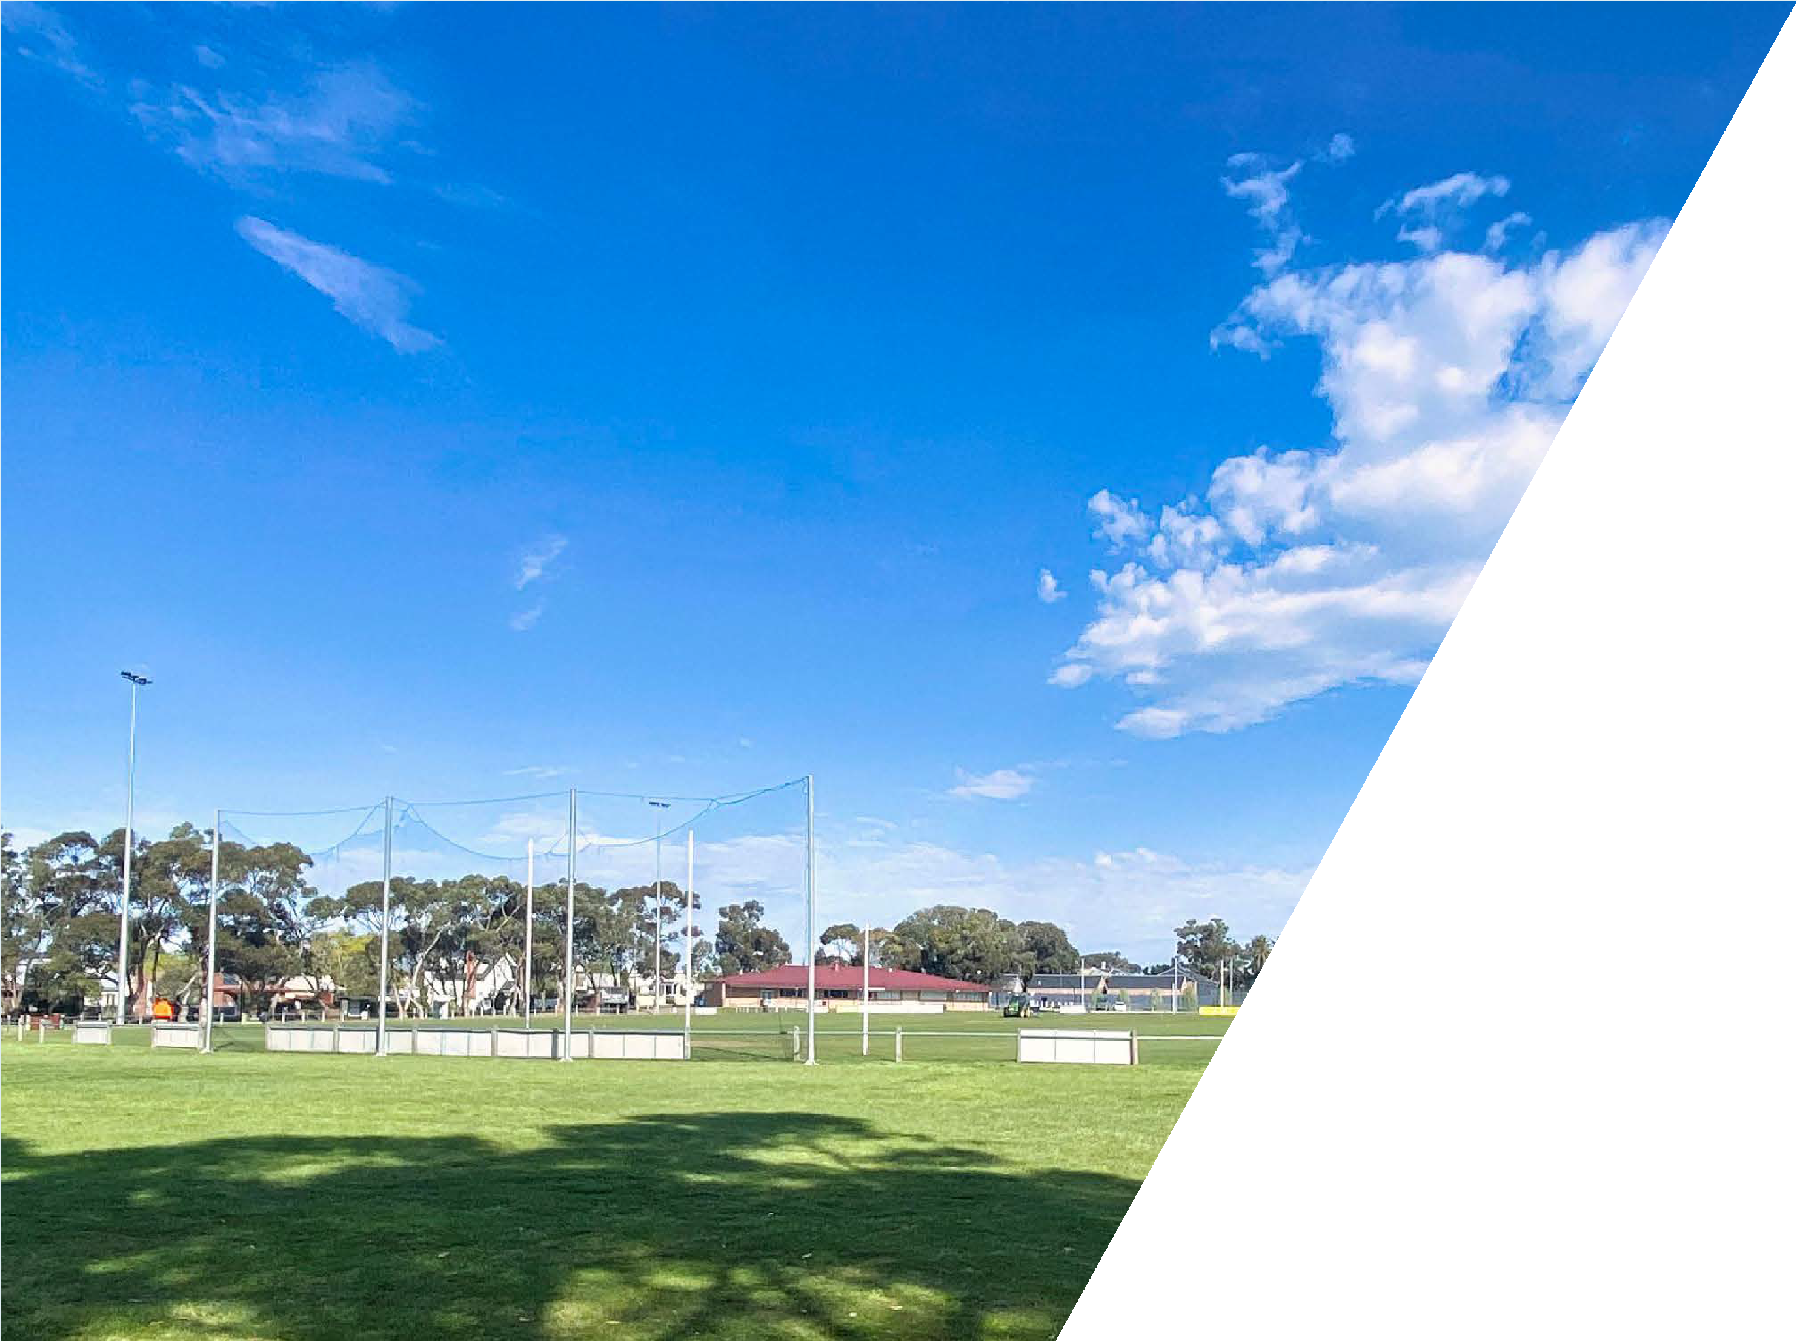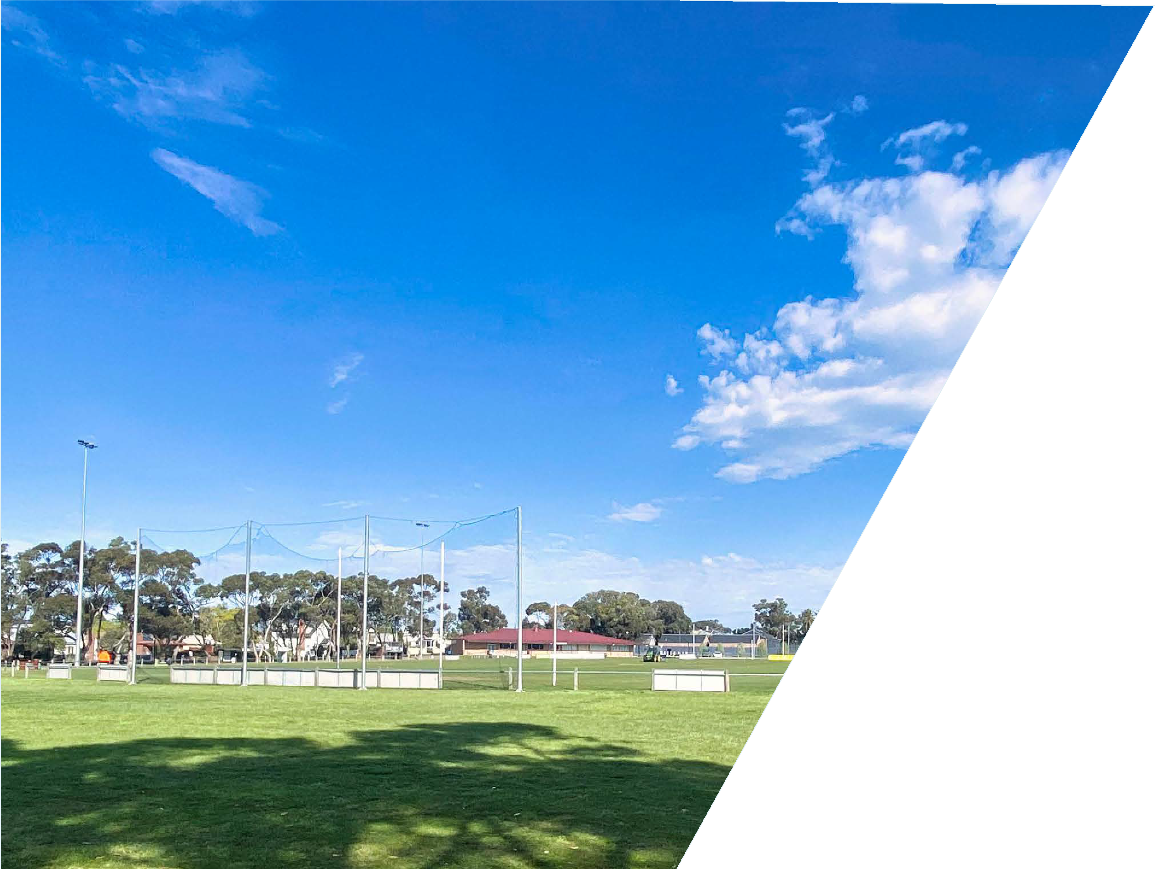

THE CITY OF
GREATER GEELONG

ELDERSLIE RESERVE FACILITY DEVELOPMENT PLAN
APRIL 2022

ACKNOWLEDGEMENT OF COUNTRY

WE ACKNOWLEDGE THE WADAWURRUNG PEOPLE AS THE TRADITIONAL OWNERS OF THE LAND, WATERWAYS AND SKIES. WE PAY OUR RESPECTS TO THEIR ELDERS, PAST AND PRESENT. WE ACKNOWLEDGE ALL
ABORIGINAL AND TORRES STRAIT ISLANDER PEOPLE WHO ARE PART OF OUR GREATER GEELONG COMMUNITY TODAY.

PAGE 2

CONTENTS

THIS DOCUMENT 1. INTRODUCTION
- Introduction

ISSUES AND OPPORTUNITIES
  - Stakeholder Consultation

The Elderslie Reserve Facility Development Plan has been prepared by SBP Advisory in partnership with The OCD and WT Partnership on behalf of the City of Greater Geelong.
We would like to extend our gratitude to the consultants for helping us to prepare this plan.
This project was funded via City of Greater Geelong and developed with input and guidance from the Newtown & Chilwell Football Netball Club.
The plan aims to provide a strategic framework for identified infrastructure upgrades ensuring facilities are compliant, fit-for-purpose, welcoming, gender neutral and provide access for all.
  - Executive Summary
  - Scope
  - Purpose of this Study
  - Glossary of abbreviations
  - Project Methodology
  - Project Governance
  - Planning and Policy Context
  - Analysis of Previous Master Plan

SITE CONSIDERATIONS AND ANALYSIS
  - Site Context
  - Accessibility
  - Connections and Access

EXISTING CONDITION AND USAGE
  - Community Profile
  - User Groups and Participation
  - Existing Site Plan
  - AFL Facility Guidelines
  - Existing Facilities
- SWOC Analysis

FACILITY DEVELOPMENT PLAN
  - Vision
  - Principles
  - Design Objectives
  - FDP Development Process
  - Accessibility and Entry
  - Connections and Circulation
  - Reserve Activities
  - Spectator Amenities
  - Overall Site Landscape Plan
- Area Plan: Football
- Area Plan: Netball
- Area Plan: Community Open Space
- Pavilion Concept Development
- Change Facility Upgrade Concept

IMPLEMENTATION
  - Funding Strategy
  - Project Costs
  - Implementation
  - Project Benefits

APPENDICES
  - Football Pavilion Concept Plans
  - Cost Estimates

PAGE 3

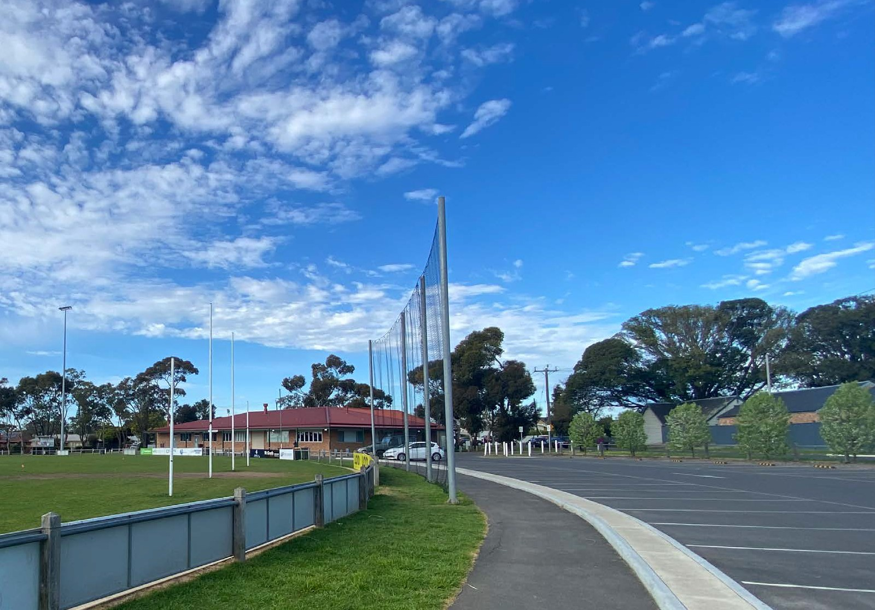1 INTRODUCTION

INTRODUCTION

City of Greater Geelong engaged SBP Advisory to develop a Facility Development Plan for Elderslie Recreation Reserve.

The purpose of the project was to provide a strategic framework for identified infrastructure upgrades, to ensure that facilities at the reserve are compliant, fit-for-purpose, welcoming, gender neutral and provide access for all.

Information for this report has been sourced from the key stakeholders outlined below. We recognise the following sources and provide a general acknowledgment for the content within this report.

City of Greater Geelong.

Newtown & Chilwell Football Netball Club.

General and appropriate research.

File image of Elderslie Reserve and club images courtesy of Newtown & Chilwell Football Netball Club

PAGE 4

1 INTRODUCTION

EXECUTIVE SUMMARY 1.03 SCOPE 1.04 PURPOSE OF THIS STUDY 1.05 GLOSSARY OF ABBREVIATIONS

The Elderslie Recreation Reserve FDP provides an informed, consolidated and long-term approach to future infrastructure development across the site.
The need for the plan has arisen from key stakeholders identifying issues and challenges within the reserve. Based on increasing participation rates in football and netball,
the current facilities will be unable to meet the future sporting and recreation needs of Newtown & Chilwell Football Netball Club and the wider Newtown community in regard to gender neutral, accessible and welcoming facilities.
The vision for the FDP is to “Celebrate and enhance the existing qualities of the reserve, whilst improving functionality, connectivity and recreation opportunities across the reserve.”
The main focus of the plan is the redevelopment of the football pavilion, which is centered around the delivery of compliant, fit- for-purpose and gender neutral change rooms.
A concept plan has been developed for the football pavilion upgrade, and associated preliminary costings have been provided.
The FDP will be delivered in a staged approach, with the main priorities being the:
- Football pavilion upgrade of change rooms and amenities.
- Relocation of public toilets.
- Netball court setback/realignment and half court.
The FDP builds on the 2008 Elderslie Reserve Master Plan, and has been developed based on:
- Existing site plan.
- Issues and Opportunities Report.
- Schematic design of the reserve and football pavilions.
- Illustrative Landscape Plan.
- Detailed area plans for netball, play space and football pavillion.
- Preliminary Quantity Surveyor cost estimates.
- Funding strategy.
- Final report outlining the strategic rationale and staged approach of the final FDP.
The purpose of this project is to deliver a FDP for Elderslie Recreation Reserve
which reflects stakeholder aspirations and provides a strategic framework for identified infrastructure upgrades. It will ensure that facilities are compliant, fit-for-purpose, welcoming, gender neutral and provide access for all.
Ageing facilities, exponential growth in female sports participation, the development of new plans and strategies, changing population and demographics all necessitate the need to review the old master plan which is now more than a decade old.
City City of Greater Geelong

FDP Facility Development Plan

The OCD The Office for Collective Design
SBP Sport Business Partners Advisory
SRV Sport & Recreation Victoria
PCG Project Control Group
PRG Project Reference Group
PWG Project Working Group
WTP WT Partnership

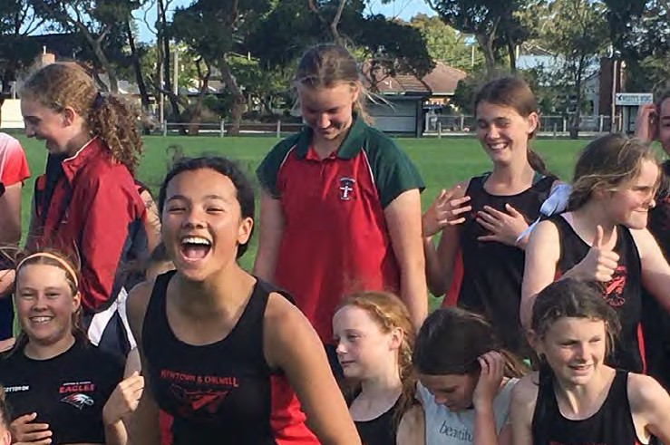

Images courtesy of Newtown & Chilwell Football Netball Club

PAGE 5

1 INTRODUCTION

1.06 METHODOLOGY 1.07 PROJECT GOVERNANCE 1.08 PLANNING AND POLICY CONTEXT

The below outlines the general methodology undertaken in developing the FDP.
Project Establishment
  - Formal scoping workshop with the PCG.
  - Project plan and Stakeholder Engagement Strategy.
  - Staff consultations.
Issues and Opportunities Paper
  - Document review.
  - Assessment of facility provision.
  - Site assessment and facility audit.
  - Stakeholder consultations.
  - Issues and opportunities paper.
Infrastructure Design Brief, Options and Cost Plan
  - Development of a site base plan to guide the concept planning.
  - Draft Infrastructure Design Brief.
  - Concept designs for the football pavilion.
  - Preliminary cost estimates.
  - Funding strategy for the delivery of the FDP.
Draft Development Plan
- Draft FDP with design drawings and documentation, cost estimates, implementation schedule.
- Draft FDP reviewed by the PRG, PWG and PCG.
Final Development Plan
- Final FDP document accompanied by a summary/advocacy document for final endorsement.
The development of the FDP was overseen by the following key stakeholder groups.
Project Reference Group (PRG): Provided input, direction and feedback into the project at key stages.
Project Working Group (PWG): Provided advice and recommendations to the PCG to ensure the project is delivered in line within scope.
Project Control Group (PCG): Provided high- level strategic direction on key issues, opportunities and approve reports as well as contract management.
Newtown & Chilwell Football Netball Club: Consulted and informed on the progress of the Elderslie Reserve FDP.
SBP and The OCD reviewed a range of documents and data in preparing this report, including:
- The City of Greater Geelong Council Plan 2018-2022 (Updated 2020-21).
- The City of Greater Geelong Our Community Plan 2021-2025.

- The City of Greater Geelong Sustainable Communities Infrastructure Development Guidelines 2016.

- The City of Greater Geelong Social Infrastructure Planning and Investment Policy 2020.

- The City of Greater Geelong Social Infrastructure Plan - Generation One: 2020 - 2023.

- AFL Barwon Towards 2030 Strategy.
- Netball Victoria Facilities Manual.
- AFL Victoria Facility Development Guidelines.

The Social Infrastructure Plan identified Elderslie Reserve as a priority for investment, recognising the need to improve conditions and build capacity. The recommendation includes upgrading the change facilities to be gender neutral.
The City will need to work closely with tenants, user groups and the local community to ensure that the planning and design of the FDP will lead to a high-quality outcome that meets the needs of all users and residents, both now and into the future.


Image courtesy of Newtown & Chilwell Football Netball Club

PAGE 6

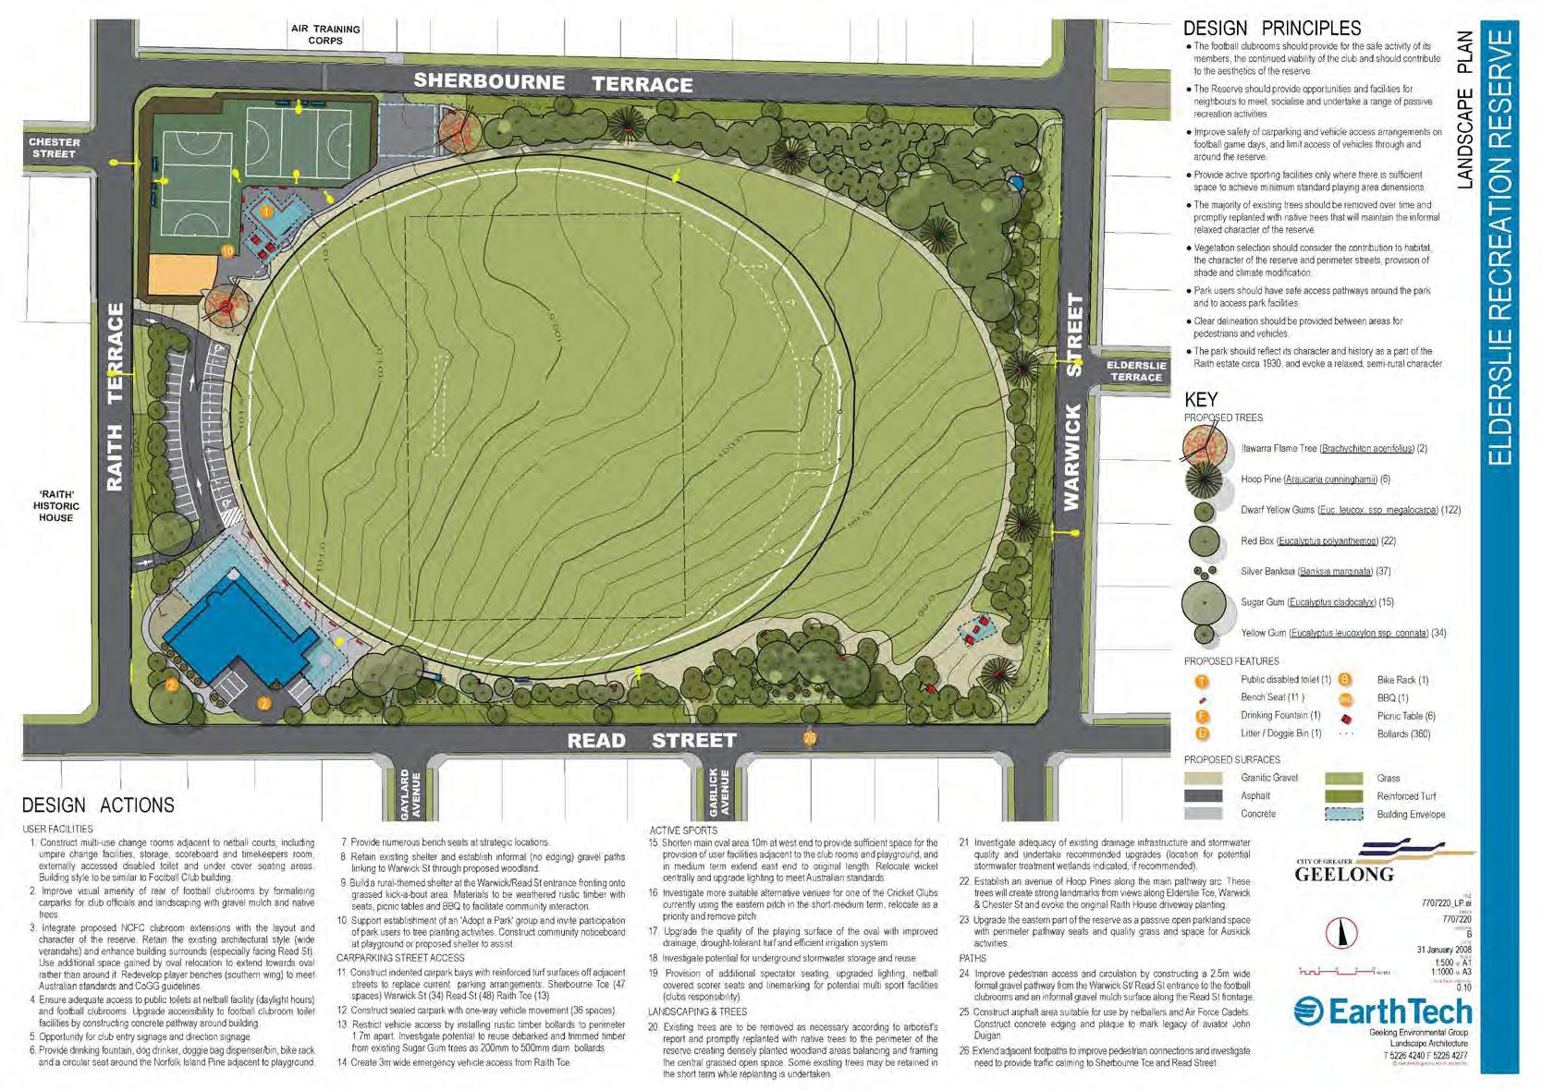INTRODUCTION

1.09 ANALYSIS OF PREVIOUS MASTER PLAN

The 2008 master plan focused on upgrades to the existing reserve and delivering upgrades to the infrastructure. Key elements of the 2008 master plan that were delivered include:
  - The netball pavilion.
  - Upgrades and expansion of the football pavilion.
  - Construction of the western car park.
  - Restricted vehicle access to the reserve.
  - Upgrades to the main oval.
  - Relocation of the cricket club.
  - Some additional planting to landscaped areas.
Key elements of the 2008 master plan that have been carried through to the current development plan include:
  - Strengthening the community open space at the eastern end of the reserve.
  - Delivery of a pedestrian pathway network which is more formailsed than the 2008 plan.
  - New angled parking where possible along Warwick Street as per the 2008 master plan.
New additions to the FDP include:
  - Upgrades to the football change facilities to be gender neutral.
  - Installation of a netball half court.
  - Greater geographical distribution of some functional purposes across the site to prevent the western side becoming crowded and congested.

PAGE 7

- SITE CONSIDERATIONS AND ANALYSIS

SITE CONTEXT
Western Cemetery

Elderslie Reserve is located at 40 Read Street in the suburb of Newtown, located in the inner west of Geelong.
It is a small reserve surrounded by residential streets on all boundaries, and is used heavily by the local community. It contains the following facilities and infrastructure:
  - A single oval with a synthetic wicket.
  - Two netball courts.
  - Pavilion/clubhouse facilities for football and netball.
  - A playground and public toilets.
  - Open space to the eastern end of the reserve including a small rotunda.
Elderslie Reserve is classified as a Community Level 1 Active Open Space Reserve. The playground within the reserve is also classified as a Local Level Playground.
LEGEND

Zillah Crawcour Park

Elderslie Reserve

The Geelong College Middle School

SUBJECT SITE

SUBJECT SITE BOUNDARY

Queens Park

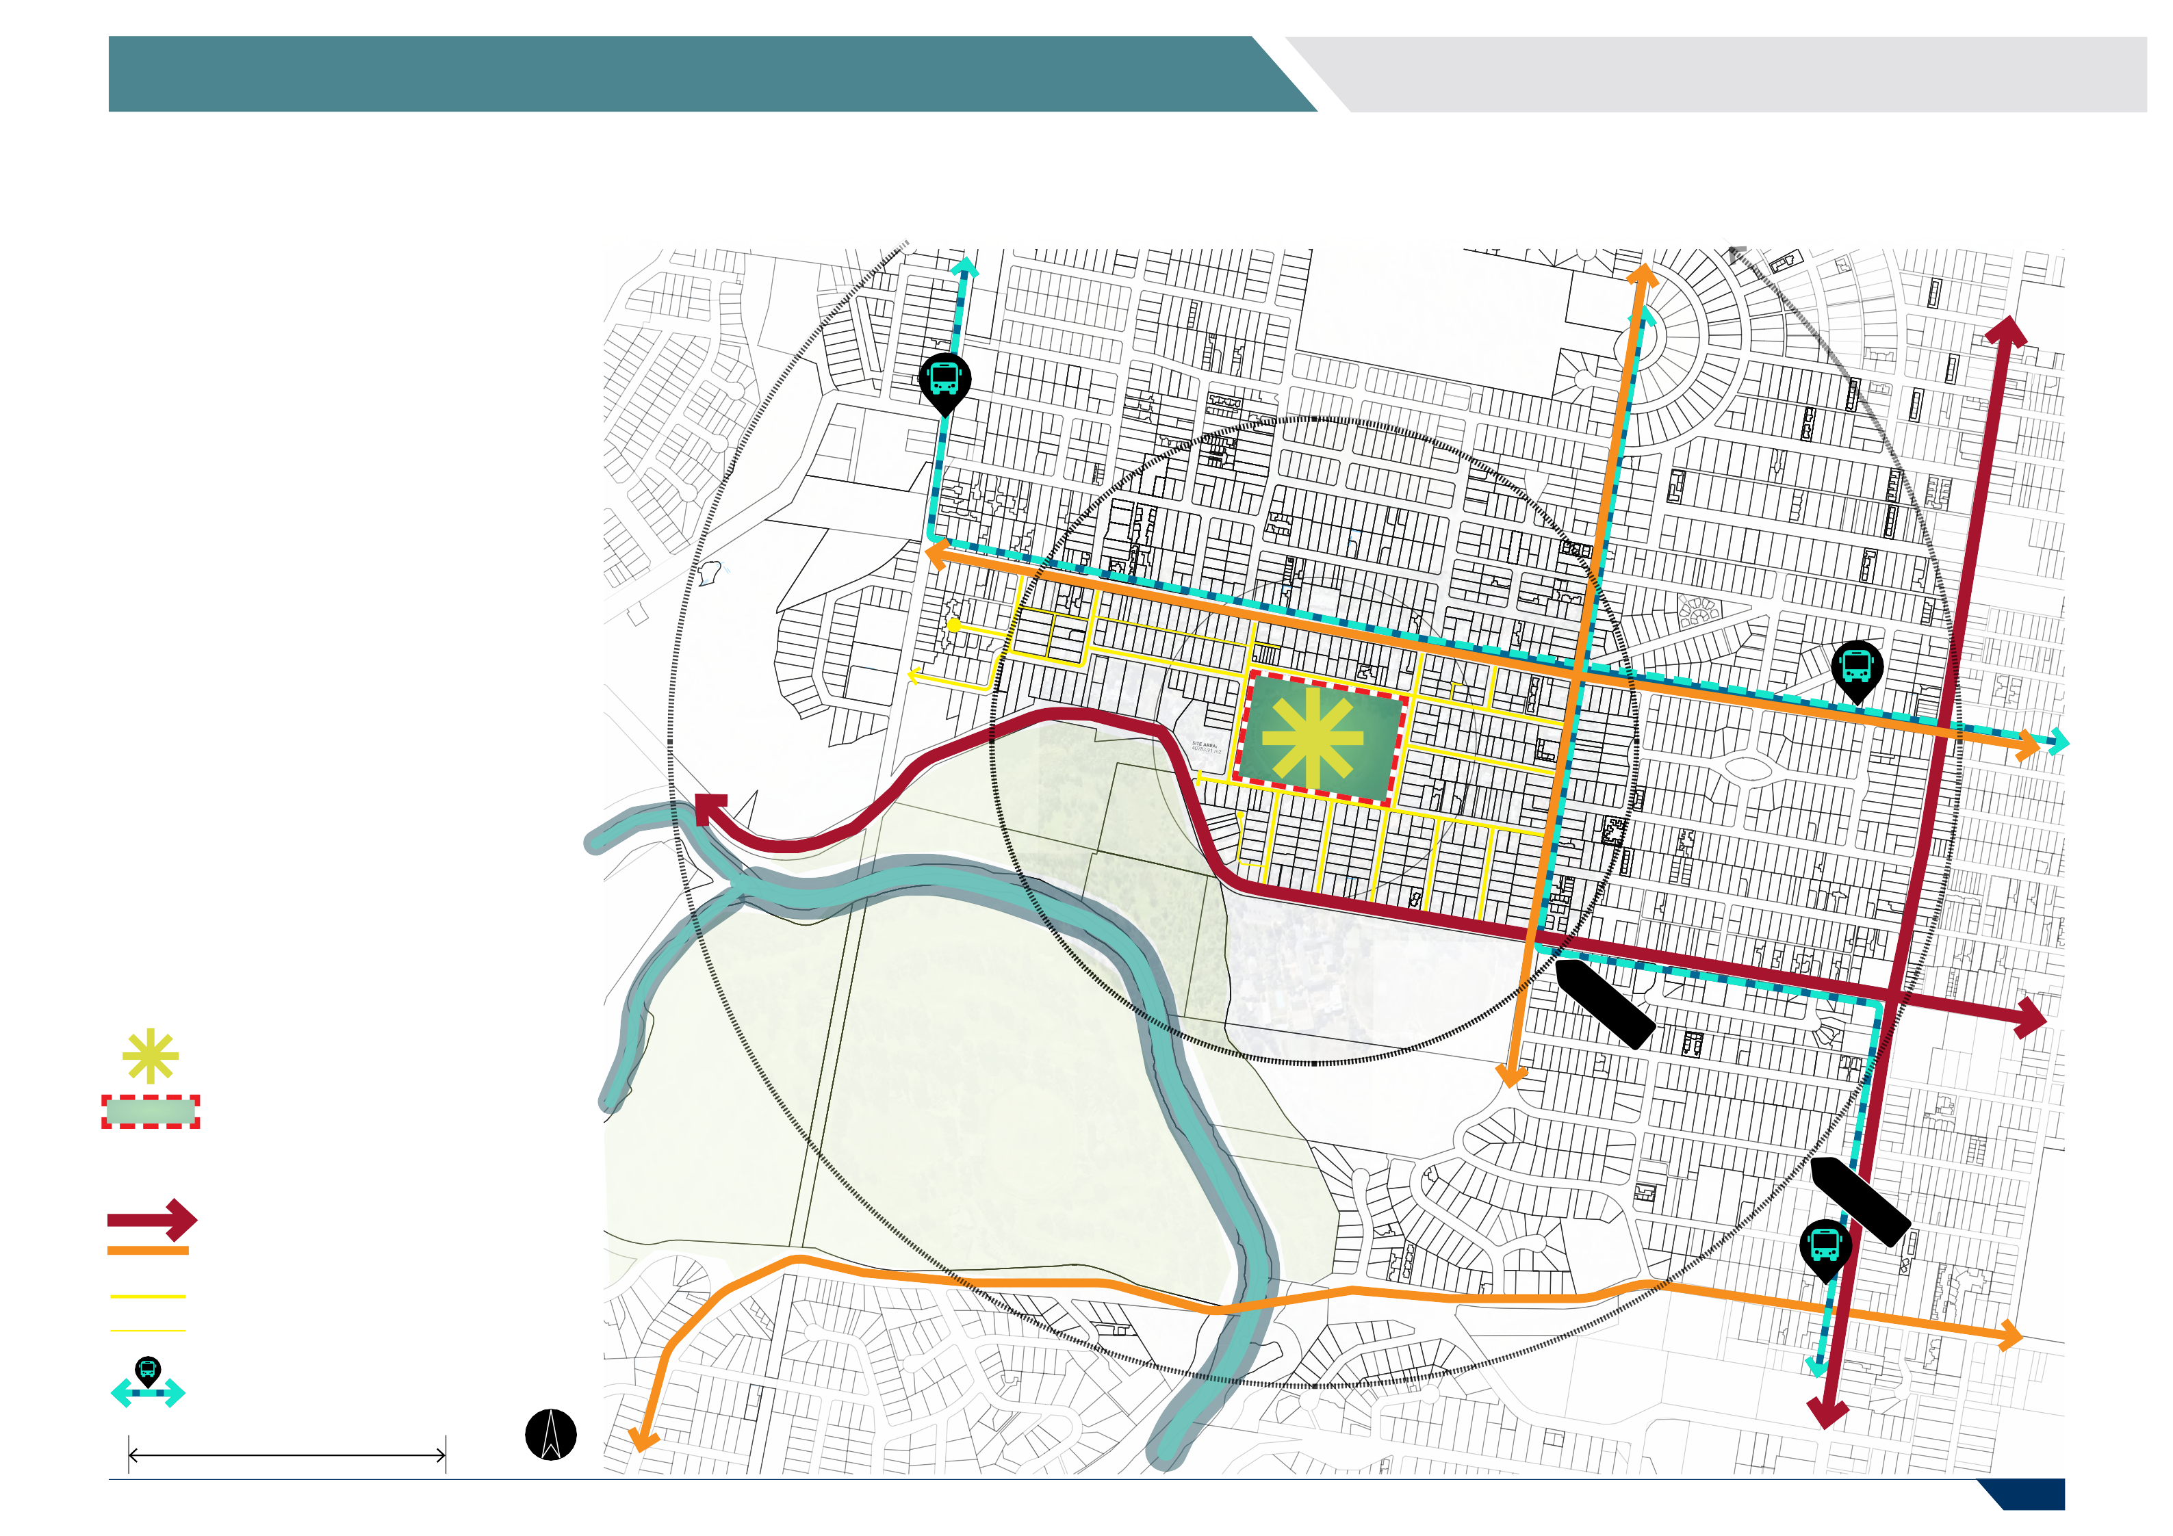

ROAD NETWORKS

MAJOR CONNECTOR ROADS COLLECTOR ROADS

LOCAL TRAFFIC ROADS LANE WAYS

BUS ROUTES

500 M

PAGE 8

2 SITE CONSIDERATIONS AND ANALYSIS

ACCESSIBILITY

  - The key entry point to the reserve is located on Raith Terrace adjacent to the football pavilion and car park.
  - The gravel area along Sherbourne Terrace is used informally for parking – but is also used by pedestrians and dog walkers.
  - The surrounding streets are residential and narrow, which leaves limited space for on- street car parking around the perimeter of the reserve.
CPTED Principles
  - The public toilets are located at the back of the football pavilion, and there are some security concerns due to lack of sightlines and dark/shadowed areas.
  - There is no formalised pedestrian access to the reserve along Read Street and Warwick Street.

Netball Club

Multiple cross-overs for cars.

Elderslie Reserve

LEGEND

Poorly located toilets

SITE BOUNDARY

SENSITIVE INTERFACES

Narrow Streets for parking.

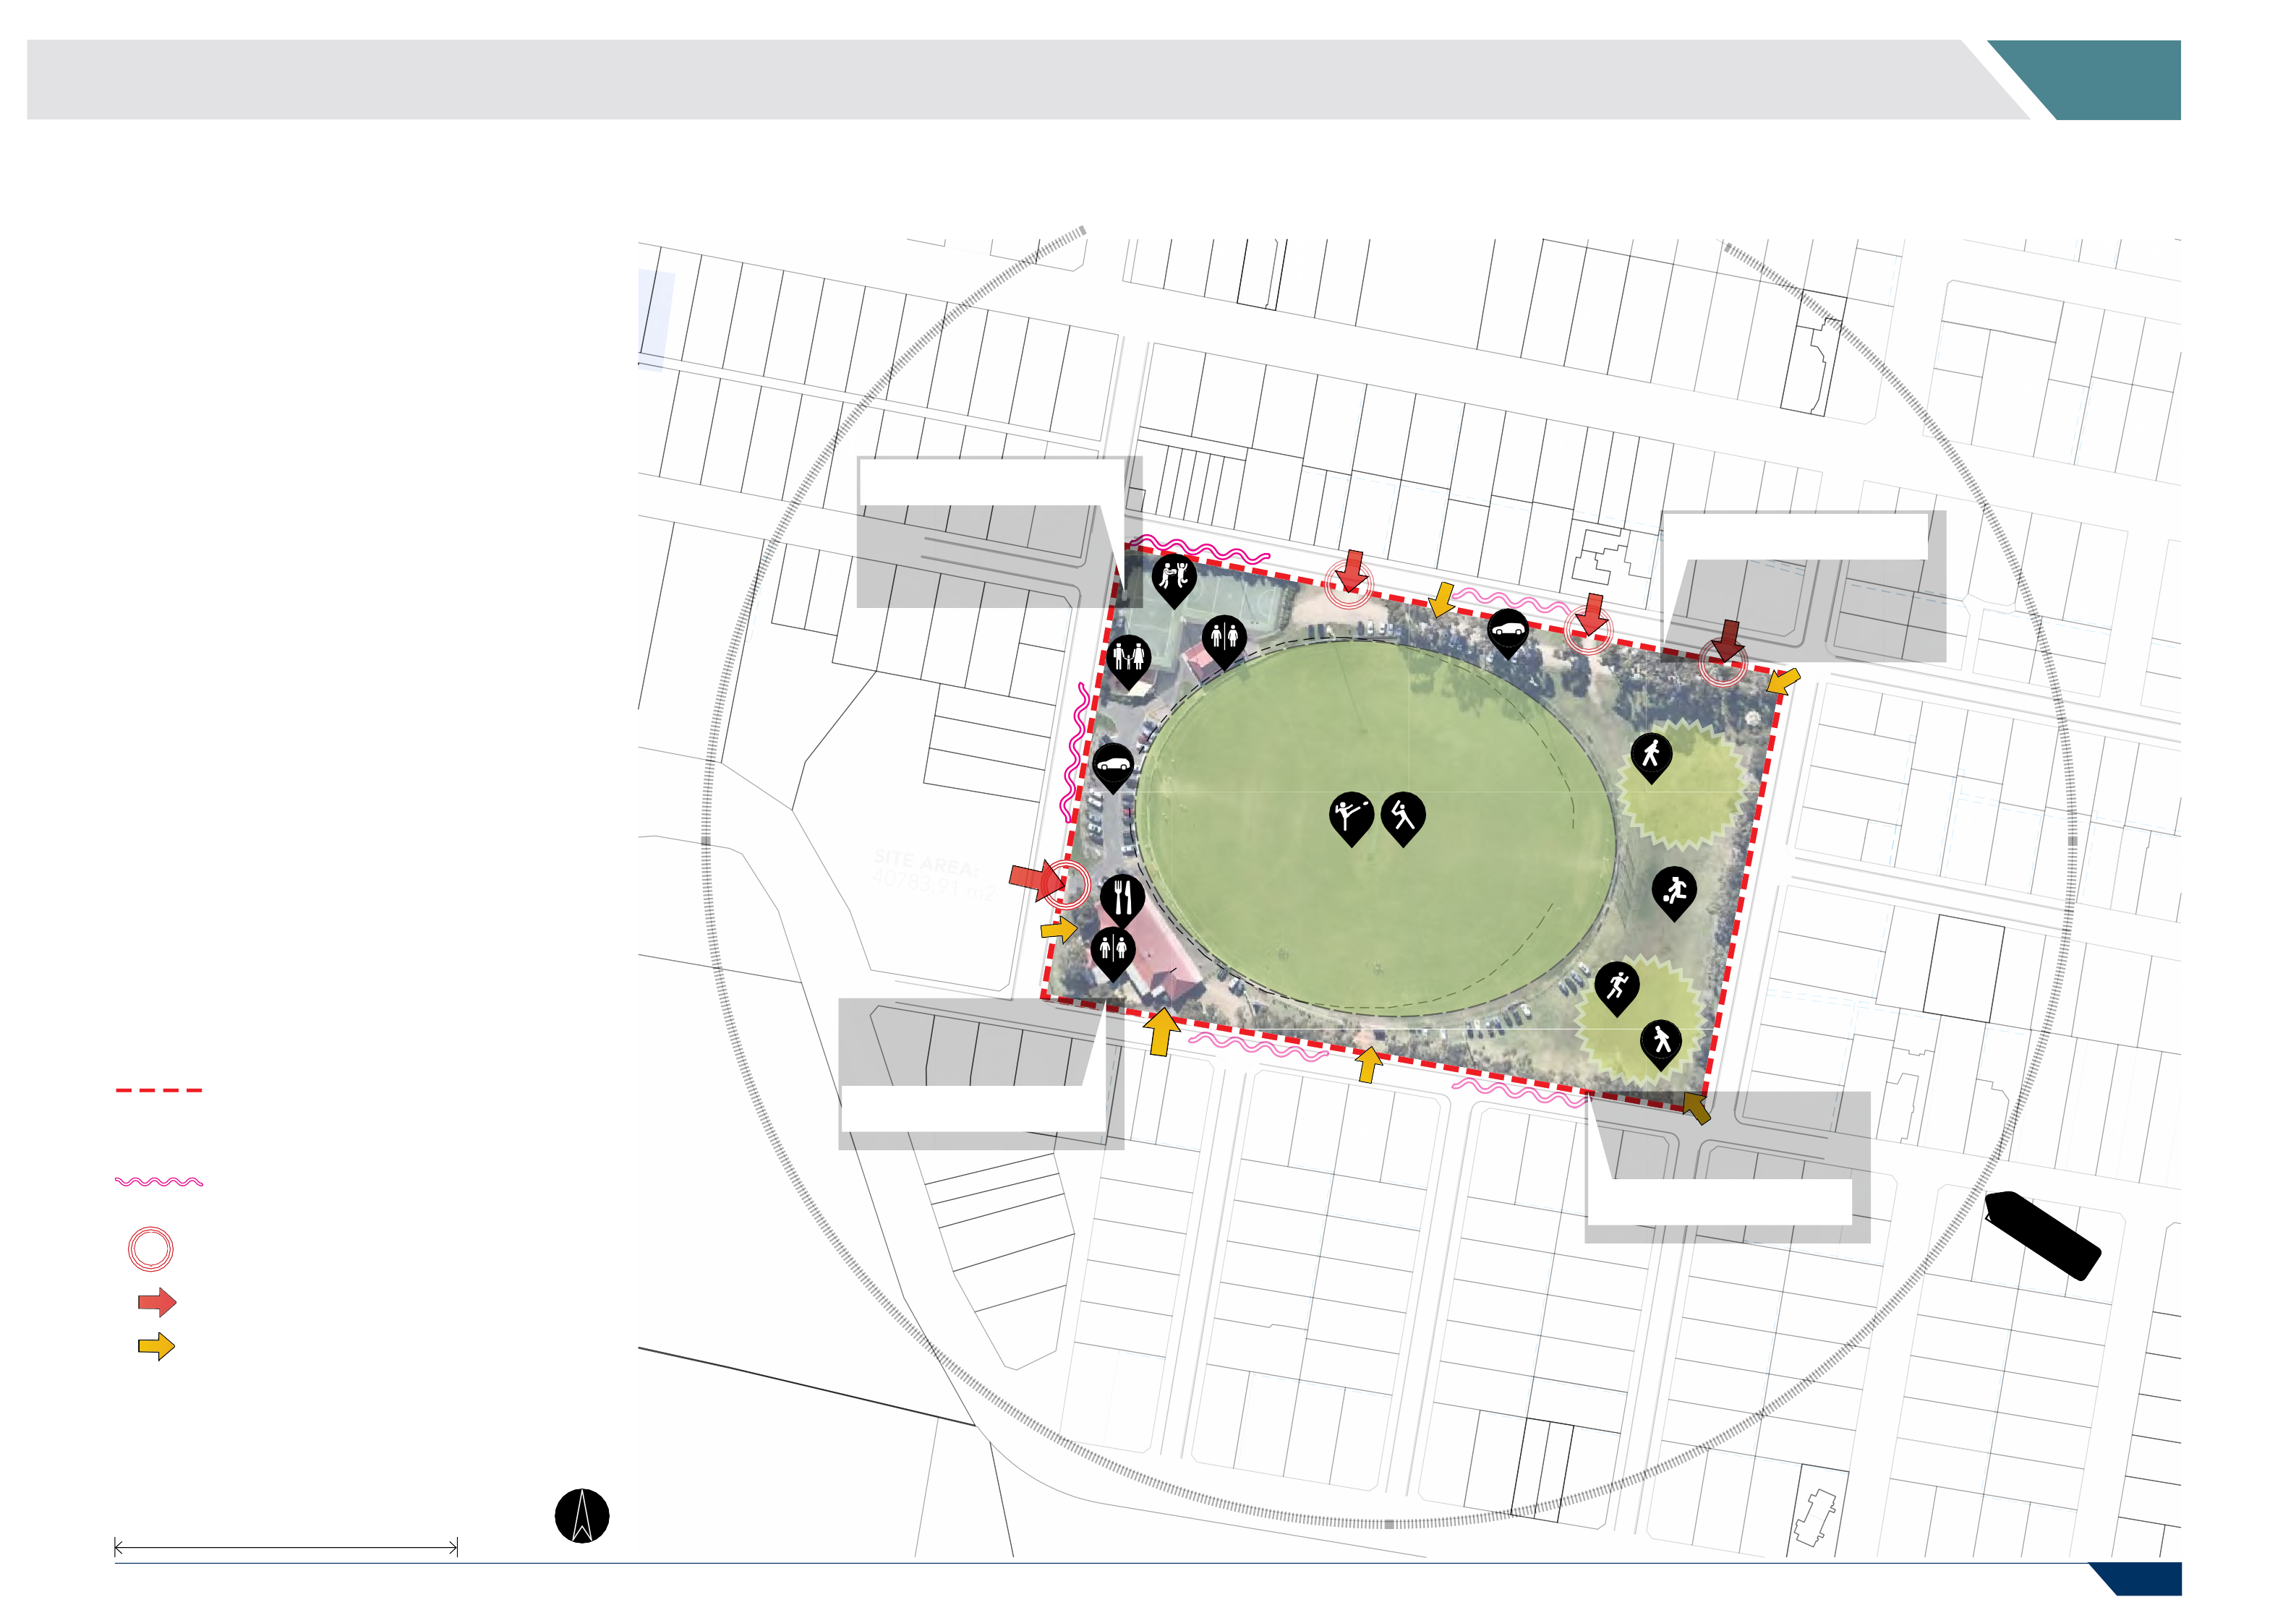
ENTRY NODES

VEHICLE ENTRY POINTS

PEDESTRIANS/BICYCLES & OTHER ENTRY

125 M
PAGE 9

2 SITE CONSIDERATIONS AND ANALYSIS

CONNECTIONS AND ACCESS
Poor corner interface & pedestrian access on corner.

  - There is a lack of defined pedestrian access to the reserve from Read Street, Warwick Street and Sherbourne Terrace.
  - Poor corner interface and pedestrian access on the corner of Sherbourne Terrace and Raith Terrace.
  - Pedestrian and car conflicts on the gravel path along Sherbourne Terrace.
  - Conflict between the back of house area at the football pavilion and public interfaces.

Pedestrian- car conflicts.
Lack of defined pedestrian access.

LEGEND
Poor corner interface & pedestrian access on corner.

CONNECTION ISSUES

PEDESTRIAN CONNECTIONS

BACK OF HOUSE/SERVICE

VEHICLE ACCESS

NO PEDESTRIAN CONNECTIVITY ERRANT BALL SPILL LOCATIONS

CONFUSING/POOR URBAN DESIGN

CONNECTING & APPROACHING VIEWS

POOR VISUAL APPROACH

BOH/public conflict zone.

Lack of defined pedestrian access.

Lack of defined pedestrian access.

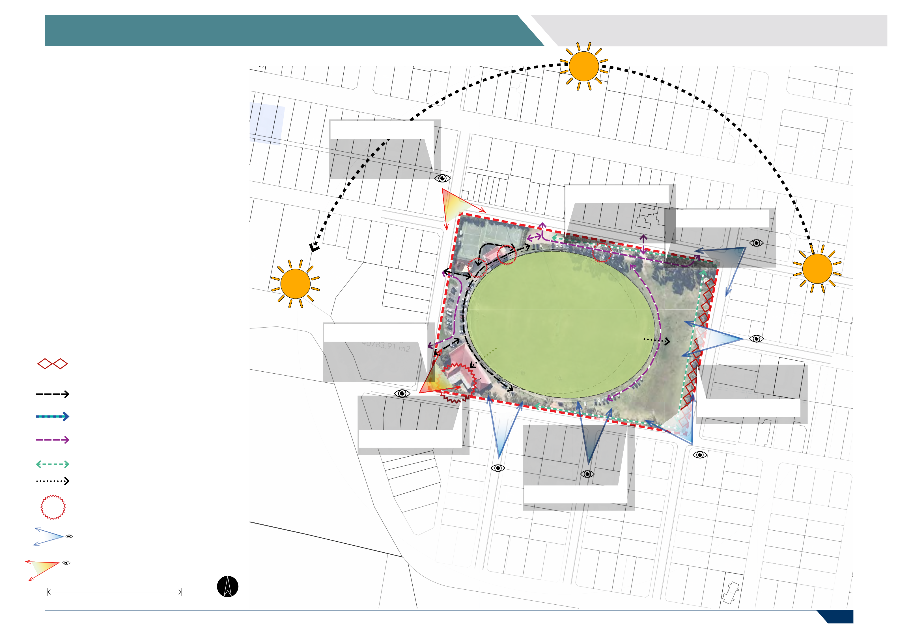

125 M

PAGE 10

- EXISTING CONDITION AND USAGE

COMMUNITY PROFILE

Between 2016 and 2041, the population for the City of Greater Geelong is forecast to increase by 153,685 persons (64.16% growth), at an average annual change of 2%.
Newtown is expected to see an additional 2,528 residents, which is one of the lower growth forecasts when compared to Armstrong Creek (20,877) and Marshall Charlemont (15,811).
The population estimate for Newtown as of the 30th June 2020 is 10,945. Since the previous year, the population has grown by 1.02%
whilst the population growth in City of Greater Geelong was 2.29%.
In 2016, 30.4% of households were made up of couples with children, compared with 27.7% in City of Greater Geelong. Newtown also had a higher proportion of children and a lower proportion of persons aged 60 or older than City of Greater Geelong, with the largest age group being 15 to 19-year olds
The Elderslie Recreation Reserve FDP will need to consider the additional demand for sport and recreation infrastructure based on forecast population changes.
CITY OF GREATER GEELONG POPULATION

AREA | 2021 | 2026 | 2031 | 2036 | 2041 | TOTAL CHANGE
City of Greater Geelong | 268,984 | 298,716 | 330,428 | 361,014 | 393,216 | +153,685
Armstrong Creek | 9,787 | 16,023 | 22,050 | 24,742 | 25,274 | +20,877
Barwon Heads - Connewarre - Breamlea | 5,074 | 5,237 | 5,452 | 5,722 | 6,029 | +1,266
Bell Park | 5,788 | 5,934 | 6,016 | 6,224 | 6,459 | +1,263
Bell Post Hill | 5,182 | 5,651 | 7,876 | 10,454 | 12,913 | +7,883
Belmont | 15,165 | 15,833 | 16,409 | 17,104 | 17,777 | +3,476
Clifton Springs | 8,226 | 8,663 | 9,466 | 9,922 | 10,246 | +2,660
Corio | 15,815 | 16,440 | 16,763 | 17,160 | 17,590 | +1,849
Curlewis | 3,699 | 5,070 | 6,917 | 8,126 | 8,669 | +7,067
Drysdale - Bellarine | 5,708 | 6,191 | 6,859 | 7,476 | 7,989 | +3,416
East Geelong | 4,028 | 4,094 | 4,277 | 4,525 | 4,849 | +822
Geelong - South Geelong - Drumcondra | 8,068 | 9,107 | 10,151 | 12,151 | 15,058 | +8,111
Geelong West - Manifold Heights | 10,287 | 10,474 | 10,751 | 11,266 | 11,925 | +2,041
Grovedale | 15,363 | 15,897 | 16,296 | 16,968 | 17,661 | +3,045
Hamlyn Heights | 6,842 | 7,198 | 7,564 | 8,000 | 8,456 | +1,974
Herne Hill - Fyansford | 4,385 | 4,895 | 5,917 | 6,646 | 6,777 | +3,125
Highton - Wandana Heights - Ceres | 24,008 | 25,666 | 26,045 | 26,678 | 27,135 | +5,160
Lara | 18,250 | 19,315 | 20,797 | 22,126 | 24,551 | +7,795
Leopold | 13,455 | 14,057 | 15,522 | 16,914 | 18,263 | +5,123
Lovely Banks - Batesford - Moorabool | 2,863 | 3,100 | 4,898 | 9,439 | 16,269 | +13,533
Marshall - Charlemont | 4,024 | 6,765 | 9,754 | 13,911 | 18,101 | +15,811
Mount Duneed | 4,201 | 8,970 | 12,653 | 14,265 | 15,544 | +14,375
Newcomb - Moolap | 6,630 | 6,908 | 7,095 | 7,359 | 7,648 | +1,658
Newtown | 10,895 | 11,113 | 11,408 | 11,757 | 13,011 | +2,528
Norlane - North Shore | 9,564 | 9,876 | 10,105 | 10,367 | 10,911 | +2,021
North Geelong - Rippleside | 4,447 | 4,588 | 4,645 | 4,715 | 4,800 | +894
Ocean Grove | 16,633 | 18,230 | 19,447 | 20,335 | 21,316 | +6,709
Portarlington | 4,141 | 4,639 | 5,267 | 5,590 | 5,853 | +2,182
Rural Bellarine Peninsula | 3,645 | 4,581 | 4,822 | 4,789 | 4,752 | +1,851
Rural North | 1,867 | 1,943 | 2,061 | 2,184 | 2,314 | +486
St Albans Park | 5,013 | 5,131 | 5,196 | 5,306 | 5,453 | +527
St Leonards - Indented Head | 4,094 | 4,601 | 5,010 | 5,588 | 6,122 | +2,443
Thomson - Breakwater | 2,822 | 2,990 | 3,089 | 3,195 | 3,310 | +631
Waurn Ponds | 5,017 | 5,473 | 5,733 | 5,795 | 5,865 | +713
Whittington | 3,995 | 4,063 | 4,116 | 4,214 | 4,324 | +368

PAGE 11

3 EXISTING CONDITION AND USAGE

USER GROUPS AND PARTICIPATION

Regional Participation Trends
Greater Geelong is forecast to see an additional 3,003 football players between 2019 and 2030. This is the greatest growth forecast of all the LGA’s in the G21 region.
Similarly, netball participation is also forecast to grow, with an increase of 1,189 participants in Greater Geelong between 2019 and 2030. This growth will create increased pressure on existing infrastructure, and future development at Elderslie will need to consider this increased demand.
Club Participation Trends
There are a total of 1,484 members at the Newtown & Chilwell Football Netball Club, including 614 football members, and 258 netball members. The remaining membership is made up by social or non-playing members.
Auskick participants makeup the largest proportion of football members (23%), followed by Senior Men’s and Women’s (22% combined). Interestingly, the Women’s teams have only been added to the Club in the last 12-24 months, which has seen an additional 71 playing members.
There are 258 netball members at the Club, with Under 15 (58 members) and Under 11 (56 members) being the most popular age brackets.

REGIONAL FOOTBALL AND NETBALL PARTICIPATION TRENDS Source: G21 And AFL Barwon | Towards 2030: Strategy (2020).

LGA- | Population |  | 2019  Participation Rate  (Club participa- tion/G21 popula- tion) | Total registered AFL Players |  | Change in Registered Players 2015-2019 | Rate of Change in Participation 2015-2019  (%) | Estimated Change ( +/- ) in Registered Players
Football | 2019 | 2025 |  | 2015 | 2015 | Change in Registered Players 2015-2019 | Rate of Change in Participation 2015-2019  (%) | 2015-2019 | 2015-2019
Colac-Otway | 21,685 | 22,846 | 8.29% | 1,527 | 1,797 | 270 | 17.68% | 96 | 187
Golden Plains | 23,384 | 26,356 | 3.52% | 576 | 824 | 248 | 43.06% | 105 | 194
Greater Geelong | 257,181 | 292,855 | 4.40% | 8,365 | 11,509 | 3,163 | 37.90% | 1,596 | 3,003
Surf Coast | 32,654 | 37,193 | 6.20% | 1,697 | 2,024 | 327 | 19.27% | 281 | 520
Queenscliffe | 2,940 | 3,083 | 9.00% | 230 | 266 | 36 | 15.65% | 13 | 17
Total | 337,844 | 382,333 | - | 12,395 | 16,420 | 4,044 | - | 2,091 | 3,921
Netball 2015-2019
Colac-Otway | 21,685 | 22,846 | 3.84% | 103 | 832 | 729 | 707.77% | 45 | 87
Golden Plains | 23,384 | 26,356 | 0.92% | 200 | 216 | 16 | 8.00% | 27 | 51
Greater Geelong | 257,181 | 292,855 | 1.77% | 3,078 | 4,555 | 1,477 | 47.99% | 632 | 1,189
Surf Coast | 32,654 | 37,193 | 3.00% | 337 | 980 | 643 | 190.80% | 136 | 252
Queenscliffe | 2,940 | 3,083 | 5.71% | 179 | 168 | -11 | -6.15% | 8 | 11
Total | 337,844 | 382,333 | - | 3,897 | 6,751 | 2,854 | - | 848 | 1,590

CLUB PARTICIPATION TRENDS
 | 2021 Newtown Football Netball Club
 | Membership - Football
160
160 | 140
140
120
120 |  |  | 88
100
100 |  |  |  |  | 66 |  | 66 |  |  |  | 71
80
60 |  |  |  |  |  | 44 |  | 44
40 |  |  |  |  |  |  |  |  | 30
20
0
0 | Auskick |  |  | U 09 | U 10 | U 11 | U 13 | U 15 | U 17 | Snr Mens | Snr Women

614
2021 Newtown Football Netball Club Membership - Netball
70
60
50
40
30
20
10
0
56
58
49
31
12
12
10
10
10
10
U 11 U 13 U 15 U 17 U 19 E Grade D C B A
Grade Grade Grade Grade
Football Members
258
Netball Members
612
Social Members

PAGE 12

3 EXISTING CONDITION AND USAGE

EXISTING SITE PLAN
Netball courts setback from street

Multiple informal vehicle cross-overs along Terrace.

LEGEND

    - Elderslie Reserve Oval.

    - Western Car Park. 03 Football Pavilion. 04 Public Toilets.
- Play Ground.

- Netball Courts.

- Netball Pavilion & Scoreboard.
corner.

S S

08
06
S
L
L
L

S

07

05

09
10 11

- Gravel Car Park.

- Informal Parking.

- Vehicle Access to Reserve.
02
- Pergola/Shelter. 01
- Recent Planting Strip. 12
- Public Open Space Areas.
- Car Parking on Grass. 13
- Interchange Boxes. 14
03

SITE BOUNDARY ENTRY NODES
04 15

VEHICLE ENTRY POINTS
PEDESTRIANS/BICYCLES & OTHER ENTRY SCOREBOARD LOCATION

SAFETY NETTING BEHIND GOALS
L LIGHTING
Public Toilets located behind football pavilion in service area.
Football pavilion BOH and refuse collection.

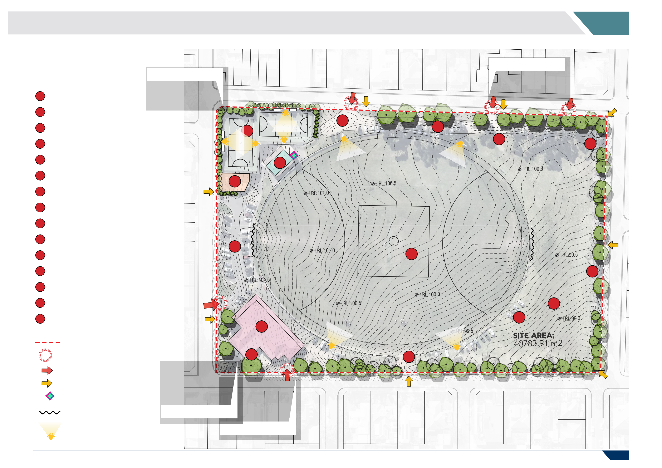
PAGE 13

3 EXISTING CONDITION AND USAGE

AFL VICTORIA FACILITY GUIDELINES

The AFL Preferred Facility Guidelines outline the preferred facility requirements for State League, Regional and Local level facilities.
PLAYING FIELD FACILITIES | State | Regional | Local | Elderslie
Player Amenities (toilet/showers) | 35m2x 2* | 25m2x 2* | 25m2x 2* | ✓
Number of cubicle showers (gender neutral) | 5 x showers per amenity | 4 x showers per amenity | 3 x showers per amenity | ✗
Number of pan toilets | 5 x toilets per amenity | 4 x toilets per amenity | 3 x toilets per amenity | ✗
Player Change Rooms | 2* x75m2-90m2 | 2* x 55m2-75m2 | 2* x45m2-55m2 | ✓
Doctors Room | 15m2 | 10m2  Optional | 10m2  Optional | ✗
Massage/Strapping Room | 2 x 20m2 | 2 x 15m2 | 2 x 10m2  Optional | ✗
External covered viewing area | 150m2 | 75m2 | 50m2 | ✓
Gymnasium/Fitness Room | 40m2-50m2 | 25m2-30m2  Optional | 20m2-25m2  Optional | ✓
Kitchen & Kiosk | 40m2 | 30m2 | 20m2 | ✓
First Aid/Medical Room (Public Access) | 15m2 | 15m2  Optional | 15m2  Optional | ✗
Office/Administration/Meeting | 25m2 | 20m2 | 15m2 | ✓
Public Toilets | Male 20m2  Female 20m2Accessible 5m2  (or can be gender neutral  to size specified) | Male 15m2  Female 15m2Accessible 5m2  (or can be gender neutral  to size specified) | Male 10m2  Female 10m2Accessible 5m2  (or can be gender neutral  to size specified) | ✓
Storage (internal and external) | 25m2+ | 20m2+ | 20m2 | ✗
Social/Community Room | 200m2 | 150m2 | 100m2 | ✓
Third umpire/match referee/venue management room | 15m2 | 10m2  Optional | 10m2  Optional | ✗
Timekeeping/Scorers Box | 15m2 | 10m2 | 10m2 | ✓
Umpires Rooms (inc. toilet, showers) | 30m2-40m2 | 30m2-40m2 | 20m2-25m2 | ✗
Utility/Cleaners Room | 5m2+ | 5m2+ | 5m2+ | ✗

The Guidelines can be used as a key tool during the planning phase of a project to identify the need for a new/upgraded facility. They also provide relevant guidance, particularly around spatial requirements that can inform concept and/or master planning processes.
Elderslie Reserve is classified as a local level facility, and therefore the future pavilion design should include the area allocations as shown in bold to the right.
The right-hand column demonstrates whether the existing facilities at Elderslie Reserve meet the guidelines. As shown, there is currently not the required provision of:
- Gender neutral cubicles.
- Pan toilets.
- Doctors room.
- Massage/strapping room.
- First Aid/Medical Room.
- Storage.
- Third umpire room/match referee/venue management room.
- Umpires room.
- Utility/cleaners box.
Each of these aspects have been considered in developing the concept plan for the updated change facilities.

PAGE 14

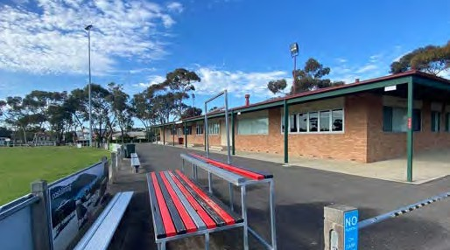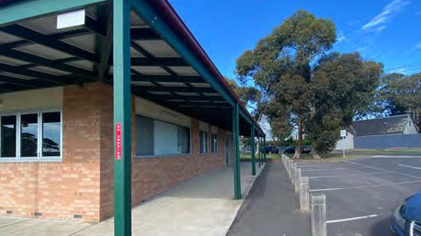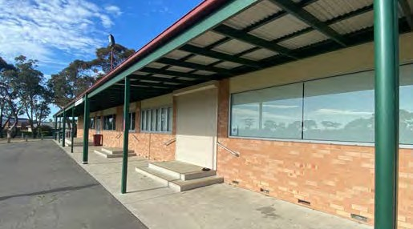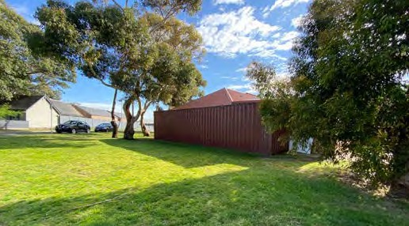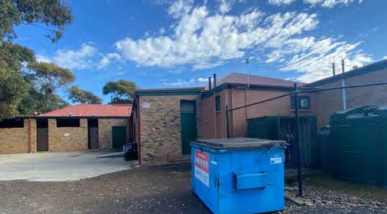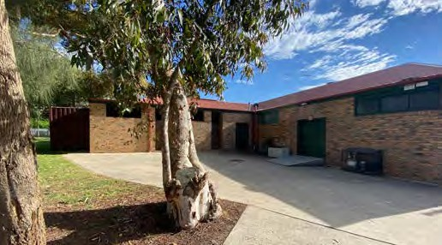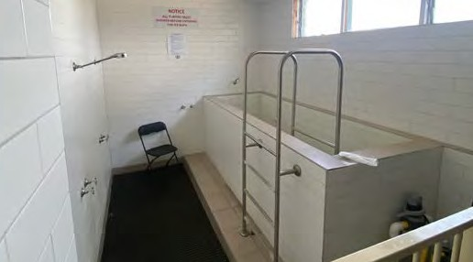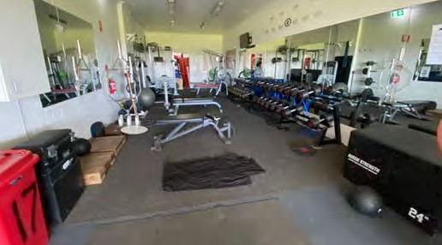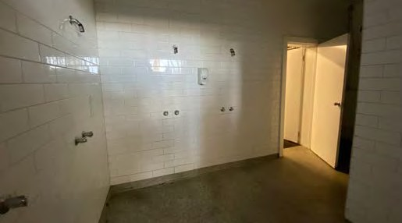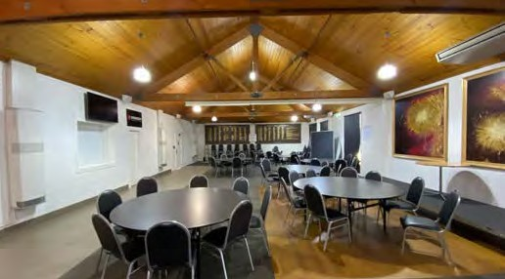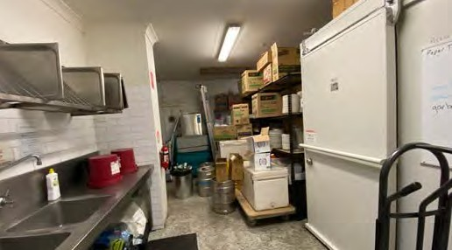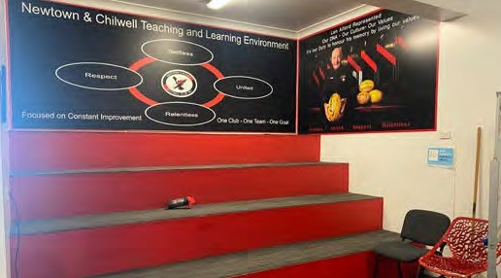3 EXISTING CONDITION AND USAGE

EXISTING FACILITIES: FOOTBALL PAVILION

The existing football pavilion is popular facility widely used by the local community.
The condition of the building is varied with the public areas including the bar area, offices and meeting rooms in good condition.
General observations made during site investigations were:
- There is a distinct lack of adequate storage space for equipment.
- The public toilets located within the building at the rear are in sub-standard condition.
- No public DDA toilet.
- No provision of female friendly change rooms, the amenities are not fit-for-purpose and do not meet the requirements of the facility guidelines.
- The change in surface levels at various building access points is unsafe, and there is no DDA access.
- Gym facility doubles up as treatment room.

PAGE 15

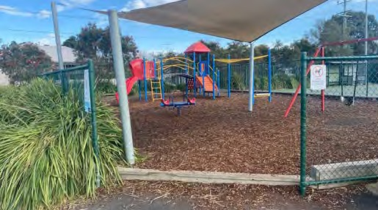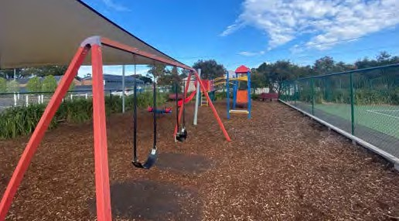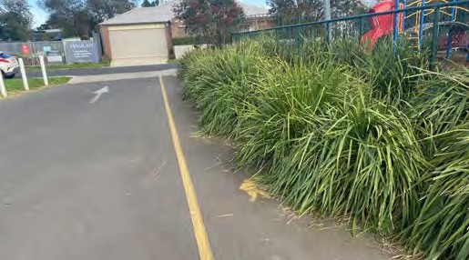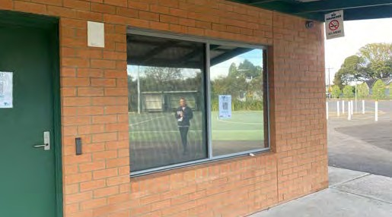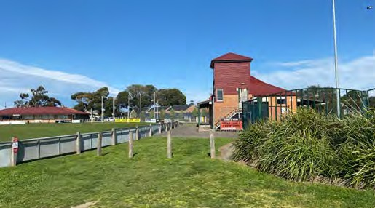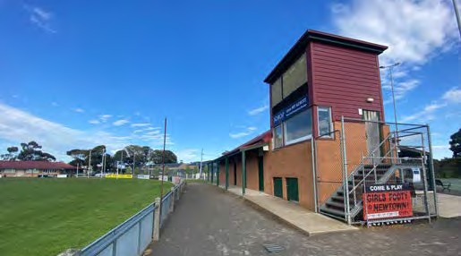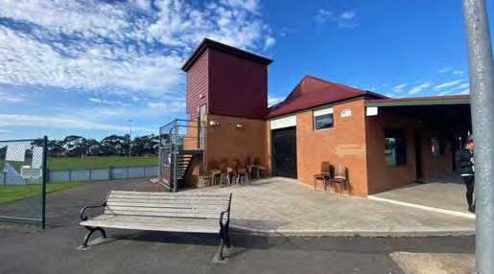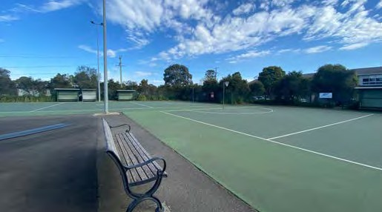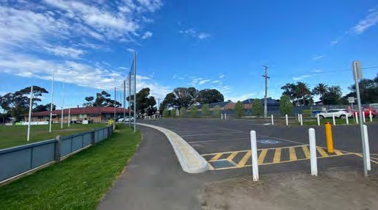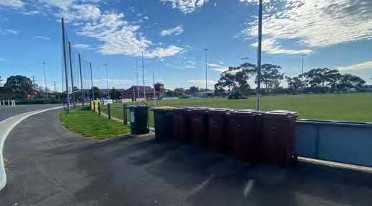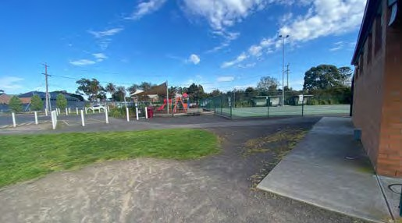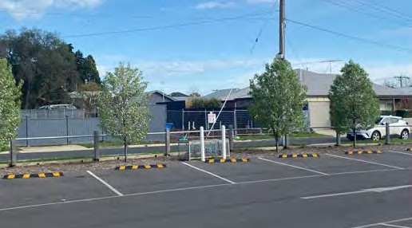3 EXISTING CONDITION AND USAGE

EXISTING FACILITIES: NETBALL PAVILION, COURTS & PLAY SPACE

The netball pavilion was constructed in 2011 and is in generally good condition.
However some other issues related to the netball pavilion & courts are:
- The courts do not meet current netball guideline standards.
- Lack of circulation space and warm up area.
- The pavilion currently houses football functions which restricts full use of the pavilion space by netball users.
- The current umpire change rooms and DDA change located at the rear of the
building also are used for storage of football equipment.
- There are privacy issues within the change room with direct access to the general office.
The existing playground is well used by the netball club. The key issues observed with regards to the playground are:
- The playground is constrained between the netball courts and car park.
- Current location of the playground restricts greater community access.
- Lack of proximity to open space and grassed area.

PAGE 16

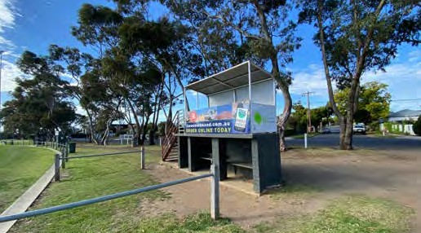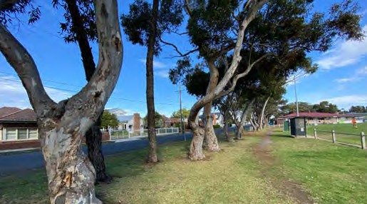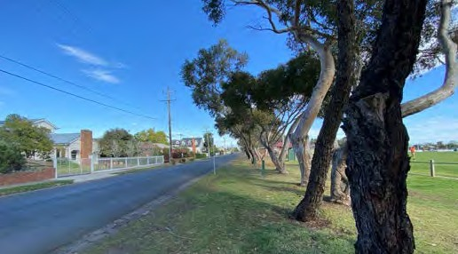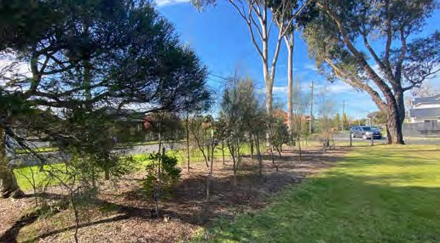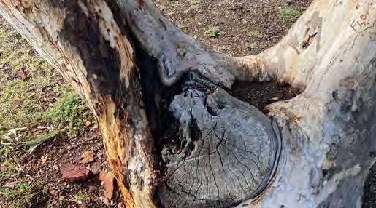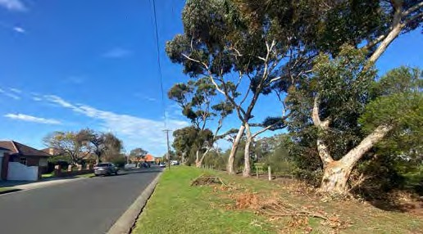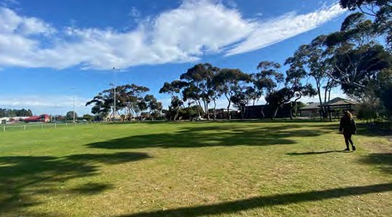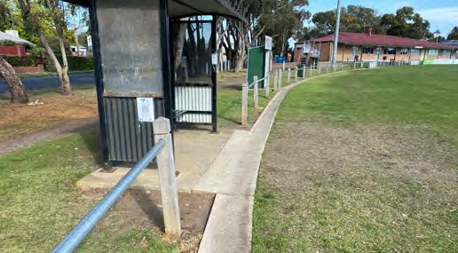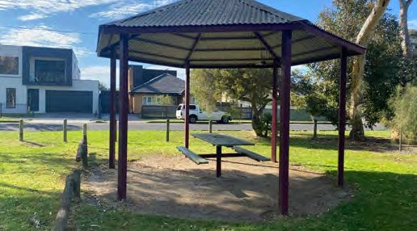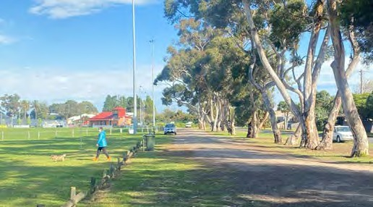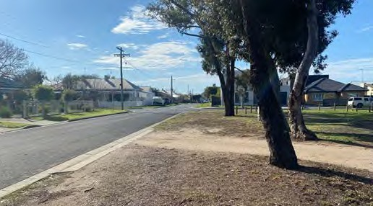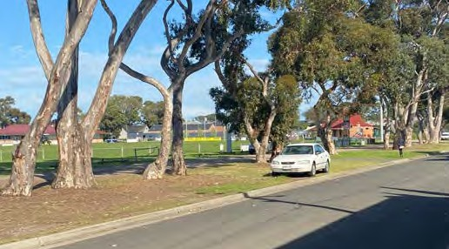3 EXISTING CONDITION AND USAGE

EXISTING FACILITIES: OPEN SPACE

Elderslie Reserve provides the community with a large area of passive open space and is surrounded by mature native trees. Generally, the trees are in good condition with some evidence of falling branches.
The informal gravel car park to the north of the site is used by the community to access the open space and other functions within the reserve.
Other observations made on-site are:
- During games on the oval, vehicles are given access to park across the open space to watch games.
- There is a lack of formal pedestrian entry points and pathways.
- The site lacks footpaths, landscaping, and bollards, which leads to cars illegally parking on the verge.
- Due to a lack of formalised parking at the reserve, tree root systems could be damaged by cars.
- There is poor cross-site circulation.

PAGE 17

- ISSUES AND OPPORTUNITIES

STAKEHOLDER CONSULTATION 4.02 PERCEPTIONS OF THE RESERVE 4.03 QUALITY OF INFRASTRUCTURE AND

AMENITY

4.04 KEY GAPS AND IMPROVEMENT AREAS

The consultation for this project involved one-on-one interviews with City staff from the following teams: Connected Communities, Property, Procurement & Assets, Open Space and Parks.
In addition, key stakeholders from the primary user group at the site, the Newtown & Chilwell Football Netball Club were also interviewed.
The key questions asked of respondents were structured around understanding the current perceptions of the reserve, the
overall quality and condition of infrastructure and amenity, as well as potential gaps and areas for improvement. The key findings from the consultation are outlined on this page.

“In terms of overflow training, improved surfaces and access to the site is important – irrigation and drain- age to improve the surface but keep it open to the public would be great.”

“There is no perimeter footpath and no footpath on Sherbourne Terrace. A walking path would be great - from an access and safety point of view, and for the provision of wheeled activities.”
Built infrastructure
- The built infrastructure on-site is generally of a high quality and provides a valued community space for both club and community events.
Playspace
- The playspace services the whole suburb and is important to the neighbourhood. It is the only one on-site and is always accessible, although is not in an ideal location to service the whole site.
Open space
- The open space on the eastern side of the site is very basic and there are no embellishments or supporting
infrastructure. The rotunda seems oddly placed with no bin, benches or drinking fountain. There is a lone picnic table under the shelter which is rarely used.

“The playground is highly valued by the local community – it is the only one on the site and is accessible at all times. It is tucked away a bit and not an ideal spot, but it services the club well.”

“The public toilets aren’t too flash at the back of the facility. There is no DDA toilet for public use without the club being open - it should be open to the public, even if the clubrooms aren’t.”
Built infrastructure
- The condition rating on the buildings is high, with all buildings sitting between
3.5 to 4.5. This indicates they are in good condition and not in immediate need of replacement or development.
- The public toilets at the back of the football clubhouse “aren’t too flash” and there is no DDA toilet for public use without the club being open. From a location point of view, the public toilets are not well orientated towards public viewing areas which has security
implications. The preference would be to have standalone amenities that reduce vandalism.
- The rotunda has not had any works completed on it in at least the last 18 months, and has suffered from neglect.
Playspace
- The playspace was installed in 2003 and is coming up for renewal (20 year lifespan). It is slated for renewal in 2024-
25, and has a condition rating of 3 out of 10, with 1 being the best and 10 being the worst.
Sport-specific Infrastructure
- The lighting around the football pavilion and netball clubhouse has been recently replaced with LED.
- The football scoreboard is in poor condition and some of the players boxes around the oval are showing signs of wear and tear.
Paths and Open Space
- There is no perimeter path around the reserve, and no footpath on Sherbourne Road. Path provision would improve access and enable increased utilisation of the reserve for passive recreation.
- The grassy open space at the east of the reserve is very basic and could be
enhanced through strategic plantings and infrastructure improvements to increase utilisation.
Parking
- Off-street parking is very limited and there is not enough car parking on match days. This sees cars overflow into surrounding streets.
Sport-specific Infrastructure
- Netball courts are at full capacity on game days and there is no warm-up area for netball.
- The Club does not have enough storage, and a shipping container at the back of the pavilion is used for overflow. This is not purpose built and is not in keeping with the neighbourhood amenity.
- Points of egress within the football pavilion are non-compliant, with roller shutters over all doors. Without a remote for the doors, exit from the building is impossible, and the door at back of the kitchen has a large metal bar across it.
- Recent growth in female football participation has put pressure on usage of the oval and the site is constrained for training space.



PAGE 18

- ISSUES AND OPPORTUNITIES

4.05 SWOC ANALYSIS

A SWOC analysis was undertaken to document the strengths, weaknesses, opportunities, and challenges identified from the key findings and associated gaps and implications on the future functionality, amenity and design of Elderslie Reserve.
WEAKNESSES
  - Poor pedestrian access and connectivity across the site.
STRENGTHS
- Elderslie is a highly valued sport and open space reserve for the local community.
- The precinct offers a range of different functions and attracts a variety of users from different groups – netball, football, cricket, running, walking, and dog walking.
- The open space at the eastern end of the reserve is well utilised by local residents to exercise their dogs.
- The reserve is well visited on the weekend for organised sport, and in the morning and evening for informal recreation.
- The buildings on-site are in good condition, with a rating between 3.5 to 4.5 out of 5 (with 1 being poorest condition and 5 being the best condition).
  - Lack of adequate parking to service the site and all users on busy game days.
  - No female friendly amenities within the football pavilion.
  - Poor accessibility to the DDA toilet, which is located at the netball pavilion – away from the main functions of the site.
  - Limited storage space within the football and netball pavilions.
  - Lack of a warm-up area for netball, when all courts are in use.
  - Internal design issues within the netball pavilion including poor sightlines from the office across the court, and ability to access the change rooms from the office.
  - Safety issues with location of the public toilets.



OPPORTUNITIES
- Upgrade the change facilities within the football clubhouse pavilion to be gender neutral.
- Install a circuit track around the perimeter of the reserve and enhance pedestrian access and connectivity.
- Introduce strategic plantings and vegetation to improve the open space area.
- Investigate formalised parking along Warwick Street and Sherbourne Terrace.
- Internal re-design of the netball pavilion to address pedestrian flow issues and improve functionality.
- Investigate the removal or relocation of the public toilets.
- Investigate renewal and/or relation of the existing playground and additional bench seating for the playground area.
CHALLENGES
- Increasing football participation rates amongst women and girls placing pressure on facilities.
- Balancing demand from the community for unstructured passive and active recreation areas with the requirements of a highly active sporting club.
- Managing requirements for parking at the reserve, whilst maintaining neighbourhood amenity and ensuring the needs and expectations of the surrounding residents are met.
- The potential relocation of the playground to the eastern end of the site will need to consider the pro’s and con’s and overall community benefit.
PAGE 19

- FACILITY DEVELOPMENT PLAN

VISION

The vision for the Elderslie Reserve Facility Development Plan is to...

“Celebrate and enhance the existing qualities of the reserve, whilst improving functionality, connectivity and recreation

opportunities across the site.”

The FDP aims to strengthen the sustainability and natural qualities that make Elderslie Reserve a popular community asset.

NETBALL PLAY
SPACE
R A I T H T E R R A C E
DIVERSE PRECINCTS
T E R R A C E

FOOTBALL PAVILION
PLAY SPACE
R A I T H

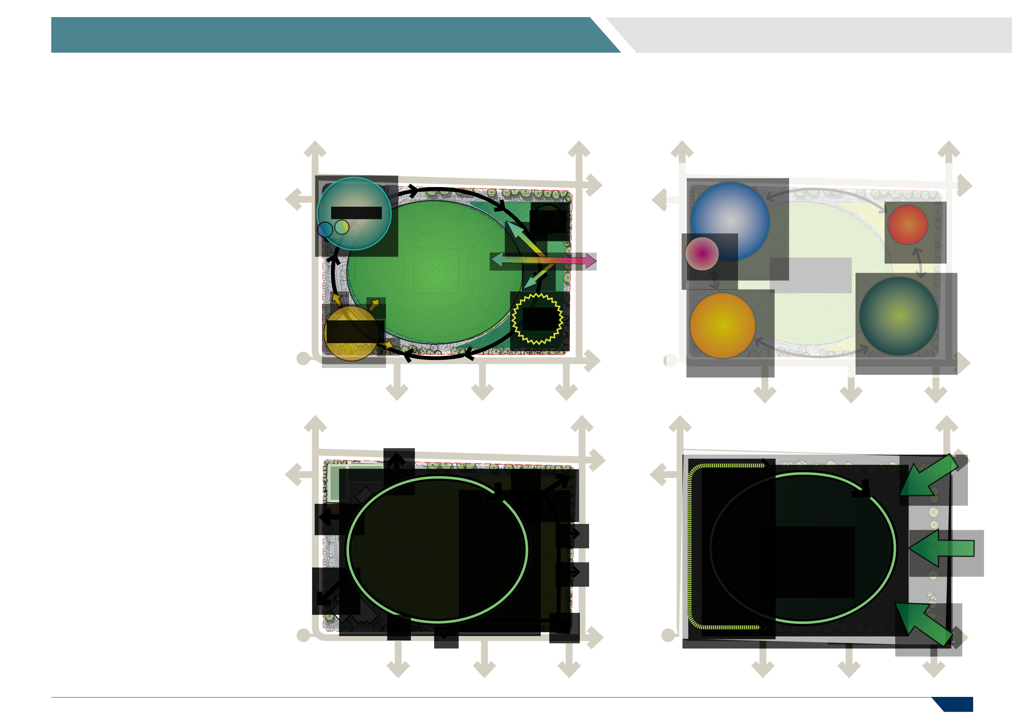
TED S
INTEGRA
LINK
PROTECT & ENHANCE COMMUNITY SPACE
T E R R A C E
T E R R A C E

PAGE 20
R A I T H
R A I T H

5 FACILITY DEVELOPMENT PLAN

PRINCIPLES

The City of Greater Geelong is committed to all sections of the community having reasonable access to the places, spaces and
services they need. The City’s objectives and aspirations for social infrastructure are:

Equitable
Fair access to facilities and services that are needed across the municipality including healthy, safe and inclusive places, spaces and services.

Accessible
Accessible for all abilities, affordable and easy for people to get to.

Adaptable
Flexible to meet the changing needs of the community.

Integrated - Integrated with other services where possible and a place for the community to come together.

Sustainable - Environmentally, fiscally, socially and culturally responsible, well designed, effectively managed and usage is optimised, now and into the future.

DESIGN OBJECTIVES

The Elderslie Reserve FDP has been developed in alignment with the City’s social infrastructure objectives and aspirations to ensure that it:
- Is welcoming, accessible and fit-for- purpose.
- Includes planning for people and place (e.g. gender-neutral provision and positive ageing).
- Is designed to support equitable, integrated and flexible use to provide valuable social, community,
environmental and economic benefits to our community.
- Ensures Environmentally Sustainable Design practices and Universal Design principles are considered and represented.
- Addresses safety issues by using effective built environment design principles
and ensure Crime Prevention Through Environmental Design (CPTED) principles are considered and represented.
- Resolves any vehicular circulation, parking, access and/or egress issues within the Reserve and ensures views and access into and out of the site will not impact on neighbouring residences or businesses.
- Where possible, consolidates built facilities to defined precincts and minimises the visual impact of any infrastructure developments throughout the Reserve to protect and enhance any social, environmental and heritage values of the Reserve.

FDP DEVELOPMENT PROCESS

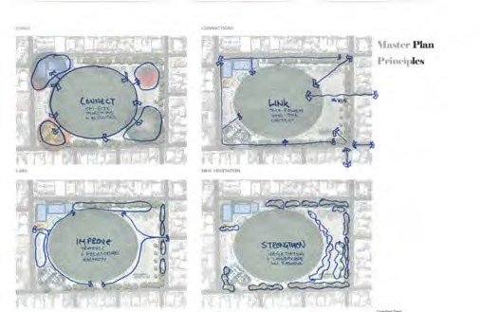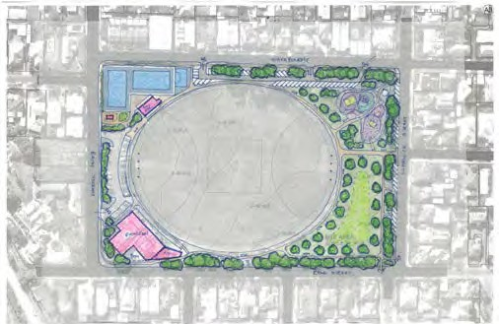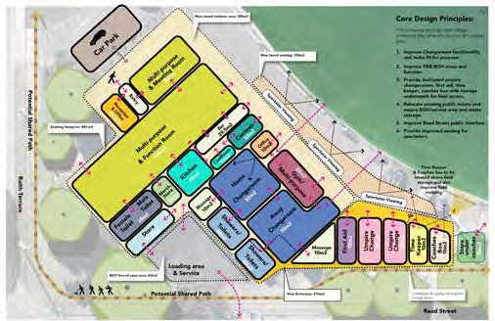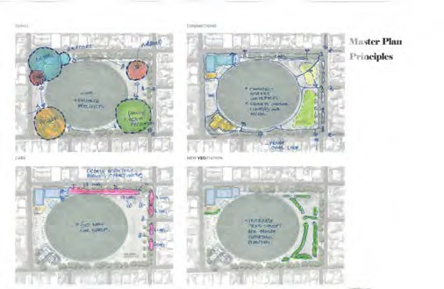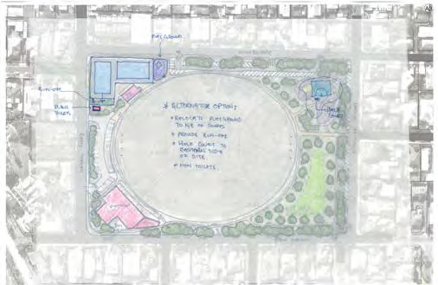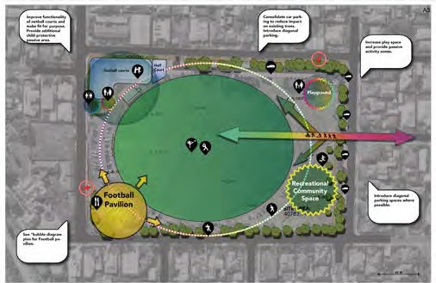

PAGE 21

5 FACILITY DEVELOPMENT PLAN

ACCESSIBILITY AND ENTRY 5.06 CONNECTIONS AND CIRCULATION

R E A D S T R E E T
R E A D S T R E E T
R A I T H T E R R A C E
R A I T H T E R R A C E

Overview

  - Improve and define patron access to the reserve.
  - Create logical entry points to the reserve.
  - Strengthen desire lines and approach.
  - Upgrade northern carparking.
  - Remove vehicle access to public open space areas.
Legend

PRIMARY ENTRY LOCATION

SECONDARY ENTRY LOCATION EXISTING VEHICLE ACCESS
UPGRADED VEHICLE ACCESS

EXISTING PEDESTRIAN ACCESS

NEW DEFINED PEDESTRIAN ACCESS
Overview

  - Integrate the reserve with the surrounding pedestrian network.
  - Connect reserve functions with logical pathway networks.
  - Provide accessibility for all across the reserve.
  - Define the open space network with pedestrian pathways and entry points.
Legend

EXISTING PEDESTRIAN CONNECTIONS UPGRADED PEDESTRIAN CONNECTIONS
NEW DEFINED PEDESTRIAN CONNECTIONS NEW COUNCIL PEDESTRIAN PATHWAY
EXISTING COUNCIL PATHWAYS

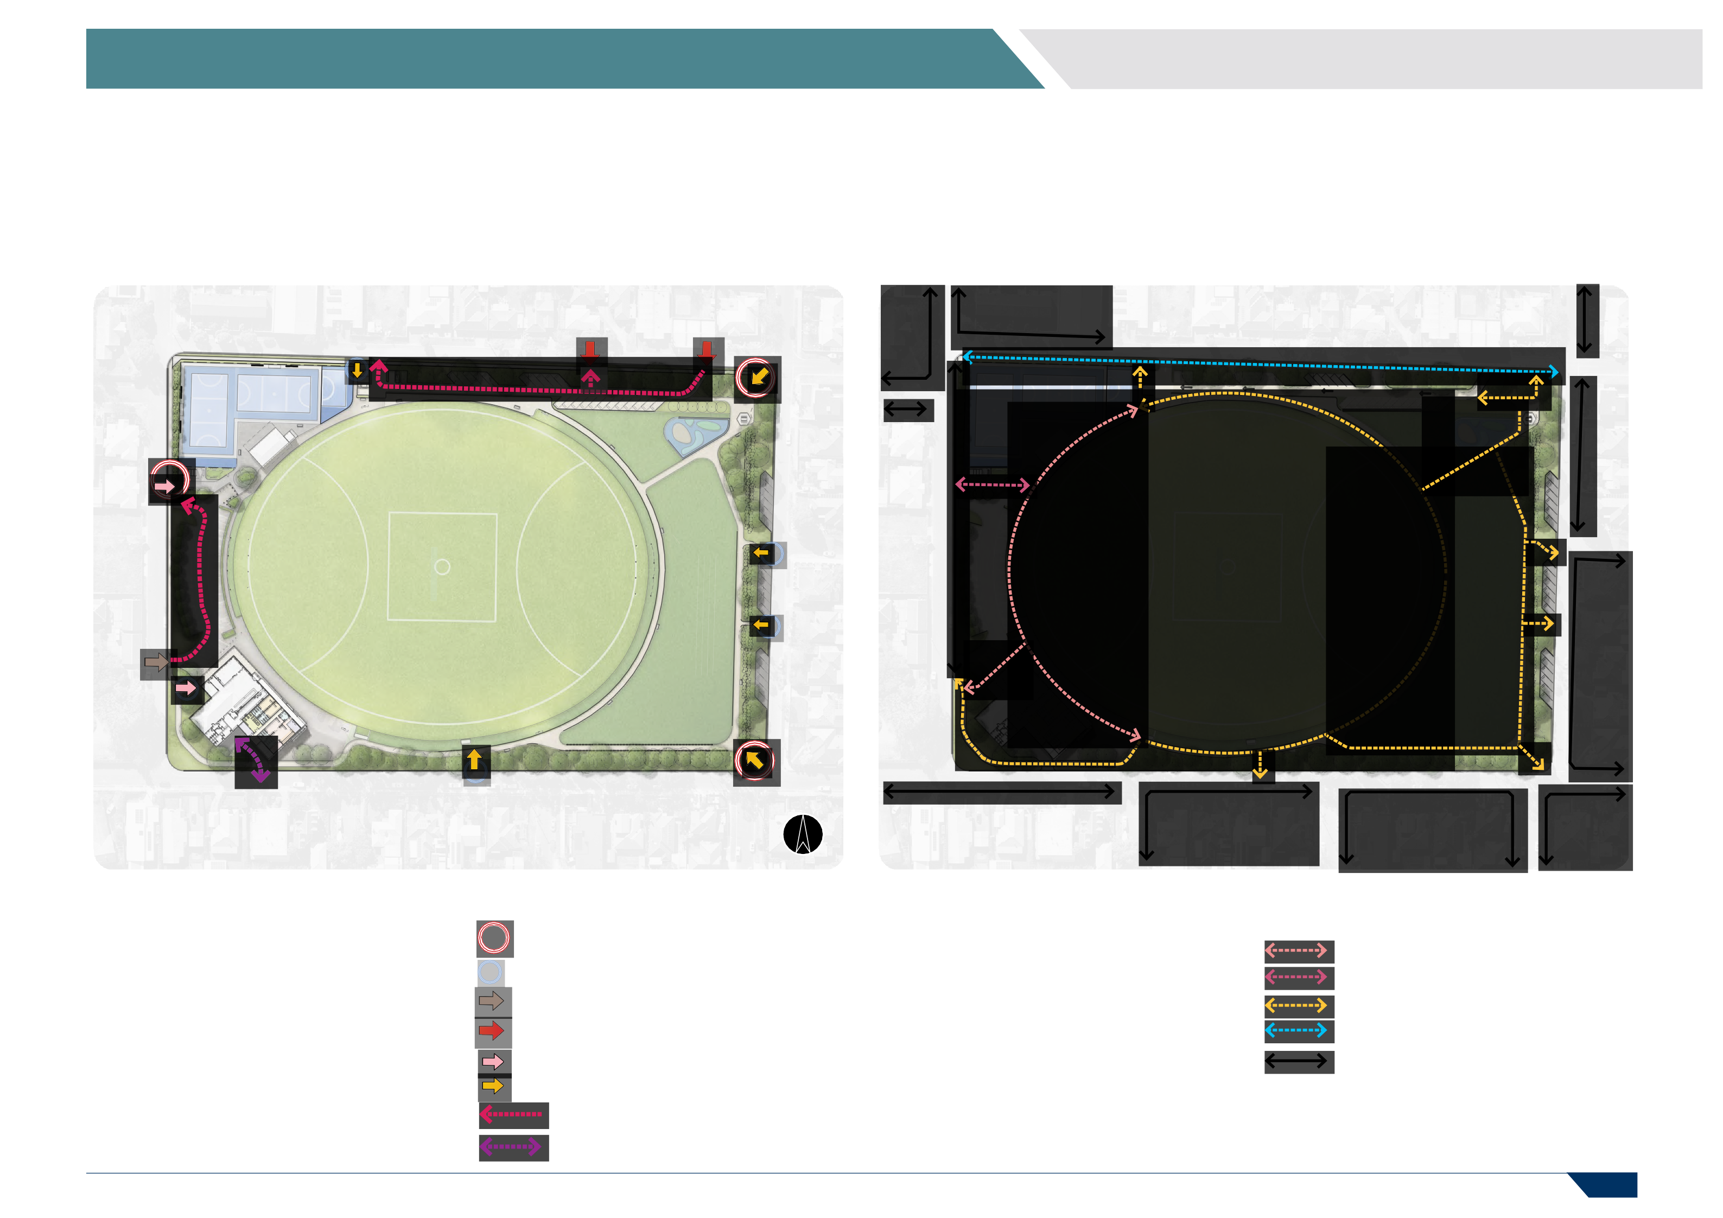
VEHICLE ACCESS

SERVICE VEHICLE ACCESS

PAGE 22

5 FACILITY DEVELOPMENT PLAN

5.07 RESERVE ACTIVITIES 5.08 SPECTATOR AMENITY

OP

OP
R A I T H T E R R A C E
R A I T H T E R R A C E

R E A D S T R E E T R E A D S T R E E T

Overview

  - Relocate existing public toilets to a more central and accessible location.
  - Relocate the currently constrained play space to the public open area for greater flexibility and access.
  - Define the open space area to enable use by multiple user groups.
  - Redesign the netball courts to meet standards.
  - Develop a new warm up area and halfcourt for netball.
Legend

OP

FOOTBALL PAVILION CAR PARKING

PUBLIC TOILETS

NETBALL COURTS/HALF COURTS NETBALL PAVILION & SCOREBOARD PLAY SPACE AREA
OPEN SPACE AMENITY

DEDICATED OPEN SPACE
Overview

  - Provide complete pathway circulation to improve spectator access and amenity.
  - Improve spectator access and parking on the eastern side of the reserve.
  - Improve and upgrade spectator viewing for the football pavilion.
Legend

SPECTATOR VIEWING

IMPROVED SPECTATOR ACCESS

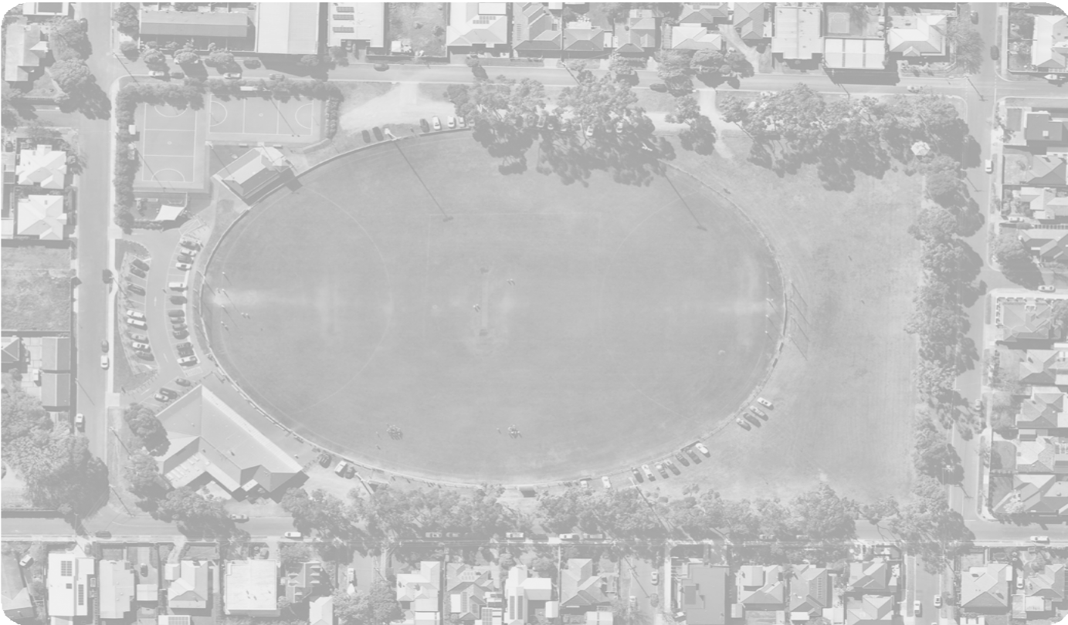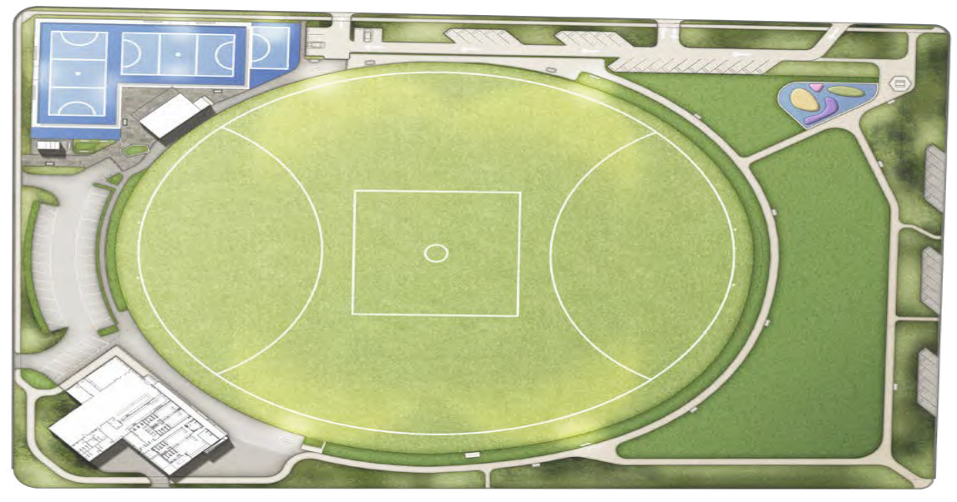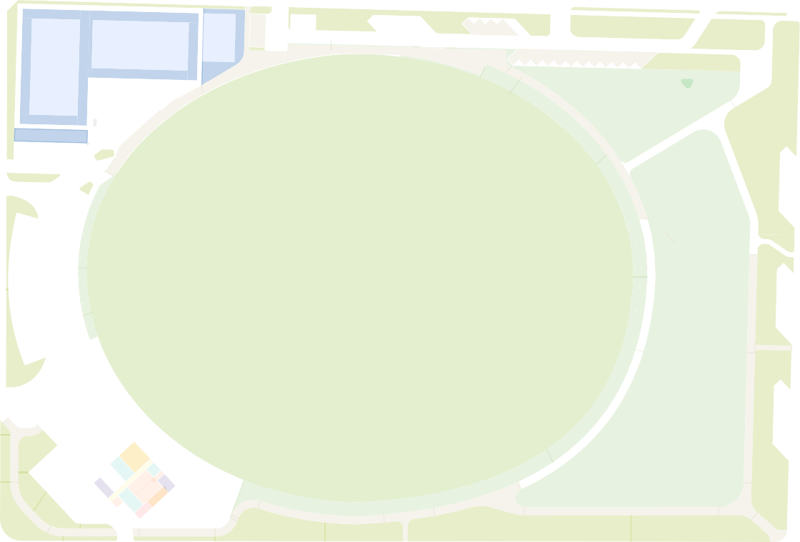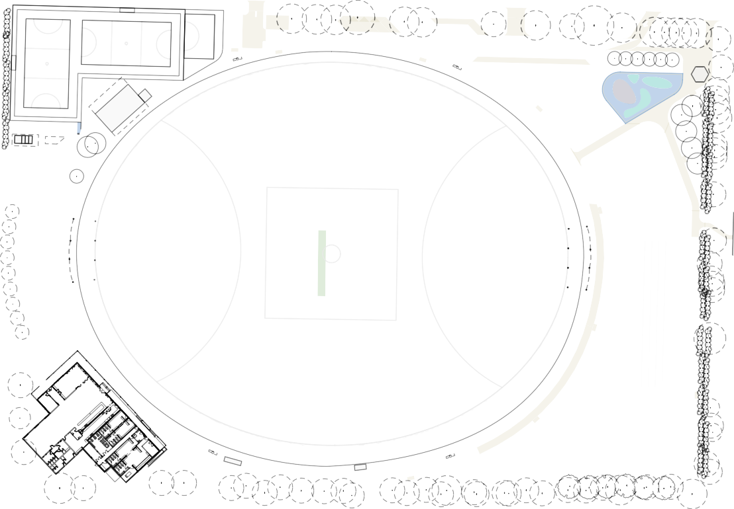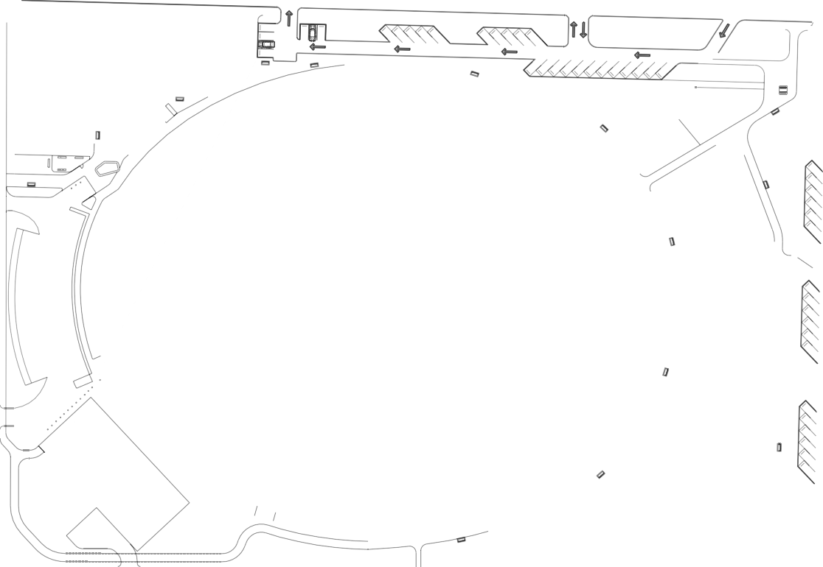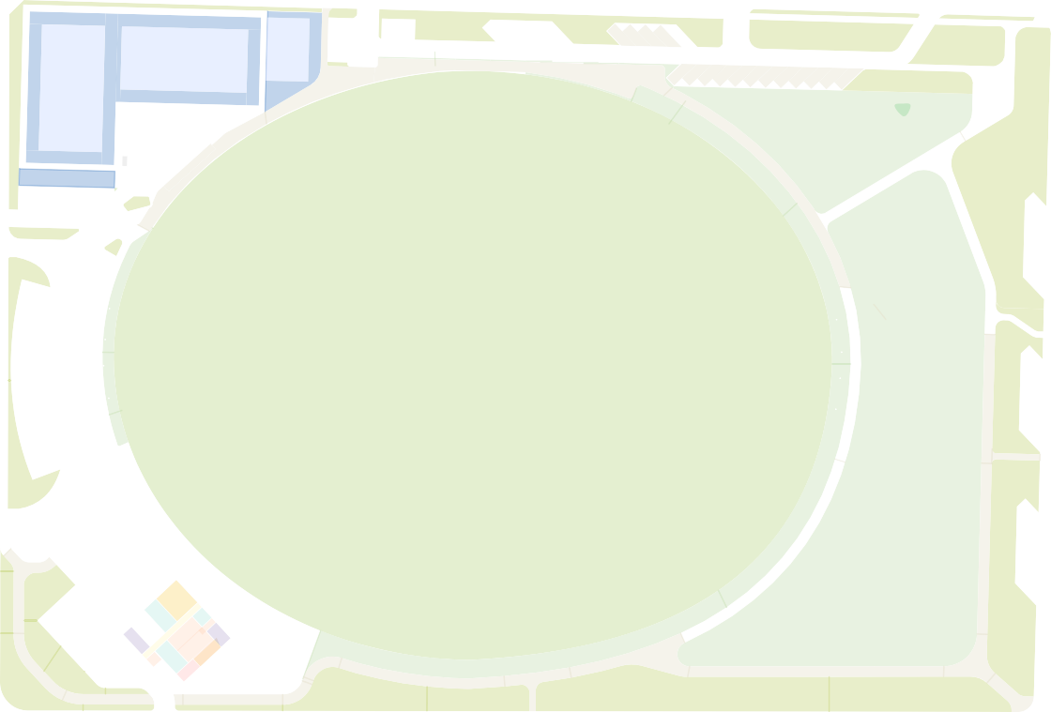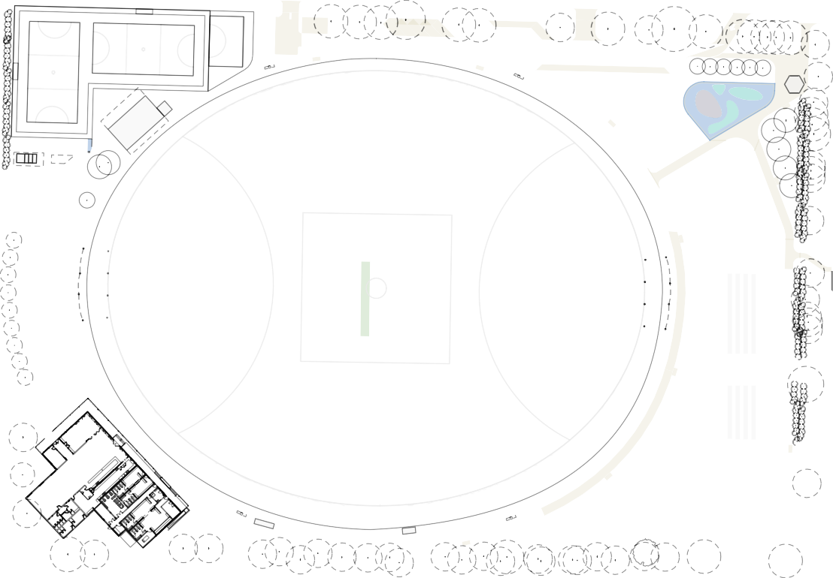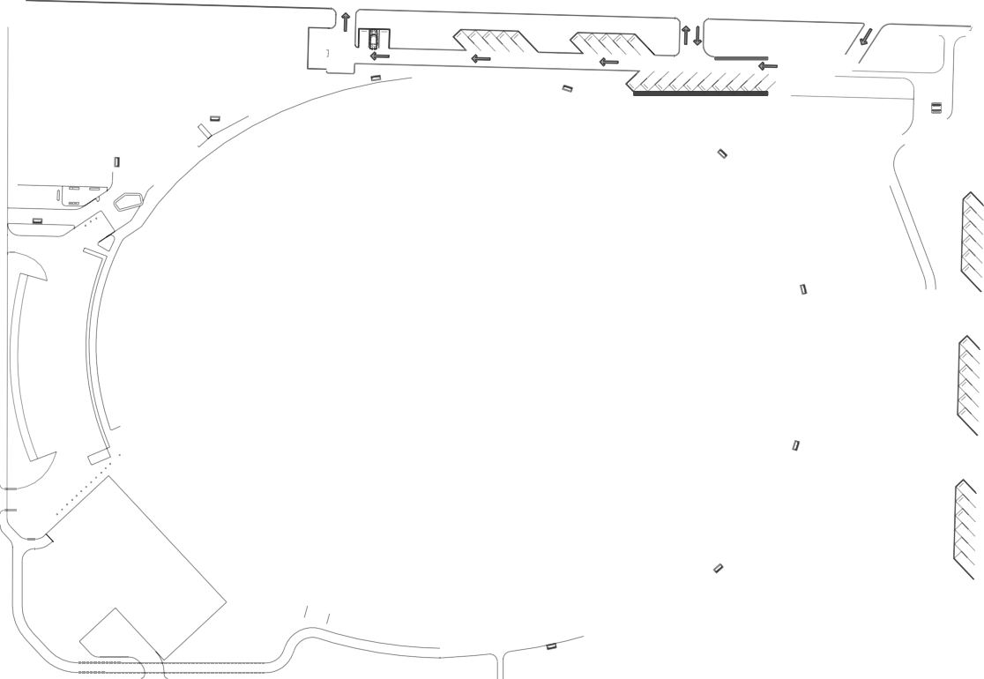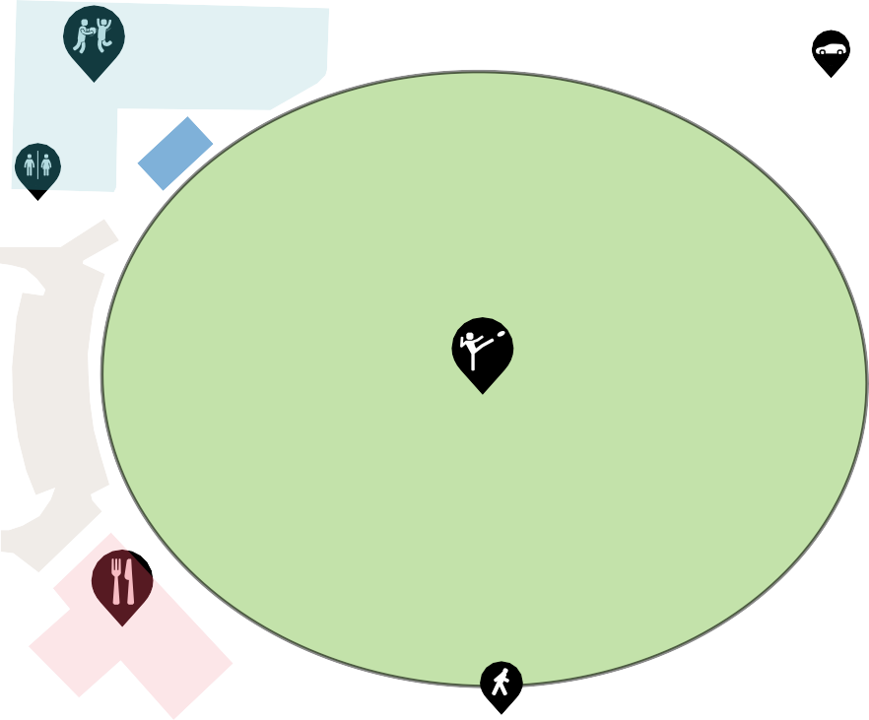
PAGE 23

5 FACILITY DEVELOPMENT PLAN

5.09 LANDSCAPE PLAN DESIGN CONSIDERATIONS

- Elderslie Reserve Oval

- Football Pavilion
- Oval North Boundary Area
Provide compacted gravel area for spectators, pedestrians and patrons.

12
L L

11 13
L

L
L

P4

10

7 9
PS
T E R R A C E
SI 8
S
+
R A I T H

6

CP CP

S
S

14

CP CP

15
S

1

SI

16 18
CP
SH
PS
17

S

24

CP

P2

S
SI
19

P3

20
21
CP

S P3

P2

P2
- Proposed Football Change room Upgrades
Upgrade change facilities to be gender neutral.

- Football Pavilion Service Yard
Improve service yard security and safety. Install fence, gate and secure waste/rubbish area.
Relocate existing public toilets to location indicated (7).
- Potential Pavilion Expansion Opportunity
Indicative area for future pavilion expansion including first aid, umpire change rooms and time keeper box with storage underneath.

- Existing Car Park

- Relocated Public Toilets
Relocate public toilets to provide two unisex accessible cubicles and a dedicated DDA toilet. These upgrades should improve accessibility and enhance passive security/surveillance.

- Enclosed Play Space
Provide enclosed play area with additional shade and seating.
- Warm Up Area

- Netball Pavilion Areas
Potential future upgrade opportunity to upgrade the pavilion and reconfigure the internal lay-out to improve functionality and better meet the
needs of netball. Investigate extending the verandah to provide more undercover viewing areas. Repair uneven and non-uniform surface
- Netball Courts
Re-surface courts and provide uniform surface for all run-offs. Ensure new line marking delivers two compliant courts. Upgrade floodlighting
to local competition standard (100 lux) and
upgrade players benches to meet Netball Victoria standards.
- Netball Courts Setback
Remove setback of corner court to improve overall design layout, access and amenity of netball courts.
- New Multi-purpose Half court
Provide a multi-purpose half court with
floodlighting to local training standard (100 lux) allowing for multiple active recreation
opportunities whilst doubling up as a warm-up and training area for netball.

- Sherbourne Terrace
- Car Park Area
Formalise existing car park area to limit parking locations, protect trees and provide one-way
traffic flow.

- Play Space
Construct a new play space area with protective
screening and fences where required as per local/ neighbourhood standards.

- North Eastern Corner
Introduce a new signposted pedestrian access pathway from the corner of Warwick Street and Sherbourne Terrace.

- New Pedestrian Access
Provide new pathway access from Warwick Street.

- New Car Parking
Provide new angled car parking to Warwick Street.

- Active open Space Area
Provide a dedicated active open space area for the flexible use of the community and sporting groups. Investigate installing irrigation.

- South Eastern Corner
Introduce a new signposted pedestrian access and entry into the site from the corner of Warwick Street and Read Street.
- Read Street
Introduce a new pedestrian entry path to align with the centre of the oval.
- New Tree Planting
Strengthen the tree planting throughout the Reserve with species and location in alignment with the City’s Urban Forest Strategy.
- New Pedestrian Pathways
Provide pedestrian connections throughout the reserve allowing for safe connections between
the new proposed play space and netball courts as well as providing increased opportunities for passive recreation.
- New Seating
Provide additional seating around the reserve at regular intervals as indicated on this plan.
Upgrade existing seats where required, ensuring

2
S 26
CP Construct a new standard concrete footpath along the Sherbourne Terrace nature strip to
connect Raith Terrace to Warwick Street. Provide bollards to limit vehicle access onto nature strip.
25 LEGEND
consistency in design and aesthetic across the reserve.
- Coaches Box Upgrades
Upgrade home coaches box with elevated structure.

3
5 27
4

P2
S
23
P3

R E A D S T R E E T
SI

S
22 +
P1
SI CP
CP SH

NEW SIGNAGE

NEW SEATING

EXISTING EMERGENCY ACCESS

UPGRADED CAR PARKING

NEW CAR PARKING EXISTING SHELTER
P1 3m WIDE GRAVEL ENTRY PATH

P2 2.5m WIDE GRAVEL PATH P3 1.5m WIDE GRAVEL PATH ASPHALT SURFACE
P4
EXISTING VEHICLE ACCESS UPGRADED VEHICLE ACCESS

PS PLAY SPACE

PUBLIC TOILETS

EXISTING PEDESTRIAN ACCESS NEW PEDESTRIAN ACCESS

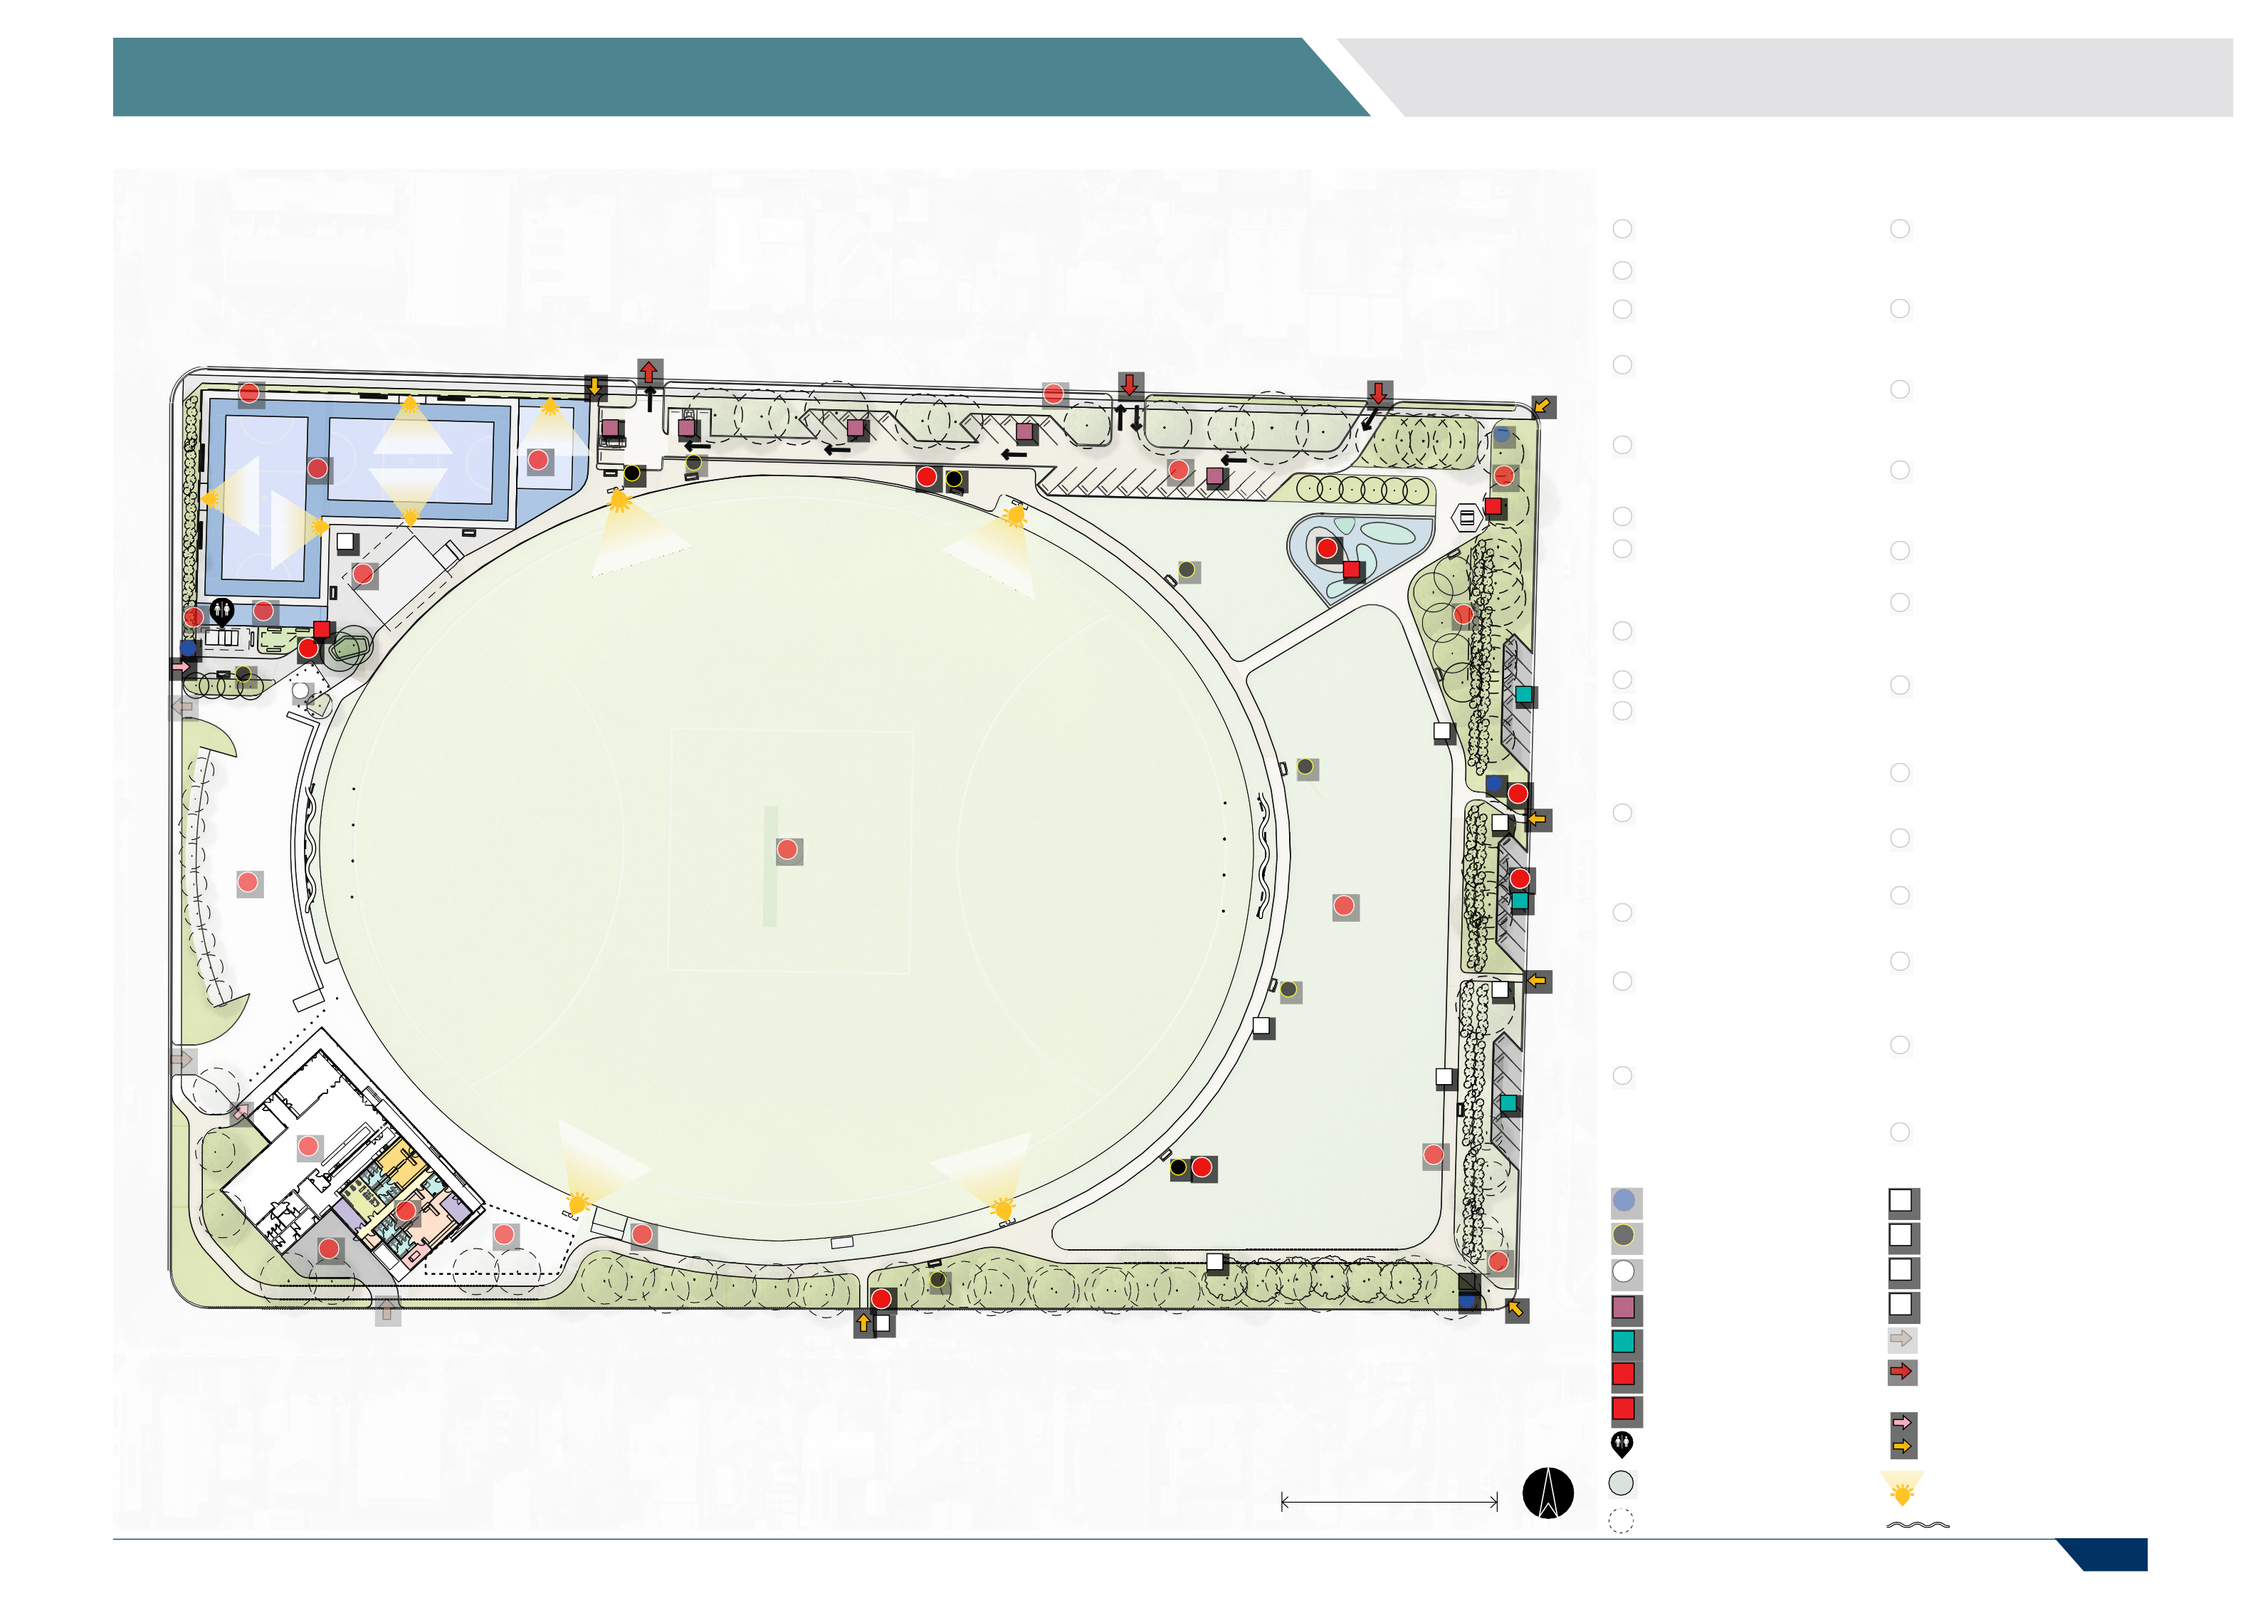
40 M

+ PROPOSED TREES

+ EXISTING TREES

L LIGHTING

SAFETY NETTING

PAGE 24

5 FACILITY DEVELOPMENT PLAN

6 SH SI 1

P3
4
SI
7
CP
R A I T H T E R R A C E
2

5 S
5
SH
SH
R A I T H T E R R A C E

S S
P2
P4 3
S
1
S 4
6
3
3 4 5 P2
SI
1
2 2 P2

SI 6
P2

S S
+
R E A D S T R E E T

5.10 FOOTBALL PAVILION 5.11 NETBALL PAVILION 5.12 PLAY SPACE AREA

- Proposed Football Change room Upgrades
Upgrade change facilities to be gender neutral.

- Football Pavilion Service Yard
Improve service yard security and safety. Install fence, gate and secure waste/rubbish area.
Relocate existing public toilets to location indicated (7).

- Existing Public Toilets
Relocate existing public toilets to location indicated (6)

LEGEND
- Future Pavilion Expansion Opportunity
Indicative area for future pavilion expansion including first aid, umpire change rooms and time keeper box with storage underneath.

- Coaches Box Upgrades
Upgrade home coaches box with elevated structure.

- Reserve Loop Track
Connect the existing pathway network into a
dedicated reserve loop track. This is proposed to be a 2.5m wide compacted gravel path.
  - Relocated Public Toilets
Relocate public toilets to provide two unisex accessible cubicles and a dedicated DDA toilet. These upgrades should improve accessibility and enhance passive security/surveillance.

  - Enclosed Play Space
Provide enclosed play area with additional shade and seating.
  - Warm Up Area
  - Netball Pavilion Areas
Potential future upgrade opportunity to upgrade the pavilion and reconfigure the internal lay-out to improve functionality and better meet the
needs of netball. Investigate extending the verandah to provide more undercover viewing areas. Repair uneven and non-uniform surface

LEGEND
  - Netball Courts
Re-surface courts and provide uniform surface for all run-offs. Ensure new line marking delivers two compliant courts. Upgrade floodlighting
to local competition standard (100 lux) and
upgrade players benches to meet Netball Victoria standards.

  - Netball Courts Setback
Remove setback of corner court to improve overall design layout, access and amenity of netball courts.
  - New Multi-purpose Half court
Provide a multi-purpose half court with
floodlighting to local training standard (100 lux) allowing for multiple active recreation
opportunities whilst doubling up as a warm-up and training area for netball.
    - Sherbourne Terrace
Construct a new standard concrete footpath along the Sherbourne Terrace nature strip to connect Raith Terrace to Warwick Street. Provide bollards to limit vehicle access onto nature strip.

    - Car Park Area
Formalise existing car park area to limit parking locations, protect trees and provide one-way
traffic flow.

    - Play Space
Construct a new play space area with protective
screening and fences where required as per local/ neighbourhood standards.

LEGEND
    - North Eastern Corner
Introduce a new signposted pedestrian access pathway from the corner of Warwick Street and Sherbourne Terrace.

    - Existing Shelter
Upgrade and refurbish existing shelter with new concrete floor. Integrate with new compacted gravel pathways.

    - New Tree Planting
Strengthen the tree planting throughout the Reserve with species and location in alignment with the City’s Urban Forest Strategy.

SI NEW SIGNAGE

S NEW SEATING
+ EXISTING EMERGENCY ACCESS
CP UPGRADED CAR PARKING

CP NEW CAR PARKING

SH EXISTING SHELTER
P1 3m WIDE GRAVEL ENTRY PATH

P2 2.5m WIDE GRAVEL PATH P3 1.5m WIDE GRAVEL PATH P4 ASPHALT SURFACE
EXISTING VEHICLE ACCESS UPGRADED VEHICLE ACCESS
SI NEW SIGNAGE

S NEW SEATING
+ EXISTING EMERGENCY ACCESS
CP UPGRADED CAR PARKING

CP NEW CAR PARKING

SH EXISTING SHELTER
P1 3m WIDE GRAVEL ENTRY PATH

P2 2.5m WIDE GRAVEL PATH P3 1.5m WIDE GRAVEL PATH P4 ASPHALT SURFACE
EXISTING VEHICLE ACCESS UPGRADED VEHICLE ACCESS
SI NEW SIGNAGE

S NEW SEATING
+ EXISTING EMERGENCY ACCESS
CP UPGRADED CAR PARKING

CP NEW CAR PARKING

SH EXISTING SHELTER
P1 3m WIDE GRAVEL ENTRY PATH

P2 2.5m WIDE GRAVEL PATH P3 1.5m WIDE GRAVEL PATH P4 ASPHALT SURFACE
EXISTING VEHICLE ACCESS UPGRADED VEHICLE ACCESS

PS PLAY SPACE

PUBLIC TOILETS

+ PROPOSED TREES

+ EXISTING TREES

EXISTING PEDESTRIAN ACCESS NEW PEDESTRIAN ACCESS

L LIGHTING

SAFETY NETTING
PS PLAY SPACE

PUBLIC TOILETS

+ PROPOSED TREES

+ EXISTING TREES

EXISTING PEDESTRIAN ACCESS NEW PEDESTRIAN ACCESS

L LIGHTING

SAFETY NETTING
PS PLAY SPACE

PUBLIC TOILETS

+ PROPOSED TREES

+ EXISTING TREES

EXISTING PEDESTRIAN ACCESS NEW PEDESTRIAN ACCESS

L LIGHTING

SAFETY NETTING

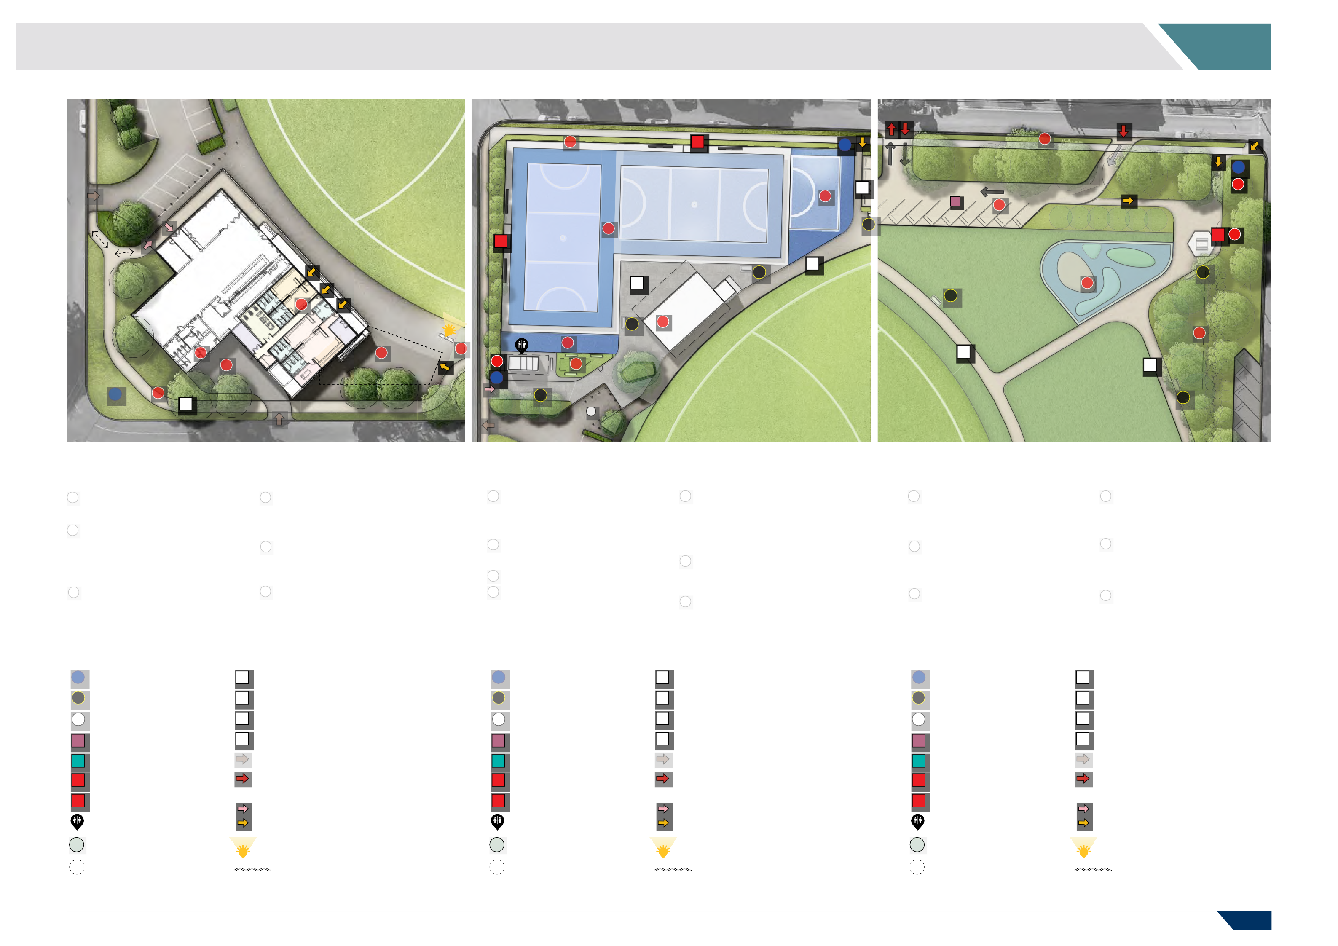

PAGE 25

- 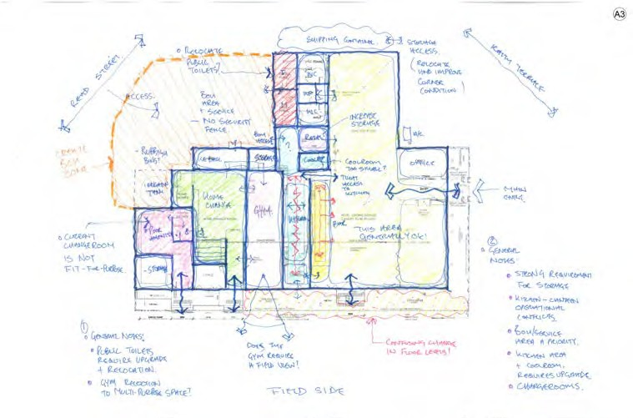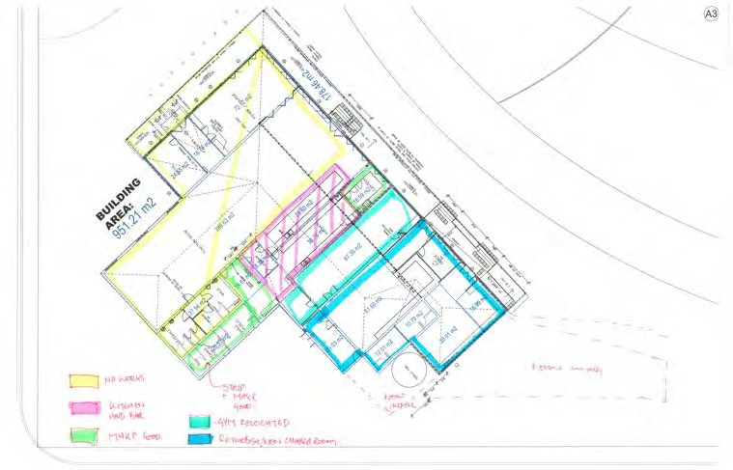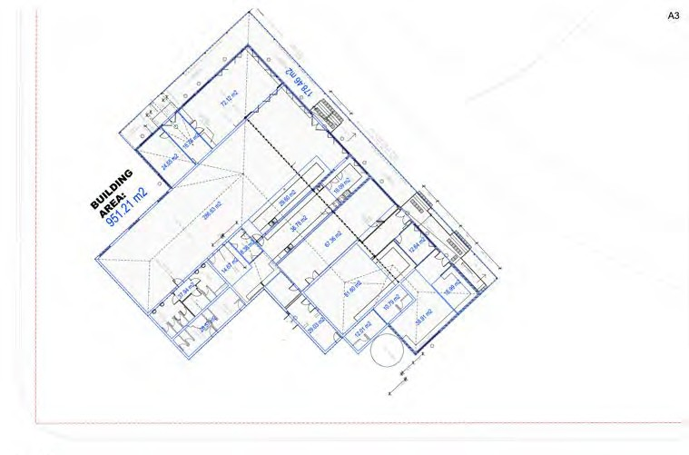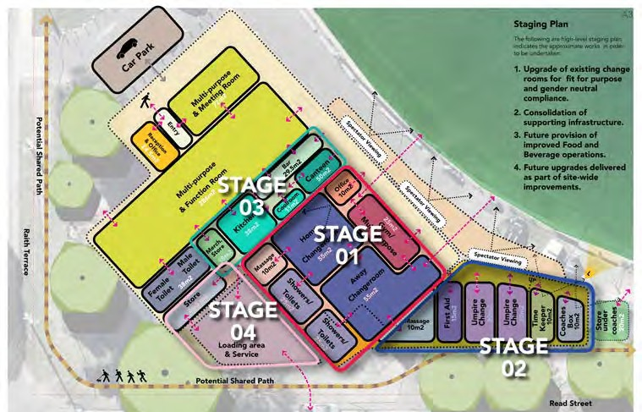FACILITY DEVELOPMENT PLAN

PAVILION CONCEPT DEVELOPMENT

Our initial observations of the building found the overall pavilion to be in generally good condition and well serviced by
the community, so the key focus was on developing a staged hierarchy to deliver the improved change rooms first.
A key focus of the design process was on developing initial hand-drawn sketches to share for feedback with the Club stakeholders and PWG.
Once all stakeholders had confirmed the approach and approved the overall direction of the designs, functional diagrams were developed outlining the key stages of delivery.
Stage 1 is supported by the City, however, for any future stages, further lobbying and support from external funding partners will be required.

Football change facility upgrade concept plan development.

PAGE 26

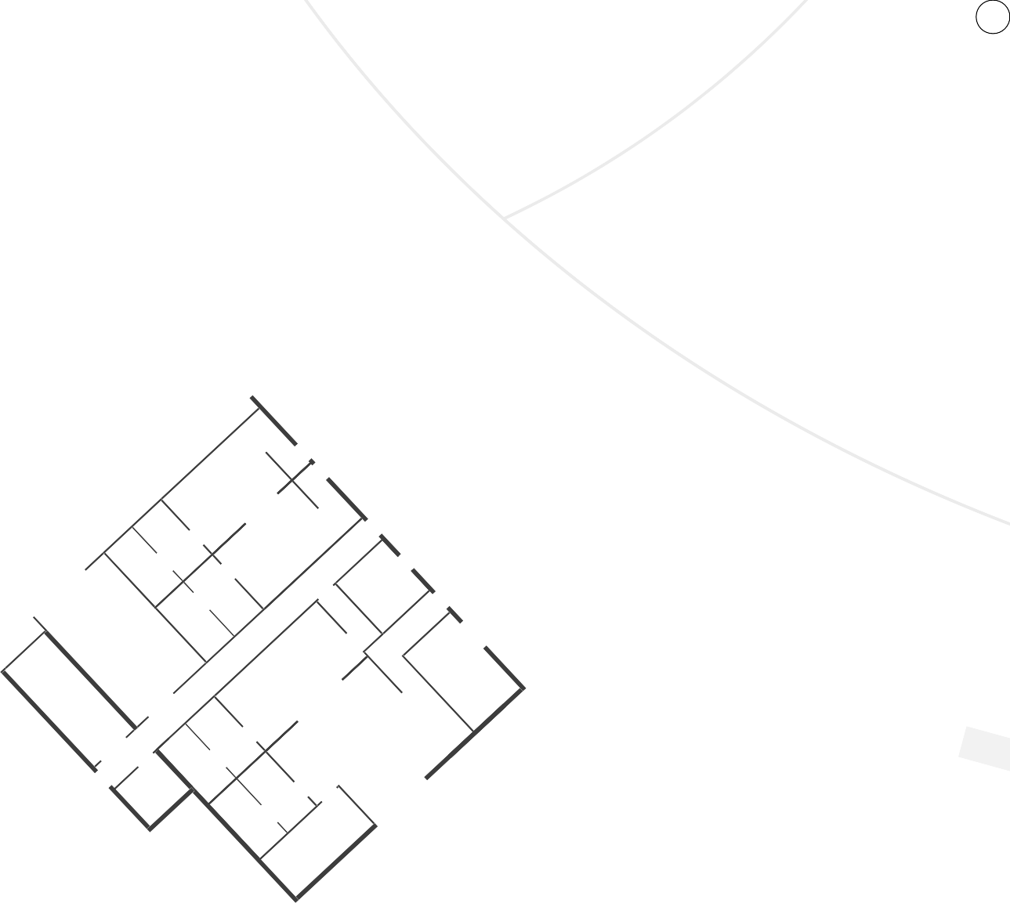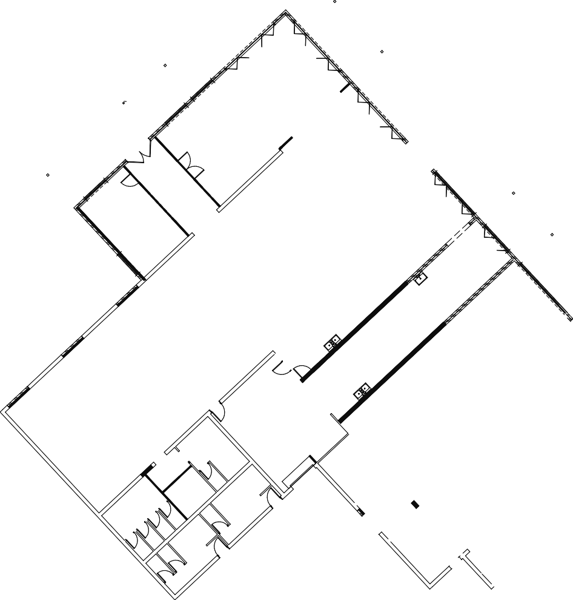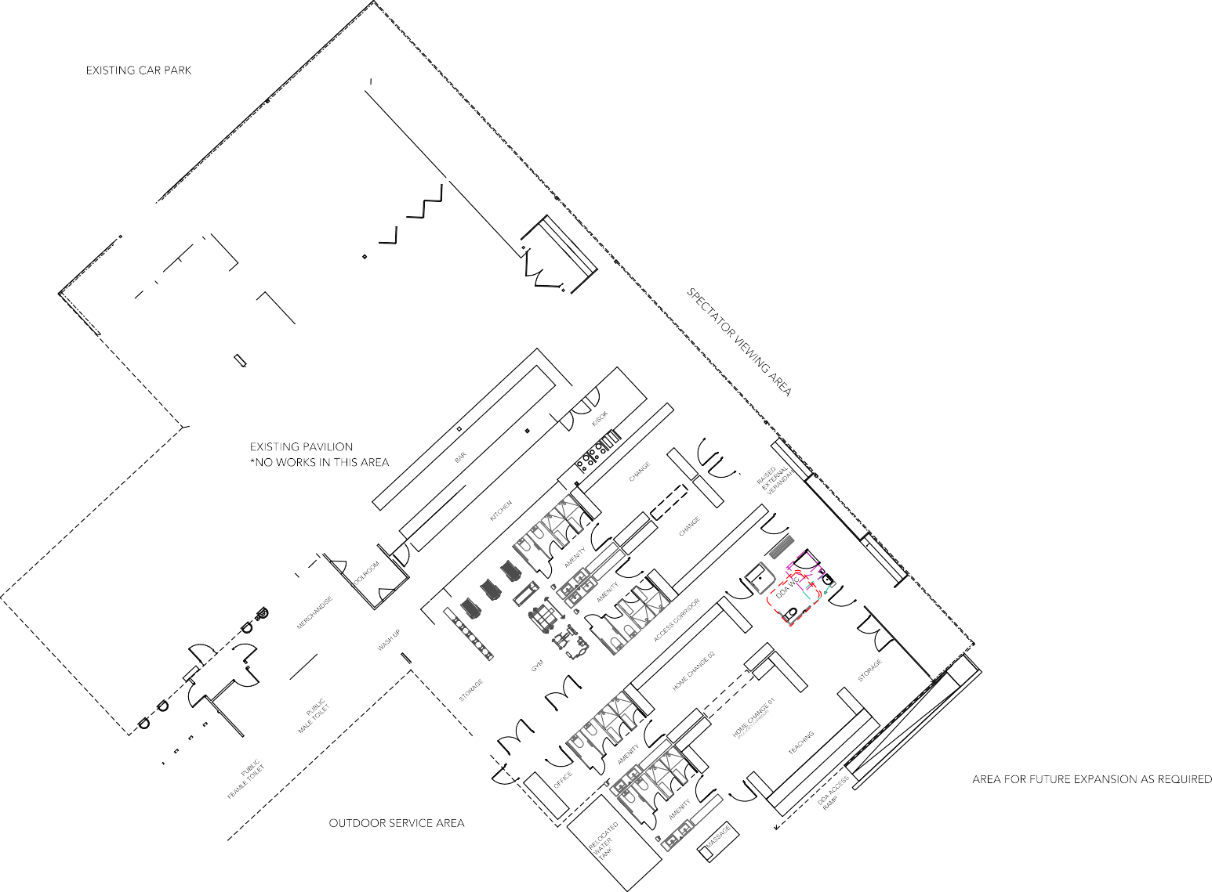5 FACILITY DEVELOPMENT PLAN

STAGE 1 - FOOTBALL CHANGE FACILITIES UPGRADE

The current football pavilion has only two change rooms with amenities that are in poor condition and not fit-for-purpose for womens football.
As part of the project brief, a concept plan was developed to:
    - Upgrade the current football pavilion change rooms to be fit-for-purpose.
    - Increase the number of change facilities from two gender specific rooms to four multi-purpose and gender neutral change areas. This will enable the space to be adapted for use by a broader range of participants and user groups.
    - Provide upgraded amenities including a DDA change room, dedicated first aid and additional storage rooms.

Football change facility upgrade concept plan.

PAGE 27

- IMPLEMENTATION

FUNDING STRATEGY

As there are a number of projects included within the FDP with varying priority levels, a range of funding strategies will need to be considered as each project progresses into planning and detailed design phases.
The following table shows the various funding streams that may be used to finance each aspect of the FDP, and a list of potential grants is provided below.

Sport & Recreation Victoria (SRV) Local Sports Infrastructure Fund*
    - This fund provides a range of grant opportunities across funding streams including Female Friendly Facilities (up to
$500,000), Community Sports Lighting (up to $250,000), Scoreboards and Fixed Equipment (up to $25,000).

Sport & Recreation Victoria (SRV) Country Football & Netball Program*
    - This Program provides a range of grant opportunities for projects such as improved playing surfaces, female friendly player and umpire change facilities and sports lighting upgrades.
Up to $150,000 is available through this program.

City of Greater Geelong’s Community Infrastructure Grants Program
    - This program supports funding for the planning and delivery of community sports related infrastructure upgrades within the City of Greater Geelong. Up to $350,000 is available through this program.
Funding may also be sourced through the City’s annual budget process and Club fundraising activities.

OPTION | BENEFITS | IMPLICATIONS | POTENTIAL PROJECTS
STATE AND FEDERAL GOVERNMENT GRANTS | - Large funding opportunities.  - Opportunity to access multiple funding grants for a single project.  - Increases public profile of the project. | - Subject to identifying suit- able grants which align with master plan time frames.  - Significant time and resources required to complete documentation and advocacy. | - Football pavilion upgrade  - Netball pavilion upgrade  - Reserve works
SPORT-SPECIFIC FUNDING AND GRANTS | - Guarantees alignment with best practice sport specific design guidelines. | - Subject to access, alignment, availability and terms. | - Netball court realignment  - Coaches box upgrades  - Scoreboard replacement
DIRECT COUNCIL FUNDING | - Maintains complete control over project delivery. | - Competing with other Coun- cil projects and priorities. | - Lighting upgrades
*The City is required to apply for these grants on behalf of the Club.

PAGE 28

6 IMPLEMENTATION

PROJECT COSTS

Preliminary cost estimates have been prepared by WT Partnership. These are outlined below and in the table to the right.
The preliminary cost estimates relate to the refurbishment of the existing football pavilion and development plan of the surrounding reserve, including additional
parking, paths, netball court and public toilet block. These costs are summarised below, and a full cost estimate is provided as an appendix.
- Elderslie Reserve Football Pavilion:
$1,732,000.
- Elderslie Reserve FDP: $4,669,000. Note: All costs are excluding GST.
The following items are excluded from the Main Scope of Works that have been costed.
However as requested by the Club, WT has included the following items below the line for consideration. These upgrades would not be funded by Council.
- Scoreboard Replacement - $371,000
- Coaches Box - $247,000
This cost advice does not make allowance for costs or additional time that may occur as a result of COVID-19.
WT recommends a periodic review of this estimate to adjust as appropriate, for any ongoing implications of COVID-19
restrictions and consequential impacts on the construction market.

IMPLEMENTATION

PRIORITY | DESCRIPTION | COST | FDP PRINCIPLES
HIGH | Football pavilion upgrade of change rooms and amenities | $1,732,000
HIGH | Relocation of public toilets | $131,050
HIGH | Netball court setback/realignment and half court | $682,312 | 
HIGH | New enclosed play space area near netball courts | $51,700 | 
MEDIUM | New community play space | $545,000
MEDIUM | Perimeter walking track | $263,175 | 
MEDIUM | Landscaping, tree plantings and way finding signage | $567,050 | 
LOW | Car parking on Warwick Street | $55,950 | 
LOW | Formalise existing car park on Sherbourne Terrace | $142,365
Please note, the City is not obligated to fund any of the proposed facility upgrades.

PAGE 29

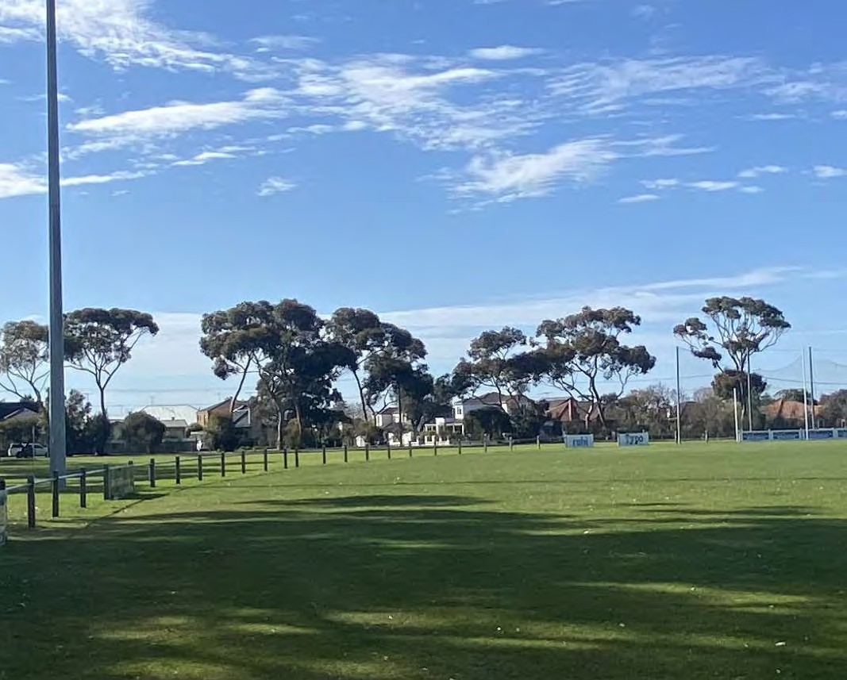6 IMPLEMENTATION

PROJECT BENEFITS

The key benefits that will be delivered and how they relate to the guiding principles are outlined below:

Equitable
- Upgraded change rooms within the football pavilion to ensure gender neutral facilities.

Accessible
- Increased accessibility through improved pedestrian pathways and entry points.
- Provision of public DDA toilets to service all users of the reserve.

Adaptable
- Dedicated grassed open space area that can be used for both passive and active recreation activities.

Integrated
- Improved way finding and connections across the reserve through the installation of a perimeter walking path and improved car parking.

Sustainable
- Increased tree plantings across the reserve, and ESD allowances within the pavilion upgrade.

PAGE 30

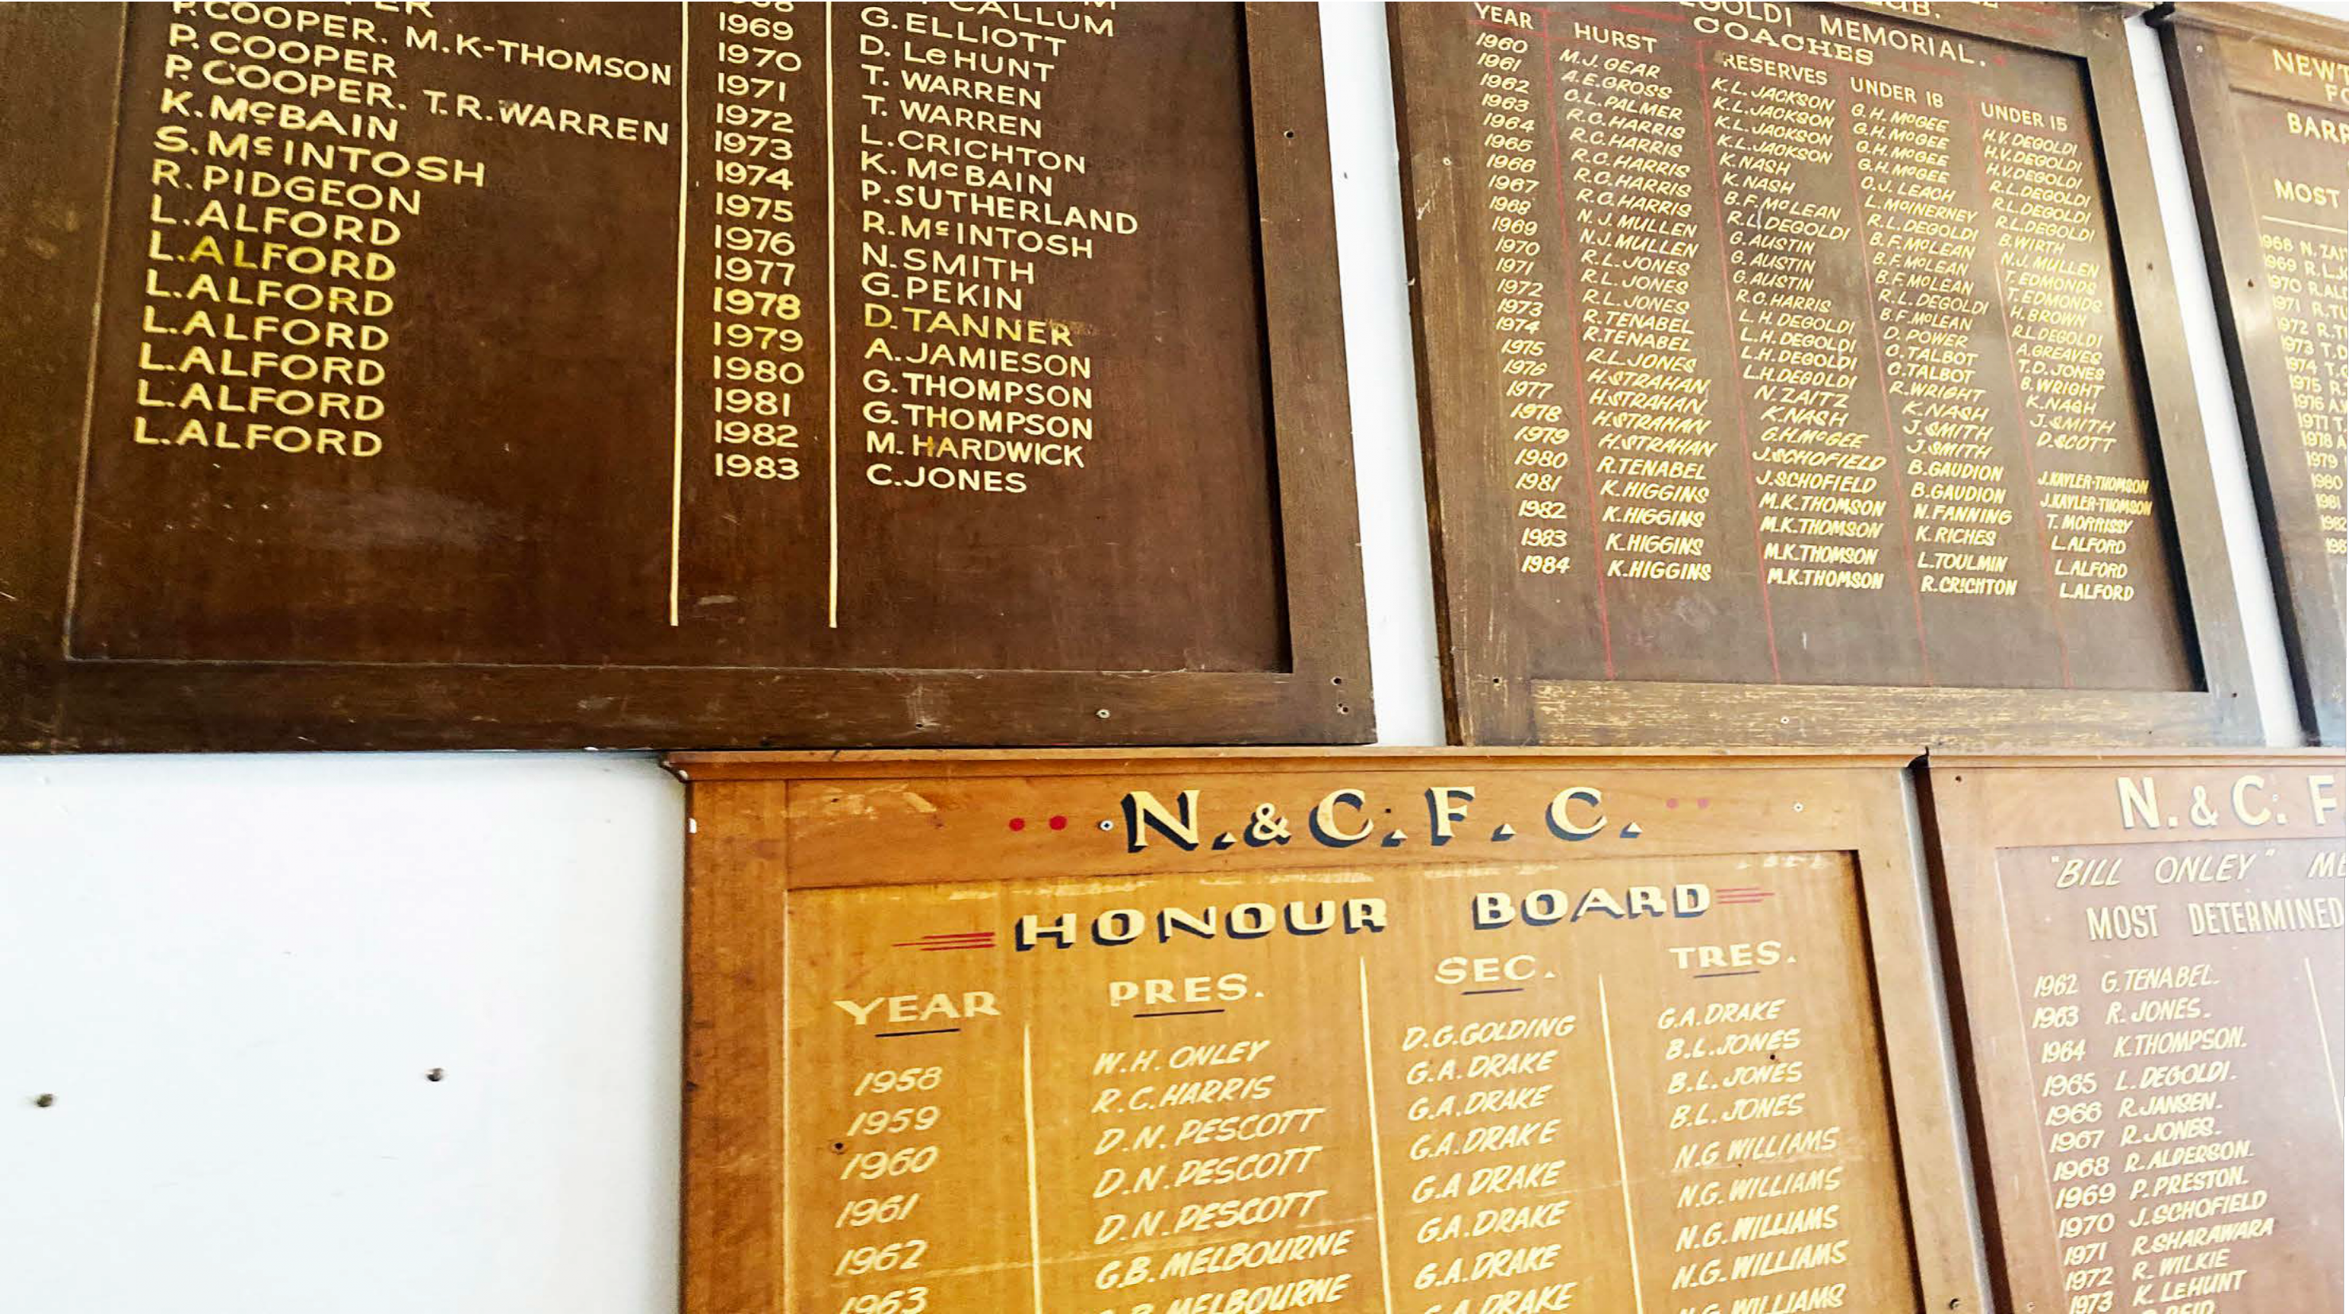

PAGE 31

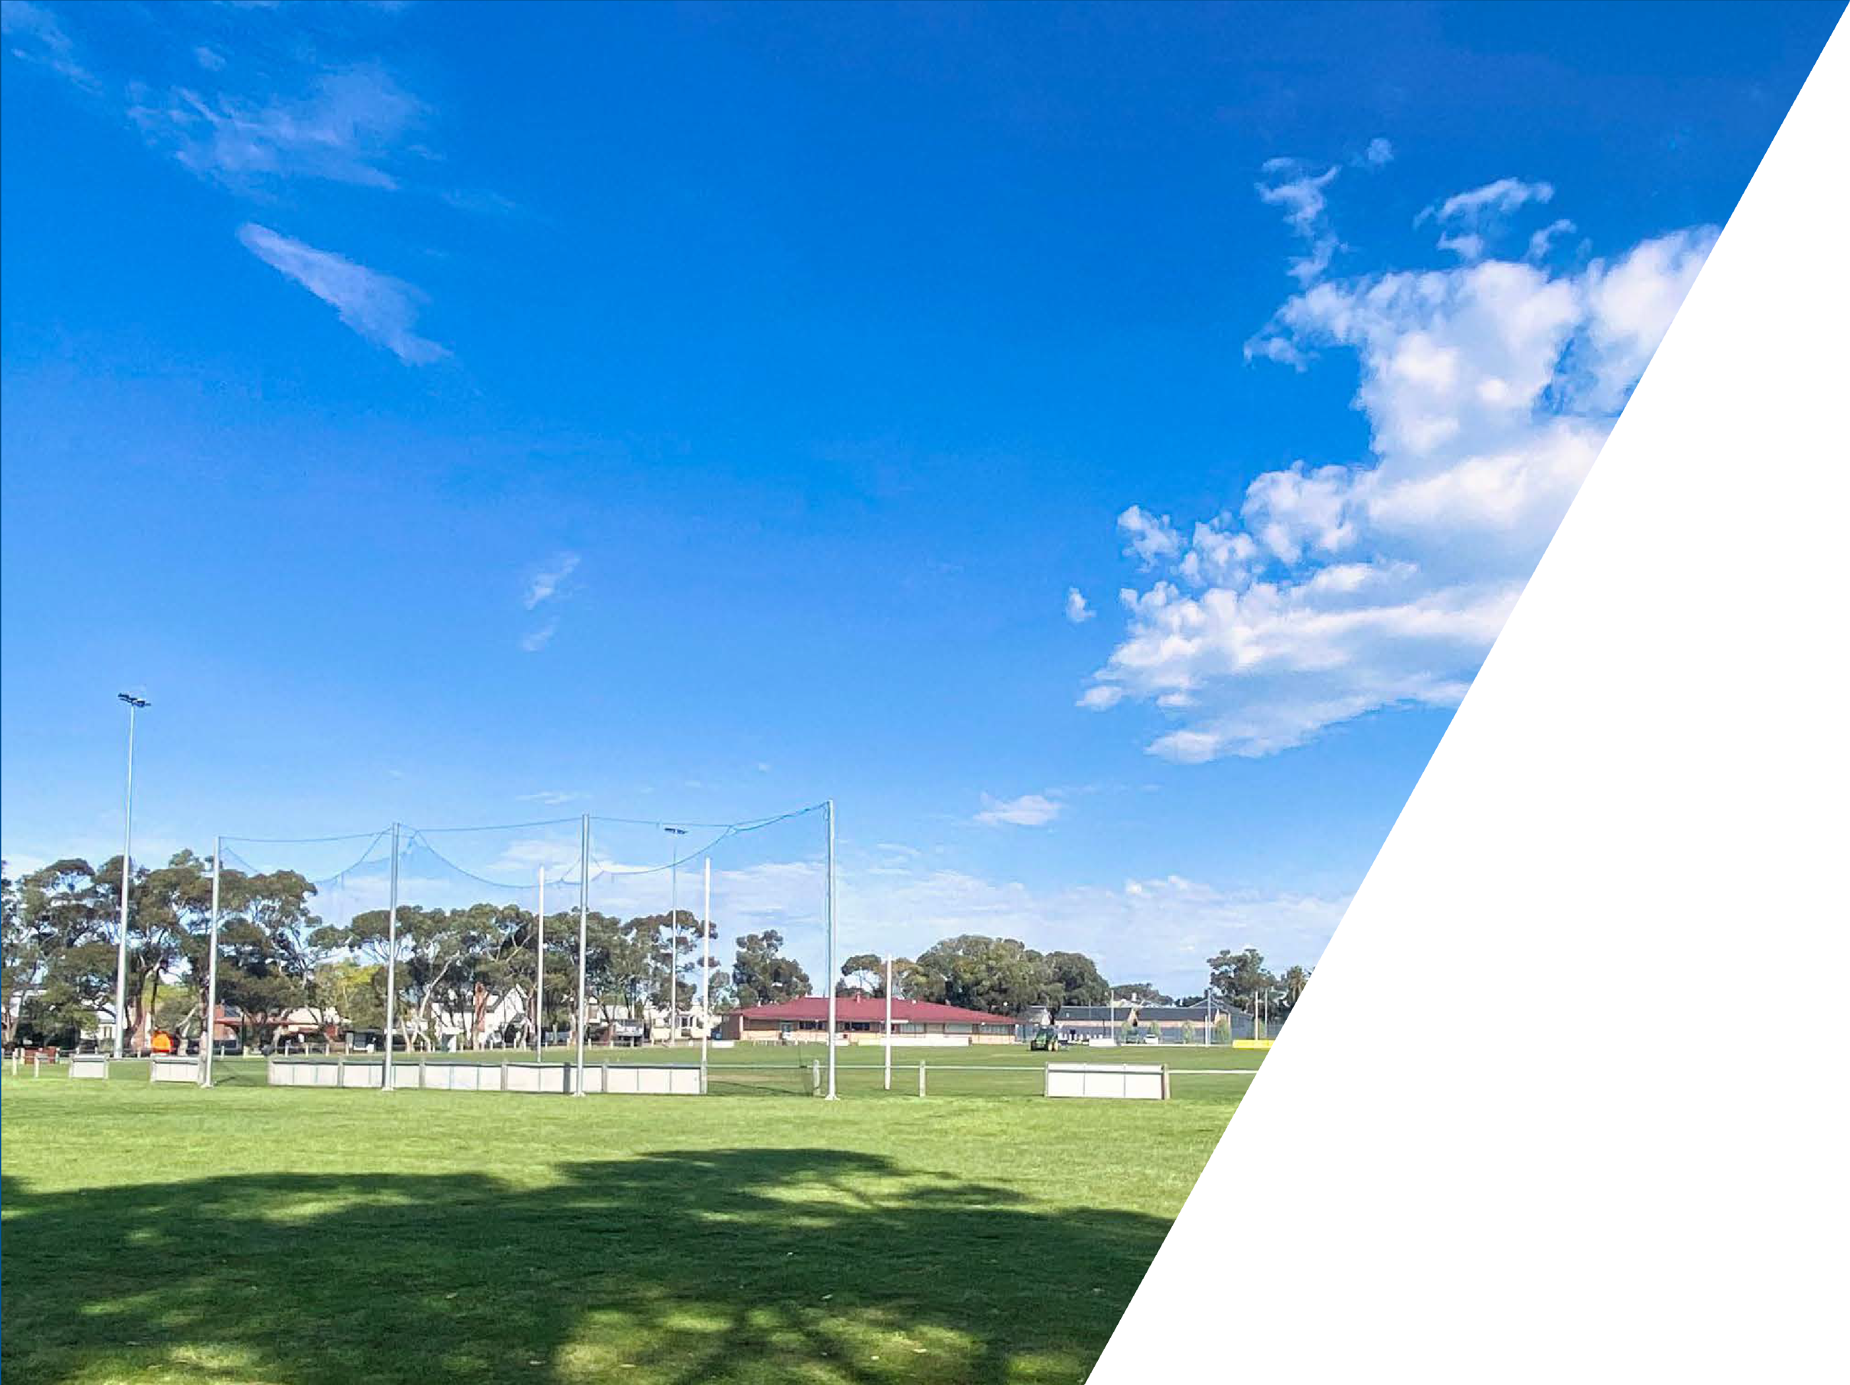

CITY OF GREATER GEELONG

PO Box 104

Geelong VIC 3220
P: 5272 5272

E: contactus@geelongcity.vic.gov.au www.geelongaustralia.com.au

CUSTOMER SERVICE CENTRE

100 Brougham Street Geelong VIC 3220 8.00am - 5.00pm

© City of Greater Geelong 2022

ELDERSLIE RECREATION RESERVE
PAVILION UPGRADES

Client:


Consultant Team:

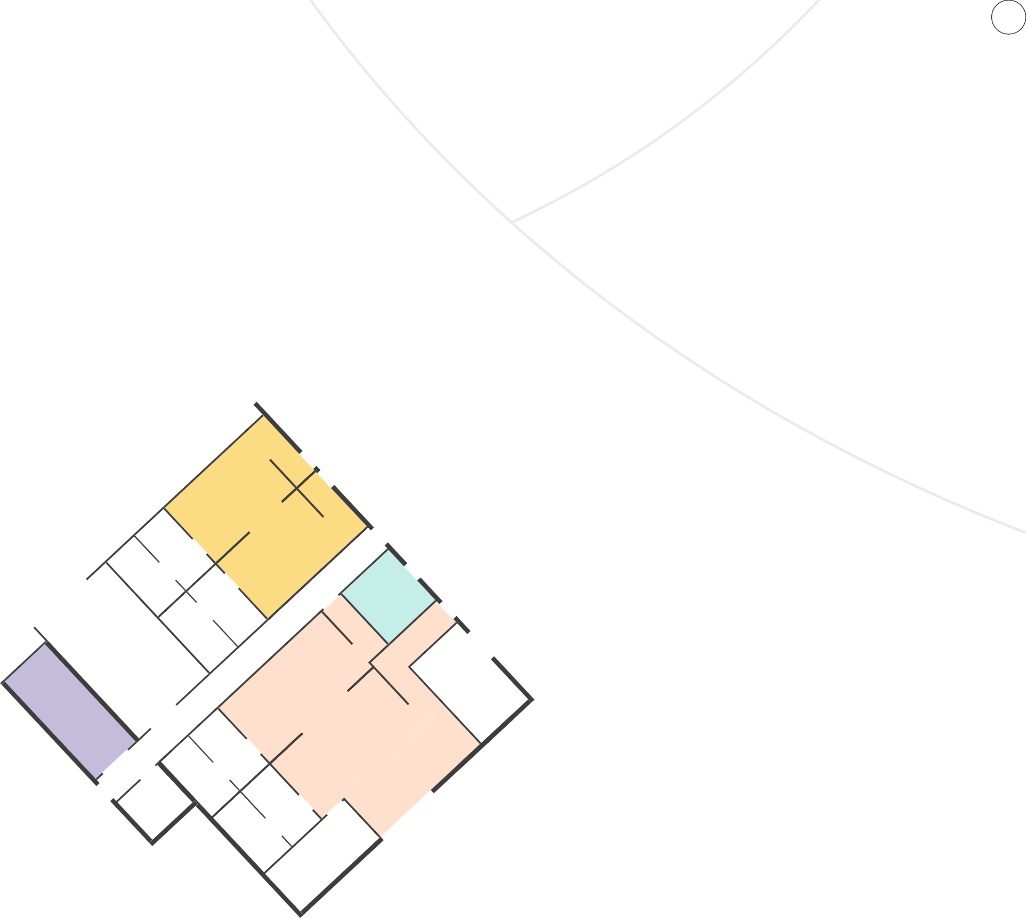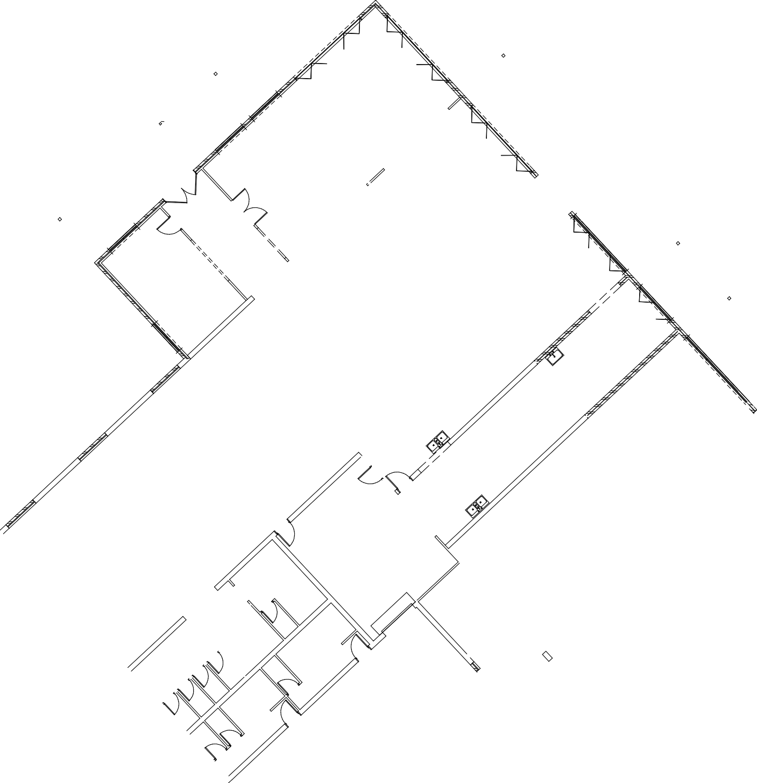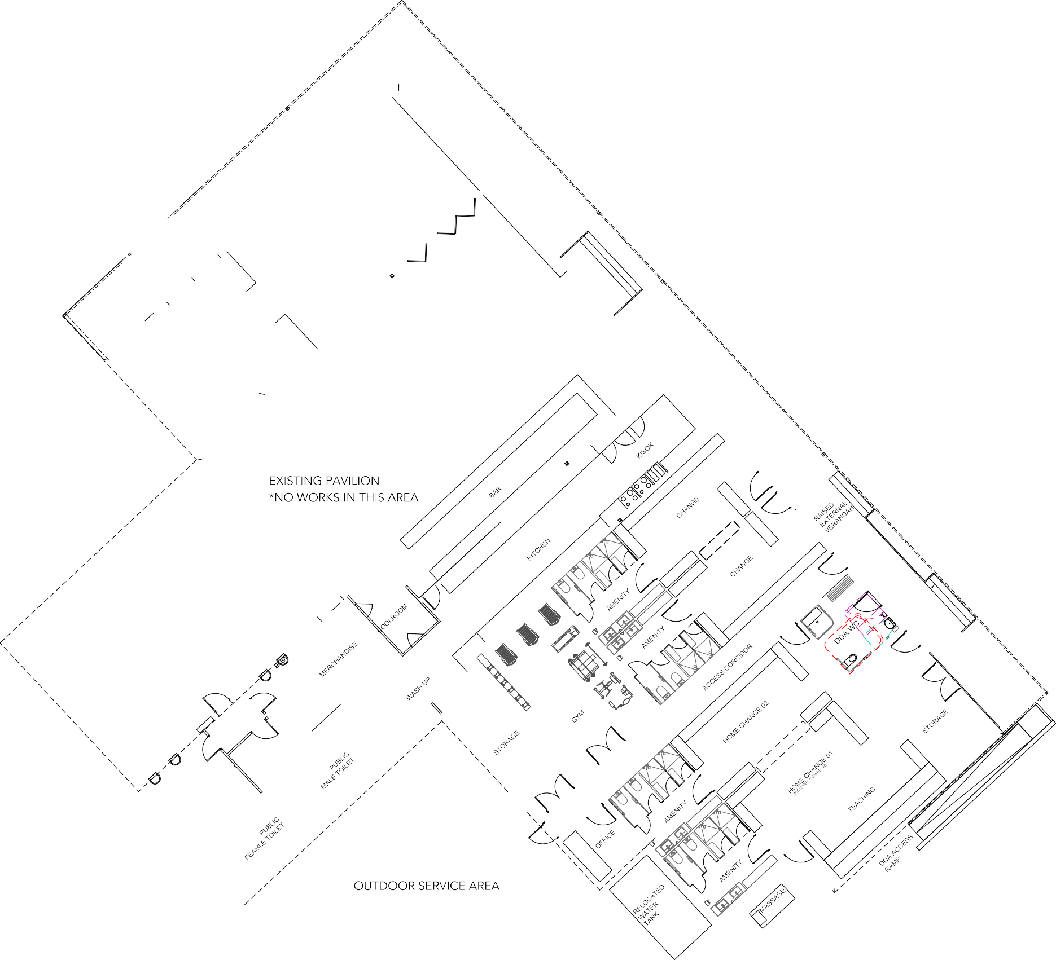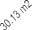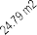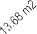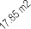FACILITY DEVELOPMENT PLAN

Date:

March 2022
 theocd.com.au

ELDERSLIE RECREATION RESERVE

PAVILION UPGRADES

Client:

Consultant Team:

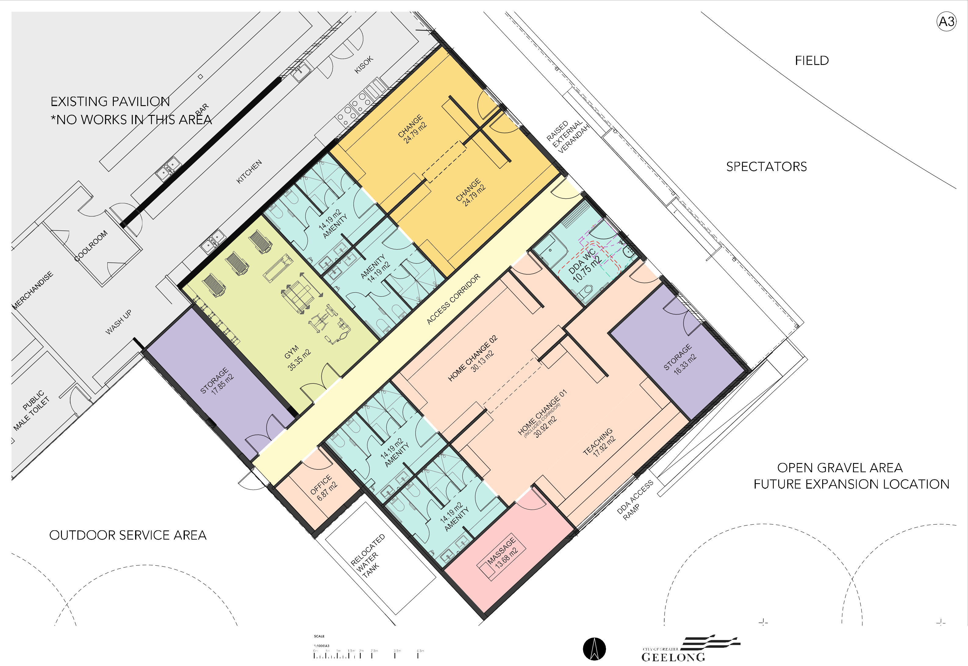FACILITY DEVELOPMENT PLAN

Date:

March 2022
theocd.com.au

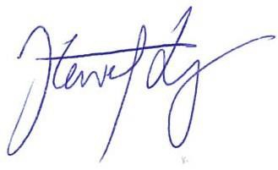

8 April 2022

Anna Eades SBP Advisory Level 3
456 High Street
PRAHRAN VIC 3181
Anna@Sportbusiness.com.au

Dear Anna

ELDERSLIE RECREATION RESERVE PRELIMINARY COST ESTIMATE NO. 1 (REV 1)
We are pleased to confirm our Preliminary Cost Estimate No. 1 (Rev 1) dated 7 April 2022, for the above project.
Please do not hesitate to contact us to discuss any aspect which requires clarification or amendment to the assumed scope of works on our part.
Yours sincerely

STEWART LYONS
Associate Director WT

WT REF: PR-011967-03 - EST 1 (PRELIM) (REV 1)



ELDERSLIE RECREATION RESERVE

PRELIMINARY COST ESTIMATE NO. 1 (REV 1)
8 April 2022



CONTENTS
- ESTIMATE SUMMARY 1
- PROJECT DEFINITION 3
- SCHEDULE OF AREAS 3
- DOCUMENTATION 4
- SPECIFIC INCLUSIONS 4
- SPECIFIC EXCLUSIONS 4
- ASSUMPTIONS 6
- CONCLUSION / DISCLAIMER 7

APPENDICES
APPENDIX A PRELIMINARY COST ESTIMATE NO. 1



ESTIMATE SUMMARY
We provide the following current day cost estimates:
- Main Works - Elderslie Pavilion - $1,732,000 (Excl GST)
- Masterplan - Elderslie Reserve - $4,669,000 (Excl GST)

  - PAVILION

The Pavilion Estimate No. 1 is summarised as follows:

 | GFA (M²) | GFA ($/M) | $ (EXCL GST)
Building Works | 330 | 2,852 | 941,320
External Works and Services | 57 | 589 | 33,578
Preliminaries and Margin |  |  | 117,102
Subtotal | 387 | 2,822 | 1,092,000
ESD Initiatives |  |  | 100,000
Design & Construction Contingency |  |  | 123,000
Cost Escalation to April 2023 |  |  | 130,000
Authority Fees / Headworks Charges |  |  | 30,000
Consultant Fees |  |  | 145,000
Council Costs |  |  | 30,000
Project Contingency |  |  | 82,000
TOTAL ESTIMATE (EXCL GST) | 387 M² | $4,264/M² | $1,732,000

ELDERSLIE RECREATION RESERVE | PRELIMINARY COST ESTIMATE NO. 1 (REV 1)
WT REF: PR-011967-03 - EST 1 (Prelim) (Rev 1) | CLW SA1 1

  - RESERVE WORKS

The Reserve Estimate No. 1 is summarised as follows:

 | GFA (M²) | GFA ($/M) | $ (EXCL GST)
External Works and Services | 19,782 | 135 | 2,674,397
Preliminaries and Margin |  |  | 320,603
Subtotal | 19,782 | 151 | 2,995,000
ESD Initiatives |  |  | Included above
Design & Construction Contingency |  |  | 310,000
Cost Escalation to April 2025 |  |  | 596,000
Authority Fees / Headworks Charges |  |  | 78,000
Consultant Fees |  |  | 390,000
Council Fees |  |  | 78,000
Project Contingency |  |  | 222,000
TOTAL ESTIMATE (EXCL GST) | 19,782 M² | $ 236/M² | $4,669,000

The following line items have been included as below the line options for the Club.

CLUB COSTS

The following items are excluded from the Main Scope of Works above, however as requested by the Club, WT has included the following items below the line for consideration:
    - Scoreboard Replacement - $371,000
    - Coaches Box - $247,000
This cost advice does not make allowance for costs or additional time that may occur as a result of COVID-19. The implications that may result from COVID-19 restrictions include, but are not limited to:
    - Costs arising from delays in the delivery or installation of plant and materials
    - Increased costs relating to substitution of plant or materials required for the project due to shortages or delivery issues in Australia or overseas
    - A reduction in productivity due to a direction of any Government or Authority as a result of COVID-19

ELDERSLIE RECREATION RESERVE | PRELIMINARY COST ESTIMATE NO. 1 (REV 1)
WT REF: PR-011967-03 - EST 1 (Prelim) (Rev 1) | CLW SA1 2

WT recommends a periodic review of this estimate to adjust as appropriate, for any ongoing implications of COVID-19 restrictions and consequential impacts on the construction market

PROJECT DEFINITION
This project relates to the refurbishment of the existing pavilion and masterplan works to the surrounding reserve, including additional parking, paths, netball court and public toilet block.

SCHEDULE OF AREAS
The estimate is based on the following schedule of areas and functions. The Gross Floor Area is made up as follows:
M²
Amenities | 59
DDA WC | 12
Change Rooms | 51
Home Change Rooms | 85
Massage | 15
Gym | 37
Office | 8
Storage | 37
Corridors | 26
TOTAL | 330 M²

  - AREA ANALYSIS

Site Area 19,782 m²

M²
FECA | 330
UCA | 57
TOTAL | 387 M²

ELDERSLIE RECREATION RESERVE | PRELIMINARY COST ESTIMATE NO. 1 (REV 1)
WT REF: PR-011967-03 - EST 1 (Prelim) (Rev 1) | CLW SA1 3

WTP Australia Pty Ltd (WT) has calculated the Gross Floor Area (GFA) as defined by the Australian Institute of Quantity Surveyors (AIQS) Australian Cost Management Manual. This convention provides consistency of the measurement process and assists benchmarking of comparable projects.
WT’s GFA differs from the Property Council of Australia’s Gross Floor Area and the City of Melbourne Planning Scheme Amendment C262 Gross Floor Area definitions which are used for the calculation of the Site Plot Ratio. Such areas should be quantified separately as per the required authority’s definitions where required.
Refer Appendix A for detailed schedule of areas.

DOCUMENTATION
This estimate is based on the following documentation:
- Facility Development Plan Drw1-5 prepared by The OCD dated February 2022
- Site visit with Club representative dated 14 February 2022

SPECIFIC INCLUSIONS
The Estimate assumes competitive lump sum tender for the whole of the Works from suitably qualified contractors.
The Estimate is inclusive of the following allowances:
- ESD Initiatives to Pavilion - $100,000
- Design Contingency (5%)
- Construction Contingency (5%)
- Consultant’s Fees (10%)
- Cost Escalation (beyond April 2025)
- Headworks Charges & Authority Contribution (2%)
- Council Fees (2%)
- Project Contingency (5%)

SPECIFIC EXCLUSIONS
The estimate excludes the following:
- Site access restrictions
- Removal of contaminated or hazardous materials including site remediation
- Abnormal and unforeseen ground conditions (i.e. rock excavation, poor soil, water table issues, piling, etc.)
- Works outside of the site boundary unless noted otherwise

ELDERSLIE RECREATION RESERVE | PRELIMINARY COST ESTIMATE NO. 1 (REV 1)
WT REF: PR-011967-03 - EST 1 (Prelim) (Rev 1) | CLW SA1 4

- Protection of adjoining properties and footpath including owner issues
- Relocation and decanting of existing building
- Relocation or upgrade of existing services and infrastructure (i.e. power/ water/ gas/ sewer/ comms/ NBN, other than those allowances noted within estimate)
- Make good works to existing Pavilion roof including drainage, framing, sheeting, roof safety systems, etc. other than noted
- Works to existing Pavilion facade, i.e. paint or render
- Timber decking between existing function room stairs and existing concrete terrace deck
- Works to Active Open Space (Design Consideration No. 21), as advised by Sport Business
- Play equipment to Child Safety Enclosure (Design Consideration No. 8), as advised by Sport Business
- Concrete kerb and channel to Car Park Area (Design Consideration No. 16)
- External lighting other than those noted within estimate
- Client costs
- Public Artwork and Sculptures
- Loose furniture, fittings and equipment (costs covered by Club)
- Whitegoods and appliances allowances other than noted
- AV and IT equipment allowances (costs covered by Club)
- ESD allowances other than those identified in the estimate
- Fire-sprinkler systems
- Termite treatments
- Staging costs / Work out of normal working hours / Temporary works
- Authority fees, charges and headworks, public open space contribution, building cladding levy (in addition to 2% allowance)
- Negotiated Contract/ Construction Management
- Cost escalation beyond April 2025
- Delay and prolongation allowances
- Any non-construction development costs
- Financing costs
- Land, legal and holding costs
- GST

ELDERSLIE RECREATION RESERVE | PRELIMINARY COST ESTIMATE NO. 1 (REV 1)
WT REF: PR-011967-03 - EST 1 (Prelim) (Rev 1) | CLW SA1 5

ASSUMPTIONS
- Assume allowance required to make good to existing structure for new fitout, i.e. re-screed over existing slab to create levels
- Assume new external wall to Pavilion extension to be brick veneer and to tie into existing
- Assume vinyl floor and wall finishes to Pavilion amenities
- Assume acoustic ceiling and flooring to Pavilion's Gym
- Assume existing services to the Pavilion to be temporarily sealed and capped for re-use
- Assume Service Yard behind Pavilion (Design Consideration No. 4) to be asphalt, as advised by Sport Business
- Assume new public toilets (Design Consideration No. 7) to be a standard design and build, i.e. brick veneer external walls or similar, vinyl internal floor and wall finishes
- Assume minor works are required to seal off existing public toilets including seal off openings with mesh screens, and add additional door hardware to secure doors
- Assume existing Child Safety Enclosure (No. 8) to be enclosed by palisade fencing, have seating and minor landscaping works. No allowance for play equipment has been included as advised by Sport Business and The OCD
- Assume minor make good works to the Netball Pavilion (Design Consideration No. 10) facade only, i.e. sand patch and paint
- Assume compacted crushed rock to existing carpark along Sherbourne Terrace (Design Consideration No. 16)
- Assume new play area includes new play equipment, fencing, etc.
- Assume make-good works to existing shelter only
- An allowance of $100,000 has been included for ESD Initiatives to the Pavilion, over and above Section J, i.e. solar panels, water tanks, etc.
- A below-the-line Client funded option has been included for the Coaches Box (Design Consideration No. 27)
- A below-the-line Client funded option has been included for the Scoreboard replacement
- WT has been advised to allow for cost escalation, however, no date has been set for start of construction on either Pavilion or Reserve Works. WT has allowed for 12 months cost escalation to April 2023, and up to April 2025 for the Masterplan + Cost Options (based on discussions with Sport Business on the 7 April 2022).

ELDERSLIE RECREATION RESERVE | PRELIMINARY COST ESTIMATE NO. 1 (REV 1)
WT REF: PR-011967-03 - EST 1 (Prelim) (Rev 1) | CLW SA1 6

CONCLUSION / DISCLAIMER
We highlight that due to the preliminary nature of the documentation, our Estimate should be viewed as indicative and a preliminary opinion of the probable order of cost based on a concept without definition of design scope or quality.
Where WT has not been provided with sufficient information, we have made assumptions and allowances which will require detailed review once the design is developed.
Please review the detail of our Estimate, in particular the many assumptions as to scope, quality, performance and finishes of the current design intent to ensure it generally reflects your requirements.
The estimate has been prepared expressly for SBP Advisory for the purpose of preparing a preliminary feasibility assessment and is not to be used for any other purpose or distributed to any third party.

ELDERSLIE RECREATION RESERVE | PRELIMINARY COST ESTIMATE NO. 1 (REV 1)
WT REF: PR-011967-03 - EST 1 (Prelim) (Rev 1) | CLW SA1 7



APPENDIX A

PRELIMINARY COST ESTIMATE NO. 1

ESTIMATE DETAIL

PR-011967
Elderslie Recreation Reserve
Est 01 - Preliminary Cost Estimate Rev. A

Job No: PR-011967

Cost Base Date: April 2022
GFA (m2): 387.00

Date Printed: 8/04/2022

Item | Section | Unit | Qty | Rate | Cost $
1 | Estimate Criteria
 | ESTIMATE CRITERIA
1.1 | This is a Preliminary Cost Estimate has been prepared for COGG and The OCD for the proposed masterplan and refurbishment of the Elderslie Pavilion and reserve
 | located on Raith Terrace, Newtown
 | PROJECT DESCRPTION
1.2 | This project relates to the refurbishment of the existing pavilion and masterplan of the surrounding reserve, including additional parking, paths, netball court and
 | public toilet block.
 | DOCUMENTATION
1.3 | This estimate is based on the following documentation:
1.4 | - Facility Development Plan Drw1-5 prepared by The OCD dated February 2022
1.5 | - Site visit with Club representative dated 14 February 2022
1.6 | - Discussions with SportBusiness and The OCD up to the 7th April2022
 | SITE AREA
1.7 | Site area (excludes existing parking, oval and pavilion) | m2 | 19,782
 | TOTAL SITE AREA | m2 | 19,782
 | PAVILION - GROSS FLOOR AREA
1.8 | FECA | m2 | 330
 | TOTAL FECA | m2 | 330
1.9 | UCA | m2 | 57
 | TOTAL UCA | m2 | 57
 | TOTAL PAVILION GFA | m2 | 387
 | Area Schedule

PR-011967 WT Partnership
Page 1

ESTIMATE SUMMARY

PR-011967
Elderslie Recreation Reserve
Est 01 - Preliminary Cost Estimate Rev. A

Job No: PR-011967

Cost Base Date: April 2022
GFA (m2): 387.00

Date Printed: 8/04/2022

Section |  | Unit | Quantity | Rate | Cost ($)
1 | Estimate Criteria Exclusions Assumptions  MAIN WORKS - PAVILION  Refurbishment  Building Works  Subtotal Pavilion  External Canopy  External Works and Services  Subtotal External Works and Services  CONSTRUCTION WORKS SUB-TOTAL  Builder's Preliminaries and Supervision Builder's Margin  SUBTOTAL - CONSTRUCTION COST  ESD Initiatives (Over and above BCA Section J), i.e. rainwater tanks, solar PV panels, etc.  Design Development Contingency Construction Contingency  Cost Escalation - to a commencement date of April 2023 | FECA | 330 | 2,852 | 941,320
 |  | FECA | 330 | 2,852 | 941,320
2 |  | UCA | 57 | 589 | 33,578
 |  | UCA | 57 | 589 | 33,578
 |  | GFA | 387 | 2,519 | 974,898
3 |  | % | 12.0 | 974,898 | 117,102
4 |  |  |  |  | Included
5
 |  | GFA | 387 | 2,822 | 1,092,000
6 |  | Item | 1 | 100,000 | 100,000
7 |  | % | 5.0 | 1,192,000 | 60,000
8 |  | % | 5.0 | 1,252,000 | 63,000
9 |  | % | 10.0 | 1,315,000 | 130,000

ESTIMATE SUMMARY

PR-011967
Elderslie Recreation Reserve
Est 01 - Preliminary Cost Estimate Rev. A

Job No: PR-011967
Cost Base Date: April 2022
GFA (m2): 387.00

Date Printed: 8/04/2022

Section |  | Unit | Quantity | Rate | Cost ($)
 | TOTAL CONSTRUCTION COST AS AT APRIL 2023  (Excl GST)  Authority Fees/ Headworks Charges Consultant Fees  Council Fees Project Contingency GST  TOTAL PAVILION ESTIMATED COST AT APRIL 2023  (Excl GST)  MASTER PLAN - RESERVE WORKS  Reserve Works  External Works and Services  Subtotal Reserve Works  CONSTRUCTION WORKS SUB-TOTAL  Builder's Preliminaries and Supervision Builder's Margin  SUBTOTAL - CONSTRUCTION COST  ESD Initiatives (allowed to Pavilion above only)  Design Development Contingency Construction Contingency | GFA | 387 | 3,734 | 1,445,000
10 |  | % | 2.0 | 1,445,000 | 30,000
11 |  | % | 10.0 | 1,445,000 | 145,000
12 |  | % | 2.0 | 1,445,000 | 30,000
13 |  | % | 5.0 | 1,650,000 | 82,000
14 |  |  |  |  | Excluded
 |  | GFA | 387 | 4,475 | 1,732,000
15 |  | m2 | 19,782 | 135 | 2,674,397
 |  | m2 | 19,782 | 135 | 2,674,397
 |  | m2 | 19,782 | 135 | 2,674,397
16 |  | % | 12.0 | 2,674,397 | 320,603
17 |  |  |  |  | Included
 |  | GFA | 19,782 | 151 | 2,995,000
18 |  | Note
19 |  | % | 5.0 | 2,995,000 | 151,000
20 |  | % | 5.0 | 3,146,000 | 159,000

ESTIMATE SUMMARY

PR-011967
Elderslie Recreation Reserve
Est 01 - Preliminary Cost Estimate Rev. A

Job No: PR-011967
Cost Base Date: April 2022
GFA (m2): 387.00

Date Printed: 8/04/2022

Section |  | Unit | Quantity | Rate | Cost ($)
21 | Cost Escalation - to a commencement date of April 2025  TOTAL CONSTRUCTION COST AS AT APRIL 2025  (Excl GST)  Authority Fees/ Headworks Charges Consultant Fees  Council Fees Project Contingency GST  TOTAL RESERVE WORKS ESTIMATED COST AS AT  APRIL 2025 (Excl GST)  CLIENT COSTS  Note: Optional Items for the Clubs consideration. Allowances included for non-construction costs, i.e. contingency, professional fees, etc.  Scoreboard Coaches Box | % | 18.0 | 3,305,000 | 596,000
 |  | GFA | 19,782 | 197 | 3,901,000
22 |  | % | 2.0 | 3,901,000 | 78,000
23 |  | % | 10.0 | 3,901,000 | 390,000
24 |  | % | 2.0 | 3,901,000 | 78,000
25 |  | % | 5.0 | 4,447,000 | 222,000
26 |  |  |  |  | Excluded
 |  | GFA | 19,782 | 236 | 4,669,000
27 |  | Note
28 |  |  |  |  | 371,000
29 |  |  |  |  | 247,000

ESTIMATE DETAIL

PR-011967
Elderslie Recreation Reserve
Est 01 - Preliminary Cost Estimate Rev. A

Job No: PR-011967
Cost Base Date: April 2022
GFA (m2): 387.00

Date Printed: 8/04/2022

Item | Section | Unit | Qty | Rate | Cost $
1 | Estimate Criteria |  |  |  | (Continued)
 | Pavilion
1.10 | Amenities | m2 | 59
1.11 | DDA WC | m2 | 12
1.12 | Change Rooms | m2 | 51
1.13 | Home Change Rooms | m2 | 85
1.14 | Massage | m2 | 15
1.15 | Gym | m2 | 37
1.16 | Storage | m2 | 37
1.17 | Office | m2 | 8
1.18 | Corridors | m2 | 26

- Exclusions
EXCLUSIONS
2.1

2.2

2.3

2.4

2.5
The cost advice does not make allowance for costs or additional time that may occur as a result of increased or new restrictions introduced by Authorities due to COVID-19. The implications that may result from COVID-19 restrictions include, but are not limited to:
- Costs arising from delays in the delivery of installation of plant and materials
- Increased costs relating to substitution of plant or materials required for the project due to shortages or delivery issues in Australia or overseas
- A reduction in productivity due to a direction of any Government or Authority as a result of COVID-19
We recommends a periodic review of this estimate to adjust as appropriate, for any ongoing implications of COVID-19 restrictions and consequential impacts on the construction market
This estimate specifically excludes the following items:

ESTIMATE DETAIL

PR-011967
Elderslie Recreation Reserve
Est 01 - Preliminary Cost Estimate Rev. A

Job No: PR-011967
Cost Base Date: April 2022
GFA (m2): 387.00

Date Printed: 8/04/2022

Item | Section | Unit | Qty | Rate | Cost $
2 | Exclusions |  |  |  | (Continued)
2.6 | Site access restrictions
2.7 | Removal of contaminated or hazardous materials including site remediation
2.8 | Abnormal and unforeseen ground conditions (e.g. rock excavation, poor soil, water table issues, piling, etc.)
2.9 | Works outside of the site boundary unless noted otherwise
2.10 | Protection of adjoining properties and footpath including owner issues
2.11 | Relocation and decanting of existing building
2.12 | Relocation or upgrade of existing services and infrastructure, i.e. power/ water/ gas/ sewer/ comms/ NBN, other than those allowance noted within this
 | estimate
2.13 | Make good works to existing Pavilion roof including drainage, framing, sheeting, roof safety systems, etc.
 | other than noted
2.14 | Works to existing Pavilion facade, i.e. paint or render
2.15 | Timber decking between existing function room stairs and existing concrete terrace deck
2.16 | Works to Active Open Space (Design Consideration No. 21), as advised by SportBusiness
2.17 | Play equipment to Child Safety Enclosure (Design Consideration No. 8), as advised by Sport Business
2.18 | Concrete kerb and channel to Car Park Area (Design Consideration No. 16)
2.19 | External lighting other than those noted within estimate
2.20 | Client costs other than those noted within estimate
2.21 | Public Artwork and Sculptures
2.22 | Loose furniture, fittings and equipment other than noted (Costs covered by Club)
2.23 | Whitegoods and appliances allowances other than noted
2.24 | AV and IT equipment allowances other than noted (Costs covered by Club)

ESTIMATE DETAIL

PR-011967
Elderslie Recreation Reserve
Est 01 - Preliminary Cost Estimate Rev. A

Job No: PR-011967
Cost Base Date: April 2022
GFA (m2): 387.00

Date Printed: 8/04/2022

Item | Section | Unit | Qty | Rate | Cost $
2 | Exclusions |  |  |  | (Continued)
2.25 | ESD allowances other than those identified in the estimate
2.26 | Fire-sprinkler systems
2.27 | Fire services other than dismountables and relocation of hose
2.28 | Termite treatments
2.29 | Staging costs / Work out of normal working hours / Temporary works
2.30 | Authority fees, charges and headworks, public open space contribution, building cladding levy (in addition to
 | 2% allowance)
2.31 | Negotiated Contract/ Construction Management
2.32 | Cost escalation beyond date of April 2023 for the Pavilion (in line with Sport Business advice via email
 | correspondence dated 31 March, 2022)
2.33 | Cost escalation beyond date of April 2025 for the Masterplan + Cost Options (in line with Sport Business
 | advice via email correspondence dated 31 March, 2022)
2.34 | Delay and prolongation allowances
2.35 | Any non-construction development costs
2.36 | Financing costs
2.37 | Land, legal and holding costs
2.38 | GST

- Assumptions
This estimate assumes the following:
3.1

3.2
Assume allowance required to make good to existing structure for new fitout, i.e. re-screed over existing slab to create levels
Assume new external wall to Pavilion extension to be brick veneer and to tie into existing

ESTIMATE DETAIL

PR-011967
Elderslie Recreation Reserve
Est 01 - Preliminary Cost Estimate Rev. A

Job No: PR-011967
Cost Base Date: April 2022
GFA (m2): 387.00

Date Printed: 8/04/2022

Item | Section | Unit | Qty | Rate | Cost $
3 | Assumptions |  |  |  | (Continued)
3.3 | Assume vinyl floor and wall finishes to Pavilion amenities
3.4 | Assume acoustic ceiling and flooring to Pavilion's Gym
3.5 | Assume Service Yard behind Pavilion (No. 4) to be asphalt
3.6 | Assume new public toilets (No. 7) to be a standard design and build, i.e. brick veneer external walls or
 | similar, vinyl internal floor and wall finishes
3.7 | Assume minor works are required to seal off existing public toilets including seal off openings with mesh screens, and add additional door hardware to secure
 | doors
3.8 | Assume existing Child Safety Enclosure (No. 8) to be enclosed by palisade fencing, have seating and minor
 | landscaping works. No allowance for play equipment has been included as advised by Sport Business and The
 | OCD
3.9 | Assume minor make good works to the Netball Pavilion (No. 10) facade only, i.e. sand patch and paint
3.10 | Assume compacted crushed rock to existing carpark along Sherbourne Terrace (No. 16)
3.11 | Assume new play area includes new play equipment, fencing, etc.
3.12 | Assume make good works to existing shelter only (SH)
3.13 | Loose furniture, fittings and equipment to be funded by the Club, as advised by Sport Business
3.14 | AV and IT equipment allowances other than noted to be funded by the Club, as advised by Sport Business
3.15 | An allowance of $100,000 has been included for ESD Initiatives to the Pavilion, over and above Section J, i.e.
 | solar panels, water tanks, etc.
3.16 | A below-the-line Client funded option has been included for the Coaches Box (Design Consideration No. 27)
3.17 | A below-the-line Client funded option has been included for the Scoreboard replacement
3.18 | WT has been advised to allow for cost escalation. However, no date has been set for start of construction
 | on either Pavilion or Reserve Works. WT has allowed for 12 months cost escalation to April 2023, and up to April
 | 2025 for the Masterplan + Cost Options (based on
 | discussions with Sport Business on the 7 April 2022)

ESTIMATE DETAIL

PR-011967
Elderslie Recreation Reserve
Est 01 - Preliminary Cost Estimate Rev. A

Job No: PR-011967
Cost Base Date: April 2022
GFA (m2): 387.00

Date Printed: 8/04/2022

Item Section Unit Qty Rate Cost $
- Assumptions (Continued)

- Building Works
NOTES / ASSUMPTIONS
4.1 No allowance for asbestos or hazardous material, i.e. lead
4.2 No allowance has been included to make good to existing roof structure
4.3 No allowance has been included to render or paint existing brick facade
4.4 No allowance has been included for roof safety and fall protection - WT assume existing is to remain
4.5 No allowance for furniture, fittings and equipment
4.6 No allowance for client costs, i.e. gym equipment
4.7 Assume minor make good works required to existing structural flooring (WT assume existing floor is concrete
slab)
4.8 Assume new external wall to be brick veneer and to tie into existing
4.9 Assume vinyl floor and wall finishes to amenities
4.10 Assume acoustic ceiling and flooring to Gym
4.11 Assume existing services to be temporarily sealed and capped for re-use
Demolition
4.12 Allow to demolish existing internal fitout including internal walls, finishes, doors, fitments, etc. | m2 | 304 | 25 | 7,600
4.13 Allow to make good to receive new fitout | m2 | 330 | 100 | 33,000
4.14 Allow to demolish existing concrete ramp to front facade of building | Item | 1 | 500 | 500
4.15 Allowance to temporarily capp and seal existing mechanical services to the Pavilion for reuse | m2 | 304 | 5 | 1,520
4.16 Allowance to temporarily capp and seal existing electrical services to the Pavilion for reuse | m2 | 304 | 25 | 7,600

ESTIMATE DETAIL

PR-011967
Elderslie Recreation Reserve
Est 01 - Preliminary Cost Estimate Rev. A

Job No: PR-011967
Cost Base Date: April 2022
GFA (m2): 387.00

Date Printed: 8/04/2022

Item | Section | Unit | Qty | Rate | Cost $
4 | Building Works |  |  |  | (Continued)
4.17 | Allowance for re-running hydraulic pipeworks to new fitments and fixtures (Assume max 5m per point) | No | 27 | 1,150 | 31,050
4.18 | Allow relocation of fire services if required - fire hose only | Item | 1 | 750 | 750
 | Building Refurbishment
4.19 | Amenities | m2 | 59 | 4,300 | 253,700
4.20 | DDA WC | m2 | 12 | 3,400 | 40,800
4.21 | Change Rooms | m2 | 51 | 2,100 | 107,100
4.22 | Home Change Rooms | m2 | 85 | 2,200 | 187,000
4.23 | Massage | m2 | 15 | 3,100 | 46,500
4.24 | Gym | m2 | 37 | 2,800 | 103,600
4.25 | Storage | m2 | 37 | 1,400 | 51,800
4.26 | Office | m2 | 8 | 2,100 | 16,800
4.27 | Corridors | m2 | 26 | 2,000 | 52,000
 |  |  |  |  | 941,320
5 | External Works and Services
 | Demolition
5.1 | Allow to demolish and remove sundries to under pavilion canopy including existing tactiles, fencing, etc. | Item | 1 | 1,000 | 1,000
5.2 | Allowance to remove and temporarily store for reuse existing handrails | Item | 1 | 1,000 | 1,000
5.3 | Demolish and remove existing concrete stairs - EXCLUDED (Assume existing to remain and tie into new | Note |  |  | Excluded
 | decking)
5.4 | Demolish and remove existing concrete stairs to the Function Room - EXCLUDED | Note |  |  | Excluded
5.5 | Allowance to relocate or upgrade existing services - EXCLUDED | Note |  |  | Excluded
 | Site Preparation

ESTIMATE DETAIL

PR-011967  Elderslie Recreation Reserve  Est 01 - Preliminary Cost Estimate Rev. A |  |  | Job No: PR-011967  Cost Base Date: April 2022  GFA (m2): 387.00
 |  |  | Date Printed: 8/04/2022
Item Section | Unit | Qty | Rate Cost $
5 External Works and Services |  |  | (Continued)
5.6 Allowance for site preparation and clearance | m2 | 163 | 5 | 815
Terrace
5.7 Allowance for reinforced concrete slab to infill corner of existing concrete deck (where existing ramp was) | m2 | 14 | 395 | 5,530
5.8 Allowance for new concrete ramp including handrails | m2 | 11 | 815 | 8,963
5.9 Allowance for reinforced concrete suspended slab decking between existing function room stairs and | m2 | 26 | 395 | 10,270
existing concrete terrace deck
5.10 Extra over above line item for raised timber decking between existing function room stairs and existing | Note |  |  | Excluded
concrete terrace deck - EXCLUDED
5.11 Allow for miscellaneous items including tactiles, re-install railing | Item | 1 | 6,000 | 6,000
 |  |  |  | 33,578
6 External Works and Services
Masterplan Works
6.1 Note:
- Sub-headings and reference numbers relate to Design Considerations noted on the Masterplan created by The
OCD and SBP Advisory
No. 4) Football Pavilion Service Yard
6.2 Notes:
- Assume asphalt to Service yard
- Assume no extra work required to crossover, i.e. drainage
- Assume palisade fence (as per The OCD's mark-up)
and height of 1.8m
6.3 Allow for asphalt paving to outdoor service area including sub-base preparation | m2 | 154 | 145 | 22,330
6.4 Allow to remove and relocate existing 5,000 litre water tank | No | 1 | 3,500 | 3,500
6.5 Extra over allowance to modify roof drainage for water run-off to water tank | No | 1 | 1,500 | 1,500

ESTIMATE DETAIL

PR-011967  Elderslie Recreation Reserve  Est 01 - Preliminary Cost Estimate Rev. A |  |  | Job No: PR-011967  Cost Base Date: April 2022  GFA (m2): 387.00
 |  |  | Date Printed: 8/04/2022
Item Section | Unit | Qty | Rate Cost $
6 External Works and Services |  |  | (Continued)
6.6 Allowance for paving below relocated water tank (WT assume crushed rock) | m2 | 25 | 85 | 2,125
6.7 Allowance for new palisade fencing to relocated water tank (assume 1.8m high fencing) | m | 11 | 540 | 5,940
6.8 Allow to close off public toilet - WT assume minor works including seal off openings with mesh screens, and | Item | 1 | 5,000 | 5,000
additional door hardware to lock public toilets from use
No. 7) Relocate Existing Toilets
6.9 Note: WT assume standard external wall cladding and internal finishes, i.e. brick veneer external walls or | Note
similar, vinyl internal finishes
6.10 Allow to remove and demolish existing play area for new public toilet block and new shaded play space (No. | m2 | 121 | 50 | 6,050
8)
6.11 Allowance for public toilet block comprising 2 No. unisex ambulant WC and 1 No. Accessible WC, including external walls, partitions, roof and drainage, services, | m2 | 17 | 4,500 | 76,500
etc.
6.12 Extra over for canopy to toilet block | m2 | 37 | 500 | 18,500
6.13 Allow for external services and infrastructure works including connection to existing mains (WT assume connection to existing mains to be in relatively close | Item | 1 | 30,000 | 30,000
proximity)
No. 8) Child Safety Enclosure
6.14 Note:
- WT assume no re-use of existing playground equipment or shading cloth, based on discussions with
the Club
- Assume playground fencing to comprise of palisade
fence infill, posts, footings, etc.
- No play equipment to child safety enclosure (as
advised by Sport Business)
6.15 Allow for new play area including softfall mulch, shading, etc. | m2 | 47 | 600 | 28,200
6.16 Allow for safety enclosure palisade fencing (WT assume 1.5m height) | m | 32 | 450 | 14,400
6.17 Allow 1 No. gate | No | 1 | 2,500 | 2,500

ESTIMATE DETAIL

PR-011967
Elderslie Recreation Reserve
Est 01 - Preliminary Cost Estimate Rev. A

Job No: PR-011967
Cost Base Date: April 2022
GFA (m2): 387.00

Date Printed: 8/04/2022

Item | Section | Unit | Qty | Rate | Cost $
6 | External Works and Services |  |  |  | (Continued)
6.18 | Bench seating (Assume 3 No.) | No | 3 | 2,200 | 6,600
 | No. 10) Netball Pavilion Areas
6.19 | Note:
 | - No allowance has been included for any major refurbishment works. WT have allowed for minor make
 | good works to the facade only
6.20 | Allow to make good to existing netball pavilion including sand, patch and paint external facade | Item | 1 | 10,000 | 10,000
6.21 | Allow for new scoreboard - INCLUDED (Refer 'Client Costs') | Note
 | No. 11+ 12 ) Netball Courts + Setbacks
6.22 | Note:
 | -Assume court extension is to be run along Sherbourne Terrace (align vertical court with horizontal based on
 | plan view) and extended on the Netball Pavilion side (as
 | discussed with The OCD)
6.23 | Allow to remove 2 No. netball lights including poles, footings, etc. (as discussed with SBP Advisory) | No | 2 | 5,000 | 10,000
6.24 | Allow for 2 No. new flood lights including pole, footings, 100 Lux lighting, etc. | No | 2 | 100,000 | 200,000
6.25 | Allow to remove and dispose of existing fencing along Sherbourne Terrace for re-use (WT assume existing not | m | 26 | 45 | 1,170
 | to be re-used)
6.26 | Remove and dispose of existing soft landscaping for netball court extension | m2 | 107 | 10 | 1,070
6.27 | Allow for reinforced concrete slab including connection to existing - Court slab extension | m2 | 346 | 230 | 79,477
6.28 | Re-surface netball courts including line marking (Note: Qnty includes new extension) | m2 | 1,914 | 75 | 143,550
6.29 | Netball bench seating | No | 4 | 2,200 | 8,800
6.30 | Upgrade existing floodlight to 100lux (WT assume light poles to remain and globes to be replaced - 2 No. light | No | 4 | 7,500 | 30,000
 | fittings per pole)
6.31 | Allow for new netball hoops - EXCLUDED (WT assume existing to be reused) | Note |  |  | Excluded

ESTIMATE DETAIL

PR-011967
Elderslie Recreation Reserve
Est 01 - Preliminary Cost Estimate Rev. A

Job No: PR-011967
Cost Base Date: April 2022
GFA (m2): 387.00

Date Printed: 8/04/2022

Item | Section | Unit | Qty | Rate | Cost $
6 | External Works and Services |  |  |  | (Continued)
6.32 | Allowance for stormwater drainage including connection to existing services - EXCLUDED (Assume existing netball courts water run-off goes into | Note |  |  | Excluded
 | surrounding gardens or existing pits)
 | No. 13) New Multi-purpose Half Court
6.33 | Site preparation and clearance | m2 | 265 | 5 | 1,325
6.34 | New multi-purpose netball half court including line marking | m2 | 265 | 380 | 100,795
6.35 | Allow to remove existing fencing between new and existing courts | m | 25 | 45 | 1,125
6.36 | Allow for new netball hoop (WT assume 1 No.) | No | 1 | 5,000 | 5,000
6.37 | Allow for 1 No. new flood light including pole, footings, 100 Lux lighting, etc. | No | 1 | 100,000 | 100,000
 | No. 14) Sherbourne Terrace
6.38 | Concrete footpath to Sherbourne Terrace | m2 | 356 | 150 | 53,400
 | No. 15) Oval North Boundary Area
6.39 | Compacted gravel for spectators - INCLUDED (Refer 'General External Works and Services' Below) | Note
 | No. 16) Formalise Existing Carpark
6.40 | Allow to formalise carpark along Sherbourne Terrace including crushed rock paving (WT assume crushed rock | m2 | 1,327 | 85 | 112,795
 | paving)
6.41 | Allow for timber edging to perimeter of carpark | m | 399 | 30 | 11,970
6.42 | Allow for wheelstops | No | 32 | 550 | 17,600
6.43 | Allow for kerb and channel - EXCLUDED (as advised by The OCD) | Note |  |  | Excluded
6.44 | Allowance for external lighting - EXCLUDED | Note |  |  | Excluded
 | No. 17) New Play Space

ESTIMATE DETAIL

PR-011967
Elderslie Recreation Reserve
Est 01 - Preliminary Cost Estimate Rev. A

Job No: PR-011967
Cost Base Date: April 2022
GFA (m2): 387.00

Date Printed: 8/04/2022

Item | Section | Unit | Qty | Rate | Cost $
6 | External Works and Services |  |  |  | (Continued)
6.45 | Note:
 | - Assume playground includes mounds and new play
 | equipment
 | -60m of palisade fencing included, as advised by The
 | OCD and Sport Business
6.46 | Allowance for play space including softfall mulch, edging, etc. | m2 | 320 | 150 | 48,000
6.47 | Extra over above for canopies | Item | 1 | 100,000 | 100,000
6.48 | Extra over above for play equipment | Item | 1 | 350,000 | 350,000
6.49 | Extra over for fitments and furniture, i.e. bench seats, drinking fountain, etc. | Item | 1 | 20,000 | 20,000
6.50 | Allow for palisade fencing (quantity as advised by The OCD) | m | 60 | 450 | 27,000
6.51 | Allow for playground fencing and gate - EXCLUDED (WT assume no fence required to new play space) | Note |  |  | Excluded
 | No. 18) Northern Eastern Corner
6.52 | Allow for feature sign post - INCLUDED (Refer 'General External Works and Services' Below) | Note
 | No. 19) Pedestrian Access | Note
6.53 | New pedestrian pathway - INCLUDED (Refer 'General External Works and Services' Below) | Note
 | No. 20) New Carparking
6.54 | Vehicular grade asphalt to carparking along Warwick street | m2 | 375 | 95 | 35,625
6.55 | Extra over kerb and channel | m | 172 | 75 | 12,900
6.56 | Line marking | m2 | 375 | 15 | 5,625
6.57 | Bollards (Assume 1 No. per bay) | No | 3 | 600 | 1,800
6.58 | Wheelstops - EXCLUDED (Assume line marking to asphalt) | Note |  |  | Excluded
6.59 | Allowance for stormwater drainage including connection to existing services - EXCLUDED | Note |  |  | Excluded

ESTIMATE DETAIL

PR-011967
Elderslie Recreation Reserve
Est 01 - Preliminary Cost Estimate Rev. A

Job No: PR-011967
Cost Base Date: April 2022
GFA (m2): 387.00

Date Printed: 8/04/2022

Item | Section | Unit | Qty | Rate | Cost $
6 | External Works and Services |  |  |  | (Continued)
6.60 | Allow for relocation of existing stormwater services and infrastructure - EXCLUDED | Note |  |  | Excluded
6.61
 | No. 21) Active Open Space
6.62 | Note:
 | - WT have not allowed for any mounds created in active
 | open space
 | - WT have made no allowance for works to Active Open Space, as advised by Sport Business dated 3 March
 | 2022
6.63 | Site preparation - EXCLUDED (existing surface to remain, as advised by Sport Business) | m2 | 5,276 |  | Excluded
6.64 | Allow for instant turf including topsoil - EXCLUDED (existing surface to remain, as advised by Sport | m2 | 5,276 |  | Excluded
 | Business)
6.65 | Allow for basic irrigation system to active space - EXCLUDED (existing surface to remain, as advised by | m2 | 5,276 |  | Excluded
 | Sport Business)
6.66 | Allowance for minor works to existing grassed open space, i.e. re-seeding area - EXCLUDED (no works | Note |  |  | Excluded
 | advised by Sport Business)
6.67 | Allow for line marking for 50m sprint track | Note |  |  | Excluded
 | No. 22) South Eastern Corner
6.68 | Allow for new signposted entry - INCLUDED (Refer 'General External Works and Services' Below) | Note
 | No. 23) Read Street Entry
6.69 | New pedestrian path - INCLUDED (Refer 'General External Works and Services' Below) | Note
 | No. 24) Tree Planting
6.70 | Additional trees - INCLUDED (Refer 'General External Works and Services' Below) | Note
 | No. 25) Pedestrian Pathways
6.71 | Pedestrian pathway - INCLUDED (Refer 'General External Works and Services' Below) | Note

ESTIMATE DETAIL

PR-011967  Elderslie Recreation Reserve  Est 01 - Preliminary Cost Estimate Rev. A |  |  | Job No: PR-011967  Cost Base Date: April 2022  GFA (m2): 387.00
 |  |  | Date Printed: 8/04/2022
Item Section | Unit | Qty | Rate Cost $
6 External Works and Services |  |  | (Continued)
No. 26) New Seating
6.72 Bench seating (S) | No | 10 | 2,200 | 22,000
No. 27) Coaches Box
6.73 Allowance to demolish existing Coaches Box and replace with new elevated structure - EXCLUDED (Refer | Note |  |  | Excluded
'Client Costs')
General / Other
Roads/Footpaths/Pavings
6.74 Gravel paving | m2 | 2,457 | 80 | 196,560
6.75 Asphalt surface between netball courts and pavilion | m2 | 517 | 95 | 49,115
6.76 New pedestrian crossovers | No. | 7 | 2,500 | 17,500
Nets/ Fencing & Gates
6.77 Safety netting to both ends of oval including posts, footings, etc. (WT assume height of 6m) | No | 2 | 45,000 | 90,000
Outbuildings & Covered Ways
6.78 Allowance to demolish and replace existing scoreboard including services connections (WT assumes LED | Note |  |  | Excluded
screen) - EXCLUDED (Refer 'Client Costs')
6.79 Allowance to make good to existing shelter by new play space (SH) - PROVISIONAL SUM ALLOWANCE (as advised | Item | 1 | 20,000 | 20,000
by The OCD and Sport Business)
Landscaping and Improvements
6.80 Allowance for minor soft landscaping to perimeter of site, i.e. instant turf or grass seeding (WT assume area | m2 | 5,876 | 50 | 293,800
based on light-green hatching from mark-up)
6.81 Allowance for garden beds including mulch, topsoil and planting (WT assume area opposite relocated toilets and next to new play space based on mark-up provided by | m2 | 546 | 150 | 81,900
The OCD)
6.82 Extra over above for raised garden bed including concrete retaining walls (WT assume less than 1m high | m | 20 | 1,500 | 30,000
but with attached bench seat)

ESTIMATE DETAIL

PR-011967  Elderslie Recreation Reserve  Est 01 - Preliminary Cost Estimate Rev. A |  |  | Job No: PR-011967  Cost Base Date: April 2022  GFA (m2): 387.00
 |  |  | Date Printed: 8/04/2022
Item Section | Unit | Qty | Rate Cost $
6 External Works and Services |  |  | (Continued)
6.83 Small trees/ shrubs | No | 229 | 350 | 80,150
6.84 Large trees | No | 24 | 650 | 15,600
6.85 Entry / Passage signage | Item | 1 | 50,000 | 50,000
6.86 Allowance for bollards to existing emergency access (WT assume demountable) | No | 13 | 1,200 | 15,600
6.87 Allowance to make good existing carparking along Raith Terrace - EXCLUDED (Not included within scope - WT assume make good works and line marking is included | Note |  |  | Excluded
within a separate budget and scope)
 |  |  |  | 2,674,397
7 Scoreboard
Notes/ Assumptions
7.1 Allowances below do not include works to existing Netball Pavilion fitout/ refurbishment | Note
7.2 WT assume LED screen would form part of the new scoreboard | Note
7.3 As advised by The OCD and Sport Business, funding will be undertaken by the Club and not by COGG | Note
7.4 WT assume scope will not form part of the Contract and that the Club will contract out the works themselves at | Note
a later date
Scoreboard
7.5 Allowance to demolish and replace existing scoreboard including services connections (WT assumes LED | Item | 1 | 100,000 | 100,000
screen) - PROVISIONAL SUM ALLOWANCE
SCOPE SUB-TOTAL | Item | 1 | 100,000 | 100,000
7.6 Builder's Preliminaries and Supervision | % | 12.0 | 12,000 | 143,000
7.7 Builder's Margin |  |  |  | Included
SUBTOTAL - CONSTRUCTION COST | Item | 1 | 243,000 | 243,000
7.8 Design Development Contingency | % | 5.0 | 243,000 | 12,000

ESTIMATE DETAIL

PR-011967  Elderslie Recreation Reserve  Est 01 - Preliminary Cost Estimate Rev. A |  |  | Job No: PR-011967  Cost Base Date: April 2022  GFA (m2): 387.00
 |  |  | Date Printed: 8/04/2022
Item Section | Unit | Qty | Rate Cost $
7 Scoreboard |  |  | (Continued)
7.9 Construction Contingency | % | 5.0 | 255,000 13,000
7.10 Cost Escalation - to a commencement date of April 2025 | % | 18.0 | 268,000 48,000
TOTAL CONSTRUCTION COST AS AT APRIL 2025 Item |  | 1 | 316,000 | 316,000
(Excl GST)
7.11 Authority Fees/ Headworks Charges | % | 2.0 | 316,000 | 5,000
7.12 Consultant Fees | % | 10.0 | 316,000 | 32,000
7.13 Council Fees |  |  |  | Excluded
7.14 Project Contingency | % | 5.0 | 353,000 | 18,000
7.15 GST |  |  |  | Excluded
TOTAL ESTIMATED PROJECT COST AS AT APRIL 2025  (Excl GST) | Item | 1 | 371,000 | 371,000
 |  |  |  | 371,000
8 Coaches Box
Notes / Assumptions
8.1 As advised by The OCD and Sport Business, funding will be undertaken by the Club and not by COGG | Note
8.2 WT assume scope will not form part of the Contract and that the Club will contract out the works themselves at | Note
a later date
Coaches Box
8.3 Allowance to demolish existing Coaches Box and replace with new elevated structure - PROVISIONAL SUM | Item | 1 | 65,000 | 65,000
ALLOWANCE
SCOPE SUB-TOTAL | m2 | 1 | 65,000 | 65,000
8.4 Builder's Preliminaries and Supervision | % | 12.0 | 7,800 | 96,000
8.5 Builder's Margin |  |  |  | Included
SUBTOTAL - CONSTRUCTION COST | Item | 1 | 161,000 | 161,000

ESTIMATE DETAIL

PR-011967
Elderslie Recreation Reserve
Est 01 - Preliminary Cost Estimate Rev. A

Job No: PR-011967
Cost Base Date: April 2022
GFA (m2): 387.00

Date Printed: 8/04/2022

Item | Section | Unit | Qty | Rate | Cost $
8 | Coaches Box |  |  |  | (Continued)
8.6 | Design Development Contingency | % | 5.0 | 161,000 | 8,000
8.7 | Construction Contingency | % | 5.0 | 169,000 | 8,000
8.8 | Cost Escalation - to a commencement date of April 2025 | % | 18.0 | 177,000 | 32,000
TOTAL CONSTRUCTION COST AS AT APRIL 2025 Item |  |  | 1 | 209,000 | 209,000
(Excl GST)
8.9 Authority Fees/ Headworks Charges |  | % | 2.0 | 209,000 | 5,000
8.10 Consultant Fees |  | % | 10.0 | 209,000 | 21,000
8.11 Council Fees |  |  |  |  | Excluded
8.12 Project Contingency |  | % | 5.0 | 235,000 | 12,000
8.13 GST |  |  |  |  | Excluded
TOTAL ESTIMATED PROJECT COST AS AT APRIL 2025  (Excl GST) |  | Item | 1 | 247,000 | 247,000
 |  |  |  |  | 247,000

