The City Of
Greater Geelong

basic food safety training for volunteers

Contents

Executive summary 4
Training overview 5
Training areas 6
Golden Rules of Food Safety 9
Personal Hygiene 10
Handwashing 11
Changing Gloves 12
Food Handling 13
Defrosting frozen food 13
Cooking Temperatures 13
Cooling 13
Reheating food safely 14
Monitoring food temperature 15
Food delivery, storage & display 16
Delivery 16
Storage 16
Display 17
Ready to eat foods 17
Food Contamination 18
Causes of food contamination 18
Where do bacteria come from? 18
Food poisoning bacteria 19
Temperature Danger Zone 20
2-hour/4-hour rule 20
Cross-contamination 21
Cleaning & sanitising 22
Cleaning 22
Sanitising 23
Disinfectants 23
Dishwashers 23
Rubbish 24
Pest and animal control 24
Food allergens and intolerances 25
Common food allergies and intolerances 25
Food handler responsibilities 26
Food safety at a sausage sizzle 27
How to set up for a sausage sizzle 27
What to do during your sausage sizzle 28
Cooking: 28
Displaying and serving: 28
Acknowledgements 29
Further information 29
Poster - Basic Food Safety - Golden Rules 30
Poster - Basic Food Safety - Golden Rules 31
Poster- Keep hands clean and food safe 32
Poster- Food Safety Rules 33
Poster – Temperature Zones 34

Executive summary

From December 8th, 2023, the Food Standards Code 3.2.2A was introduced, all businesses need to ensure all food handlers including volunteers have adequate skills and knowledge in food safety and hygiene in line with the work that they do.
The Standard requires that food handlers who handle high-risk foods complete food safety training. The recommendation is that DoFoodSafely free online course is completed.
If you are unable to complete the DoFoodSafely free online course, as Volunteers, the training on the following pages will help ensure you meet training obligations and is to be used in conjunction with food preparation processes.

Training overview

Training will cover the following topics
Personal hygiene includes:
- Personal hygiene
- Handwashing
- Changing gloves
Food handling includes:
- Defrosting frozen foods
- Cooking temperatures
- Cooling food
- Reheating food
- Monitoring food temperature
Food contamination includes:
- Causes of food contamination
- Where bacteria come from
- Food poisoning bacteria
- Temperature danger zone
- Cross contamination
- Food handler responsibilities
Food Delivery, Storage and Display includes:
- Delivery
- Storage
- Display
- Ready to eat foods.
Cleaning and Sanitising includes:
- Cleaning
- Sanitising
- Disinfectants
- Dishwashers
- Rubbish
- Pest and animal control.
Food allergens includes:
- Common food allergies & intolerances
- Food handler responsibilities.

Training areas
Example of training areas relevant to food being prepared and served at (insert club or business name)
Example as you can see the person in charge training and volunteer training may differ
 |  | Supervisor | Volunteers in kitchen | Volunteers serving only
Golden Rules of Food Safety | Includes all golden rules
Personal Hygiene | Includes all topics
Food Handling | Defrosting food
 | Cooking Temperatures
 | Cooling Food
 | Reheating Food
 | Monitoring Food Temperature
Food Delivery, Storage & Display | Delivery
 | Storage
 | Display
 | Ready to Eat Foods
Food Contamination | Causes of food contamination
 | Where bacteria comes from
 | Food poisoning bacteria
 | Temperature Danger Zone
 | Cross Contamination
 | Food Handler Responsibilities
Cleaning & Sanitising | Cleaning
 | Sanitising
 | Disinfectants
 | Dishwashers
 | Rubbish
 | Pest Control
Food Allergens | Common Food Allergies and Intolerances
 | Food Handler Responsibilities
Food Safety at a Sausage Sizzle | Includes all topics

Training areas relevant to food being prepared and served at (insert club or business name)
Example as you can see the person in charge training and volunteer training may differ
 |  | Supervisor | Volunteers in kitchen | Volunteers serving only
Golden Rules of Food Safety | Includes all golden rules
Personal Hygiene | Includes all topics
Food Handling | Defrosting food
 | Cooking Temperatures
 | Cooling Food
 | Reheating Food
 | Monitoring Food Temperature
Food Delivery, Storage & Display | Delivery
 | Storage
 | Display
 | Ready to Eat Foods
Food Contamination | Causes of food contamination
 | Where bacteria comes from
 | Food poisoning bacteria
 | Temperature Danger Zone
 | Cross Contamination
 | Food Handler Responsibilities
Cleaning & Sanitising | Cleaning
 | Sanitising
 | Disinfectants
 | Dishwashers
 | Rubbish
 | Pest Control
Food Allergens | Common Food Allergies and Intolerances
 | Food Handler Responsibilities
Food Safety at a Sausage Sizzle | Includes all topics

Once you have reviewed the document please print name, sign, and date below, if you have completed DoFoodSafely online course please indicate below and send through a copy of your certificate
Name | Signature | In House Training Document | DoFoodSafely completed online & certificate submitted | Date
Katherine Perkins | K Perkins |  |  | 21.12.23

Golden Rules of Food Safety

The following information is designed to enable you to understand how to safely work with, and handle food in which is sold to the public.
As a food handler it is your responsibility
to ensure you are providing safe and suitable food.
- Even the best food in the world can turn nasty if poorly handled, stored, or cooked.
- Once the food is in your hands, it's up to you to keep it safe to eat.


All food handlers
- WASH & DRY HANDS THOROUGHLY IN THE HAND WASH BASIN ONLY, USING SOAP AND PAPER TOWELS
  - Entering the kitchen at the start of shift or after a break
  - Throughout your shift
  - After handling raw foods
  - After using a handkerchief or tissue
  - After using the toilet
  - After handling garbage
- IF YOU WEAR GLOVES, change them when you would wash your hands.
- KEEP IT CLEAN. Clean as you go.
- KEEP FOOD AT THE CORRECT TEMPERATURE, OUT OF THE TEMPERATURE DANGER ZONE; Keep hot food hot (>60˚C) and cold food cold (<5˚C)
- DO NOT PREPARE OR HANDLE FOOD IF YOU ARE SICK OR HAVE UNPROTECTED CUTS OR SORES ON YOUR HANDS. Remember, cuts and sores can be protected by waterproof bandages and gloves.
- NEVER SMOKE OR VAPE in or around food areas.
- DO NOT EAT in food preparation or service areas.
Person in charge/food safety supervisor/cooks & chefs
- DEFROST FOOD IN THE FRIDGE (or microwave if needed urgently), DO NOT RE-FREEZE THAWED FOOD
- COOL ROOM / REFRIGERATOR
- Keep all shelves, walls, and floor clean.
- Do not store food bowls on top of each other.
- Keep raw and cooked food separate – Raw on bottom shelves cooked on top shelves.
- Do not place anything on the floor.
- Do not overload the fridge.
- Date label food.
- STORE FOOD AND EQUIPMENT PROPERLY
- AVOID CROSS CONTAMINATION
- CLEAN AND SANITISE ALL UTENSILS, EQUIPMENT AND BENCHES PROPERLY, remember to clean and sanitise your benches at the start of the shift – you may not have been in the kitchen for a few days.
- KEEP PREMISES FREE OF PESTS

- UNSURE OF ANYTHING? - ASK THE PERSON IN CHARGE

Personal Hygiene

People carry food poisoning bacteria in their ears, nose, throat, and on their skin and hands without knowing it.
If you do not have good personal hygiene, food may be contaminated by your body, clothing, and hands.
Bacteria in food may make a customer ill.
Do | Don’t
- wash and dry your hands thoroughly  - keep your nails short and clean  - keep your hair clean, tied back or covered at all times  - have a clean body and clean clothing at all times  - wear protective clothing to protect food from contamination  - keep personal belongings and clothing in a locker or changing room  - take your apron off before going to the toilet or outside the food preparation area  - cover all cuts and wounds with a waterproof, brightly coloured bandage and a glove. The bright colour makes it easier to find if it drops in the food and the glove will stop it falling into the food. | - touch ready-to-eat foods with your bare hands – use tongs or gloves  - go to work if you are unwell, especially if you have diarrhoea, vomiting, or fever  - blow on food, cough, sneeze, or spit over food or food preparation surfaces  - eat or drink over unprotected food or food preparation surfaces  - smoke near or around food or preparation areas  - wear artificial nails as they can fall off into the food  - wear nail polish, as it can chip off into food. You also won’t be able to see if your nails are clean  - touch or comb your hair when preparing food  - wear rings, earrings or body piercings with stones, as they can fall into food  - touch your face or piercings while preparing or serving food  - store personal belongings and clothing in food preparation or food storage areas.

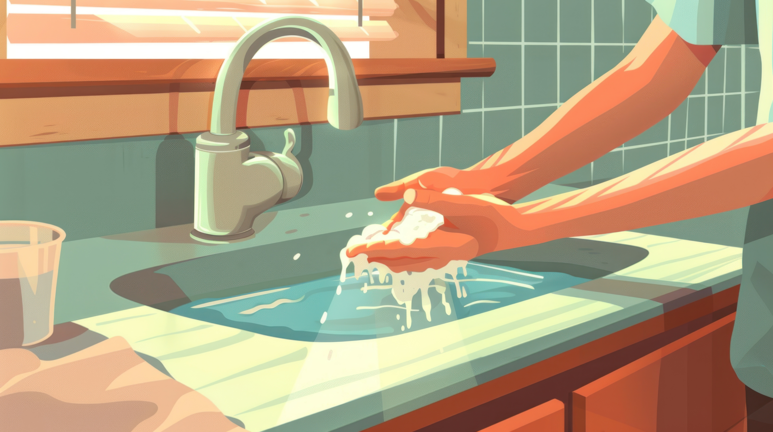

Handwashing

When handling food, you must wash your hands regularly and thoroughly.
Hands should be washed in the hand washing sink and not in the dishwater or food preparation sink.
When to wash your hands | How to wash your hands
- going to the toilet  - every break  - eating and drinking  - smoking  - handling raw food such as meat, chicken, and eggs  - blowing your nose  - using a tissue or handkerchief  - handling rubbish  - touching your ears, nose, mouth, or other parts of the body  - handling your mobile, keys or personal items  - touching animals and people. | - use the designated sink provided for just washing hands  - apply liquid soap and use warm water  - wash your hands for at least 20 seconds, including between your fingers, under your nails, the back of your hands, thumbs and wrists  - rinse under warm, running water  - dry your hands using a paper towel.

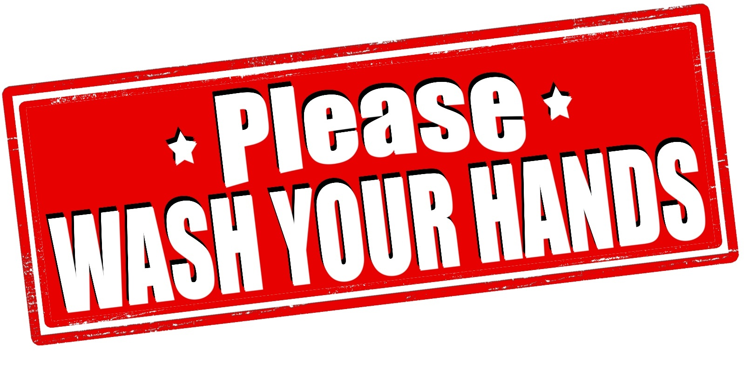

Changing Gloves

Gloves can be a great way to prevent contamination of the food you are preparing, but used incorrectly they can contaminate food just as easily as your bare hands.
Always wash and dry your hands before putting on new gloves.
Changing your gloves frequently is one of the best steps for making sure the food you handle and serve is safe.
Always change your gloves:
- between handling ready-to-eat and raw food
- after taking money or providing change to a customer.
- between different tasks
- if the gloves tear
- after taking the rubbish out
- after sweeping, mopping, and cleaning

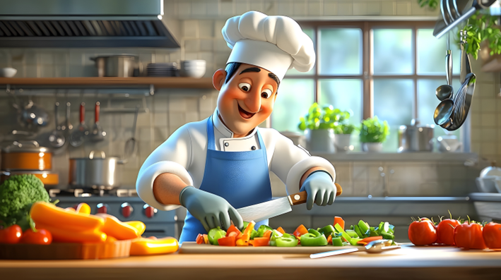

Food Handling

Defrosting frozen food
Bacteria stop growing when food is frozen, but freezing does not kill the bacteria.
Defrosting food correctly ensures the bacteria do not continue to grow and cause food poisoning.
Rules for defrosting frozen food
- defrost food thoroughly before cooking or reheating it
- frozen food should be defrosted either in a microwave, or in the fridge
- if using the fridge, defrost food on the bottom shelf, away from other foods just in case it drips as it is defrosting
- you can keep fully defrosted food in the fridge for a short time until it is ready to be cooked or reheated
- cook or reheat the food immediately if it is defrosted in a microwave
- allow plenty of time to defrost food thoroughly
- large cuts of meat or large chickens may take longer to defrost all the way through to the centre.
- do not re-freeze defrosted food
- do not defrost food on the bench; the external surface could be at room temperature with bacteria or other microorganisms growing quickly, while the centre is still frozen.

Cooking Temperatures
Cooking temperatures
- Cooking food to temperatures above 75°C kills most bacteria.
- Use a washed and sanitised thermometer to check that the thickest part, or the centre of the cooked food, has reached 75°C.
- Always serve or keep cooked food at 60°C or hotter.
- Whole pieces of red meat and fish can be cooked to preference, for example, steaks can be cooked medium rare. They do not need to be cooked to 75°C because bacteria will only be on the surface of the whole piece. Cooking will destroy the bacteria and minimise the risk of contamination.

Cooling
Food that has just been cooked or taken out of the oven to cool should be cooled as quickly as possible to prevent the growth of bacteria.
Hot food cannot be put directly into the fridge after cooking.
Putting hot food into a fridge may cause the fridge temperature to increase above 5 °C.
If the fridge temperature goes above 5 °C all other food stored in the fridge is at risk of growing bacteria.
You need to know the right time to put away food once it has been cooked.

Rules for cooling food | Storage of cooled food
To make sure that food is cooled quickly you should:  - stir cooked foods frequently to help the food cool  - take food out of the larger container you cooked it in and carefully put it into smaller containers so it will cool quicker  - monitor the temperature using a clean and sanitised thermometer  - allow cool air to circulate around the containers of food to be cooled.  - Food must be cooled to 21°C within two hours. | - once food has cooled to 21°C it must be put in the fridge, cool room or freezer to cool to below 5°C in the next four hours  - when food stops giving off steam it can be placed in cold storage  - cover and mark containers with the food type, the date, before putting in the cool room, fridge or freezer  - cool on racks and not on the floor of a cool room  - check that the temperature inside the fridge is below 5°C while cooling food.  - Once cooked food has cooled down it should not be left out of the fridge for any longer than two hours.

Reheating food safely

To reheat food safely you need to: | Pie warmers and bain-maries  are used to hold hot food for display.
- reheat food in the oven or microwave until it reaches 75°C or hotter in the centre.  - if reheated food is displayed it must be kept at 60°C or hotter.  - reheat and display food only once and throw it out if not eaten or sold - this will avoid the food being at temperatures that support the growth of harmful bacteria | It is important to:  - preheat the pie warmer or bain-marie before use  - ensure the temperature of the hot-holding equipment is set at 60°C or hotter to maintain temperature control  - heat or reheat the food quickly to a temperature of at least 60°C before being transferred to the hot-holding equipment  - dispose of any reheated food left over at the end of the day.  - It is unsafe to use the pie warmer or bain-marie to reheat the food as it takes too long and harmful bacteria will grow quickly.

Monitoring food temperature

The most important way to prevent bacteria from growing in food is to maintain it at the right temperature. The temperature of food is most accurately taken using a probe thermometer. The thermometer must be cleaned and sanitised before and after every use.

Always remember to FIX the problem if food is not at the required temperature, for example, continue to heat it or throw it out.

How to clean and use a probe thermometer  to check food temperature | Helpful tips
- wipe away any food waste or other visible contamination  - wash the probe with warm water and detergent  - sanitise using an appropriate sanitiser (for example, an alcohol wipe) or hot water (for example, 77 °C or hotter for at least 30 seconds)  - dry thoroughly by leaving to air dry or by using a single use towel  - insert the probe into the centre or thickest part of the food  - read the temperature (and record if applicable). | - put the probe into the thickest part of the food  - wash and sanitise the probe between every reading  - store the probe where all staff have access to it  - make sure the thermometer is calibrated regularly
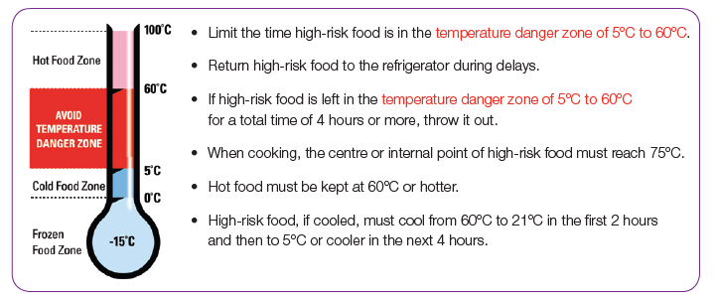
Image courtesy of the Victorian Department of Health

Food delivery, storage & display

It is extremely important to handle food correctly while it is being received, stored, prepared, and served.

Delivery
- refrigerated food is received below 5 °C
- frozen foods are frozen hard
- the hot food delivered has been kept above 60 °C
- eggs are not cracked or dirty
- the food packaging isn’t damaged
- the food is within its 'best-before’ or ’use-by’ date
- the foods are properly labelled
- the food storage area of the transport vehicle is clean
- there are no chemicals or anything other than food in the truck.
Do not accept the delivery if the food is not safe and suitable.

Storage
When you receive a delivery of food you need to store it in the appropriate storage area to help prevent contamination.
You should always follow the food storage instructions on the labels.
Depending upon the food being stored, there are several kinds of storage options available.
dry storage is for ‘dry’ foods that have a long shelf-life and can be kept at room temperature, such as flour, tea, coffee, dried pasta, sugar, canned food, biscuits, rice and other uncooked grains.
cold storage is for foods that must be kept in the refrigerator or cool room below 5 °C.
frozen storage is for foods that need to be kept frozen solid at -15 °C or colder.
Do | Don’t
- store cooked food above raw food  - check the refrigerator, freezer and cool room temperatures regularly  - keep the opening and closing of the fridge or freezer to a minimum  - regularly check food, in particular packaged food items, for signs of dampness, expired use-by dates, dented or rusty cans, holes in packaging or signs of pest infestation  - cover, label and date the food on delivery  - rotate the food stock by using the first in-first out rule  - clean and defrost the refrigerator and freezer on a regular basis  - tell your supervisor or manager if you notice a pest problem in the storage area. | - overload or over-stock the refrigerator, as the cold air won’t be able to circulate properly  - store food on the floor  - store food with items like chemicals, cleaning equipment, clothing and personal belongings  - store food in toilets.

Display
A selection of foods that are displayed for a customer to serve themselves or staff member to serve is an efficient way of serving many people at once but has the potential to increase the risk of food contamination.
The risks are often associated with customers hygiene. For example, touching, coughing, or sneezing on the food, mixing of one type of food with another, foods being out of temperature control, foreign objects falling into the food, and unclean serving utensils and equipment.
As a food handler it is important to ensure that the displayed food is not being contaminated by customers or staff.
Rules for self-service foods
- supervise the display when customers are accessing food from the display.
- quickly remove the food if someone has contaminated the food.
- food must be kept under 5 °C or above 60 °C to avoid the temperature danger zone.
- always use a clean and sanitised thermometer to check the temperature at the centre of the food.
- never use a pie warmer or bain-marie to heat up cold food. They are only designed to keep hot food hot.
- refresh food displays with completely fresh batches of food. Food poisoning bacteria can be transferred from an old batch of food to a new batch if the container has not been cleaned properly first.
- never re-use any self-service food.
- make sure that each food item or dish has its own serving utensil.
- ensure that the handles of the serving utensils do not touch the food as bacteria can be transferred from the customers hand to the utensil to the food.
- always remove utensils that have become contaminated from service and replace with a clean and sanitised utensil. This is especially important to prevent the transfer of allergens from one food to another.
- throw away ’single-use’ items after using them once, including gloves, straws, paper towels, cups and plates.

Ready to eat foods
Ready-to-eat foods are foods that do not require any further preparation and are eaten in the same state that they are sold in. For example, hot pies, sandwiches, pastries and noodle dishes.
As a general rule, the total time a ready-to-eat and potentially hazardous food can be kept in the temperature danger zone is four hours. Remember the temperature danger zone! Keep hot food HOT at 60 °C or hotter and cold food COLD at or below 5 °C.
Do | Don’t
- clean and sanitise utensils, like tongs, spoons and spatulas before use  - hold the food using a piece of food grade greaseproof paper, a paper serviette or a plastic bag turned inside-out  - cover or wrap ready-to-eat foods on display where people could handle, cough or sneeze on them  - be aware of how long the food has been on display and out of temperature control. | - use tags or labels directly on the food items  - touch the food with your bare hands without thoroughly washing them first.

Food Contamination

Food contamination occurs when something is found in food that shouldn’t be there. Contaminated food can be unsafe for consumption.

Causes of food contamination
There are three ways that food can be contaminated:
- biological hazards (microorganisms) including bacteria, fungi, yeasts, mould and viruses
- chemical hazards, including cleaning chemicals or foods with naturally occurring toxins, such as green potatoes
- physical hazards including dangerous physical objects such as plastic, glass, elastic bands, wood chips or bandages.
Beware! Selling contaminated food could lead to customer illness or injury, legal action taken by the local council and the customer, bad publicity including the closure of the premises or loss of your job.
- You must follow the correct food handling techniques to ensure that food is not contaminated.

Where do bacteria come from?
Food poisoning is most often caused by bacteria that have been able to multiply or form a toxin in the food.
Bacteria and other microorganisms can be found in soil, on animals, on people and on the things, people touch and use.
One of the greatest threats to food safety is the fact that bacteria can multiply from just a few cells to millions in a very short period of time.

Some of the factors that affect the growth of bacteria include:
- the temperature of food
- the moisture content of food
- the time they have to grow in food, particularly food kept in the danger zone of 5°C to 60°C.
- exposure to air.
Bacteria will not grow quickly if these factors are controlled.
Anyone who eats contaminated food can get food poisoning; however, vulnerable people are at higher risk of developing severe symptoms from unsafe food. Food poisoning symptoms can appear within an hour or two, but may take up to 36 hours to appear.

Food poisoning bacteria
- can multiply quite quickly given the right conditions.
- food poisoning bacteria does not affect the smell, taste, or appearance of food.
- food poisoning is caused by contaminated food that has been poorly handled, stored or not cooked properly.
- you cannot tell just by looking at a food whether it has been affected by food poisoning bacteria.
It is important to take steps to prevent food from being contaminated in the first place.

Certain types of food allow quick growth of bacteria because they are generally moist and high in nutrients. These are called high-risk foods.
Foods that are less able to support bacterial growth are called low-risk foods. Low-risk foods do not need to go in the fridge and are typically dry foods.
High-risk foods | Low risk foods
- dairy products (such as custard and cream)  - meat  - poultry  - seafood  - cooked rice  - cooked pasta  - sliced delicatessen meats  - prepared salads, such as coleslaw, pasta salads and rice salads  - prepared fruit salads  - foods containing eggs* (cooked or raw)  - ready-to-eat foods containing any of the above foods, for example sandwiches and sushi. | - cereal  - flour  - confectionery  - sugar  - dry biscuits  - spices  - uncooked grains.
*Eggs and risk
Eggs, especially raw and lightly cooked eggs have been associated with a large number of food poisoning outbreaks as bacteria can be found on the shell or inside an egg, especially if it is cracked or dirty. Foods that contain raw or just cooked eggs are at higher risk of food contamination and food poisoning.

Menu items commonly associated with food poisoning are sauces such as mayonnaise, aioli and hollandaise; spreads, such as 'egg butter'; desserts, such as mousse and tiramisu; and drinks, such as eggnog and high-protein smoothies.
To handle eggs safely:
- wash your hands after handling eggs
- do not use dirty or cracked eggs; these eggs should be thrown away
- do not wash eggs as it makes it easier for bacteria to penetrate the shell
- refrigerate the egg product immediately after preparation as refrigeration will slow the growth of bacteria
- keep egg-based foods refrigerated until just before they are to be consumed
- foods with egg sauces must be prepared just before service and held only for the service period
- prepare only enough product to be used on the same day
- thoroughly clean and sanitise stick blenders, mixers and other equipment.

Temperature Danger Zone
An important part of food safety is food temperature and storage.
Bacteria can grow on food that isn’t kept at the correct temperature.
Correct temperatures | Temperature danger zone
Keep hot food HOT at 60°C or hotter.  Keep cold food COLD at or below 5°C.  Keep frozen food FROZEN at or below -15°C. | The ideal temperatures for bacteria to multiply is between 5°C and 60°C.  Food should be kept between these temperatures for as little time as possible.  Bacteria multiply quickly especially in high-risk food.

2-hour/4-hour rule
Your business may use the 2-hour/ 4-hour rule for displaying high-risk food, the 2-hour/ 4-hour rule uses time to keep food safe when it is in the temperature danger zone of 5°C to 60°C.
The total time includes all the time the food has been at room temperature, for example during delivery, display, preparation, and transportation.
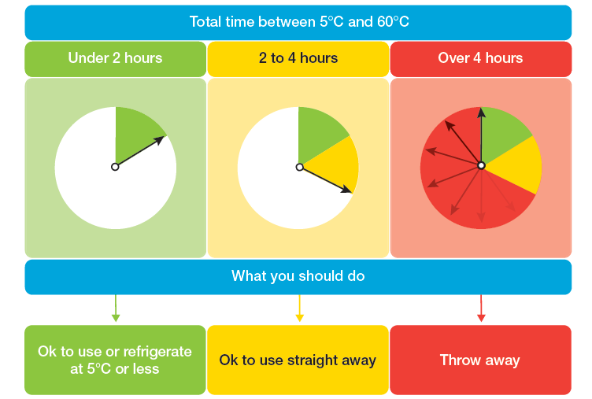
Courtesy of the Victorian Department of Health

Cross-contamination
Cross-contamination occurs when harmful bacteria or allergens spread to food from other food, surfaces, hands, or equipment.
It can occur if equipment used for raw food preparation is then used for cooked or ready-to-eat food or between foods that cause allergic reactions and other foods.
Food poisoning can occur when bacteria in raw food (such as meat juice) comes in contact with cooked or ready-to-eat food and the bacteria then have the chance to grow.
It is your responsibility as a food handler to prevent cross-contamination.
Do | Don’t
- keep raw meat, eggs and vegetables away from cooked food  - keep cooked meat above raw meat in the refrigerator  - keep food covered and protected  - clean and sanitise all equipment and benches  - store food at the right temperatures  - wear clean clothing  - wash hands before handling food  - wash your hands after handling raw meat, chicken, seafood and eggs  - have separate chopping boards for raw and cooked meats if possible. | - chop raw and cooked meat on the same chopping board without washing and sanitising the board between use  - handle raw and then cooked food without washing your hands  - use food handling gloves for handling money  - store food uncovered in the fridge or cool room  - have uncovered foods on display where they may be handled, touched, coughed, or sneezed on.

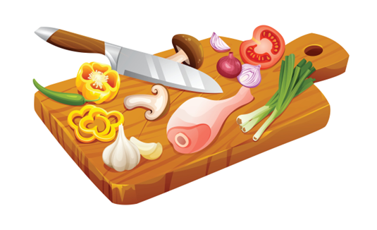

Cleaning & sanitising

When you work in the food industry, apart from other food handling tasks, you may also be responsible for certain cleaning and sanitising tasks.
Reasons for cleaning and sanitising
- helps to prevent disease and food poisoning
- will keep your customers satisfied about the quality and safety of the food that you serve
- helps prevent food from becoming contaminated
- ensures that all your equipment remains clean and well–maintained
- helps to keep disease-spreading pests away.
- ensures a safe and hazard free work environment

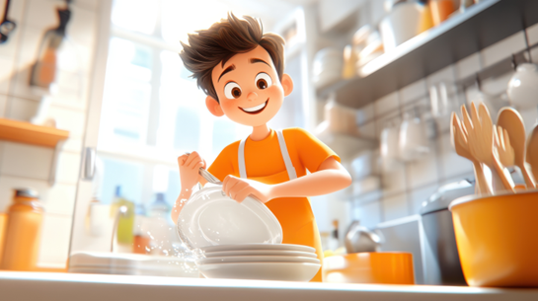

Cleaning
Involves removing grease, food, dust, stains and other contamination—including smells and tastes—from food preparation surfaces and equipment.
Detergents like soap remove the grime, grease, food, dust and stains. They do not kill bacteria.
This is why, after cleaning, you must sanitise the food preparation surfaces and equipment.
Clean as you go as it will save you time and effort in keeping food preparation areas and premises clean.

Sanitising
Sanitising is a necessary and required step to ensure that food is as free as possible from microorganisms that can cause foodborne illness.
When used properly, sanitisers will kill or reduce microorganisms to safe levels.
Sanitising can be achieved through using hot water, chemicals, or other processes.
Some examples are:
soaking items in very hot water
soaking items in diluted bleach
applying a commercial food grade sanitiser, following the instructions, and leaving it on for the required time period.
A sanitiser will only work if food preparation surfaces or equipment have been thoroughly cleaned first.
It is important to
- follow the instructions as too little sanitiser will not reduce the level of harmful microorganisms to a safe level and too much will leave residues which may be harmful
- check, if using diluted sanitiser, when the sanitiser batch was made up as it has a short shelf-life
- pay special attention to blenders, stab mixers, meat slicers and can openers - you may need to dismantle them to get access to properly clean and sanitise them
- leave equipment to thoroughly air dry (bacteria can be transferred from partially dried equipment to food)
- use clean, dry and ideally single use towels because if they get contaminated they may then transfer harmful microorganisms between items
- not repeatedly use tea towels without washing and drying between uses.
- Most food poisoning bacteria are killed if they are exposed to chemical sanitisers, heat, or a combination of both.

Disinfectants
Disinfectants are not sanitisers they are very strong chemicals which are more suitable for toilets and floors than for food contact surfaces, they often have a strong smell and should be used with caution.

Dishwashers
Dishwashers have been shown to consistently perform better than washing dishes by hand. Commercial dishwashers use hot water temperatures that sanitise the dishes.
If using a dishwasher
- always follow the manufacturer's instructions
- set the correct cycle, the longest hottest cycle is usually recommended
- scrape or rinse off excess food from utensils and dishes
- load the dishwasher correctly allowing space around each item for water to reach all surfaces
- use an appropriate detergent
- use clean hands to unload the dishwasher
- visually check the utensils and dishes are clean and dry when unloading the dishwasher
- ensure the dishes and utensils are thoroughly dry before use.

Rubbish
Rubbish is an unavoidable by-product of working in the food industry. It is important to learn how to handle and dispose of it correctly. By doing this you will minimise the risk of contamination, odour and pests.
- Kitchen rubbish bins are not required to have lids. Lids can cause cross-contamination if a food handler touches the dirty lid and then food.
- Kitchen rubbish bins must be emptied regularly, that is, after each meal service or more often if full.
- Wash out each kitchen bin with hot soapy water if required, and line it with a plastic bin liner.
- Always wash your hands after touching, emptying, or washing out a bin.
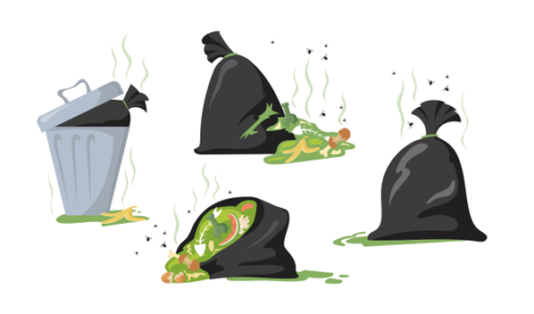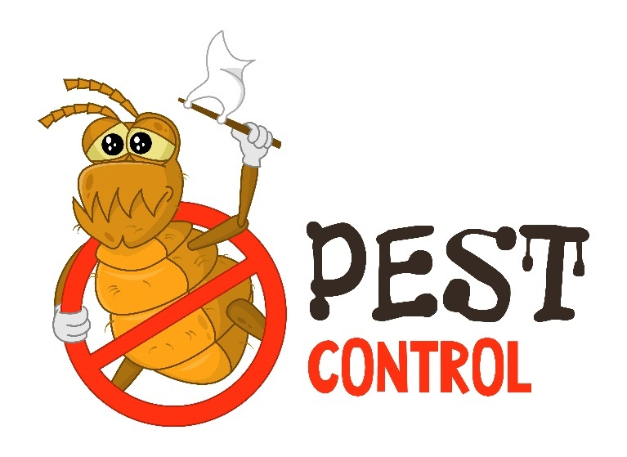

Pest and animal control
Food preparation and storage areas are much less attractive to pests when they are kept clean. This is important because pests spread disease and bacteria through physical contamination and droppings. They can cause food poisoning and damage equipment. Pests like to live in areas that are dark, undisturbed, and where there is access to food and water. You must ALWAYS keep pests out of food preparation and handling areas.
Preventing pests | Getting rid of pests
- never permit animals, including pets, in any place where food is prepared, stored or transported  - report any signs of pest activity, such as droppings, fur or scratch marks  - remove rubbish regularly  - ensure bins do not overflow  - put lids on outside rubbish bins  - keep doors closed when not in use  - store food and equipment off the floor  - store food in sealed containers. | - report the pest activity to your supervisor or manager  - follow instructions given by the supervisor or manager  - if using sprays or baits follow the instructions on the label  - remove dead pests  - label bait stations with the date they were set  - remove any accumulated rubbish.  - If a licensed pest controller is hired, ensure that food and surfaces are protected from chemical contamination.
Helpful tips
- Regularly check pest-prone hiding places, for example, under sinks.
- Ensure that insect zappers, spray dispensers, ultraviolet insect killers are not located above food preparation or packaging areas.
- Report any cracks or holes in floors, ceilings, walls and fly-screens.

Food allergens and intolerances
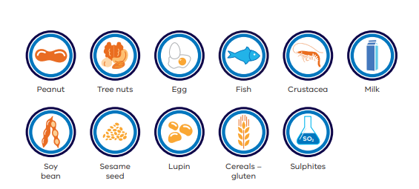
Courtesy of Victorian Department of Health
As a food handler it is important that you have an understanding of food allergies and food intolerances.
An allergy is an overreaction by the body’s immune system to a normally harmless substance.
Food is a common cause of allergic reactions which are becoming more common in Australia.
The allergic reaction to food is caused by a protein in the food that the immune system mistakenly believes is harmful.
A food intolerance is easily confused with a food allergy, but they are different because food intolerances:
- do not involve the immune system
- are slower in onset
- are not life threatening.

Common food allergies and intolerances
There are eleven food allergens that you must be able to advise customers of if they ask if they are present in the food you sell.

- cereals containing gluten and their products – namely wheat, rye, barley, oats and spelt
- shellfish, crustaceans and their products
- egg and egg products
- fish and fish products
- milk and milk products
- peanuts and peanut products
- tree nuts and tree nut products (this does not include coconut)
- sesame seeds and sesame seed products
- soybean and soybean products
- added sulphites in concentrations of 10mg/kg or more
- lupin and lupin products.

In addition to the eleven allergens listed above, there are many other foods that can cause allergic reactions for people, such as kiwi fruit, banana, mustard and celery.
Listen to the customer,
even if their allergy is not included in the list above and
treat their inquiries very seriously.

Food handler responsibilities

Do | Don’t
- be absolutely sure you understand the customer's needs and are giving them correct information  - ask your manager or chef if you don’t know or are unsure  - ask if your workplace has a way of identifying meals that are to be delivered to an allergic customer, such as using different coloured plates  - when delivering the meal, identify the allergen free product to ensure it is given to the right customer  - use separate, clean utensils, cutting boards and kitchen equipment for customers with a food allergy  - call an ambulance if a customer has trouble breathing, tightness and swelling of their throat and tongue and is faint or collapses. | - ever guess what is in a food. If you don’t know ask - your guess could prove fatal to your customer  - remove an allergen from a finished meal. For example, take the nuts off a plate of food thinking that this is a safe meal to provide to a customer with a nut allergy. It is not, even the smallest trace can cause anaphylaxis and death.

Remember
- It is extremely important to use clean and sanitised or separate utensils, cutting boards and cooking equipment when making food for a customer with an allergy.
- Even the smallest amount of the allergen on surfaces can cause an allergic reaction.
- Cooking and heating do not destroy allergens in food.
- Even cooking on the same grill or in a deep fryer may trigger an allergic reaction for the customer if the cooking equipment hasn't been cleaned and sanitised and has previously been used to prepare food that was not allergen free.

Food safety at a sausage sizzle

How to set up for a sausage sizzle
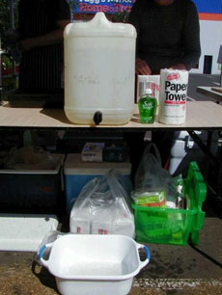

- Food handlers must use soap and warm water to wash their hands.
- Single use paper towel to be used to dry hands.

- Sausages must be stored below 5 degrees Celsius,
for example sausages must be kept in an esky with enough ice to maintain this temperature, or in a fridge.
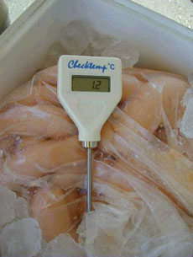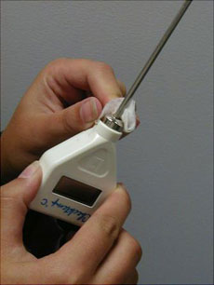

- Ensure that the thermometer is sterilised before it comes into contact with food.
- Use alcohol swabs or boiling water to sterilise probe.

What to do during your sausage sizzle

Cooking:

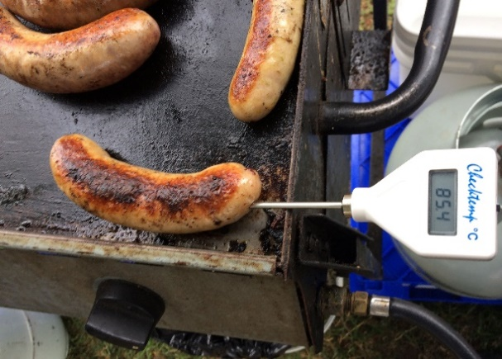
- When cooking, make sure that raw food does not come into contact with cooked food.
- Meat must be cooked to at least 75 degrees Celsius.

Displaying and serving:

- Different utensils and plates must be used when handling raw meat and cooked meat.
- Food handlers must wash their hands in between handling raw and cooked meat.
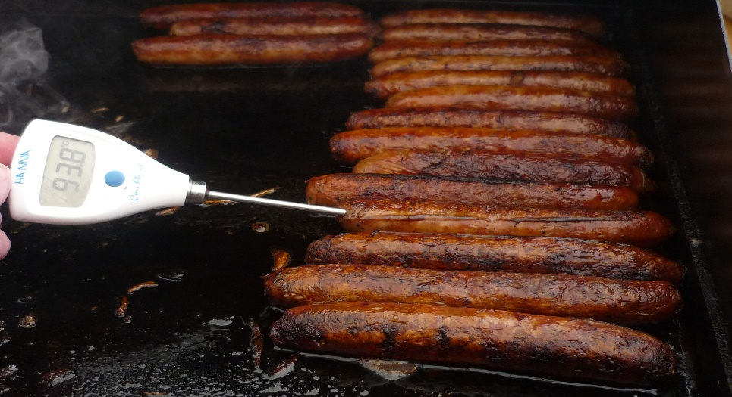

- Tongs or disposable gloves must be used when handling cooked meat and ready to eat food, such as bread.
- Disposable gloves must be changed often or immediately if they tear or if the food handler changes tasks.

Acknowledgements

Department of Health Victoria Food Safety information pages including:
Information for community groups and fundraising with food
Food businesses – information and resources for Victorian food businesses
Food safety library - publications, guides, resources and posters
Food allergens
DoFoodSafely

NSW Food Authority

Food Standards Australia and New Zealand

Allergy & Anaphylaxis Australia

All about Allergens training for food service industry

Further information
Contact Environmental Health at contactus@geelongcity.vic.gov.au

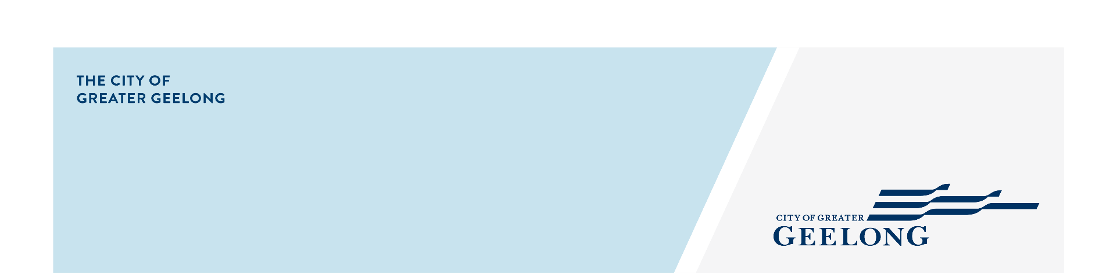

Poster - Basic Food Safety - Golden Rules

All food Handlers

As a food handler it is your responsibility
to ensure you are providing safe and suitable food.
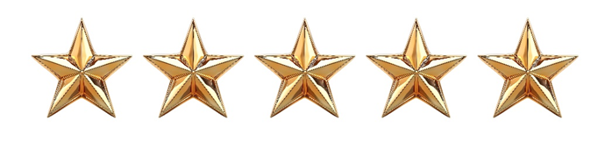
Golden Rules of Food Safety
All food handlers

- WASH & DRY HANDS THOROUGHLY IN THE HAND WASH BASIN ONLY, USING SOAP AND PAPER TOWELS
  - Entering the kitchen at the start of shift or after a break
  - Throughout your shift
  - After handling raw foods
  - After using a handkerchief or tissue
  - After using the toilet
  - After handling garbage
- IF YOU WEAR GLOVES, change them when you would wash your hands.
- KEEP IT CLEAN. Clean as you go.
- KEEP FOOD AT THE CORRECT TEMPERATURE, OUT OF THE TEMPERATURE DANGER ZONE; Keep hot food hot (>60˚C) and cold food cold (<5˚C)
- DO NOT PREPARE OR HANDLE FOOD IF YOU ARE SICK OR HAVE UNPROTECTED CUTS OR SORES ON YOUR HANDS. Remember, cuts and sores can be protected by waterproof bandages and gloves.
- NEVER SMOKE OR VAPE in or around food areas.
- DO NOT EAT in food preparation or service areas.

- UNSURE OF ANYTHING - ASK THE PERSON IN CHARGE

Poster - Basic Food Safety - Golden Rules

Person in charge/Food Safety Supervisor
Chefs & Cooks

As a food handler it is your responsibility
to ensure you are providing safe and suitable food.
Golden Rules of Food Safety
Person in charge / food safety supervisor / chefs & cooks

- DEFROST FOOD IN THE FRIDGE (or microwave if needed urgently), DO NOT RE-FREEZE THAWED FOOD
- COOL ROOM / REFRIGERATOR
- Keep all shelves, walls, and floor clean.
- Do not store food bowls on top of each other.
- Keep raw and cooked food separate – Raw on bottom shelves cooked on top shelves.
- Do not place anything on the floor.
- Do not overload the fridge.
- Date label food.
- STORE FOOD AND EQUIPMENT PROPERLY
- AVOID CROSS CONTAMINATION
- CLEAN AND SANITISE ALL UTENSILS, EQUIPMENT AND BENCHES PROPERLY, remember to clean and sanitise your benches at the start of the shift – you may not have been in the kitchen for a few days.
- KEEP PREMISES FREE OF PESTS

- UNSURE OF ANYTHING - ASK THE PERSON IN CHARGE

Poster- Keep hands clean and food safe
Courtesy of the Victorian Department of Health
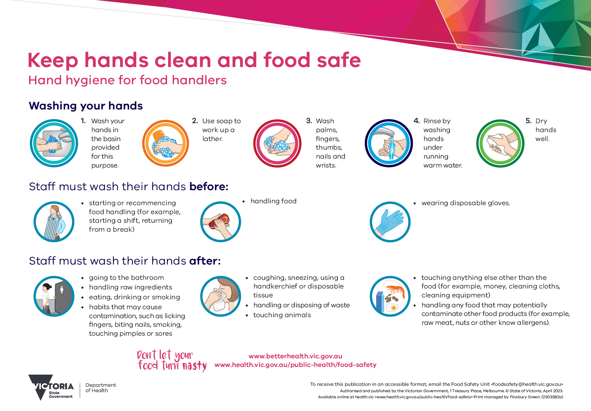

Poster- Food Safety Rules
Courtesy of the Victorian Department of Health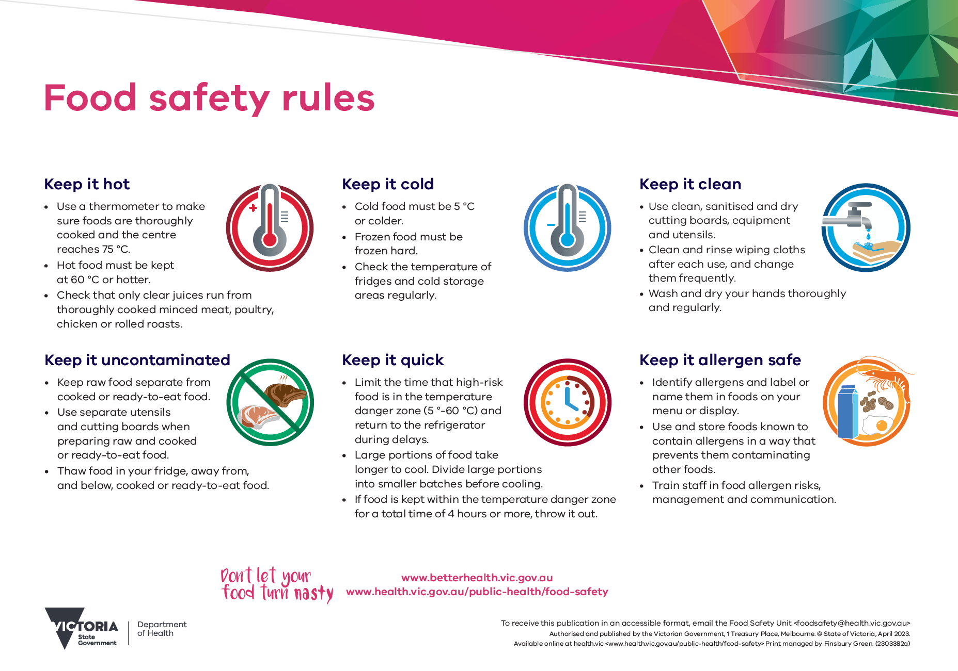

Poster – Temperature Zones
Courtesy of the Victorian Department of Health

