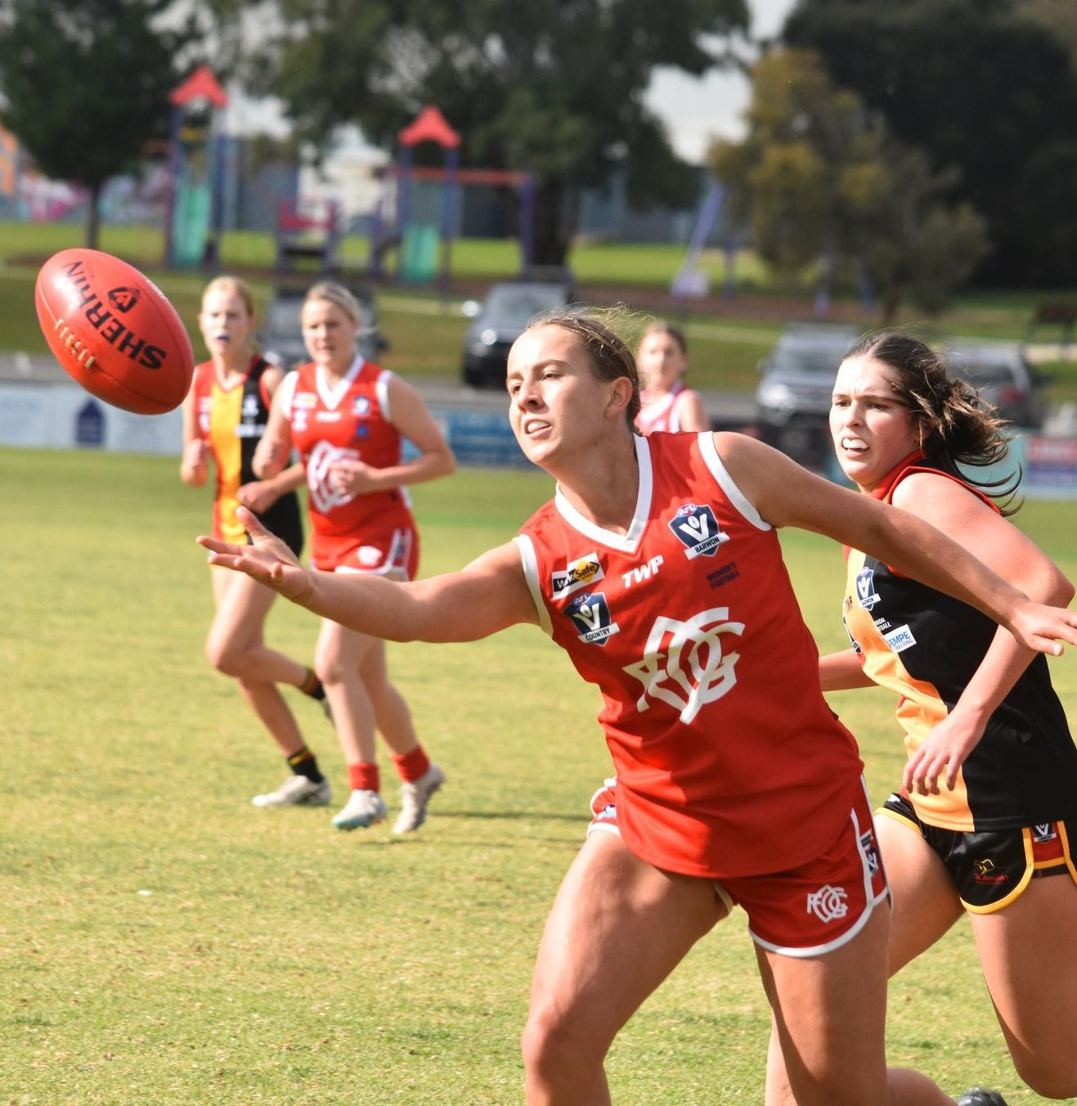





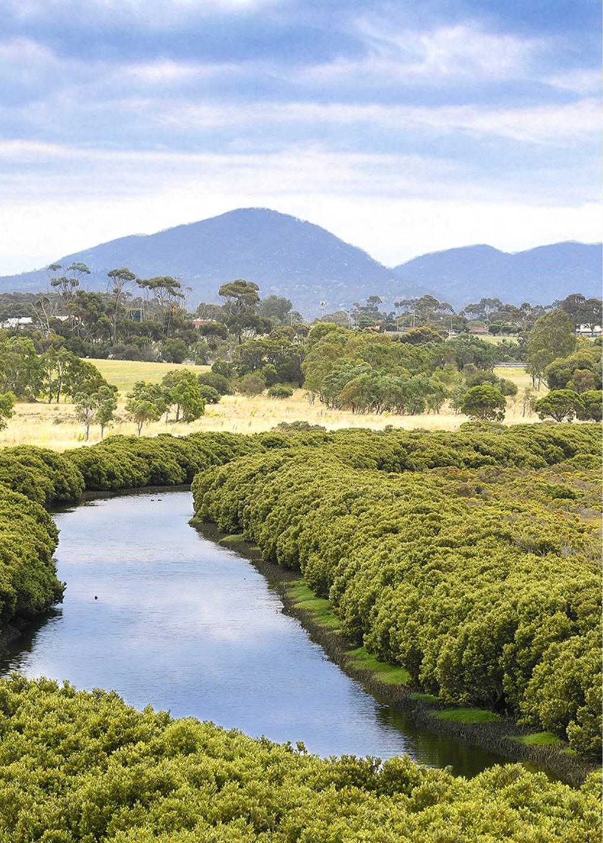


|

CONTENTS

EXECUTIVE SUMMARY 4
BACKGROUND & CONTEXT 6
About Ocean Grove 7
About the OGSI P 8
Strategic Context 9
Club Participation 10
Participation Trends 11
FACILITY DEMAND ASSESSMENT 12
CLUB AND FACILITY USER NEEDS 15
STRATEGIC FRAMEWORK 18
RESERVE SUMMARIES 20
Shell Road Reserve 22
Memorial Reserve 24
Collendina Reserve 26
Devlins Road Reserve 28
Arthur Powell Reserve 30
Wallington Recreation Reserve 32
IMPLEMENTATION PLAN 34

OCEAN GROVE SPORTING INFRASTRUCTURE PLAN | 3

EXECUTIVE SUMMARY

The Ocean Grove Sporting Infrastructure Plan 2025 (OGSI P) establishes the priorities for the development of sporting reserves across Ocean Grove and Wallington to ensure our community can participate in a diverse range of sport and recreation activities.
The update of the previous Ocean Grove Sporting Infrastructure Plan (2010) identifies changes in sports participation, club needs and community demographics, all of which are driving the need for increased provision of sporting infrastructure.
Ocean Grove and Wallington are growing at a steady rate, with the population forecast to reach approximately 24,000 residents by 2035, representing 14.6% growth over a 10- year period.
Club participation has been growing across the majority of existing sports over the last five years, with a number of clubs struggling to meet demand due to the limitations of existing facilities:

Participation Growth

Sport | 2019 | 2024 | +/-
Baseball | 100 | 116 | +16 (+16%)
Cricket | 441 | 435 | -6 (-1%)
AFL | 701 | 1044 | +343 (+49%)
Soccer | 280 | 495 | +215 (+77%)
Netball | 176 | 250 | +74 (+42%)
Tennis | 420 | 369 | -51 (-12%)

The OGSI P provides a plan to improve the provision of infrastructure for community sport across Ocean Grove and Wallington.
The key pillars of the OGSI Pare:
- Facility Provision: The Ocean Grove and Wallington community has access to sports facilities that support future growth and provide a diversity of opportunities to participate
- Sustainable Clubs: Our clubs are successful and sustainable, with access to high quality facilities that meet user needs and enable efficient club operation
- Access & Inclusion: Our facilities are accessible and inclusive, creating more opportunities for all people to play, officiate, volunteer and spectate

The OGSI P identifies the need to retain existing facilities as well as provide additional infrastructure to support participation, including:
  - An additional baseball diamond
  - An additional oval for AFL/Cricket
  - An additional court for Netball
  - Additional pitches for Soccer; and
  - Retention of existing tennis courts.
To enable the continued growth of sports participation and the health of local clubs, the OGSIP identifies opportunities to improve infrastructure across six reserves (see Key Development Priorities on page 5).
The staged implementation of the OGSIP will ensure that the residents of Ocean Grove and Wallington are healthy, active and connected.

KEY DEVELOPMENT PRIORITIES

Across the six sporting reserves identified within the OGSI P, the following infrastructure development priorities are:

Shell Road Reserve
- Construct a second oval on the site of the existing soccer pitches and upgrade other infrastructure including change rooms, amenities and canteen.
- Upgrade and expand the cricket practice facility (one additional lane) and provide an adjacent cricket storage facility.
- Construct one additional undercover netball court (show court) and provide fit­ for-purpose off-court netball facilities.

Collendina Reserve
- Upgrade the pavilion to provide compliant gender-neutral player and umpire change rooms, and improved social and kitchen facilities.
- Upgrade the cricket practice facility, including the installation of a fourth lane.

Devlins Road Reserve
- Construct soccer pitches, a pavilion and associated supporting infrastructure in the southern section of the reserve to support the relocation of Ocean Grove Soccer Club to the reserve.

Memorial Reserve
- Complete detailed investigations and preliminary design work to determine the viability of an extension of the recreation hall to the west.

- Upgrade the pavilion, including the provision of gender- neutral player and umpire change rooms, and additional storage space for user groups.

Arthur Powell Reserve
- Reconstruct the two public tennis courts to provide two new compliant acrylic courts with sportslighting.

Wallington Recreation Reserve
- Redevelop the existing senior baseball diamond to comply with guidelines and plan for a future second junior-sized diamond as demand is demonstrated.
- Upgrade the pavilion to provide gender­ neutral player and umpire change rooms, improved social and kitchen facilities, and public toilets.

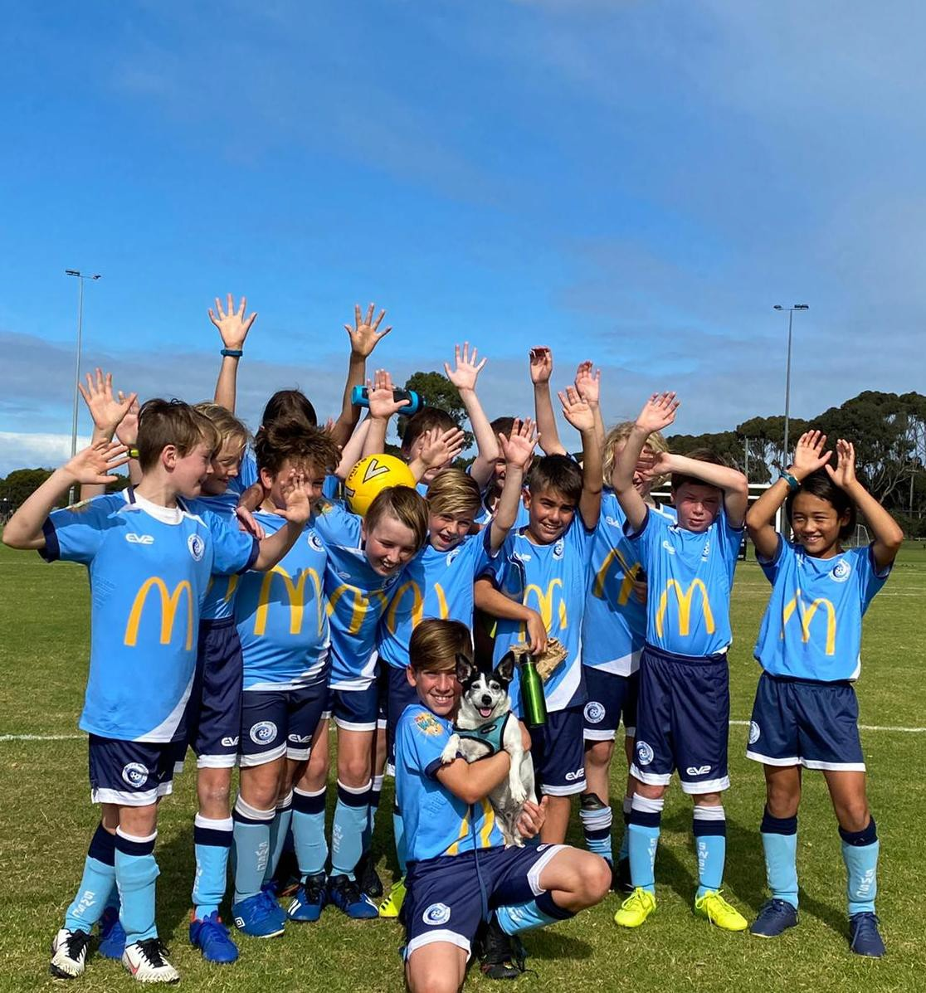



ABOUT OCEAN GROVE

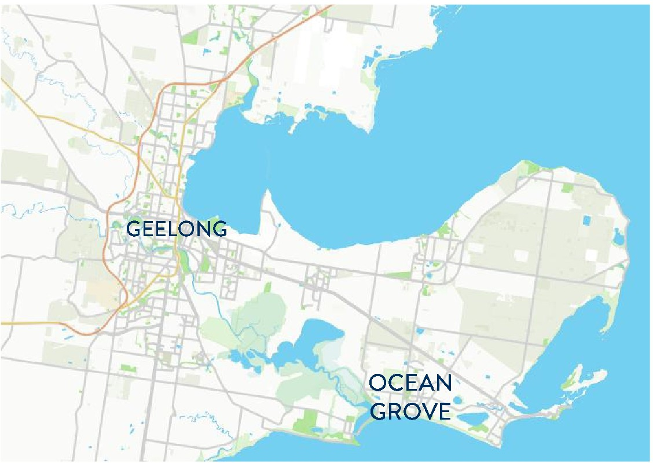
Ocean Grove is a coastal community on the Bellarine Peninsula, approximately 23 kilometres south­ east of Geelong.
Renowned for its pristine beaches and natural environment, Ocean Grove is a growing community, with the population forecast to grow to over 24,000 by 2035, representing an increase of 14.6%.

The total number of residents in the 'active age' cohort (5-39 years), will grow by 9.5% by 2035, increasing the demand for community sporting infrastructure.

The older adults cohort (60+ years) is projected to have the largest increase, growing by 28.6% by 2035.

The demographic profile of Ocean Grove represents a growing community, with the total number of residents to increase across all age cohorts other than a marginal decrease in the number of young children (0-4 years).

21,015
Projected Population 2025

+3,073

Population 2025-2035
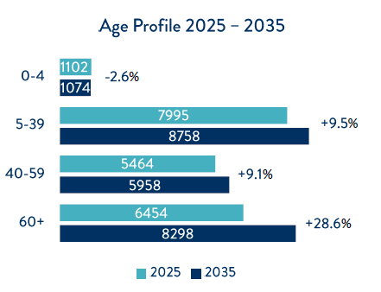

24,088
Projected Population 2035

+14.6%

% Growth 2025-2035

Source: Victoria in Future
Catchment: Ocean Grove Statistical Area Level 2 (SA2)

ABOUT THE OCEAN GROVE SPORTING INFRASTRUCTURE PLAN

The Ocean Grove Sporting Infrastructure Plan (OGSI P) establishes the investment priorities for sporting facilities within Ocean Grove to meet the needs of a growing and active community.
The OGSI P 2025 builds on the original Ocean Grove Sporting Infrastructure Plan developed in 2010 (OGSIP 2010). Since the development of the OGSIP 2010, Ocean Grove has continued to grow, placing additional pressure on facilities.

Planning for Change: OGSIP 2010

The OGSIP 2010 established the sporting infrastructure needs of Ocean Grove, with a focus on the transformation of Shell Road Reserve to cater for the needs of Ocean Grove Soccer Club (formerly Surfside Waves Soccer Club) and the transition of the Ocean Grove Football Netball Club and Ocean Grove Cricket Club to the site.

The OGSIP 2010 was successful in delivering investment in priority projects, including the development of the new pavilion, netball courts and cricket practice facility, and upgrade of the oval and soccer pitches.

The outcome of the OGSIP 2010 saw the successful co-location of Australian football, cricket, soccer, netball and tennis at Shell Road Reserve.

A New Perspective: OGSI P 2025
Since the implementation of the key priorities from the OGSIP 2010, participation in organised sport has continued to grow across Ocean Grove and Wallington, with a number of clubs now requiring additional infrastructure to support demand.

The co-location of sports at Shell Road Reserve has also led to conflicts in usage of facilities between clubs, as well as club activities being split across multiple reserves throughout the township.

The OGSI P 2025 examines the future needs of sports clubs and the community to determine the best use of facilities to support growing participation and accessibility.

Key objectives of the OGSI P 2025:

- Assess the adequacy of sporting infrastructure provision to meet the current and future needs of the Ocean
Grove and Wallington community

- Examine trends in sports participation and the implications for sporting infrastructure needs

- Establish the sporting infrastructure development requirements to meet club, user group and community needs

- Update existing reserve master plans and develop master plans for new active open space

- Prepare a prioritised implementation plan for recommended projects

STRATEGIC CONTEXT

The development of the OGSI P 2025 has been informed by a range of plans and strategies, ensuring that the OGSI P aligns with local, municipal and regional directions for community infrastructure and sporting facilities.

Ocean Grove Sporting Infrastructure Plan 2010 (OGSIP 2010)
The OGSIP 2010 was prepared to guide the future development of Shell Road Reserve, Collendina Reserve and Memorial Reserve.
The Plan focused on the improvement of Shell Road Reserve to better provide for the needs of Ocean Grove Soccer Club
(formerly Surfside Waves Soccer Club) and enable the transition of Ocean Grove Football Netball Club and Ocean Grove Cricket Club to the site from Memorial Reserve.
The implementation of the OGSI P 2010 has seen the delivery of a new pavilion at Shell Road Reserve, upgraded oval and soccer pitch surfaces, construction of four new netball courts and new cricket practice facilities.
Existing netball courts at Memorial Reserve were decommissioned and sportslighting upgraded at Collendina Reserve.

Ocean Grove Structure Plan (Amended 2016)
The Ocean Grove Structure Plan provides a strategic framework for the development of Ocean Grove, ensuring that future growth and development is supported while retaining the character of the coastal township.
Key directions from the Structure Plan relevant to sporting infrastructure include:
- Development of a regional public open space (8 ha) in the north-east growth
area, including two ovals, netball courts, pavilion and informal park facilities through the use of developer contributions (partially actioned and superseded by site master plan)
- Develop Shell Road Reserve, including a $6 million pavilion, to be shared by Ocean Grove Football Netball Club, Ocean Grove Cricket Club and Ocean
Grove Soccer Club (formerly Surfside Waves Soccer Club) (actioned)

Other plans and strategies that have influenced the development of the OGSI P 2025 include:

- Our Community 2021-2025 (Council Plan)
- Social Infrastructure Plan - Generation One 2023-2025
- Bellarine Peninsula Distinctive Areas and Landscapes
- Ocean Grove Principal Pedestrian Network: Consultation Findings (2016)
- Fair Play Strategy 2017
- G21 Regional Football (Soccer) Strategy 2023- 2033
- G21 & Cricket Victoria Barwon Regional Strategy (2019)
- G21 & AFL Barwon Towards 2030 (2020)
- Barwon Tennis Strategy 2024-2034

CLUB PARTICIPATION

Participation in organised sport in Ocean Grove and Wallington has grown significantly between 2019 and 2024, with sporting clubs attracting new participants and participation rates continuing to increase.
All club-based sports have attracted new participants over the five-year period to 2024, with existing sporting infrastructure under pressure to cater for growing demand.
With the population of Ocean Grove and Wallington forecast to grow to by 14.6% by 2034, participation in organised sport is expected to continue to increase, with additional sports facilities provision required to cater for demand.
Participation by Club
Sport / Club | 2019 Participation | 2024 Participation | 2019-2024 Growth | Participation Rate
 |  |  |  | Ocean Grove / Wallington | Victoria*
Baseball  Bellarine Bears Baseball Club | 100 | 116 | +16 (+16%) | 0.6% | 0.2%
Cricket  Ocean Grove Cricket Club  Collendina Cricket Club  Wallington Cricket Club | 441  191  170  80 | 435  65  183  187 | -6 (-1%)  -126 (-67%)  +13 (+8%)  +107 (+134%) | 2.1% | 2.7%
AFL  Occean Grove FNC (Football)  Ocean Grove Cobras Junior FC | 701  301  400 | 1044  440  604 | +343 (+49%)  +139 (+46%)  +204 (+51%) | 5.1% | 4.6%
Soccer  Ocean Grove Soccer Club | 280 | 495 | +215 (+77%) | 2.4% | 2.8%
Netball  Ocean Grove FNC (Netball) | 176 | 250 | +74 (+42%) | 1.2% | 2.7%
Tennis  Ocean Grove Tennis Club | 420 | 369 | -51 (-12%) | 1.8% | 3.5%

*Note: Victorian Participation Rate is derived From the Aus Play Victorian Club Participation Rates (collated data 2015-2023)
Club participation rate for baseball is not available, with the overall participation by activity rate used for comparison purposes

PARTICIPATION TRENDS

Trends in participation continue to evolve, with communities participating in ways that are driving the need for increased sporting infrastructure provision.
The national AusPlay participation survey identified the top club-based participation sports within the City of Greater Geelong between 2015-2023 (see below) and sets a baseline for the type and frequency of participation undertaken by adults and children (2022-2023).

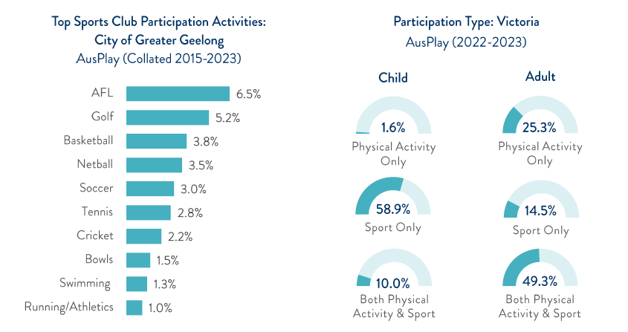

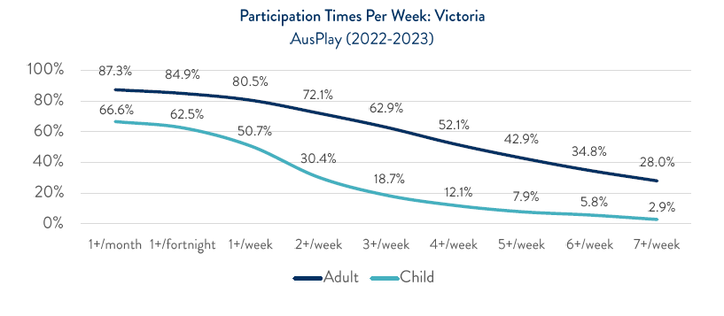
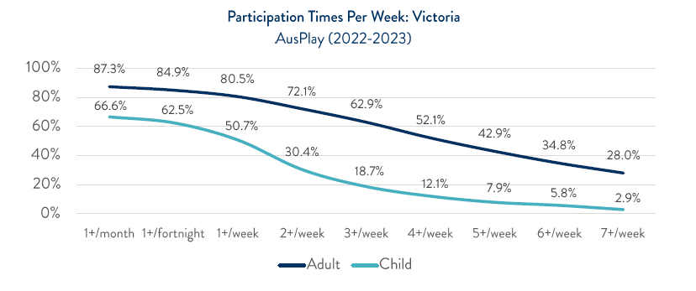





FACILITY DEMAND ASSESSMENT

Ocean Grove and Wallington must increase sports facility provision to cater for growing population and participation rates across the community.
An assessment of facility demand supports the need for sports facility development relative to population provision ratios and participation growth over the next 10 years.

Facility Provision by Population
.

Facility Type | Current Provision | Provision Ratio | 2025 |  | 2035
Facility Type | Current Provision | Provision Ratio | Provision Required | Surplus / Deficit | Provision Required | Surplus / Deficit
Baseball diamond | 1 diamond | 1:40,000 | 0 | +1 | 0 | +1
Cricket oval | 6 ovals | 1:4,000 | 5 | +1 | 6 | 0
AFL oval | 4 ovals | 1:5,000 | 4 | 0 | 5 | -1
Soccer pitch | 2 pitches | 1:5,000 | 4 | -2 | 5 | -3
Netball court | 5 courts | 1:5,000* | 4 | 0 | 5 | -1
Tennis court | 17 courts | 1:3,000 | 7 | +10 | 8 | +9

*Note: The netball court provision ratio has been calculated by applying the Netball Victoria participant-to-court ratio For regional areas (1:60) to determine the current number of courts required and calculating an adjusted provision ratio of1:S,000 based on population data

Participation Analysis by Sport

Sport | Participation |  |  | Participation Rate |  | Forecast Participation 2023 (based on participation rate)
Sport | 2019 | 2024 | Growth | Ocean Grove / Wallington | Victoria** | Forecast Participation 2023 (based on participation rate)
Baseball | 100 | 116 | +16 (+16%) | 0.6% | 0.2%** | 145
Cricket | 441 | 435 | -6 (-1%) | 2.1% | 2.7% | 506
AFL | 701 | 1,044 | +343 (+49%) | 5.1% | 4.6% | 1,228
Soccer | 280 | 495 | +215 (+77%) | 2.4% | 2.8% | 578
Netball | 176 | 250 | +74 (+42%) | 1.2% | 2.7% | 289
Tennis | 420 | 369 | -51 (-12%) | 3.6% | 3.5% | 897

**Note: Victorian Participation Rate is derived from the AusPlay Victorian Club Participation Rates (collated data 2015-2023) Club Participation Rate For baseball is not available, with the overall participation by activity rate used for comparison purposes

FACILITY DEMAND ASSESSMENT

Based on the Facility Demand Assessment, the following sports infrastructure needs have been identified for Ocean Grove and Wallington:

Baseball
Provision of an additional oval to cater for growing participation and mitigate the need for clubs to use ovals outside of the Ocean Grove/Wallington area for home matches

Cricket

Australian Football
Netball

Soccer

Tennis
Provision of an additional baseball diamond due to participation at Wallington Reserve and the broader service catchment across the Bellarine Peninsula

Provision of an additional oval to cater for demand generated through population and participation growth
Provide an additional court to cater for growing demand, and provide flexible use and fixturing options for clubs and user groups
Provision of two additional soccer pitches to cater for existing needs and projected participation growth
Retention of existing courts to cater for club needs within Ocean Grove (12 courts) and public access at Wallington (5 courts)

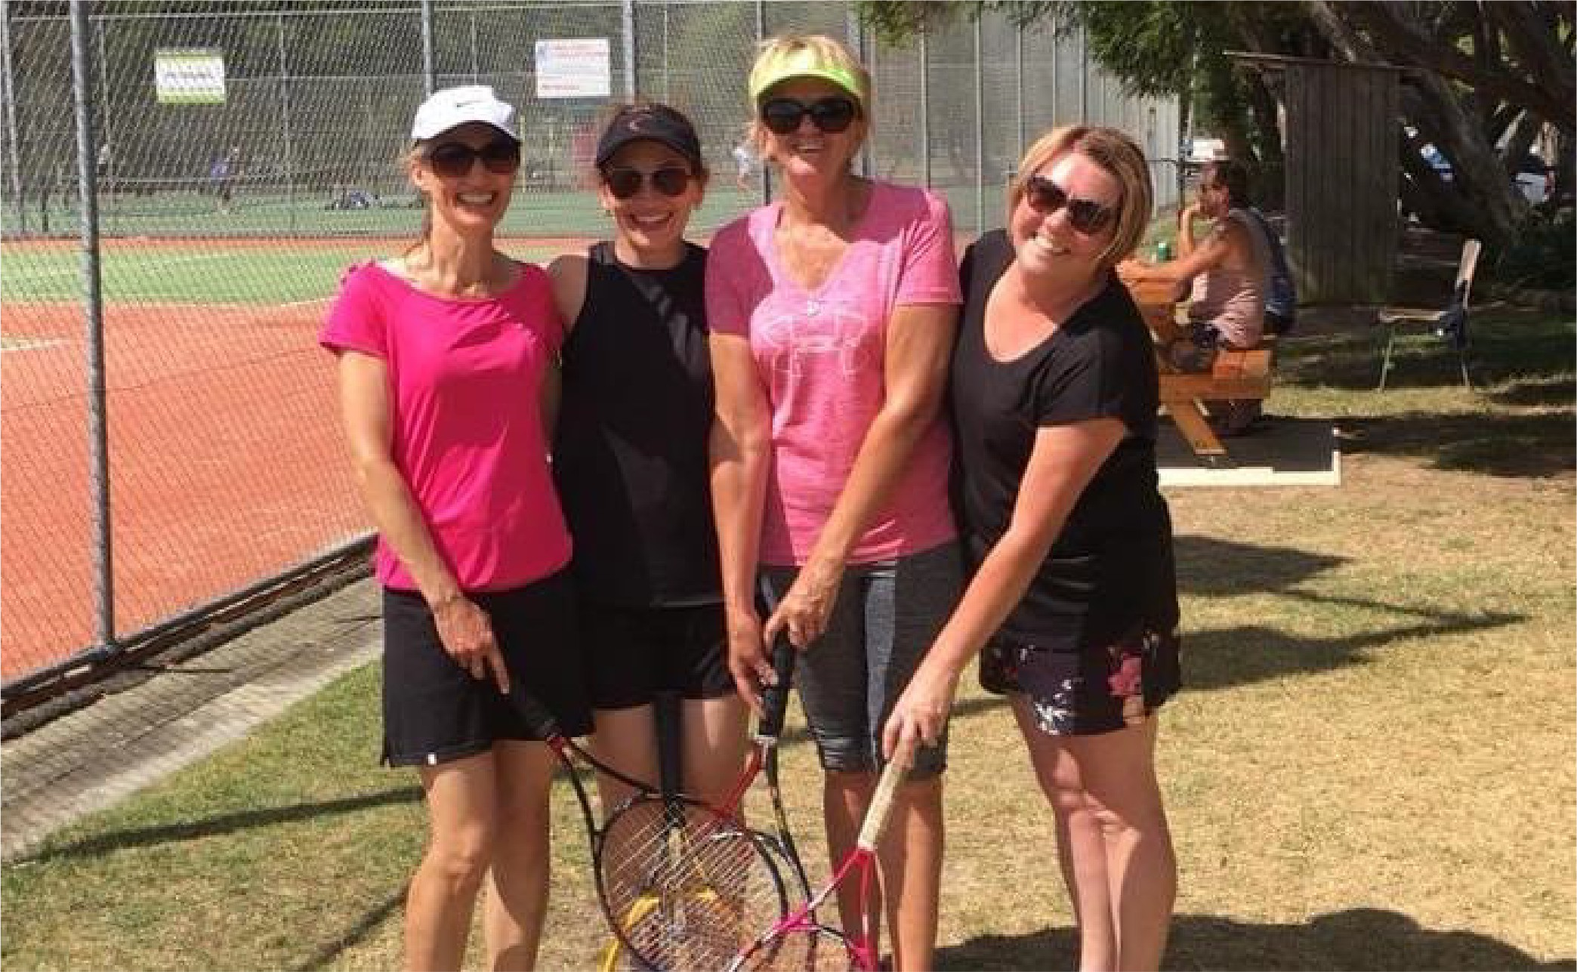





CLUB & FACILITY USER NEEDS

Based on the analysis of facility provision and consultation with clubs and user groups, the following club and user group needs have been identified to optimise club and user group operations, and continue to grow participation.

CLUB & FACILITY USER NEEDS

Club | Facilities Used | Infrastructure Needs Analysis
Ocean Grove Football Netball Club (Football) | Shell Road Reserve (1 oval)  Memorial Reserve (1 oval) | • Two ovals meet club needs for matches and training, with a preference for two ovals to be located at Shell Road Reserve to centralise club operations  • Upgraded sportslighting and coaches boxes, and behind goal netting required on the oval at Shell Road Reserve
Ocean Grove Football Netball Club (Netball) | Shell Road Reserve  (4 courts) | • Existing netball courts at Shell Road Reserve are adequate to meet club needs  • Improvements to seating, shelter and player amenities  • Addition of fifth court (show court) as demand grows
Ocean Grove Cricket Club | Shell Road Reserve (1 oval)  Memorial Reserve (1 oval) | • Two ovals meet club needs for matches and training, with a preference for two ovals to be located at Shell Road Reserve to centralise club operations  • Upgrading the practice facility at Shell Road Reserve from 3 lanes to 4 lanes would enable the consolidation of club training
Ocean Grove Soccer Club | Shell Road Reserve (2 pitches) | • Two pitches are reaching capacity, with an additional pitch required to meet club needs  • Fixturing clashes with OGFNC on match days create pavilion access issues
Ocean Grove Cobras Junior Football Club | Collendina Reserve (1 oval)  Memorial Reserve (1 oval)  Shell Road Reserve (1 oval) | • Two ovals meet current club needs, with access to an additional oval required within five years.  • Change facilities require upgrading to meet accessibility and inclusion requirements
Collendina Cricket Club | Collendina Reserve (1 oval)  Bellarine Secondary College  (1 oval) | • Two ovals meet club needs for matches and training  • Upgrade of the practice facility to four lanes and  improve condition  • Upgrade of pavilion and change facilities

CLUB & FACILITY USER NEEDS

Club | Facilities Used | Infrastructure Needs Analysis
Ocean Grove Tennis Club | Arthur Powell Reserve (7 courts)  Shell Road Reserve (5 courts) | • Retention of access to all existing courts required to meet club needs  • Upgrade of public courts and installation of sportlighting at Arthur Powell Reserve to increase capacity and accessibility
Bellarine Bears Baseball Club | Wallington Reserve (1 diamond) | • Upgrade of current baseball diamond to comply with requirements for senior baseball
Wallington Cricket Club | Wallington Reserve (1 oval)  Devlins Road Reserve North (Oakdene) (1 oval) | • Two ovals meet club needs for matches and training with a preference for acess to a second oval in Ocean Grove / Wallington  • Upgrade of change rooms to meet user needs
Memorial Reserve Hall Committee of Mangement | Memorial Reserve Hall | • Complete detailed investigations and preliminary design work to determine to the viability of an extension of the recreation hall to the west  • Retain access to the recreation hall and improve access to storage for equipment for active clubs and user groups  • Provision of suitable change facilities for children  • Investigate options to access additional courts for pickleball at Memorial Reserve, Shell Road Reserve or Wallington Reserve as demand is demonstrated





STRATEGIC FRAMEWORK

- Facility Provision  The Ocean Grove and Wallington community has access to sports facilities that support future growth and provide a diversity of opportunities to participate | - Sustainable Clubs  The Ocean Grove and Wallington community has access to sports facilities that support future growth and provide a diversity of opportunities to participate | - Access & Inclusion  Our facilities are accessible and including, creating more opportunities for all people to play, officiate, volunteer and spectate
1.1 Increase the capacity of existing facilities to support growing participation  1.2 Improve the capability of facilities to meet user needs and create new opportunities to participate  1.3 Establish new facilities in areas of population growth and residential development | 2.1 Enable clubs to prosper through the appropriate provision of facilities for club needs  2.2 Optimise facility use arrangements to enable efficient club operation and minimise impacts on volunteers  2.3 Support our clubs and user groups in advocating for investment in facility development priorities | 3.1 Create sports facilities that are accessible to people with diverse needs  3.2 Increase the flexibility of facilities to provide new opportunities for participation  3.3 Provide infrastructure that engages our community as participants, officials, volunteers and spectators
Sport | Strategic Infrastructure Priorities
Baseball | Provision of a second baseball diamond at Wallington Recreation Reserve as increasing demand is demonstrated
Cricket | Provision of an additional oval at Shell Road Reserve to cater for demand
Australian Football | Provision of an additional oval at Shell Road Reserve to cater for demand
Netball | Provision of an additional covered court and courtside player/umpire amenities at Shell Road Reserve to cater for demand and provide flexibility of use
Soccer | Provision of two soccer pitches at Devlins Road Reserve to enable the transition of soccer to the site from Shell Road Reserve
Tennis | Retain existing courts and explore opportunities to expand use

Strategic Sporting Infrastructure Provision Recommendations

Note: While this plan focuses on the provision of outdoor sporting infrastructure, it also acknowledges broader trends across the sporting network. This includes the City's 2022 review of the Geelong Indoor Recreation Facilities Strategy, which serves as a key supporting document and outlines a strategic approach to the provision, enhancement, and development of indoor facilities over the next 20 years. The plan also recognises the growing popularity of emerging sports, including pickleball.

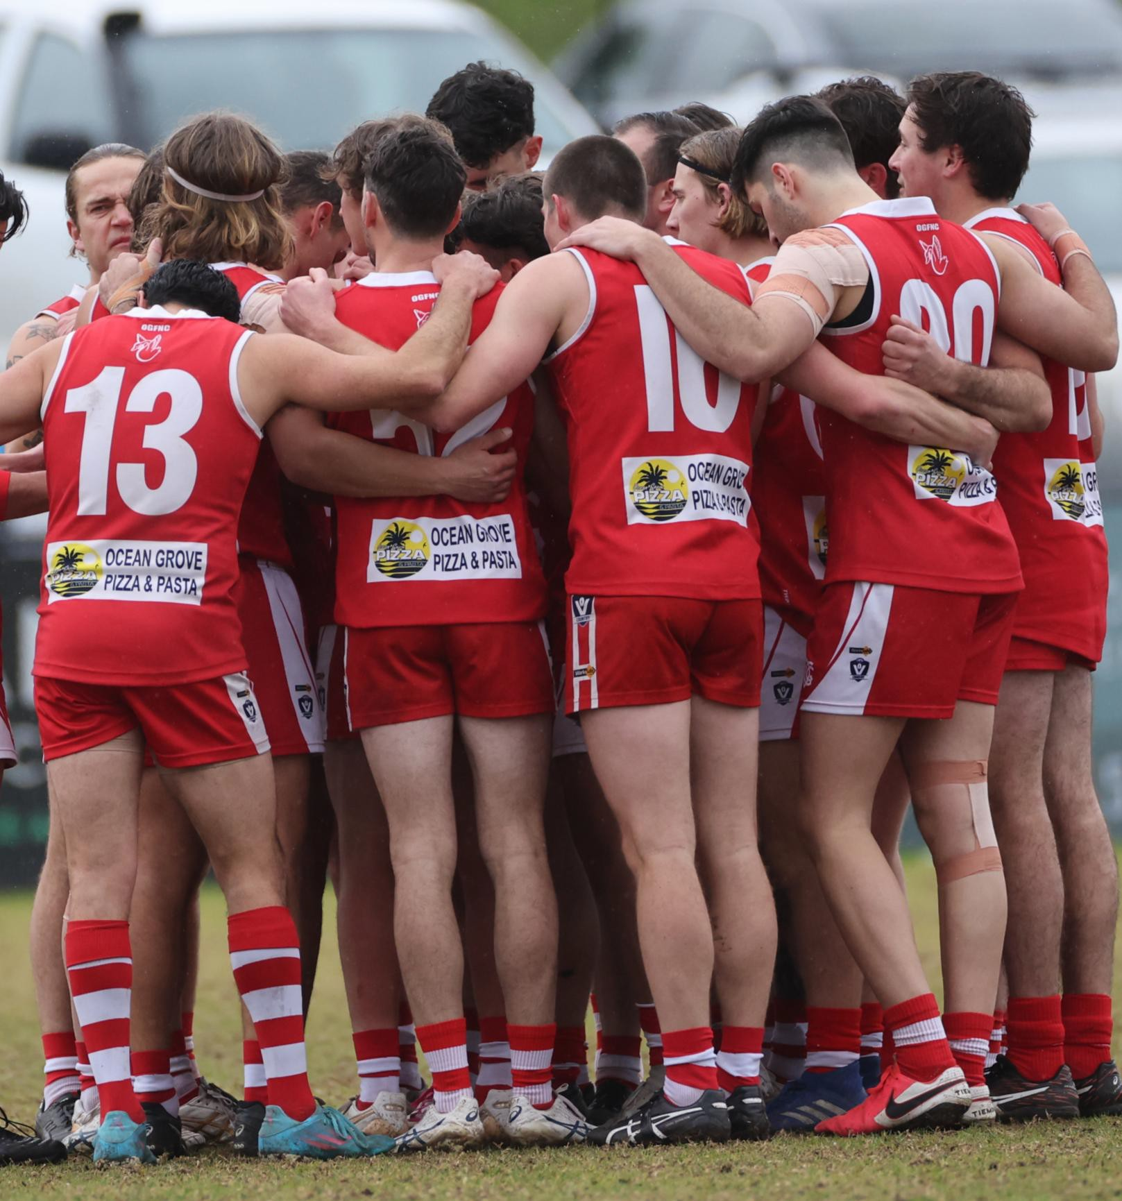



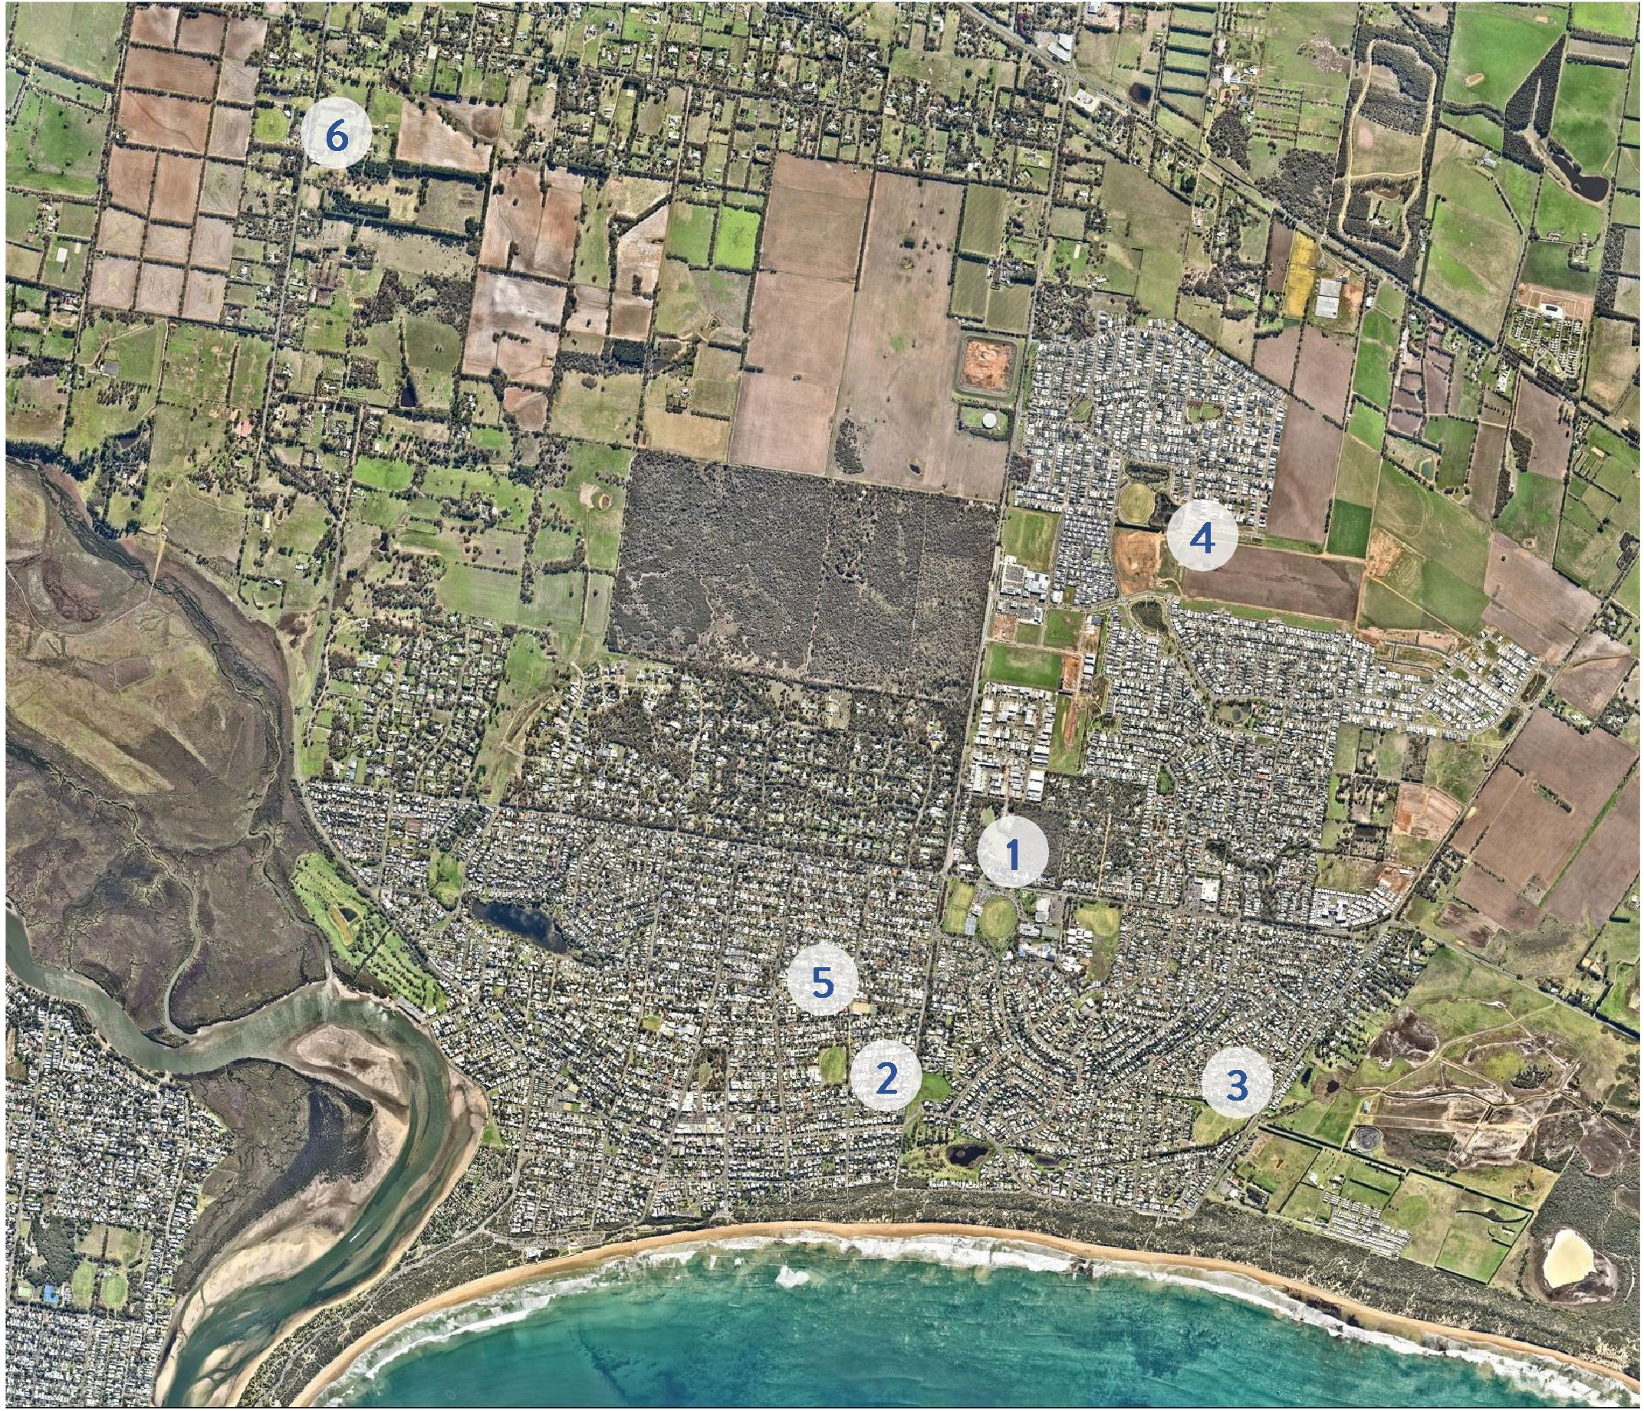

Sporting Reserves

No | Reserve | Address | Existing Sporting Facilities | Proposed Sporting Facilities
1 | Shell Road Reserve | 2A Shell Road, Ocean Grove | Two soccer pitches, one AFL/cricket oval, four netball courts, five tennis courts, cricket nets (three lanes) | Two AFL/cricket ovals, five netball courts (including a covered court), five tennis courts, cricket nets (four lanes)
2 | Memorial Reserve | 123-127 The Avenue, Ocean Grove | One AFL/cricket oval, recreation hall, scout hall, cricket nets (three lanes) | One AFL/cricket oval, recreation hall, scout hall, cricket nets (three lanes)
3 | Collendina Reserve | 18A Minerva Close, Ocean Grove | One AFL/cricket oval, cricket nets (three lanes) | One AFL/cricket oval, cricket nets (four lanes)
4 | Devlins Road Reserve | 152 Devlins Rd, Ocean Grove | One AFL/cricket oval | One AFL/cricket oval, two soccer pitches, soccer training area
5 | Arthur Powell Reserve | 139-151 Asbury Street East, Ocean Grove | Seven tennis courts | Seven tennis courts
6 | Wallington Recreation Reserve | 481-487 Wallington Road, Wallington | Once cricket oval/baseball diamond, cricket nets (three lanes), five tennis courts | One cricket oval/two baseball diamonds, cricket nets (three lanes), multipurpose hardcourts

SHELL ROAD RESERVE

Shell Road Reserve is a sub-regional sport and recreation reserve that hosts a range of sport and active recreation activities, including Australian football, cricket, soccer, netball and tennis.
The reserve is located centrally within Ocean Grove at the corner of Shell Road and Tuckfield St.
The reserve currently provides one AFL/cricket oval, two soccer pitches, three-lane cricket practice facility, four netball courts, five tennis courts and a main pavilion.
Ocean Grove Football Netball Club requires access to additional facilities after growing significantly in the past five years (AFL: +54%, Netball: +42%), while Ocean Grove Soccer Club requires further room to expand after growing by 77% since 2019.
Growth in participation and conflicting user needs have created the need for change at Shell Road Reserve to ensure all clubs are sustainable in the future.

Key Development Drivers

    - Consolidation of club operations for Ocean Grove Football Netball Club and Ocean Grove Cricket Club at Shell Road Reserve.
    - Increase the capacity of facilities to cater for AFL, cricket, netball and tennis, with the transition of soccer away from Shell Road Reserve.
    - Mitigate pavilion access conflicts created by the concurrent fixturing of senior AFL and soccer matches.
    - Improve equity of access to change facilities and amenities for female participants.
    - Retain the existing site use for tennis.
    - Improve supporting infrastructure to cater for increasing use by clubs, user groups and the community.
Facility Development Recommendations

- Construct a second oval on the site of the two soccer pitches and upgrade other infrastructure including the western change rooms, amenities and canteen.
- Following the relocation of the Ocean Grove Soccer Club to Devlins Road Reserve, seasonally allocate the new oval to Ocean Grove Football Netball Club and Ocean Grove Cricket Club.
- Upgrade and expand the cricket practice facilities (one additional lane), and provide an adjacent cricket storage facility.
- Construct one additional undercover netball court (show court), and provide fit-for purpose off-court netball facilities.
- Retain and upgrade the public tennis courts and pavilion, and when demand arises, overlay line-marking for pickleball on to two courts.

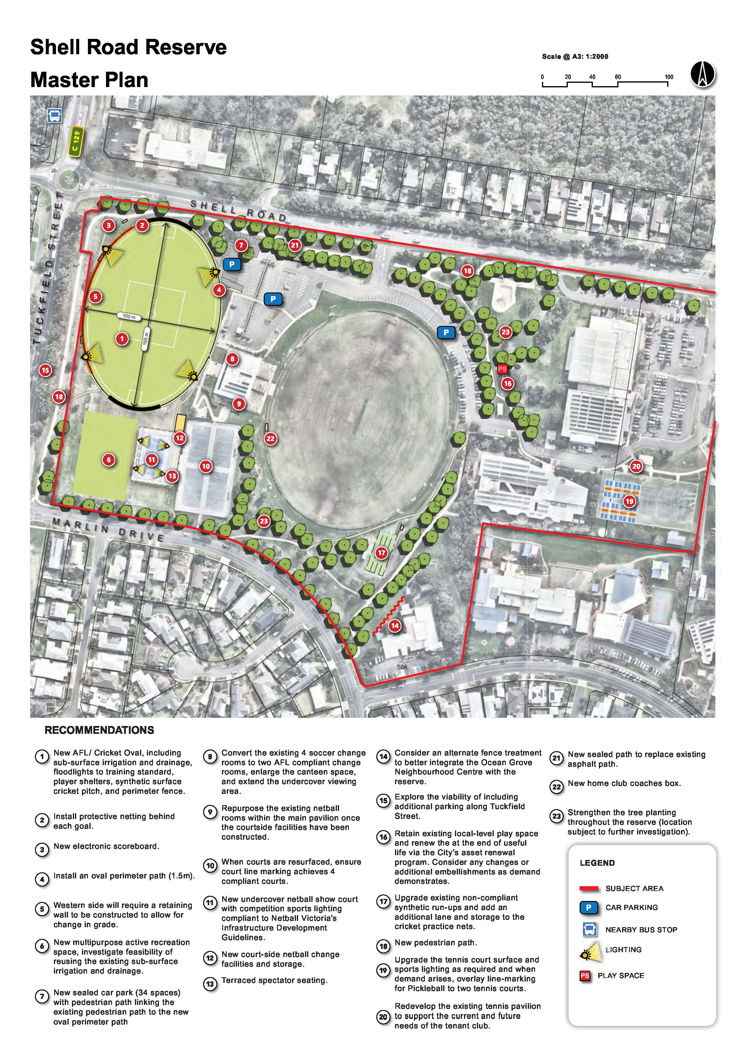

MEMORIAL RESERVE

Memorial Reserve, formerly Ocean Grove's primary sporting reserve, plays an important role in providing a diverse range of participation opportunities for the Ocean Grove community.
Prior to the Ocean Grove Football Netball Club (OGFNC) and Ocean Grove Cricket Club (OGCC) relocating to Shell Road Reserve in 2016, Memorial Reserve was the home facility for both clubs. Since the transition, the site has been used as a secondary facility for organised sport.
With the redevelopment of Shell Road Reserve to provide a second oval and centralised use of the reserve by OGFNC and OGCC, Memorial Reserve will play an important role in providing additional facilities for Cobras Junior Football Club and Collendina Cricket Club.
In addition to use for organised sport, the recreation hall provides a central venue for a range of organised activities including badminton, table tennis, calisthenics, soft tennis and pickleball.
The site is also home to a scout hall, which is primarily used for scout group activities.

Key Development Drivers

- Extend the recreation hall and improve facilities to better cater to the needs of user groups and community.
- Retain and improve the capability of the reserve to host football and cricket matches and training.
- Enhance the open space character of the reserve to promote increased unstructured use by the community.
Facility Development Recommendations
- Complete detailed investigations and preliminary design work to determine the viability of an extension of the recreation hall to the west.
- Implement an integrated upgrade to the pavilion, including the provision of gender- neutral player/umpire change rooms and improve accessibility throughout the facility.
- Upgrade sportslighting to competition standard for AFL.
- Following the completion of the second oval at Shell Road Reserve, seasonally allocate Memorial Reserve to the Cobras Junior Football Club and Collendina Cricket Club.
- Remove surplus sporting infrastructure and enhance informal open space with landscaping embellishments.

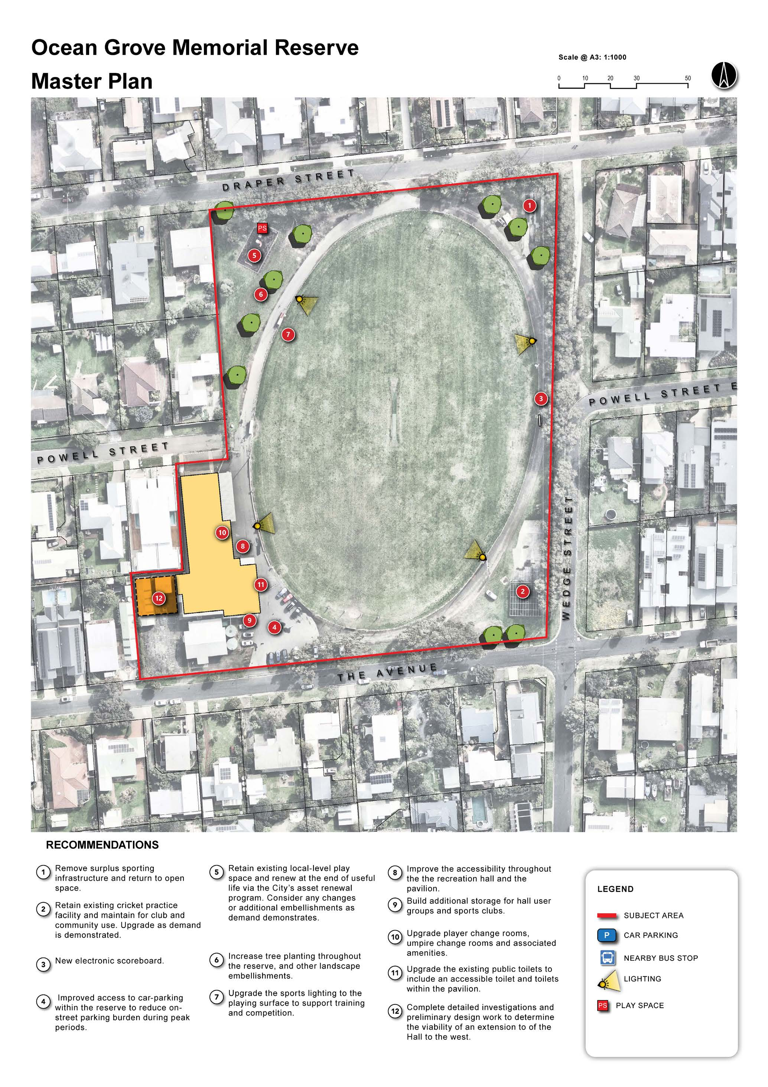

COLLENDINA RESERVE

Collendina Reserve is a local sport and recreation reserve that hosts AFL and cricket matches and training.
The reserve is located on Bonnyvale Road in the south-east of Ocean Grove, with access to the reserve off Minerva Close.
The site provides a single oval, three-lane cricket practice facility and pavilion, as well as a playspace for community use.
While the existing oval meets club needs for Collendina Cricket Club, a pavilion and change facilities upgrade is required to ensure facilities are inclusive and accessible. The cricket practice facility also requires an upgrade and expansion to cater for club needs.
Increased use of the reserve by the broader community can be encouraged through improved supporting infrastructure and improved safety.

Key Development Drivers

- Retain use of Collendina Reserve by existing clubs
- Improvement of the pavilion and change facilities to comply with facility guidelines and increase accessibility for all users
- Improvement of infrastructure relating to the oval
- Improvement of internal roadways and parking to increase user safety
- Create infrastructure that encourages greater unstructured use of the reserve by the local community
Facility Development Recommendations
- Upgrade and extend the pavilion to provide compliant gender-neutral player and umpire change rooms, and improved social and kitchen facilities.
- Improve infrastructure relating to the oval, including boundary fence and building for timekeepers, storage, first aid and spectators.
- Upgrade the cricket practice facility, including the installation of a fourth lane.
- Construct new internal roads and car parking to improve user safety.
- Encourage increased community use through the construction of a new path network and other landscape improvements.

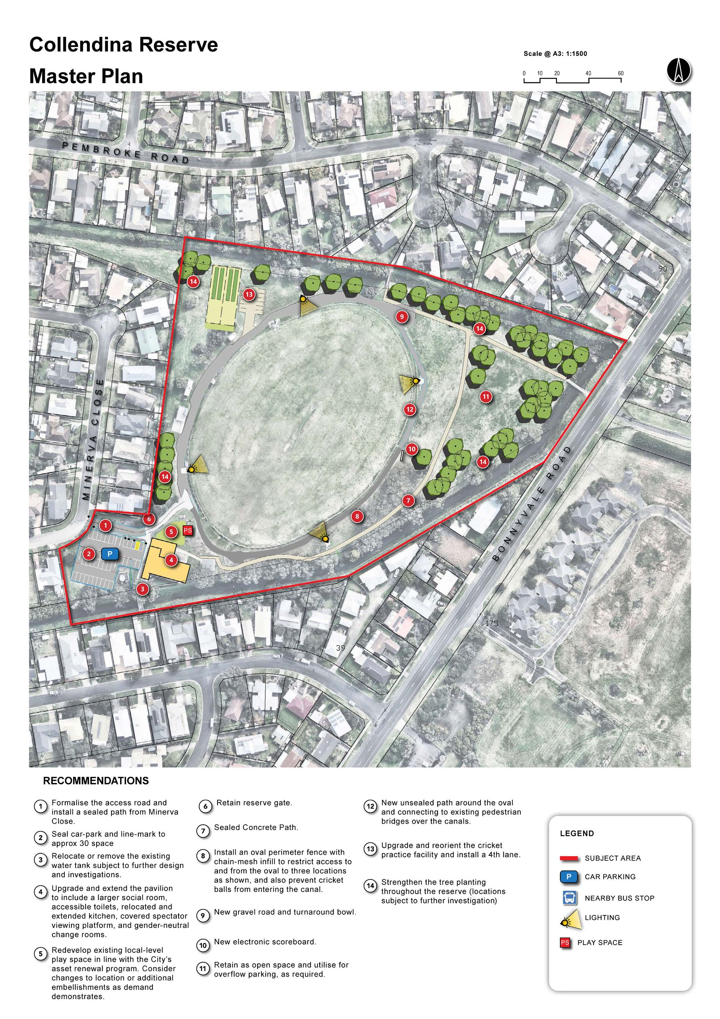

DEVLINS ROAD RESERVE

Devlins Road Reserve is a new reserve located within Ocean Grove's northern growth corridor, forming part of the open space contribution aligned with the Kingston and Oakdene residential estates.
The reserve is partially developed, with a senior-sized AFL/cricket oval constructed on the northern side of the site.
The southern section of the reserve is currently undeveloped, with space allocated to provide additional sports playing fields, pavilion, playspace, and supporting infrastructure such as paths and landscape improvements.
The development of Devlins Road Reserve will enables the transition of use across a number of sites, with the transfer of Ocean Grove Soccer Club to the site enabling the development of a second oval at Shell Road Reserve.

Key Development Drivers

- Increase the playing field capacity within Ocean Grove to cater for participation growth across soccer, AFL and cricket
- Creation of new home facility for soccer in Ocean Grove, enabling the transition of Shell Road Reserve to provide ovals primarily for AFL and cricket use
- Activate use of the site as an overflow venue for football and cricket.
Facility Development Recommendations

- Develop soccer pitches, a pavilion and associated supporting infrastructure in the southern section of the reserve and relocate the Ocean Grove Soccer Club to the reserve.
- Seasonally allocate the northern oval to the Ocean Grove Soccer Club for junior soccer as the priority winter sport, and to the Cobras Junior Football Club for overflow junior football, to scheduled around soccer use.
- Seasonally allocate the northern oval to the Wallington Cricket Club as an overflow oval.

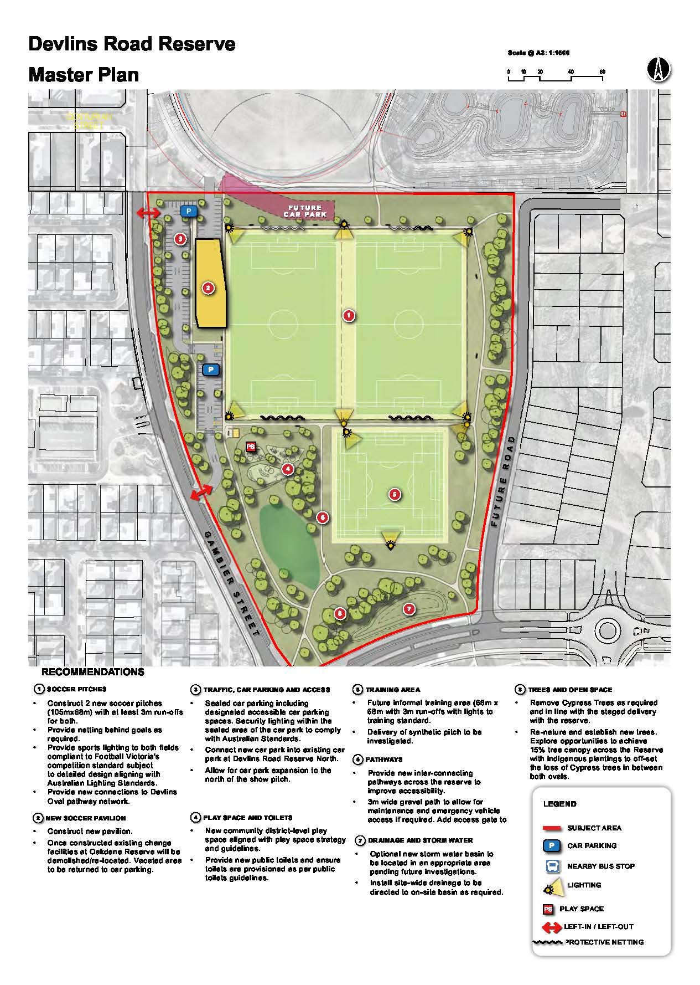
2

1

p

P

ARTHUR POWELL RESERVE

Arthur Powell Reserve is Ocean Grove's primary tennis facility and the home of the Ocean Grove Tennis Club.
The reserve is centrally located on Asbury Street East, Ocean Grove, 150 metres north of Memorial Reserve.
The site provides seven courts, with five exclusive use club courts (synthetic grass) and two public access courts (hard court surface). The club courts are in good condition and have sportslighting, while the two public courts are in poor condition, are non-compliant, and have no sportslighting.
Ocean Grove Tennis Club is a vibrant community club with a large membership base, requiring access to additional courts to support competition, coaching and social play.
Integration of the public access courts with the club courts to provide a seven-court club facility with access to the community outside of times of use by the club will enable growth in organised tennis participation.

Key Development Drivers

- Integration of the club courts and public access courts to provide an improved facility to support tennis participation.
- Improvement of the condition and compliance of the public access courts.
- Retain options for public access of tennis courts at the site outside of times of club use for competitions, programs and coaching.
Facility Development Recommendations
- Reconstruct the two public tennis courts into two new compliant acrylic courts with floodlights by extending the footprint to the south-east.
- Redevelop the existing club tennis courts to comply with facility guidelines
- Allocate the new courts to the Ocean Grove Tennis Club for a total of seven onsite courts, making sure the courts remain accessible to the public via a book-a-court system when not required by the club (in accordance with the City of Greater Geelong's Fair Play Strategy 2017).
Note: The tennis pavilion at Shell Road Reserve will be upgraded to support access to tennis.

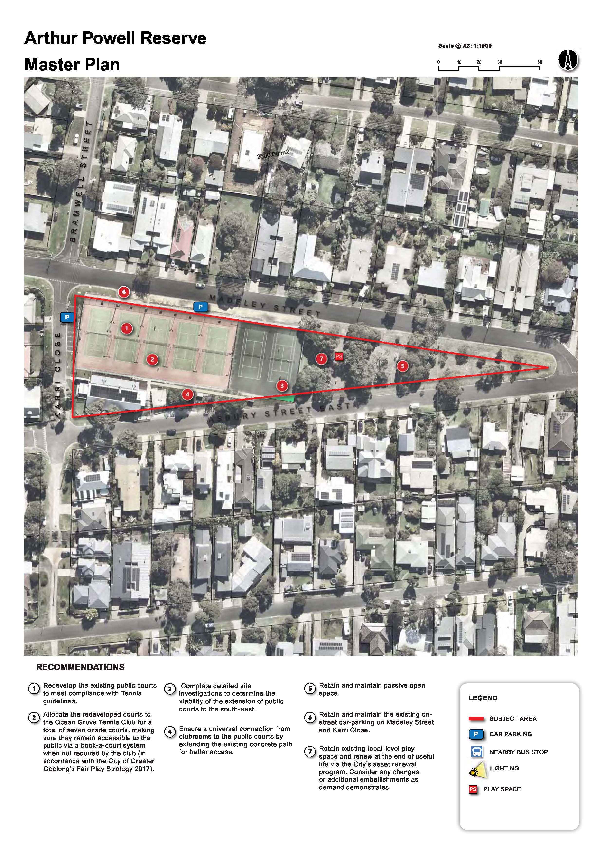

WALLINGTON RECREATION RESERVE

Wallington Recreation Reserve is the primary sport and recreation reserve within Wallington, located approximately 6 km north-west of the Ocean Grove town centre.
The reserve provides a diverse range of facilities, including an oval (incorporating a baseball diamond), cricket and baseball practice facilities, pavilion, five tennis/netball courts and associated clubroom.
While the facilities at the site create opportunities to participate in a range of activities, improvements are required to comply with sport guidelines and encourage the future growth of clubs and user groups.

Key Development Drivers

- Expand the provision of compliant playing fields that support baseball participation, while retaining use for cricket
- Increase accessibility within the pavilion, change facilities and public amenities
- Retain public access to tennis and netball facilities at the site
Facility Development Recommendations
- Retain use of the reserve for cricket (Wallington Cricket Club) and baseball (Bellarine Bears Baseball Club).
- Construct a compliant senior baseball diamond, and master plan for a future second diamond (junior size) as demand is demonstrated.
- Install sportslighting on the senior baseball diamond.
- Upgrade the pavilion to provide fit-for­ purpose and gender-neutral player and umpire change rooms, and improved social and kitchen facilities, and public toilets.
- Consider the future potential to upgrade the tennis courts and netball court, and add a hardcourt area for additional potential ball sports.

1 5
1 6
1 2

1 7
1 3
1
1 4

1 1

8
P S

p

p
9

1 8

7
1 9
6

1 8

6
1 7
2

4
1 0
5
3

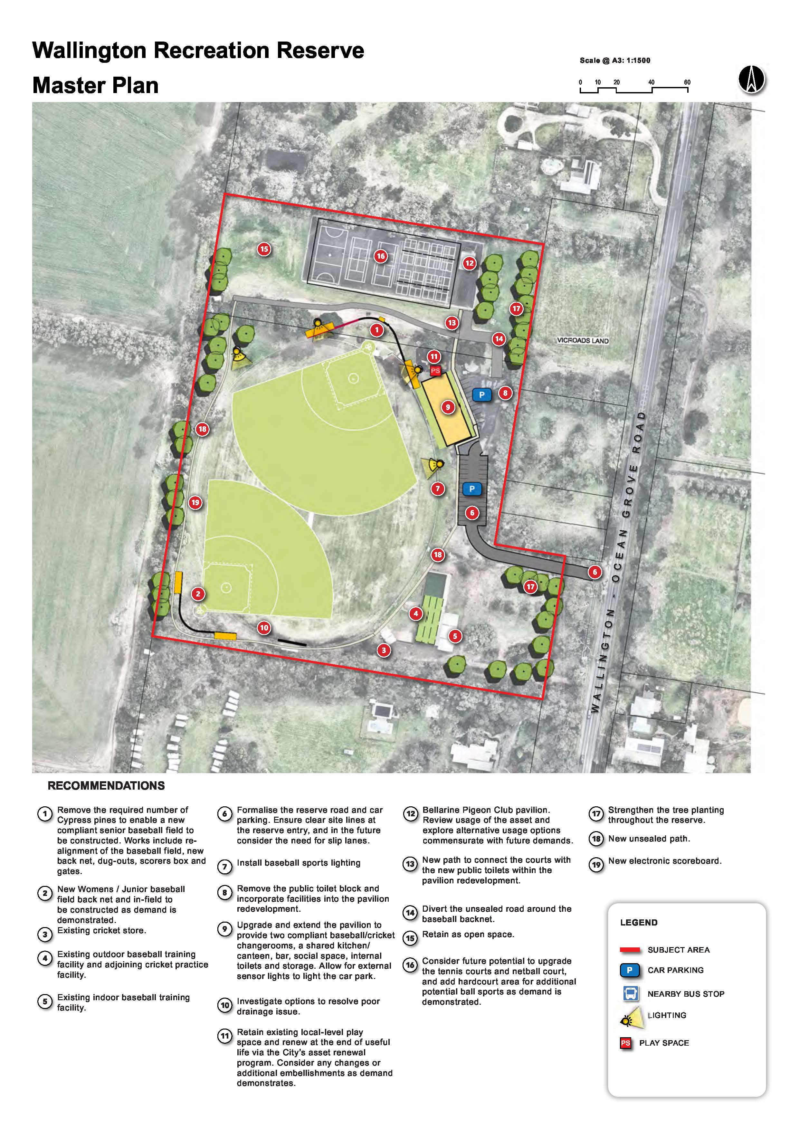

d e m o n s tr a te s .

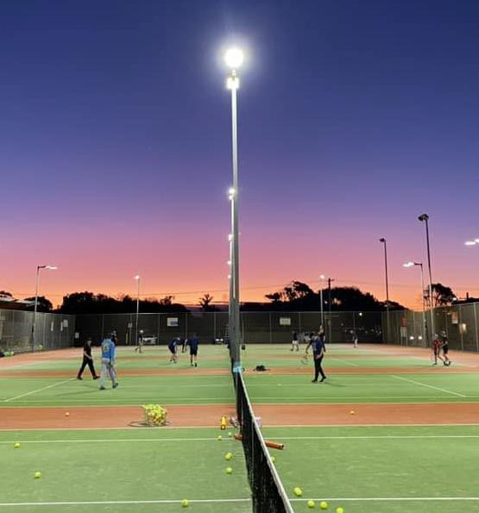



IMPLEMENTATION PLAN

The Ocean Grove Sporting Infrastructure Plan establishes recommendations for development of sport and recreation reserves across Ocean Grove and Wallington. The implementation of the OGSI P will occur in a staged approach, with projects prioritised based on community need, funding availability and required project sequencing.

Project Prioritisation

Facility development recommendations are allocated into high, medium and low prioritisation categories.

While the prioritisation categories provide an indicative order of implementation, the categories do not indicate specific timeframes for the delivery of projects within the implementation plan.
This implementation plan outlines the proposed facility development projects for each reserve, including estimated project cost, priority level, predecessors and responsibilities.

The implementation of the recommendations of the OGSI P will require a collaborative approach between Council, stakeholders and the community.

The implementation of projects is subject to a range of factors, including:
- Funding availability
- Further investigation, research, design and consultation
- Current and future priorities of the City of
Greater Geelong, the relevant sporting
clubs and user groups, and other
community stakeholders.

Project Costs

Indicative cost estimates have been developed as part of the report and are based on the best available information at the time of preparation.

- Estimates have been prepared using conceptual details known at the time and may change as the project progresses
though further detailed design and site investigations.
- Each cost component is subject to funding availability, meaning the estimates provided are not final and will
require further review.
- As additional project details are confirmed and funding is secured, cost estimates and underlying assumptions will
need to be reassessed to ensure accuracy and alignment with the final project scope.

OCEAN GROVE SPORTING INFRASTRUCTURE PLAN | 35

IMPLEMENTATION PLAN

No. | Development Priorities | Priority
Shell Road Reserve
1 | Construct a second oval on the site of the two soccer pitches and upgrade other infrastructure including change rooms, amenities and canteen | High
2 | Upgrade and expand the cricket practice facility (one additional lane), and provide an adjacent cricket storage facility | Medium
3 | Construct one additional undercover netball court (show court), and provide fit-for purpose off-court netball facilities | Medium
Memorial Reserve
1 | Complete detailed investigations and preliminary design work to determine the viability of an extension of the hall to the west | High
2 | Upgrade the recreation hall and social rooms, including the provision of gender­ neutral player and umpire change rooms, and additional storage space for user groups | High
Collendina Reserve
1 | Upgrade the pavilion to provide compliant gender-neutral player and umpire change rooms, and improved social and kitchen facilities | High
2 | Upgrade the cricket practice facility, including the installation of a fourth lane | High
Devlins Road Reserve
1 | Develop soccer pitches, a pavilion and associated supporting infrastructure in the southern section of the reserve to support the relocation of Ocean Grove Soccer Club to the reserve | High
Arthur Powell Reserve
1 | Reconstruct the two public tennis courts to provide two new compliant acrylic courts with sportslighting | Medium
Wallington Recreation Reserve
1 | Redevelop the existing senior baseball diamond to comply with guidelines and plan for a future second junior-sized diamond as demand is demonstrated | Medium
2 | Upgrade the pavilion to provide gender-neutral player and umpire change rooms, improved social and kitchen facilities, and public toilets | Medium

