The City Of
Greater Geelong

music – MOdelling approach and parameters
  - Design note 3 (Nov 24)

Contents

1.0 Introduction 4
1.1 Purpose of document 4
2.0 Climate Data 5
3.0 General Guidelines for Treatment Nodes 7
3.1 High flow bypass and overflow 7
4.0 Proprietary Stormwater Treatment Devices 8
5.0 Wetlands 9
5.1 Wetland inundation frequency analysis 9
5.2 Stage-storage discharge relationships 13
6.0 Bioretention 14
6.1 Asset dimensions and large bioretention assets 15
6.2 Design to manage sediment loads 16
6.3 Soil moisture conditions 17
6.4 Infiltration and proximity to infrastructure 18
6.5 Construction phase 19
7.0 Stormwater Harvesting and Reuse 20
7.1 Basic design parameters for stormwater reuse systems 20
7.1.1 Total and directly connected impervious 21
8.0 MUSIC Auditor and Wetland Analysis Tool 23
9.0 Submission Requirements for MUSIC Modelling 24
9.1 Concept design 24
9.2 Functional/Detail design 24
Appendix A: Stage-Storage-Discharge Relationships 27
Extended detention depth 27
Stage-storage 27
Stage-Discharge Relationship 29
Appendix B: Selection of Rainfall Templates 32
Appendix C - When is a Bioretention Asset Appropriate? 33

List of Figures
Figure 1: Rainfall region boundaries determined for Greater Geelong 5
Figure 2: Comparing plant heights and effective water depth. 10
Figure 3: Typical inundation frequency graph for assessing. 11
Figure 4: Typical plant selection to select suitable plants. 11
Figure 5: Example results demonstrating compliance with all requirements. 12
Figure 6: Example results demonstrating non-compliance. 12
Figure 7: Typical spells analysis output indicating compliance with requirement 3 13
Figure 8: Monthly rainfall totals. 20
Figure 9: Set Extended Detention Depth 27
Figure 10: Example Stage-Storage Relationship. 28
Figure 11: Extrapolation of storage to target stage value. 29
Figure 12: Example Stage Discharge Relationship for Pipe Flow. 30
Figure 13: Example Stage Discharge Relationship for Weir Flow. 31

List of Tables
Table 1: Catchment ranges for coarse sediment forebays and ponds. 17
Table 2: Design requirements for coarse sediment forebays and ponds. 17
Table 3: Offset distances 19
Table 4: Typical reuse demand. 21
Table 5: Monthly distribution of reuse demand. 21
Table 6: Submission Requirements and Assessment Criteria 25
Table 7: Rainfall templates for City of Greater Geelong. 32
Table 8: Criteria for when to use a bioretention. 33
Table 9: Criteria for when not to use a bioretention. 34

1.0 Introduction

This Design Note 3 guideline sets out the preferred approach for MUSIC modelling with the City of Greater Geelong (the City). It provides information for developers, consultants and reviewers on the use of the MUSIC software.
As a general approach, the MUSIC modelling approaches should follow Melbourne Water MUSIC guidelines for MUSIC (Model for Urban Stormwater Improvement Conceptualisation) Guideline, published online by Melbourne Water in 2024 (as revised). Design Note 3 highlights specific information, advice, and parameters that differ from the Melbourne Water MUSIC guidelines. It also includes appropriate climate data and input parameters to adopt for stormwater treatment and reuse systems within the City. Specific submission requirements are provided in Chapter 9 of this document.
This guideline was originally developed by the City in consultation with E2Designlab.

1.1 Purpose of document
This document provides guidance on modelling approaches and input parameters for MUSIC models that are submitted to the City. The MUSIC user manual is also useful for building a model and can be accessed from the eWater website or from MUSIC https://ewater.atlassian.net/wiki/spaces.
Users are expected to have an understanding of water sensitive urban design (WSUD) principles, along with knowledge and training in the use of the MUSIC software.
This document is a modelling guideline, and should be read in conjunction with appropriate design guidelines (as updated) including:
- MUSIC Guideline, (Melbourne Water, 2024)
- WSUD Engineering Procedures: Stormwater (Melbourne Water, 2005)
- Melbourne Water Constructed Wetlands Design Manual (Melbourne Water, 2020)
- Biofiltration Systems in Development Services Schemes Guideline (Melbourne Water, 2020)
- Infrastructure Design Manual (IDM, 2022)
- Adoption Guidelines for Stormwater Biofiltration Systems (CRCWSC, 2015)
MUSIC helps in understanding potential stormwater pollutant removal for WSUD infrastructure designs, but this needs to be supported with confirmation of other design aspects as outlined in the above documents. MUSIC is not suitable for validating drainage design. Other requirements are outlined in the above documents.

2.0 Climate Data
For stormwater treatment modelling using MUSIC, a meteorological data template is required based on rainfall and potential evapotranspiration data.

It is recommended the following minimum periods are used:
- 10 years for WSUD treatment performance and small-scale systems.
- 20 years for stormwater harvesting, large scale integrated water management plans and strategies (>100 ha) and catchments with an impervious fraction < 20% or where pervious flows are substantial.
Two rainfall regions were identified for the City. Areas with rainfall less than 500 mm annually were designated “Little River” and those with rainfall greater than 500 mm annually were designated “Geelong North” to coincide with the Bureau of Meteorology (BOM) station names. The rainfall regions are shown in Figure 1.

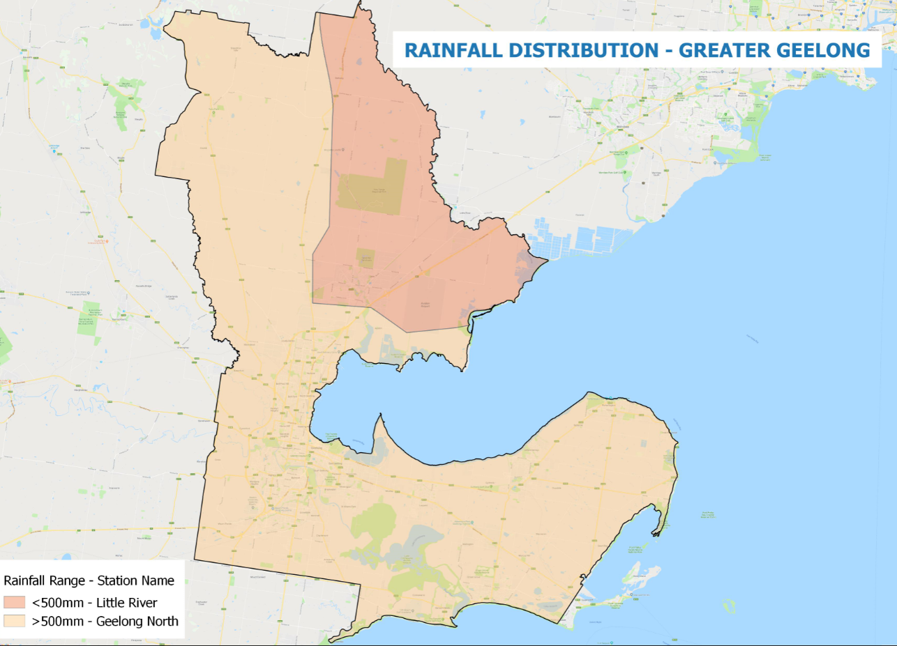
Figure 1: Rainfall region boundaries determined for Greater Geelong
Modelling timestep
The modelling timestep should be less than:
- The shortest time of concentration.
- The shortest treatment detention time under design flows.
For the City, all models should be run at a 6-minute modelling timestep. The use of larger timesteps reduces model accuracy and can increase the variability of results while allowing it to run faster. There is little justification for using larger timesteps for most practical modelling purposes with modern computers. Where a different timestep is proposed, it must be agreed in writing by the City and comply with the above requirements.

Climate templates
The climate templates are available for download from the City’s website https://www.geelongaustralia.com.au/stormwater/documents/item/8d70ad1c7ad1e12.aspx.

The filenames are as follows:
- 10year_GeelongNorth_1971-1980_6min_mlb
- 10year_GeelongNorth_1971-1980_6min_sqz
- 20year_GeelongNorth_1971-1990_6min_mlb
- 20year_GeelongNorth_1971-1990_6min_sqz
- 10year_LittleRiver_1992-2001_6min_mlb
- 10year_LittleRiver_1992-2001_6min_sqz
- 20year_LittleRiver_1989-2008_6min_mlb
- 20year_LittleRiver_1989-2008_6min_sqz
The user should select the appropriate template for the project location and type of analysis. Note that as the templates have been infilled to improve quality, they cannot be reproduced by creating a template directly from the raw data.
Where an alternative climate template is proposed to be adopted, it must be based on a similarly rigorous approach as that used to determine the above (see Appendix B) and its use is subject to agreement in writing by the City.

3.0 General Guidelines for Treatment Nodes

3.1 High flow bypass and overflow
It is good design practice and a requirement that assets and vegetation are protected from high velocities and large storm event flows that may result in scour, erosion, damage to vegetation or biofilms, where practical.
This may be achieved using structures such as weirs, pits and pipes. These structures direct smaller and more frequent flows into the asset for treatment. Higher flows are diverted around the main treatment asset either by diverting flows that exceed a design flow rate or diverting flows once water levels rise above a certain level over an overflow, subject to meeting velocity requirements. This means the main treatment element, which may be a vegetated area or a filter bed, is only exposed to flow rates up to the design flow or that high flows associated with infrequent events are diverted around the treatment once the storage capacity is reached.
An asset may be protected by bypass of flows above a specified rate, by an overflow weir that engages at a specified level at the upstream end of an asset or a combination of bypasses and overflow weirs.
It is common to design treatment assets such as wetlands and bioretention to treat limited flows up to the 4 Exceedances per Year or 4EY [1 in 3 month annual recurrence interval (ARI)] design event.
The configuration and model inputs should aim to represent the likely real-world behaviour of flows through the system to accurately estimate treatment performance and correctly size assets for catchment flows. This may include use of high flow bypass, overflow weir and secondary links. The high-flow bypass rate used should match the relevant design flow rate as calculated using an appropriate method.
Design flows for treatment assets are usually calculated using:
- The Rational Method;
- A hydrologic model; or
- Partial series analysis of flows from a MUSIC model with appropriate design and routing.
The user is referred to the Australian Rainfall and Runoff (AR&R) Guidelines 2019 at http://arr.ga.gov.au/ and Part D of the Constructed Wetlands Design Manual (Melbourne Water, 2020) at https://www.melbournewater.com.au/planning-and-building/developer-guides-and-resources/standards-and-specifications/constructed-0 for calculation approaches including guidance on the use of RORB for calculating design flows. RORB can now calculate 4 EY flow rates directly and this is preferred over rules of thumb. The Rational Method may be used for small infill developments without significant upstream storage.

4.0 Proprietary Stormwater Treatment Devices
See Melbourne Water’s MUSIC Guidelines, Chapter 5.
Please note that proprietary devices generic nodes are not to be included in the modelling as performing treatment unless otherwise agreed.

5.0 Wetlands
See Melbourne Water’s MUSIC Guidelines, Chapter 4.

Wetlands that are to be handed over to the City should generally be designed and modelled in accordance with Melbourne Water’s Constructed Wetland Design Manual (2020) as updated. Specific requirements include:
- The macrophyte zone extended detention depth (EDD) must be less than or equal to 350 mm.
- At least 80% of the macrophyte zone at normal water level (NWL) must be less than or equal to 350 mm deep to support shallow and deep marsh vegetation. The bathymetry should provide approximately equal amounts of shallow marsh (100-150 mm deep) and deep marsh (150-350 mm deep).
- The macrophyte zone must be offline from all waterways and drains.

5.1 Wetland inundation frequency analysis
A key consideration in the design of a wetland is ensuring that water levels are suitable for planting. This is primarily achieved by limiting the extended detention depth (EDD) and permanent pool depth within the shallow and deep marsh zones to ensure the total depth of water will support emergent macrophyte plants. Further consideration of inundation patterns as well as the frequency and duration of spells where the water levels will exceed various thresholds can also help inform the planting design.
An inundation frequency analysis should be undertaken to support the design of each wetland. This can be used to demonstrate compliance with a range of requirements, all of which must be met. Reasonable efforts must be made to resolve any non-compliance. Any remaining non-compliance must be discussed with the City and is subject to agreement and written approval.
Users may use the Wetland Analysis Tool on the MUSIC Auditor website to undertake an inundation frequency analysis. Refer Melbourne Water’s Guidelines for Constructed Wetlands for further background and guidance.
- The following requirements are intended to reduce (but do not eliminate) the risk of plants drowning due to excessive depth, frequency and duration of inundation, they are minimum requirements and may be supported with input from an experienced ecologist and other metrics:
  - The effective water depth (permanent pool depth plus depth above NWL) must not exceed half the average plant height for more than 20% of the time, see Figure 2.
  - The average water level should not be more than 50 mm above normal water level.
  - No more than one spell of 10 days or more occurs where the water level is greater than or equal to 300 mm above NWL (in a reference period of 10 years).
- The following requirement is intended to ensure water spends enough time in the wetland to be adequately treated:
  - The macrophyte zone must provide a 90th percentile residence time of at least 72 hours. A lower detention time of not less than 48 hours may be considered in retrofit circumstances to achieve the plant inundation frequency criteria.

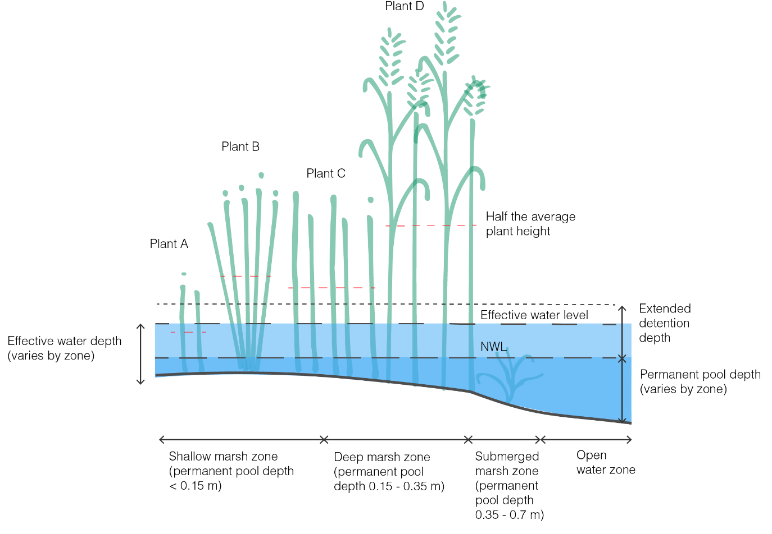
Figure 2: Comparing plant heights and effective water depth.

An example of Wetland Analysis Tool outputs is shown in the Figures 3 through 7 illustrating the following:
- A typical inundation frequency graph which can be used to obtain water levels exceeded 20% and 50% of the time.
- Plant selection to choose plants for the shallow and deep macrophyte zones.
- A summary report indicating compliance or non-compliance with each requirement.
- A spells analysis showing that the resulting spells for significant depths above NWL are acceptable.

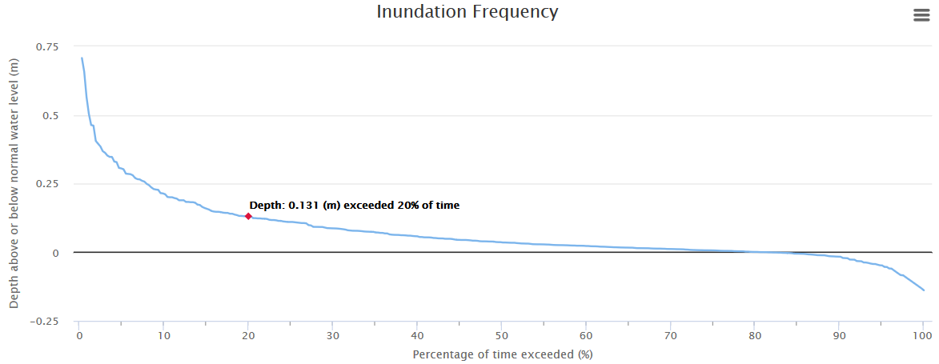
Read water level exceeded 20% of time which is 0.131 m
Figure 3: Typical inundation frequency graph for assessing.

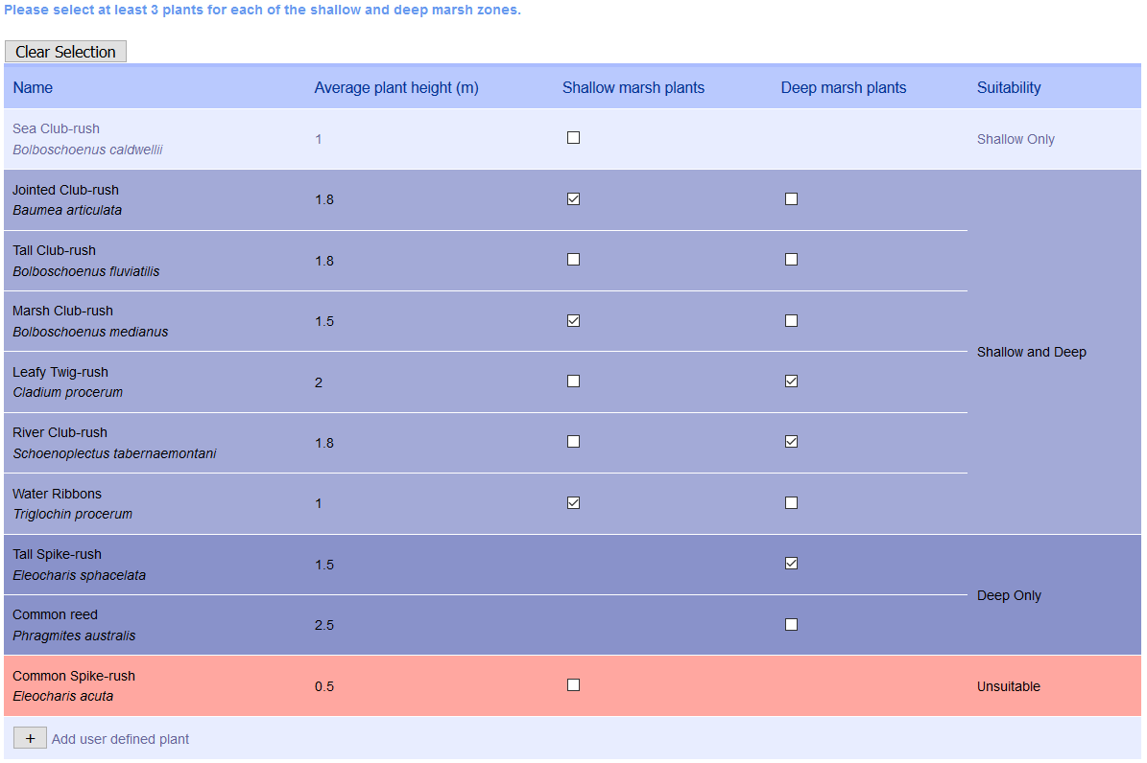
Figure 4: Typical plant selection to select suitable plants.

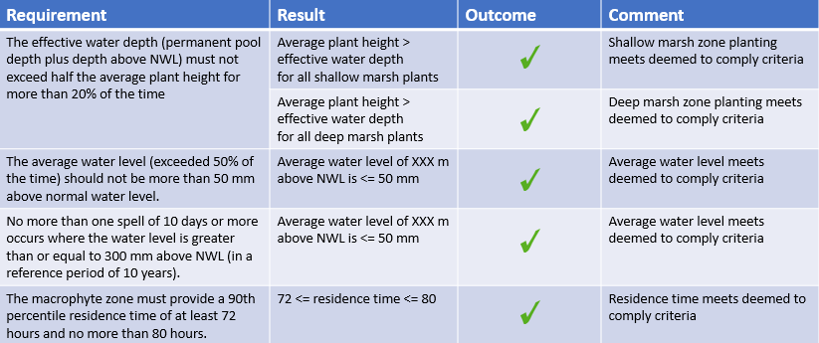
Figure 5: Example results demonstrating compliance with all requirements.

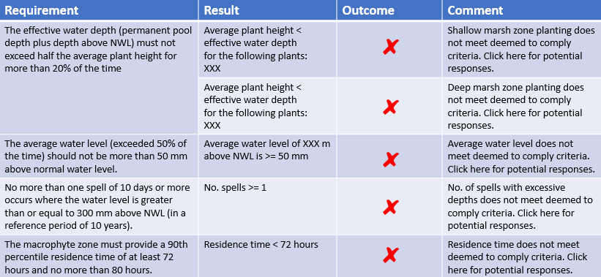
Figure 6: Example results demonstrating non-compliance.

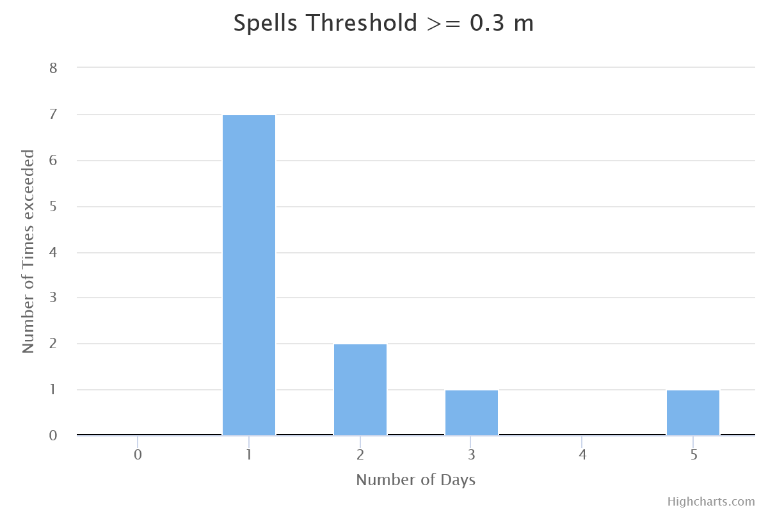
3
Figure 7: Typical spells analysis output indicating compliance with requirement 3
(Longest spell is 5 days, not more than one spell of 10 days or more).

5.2 Stage-storage discharge relationships
See Melbourne Water’s MUSIC Guidelines, Chapter 7.
A custom stage-storage-discharge relationship is required to be used for wetlands intended to be handed over to the City at the functional and detailed design stages. The following should be submitted to provide evidence of design and calculations for this:
- Screenshot of output from earthworks modelling software of stage-storage relationship.
- MUSIC model with defined stage-storage-discharge relationships.
- Area and volume at NWL and EDD.
- Calculations used for stage-discharge relationships for both wetland outflows and overflows.
- Peak top water level for the 1 EY storm event (1 in 1 year ARI) and maximum flows through wetland as per design.
- Check of node water balance to confirm that mass balance error is negligible.
- Provide the Flux file results.

6.0 Bioretention
Bioretention assets should be designed in accordance with the fundamental principles and guidance provided in current version of the following documents as amended:
- Adoption Guidelines for Stormwater Biofiltration Systems (CRCWSC, 2015)
- Biofiltration Systems in Development Services Schemes Guideline (Melbourne Water, 2020)
- MUSIC Guideline (Melbourne Water 2024)
The reader is referred to the first two of these for descriptions of what a bioretention asset is and how it works.
The designer should consider whether a bioretention asset is appropriate for the site with reference to Table 8 in Appendix C - When is a Bioretention Asset Appropriate?.
Bioretention assets should be designed and modelled in accordance with the requirements and specifications set out in this guideline unless agreed in writing by the City and this document takes precedence over other guidelines. The City have no obligation to accept any design that does not comply with the following requirements and non-complying designs and models will be considered on a case-by-case basis. The following specific requirements apply:
- Design plans and model
  - The asset configuration shown on the design plans must be consistent with the parameters adopted in the MUSIC model.
- Flows and velocities
  - Design flows shall be estimated in accordance with methods in the current Australian Rainfall and Runoff.
  - High flows above the 18.13% AEP (1 in 5 year ARI) event shall be diverted or the bioretention system protected by ‘feedback control’ to cause high flows to either bypass the asset or enter an overflow in proximity to the inlet after extended detention is filled.
  - Flow velocities should not exceed 1 m/s over the planted filter media area for the 1% AEP (1 in 100 year ARI) event.
- Design configuration
  - The EDD shall be less than or equal to 300 mm.
  - Underdrainage with an invert at a depth of at least 500 mm shall be included to ensure the root zone remains aerated.
  - Tree species should be suitable for the wetting and drying conditions expected within a bioretention and deciduous trees should generally be avoided due to significant seasonal leaf drop which may lead to clogging.
- Soil moisture and wetting and drying conditions
The following specifications are intended to ensure that soil moisture conditions are suitable to sustain plants:
  - The filter media depth shall be 500-600 mm for standard planting and may be 500-800 mm for bioretention assets with tree planting. Lesser filter media depths may only be considered for highly constrained sites. Lesser depths will not be accepted where it is possible to achieve a depth of 500 mm.
  - A submerged zone is required for all bioretention assets designed within the City and should be included below the outlet invert. The submerged zone must not be less than 300 mm and should preferably have a depth of 450-500 mm in total (including transition and drainage layer). It is recommended the submerged zone include an appropriate carbon source to support denitrification.
  - The saturated hydraulic conductivity of filter media must be within 100-300 mm/hour and it is recommended it should not exceed 200 mm/hour. Hydraulic conductivity should be modelled at 100 mm/hour to allow for potential decline in infiltration capacity due to sediment clogging over time.
  - It is essential to ensure bioretention assets retain enough moisture within the filter media, submerged zone and surrounding soils to sustain plants through dry periods. Where any of the above 3 items will be compromised the following is required:
    - Confirm that no other element will be compromised
    - Laboratory testing of the filter media demonstrating the soil moisture retention capacity of the filter media at a root zone depth of 300 mm is at least 15%.
    - Laboratory testing of the filter media demonstrating that the hydraulic conductivity will be within 100-200 mm/hour (if filter media or submerged zone depth reduced)
    - Compensation of loss of soil moisture where practical through:
        - Increased depth of filter media or submerged zone.
        - Choosing plant species with a high level of drought tolerance.
    - A spells analysis indicating the filter media will not experience soil moisture conditions at or below wilting point for more than 20 days within a 10 year period (this can be determined with a spells analysis of soil moisture).
  - The asset must not be subject to continuous or long duration flows.
The design of a bioretention asset should take into consideration the following:
- Asset dimensions and potential issues with large bioretention assets.
- Catchment sediment loads and sediment management to minimise clogging risks.
- Soil moisture conditions.
- Infiltration and the capacity of underlying soils to absorb and drain away water including soil conditions and any layering, depth to rock, depth to groundwater and slope.
- Proximity to infrastructure that may be affected by infiltration and provision of adequate offset distances.

6.1 Asset dimensions and large bioretention assets
Bioretention assets should be designed within the following dimensional ranges:

- Maximum recommended cell size 800 m².
- Minimum width 600mm, >1 m recommended.
- Maximum width of 14m where construction access is available from opposite sides.
- Maximum width of 7m where construction access is available from only one side.
- Inlets should be designed to ensure inflows will be evenly distributed across the bioretention surface area. This may be achieved using multiple inlets, flush kerbs, weirs, slotted pipe, distribution channels or other methods of distribution where approved. The use of a single large inlet without some form of distribution should be avoided for assets over 100 m².
Where a site will have a total surface area of bioretention >800 m², serious consideration should be given to preferentially using a wetland and the designer shall be responsible for ensuring the bioretention surface will not be continually or excessively frequently wet by interflow or baseflow leading to excessive algal growth and/or clogging.
For larger catchments, wetlands are generally preferred as they tend to be more resilient, require less maintenance, provide greater amenity and cope better with persistent baseflows that are more likely to occur in larger catchments.

6.2 Design to manage sediment loads
Bioretention assets treating larger catchments may receive significant sediment loads that can cause clogging and impact upon treatment performance. These are usually due to:
- Construction and building activity in the catchment.
- Sediment inflows to large assets that:
  - Are online to the main flow path.
  - Receive bed load.
  - Receive large event inflows and associated sediment.
- Fine sediment accumulation in catchments with dispersive clay soils.
Upstream sediment management responses should be designed to minimise sediment inflows to bioretention assets as much as possible. A guide to sediment management responses at different scales is provided in Table 1 and design requirements are provided in Table 2.
Any upstream sediment pond must be designed in accordance with the Draft Melbourne Water Design Guide: Bioretention systems in Melbourne Water Development Services Schemes (Melbourne Water, 2019).
While sediment management tends to target coarse sediment, it is important to understand that it is the fine fraction (2-6 µm) that causes the greatest clogging effect in bioretention assets and this should be considered in the design.

Table 1: Catchment ranges for coarse sediment forebays and ponds.
Area | Coarse sediment management
Roof catchment only < 2 ha | None
Catchment < 2 ha and  Total filter surface area < 100 m² | None, where no road runoff received and sediment accumulation at inlet can be regularly assessed and cleared
2 ha ≤ Catchment ≤ 5 ha and  100 m² ≤ Total filter surface area ≤ 800 m² | Vegetated swale, coarse sediment forebay or coarse sediment pond
Catchment > 10 ha or  Total filter surface area > 800 m² | Coarse sediment pond

Design requirements for coarse sediment forebays and ponds is provided in Table 2.
Table 2: Design requirements for coarse sediment forebays and ponds.
Area | Coarse sediment forebay | Coarse sediment pond
Sediment capture | Capture 95% of coarse particles ≥125μm diameter from 4 EY (1 in 3 month ARI) flow
Depth | Be ≤300mm deep | Be ≤ 1.6 m deep
Sediment storage | Provide adequate sediment storage volume to store 1 year of sediment | Provide adequate sediment storage volume to store 5 years of sediment
Velocity | - | Ensure velocity through sediment pond for 1% AEP (1 in 100 year ARI) event is ≤ 0.5 m/s
Energy dissipation | Provide energy dissipation of incoming flows | -
Drainage | Be free draining | -

6.3 Soil moisture conditions
Bioretention assets are expected to have wetting and drying cycles, being wet and even saturated during storm events then allowed to dry out between events. Both aerobic conditions (typically occurring in the filter media root zone) and anaerobic conditions (typically occurring in the submerged zone) are useful for effective nitrogen removal. However, conditions that are too dry or wet for long periods may lead to poor plant health or loss or poor nutrient removal performance and need to be avoided. The design of bioretention assets should aim to minimise the frequency with which complete drying of the filter media occurs to effectively sustain plants and microbes. This includes considering each of the following:

- Depth and type of filter media and resulting depth of soil water stored.
- Depth of submerged zone.
- Catchment to treatment area ratio and frequency of inflows.
The ‘submerged zone’ is intended to provide a reservoir of water that can be accessed by the plants between the events as well as enhance anaerobic denitrification processes that increase overall total nitrogen removal. Either a temporary submerged zone (unlined bioretention in underlying soils with low hydraulic conductivity (<=36 mm/hour) or permanent submerged zone (lined bioretention) in any soils may be used. It is preferable not to line a bioretention asset unless necessary to protect infrastructure or retain moisture.
Specifications to ensure adequate soil moisture conditions are provided above.
As a general guide, conditions that may be considered excessively wet or dry include:
- Saturated conditions (>80% soil moisture) for greater than 5 days at least once in 10 years.
- Excessively dry conditions (<11% soil moisture) for greater than 35 days at least once in 10 years (this is for Carex Appressa) This may be less for plants that are less drought tolerant and a target of 20 days has been set for Geelong to support a range of planting and minimise loss of biofilms required for treatment.

6.4 Infiltration and proximity to infrastructure
Infiltration to surrounding soils should be encouraged where possible but must be undertaken in combination with an understanding of underlying soil conditions based on desktop data, geotechnical investigations and other information where available. The designer should consider the potential impacts of infiltration and capacity of surrounding soil to absorb infiltrated flows. This includes consideration of:
- Underlying soil type and capacity to absorb and infiltrate water.
- Soil conditions where infiltration may be undesirable such as dispersive soils at risk of erosion.
- Depth to groundwater that may inhibit infiltration.
- Saline soil or groundwater conditions that may be exacerbated or transmitted through infiltration.
- Depth to bedrock and capacity of to absorb or transmit flows where relevant.
- Slope and down-slope infrastructure and conditions.
- Scale and volume of anticipated infiltration relative to receiving soil environment.
While a partial or full lining may be used where surrounding soils have high infiltration rates (i.e. sands), infiltration into soils with low or medium infiltration rates (clays, silts and loams) allow water to be retained within these soils and encourages plant roots to grow into these. This should be seen as complementary and supportive of the submerged zone.
Infiltration can usually be used in combination with a submerged zone without compromising its purpose and function. This is the case where underlying soils have low infiltration rates (e.g. clays, silts and loams) and soil moisture storage within the underlying and surrounding soil will be accessible to plants. Where underlying soils are sands or have higher infiltration rates (>3.6 mm/hour), a partially or fully lined submerged zone should be adopted to ensure water remains available to plants.
Allowable offset distances for infiltration in proximity to structures should take into consideration the soil type present as outlined in Table 3. For detailed information refer to Australian Runoff Quality (Wong, 2006). The soil types present must be confirmed with a geotechnical report for bioretention assets > 100 m².
Table 3: Offset distances
Soil type | Soil type hydraulic conductivity (mm/h) | Offset distance
Deep, confined or unconfined sands (homogenous) | ≥180 | 1m
Sandy clays (homogenous) | 36 to 180 | 2m
Medium clays (homogenous) | 3.6 to 36 | 4m
Heavy clays (homogenous) | 0.036 to 3.6 | 5m
Constructed clay soils (homogenous) | 0.0004 to 0.036 | 5m
Sites with rock or shallow soil over rock | 3.6 to 36 | 2m

6.5 Construction phase
Bioretention assets must be protected from sediment clogging during construction works within their catchment until at least 90% of the catchment is developed. For all greenfield assets, construction should be undertaken in accordance with the Design Guide for Bioretention Systems in Melbourne Water Development Services Schemes (Melbourne Water, 2019).
The proposed construction process, timing and key hold points for construction and inspection must be identified.

7.0 Stormwater Harvesting and Reuse
Stormwater harvesting schemes should be modelled using the 20 year climate template. Results for this period should be used to predict the likely long-term reliability and yield of the scheme, and for economic assessment. The 20 year templates are based on the long-term average of multiple stations using all available data and are considered the best available estimate for likely future behaviour.
Climate change projections indicate that temperatures are likely to rise and mean annual rainfall is likely to reduce in future. This may affect stormwater harvesting schemes by increasing irrigation demands and reducing inflow volumes. While the effects are likely to be minimal in the short term (20-30 years), they will increase over time. There is also potential for a ‘step’ change in climate resulting in more severe impacts being felt sooner.
Sensitivity testing should ideally be undertaken using a selected historical period with lower rainfall or a climate change adjusted time series to indicate potential future performance during drought or long-term climate conditions. A period of good quality data (minimal missing or accumulated) should be selected with a mean annual rainfall based on consideration of likely average conditions for the location and future climate projections for the period of time of interest.
It is recognised that rainfall during the recent period including the millennium drought (1996-2009) has been significantly lower than the long-term average. This is illustrated in Figure 8, with a snapshot of selected data for the City’s Anakie Road depot (2004-2017) and North Geelong (1980-1989) rainfall stations.

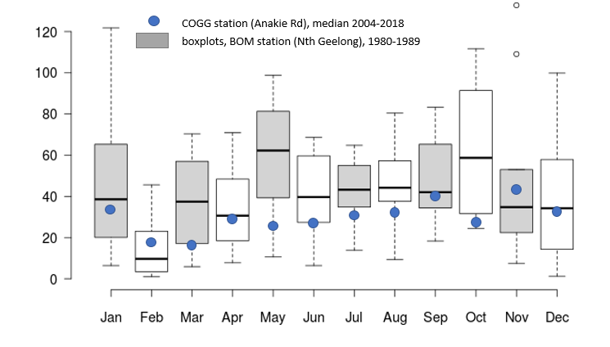
Figure 8: Monthly rainfall totals.
- Geelong North BOM station 1980-1989 (box plots); and
- Anakie Road depot 2004-2017 (blue dots depicting median values).

7.1 Basic design parameters for stormwater reuse systems
Stormwater reuse systems should aim to provide an alternative to potable water as the primary source with a minimum reliability of 75%, minimum total demand of 22 ML/year and yield of 16.5 ML/year. Smaller systems may be considered on a case-by-case basis subject to agreement and approval in writing by the City.
Any proposed re-use system must be discussed with the City’s Irrigation Manager (Parks and Gardens Department) to determine project specific requirements as part of the detailed design and approval process.
For reference, typical reuse demand figures are provided in Table 4, below. However, specific re-use demand must be discussed with the City’s Irrigation Manager (Parks and Gardens Department) to determine project specific requirements as part of the detailed design and approval process. Values for monthly distribution of irrigation demand are also provided for reference in Table 5, below.
Table 4: Typical reuse demand.
Type | Typical Reuse Demand (ML/Ha/yr)
Warm Season Turf | 3.2
Cool Season Turf | 4.5

Table 5: Monthly distribution of reuse demand.
Month | Jan | Feb | Mar | Apr | May | June | July | Aug | Sept | Oct | Nov | Dec
% of annual demand | 29 | 19 | 13 | 1 | 0 | 0 | 0 | 0 | 0 | 1 | 13 | 24

7.1.1 Total and directly connected impervious
It is recognised that flow volumes from existing areas may be over-estimated if the total impervious (TI) fraction, rather than directly connected impervious (DCI) fraction is used. Calibration studies to observed flows suggest that the ratio of DCI:TI may average around 66% but vary from as low as 30% up to 90% for established urban areas. Where a stormwater reuse scheme is treating and reusing water from a well-established existing area, impervious fractions for the catchment should be based on estimated DCI using a DCI:TI ratio of 66%.
NOTE: TI must be used for the design of treatment assets for all new developments as they typically have high levels of imperviousness and drainage connection and a higher proportion of connectivity should conservatively be assumed.
Where diversions and pumps are used to divert flows for a stormwater reuse scheme, the modelling should reflect anticipated real conditions. This includes, bypass of low flows to preserve baseflows where needed and bypass of high flows above the design. This is important, even at concept level, to avoid over-stating potential reuse volumes captured.
Where diversions occur, these should not adversely impact upon baseflows for receiving waterways. Baseflows should be separated and bypassed with a diversion for catchments greater than 100 ha unless otherwise agreed in writing by the City.
The low flow bypass rate should be calculated such that the volume of water bypassed is not less than the total baseflow volume expected from the upstream catchment. This may be estimated using the node water balance for the upstream source nodes in MUSIC or more sophisticated analysis considering observed flows for the waterway for larger schemes.
The design flow rate for treatment and diversion should be estimated using rational method or a hydrologic model such as RORB. This should be the 4 EY (1 in 3 month ARI).
Weir overflows from an upstream sediment basin or wetland inlet pond should be diverted around the stormwater storage to ensure only fully treated flows are directed to reuse.

8.0 MUSIC Auditor and Wetland Analysis Tool
The MUSIC auditor is a tool that has been developed for checking the parameter inputs to MUSIC models to ensure they comply with relevant guidelines and are within expected or reasonable ranges. The MUSIC Auditor is intended for use by suitably experienced professionals with an understanding of WSUD and the MUSIC software.
The MUSIC Auditor is free for anyone to use within Melbourne Water's area of responsibility and the City of Greater Geelong and can be accessed using the following website: http://www.musicauditor.com.au/
The Wetland Analysis Tool can also be accessed from the MUSIC Auditor website:
https://www.musicauditor.com.au/wetlandanalysistool
The Wetland Analysis Tool allows the proposed design and inundation patterns of a wetland to be assessed to ensure they meet minimum requirements so that the wetland is likely to be able to sustain healthy plants. This includes assessment of:
- Water levels exceeded 20% of the time relative to plants heights.
- Water level exceeded 50% of the time establishing the effective water level.
- The frequency and duration of spells where the wetland is at a significant depth may put plants at risk.
- The residence time of the wetland is >= 72 hours to ensure adequate time for treatment of nitrogen – this replaces the notional detention time for wetlands using a custom stage-storage-discharge relationship.

9.0 Submission Requirements for MUSIC Modelling
Specific submission requirements should be discussed with the City with the following list to be used as a guide.

9.1 Concept design
- Summary of MUSIC modelling (or alternative method or models), including:
  - version of MUSIC
  - meteorological data used
  - map outlining catchment areas and direction of flows
  - calculations and justification for choice of source node impervious percentage
  - any routing used and calculations
  - treatment node parameters
  - any modelling parameters that are not in accordance with this document and Melbourne Water’s MUSIC Modelling Guidelines with justification for variations
  - pollutant removal results
- A copy of the MUSIC model
- A report from the MUSIC Auditor tool (www.musicauditor.com.au)
- Drawings of the treatment system, including placements, which match the model.

9.2 Functional/Detail design
All of the above and the following:
- A description of the updated MUSIC model, including matching:
  - the inlet pond volume in MUSIC to the sediment pond volume shown on plans (from halfway up the sediment accumulation zone).
  - the permanent pool volume to the proposed bathymetry (using the user defined stage-storage relationship).
  - the high flow bypass configuration to the design.
  - the extended detention controlled outlet configuration to the design (using the user defined stage-storage relationship).
  - Provide flux file in .csv.
  - Include the checklist from the following Table 6 and associated documents.

Table 6: Submission Requirements and Assessment Criteria
Submission Requirement | Assessment | Check | Comments
Screenshot of output from earthworks modelling software of stage-storage relationship | No vertical, horizontal or negative slopes in the stage storage relationship (for example: same stage with multiple storage or same storage at multiple stages) | ☐
 | Consistency with stage-storage table from MUSIC | ☐
 | Values are provided for EDD plus 2.0 metres in stage storage discharge relationships | ☐
MUSIC model with defined stage storage discharge relationships | (Weir) overflow is zero up to EDD, then increases at an increasing rate | ☐
 | (Pipe) outflow increases from NWL upwards. | ☐
 | No negative slopes in the specified relationships | ☐
 | The sum of (pipe) outflow and (weir) overflow curves produces unique values for each stage. | ☐
Areas and volume at NWL and EDD | Design treatment area and volume are consistent with the stage-discharge relationship and proposed asset design | ☐
 | Reconcile adopted stage-storage relationship with area and volume reported at NWL and EDD | ☐
Calculations used for stage-discharge relationship for both wetland outflows and overflows | Reconcile stage-discharge relationship in MUSIC for (pipe) outflow and (weir) overflow with provided calculated values | ☐
 | Check (weir) overflows engage at the expected EDD level | ☐
 | Check assumptions for stage discharge relationships including pipe diameters, weir widths and outlet coefficients | ☐
 | Review proposed dimensions, equations and coefficients are appropriately selected | ☐
Peak top water level for the 1design storm event (for example: 1 EY) and maximum flows through wetland as per design | Check the highest stage has both a storage and discharge value associated with it | ☐

- An inundation frequency analysis of water levels in the macrophyte zone and the 90th percentile residence time in the macrophyte zone (Report form Wetland Analysis Tool or equivalent).

Appendix A: Stage-Storage-Discharge Relationships
Custom stage-storage-discharge relationships are required when modelling wetlands at the functional and detailed design stages. Guidance on preparing these is provided below.
The stage-storage relationship defines the physical topographic conditions of the proposed asset.

Extended detention depth
It is important when creating a new custom stage-storage relationship that the user first enters the correct extended detention depth in the treatment properties dialogue. MUSIC then expects values will be provided in the stage-storage-discharge relationships for at least 2.0 m above this EDD value.

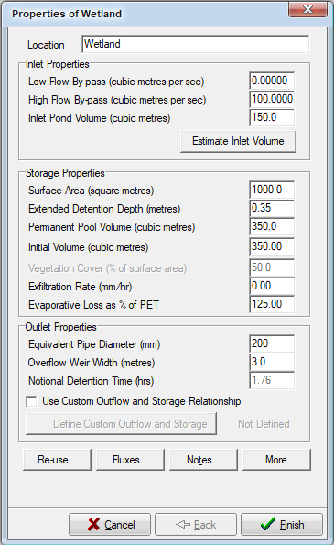
Figure 9: Set Extended Detention Depth
before entering ‘Custom Outflow and Storage Relationship’.

Stage-storage
The stage-storage relationship should be entered prior to defining the stage-discharge relationships for pipe and weir flow.
A stage value of 0 represents the wetland NWL and the corresponding storage volume at NWL represents the wetland permanent pond volume. The specified stage-storage relationship must be consistent with the submitted functional design.
Figure 10 is a screenshot of an example stage-storage relationship dialogue box from MUSIC. The relationship is generally defined by the output of an earthworks model.

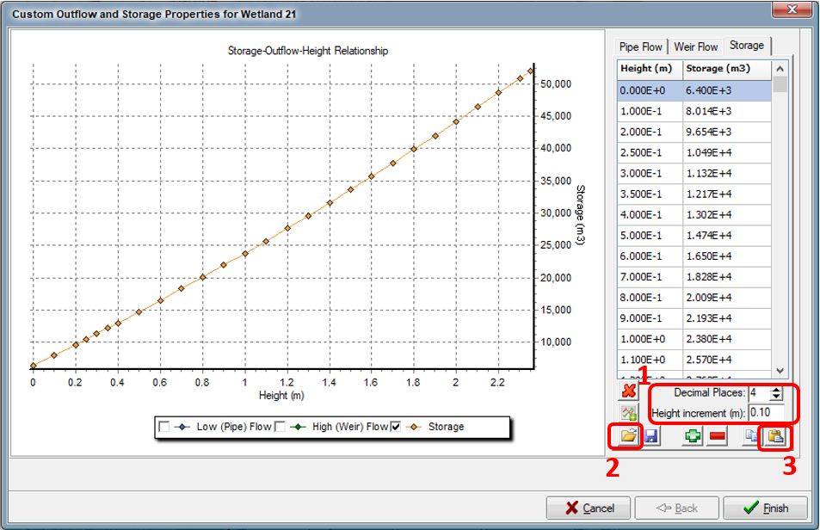
Figure 10: Example Stage-Storage Relationship.
Where 1 is the Height increment and decimal places settings, 2 is the option to open data from a text file and 3 is the option to paste copied data from a text file.

The data output from the earthworks model should be saved with a *.csv file extension. It is recommended the data is viewed in a text editor (e.g. Notepad) to ensure the data does not contain additional formatting or formulas. The data must be presented in the following format for input to MUSIC:
- No header line
- Comma or space delineated
- Set Height increment (m) to 0.1 m and Decimal places to at least 4 decimal places (Recommended) (Note 1 Figure 10)
- Stage-Storage relationship must extend at least 2.0 m above the extended detention level (rounded up to the nearest 100 mm) – to ensure significant changes in storage are recorded and rounding errors avoided
- Use standard number format (MUSIC will convert these to scientific format)
- A starting height of 0.00 m represents NWL of the wetland
- Starting volume is the storage below NWL (i.e. permanent pool volume)
Once formatted correctly, the *.csv file containing the earthworks model data can be imported using the open button (Note 2, Figure 10) or copied to the clipboard and pasted using the paste button (Note 3, Figure 10).
In the example provided in Figure 10, an extended detention depth of 0.35 m was adopted and therefore the stage-storage relationship must be defined up to a height of at least 2.35m (2.0 m above the EDD = 2.0 + 2.35 = 2.35 m).
Often the data from the associated earthworks model will not contain storage values for all stages up to 2.35m above NWL, unless the wetland is located within a retarding basin. Generally, the stage-storage curve can be extrapolated linearly from the highest two stage-storage data points to the target stage value (2.0 m + EDD), see Figure 11. Since the wetland should rarely reach these water levels this should usually be a reasonable approximation.

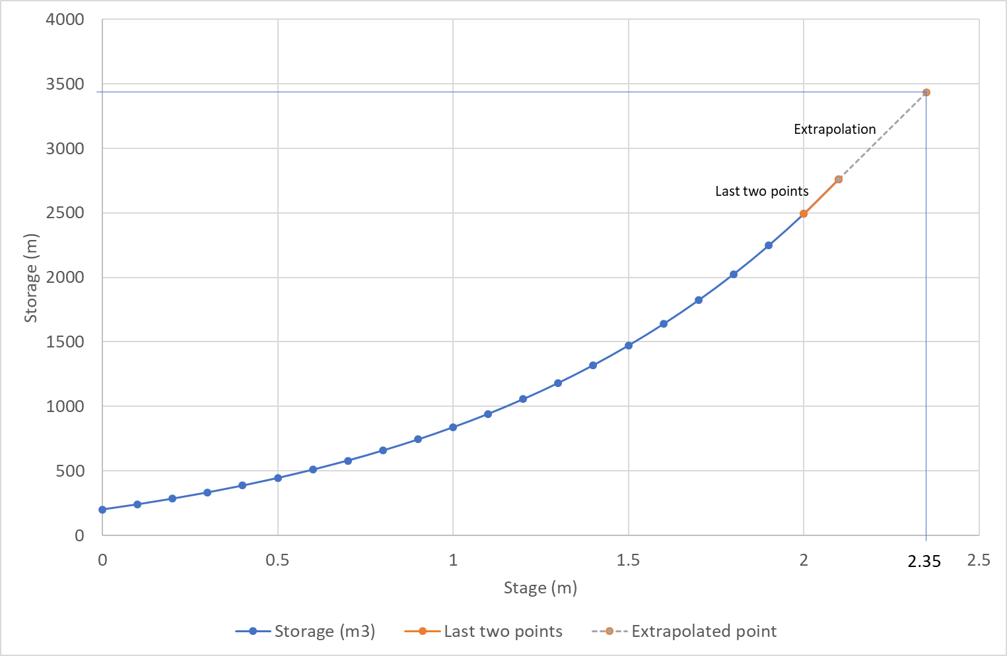
Figure 11: Extrapolation of storage to target stage value.

Stage-Discharge Relationship
The stage-discharge relationship defines the outflow behaviour in terms of both outflow (pipe flow) and overflow (weir flow).
In its calculations, MUSIC interpolates between the stage (water level) and total discharge, which is the sum of pipe and weir discharges. To support this, all possible combinations of stage and total discharge should be unique and the total discharge should always increase with stage. The curve cannot be flat or increase then decrease as there would then be two possible stages which have the same discharge.
Figure 12 and Figure 13 show example stage discharge curves for low (‘pipe’) flows and high (‘weir’) flows, respectively.
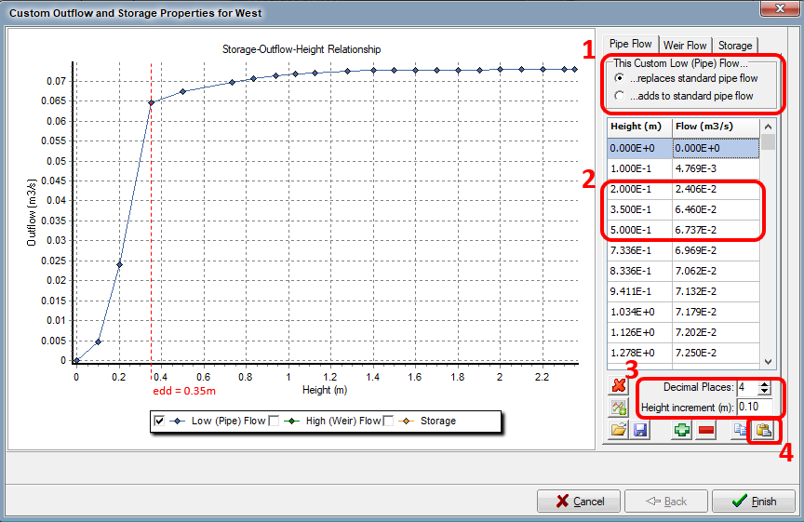
Figure 12: Example Stage Discharge Relationship for Pipe Flow.
Where 1 denotes whether the imported data will replace or add to the pipe flow based on the equivalent pipe diameter in MUSIC (usually use replace), 2 denotes the stage-discharge table and 3 denotes the settings for Height increment and decimal places.

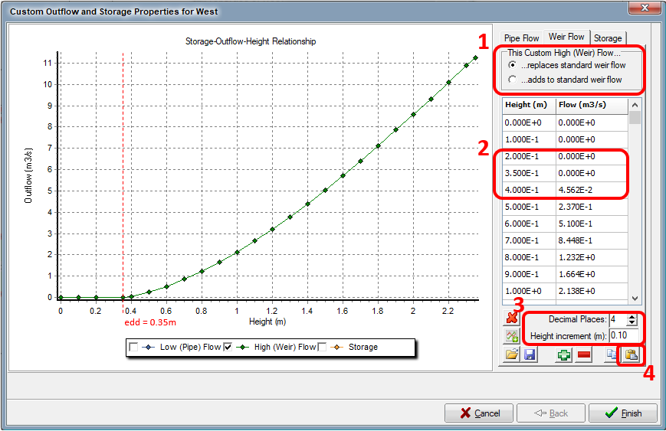
Figure 13: Example Stage Discharge Relationship for Weir Flow.
Where 1 denotes whether the imported data will replace or add to the pipe flow based on the equivalent pipe diameter in MUSIC (usually use replace), 2 denotes the stage-discharge table and 3 denotes the settings for Height increment and decimal places.
Inputs for the stage-discharge curves can be calculated using standard orifice and weir equations. Weirs and orifices should use accepted equations for weir and orifice design as prescribed on the Melbourne Water website. The designer must consider the type of outlet structure and the resulting outflow behaviour and adopt the appropriate equations accordingly.
The Custom High (Weir) Flow in must be set such that the calculated outflows replace standard flows (Note 1, Figure 12 and Figure 13).
The adopted relationships for low and high flows can be verified by observing the curves of the respective data and noting changes at the stage corresponding to the adopted EDD of the wetland (Note 2, Figure 12 and Figure 13).
For the high (weir) flow relationship, it is expected that the outflow will be zero up to EDD, then increase at an increasing rate as the stage increases above the EDD level.
Please refer to Table 6 for Submission requirements and assessment criteria.

Appendix B: Selection of Rainfall Templates

Two climate regions were identified within the City. A 10 year and a 20-year climate template was prepared for each of these. The rainfall periods were infilled using data from other stations to create ‘patched point’ rainfall data sets and have less accumulated and missing data than the original data sets. The method was based on that used by SILO (Jeffrey, 2001) modified for 6-minute rainfall data. The following was then considered to select the periods recommended below in Table 7:
- Rainfall quantity – Mean annual rainfall from all nearby daily rainfall gauges.
- Data integrity – Percentages of missing and accumulated data
- Rainfall variation – Rainfall percentiles similar to those for reference daily gauges
Table 7: Rainfall templates for City of Greater Geelong.
Rainfall band | Rainfall station | Period | Mean annual rainfall (mm) | Evapo-transpiration | % accumulated | % missing
>500 mm | 087133 Geelong North | 1974-1983 | 526 | 1,217 | 1% | 1%
>500 mm | 087133 Geelong North | 1971-1990 | 531 | 1,217 | 1% | 1%
<500 mm | 087033 Little River | 1992-2001 | 485 | 1,217 | 5% | 5%
<500 mm | 087033 Little River | 1989-2008 | 464 | 1,217 | 5% | 5%

Monthly evapotranspiration values were adopted based on the templates from MUSIC for North Geelong and Little River respectively and are included in the climate templates.

Appendix C - When is a Bioretention Asset Appropriate?

The following tables (Table 8 and Table 9) provide a summary of decision criteria to decide when a bioretention asset may or may not be appropriate for a given site. This table has been adapted from the Bioretention System Guidelines (Melbourne Water, 2020).
Table 8: Criteria for when to use a bioretention.
Yes | Why | Notes
Terrain won’t support wetlands | Where the terrain can’t reasonably support a wetland’s shape and size without excessive land-take resulting from batters
Footprint needs to be minimised | Where a wetland cannot be co-located within land set aside for other public purposes and the authorities face difficulty with the resulting land-take. | E.g. where small scale means that land acquisition has a disproportionately large impact on costs.

Table 9: Criteria for when not to use a bioretention.
No | Why | Potential mitigating design response
Too Wet.  Sites that are constantly wet or receive continuous or very frequent flows. This includes sites:  - In retarding basins  - In flow paths  - Downstream of wetlands  - Catchments >10 ha  - On floodplains*  - Areas with too much shade (<8 hours sunlight per day) | Moss or algae can form thick surface biofilms in continuously wetted or shaded systems, which reduce the rate of infiltration into the filter media and cause clogging.  Assets fully connected to larger catchments or downstream of regional wetlands are at risk of excessive wetting due being exposed to almost continuous inflows.  Regular wetting and drying of a bioretention system is necessary. Continuous inflows, damp flow paths and floodplains may inhibit this. They are also more likely to back-water drainage layers. | Low flow diversions may reduce problems caused by continuous inflow but may also compromise overall pollutant reduction performance.  *Floodplain sites may be considered as long as it can be shown the site will not experience frequent interflows (shallow groundwater) and has free drainage into the waterway.
Too dry.  Downstream of oversized sediment ponds.  Bioretention overflowing in series. | Upstream sediment ponds must not be oversized for their catchment as these may reduce the frequency of flows into the bioretention and lead to long dry periods with inadequate soil moisture to sustain planting.  A bioretention downstream of another bioretention asset receiving only overflows may experience long dry periods between inflow events. | Over-sized sediment ponds are not acceptable under any circumstances.  Bioretention assets in series should each have an independent impervious catchment. to ensure each bioretention relatively frequent inflows.  Modelling to track soil moisture patterns (durations, spells) may be needed to verify design in uncertain circumstances.  The media should be specified to increase soil moisture retention capacity, a submerged zone of at least 450 mm adopted and more drought resilient plants chosen for any assets with overflows in series.
Site without appropriately sized pre-treatment measures including gross pollutant traps (GPTs) and sediment traps. | Correct treatment train sequencing is important.  GPTs are required to ensure that litter and debris does not smother vegetation or increase the difficulty and cost of litter removal.  GPTs or sediment ponds/traps are required to ensure coarse sediment does not block the surface of the filter media. These must have adequate storage capacity with respect to expected sediment loads and clean-out frequency. | Requirements for upstream primary treatment are catchment specific. Cleaner catchments may need only smaller-scale primary treatment elements.
Sites subject to velocities >1m/s for the 1% AEP (1 in 100 year ARI). | Velocities >1m/s are likely to scour the surface of bioretention systems and damage vegetation. | High flows to be diverted or the bioretention system protected by ‘feedback control’ through back-watering of the inlet to prevent inflow after extended detention is filled.
Where dwarf galaxia habitat needs to be protected. | The absence of permanent water in a bioretention system prevents the distribution of species that are a threat to dwarf galaxia. | Consider using a wetland instead or establishing complementary dwarf galaxia habitat such as wetlands or ponds.
Sites with insufficient drainage outfall depth or no option to provide an overflow weir and high flow bypass. | A frequently back-watered drainage layer will not support drainage of the filter media – which may adversely impact plant health; and may cause blockages in the pipes within the drainage layer. | Designs for potentially vulnerable sites need to be informed by an understanding of downstream water level pattern (e.g. dry weather flows for all seasons. Frequent event water levels and associated spells).  A design for a submerged zone is compatible with a shallower drainage outfall.
Sites with tidal influence or shallow saline groundwater. | Saline water compromises the biological function of the system. | Designs for potentially vulnerable sites need to be informed by an understanding of observed tidal patterns. As above, a submerged zone may help to raise the outlet pipe above the tidal influence.
Sites subject to toxic runoff. | When the system is at risk of being exposed to toxic substances such as herbicides, solvents or industrial contaminants, its biological function will be compromised. | Structural separation must be used to mitigate the impact of industrial activity (and associated harmful toxicants) on the stormwater system.
Asset cannot be accessed for maintenance. | Regular maintenance is vital to ensure optimal function of the system and asset longevity. | Design to minimise maintenance requirements, e.g. upstream litter and sediment control, tree planting and dense planting to control weeds.
Sites with acid sulphate soils. | Acid sulphate soils are harmful when exposed to air, such as through drainage or excavation. | Activities with the potential to disturb acid sulphate soils must be managed carefully to avoid serious environmental harm.
The quality of inflow is impacted by upstream construction phase activities. | High sediment loads running off developing catchments clog the filter media requiring it to be reset. Bioretention assets need to be protected from sediment runoff until at least 90% of construction and building works are completed. | The bioretention asset may be constructed without planting and covered with a protective surface that will be removed (together with accumulated sediment) once the high-risk development activity threshold has passed.

