The City Of
Greater Geelong

policy and legislative context

COMMUNITY HEALTH AND WELLBEING STRATEGY 2025-29

COMPANION DOCUMENT 2

Contents
1. Introduction 4
2. International 5
2.1 Government Policy and Strategy 5
2.1.1 Climate and Health 5
2.1.2 Physical Activity 6
2.2 Evidence 6
3. Federal 9
3.1 Legislation 9
3.2 Government Policy and Strategy 9
3.2.1 Climate Change and Health 10
3.2.2 Healthy Eating 11
3.2.3 Oral Health 11
3.2.4 Immunisation 11
3.2.5 Physical Activity 11
3.2.6 Mental Health 12
3.2.7 Alcohol and Other Drugs 13
3.2.8 Tobacco 13
3.2.9 Gambling 13
3.2.10 Arts 13
3.2.11 Equity 14
4. State 19
4.1 Legislation 19
4.2 Government Policy and Strategy 22
4.2.1 Public Health and Wellbeing 22
4.2.2 Placemaking (Built and Natural Environment) 24
4.2.3 Climate Change 25
4.2.4 Food Security 26
4.2.5 Physical Activity 26
4.2.6 Mental health 27
4.2.7 Tobacco 28
4.2.8 Gambling 28
4.2.9 Arts 28
4.2.10 Equity 29
5. Regional 38
6. Local 43
7. Appendices 44
Appendix 1. Municipal Planning Strategy 44

1. Introduction
The Victorian Public Health and Wellbeing Act 2008 requires councils to develop municipal public health and wellbeing plans (MPHWPs) every four years and within 12 months of a council election.

The MPHWP establishes the goals and strategies for protecting, improving, and promoting the public health and wellbeing of the local community.

A MPHWP must:
- Include an examination of data about health status and health determinants in the municipal district,
- Identify goals and strategies based on available evidence for creating a local community in which people can achieve maximum health and wellbeing,
- Specify measures to prevent family violence and respond to the needs of victims of family violence in the local community,
- Provide for the involvement of people in the local community in the development, implementation and evaluation of the public health and wellbeing plan,
- Specify how the council will work in partnership with the Department and other agencies undertaking public health initiatives, projects, and programs to accomplish the goals and strategies identified in the public health and wellbeing plan,
- Be consistent with the Council Plan
- Have regard to the State Public Health and Wellbeing Plan
- Be reviewed annually and if appropriate, amended (including a review of family violence measures)
One of the first steps in developing a municipal public health and wellbeing plan (MPHWP) is to undertake a municipal scan. This provides a “preliminary understanding of the health and wellbeing status of the community and the determinants that contribute to this health status. It needs to take into account the context of other local, state, and national health policy and issues” (Department of Health and Human Services, 2013).

The Health and Wellbeing Profile (Companion Document 1) presents data about health status and determinants in Greater Geelong, and forms part of the municipal scan.

The Policy and Legislative Context (Companion Document 2) assesses the implications of international, federal, state, regional and local policies, and legislation on the community, indicating areas for further analysis and discussion to identify health and wellbeing priority areas (Department of Health and Human Services, 2013).

Analysing relevant legislation and policies ensures our MPHWP aligns with state priorities, evidence-based approaches, and best practices. The health and wellbeing profile further grounds our work in local data, highlighting health trends, emerging challenges, and opportunities for intervention. This process enables us to identify priority population groups, address key health determinants, and adopt integrated approaches that enhance equity, safety, and community wellbeing.

This evidence base will guide collaboration across Council departments and with community partners ensuring a coordinated effort to improve health outcomes. Information from the municipal scan and health profile will also be shared with Councillors, advisory committees, and relevant departments to support informed decision-making and targeted action across all areas that influence community wellbeing.

2. International
International policy can shape the broader political, social and environmental conditions which influence population health. This section outlines some of the most influential international policy frameworks and evidence influencing contemporary health promotion practice.

2.1 Government Policy and Strategy
Sustainable Development Goals (SDGs)

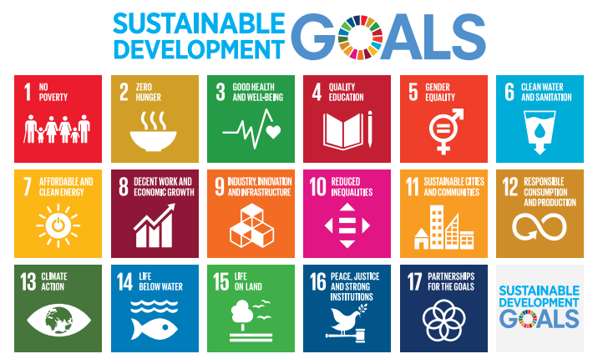
Figure 1: Sustainable Development Goals
The United Nations (UN) 2030 Agenda identifies 17 Sustainable Development Goals (SDGs) that aim to address global challenges which influence health and wellbeing (United Nations, 2020).
Australia is one of 193 countries that signed on to the 2030 Agenda for Sustainable Development and has committed to reporting on the implementation of the goals at least twice between now and 2030. Australia delivered its first voluntary review in 2018. The reporting platform for the SDGs closed on 10 March 2024, however the Australian government remains committed to the 2030 Agenda and SDGs. Alternative options for managing the data are being explored.
The World Health Organisation (WHO) identifies that health promotion and good local governance are critical for achieving the 2030 Agenda and health equity.

2.1.1 Climate and Health
COP28 UAE Declaration on Climate and Health
Declared on Health Day at COP28, the UAE Declaration on Climate and Health recognises the “urgency of taking action on climate change, and notes the benefits for health from deep, rapid and sustained reductions in greenhouse gas emissions, including from just transitions, lower air pollution, active mobility, and shifts to sustainable healthy diets”.

The declaration provides a set of common objectives including the One Health approach and strengthening the implementation of policies that prevent the worsening impacts of climate change.

Australia is one of 149 signatories to this declaration.

2.1.2 Physical Activity
Global Action Plan on Physical Activity 2018-30
The WHO’s Global Action Plan on Physical Activity provides up to date policy guidance for member states, including Australia, to increase physical activity.
Due to its role in the prevention of non-communicable diseases, physical activity has received this global focus by WHO.
The action plan was developed through a worldwide consultation process with key stakeholders across multiple sectors such as health, sports, transport, urban design and academia.
“As countries develop economically, levels of inactivity increase” (World Health Organisation, 2018)
The plan acknowledges that a systems-based approach is needed to increase physical activity, and there is no single policy solution.
The plan’s target is for a 15 per cent reduction in the prevalence of physical inactivity in adults and adolescents by 2030.
This global framework is intended to guide national action for member states such as Australia.

2.2 Evidence
This section outlines the evidence-based approaches underpinning implementation of the municipal public health and wellbeing plan.

Social Determinants of Health
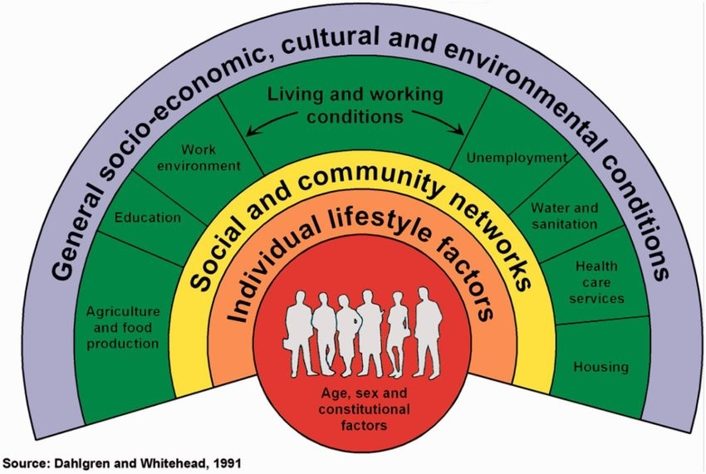
Figure 2: Social Determinants of Health
The World Health Organisation lists the following social determinants of health which can positively or negatively influence health equity:
- Income and social protection
- Education
- Unemployment and job insecurity
- Working life conditions
- Food insecurity
- Housing, basic amenities and the environment
- Early childhood development
- Social inclusion and non-discrimination
- Structural conflict
- Access to affordable health services of decent quality
The Healthy Cities movement aims to improve population health and wellbeing by building multi-sector partnerships to make cities and communities inclusive, safe, resilient and sustainable (see; SDG Goals 3, 11 and 13). It acknowledges that in urban environments, the determinants of health are linked to the built, social, economic and natural environments that affect health behaviour, risk exposure, access to healthcare and ultimately health status. (WHO, Healthy cities 2025).

Good urban governance (the role of local government and strong leadership) is key to ensuring health equity and the health and wellbeing of their citizens” (WHO, Good Urban Governance for health and wellbeing 2023).

Ottawa Charter for Health Promotion

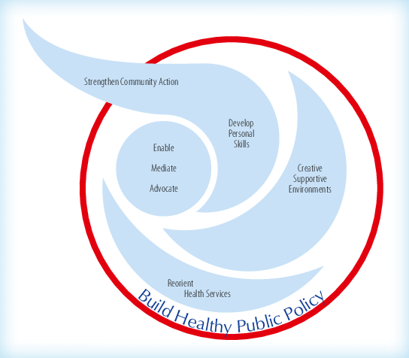
Figure 3: Ottawa Charter for Health Promotion

The Charter identifies health promotion as the process of enabling people to increase control over, and to improve, their health. Health is seen as a resource for everyday life, and promoting health goes beyond the health sector.

The fundamental conditions for health are:
- Peace
- Shelter
- Education
- Food
- Income
- A stable eco-system
- Sustainable resources
- Social justice
- Equity

Geneva Charter for Wellbeing
Established in 2021, this charter builds on the Ottawa Charter by highlighting the need for global commitments to achieve equitable health and wellbeing outcomes now, and for future generations whilst also considering planetary health.

Health in All Policies approach (HiAP)
The Health in All Policies (HiAP) approach is an approach to policymaking that systematically considers the health implications of decisions across sectors.

It recognises that our greatest health challenges such as climate change, health equity and the rising incidence of chronic disease are complex and linked to the social determinants of health. Tackling these challenges requires collaboration across many sectors.

The Adelaide Statement II on Health in All Policies was an outcome of the 2017 International Conference on Health in all Policies in Adelaide. This statement, agreed to by 21 countries, commits to build on the Health in All Policies approach by recognising that health is a political choice, and continuing to strongly advocate for health, wellbeing, and equity to be considered in all policies.

3. Federal
Federal legislation and policy play a crucial role in shaping the health and wellbeing of Australians by setting national priorities, regulatory standards, and funding frameworks. This section outlines key federal policies and legislative frameworks that influence public health, guide state and local implementation, and support coordinated action across all levels of government.

3.1 Legislation
In the context of the Municipal Health and Wellbeing Plan, federal legislation primarily governs health service funding and regulation, establishes frameworks for system sustainability, and upholds equitable access through anti-discrimination laws.

National Health Act 1953
An Act relating to the provision of pharmaceutical, sickness and hospital benefits, and of medical and dental services, including the provision of vaccines such as COVID-19.

National Health Reform Agreement (NHRA) 2020-25
This agreement between the Federal government and all states and territories commits to ensuring the future sustainability of Australia’s health system and improving health outcomes for all Australians.

Through this agreement, the Federal government provides funds to hospitals and community health settings. Primary Health Networks (PHNs) are identified as key organisations providing support to governments to deliver health services.

‘Prevention and wellbeing’ is one of six reforms aiming to reduce the burden of long term chronic disease and improve people’s quality of life.

Anti-discrimination legislation
In Australia, it is illegal to discriminate on the basis of a number of protected attributes including age, disability, race, sex, intersex status, gender identity and sexual orientation in certain areas of public life including education and employment. Federal anti-discrimination laws are contained in:
- Age Discrimination act 2004
- Disability Discrimination Act 1992
- Sex Discrimination Act 1984
- Racial Discrimination Act 1975

3.2 Government Policy and Strategy
Australia’s Long Term National Health Plan
This is the Federal government’s plan for a better health system and is focused on primary health care.

The third pillar relates to mental health and preventative health. Through this pillar, the government is conducting the Intergenerational Health and Mental Health Study which will provide a detailed evidence base for mental health planning at the local level over the next decade.

Funding is provided to PHNs to commission mental health services at a regional level, enabling them to fill gaps in services available to their communities and respond to local needs across:
- Primary mental health care services
- Mental health promotion, prevention and early intervention
- Psychosocial support
- Suicide prevention

National Preventative Health Strategy 2021-30
This strategy aims to keep people healthy and well by making changes to the health system and our surrounding environments. The focus areas are:

- Reducing tobacco use and nicotine addiction
- Improving access to and the consumption of a healthy diet
- Increasing physical activity
- Increasing cancer screening and prevention
- Improving immunisation coverage
- Reducing alcohol and other drug harm
- Promoting and protecting mental health

3.2.1 Climate Change and Health
National Health and Climate Strategy
Launched in 2023, this strategy outlines priorities for the next five years to address the health and wellbeing impacts of climate change.

The core objectives are:
- Health system resilience
- Health system decarbonisation
- International collaboration
- Health in all policies
The strategy emphasises the need to elevate the leadership, wisdom, and knowledge of First Nations people.

The National Health and Climate Strategy Implementation Plan 2024-28 has just been released, which identifies the following workstreams:
- Adaptation
- Mitigation
- Primary Care, Aged Care and Preventative Health
- First Nations
- Enablers of Action

Many actions in Primary Care, Aged Care and Preventative Health have both a mitigation and an adaptation component and include active travel.

Heat, air quality, communicable disease, mental health, housing, and homelessness have been identified under the adaptation workstream.

Dietary guidelines and climate resilience have been identified under the mitigation workstream.

3.2.2 Healthy Eating
National Obesity Strategy 2022-32
In Victoria, the implementation of this strategy will be led by the Victorian State government. Its aim is that fewer people’s health and wellbeing is impacted by overweight and obesity.

The objectives are:
- More consumption of healthy food and less consumption of discretionary food
- More physical activity and less sedentary behaviour
Action is linked to three ambitions which work towards these objectives:
- Creating supportive, sustainable, and healthy environments
- Empowering people to stay healthy
- Access to early intervention and care

Australian National Breastfeeding Strategy: 2019 and beyond
This strategy aims to guide all levels of government to develop policies and programs to support breastfeeding and provide a supportive environment for breastfeeding.

3.2.3 Oral Health
Healthy Mouths, Healthy Lives – Australia’s National Oral Health Plan 2015-24

The goal of this Plan is to improve health and wellbeing across the Australia population by improving oral health status and reducing the burden of poor oral health (Australian Government, 2015).

The Plan identifies that there is considerable scope for local government to be involved in oral health promotion (one of six foundational areas outlined in the Plan).

Effective local programs include training maternal and child health nurses in oral health promotion and screening, installing water bubblers in parks, and the provision of transport for the disadvantaged or elderly.

An action guide resource is available with specific actions that councils can incorporate into their Municipal Public Health and Wellbeing Plans.

3.2.4 Immunisation
National Immunisation Strategy for Australia 2019-24

The aim of this strategy is to outline the framework for the prevention of severe outcomes of disease by maximising immunisation coverage in people of all ages.

The City offers a public immunisation service through Barwon Health to reduce the incidence of vaccine preventable diseases.

3.2.5 Physical Activity
Sport 2030

One of the strategic priorities of this plan is to build a more active Australia, with a mission to reduce inactivity amongst Australians by 15 per cent by 2030.

This strategic priority is underpinned by the principle of ‘sport and physical activity for all, for life’ where everyone at any stage of life can undertake the exercise they want and need in a safe, fun and inclusive way, whether through sport or other types of physical activity.

3.2.6 Mental Health
National Mental Health and Suicide Prevention Plan

Mental health and suicide prevention is a national priority.

This plan details the Australian Government’s vision for an improved mental health system, outlining investments including the development of a national network of mental health treatment centres for adults, youth and children through the Head to Health and Headspace programs.

The plan has five pillars:
- Prevention and early intervention
- Suicide prevention
- Treatment
- Supporting the vulnerable
- Workforce and governance
Implementation will occur in partnership with state and territory governments through the National Mental Health and Suicide Prevention Agreement.

Local government can work with partner organisations to provide support in achieving the first pillar, which includes the following focus areas:
- Improving digital supports and services
- Supporting the social and emotional wellbeing of children, parents and carers
- Using places of employment and education as opportunities for prevention
- Taking action to reduce the stigma of mental ill-health and promote social inclusion
- Re-orienting services beyond health to identify and intervene early in illness
In terms of treatment, the plan acknowledges the need to address service gaps to cover the ‘missing middle’ – people who are too unwell to have their needs met by primary care or are not unwell enough to access intensive services. Some investment will support GPs as key entry points into the mental health system.

The plan also identifies the LGBTIQA+ community, Aboriginal and Torres Strait Islander peoples, rural, regional, and remote communities, veterans, and their families as particularly vulnerable.

National Children’s Mental Health Strategy

This strategy was endorsed in 2021 as an action falling out of the Long Term National Health Plan. The strategy is focused on children aged 0 to 12 years.

‘Focus area 1: Family and Community’ talks about promoting mental health and wellbeing as part of parenting and how services can better connect with families and communities. It also acknowledges the impact of significant social and economic disadvantage on children’s mental health and wellbeing.

3.2.7 Alcohol and Other Drugs
National Alcohol Strategy 2019-28

The strategy has four priority areas
- Improving community safety and amenity
- Managing alcohol availability, price and promotion
- Supporting individuals to obtain help and systems to respond
- Targeting a 10% reduction in harmful alcohol consumption

National Drug Strategy 2017-26
A national framework that aims to reduce and prevent the harmful effects of alcohol, tobacco and other drugs.

3.2.8 Tobacco
National Tobacco Strategy 2023-30

This is a sub-strategy of the National Drug Strategy and complements the National Preventive Health Strategy. The strategy aims to achieve a national daily smoking prevalence of less than 10 per cent by 2025 and less than five per cent by 2030 in Australia.

Public Health (Tobacco and Other Products) Act 2023
This Act gives effect to obligations Australia has under the WHO Framework Convention on Tobacco Control. It is about regulating the advertising and presentation of tobacco and e-cigarette products to discourage their use and thereby protect and improve public health.

3.2.9 Gambling
National Consumer Protection Framework for Online Wagering
The objective of the framework is to minimise gambling harm related to online wagering activity and provides a set of ten agreed consumer protection measures. It provides individuals with nationally consistent minimum protections and allows consumers to make more informed decisions.

3.2.10 Arts
National Arts and Health Framework 2014
This framework is a commitment between Australia’s Health Ministers and Cultural Ministers which recognises the role of the arts in contributing to improved health and wellbeing across the health spectrum, from prevention to treatment.

The arts can be a treatment in itself (art therapy) and enhance healthcare environments, an inclusive tool for communicating sensitive issues, a way of celebrating culture, a means of self-expression or a tool for promoting healthy living.

3.2.11 Equity

Aboriginal and Torres Strait Islander People
National Agreement on Closing the Gap
This agreement builds on past agreements in place since 2008 and recognises that structural change in the way governments work with Aboriginal and Torres Strait Islander peoples is needed.

“Aboriginal and Torres Strait Islander people and their cultures have prevailed and endured despite too many experiencing entrenched disadvantage, political exclusion, intergenerational trauma and ongoing institutional racism”. The agreement acknowledges their strength and resilience in “sustaining the world’s oldest living culture” (Agreement, Clause 2).

Local government is a party to this agreement through the Australian Local Government Association (ALGA), represented by the ALGA President (Agreement, Clause 11). The ALGA is the peak body for all Australian local governments.

The outcomes of the agreement include 17 socio-economic outcomes, including indicators related to life expectancy, birthweight, culturally appropriate early childhood education, increasing educational attainment and employment, decreasing incarceration and detention, reducing over-representation in out of home care, reducing violence against women and children, reducing suicide, increasing land rights, increasing the strength of language, and increasing digital inclusion.

Full and genuine partnership underpins ‘a new approach’ outlined by the agreement.

The agreement sets out four priority reforms to change the way governments work to improve the lives of Aboriginal and Torres Strait Islander people:
- Formal partnerships and shared decision making
- Building the Community-controlled sector
- Transforming government organisations
- Shared access to data and information at a regional level

Section 32 of the agreement outline the elements of strong partnerships:
- Partnerships are accountable and representative
- A formal agreement is in place
- Decision making is shared

A review of the Agreement by the Productivity Commission in 2024 revealed that fundamental changes are required in government operations to deliver on the Agreement, including more resources, time, listening, collaboration and rethinking mainstream government systems and culture.

National Aboriginal and Torres Strait Islander Health Plan 2021-31
The plan acknowledges the intersection of cultural determinants of health and social determinants of health as the foundations for a healthy life.
The cultural determinants of health are the protective factors that support good health and wellbeing for Aboriginal and Torres Strait Islander people.

These include:
- Connection to country
- Kinship
- Knowledge and beliefs
- Language
- Self-determination
- Cultural expression

Department of Health and Aged Care, 2021, Status and determinants of Aboriginal and Torres Strait Islander health | Australian Government Department of Health and Aged Care
“Aboriginal and Torres Strait Islander health is viewed in a holistic context that recognises not only physical health and wellbeing but also the social, emotional and cultural wellbeing of individuals, families and communities throughout the entire life course” (page 10).

“Culture is a foundation of Aboriginal and Torres Strait Islander health and wellbeing. It is a protective factor across the life course and has direct influence on broader social determinants outcomes. Gains across these broader determinants, in turn, reinforce cultural connectedness, maintenance, resurgence, nation building and pride in cultural identity” (page 10).

The plan takes a life course approach:
- Healthy babies and children (ages 0-12)
- Healthy youth and adolescents (ages 12-24)
- Healthy adults (ages 25-49)
- Healthy ageing (ages 50+)

The plan has four pillars, one of which is ‘focusing on prevention’ and its action areas are:
- Health promotion
- Early intervention
- Social and emotional wellbeing and trauma aware, healing informed approaches
- Healthy environments, sustainability, and preparedness
In terms of implementation, the plan provides states with the flexibility to work with their partners and their current policies and frameworks, such as Closing the Gap Implementation Plans.

Children and Young People
National Action Plan for the Health of Children and Young People 2020-2030

This plan provides a roadmap for a national approach to improve the health and wellbeing of children and young people. The plan builds on ‘Healthy, Safe and Thriving: National Strategic Framework for Child and Youth Health’.

The plan has five priority areas:
- Improve health equity across populations
- Empower parents and caregivers to maximise healthy development
- Tackle mental health and risky behaviours
- Address chronic conditions and preventive health
- Strengthen the workforce

Local government is identified as a key partner in improving health outcomes for children and young people.

Prevention and early intervention are the plan’s guiding principles.

Disability
Australia’s Disability Strategy 2021-31
In line with Australia’s commitments under the United Nations Convention on the Rights of Persons with Disabilities, this strategy drives action at all levels of government to protect, promote and realise the rights and improve the lives of people with disability.

The strategy’s vision is for an inclusive Australian society that ensures people with disability can fulfil their potential as equal members of the community. It has seven outcome areas:

- Employment and financial security
- Inclusive homes and communities
- Safety, rights and justice
- Personal and community support
- Education and learning
- Health and wellbeing (focusing on access in the healthcare sector and inclusive emergency responses)
- Community attitudes
The first five Targeted Action Plans focus on employment, community attitudes, early childhood, safety and emergency management.

Gender
Working for Women: A Strategy for Gender Equality
The vision for this strategy is ‘an Australia where people are safe, treated with respect, have choices and have access to resources and equal outcomes no matter their gender’.

A foundational shift towards positive gender attitudes and an end to stereotypes is needed to achieve this vision.

The strategy brings together the commitments within the National Plan to End Violence against women and children 2022-32 and the National Women’s Health Strategy 2020-2030, along with valuing and sharing care, advancing economic equality, and improving leadership and representation.

The five priority areas are:
- Gender based violence
- Unpaid and paid care
- Economic equality and security
- Health
- Leadership, representation, and decision making
The strategy has a reporting framework which will utilise outcomes and indicators to track success over time.

The Office for Women will focus its efforts on implementing the strategy’s priority areas and supporting the capability of the public service to embed gender analysis in its work.

The strategy complements state and territory plans, and other national efforts to achieve gender equality.
National Plan to end violence against women and children 2022-32
The plan’s vision is to end gender-based violence in one generation, and it provides the context for state and local policies, strategies, and action.

The plan outlines several cross-cutting principles:
- Advance gender equality
- Closing the Gap
- Centring victim-survivors
- Accountability
- Intersectionality
- Person-centred coordination and integration
Across four domains:
- Prevention
- Early intervention
- Response
- Recovery and healing
Women’s Health Strategy 2020-30
The strategy outlines Australia’s national approach to improving health outcomes for women and girls. Its purpose is to ‘improve the health and wellbeing of all women and girls in Australia, providing appropriate, equitable and accessible prevention and care, especially for those at greatest risk of poor health.

There are five priority areas:
- Maternal, sexual, and reproductive health
- Healthy ageing
- Chronic conditions and preventive health
- Mental health
- Health impacts of violence against women and girls
Action across all these priority areas is informed by five policy principles:
- Gender equity
- Health equity between women
- A life course approach to health
- A focus on prevention
- A strong and emerging evidence base
Local government is identified as a key partner in improving health outcomes for women and girls.
Men’s Health Strategy 2020-30
The goal of this strategy is that every man and boy in Australia is supported to live a long, fulfilling and healthy life.

The strategy encourages us to acknowledge the influence of gender on health, focus on prevention, ensure equity drives investment, build on what we already have, be transparent and provide male-centred information, programs, and services.

The five priority health issues:
- Sexual and reproductive health and conditions where men are overrepresented.
- Mental health
- Chronic conditions
- Injuries and risk taking
- Healthy ageing.
The strategy identifies the importance of partnerships between all levels of government, crossing sectors and portfolios.

LGBTIQA+
In 2023, the Federal Government committed to develop a 10-year national action plan for LGBTIQA+ health and wellbeing alongside an Expert Advisory Group (EAG).

Multicultural
The Federal Government is currently considering recommendations from a review of Australia’s Multicultural Framework. This review will advise the Commonwealth Government on the legislation and policy required to build Australia’s multiculturalism over the next ten years, and how to better meet the needs of Australia’s increasingly diverse society.

The review panel has made 29 recommendations. The top 3 immediately actionable recommendations are:
- Australian government to affirm commitment to multicultural Australia.
- Australia to formally observe the UN International Day for the Elimination of Racial Discrimination on 21 March.
- Develop a national plan to celebrate Australia’s cultural diversity, to synchronise existing federal, state, territory, and local government initiatives such as Harmony Week to acknowledge and celebrate Australia’s cultural diversity.

Older people
National Plan to Respond to the Abuse of Older Australians (Elder Abuse) 2019-23
The purpose of this plan is to provide a framework for action to respond to abuse of older people. It sets out the commitment of the Federal Government and each state and territory to address the complex problem of elder abuse through research, providing services, developing policy and law reforms.

As our population ages, the risk of elder abuse increases.

The plan has five priority areas:
- Enhancing our understanding
- Improving community awareness and access to information
- Strengthening service responses
- Planning for future decision-making
- Strengthening safeguards for vulnerable older adults

4. State
Legislation and policy at a state level set the legal and strategic framework for municipal health and wellbeing planning, ensuring alignment with state priorities. They guide councils in promoting public health, preventing disease, addressing health inequities, and creating supportive environments for community wellbeing. This section outlines key state-level frameworks shaping local government action.

4.1 Legislation
Charter of Human Rights and Responsibilities Act 2006
The Charter sets out the basic rights, freedoms, and responsibilities of all people in Victoria. The Charter helps in making decisions when balancing competing public interests.

Public authorities, such as local government, must act compatibly with human rights and give proper consideration to human rights when making decisions.

However, public authorities can limit human rights when those limitations can be justified e.g., when protecting people from crime, balancing rights, and using limited funding.

Local Government Act 2020
This is the governing legislation for all councils across Victoria. It is a principles-based Act which removed much of the prescriptive nature of its predecessor (1989). It enables councils to govern based on five principles:

- Community engagement
- Strategic planning
- Financial management
- Public transparency
- Service performance

Public Health and Wellbeing Act 2008
The Public Health and Wellbeing Act recognises that a key role of councils is to improve the health and wellbeing of people in their municipality.
It is a key piece of legislation designed to:
- protect public health and prevent disease, illness, injury, disability, or premature death
- promote conditions in which people can be healthy
- reduce public health and wellbeing inequalities in Victoria.
Section 26 sets out the requirements for a municipal public health and wellbeing plan. Section 27 of this Act allows for an exemption from complying with section 26 if the requirements for a MPHWP are integrated into the Council plan or other strategic plan.
Climate Change Act 2017
The Climate Change Act drives Victoria’s transition to a net zero emissions, climate resilient community and economy. The Act provides a supportive framework for local government’s continued investment in reducing emissions and increasing community resilience.

It also requires that municipal public health and wellbeing plans have regard to climate change.

Gender Equality Act 2020
The Gender Equality Act requires the City (as an organisation with more than 50 employees) to promote gender equity through gender impact assessments, workplace gender audits, create a gender equality action plan (GEAP) and monitor its progress.

The Act requires councils to consider other forms of disadvantage and discrimination that may compound gender inequality when developing our strategies, programs, services and measures.

These intersectional characteristics include:
- Race
- Aboriginality
- Religion
- Ethnicity
- Disability
- Age
- Sexual orientation
- Gender identity
The Act aims to promote, encourage, and facilitate the achievement of gender equality and improve the status of women. It also aims to enhance the economic and social participation of people identifying as different genders, and further promote the right to equality.

Disability Act 2006
Under this Act, state and local governments are required to prepare disability action plans. These plans need to describe how the authorities will address access and inclusion barriers for people with disability – for members of the community, service users and employees. Local government plans need to align with the state outcomes framework, so it is clear how they contribute to statewide outcomes.

Racial and Religious Tolerance Act 2001
This Act aims to promote racial and religious tolerance in Victoria. It acknowledges that racial and religious vilification decreases feelings of dignity, self-worth, sense of belonging and social participation. The Act prohibits behaviours that incite or encourage hatred, contempt, revulsion or severe ridicule of another person or group of people because of their race or religion.

Equal Opportunity Act 2010
This Act aims to make public life (e.g., work, school) free from discrimination, sexual harassment, and victimisation. The Act recognises that discrimination can cause social disadvantage, and unequal access to opportunities in society.

Multicultural Victoria Act 2011
This Act recognises that Australian citizenship is central to multiculturalism and refers to the rights and responsibilities of all people in a multicultural society.

Planning and Environment Act 1987 and Victoria Planning Provisions
The Planning and Environment Act provides a framework for planning the use, development, and protection of land in Victoria.

Subordinate planning instruments under the Act, such as the Victoria Planning Provisions and planning schemes provide the detail. For example, planning schemes contain policies and provisions that control land use and development such as zones and overlays.

Amongst Council’s planning roles are to prepare and administer planning schemes, refer plans of subdivision to referral authorities, certify plans and issue statements of compliance. Councils also represent the interests of the communities within their municipalities in the planning system.

The Municipal Planning Strategy (MSPS) outlines specific planning requirements and commitments for the Greater Geelong municipality. There are many areas of the MPS that can influence health outcomes, and a summary has been included as an appendix (see Appendix 1).

Mental Health and Wellbeing Act 2022
This Act is a key recommendation from the Royal Commission into Victoria’s Mental Health System and replaces the Mental Health Act 2014.
The objectives of the Act are high level, system wide aspirations to support the pursuit of the highest standard of mental health and wellbeing for all Victorians. The Act reflects a more inclusive mental health and wellbeing system which encompasses a broader range of organisations including early intervention and community-based services.
Community mental health and wellbeing service providers will work with clinical mental health services in partnership with other providers throughout a network of new Mental Health and Wellbeing Locals.
The Greater Geelong-Queenscliff Mental Health and Wellbeing Local is a new service provided by a consortium consisting of Barwon Health, ermha365, Wellways and Wathaurong. The services are free, with no referral or mental health plan needed, for people 26 years and older and for anyone with mental health and/or substance use concerns.
Tobacco Act 1987
This Act:
- established the Victorian Health Promotion Foundation (VicHealth)
- prohibits sales and promotion of tobacco products, and certain non-tobacco products,
- creates offences in relation to smoking (e.g., smoke free dining provisions) and the possession of tobacco products.
The Act has undergone numerous reforms since its introduction including a smoking and vaping ban on patrolled beaches, outdoor dining areas, within the grounds of childcare centres, kindergartens, primary and secondary schools and within four metres of these and many other entrances including community health centres and Victorian Government buildings. E-cigarette and shisha products are also regulated in the same manner as tobacco.
In addition, the Commonwealth Government banned the sale of e-cigarette products in retail outlets from 1 July 2024.
Victorian council environmental health officers are authorised to enforce the provisions of the Tobacco Act.
Inquiry into Vaping and Tobacco Controls
An inquiry into vaping and tobacco controls is being conducted by the Public Accounts and Estimates Committee, and after three public hearings and 115 submissions, the committee tabled their report in Parliament on 29 August 2024.
The purpose of the inquiry includes identifying trends in vaping and tobacco use and the associated impacts as well as assessing the effectiveness of current public health measures to prevent and reduce the harm of tobacco use and vaping in Victoria, and potential reforms.

The report has made 27 recommendations including that Victoria establish a nicotine licensing scheme and active regulatory authority to better manage vaping and tobacco products. It also recommended campaigns to increase community awareness of the environmental impacts of e-cigarettes.

The government has six months to respond to the recommendations.

4.2 Government Policy and Strategy

4.2.1 Public Health and Wellbeing
Victorian Public Health and Wellbeing Plan 2023-27
This plan provides a framework for coordinated action for promoting the health and wellbeing of all Victorians. The Public Health and Wellbeing Act 2008 requires that state and local health planning inform each other and provide the basis for an integrated planning approach.

The plan outlines ten priority areas which provide continuity from the last plan. These priorities contribute to the burden of disease and are key drivers of ill health across the lifespan. Sustained, long term action can have the biggest impact on health and wellbeing:
      - Improving sexual and reproductive health
      - Reducing harm from tobacco and e-cigarette use
      - Improving wellbeing
      - Increasing healthy eating
      - Increasing active living
      - Reducing harm from alcohol and drug use
      - Tackling climate change and its impacts on health
      - Preventing all forms of violence
      - Decreasing antimicrobial resistance across human and animal health
      - Reducing injury
This approach also focuses on:
- Collaborative action
- Supporting safe and healthy environments
- Advancing health equity

Victorian Cancer Plan 2024-28
This plan sets the Victorian Government’s direction for improving cancer outcomes for all Victorians.

The plan has two priorities:
- Equitable health outcomes for all Victorians
- Improving screening and early detection rates

Medium term goals include eliminating Hepatitis B and C as well as cervical cancer as public health problems in Victoria. One of the five pillars of change is ‘empowering Victorians to prevent cancer’.

The Victorian government will work with partners and stakeholders to deliver actions outlined in the plan.
VicHealth Strategy 2023-33

The Victorian Heath Promotion Foundation (VicHealth) is a key stakeholder for driving equitable health and wellbeing outcomes for Victorian communities.

Their ten-year strategy outlines a new approach to health promotion which transforms from “tackling individual behaviours and determinants of health to reshaping systems for a healthier, fairer Victoria” (VicHealth, 2023, p4).

The strategy outlines three 10-year aspirations:
- Health – deliver healthier, longer lives for all Victorians
- Economy – deliver value to the Victorian healthcare system and economy
- Equity – drive fairer health outcomes with and for Victorian communities

It focuses their work on reshaping three key systems which are critical for improving health and wellbeing, utilising three strategic lenses which embed health equity as depicted in the diagram below. This strategy will help guide their decisions, investments and strengthen relationships and guide the City’s systems thinking approach to improving health and wellbeing.

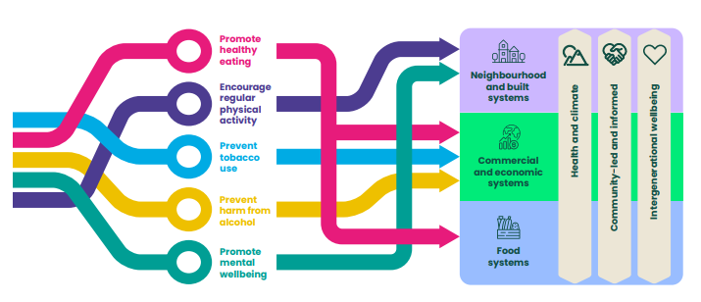
Figure 4: VicHealth Strategy 2022-23

One of the key levers to bring the strategy to life is partnerships. VicHealth works directly with local government, providing programs, technical support and capability building to support long term, place-based and systemic approaches which tackle inequities within and between communities.

“VicHealth can complement the work of local government through its power to convene, provide technical capability, contribute to funding, and evaluate impact (VicHealth, 2023, p43)

4.2.2 Placemaking (Built and Natural Environment)
Plan for Victoria
This plan from the Victorian Government establishes a statewide vision for how Victoria will grow over time:

"By 2050, Victoria will be a vibrant, accessible and connected community, valued for its diverse cultures, sustainable environmental practices and respect for the First Peoples of Victoria.
Building a state that provides choices and opportunities for current and future generations of Victorians in quality housing, transport, employment, environment and connectivity will require input from the community, government, local businesses and industry alike.
We will create a society that caters to the unique needs of all Victorians, nurturing individual health through physical and cultural recreation." (Victorian Government 2025)

To achieve this vision, the plan is structured around five pillars of action:
- Self-determination and caring for Country
- Housing for all Victorians
- Accessible jobs and services
- Great places, suburbs and town
- Sustainable environments

Plan Melbourne 2017-50
Plan Melbourne is the Victorian Government’s long term metropolitan planning strategy that outlines how Melbourne will grow and change until 2050, integrating land-use, infrastructure, and transport planning.
The plan outlines how the government will address the challenges of:
- Managing population growth
- Growing the economy
- Creating affordable and accessible housing
- Improving transport
- Responding to climate change
- Connecting communities
Among its nine principles are:
- Environmental resilience and sustainability
- Strong and healthy communities
- Living locally – 20-minute neighbourhoods
- A city of centres linked to regional Victoria
Outcome 7 is that ‘regional Victoria is productive, sustainable and supports jobs and economic growth’. The two directions aimed at achieving this are:
- Invest in regional Victoria to support housing and economic growth
- Improve connections between cities and regions

Healthy Parks Healthy People (HPHP) Framework 2020
Research has shown that spending time in nature is good for your health and wellbeing:
- Physical health and wellbeing
- Mental health and wellbeing
- Social connections
- Healthy and active ageing

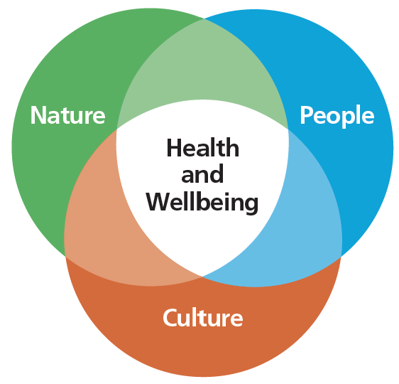
Figure 5: Healthy Parks Healthy People Framework

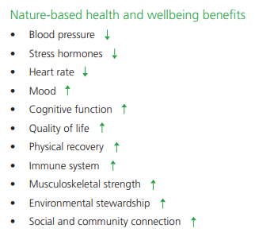

The HPHP framework from Parks Victoria highlights the fundamental connection between the health of the environment and the wellbeing benefits of spending time in nature. The framework outlines the critical role parks can play in encouraging healthier, more liveable, and more connected communities.
The framework directly contributes to outcomes in the Victorian Public Health and Wellbeing Plan 2023-27. Local Government is listed as a key partner in the Programs and Partnerships Plan, and Parks Victoria is an important stakeholder for our work in improving access to nature.

4.2.3 Climate Change
Victoria’s Climate Change Strategy
The aim of the strategy is “by 2030, Victoria will have reduced emissions by 45 to 50 per cent below 2005 levels”. The Department of Energy, Environment and Climate Action’s policies to cut emissions will mean that by 2030, amongst other outcomes:
- the community will have improved health and wellbeing due to less pollution
- all households will have organic waste recycling services
- waste generation will be down 15 per cent per person
- all new public transport buses are to be zero emissions by 2025.
The strategy acknowledges the crucial role of local government in helping to reduce emissions and promote more resilient communities.
The strategy also acknowledges the co-benefits of travelling by public transport, walking, and cycling. It endorses the development of 20-minute neighbourhoods under Plan Melbourne which will reduce car trips, and the strategy aims for 25 per cent of trips to be by foot or cycle by 2030.
Tackling climate change and its impact on health through municipal public health and wellbeing planning – Guidance for Local Government 2024
Local government is identified in the Climate Change Act 2017 as a decision maker that must consider climate change when preparing a municipal public health and wellbeing plan. The guidance recognises the important role of local government in tackling climate change and its health impacts and outlines how to incorporate climate change into the municipal public health and wellbeing planning cycle.

4.2.4 Food Security
The state government’s Inquiry into Food Security sought to understand the impacts and drivers of, and solutions for, food security in Victoria, including but not limited to:
- The impact of food insecurity in Victorian on physical and mental health as well as poverty and hardship, and
- options to lower the cost of food and improve access to affordable, nutritious and culturally appropriate food.
The inquiry made recommendations to the Victorian government that:
- Highlight the importance of nutritious and culturally appropriate food,
- Outline short term policy options for improving access to food, and
- Make the case for a long-term Victorian Food Security Strategy.
Recommendations from the inquiry of relevance for local government include:
Recommendation 23
That the Victorian Government accept Sustain’s proposal that local governments be empowered to lead the participatory development of community food systems and food security strategies via the provision of financial and supporting resources. As such, food security should be reinstated as a priority area within the next Victorian Health and Wellbeing Plan, embedding food security within strategic health planning for all local governments in Victoria.
Recommendation 24
That the Victorian Government revise the Victorian Planning Provisions (Planning and Environment Act 1987) to include health and food security as an objective when local governments and other planning authorities are making planning decisions.
At the time of writing, a state government response to the Inquiry’s recommendations was pending.

4.2.5 Physical Activity
Active Victoria 2022-26
Active Victoria is a strategic framework for sport and active recreation. It outlines six priority outcomes to ensure that more people can enjoy the benefits of sport and active recreation. Among them are:
- Increasing equitable participation in sport and active recreation
- Delivering quality infrastructure that is accessible, respectful, and inclusive.
Get Active Victoria website is a free government initiative full of useful ideas for getting active. The resources available can support organisations implementing physical activity initiatives.

Victorian Cycling Strategy 2018-28
This strategy is guiding planning and driving investment to get more people cycling for transport. Active Transport Victoria is collaborating with local government and other stakeholders to implement the strategy and provide better connected networks for cyclists.
Walking and Bike Riding Consensus Statement 2021
This statement by Bicycle Network advocates to the Victorian government for more investment in infrastructure so everyone feels safe to walk and ride bikes. It acknowledges that many councils have adopted plans to improve walking or bike riding since the pandemic, but 80 per cent lack the funding to get these plans off the ground.

The statement provides three recommendations:
- Include walking and bike riding as an essential part of integrated transport planning
- Prioritise streets for people in residential areas, around schools and shopping trips
- Upgrade cities, regional centres, and local neighbourhoods by improving footpaths, bike lanes, crossing opportunities and completing missing links

4.2.6 Mental health
Royal Commission into Mental Health
In 2021, the Royal Commission outlined 65 recommendations for redesigning Victoria’s mental health and wellbeing system, including:
Recommendation 1: Supporting good mental health and wellbeing, including the development of a Mental Health and Wellbeing Outcomes Framework
Recommendation 2: Management of promoting good mental health and preventing mental illness – set up a Mental Health and Wellbeing Promotion Office to develop and coordinate a statewide approach to promoting good mental health and wellbeing.
Recommendation 15: Supporting good mental health and wellbeing in local communities, including resourcing ‘community collectives’ in each local government area and establishing a social prescribing trial in each region.
Recommendation 42: A new Mental Health and Wellbeing Act, which was enacted in 2022 (refer to Legislation earlier in this chapter)
There are also a range of recommendations to improve the mental health service system for people living with mental illness, their families, and carers, including a focus on priority population groups and settings such as schools. In response to Recommendation 15, local governments have received ongoing funding to establish Social Inclusion Action Groups and local investment funds that foster local participation, inclusion and connection. The City is also participating in the local social prescribing trial.
Wellbeing Strategy
The Wellbeing Promotion Office was established in 2022 to lead a statewide approach to mental health promotion and prevention of mental distress.
Victoria’s first Wellbeing Strategy will provide a coordinated approach which shifts the focus of the mental health and wellbeing system from treatment and care, towards prevention, mental health promotion and healing.
The strategy was still under development at the time of writing.
Diverse Communities Mental Health and Wellbeing Framework
The development of this framework is an outcome of the Royal Commission into Victoria’s Mental Health System which found the system was not responsive to the needs of Victoria’s multicultural, LGBTQIA+ and disability communities.
This framework was still under development at the time of writing.
Suicide prevention and response strategy 2024-34
This strategy was developed in response to the Royal Commission into Victoria’s Mental Health System and guides the work of the Suicide Prevention and Response Office within the Department of Health.
It is a call to action for all levels of government, workplaces, schools, and other sectors to work together to reduce the incidence of suicide and associated stigma.
The six priority areas for action are:
- Build and support connected systems
- Build on and strengthen existing supports across the suicide prevention and response continuum
- Build and support a compassionate, trauma-informed workforce, strengthened by lived and living experience
- Reduce suicide-related stigma and enable community-wide action
- Drive whole-of-government collaboration and innovation
- Build on and use data and our evidence base in delivery and evaluation
The strategy will be delivered through implementation plans, and the first horizon focuses on setting strong foundations for a whole-of-government and community-wide approach and deliver immediate priorities.

4.2.7 Tobacco
Refer to Legislation around tobacco reform, including Tobacco Act 1987 and vaping controls.

4.2.8 Gambling
Position Statement on Harm Minimisation

The Victorian Gambling and Casino Control Commission (VGCCC) has introduced a position statement on gambling harm. It acknowledges that gambling causes harm and outlines their intention to embed a harm minimisation focus into their decision making processes to minimise problem gambling.

The VGCCC Harm Minimisation Strategy underpins this position statement to integrate a harm minimisation approach to their work and to guide their advocacy around regulatory and policy reform.

4.2.9 Arts
Creative State 2025

This is the Victorian government’s strategy to strengthen and grow Victoria’s creative industries following the COVID-19 pandemic and the impact this had on people working in the arts.
The strategy seeks to improve government support of creative industries and acknowledges the broad public value of the arts for stronger economic outcomes, cultural benefits, and improved mental health.
The health and wellbeing of the creative industries workforce is one of the strategy’s guiding principles.

4.2.10 Equity

Aboriginal and Torres Strait Islander People
Victorian Aboriginal Affairs Framework 2018-2023

This strategic document is the Victorian Government’s overarching framework for working with Aboriginal Victorians, organisations and the wider community to drive action and improve outcomes.

The framework sets a clear direction for how government will ‘Plan’, ‘Act’, ‘Measure’ and ‘Evaluate’ to progress change across government, address inequity and deliver stronger outcomes for and with Aboriginal Victorians.

The original framework ran from 2018 to 2023. It is extended until June 2025 to allow time for ongoing consultation with First Peoples stakeholders to self-determine next steps in the development of a new framework.

Korin Korin Balit-Djak: Aboriginal Health, Wellbeing and Safety Strategic Plan 2017-2027

This plan provides the overarching framework for action to improve the health, wellbeing and safety of Aboriginal Victorians by providing high-level strategic actions to advance Aboriginal self-determination.

The plan covers five domains:
- Aboriginal community leadership
- Prioritising Aboriginal culture and community
- System reform across the health and human services sector
- Safe, secure, strong families and individuals
- Physically, socially and emotionally healthy Aboriginal communities
The plan also acknowledges the importance of a cultural determinants approach to improve the social determinants of health. Cultural determinants focus on strengths-based approaches and recognise the importance of self-determination.

Cultural factors that impact the lives of Aboriginal people include:
- Identity
- Language
- Spirituality
- Connection to country, family and community
A cultural determinants’ approach also aligns with the Aboriginal understanding of health:

“Aboriginal health means not just the physical wellbeing of an individual but refers to the social, emotional and cultural wellbeing of the whole community in which each individual is able to achieve their full potential as a human being, thereby bringing about the total wellbeing of their community. It is a whole-of-life view and includes the cyclical concept of life-death-life.”

Balit Murrup: Aboriginal Social Emotional Wellbeing Framework 2017-27
The development of this framework is a key commitment from Victoria’s 10-year mental health plan and is also a companion document to Korin Korin Balit-Djak.

The objective of the framework is to reduce the health gap attributed to suicide, mental illness and psychological distress between Aboriginal Victorians and the general population.

The plan has been informed by the Aboriginal social and emotional wellbeing model which includes mental health and mental illness as elements of social and emotional wellbeing.

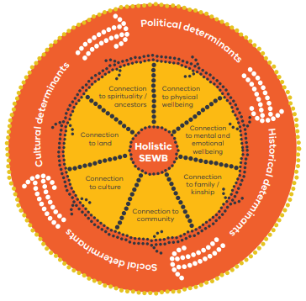
Figure 8: The social and emotional wellbeing model

The model can be applied across the mental health continuum including:
- Symptom reduction
- Recovery and ongoing support
- Health promotion
- Preventative and early intervention responses to protect and promote resilience and reduce psychological distress
The plan identifies local government as a key stakeholder and partner in change, with a key role in closing the gap in disadvantage experienced by Aboriginal people in local communities.

Victorian Aboriginal Local Government Strategy 2021-26
The strategy is a roadmap towards Aboriginal self-determination, acknowledging that all levels of government need to change the way they work and engage with Aboriginal people to help identify and remove the barriers to self-determination that exist in government systems, structures and ways of working and thinking. It recognises the important role of local government in working with Traditional Owners and providing services to Aboriginal communities.
The four enablers needed to achieve self-determination are:
- Prioritise culture
- Address trauma and support healing
- Address racism and promote cultural safety
- Transfer power and resources to communities
Local councils are well placed to work with Aboriginal communities to improve issues such as:
- Civic participation
- Environmental protection
- Reconciliation
- Planning
- Employment and economic development
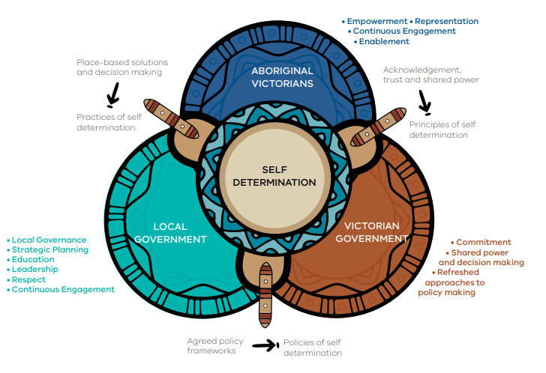
Figure 9: Elements of self-determination

The strategy’s recommended actions come under its seven strategic pillars:
- Culture, respect, and trust
- Awareness and engagement
- Accountability and direction
- Governance and participation
- Economic participation
- Health and wellbeing
- Resourcing and funding
Each pillar has three stages to measure success - understand, embrace, and embed – acknowledging that every local council is at a different stage in the journey of self-determination.
“Local councils must develop strong partnerships with Aboriginal organisations and communities. Those partnerships are integral to improving health and wellbeing outcomes for Aboriginal Victorians” (Strategic Pillar 6: Health and Wellbeing).

The City is working with Wadawurrung Traditional Owners Corporation and Wathaurong Aboriginal Cooperative to develop the Community Health and Wellbeing Strategy 2025-29.

Children and Young People
Healthy kids, healthy futures
This is the Victorian government’s five-year action plan to support children and young people to be healthy, active and well. It is consistent with the Victorian Public Health and Wellbeing Plan 2023-27 in that it has a strong focus on creating supportive environments for healthy eating and active living and captures mental wellbeing initiatives.
The goals of the plan are:
- Child, youth and family focused places provide and promote healthier food and drink
- Communities focus on the health and wellbeing of children and young people
- Children, young people and families are supported to be healthy and raise healthy children
- More opportunities to be active throughout the day.
One of the plan’s priorities is to support local action on child health and wellbeing in partnership with local government. The state government is working with local government areas through the Local Government Partnerships program led by VicHealth. The City of Greater Geelong is not currently involved in this program.

Disability
Inclusive Victoria: State Disability Plan 2022-26
Inclusive Victoria is the state government’s plan for making things fairer for people with disability and meet its obligations under the United Nations Convention on the Rights of Persons with Disability.
The plan’s vision is for ‘an inclusive, accessible and safe Victoria that upholds the rights of people with disability, celebrates our diversity and pride and expands our opportunities to belong and control our lives’.
The four pillars of the strategy are:
- Inclusive communities
- Health, housing, and wellbeing
- Fairness and safety
- Opportunity and pride
One of the six systemic reforms outlined in the strategy is to adopt intersectional approaches that address structural discrimination and disadvantage. This includes a focus on working with people with disability to implement the Gender Equality Act 2020, Free from violence strategy, Victoria’s LGBTQIA+ strategy as well as mental health reforms.
Another reform is to embed universal design principles through fully accessible public toilets and sharing a Universal Design Policy and examples of good practice with local government and community and industry stakeholders.
Measurable health outcomes as part of pillar 2 are:
- People with disability report improved physical health
- People with disability report an increase in healthy living
- People with disability report improved mental health
Most of the commitments and actions under this pillar focus on accessible health care services.
Pillar 4 of the strategy focuses on voice and leadership, and will:
- improve connections between the Victorian Disability Advisory Council and local government disability advisory committees,
- encourage and enable young people with disability to participate in government decision making.
Victoria Autism Plan: 2023 Refresh
This plan was developed in 2019 and refreshed in 2023 so it will last until 2025. It aligns with the priority areas of Inclusive Victoria.

The plan sets out actions to create a more inclusive, accessible, and safer Victoria where autistic people have greater opportunities to participate and contribute to our community. Commitments include improving mental health supports and accessibility to housing (including social housing) for people with autism.

Gender
Our equal state: Victoria’s gender equality strategy and action plan 2023-27
This is a four-year roadmap for action in gender equality, and the state government’s first Gender Equality Action Plan (GEAP) as required by the Gender Equality Act 2020.

The strategy and action plan takes a life course approach to gender equality focusing on:
- Childhood and youth
- Adulthood
- Older age
Actions under the strategy have five focus areas:
- Cultural change
- Health and wellbeing
- Safety and respect
- Economic equity
- The public sector as a leader
Australia’s first Fair Access Policy Roadmap was launched in 2022. The roadmap requires local government to have policies and practices that ensure women and girls receive fair and equitable access to publicly owned community sports infrastructure such as change rooms, ovals and courts.

Under the health and wellbeing focus area, this strategy also established an inquiry into women’s pain management.

The state government will work with local government to:
- Increase the commemoration of women in place naming
- deliver 50% women mayors and councillors by 2025
- implement the Free from Violence: second action plan 2022-25, investing in primary prevention projects across the state
Free from violence: Victoria’s Strategy to prevent family violence and all forms of violence against women
Free from violence is a primary prevention strategy for family violence and all forms of violence against women – that is, a focus on preventing violence before it occurs. It was developed in response to the Royal Commission into Family Violence. The strategy is implemented through a series of three year action cycles.

Free from violence – Second Action Plan 2022-25
Local government is one of the key settings for action under this plan to drive prevention activity across Victorian communities.
Free from Violence Local Government Guide
The Guide was developed to help all councils understand what can be done to embed primary prevention of family violence in day-to-day activities, the workplace and in service delivery. The guide is based on a whole-of-council model which means that primary prevention is built into every part of council, and everyone understands and plays their part in preventing family violence.
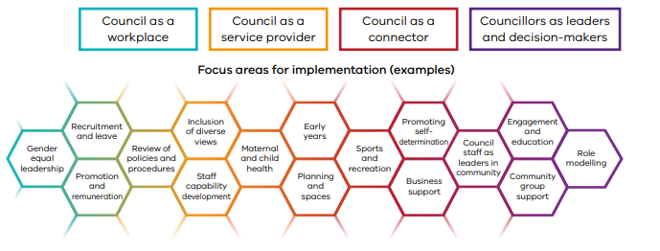
Figure 6: Whole-of-council model for preventing family violence, Department of Families, Fairness and Housing, 2023, p7.

LGBTQIA+
Pride in our future: Victoria’s LGBTIQA+ Strategy 2022-32
Victoria’s first LGBTIQA+ strategy, Pride in our Future, aims to achieve a vision where ‘all Victorians feel safe, are healthy, have equal human rights and can live wholly and freely’.
Local government is clearly nested within the LGBTQIA+ ecosystem, as shown in the diagram below.
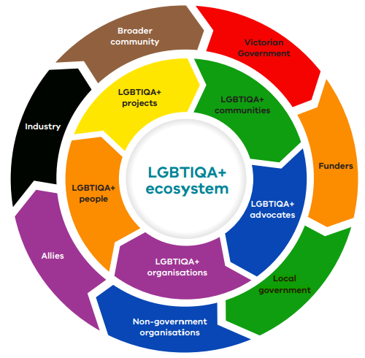
Figure 7: The Victorian LGBTQIA+ ecosystem
The priority areas of the strategy are:
- Equal rights and freedoms
- Equitable, inclusive and accessible services
- Visibility to inform decision making
- Safe, strong and sustainable communities
One of the early actions under priority 2 is to ‘develop a LGBTQIA+ health and wellbeing action plan to improve health and wellbeing outcomes’.
Inclusive data is one of the action areas under priority 3 to achieve greater visibility of LGBTQIA+ communities. One of the actions is to ‘support data collection across government to be inclusive and appropriate’. The City of Greater Geelong was able to collect data from community members who identify as belonging to the LGBTQIA+ community through the Geelong Preventative Health Survey 2024.
Addressing stigma and discrimination through awareness raising and education, public representation and community events is part of priority 4, and this is where local government has a strong role.

Multicultural
Victorian Multicultural and Multifaith Action Plan 2023-27
This plan is focused on ensuring the Victorian government’s services, programs and systems are inclusive and equitable for people from multicultural and multifaith communities.

The plan focuses on ensuring that the “justice and community safety system and workplace culture … is inclusive, equitable, culturally responsive and values people from multicultural and multifaith communities”.

Multicultural Health Action Plan 2023–27

This plan sets out improvement goals and actions to embed cultural competency into the state government’s services, programs, and policies. It provides practical guidance to the department’s internal workforce.

The six improvement goals are:

- Invest in targeted policies, programs and services that improve health equity.
- Design and deliver accessible and culturally competent mainstream policies, programs, and services.
- Provide language services and accessible communications.
- Strengthen community engagement, capacity building and lived experience representation.
- Enhance cultural competency through workforce capability and inclusive leadership.
- Build evidence-based approaches through data, research, and evaluation.
The department has good practice principles and resources to support action within each goal area.

Older People
Ageing Well Action Plan 2022-26
This is the Victorian government’s action plan for strengthening wellbeing for Senior Victorians.
The action plan includes actions to support older Victorians to achieve and live with the eight attributes of ageing well outlined by the former Commissioner for Senior Victorians in his 2020 report ‘Ageing well in a changing world’. These attributes are:
- A positive attitude
- Life has purpose and meaning
- Respected and respectful
- Connected to family, friends and society
- In touch with a changing world
- Safe and secure at home and financially
- Able to manage health issues including mental health
- Able to get around
The action plan has four priority areas:
- Resilient, connected seniors
- Tech-savvy seniors
- Valuing senior Victorians
- Health self-care
The government also encourages an ageing well lens be applied to all government services and programs, including developing alternatives to online access.
The Victorian government recognises the important role of local government in providing support for people to age in place, by making a range of activities and programs available in local communities and investing in a wide range of services and infrastructure. The government commits to continued consultation with councils to better understand changes in community needs.
Actions in the plan will be undertaken in partnership with local government, peak bodies, community organisations and government services.
The plan encourages the needs of an ageing population be included in municipal public health and wellbeing plans.

Building healthy ageing into Municipal Public Health and Wellbeing Plans: a resource guide
The Council on the Ageing (COTA) released this guide in partnership with the Municipal Association of Victoria (MAV) in 2024.
Building in an ageing lens into the municipal public health and wellbeing plan can support integrated planning for communities and underpin the City’s Positive Ageing Strategy 2021-47.

The guide recognises that as the population ages, planning for healthy ageing is a growing public health and wellbeing challenge. Prevention and population health approaches can also reduce demand on health and aged care.
In addition, the health equity focus of the Victorian Public Health and Wellbeing Plan 2023-27 also encourages the consideration of healthy ageing.

5. Regional
This section looks at the policies and strategic plans of key partner organisations to identify strategic alignment and opportunities for collaboration.
G21 2050 Regional Plan
This plan outlines the strategic roadmap for how all levels of government will work together to bring the regional vision of ‘growing well together’ to life.

The G21 region is growing faster than ever before, and particularly since the COVID-19 pandemic where the region grew by 2.24 per cent between 2016 and 2021, a higher percentage than the rest of regional Victoria (1.33 per cent).

Whilst this was a period of prosperity for the region, there remain some significant challenges:
- Pressure on housing and transport
- Rising inequity
- A changing climate
There are six aspirations that describe the type of region hoped for by 2050:
- A place to call home
- Easy, connected transport
- Healthy country
- First Nations voice
- Creative sustainable economy
- Everyone able to thrive
Within this last aspiration, the G21 Regional Alliance aims to achieve the following four outcomes:
- Help is available for all who need it
- We are healthier and have improved wellbeing
- Every child and family is supported
- We lead happy, connected lives
‘Improving wellbeing for all’ is one of seven programs of work over the next five years, and this will be led by the Health and Wellbeing Pillar. The priorities for this program are:
- Improving mental health and wellbeing
- Prevention of violence, family violence and promotion of gender equity
- Reducing tobacco and e-cigarette related harm
- Reducing harm from alcohol and other drugs
- Tackling climate change and its impact on health and strengthening community resilience
- Increasing healthy eating and active living
- Ensuring cultural safety and culturally appropriate healthcare
- Increasing the uptake of cancer screening
G21 are aligning efforts and supporting implementation of the new Barwon Health Public Health Strategy 2023-33, including working with local government partners in the Southwest Alliance, including the City of Greater Geelong.

Barwon Regional Partnership
The City of Greater Geelong is part of this partnership, which is focused on investing in good growth so the benefits can be experienced by everyone. The partnership endorsed the G21 2050 Regional Plan and seek to align partnership priorities with the plan to maximise the region’s voice.
The 2023 Priority submission to the Victorian government outlined the top 5 priorities where the Partnership is advocating for Victorian Government investment:
- Geelong Regional Priority Projects
- Housing – key worker housing, social housing, and affordable housing
- Social Procurement
- Caring for Country – a space for Wadawurrung and caring for Wadawurrung Country
- Regional recycled water grid and a series of integrated water management projects
G21 Integrated Transport Strategy 2021-2041
The strategy highlights the risks of a business-as-usual approach to regional transport planning, making the case for change. The strategy identifies eight goals which can be implemented over the short, medium, and longer term, making real change to the region’s transport network:

- Increase public transport use and competitiveness with other transport modes
- Increase use of active transport within and between local areas
- Encourage more foot and bike traffic in centres
- Reduce car dependency
- Create destinations, linkages and corridors that people love to use and visit
- Plan for a climate-neutral transport system
- Build a transport system accessible for all
- “Sweat” the road space – don’t build more roads unless necessary, explore other options

The actions within the strategy have time frames between 5 and 20 years.

“Active transport is one of the fundamental features of modern, liveable communities and a zero emissions future” (page 34)
Barwon Southwest Local Public Health Unit (LPHU) Population Health Catchment Plan 2023-29
The Catchment Plan recognises that reducing modifiable risk factors as well as improving the social determinants of health is needed for controlling and preventing chronic disease.

The plan will:

- Facilitate the implementation of state-wide programs, priorities and policy at a local level while ensuring these inform and are informed by local priorities and responses
- Strengthen local prevention capacity and networks to drive coordinated and collective impact
- Promote health and wellbeing outcomes that matter to people, their communities, and the environments in which they live
The plan has identified the following health priorities:

- Increasing healthy eating
- Increasing active living
- Reducing tobacco and e-cigarette related harm
- Reducing harm from alcohol and other drugs
- Increasing the uptake of cancer screening
- Improving mental health and wellbeing
- Prevention of violence, family violence and promotion of gender equity
- Tackling climate change and its impact on health and strengthening community resilience
Local government is one of the key collaborators and prevention partners in implementing the plan.
Barwon Southwest Regional Climate Adaptation Strategy 2020-25
This strategy is part of a broader program of work supporting climate change adaptation in Victoria. It also supports the implementation of Victoria’s Climate Change Strategy which includes a commitment to support place-based adaptation. Local government is identified as a key collaborator to address the strategy’s focus areas.

Municipal Public Health and Wellbeing Plans are identified as part of the strategic action by local government. Health promotion also forms part of the regional response by improving awareness of the link between climate change and health, promotion of active living and healthy eating as well as heat and health resources.

Equity (environmental, social and intergenerational) is one of the strategy’s guiding principles, putting the people and places that are most vulnerable at the forefront of decision making.

The strategy outlines some of the impacts of climate change which will affect the Barwon South West community:

- More stress on health and emergency services
- More heat-related deaths, particularly among the elderly and disadvantaged
- Mental health effects on young people
- Changes in disease occurrence
- Increased costs of service delivery
- Increase demand on services
- Health impacts of frontline workers
- Increased domestic violence
- Deteriorating physical and mental health of communities
- Reduced social connectedness
- Increased morbidity
Barwon Health Integrated Health Promotion Plan 2023-24
Barwon Health’s Healthy Communities Unit is a key partner organisation for the City. It sits within the structure of the Barwon Southwest Public Health Unit is funded with Community Health – Health Promotion (CH-HP) funding from the Department of Health.
The unit supports the delivery of the Catchment Plan and strengthen place based approaches through their health promotion priority areas for 2023-2024 are:
  - Active living
  - Reducing tobacco (and e-cigarette) related ham
  - Healthy eating

- Action within these priority areas also has co-benefits for:
  - Climate and health
  - Gender equity
  - Mental health and wellbeing

Bellarine Community Health: Live Well Bellarine
Live Well Bellarine is part of the Integrated Health Promotion Plan 2021-25 for Bellarine Community Health.

Their work is aligned with state, regional and local government priority areas, and the priority areas of Live Well Bellarine are:
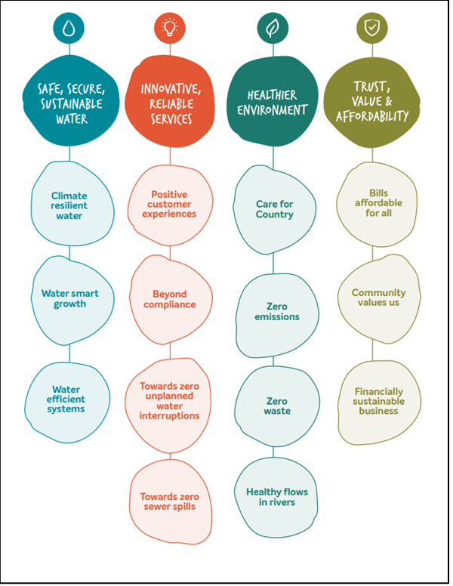
- Eat well
- Be active
- Tobacco-free living

Barwon Water Strategy 2030
Strategy 2030 is Barwon Water’s response to global challenges such as climate change, population growth, social inequities, technological advancements, and economic transitions.

The Strategy will ensure they can maintain the level of service delivery that can deliver clean, high quality drinking water and effective wastewater treatment.

Barwon Water will strive towards the following outcomes:
- Safe, secure, sustainable water
- Innovative, reliable services
- Healthier environment
- Trust, value, and affordability

Figure 10: Barwon Water Strategy 2030 Outcomes

Wadawurrung Healthy Country Plan 2020-2030
The plan has a shared vision for ‘all people working together to make Wadawurrung Country and Culture strong’. The plan identifies nine values and 16 threats to these values, along with three areas of focus:

- Taking care of country and waters
- Us supporting Us – cultural strengthening
- Strengthening Wadawurrung Corporation

Within these programs, there are 18 strategies to reduce threats and improve the health of values, including culture and language strengthening program, elders support services, employment and mentoring, recognition, and respect for Wadawurrung people (treaty) and representation on planning committees.

Western Victoria Primary Health Network 2023-25 Strategic Plan
The vision of the Western Victoria Primary Health Network (PHN) is for healthy communities with accessible and thriving primary care services.

The WVPHN supports the national health priorities of the federal government, and is also responsive to other emerging priorities:
- Aged care
- Alcohol and other drugs
- Digital health
- First nations health
- Mental health
- Population health
- Workforce
The WVPHN has also conducted a needs assessment on the catchment’s community, which includes Greater Geelong. The PHN shares these insights and seeks out opportunities to partner with the City.

6. Local
The outcomes in the City’s Community Health and Wellbeing Strategy will be achieved through the development and/or implementation of policies, strategies, and action plans from across the organisation. Cross-departmental collaboration will support integrated approaches to developing these strategic documents. We will also work in partnership with community organisations, government departments and other stakeholders where relevant.
The following strategic documents guide our work. This is not an exhaustive list. For more strategies and plans (including structure plans and urban design frameworks), refer to our website:

Advocacy Framework 2024
Arts and Culture Strategy 2021-31
Asset Plan 2022-32
Climate Change Response Plan 2021-30
Disability Access and Inclusion Plan 2024-28
Domestic Animal Management Plan 2022-25
Geelong on the Rise: a Clever and Creative International City (Economic Development Plan 2024-34) – under development
Environment Strategy 2020-30
Fair Access Policy 2024
Fair Play Strategy
Gender Equality Action Plan 2022-25
Integrated Transport Strategy - under development
Municipal Early Years Plan 2022-25
Neighbourhood Amenity Local Law 2024 adopted by Council | Neighbourhood Amenity Local Law 2014 Review | Have Your Say (geelongaustralia.com.au)
Open Space Strategy – under development
Plan for Nature (Biodiversity Strategy) – under development
Positive Ageing Strategy 2021-47
Public Realm Strategy – under development
Rainbow Action Plan - under development
Reconciliation Action Plan (Reflect)
Settlement Strategy 2020
Shared Trails Masterplan
Social Equity Framework 2022-25
Smart City Strategic Framework
Stormwater Services Strategy 2020-30
Sustainability Framework 2020
Urban Forest Strategy 2015-25
Vision Zero Geelong: Safe Local Travel 2022-27 (Road Safety Strategy)
Waste and Resource Recovery Strategy 2020-30

7. Conclusion

This comprehensive policy and legislative context document has been key to informing the development of the City’s Community Health and Wellbeing Strategy 2025-29.
Understanding the policy and legislative context influencing local government informs our health and wellbeing priorities. This allows us to align with national, state, and regional priorities, providing opportunities to work in partnership with other stakeholders such as not-for-profit organisations, health services and community organisations to create a comprehensive approach to community health and wellbeing.
Knowledge of relevant policy and legislation enables the City to apply for grants and funding opportunities, ensuring we have the resources to implement initiatives which address help to improve community wellbeing.

8. Appendices

Appendix 1. Municipal Planning Strategy
Municipal Planning Strategy (MPS) | Applicable priority from Victorian Public Health and Wellbeing Plan 2023-2027
Clause 02.02 Vision  Council’s overarching vision for Greater Geelong is:  Geelong, coast, country and suburbs, is the best place to live through prosperity and cohesive communities in an exceptional environment.  The key land use and development aspirations that support this vision are to facilitate:  - A prosperous economy that supports jobs and education opportunities.  - A fast, reliable and connected transport network.  - Sustainable development that supports population growth and protects the natural environment.  - An inclusive, diverse, healthy and socially connected community.  - A destination that attracts local and international visitors. | - Improving wellbeing  - Increases healthy eating  - Increases active living  - Tackling climate change and its impacts on health  - Reducing all forms of violence
Clause 02.03-1 Settlement  - Minimise the economic, environmental, visual and servicing impacts of residential development on rural areas.  - Locate and design urban areas to mitigate the potential impacts of climate change.  Central Geelong  - Support development of Central Geelong as an international waterfront city with world class facilities that is a highly desirable place to live.  - Create an inner city area linking the commercial centre, waterfront and transport hub that connects educational, cultural and business assets.  - Encourage buildings to maximise the overall intensity of Central Geelong respecting heritage areas and protecting the amenity of public spaces.  - Maintain and enhance public access to the waterfront.  Urban Growth Areas  - Facilitate the creation of neighbourhoods where residents can live locally and meet most of their everyday needs within a 20 minute walk, cycle or local public transport trip of their home.  Lara  - Maintain a compact urban form and provide for sustainable communities.  - Facilitate an efficient and integrated movement network for all modes of transport.  Activity Centres and Retail  - Ensure that out-of-centre development provides net community benefit.  Clause 02.03-2 Environmental and landscape values  Biodiversity, waterbodies and coastal areas  - Protect the habitats of indigenous species from the impacts of land use and development.  - Protect, restore and enhance biodiversity and natural systems.  - Protect, maintain and enhance waterways, rivers, wetlands and groundwater. | - Tackling climate change and its impacts on health  - Improving wellbeing  - Improving wellbeing  - Increases active living  - Increase healthy eating  - Improving wellbeing  - Increases active living  - Improving wellbeing  - Increases active living  - Increase healthy eating  - Improving wellbeing  - Increases active living  - Improving wellbeing  - Increases active living
Clause 02.03-3 Environmental Risk and Amenity  Bushfire  - Protect areas at risk of bushfire.  Residential  - Encourage a balance between the need for goods and services that serve local residents and workers and the potential for negative impacts on residential amenity.  Rural Living  - Discourage activities that could cause adverse amenity impacts, particularly through noise nuisances such as animal boarding, and direct them to the Farming Zone. | - Tackling climate change and its impacts on health  - Improving wellbeing  - Increases healthy eating  - Increases active living  - Reducing all forms of violence
Clause 02.03-4 Natural Resource Management  Agriculture  - Preserve the productive agricultural capacity of the land and where possible enhance the environmental condition of the land. | - Tackling climate change and its impacts on health  - Increases healthy eating
Clause 02.03-5 Built Environment and Sustainability  Built Environment  - Support the design and provision of healthy, walkable neighbourhoods.  - Encourage environmentally sustainable design in all development. | - Tackling climate change and its impacts on health  - Increases healthy eating  - Improving wellbeing
Clause 02.03-6 Housing  - Ensure housing diversity is achieved in established and growth area communities.  - Increase the level of affordable and social housing in Greater Geelong. | - Improving wellbeing
Clause 02.03-7 Economic Development  Tourism  - Contributes to the economy  - Respects the landscape character of the area.  - Does not seek to urbanise rural or coastal areas. | - Improving wellbeing  - Increases active living
Clause 02.03-8 – Transport  - Support the development of a safe, accessible, equitable and efficient traffic, transport and freight network.  - Support the delivery of safe, accessible linkages within and between towns that encourage walking, cycling and the use of alternative modes of transport.  - Prioritise active and public transport modes over private vehicle use | - Improving wellbeing  - Increases active living
Clause 02.03-9 – Infrastructure  - Encourage safe and equal access to community and development infrastructure for all members of the community.  - Develop a comprehensive, safe and accessible open space network.  - Ensure that development and community infrastructure is provided or upgraded in a sustainable and timely manner in all areas, with particular regard to the servicing of new communities in urban growth areas and large urban infill areas. | - Improving wellbeing  - Increases active living  - Tackling climate change and its impacts on health  - Reducing all forms of violence
Clause 02.03-10 Gaming  - Minimise the risk of exacerbating problem gambling by directing the location of gaming machines to venues that makes gaming accessible but not convenient. | - Improving wellbeing  - Reducing all forms of violence

Other areas of the planning scheme relevant to Health and Wellbeing
- Clause 13.01: Climate Change Impacts
- Clause 13.02: Bushfire
- Clause 13.05: Noise
- Clause 13.06: Air Quality
- Clause 13.07: Amenity, human health and safety
- Clause 15.01: Built Environment
- Clause 15.01-4S: Healthy Neighbourhoods
- Clause 16.01: Residential Development
- Clause 16.01-2S: Housing affordability
These policies are informed by the MPS, so are just greater variations from the above mentioned.

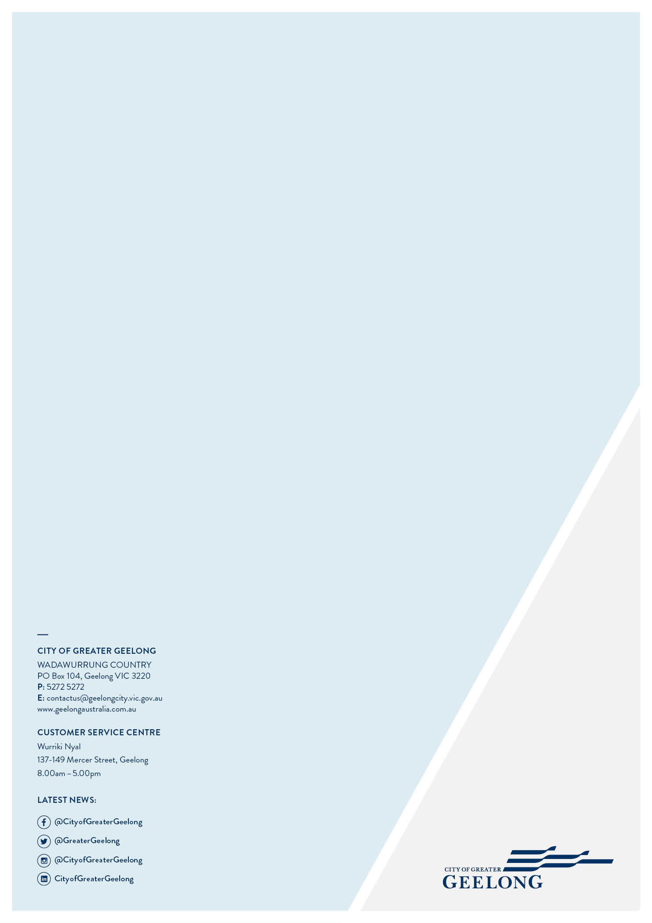

Just transitions ensure the shift to a low-carbon economy is fair and equitable, supporting affected workers and communities while maximising health, social, and economic benefits.

