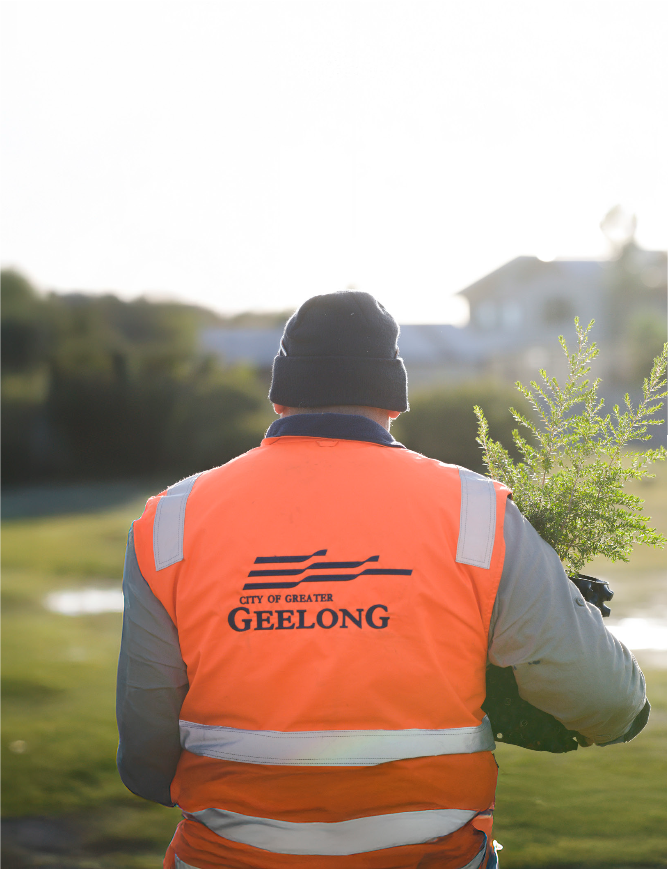

THE CITY OF GREATER GEELONG

OUR

CUSTOMER STRATEGY

2025–28


We Acknowledge the Wadawurrung People as the Traditional Owners of the Land, Waterways and Skies. We pay our respects to their Elders, past, present and emerging. We Acknowledge all Aboriginal and Torres Strait Islander

people who are part of our Greater Geelong community today.

2.


CONTENTS
CEO Message 4
Overview 5
Our Customer Experience Vision 6
What has informed this Strategy 7
Our Customer Landscape 8
Our Region and Services 10
Strategic Commitments 12
Customer Commitment 13
Customer Strategy Roadmap 14
Proposed action plan 15

“All of our people have an important role in driving greater performance, which results in our ability to have the greatest impact for our customers”
Ali Wastie
CEO, City of Greater Geelong

3.

CEO MESSAGE


At the City of Greater Geelong, we’re

committed to delivering for our customers and community, and excellent customer experience is a key enabler of our Organisation Strategy

2024-29.
Providing excellent customer service underpins the incredibly diverse range of services we provide to our community, requiring a whole of organisation approach.
This strategy details how our organisation will embed a culture where we are united in our focus on customer excellence, where each member of staff demonstrates personal leadership when assisting our community, reflecting a genuine ‘can-do’ attitude.
Guided by our organisational values, the strategy offers clear steps to achieving our goal of putting our customers at the heart of service delivery and design to make sure we are meeting their expectations.
It also acknowledges the regulatory role of local government and the strong need to make sure we are transparent and accountable to our community.
Supported by our Customer Service Charter, the actions detailed in this strategy are designed to deliver tangible outcomes for both internal and external customers. They also reflect the important role that digital technology plays in enhancing the overall customer experience.
As an organisation, we look forward to seeing the progress of this strategy and continuing to deliver the best possible outcomes for the Greater Geelong community as a whole.
ALI WASTIE
Chief Executive Officer

4.

OVERVIEW

Our Customer Strategy 2025-28 (Customer Strategy) is another milestone in City of Greater Geelong’s commitment to deliver excellent customer service.
The Customer Strategy informs our customers of how we will work to deliver and improve the experience of services provided to our residents, businesses and community.
We deliver a range of services which are driven by the needs of our community.
We aim to provide our customers with the best possible experience every time they engage with us, whether accessing a service or looking for information.
We are focused on removing the complexity experienced in interactions with our customers. We are committed to being able to help and make sure that the customer is kept informed through proactive communication.
We understand customer trends and acknowledge that customer’s expectations are rapidly evolving. We look to make sure we continue to keep pace
with evolving technology and recognise the role that technology plays in the delivery of customer service and meeting the expectations of the customer.
Customers interact with us in many ways from the traditional channels (phone calls, emails, face-to-face) and via our online channels (online forms/requests, website).
We know that systems and processes play a huge role in customer experience - but to us, it all starts with creating a culture that is truly centred around our customers.
Each time a customer uses one of our services or interacts with us, it shapes their experience. A
customer’s experience with us can start well before making contact and a customer may have more than one point of contact which can happen across multiple ‘service channels’ such as online, phone or front counter, and with more than one person in the organisation.

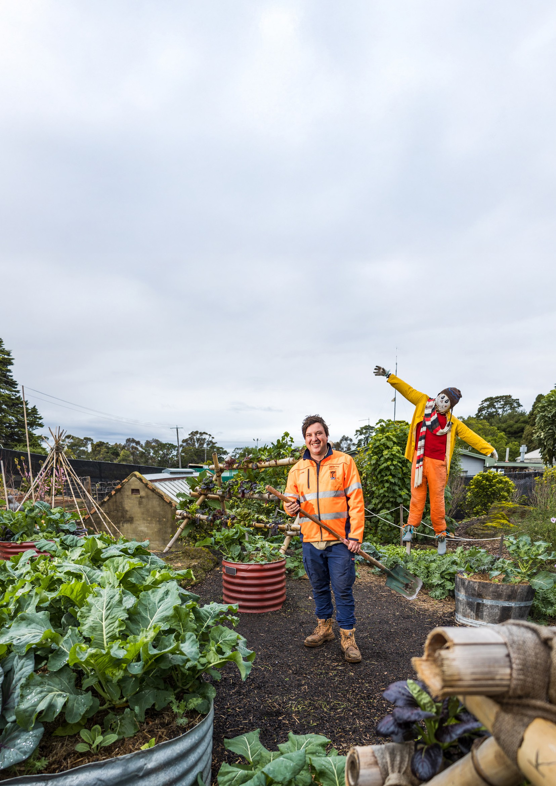

5.

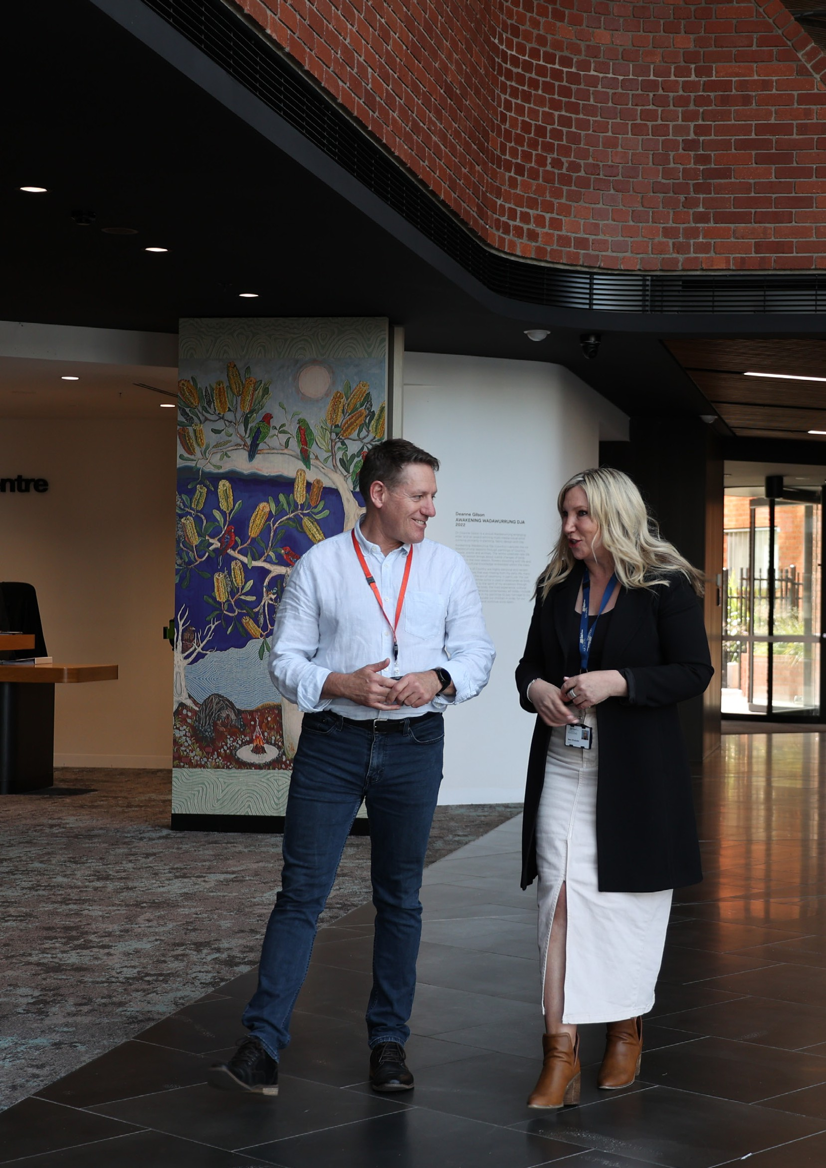
OUR CUSTOMER
EXPERIENCE VISION

The City of Greater Geelong is dedicated to understanding our customers’ current and future needs. We will create a culture where our customers

come first, designing our services to make interaction simple and easy through channels that suit our community.
The City of Greater Geelong is committed to understanding the needs of our customers. We will create meaningful experiences by making every interaction simple, easy, and valuable. We’re focused on delivering a “Customer First” culture and will design our services to make interaction with the community simple and easy through service channels that suit our community.

6.

WHAT HAS INFORMED THIS STRATEGY?


We developed the Customer Strategy by drawing on these inputs:

- Technology landscapes and customer preferences are changing at an accelerating pace. At the same
time, Local Government resources continue to be stretched as populations and demand on services grow. This calls on us to find new, innovative and efficient ways of supporting our customers while releasing capacity to support those who need greater assistance.
- Transforming the way we interact with our customers. This strategy provides the vision and
principles for this transformation and in doing so, outlines our ambition and appetite to meet our customers’ needs.
- The strategy enables the authority to move away from a view that customer service is the
responsibility of a team or department, but instead recognises that it cuts across the full organisation.
It enables Customer Strategy to become part of our values framework that every employee
subscribes too. The strategy raises the profile of the customer being the centre of our decision making and business actions.
- Our Customer Strategy recognises that effective management of relationships are not only about
how responsive, efficient and technologically advanced our services are - it’s equally about the customer feeling valued, and understanding their sentiment and emotion.
- Our Customer Strategy roadmap explains how we will bring our customer commitments to life over
the next three years. The first year aims to invest in our people, followed by improving performance to deliver the greatest impact for our community.

7.

OUR CUSTOMER LANDSCAPE

282,809
2023 ESTIMATED RESIDENT POPULATION

3,562
ABORIGINAL AND TORRES STRAIT ISLANDER PEOPLES

2.41
AVERAGE HOUSEHOLD SIZE

12%
SPEAK A LANGUAGE OTHER THAN ENGLISH AT HOME, UP FROM 11%
82%
WORKFORCE LIVE IN GREATER GEELONG

17.7%
POPULATION BORN OVERSEAS

22,090
BUSINESSES
$19.57BILLION
GROSS REGIONAL PRODUCT

144,568
JOBS

39
MEDIAN AGE
70 YEARS AND OLDER

23

14 21

IF GREATER
0-17
YEARS OLD

50-69
YEARS OLD
GEELONG WERE 100 PEOPLE




42
18-49
YEARS OLD

8.



9.

OUR REGION AND SERVICES

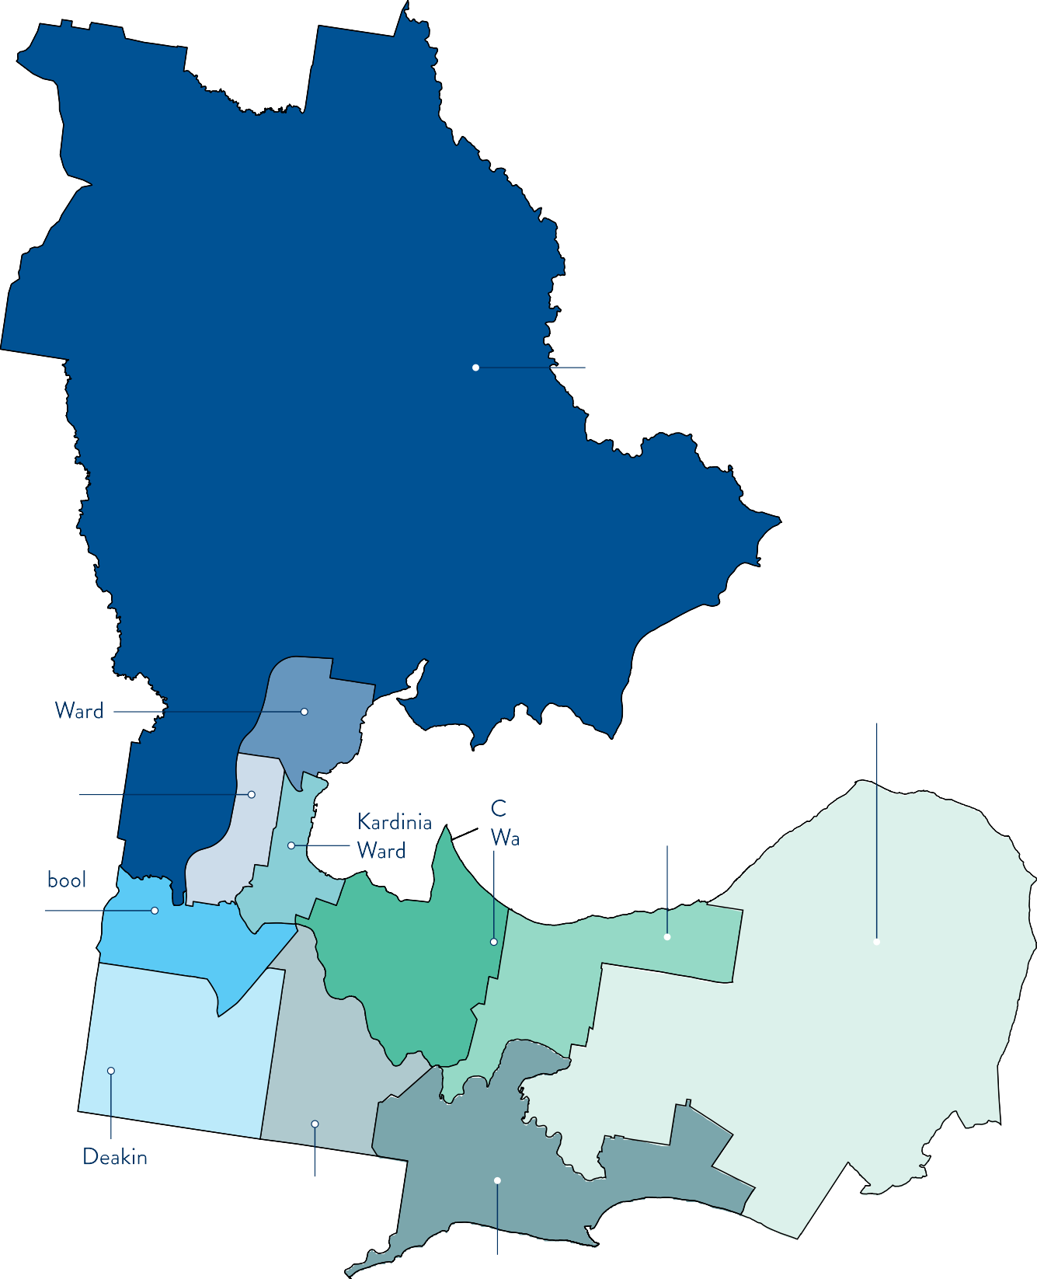
0 You Yangs Ward

Corio Murradoc

Ward

Hamlyn

Heights

Ward heetham

rd

Leopold Ward

Barra Hills
Ward 0 0

Ward Charlemont Ward
0

Connewarre Ward

10.

Over 171,000 calls serviced by Customer Service
22,489 tonnes of recyclables collected



44,501 email enquiries handled by Customer Service Centres
45.5 kilometres of roads resurfaced (spray seal 24.2 km and asphalt 21.3 km)

27,512 visitors to Customer Service Centres
230,727 total number of wi-fi sessions on City-managed free public wi-fi


12,268 participants in youth training, programs and activities

58,598 visitations to the National Wool Museum
17,288 participants in Geelong Design Week 2023



$50,130,955 estimated economic benefit of 12 events funded by Geelong Major Events


46,740 dogs and cats registered 47,500 animal registration renewal notices distributed


95,355 hours of early childhood education and care delivered

49,162 meals delivered to vulnerable residents
57 projects shared on the City’s Have Your Say webpage

9,073 requests for building information

5,000 requests to clear illegally dumped rubbish responded to
100+ events featured in the 2024 Tastes of Greater Geelong program




20,000+ inspections on roads, signage, kerbs and channels, stormwater and furniture in the Geelong region

6.2 million visitors spent 5.8 million nights in the region

$1,411 million worth of works permits issued
3,000 hectares of conservation area monitored as part of the Sparrovale Wetlands Reserve – Ngubitj yoorree

11.

STRATEGIC COMMITMENTS

HOW WE ARE DELIVERING FOR OUR COMMUNITY

GREAT PEOPLE
We will be an extraordinary employer, with innovation at our core.

GREATER

PERFORMANCE
Delivering a sustainable future, side by side with our partners.

GREATEST IMPACT
Committed to delivering for our customers, and for our sector.





Invest in our people:
We will foster a customer- centric culture by investing in our people. Drive a culture of responsiveness through
empowering our staff to make decisions.
Develop and improve processes with a view of continuous improvement:
We will gain valuable insights through improving our processes to be in line with customer needs, demands and expectations. This will enable us to deliver stronger performance across our programs.
Projects and applications to support performance impacts:
We will leverage data and technology to understand our customers better, enabling personalised experiences. This will support customer- centricity, and the streamlining of operations for greater efficiency.

12.


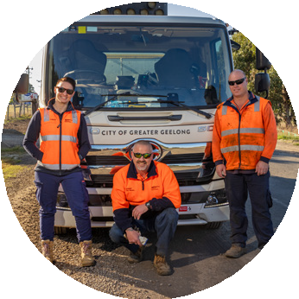

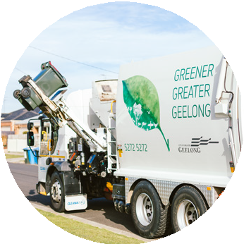
CUSTOMER COMMITMENTS

HOW WE WILL ACHIEVE GREAT CUSTOMER EXPERIENCES

BE RESPONSIVE BE SEAMLESS BE CONSISTENT
We will:
- Listen to you, addressing your needs quickly,
and make sure you feel supported throughout your experience.
- Keep you updated every step of the way with clear and timely information, like emails or SMS.
- Set clear expectations for our services, including realistic timeframes.
- Be open and honest about any challenges or issues that may arise.
We will:
- Make your experience smooth and effortless, so you can get the help you need with ease.
- Offer easy, straightforward processes and forms.
- Minimise wait times and respond quickly.
- Ensure you always have a clear point of contact for any help you need.
We will:
- Make it easy for you to connect with us and get the support you need, no matter how or where you reach out.
- Deliver a reliable experience, no matter who you interact with at the City.
- Develop and introduce new ways for you to connect with us.
- Ensure our website content is easy to access and meets all accessibility standards.

13.

CUSTOMER STRATEGY ROADMAP

PHASE | PHASE ONE: CUSTOMER CULTURE | PHASE TWO: PROCESS AND  PERFORMANCE | PHASE THREE: SCALING  IMPACT
 | Using our values, we’ll | We’ll create more | Our Customer
 | unite our people around | efficient and effective | Culture and improved
 | a customer-focused | processes, transform | processes will inform
HEADLINE | culture, and complete  the foundational | our relationship with  customer data, and | and drive technological  change to scale the
 | planning necessary | make interactions with | impact we make.
 | to deliver on our Customer Strategy. | us easier.
 | - All of our Great People | - Employee capability gaps in relation to CX are addressed.  - We have clear Service Level Agreements and KPIs for all of our high-demand services, and our customers  have access to valuable information on them.  - Managers understand current performance levels through data insights.  - We have reviewed all high-volume  processes, understand our bottlenecks, and are implementing improvements. | - Customer Self Service options are enhanced through website and automation.  - Customer records are centralised to enable personalised customer engagement.  - Applications are identified and developed to support scalability and agility for future growth.
 | understand and are
 | deeply committed to
 | their role in delivering
 | outstanding customer
 | experiences.
 | 2. Our people have a
 | customer-first mindset
 | and are effective brand
 | ambassadors.
 | 3. We have a deep
OUTCOMES | understanding of the metrics of where we  are, and where we want
 | to be when it comes to
 | Customer Experience
 | (CX) – and how to
 | get there (including
 | employee capability
 | gaps, customer
 | journeys, data insights)
 | 4. Employee experience
 | initiatives reinforce our
 | commitment to our
 | customers.

14.

PROPOSED ACTION PLAN

ID | THEME | ACTION | WHY THE ACTION IS IMPORTANT
PHASE ONE: ESTABLISH A BASELINE AND ADDRESS IMMEDIATE CONCERNS
1.1 | Assess | Conduct a comprehensive audit of customer service touchpoints. | To identify key pain points and opportunities for improvement.
1.2 | Assess | Identify existing feedback mechanisms and analyse historical CX data. | To leverage existing insights for strategic planning.
1.3 | Assess | Develop customer personas based on demographic and behavioural data. | To personalise customer experiences and communications.
1.4 | Assess | Benchmark and reset Customer Service levels | To measure and improve metrics such as avg. call handling time, count of customers using self-service tools, first call resolution.
1.5 | Engage | Launch a CX performance dashboard integrating key metrics. | To enable ongoing monitoring and transparency.
1.6 | Engage | Add CX metrics to Organisation Scorecard. | To report progress on CX goals and metrics to the ELT.
1.7 | Engage | Establish baseline satisfaction scores for different service touchpoints. | To define improvement benchmarks.
1.8 | Engage | Set short-term and long-term CX improvement goals. | To provide clear direction for customer service enhancements.
1.9 | Engage | Conduct expert-led workshops to train staff on Service Leadership and delivering exceptional customer service. | To help service leaders and their teams develop a strong customer service culture.
1.10 | Engage | Identify and develop customer action plans with core business areas to drive customer improvements | To give relevant business areas CX targets and programs to meet targets.
1.11 | Culture | Mandate ‘Customer Immersions’ for ELT and Senior Managers (via customer centre visits, customer support call shadowing etc.). | To ensure decision-makers empathise with customers and understand frontline challenges.
1.12 | Culture | Establish core CX principles, mission, and service commitments. | To align organisational strategy with customer needs.
1.13 | Culture | Create ‘Customer Centric Culture’ document | To create a document with details of our customer- focussed culture that aligns with our Staff Values.
1.14 | Quick Wins | Address recurring customer pain points with targeted service improvements. | To quickly improve customer satisfaction.

Action plans for phase two and phase three to be finalised towards the end of phase one, guided by community and council priorities.

15.







CITY OF GREATER GEELONG
Wadawurrung Country PO Box 104
Geelong VIC 3220
P: 5272 5272
E: contactus@geelongcity.vic.gov.au www.geelongaustralia.com.au

© City of Greater Geelong 2025

LATEST NEWS:
@CityofGreaterGeelong @GreaterGeelong @CityofGreaterGeelong CityofGreaterGeelong

