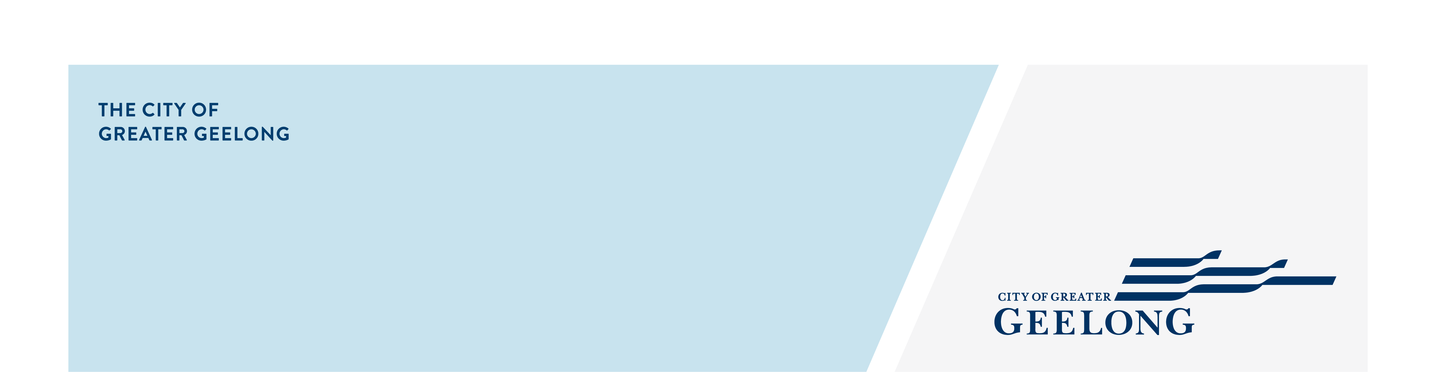
MINUTES

Youth council
ADvisory Committee

28 July 2025| 4:30-7:30pm | PODIUM, WURRIKI NYAL

Attendees
Chair – Ayush Singh (Junior Mayor)

Youth Council Members – Alanah Forbes (Junior Deputy Mayor), Archie Gaylard, Bella Harvey, Ben Pocock, Codey Broomhall, John McClure, Lola Philip-Szaraz, Mohammad Husseini, Sarah Ivey.

Council Officers – Zoe Eastick, Greg Chadwick, Fiona MacLeod-Watson

Guests
Erin McHugh |Coordinator Community Engagement | CoGG

Apologies
Lacey Young

1. Welcome & Acknowledgement of Country
The Junior Mayor welcomed everyone to the meeting.

Ben delivered the Acknowledgement of Country:

Acknowledgement of Country

We, the Youth Council, acknowledge the Wadawurrung People as the Traditional Owners of the land on which we live, learn, work, and dream. We pay our respects to their Elders past and present, and to all emerging leaders.

We walk alongside the Wadawurrung and all First Nations Peoples to build an inclusive and respectful Geelong and to care for Country so it can thrive. We honour their deep spiritual connection to Country, plants, and animals — where the soil beneath our feet, the water in our streams, and the sun rising in the sky carry stories passed down through generations.

2. Quorum
Quorum met
3. Declaration of Conflict of Interest
No conflicts of interest declared.

4. Confirmation of Previous Minutes
Youth Council meeting minutes – 23 June 2025

Confirmed: Sarah Seconded: Bella

5. Consultations / Presentations
Erin McHugh |Coordinator Community Engagement | CoGG

Erin presented about the Community Engagement Policy review and asked Youth Council members for their ideas about how to best engage with young people.

Key Ideas Shared:
- Use eye-catching posters with bold fonts, a clear issue focus, and quick messaging
- Include QR codes on materials to make them interactive and easy to access
- Promote opportunities in high-traffic youth spaces such as:
- School canteens
- Bus stops
- Bike racks
- Make content relevant to young people, including clear benefits (e.g. “What’s in it for you?”)
- Ensure it’s clear that the feedback is Geelong-specific
- Avoid generic handouts – focus on targeted and sustainable materials
- Attend youth events like music festivals (e.g. Electric Stardust) to engage directly
- Offer incentives to encourage participation (e.g. free Spotify Premium, large prizes like a holiday)
- Focus on transparency by showing how youth feedback leads to real outcomes
- Encourage Councillors to actively engage with schools in their local wards

Engaging Feedback Methods Suggested:
- Multiple choice surveys with minimal open text
- Likert scales, both online and in person
- Tactile voting tools (e.g. buttons, sticky dots, coins)
- In-person engagement in relevant locations (e.g. train stations, shops, schools)
- Use screens with live polls so young people can see how others have responded
- Run polls and surveys during school homeroom sessions

6. Updates
6.1. The Nest Reference Group meeting – 1 July.
Not discussed.
6.2. Public speaking workshop – 5 July.
Summary provided. Included that the workshop covered emotional intelligence, strategies for managing nerves, and practical speaking activities.
6.3. Geelong Nature Festival Mega Drop In – 14 July.
Successful event. Youth Council members facilitated trivia which engaged about 10 young people. They also had the opportunity to interact with insects from Bug Blitz.
6.4. 2026 Youth Council Nominations and Council Plan promotion – audio recording and filming
A Youth Council member provided an overview of the filming and audio experience. Zoe advised the video will be premiered at the Council Plan launch and played the recordings for the group.
6.5. Citizenship Ceremony attendance opportunities
Zoe invited expressions of interest from the group to attend one of the remaining Citizenship Ceremonies hosted by the City of Greater Geelong. Youth Council members may attend as guests or potentially take on a formal role during the event.
The following members expressed interest:
Ayush, Alanah, Archie, Bella, Codey, John, Lola, Mohammad, Sarah.
Zoe will provide further information to these members.
6.6. Youth Council report to Council
Youth Council report to Council will be presented by the Junior Mayor on Tuesday 26 August and members are all encouraged to attend. The meeting will run from 6pm with the Youth Council report generally presented between 6:30 – 7pm.
Due to time constraints, a printed copy of the Council report was provided for members to take home. Everyone is encouraged to read it in their own time.
6.7. Youth Awards
Nominations have now closed, with a record 190 submissions received. The judging panel will meet over the next week and a half. The Youth Awards night will be held on 5 September.
6.8. Social Inclusion Action Group
Community members aged 16 and over are invited to participate in a new action group focused on mental health and loneliness. Monthly meetings begin in December, with training and reimbursement available. Members encouraged to take home brochure if they would like to submit an EOI or share with their networks.
6.9. Youth Council Charter reflection and reminder about communication expectations
Members were reminded to read and acknowledge communications, particularly for planning purposes.
6.10. Zoe annual leave – 7 – 14 August.
Contact Greg if need anything during that time.

8. Regional Student Voice Conference
8.1. Conference Overview – 16 September 2025
Zoe provided an overview of the conference and how Youth Council has been invited to be involved in the planning.
Youth Council discussed ways to support student facilitators attending the Regional Student Leadership Conference. Suggestions included:
- Public speaking skills and confidence-building
- Strategies to manage conversation flow and participant engagement
- A facilitation guide or running sheet
- Delegation and shared leadership responsibilities
- Practice sessions and clear presentation plans
- Strategies to ensure inclusive participation
- Random selection for presenting to avoid bias

Zoe will provide further information to the group as it becomes available.
9. Mid-year reflection/ideas
9.1. Member reflections and ideas
Youth Council members reflected on the first half of the year and brainstormed ideas for the second half in small groups. Key themes included:

- Stronger branding and a lasting visual identity for Geelong Youth
- Public speaking forum and Councillor engagement
- Drug prevention campaigns and awareness
- Safety issues in local suburbs
- Youth section on the Geelong Council website
- Greater community engagement opportunities
- Resources and improved processes for 2026 applicants
- More accessible public feedback channels
- Environmental initiatives
- Leadership-focused events
- Geelong Youth logo development
Next Steps:
- Zoe to provide an overview of the ideas and members are to consider the ideas further and revisit at the August meeting.
- 30 minutes to be included in agenda for August meeting to decide on a project.
10. CCMP prep and agenda run through
10.1. CCMP meeting – Wed 20 August, 5:30 – 7:30pm
- Youth Council reviewed the postponed July CCMP agenda and brainstormed ideas for key priority areas.
- Members participated in a workshop session using worksheets to explore and plan upcoming CCMP priority topics.
11. Other Business

12. Meeting Close
Next meeting 4:30pm, Mon, 18 August 2025

