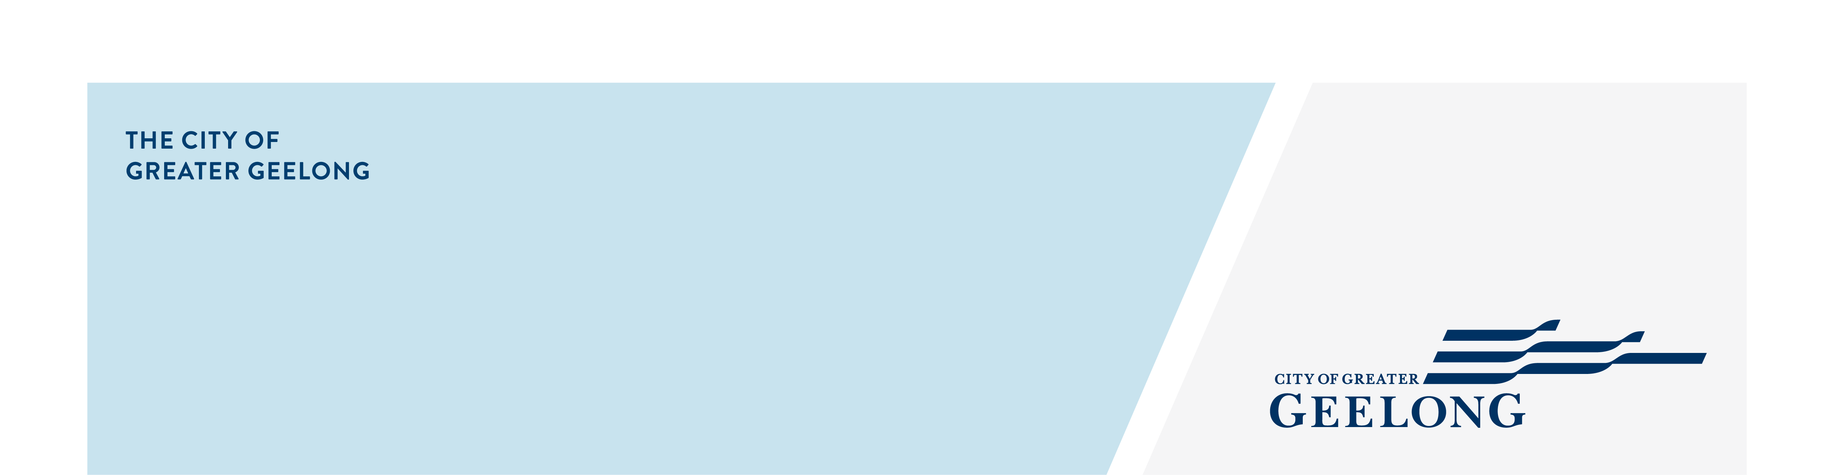
MINUTES

Youth council
ADvisory Committee

27 October 2025| 4:30-7:30pm | Council Chambers, City Hall

Attendees
Chair – Ayush Singh (Junior Mayor)
Youth Council Members – Alanah Forbes (Junior Deputy Mayor), Archie Gaylard, Bella Harvey, Ben Pocock, Lacey Young, Sarah Ivey
Council Officers – Zoe Eastick, Greg Chadwick, Steph Dunbar, Sameera Aduru,

Guests
Anastasiia Hogan | Community Engagement and Communications Coordinator – Support Services| Cultura
Members from Cultura’s Youth Council

APOLOGIES
Youth Council members: John McClure, Mohammad Husseini, Codey Broomhall, Lola Philip-Szaraz.
Council Officers: Gayathri Srinivasan | Youth Community Development Officer – Civic Participation

1. Welcome & Acknowledgement of Country
Acknowledgement of Country

Bella:
We, the Youth Council, acknowledge the Wadawurrung People as the Traditional Owners of the land where we all live, learn, work and dream. We pay our respects to their Elders past and present, and to all emerging leaders.

We walk alongside the Wadawurrung and all First Nations People to build an inclusive and respectful Geelong and to care for Country so it can thrive. We honour their deep spiritual connection to Country, plants and animals. Where the soil beneath our feet, the water in our streams, and the sun rising in the sky carry stories passed down through the generations. We extend our acknowledgement to all First Nations people who are part of Greater Geelong community today.

2. Quorum
A quorum was met.

3. Declaration of Conflict of Interest
No conflicts of interest were declared.

4. Confirmation of Previous Minutes
Youth Council meeting minutes – 15 September 2025

Confirmed: Bella Harvey Seconded: Archie Gaylard

5. Updates (4:40pm – 4.50pm)
5.1. The Nest Reference Group meeting – Update (Greg)
The current three members of the Nest Reference Group will step down at the end of the year. Expressions of Interest (EOIs) for 2026 are open from 13 October to 9 November via the Have Your Say page

5.2. Regional Student Voice Conference - 16 September - Update (Lacey)
Lacey shared that students from various Geelong schools attended the conference to discuss topics of interest and present their ideas to the broader group.

5.3. Attendance at Citizenship Ceremony - 17 September – Update (Bella)
Bella reported that over 200 people attended the ceremony. She highlighted a memorable interaction with a mother and her four-year-old daughter.

5.4. School holiday youth hub drop ins with Councillors - 24 Sep and 1 Oct – Update (Archie)
Archie noted low attendance, with only one participant engaging in discussion. Despite this, the experience at The Nest was enjoyable.

5.5. Victorian Youth Strategy Forum - 24 September - Update (Ben)
Ben attended and networked with young people from across the state, discussing the new Youth Strategy and other relevant topics.

5.6. Spirit of ANZAC leadership trip to Turkey – Update (Mo)
Mohammad is an apology. Update to be provided at next meeting.

5.7. Webpage project meeting - 13 Oct – Update (all)
Next project meeting will be on 13 November.

5.8. Final CCMP – 15 Oct – Update (all)
Members reflected they enjoyed the last CCMP. The smaller sized groups were effective and Bella was a great chair.

5.9. End of year event – Save the date 15 Dec
Ayush encouraged members to save the date and inform their parents/guardians. Ideas for celebrating the final meeting and end of term should be shared with Zoe.

6. Final Advice Preparation

A session was facilitated where Youth Council members rotated through three workstations to provide insights and feedback on the following topics:

- Vaping and substance abuse
- Social isolation, mental health, cost of living
- Transport and safety

These topics were previously identified by the group as the areas they wish to focus their final advice to council on.

7. Consultations / Presentations
Anastasiia Hogan | Community Engagement and Communications Coordinator – Support Services| Cultura
Members from Cultura’s Youth Council
Multi-Cultural Services Geelong (MCSG) Youth Council (Cultura) introduced themselves and shared their achievements and plans for the coming year. Ana presented a video highlighting Cultura’s commitment to celebrating diversity through programs and events.

Ana outlined the Goals of the Cultura Youth Council as being:
- Stronger Connections
- Keeping Cultures Alive
- Next-gen Leaders
- Building Bridges

Members shared personal stories and experiences related to their three focus areas: Racism and discrimination, mental health and youth employment.

The presentation concluded with a creative vision of the future Cultura Youth Council, featuring hypothetical media coverage from Geelong Advertiser, Channel 7, Krock, and SBS News.

Ayush thanked Cultura Youth Council for their presentation.

Both youth councils spent some time networking over light refreshments.

8. Final Advice Preparation (cont.)
Youth Council members finalised their advice.

9. Meeting Close

Next meeting 4:30pm, Mon, 24 November 2025.

