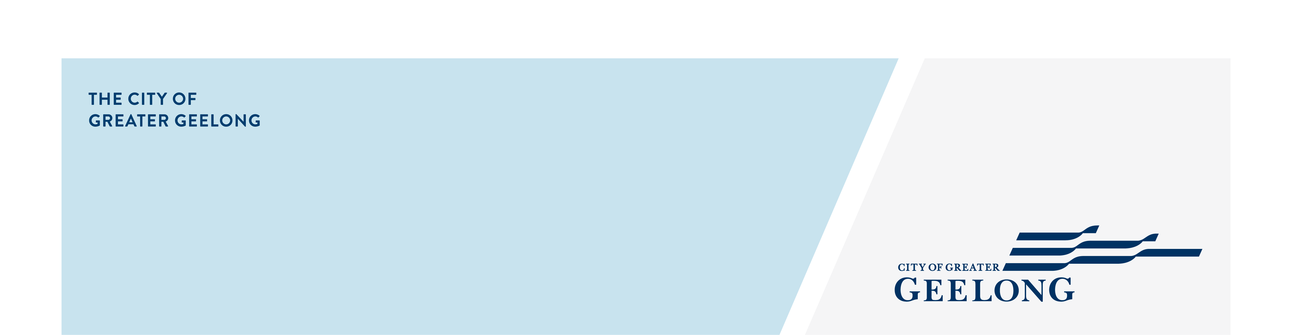
MINUTES

Youth council
ADvisory Committee

24 November 2025| 4:30-7:30pm | Council Chambers, City Hall

Attendees
Chair – Ayush Singh (Junior Mayor)

Youth Council Members – Alanah Forbes (Junior Deputy Mayor), Archie Gaylard, Bella Harvey, Ben Pocock, Codey Broomhall, John McClure, Lacey Young, , Mohammad Husseini, Sarah Ivey.

Council Officers – Guy Srinivasan, Greg Chadwick

Guests
Michael Enright | Senior Landscape Architect – Urban Design & Place | COGG
Sarah McCamish | Youth Engagement & Connections Officer | COGG

Apologies
Lola Philip-Szaraz
Zoe Eastick | Team Leader Youth Community Development | COGG

1. Welcome & Acknowledgement of Country
The Junior Mayor welcomed everyone to the meeting.

Ben delivered the Acknowledgement of Country
Acknowledgement of Country

We, the Youth Council, acknowledge the Wadawurrung People as the Traditional Owners of the land on which we live, learn, work, and dream. We pay our respects to their Elders past and present, and to all emerging leaders.

We walk alongside the Wadawurrung and all First Nations Peoples to build an inclusive and respectful Geelong and to care for Country so it can thrive. We honour their deep spiritual connection to Country, plants, and animals - where the soil beneath our feet, the water in our streams, and the sun rising in the sky carry stories passed down through generations.

2. Quorum
Quorum met

3. Declaration of Conflict of Interest
No conflicts of interest were declared

4. Confirmation of Previous Minutes
Youth Council meeting minutes – 27 October 2025

Confirmed: Codey Broomhall Seconded: Sarah Ivey

5. Consultations / Presentations
Michael Enright | Senior Landscape Architect – Urban Design & Place | COGG
4:35pm – 5:20pm

Geelong Waterfront Master Plan

The draft master plan sets a long-term vision for renewing Geelong’s iconic waterfront. It builds on the waterfront’s role as a premier destination, responds to ageing infrastructure and climate challenges, and replaces the 2011 plan with a forward-looking framework for investment and urban renewal. The draft master plan has been endorsed by Council to go out for community consultation and feedback – including that of the youth council.

- Michael and Daniela gave an overview of the Geelong Waterfront Master Plan.
- Presenters shared First Nations connection to Geelong area and their historical ties to the waterfront.
- Michael outlined the consultation process and explained how community feedback has been reflected within the Plan.
- Daniela provided an overview of the planned development area and presented illustrated views of the proposed waterfront design from multiple angles
- Michael and Daniela ran an interactive workshop with Youth Council members to gather feedback and discuss priority areas for young people.
- Ayush thanked Michael and Daniela for their presentation, workshop, and the opportunity to provide youth feedback.
Sarah McCamish | Youth Engagement & Connections Officer | COGG
5:20pm – 5:35pm

Year 6 to Year 7 Transition Program

The Youth Engagement and Connections Team are developing workshops for a year 6-7 transition program to assist students in their transition to high school. They are hoping to get the Youth Council's ideas and input on what these workshops should include.

Sarah broke the group into four and gave each an A4 paper with a question to collect the Youth Council’s feedback and input into the 6-7 transition program.

Ayush thanked Sarah for attending Youth Council and conducting the workshop
6. Updates (5:35 – 5.50pm)
6.1. 2026 Youth Council Elections – Elections have closed (Guy).
Guy shared that this year there were 2277 votes from 18 schools and thanked the current members for getting the word out there and sharing their YC experience in school assemblies, etc. Guy also shared that the vote count for each candidate is currently being counted and the outcome will likely be ready by first week of December.
6.3. Youth Council Report to Council - Scheduled for Dec 9th. All Youth Council members are encouraged to attend.
Invited all youth council members to attend and listen to Ayush’s speech.
6.4 Website Review Project – Opportunity to present YC members’ work to the COGG Youth Development team (Guy)
Guy offered an opportunity to the group to present the website project review findings to the COGG Youth Development team. The members showed interest in presenting in hybrid mode. Date to be finalised with the team and YC members.
6.4. The Nest Reference Group meeting (Greg).
The last Nest Reference group meeting is tomorrow (24th Nov) – Greg invited the group to attend. Applications for the young people to be on the Nest Reference group for 2026 have closed and selection will begin shortly.
6.5. End of year event – Save the date 15th Dec, 5.30pm. RSVP with number of guests and dietary requirements by Dec 1st.
6.6. Basketball Match – Confirming attendance for the match on Dec 13th at 6:00pm. (TBC: John, Alanah, Sarah, Lola). Codey expressed his interest to attend.
7. Ayush speech run through – Youth Council report to Council (5:50 - 6:00pm)
7.1. Ayush to run through speech for Youth Council reporting and seek feedback from Youth Council
Ayush presented his speech to the Youth Council. The Youth Council provided positive feedback in majority.
Dinner 6.00pm – 6:20pm
8. Web project Report presentation (6:20pm – 6:35pm)
8.1 Presentation of the Website review project report
Guy presented an overview of the Website review report and gave the youth council a hard copy to review and add input into. The Youth Council members provided some feedback on parts of the report such as angle, clarity and punctuation.
9. Evaluation (6:35pm – 7:05pm)
9.1. Start, middle and end of year Youth Council evaluation form
9.2. End of year Youth Council evaluation form
Youth Council completed the evaluation forms

10. Final Advice Presentation work (7:05pm – 7:15pm)
8.1. Presentation of the Advice preparation journey (Zoe)
In Zoes absence we did not get to this item
In Zoes absence
11. Other Business (7:15pm – 7:30pm)
Youth Council members to write reflective pieces – Guy
Guy informed Youth Council members that they will each have the opportunity to present a short reflective speech (1–2 minutes) at the upcoming end of year celebration. A list of suggested topics has been prepared and emailed to all members, and they are welcome to choose a topic from the list. Questions were raised about the available topics, and two members confirmed their selections during the meeting. Guy encouraged the remaining members to contact her if they would like to participate so she can allocate a topic. She also advised that draft speeches are due to her by 1st Dec.

12. Meeting Close
Last meeting of the year. End of Year Celebration. 15th Dec, 5.30pm
Both Guy and Ayush shared their experiences working with the Youth Council and congratulated them for their amazing work.

