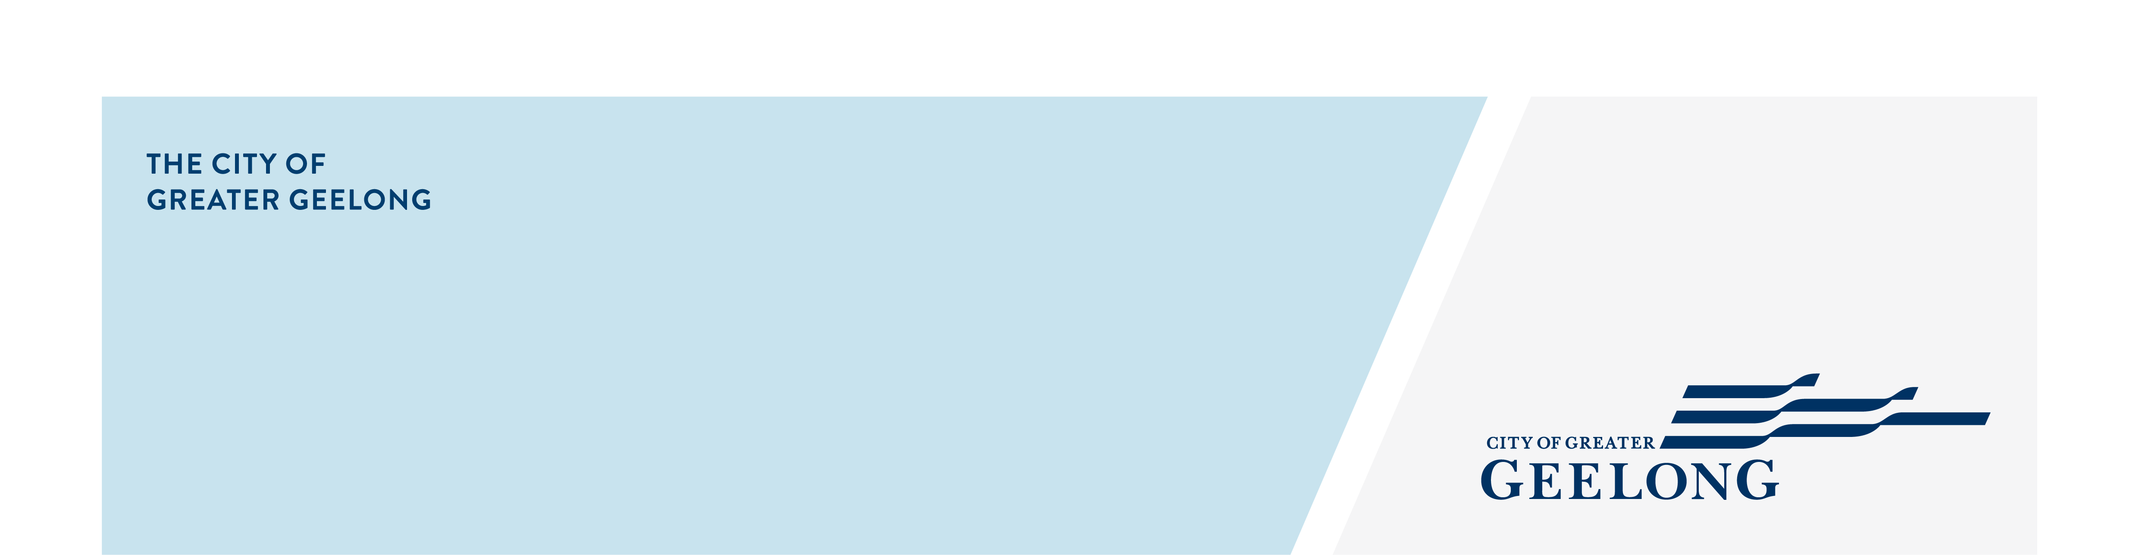
MINUTES

Youth council
ADvisory Committee

Monday 09 February 2026| 4:30-7:30pm | City Hall

Attendees
Chair – Vignesh Ram (Junior Mayor)

Youth Council Members – Bailey Roberts (Junior Deputy Mayor), Anthony Huynh, Ethan Pearce, Farzan Samar, Kieley Delbridge, JJ Naijan, Matilda Singleton, Mustafa Hussaini, Nevaeh Huynh, Zara Leith

Council Officers – Guy Srinivasan, Zoe Eastick, Greg Chadwick

Guests
Kai Leipins | Strategy Analyst | COGG
Neil Allen| Strategy Lead | COGG
Tina Biggs | First Nations Engagement and Outcomes| COGG
Ben Warren | Youth Participation and Inclusion Project Officer | COGG

Apologies
1. Welcome & Acknowledgement of Country
Acknowledgement of Country

On behalf of the Youth Council, I acknowledge the Wadawurrung People as the Traditional Owners of the land where we live, learn, work and play. We pay our respects to their Elders past and present. We honour their deep spiritual connection to Country, where the soil beneath our feet, the water in our streams and the sun rising in the sky carry stories passed down through the generations. We walk alongside Wadawurrung people and the wider First Nations community to build an inclusive and respectful community, and to preserve Country, so it can thrive for generations to come. We extend our acknowledgment to all First Nations people who are part of our Greater Geelong community and acknowledge any First Nations people present at today’s meeting.

2. Quorum

We have a Quorum

3. Declaration of Conflict of Interest

No conflicts of interest were declared

4. Confirmation of Previous Minutes
N/A

5. Consultations / Presentations 4:35pm – 6:00pm
Kai Leipins | Strategy Analyst | COGG
Neil Allen| Strategy Lead | COGG
The Strategy & Organisational Impact | COGG | 4.35pm – 5.30pm
The Strategy & Organisational Impact team gave an overview of the City’s Strategic Landscape, unpacked the 2025–29 Council Plan and the 2024-29 Organisation Strategy, and discussed how strategies and plans shape the City’s future direction.
They then facilitated a practical exercise of negotiating and choosing a Council priority. When a council priority gets more than 6 votes from the youth council members, it will be passed. The Youth Council members had a robust discussion, presenting arguments and healthy debate to arrive at their decision. The 4 priorities decided upon in this exercise were
- Planning for housing and infrastructure development
- Integrated transport strategy
- Activate Geelong
- Financial sustainability
The presenters thanked Youth Council for their time and reflections.
Viggy thanked Kai and Neil for presenting to Youth Council.

Tina Biggs | First Nations Engagement and Outcomes| COGG

Youth Council Acknowledgement of Country | 5.30pm – 6pm

Tina presented an overview of the Acknowledgement of Country and discussed the reasons behind the welcome which is to show respect for First Nations Culture and continued connection and care for the Country. Youth Council members were also encouraged to think about their own personal Acknowledgement of Country that they may wish to use in a less formal capacity.
Youth Council members were asked to consider the Acknowledgement of Country that was created by the 2025 Youth Council and determine if there were any changes they wished to make to it in their own time. This was decided to be reviewed in the next youth council meeting to form this year’s Acknowledgement of Country.
Tina thanked the Youth Council for their attention and input today.
Viggy thanked Tina for presenting to Youth Council.

Ben Warren | Youth Participation and Inclusion Project Officer | COGG

Social Inclusion Action Group | 6pm – 6.10pm

Ben did a quick meet and greet, introduced his role and potential future involvement with the group in regard to their projects.
Ben gave an overview of his background and passion for issues pertaining to community and the arts. Ben also took questions about his acting background.
Ben thanked the Youth Council for their attention today.
Viggy thanked Ben for his time and for presenting to Youth Council.
Dinner 6:10 – 6:40pm

6. Updates (6:40pm – 6:55pm)
6.1 Vape Prevention Action Group and Vape Prevention Short Film Screening – Feb 26, 5:30 - 7:30pm (Mustafa)
- Mustafa gave a brief summary of the Vape Prevention Action Group.
- Guy and Zoe also spoke of the screening and encouraged everyone to attend to support Mustafa.
- It is a 23-minute film and will be available for schools and other youth groups to use after the premier.
6.2 Pako Festa – Update on In-Person meeting, reminder: online meeting February 18th, event on 28th February

Viggy stated that 9 of the Youth Councillors attended the Pako Festa information session. The Youth Council members will be doing surveys and providing information to young people. There will be 2 shifts which Guy will facilitate offline. Viggy encouraged all the Youth Council members to attend the fest.

6.3 Nest Youth Hub Open Day - Update (Farzan)

Farzan gave an overview of the Nest Youth Hub first year anniversary. 6 youth councillors attended. The Youth Council members were thanked for attending by The Nest staff and supporters. Viggy encouraged the Youth Councillors to attend The Nest whenever they can.

6.4 The Nest Reference Group (Zoe)

Zoe gave an overview of The Nest and outlined the 2-year pilot program and reinforced the need for The Nest to be activated in the next year to secure a permanency.

6.5 Youth Council Priorities for 2026 (Guy)
Guy took a few minutes to reinforce the Youth Councils priorities for 2026.
6.6 First Youth Council Report draft and review member introductions (Guy)

Guy took the group through the draft of the first Council Report which outlines the priorities Youth Council have decided upon, their Group Agreement, member introductions, etc. Guy asked them to read the introductions and provide any feedback. All the Youth Councillors were happy with the draft.

6.7 Youth Council Annual project update (Zoe)

Zoe explained the planning process for the project and presented how local government has a process which can be time consuming. At present the project is in concept stage. Zoe explained that a grant will be applied for the project to occur in September.
6.8 Youth Council meetings time 4.30pm or 5pm

Guy asked the group for their preferences for the times for the Youth Council meetings. After discussion it was decided that the group will meet from 5.00pm to 7.30pm with some online follow up if required.

7. Youth Council Team Agreement (6:55pm – 7.00pm)
7.1 Review Youth Council Group Agreement aspects previously identified at induction.
Guy revisited the Youth Council Group Agreement which the Youth Council members devised during induction. Guy asked the Youth Council to read the Agreement draft and see if they were still supportive of the content. There was a brief discussion and a couple of small amendments made.
7.2 Vote to endorse the Youth Council Group Agreement.
The Youth Council endorsed the Youth Council Group Agreement
8. Councillor Connect Mentoring Program (7.00pm – 7:30pm)
8.1 Run through CCMP process and expectations.
Zoe gave an overview of the CCMP meetings and asked the group what they would like to do discuss with Councillors. The group said they would like to have an informal session such as a meet and greet for the first meeting.
10. Other Business

JJ reported that a few of the Youth Council members went to the market on the weekend and decided that the market really needed some improving. They discussed some of the improvements that could be made including opening times for young people.

11. Meeting Close

Viggy closed the meeting and thanked everyone for their attendance and input.

Next meeting 5.00pm, Mon, 2nd March 2025.

