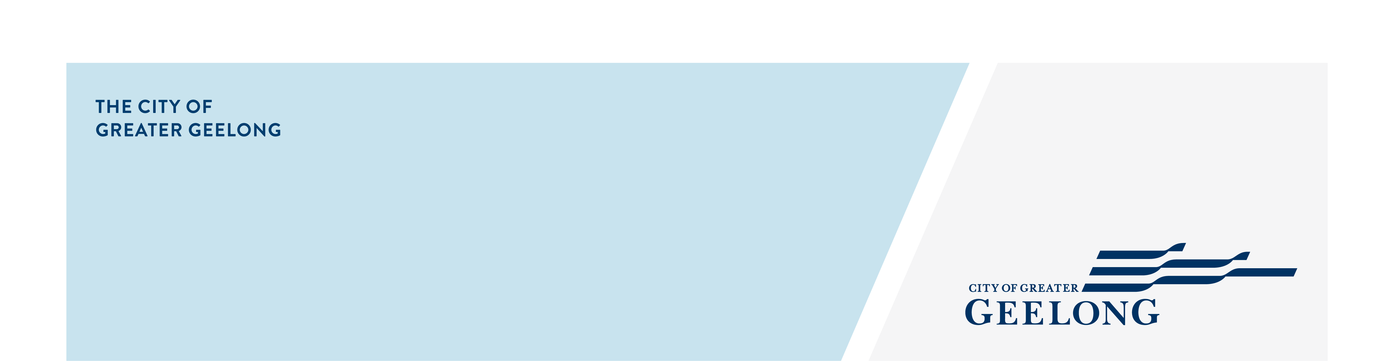
MINUTES

Youth council
ADvisory Committee

Monday 02 MARCH 2026| 5:00-7:30pm | City Hall

Attendees
Chair – Vignesh Ram (Junior Mayor)

Youth Council Members – Anthony Huynh, Ethan Pearce, Farzan Samar, Kieley Delbridge, JJ Naijan, Mustafa Hussaini, Nevaeh Huynh, Zara Leith

Council Officers – Guy Srinivasan, Zoe Eastick,

Guests
Ben Warren | Youth Participation and Inclusion Project Officer | COGG
Steph Dunbar| Youth Development Coordinator | COGG

Apologies
Greg Chadwick, Matilda Singleton
Late – Bailey Roberts (Junior Deputy Mayor)
1. Welcome & Acknowledgement of Country
JJ Naijan presented an Acknowledgement of Country

On behalf of the Youth Council, I acknowledge the Wadawurrung People as the Traditional Owners of the land where we live, learn, work and play. We pay our respects to their Elders past and present. We honour their deep spiritual connection to Country, where the soil beneath our feet, the water in our streams and the sun rising in the sky carry stories passed down through the generations. We walk alongside Wadawurrung people and the wider First Nations community to build an inclusive and respectful community, and to preserve Country, so it can thrive for generations to come. We extend our acknowledgment to all First Nations people who are part of our Greater Geelong community and acknowledge any First Nations people present at today’s meeting.

2. Quorum
Quorum met
3. Declaration of Conflict of Interest
Nil
4. Confirmation of Previous Minutes
Youth Council meeting minutes – 09 February 2026
Confirmed

5. Consultations / Presentations 5:05pm – 6:00pm
Ben Warren | Youth Participation and Inclusion Project Officer | COGG

Youth Social Connection Project | 5.05pm – 5.35pm

- Ben outlined the youth social connection project, including its purpose, upcoming EOI, and co-design approach.
- Key drivers: rising youth loneliness, the link between belonging and wellbeing, and Youth Council’s focus on inclusion.
- Overview of the Social Inclusion Action Group (SIAG): 18 community members, no youth representation; this project ensures young people’s ideas feed into SIAG’s work.
- Project aims: co-design youth-led solutions, build social connection through workshops, and create value in both process and outcomes.
- Ben shared the draft structure for the co-design process and sought Youth Council’s feedback about duration, structure and frequency.
- Practical considerations discussed: accessibility, location, remuneration for young participants, and inclusion of meal breaks in workshop planning.
Steph Dunbar| Youth Development Coordinator | COGG

Youth Brand and Identity Project | 5.35pm – 5.55pm

- Steph provided an update on the Youth Brand and Identity Project.
- The project is informed by 2025 Youth Council priorities and recent youth survey feedback.
- A flexible engagement approach will be used so young people can provide input in multiple ways.
- Steph shared local data showing high levels of youth loneliness, social isolation, and low awareness or participation in City of Greater Geelong youth programs.
- Purpose of the project: build a strong, reputable youth brand; improve awareness and accessibility of services; increase trust in Council’s youth services; and boost participation to strengthen community connection.
- Steph introduced the graphic design business leading the work and the key team members who will run the co‑design workshop and design the brand.
- She outlined the youth survey structure, covering tone direction, brand voice, brand personality, visual direction, empowering language, and interactive mood‑board activities.
- Project timeline runs from March to July.
- Steph invited Youth Council involvement: attending the April co‑design workshop, sharing materials, encouraging peers to participate, and promoting the opportunity through schools (speaking at assemblies, homerooms, etc.).
- Communications channels identified by the group that are currently used: Snapchat, TikTok, school networks, Discord and parent‑targeted social media.
- The group discussed that communication cannot rely solely on social media, as many young people do not use it; newsletters, school‑based communication, and parent‑focused channels are also essential.
- When asked about free‑text survey questions, Youth Council members said they generally skip them unless they strongly want to give feedback (usually negative), noting they can attract random or low‑value comments.
- In response to a Youth Council question about what “brand” actually means and what the project will produce, Steph explained that the outcome will be a youth brand and logo that sits alongside the City of Greater Geelong logo, creating a clear look and feel so young people can easily recognise “Geelong Youth” services and opportunities.

Dinner 6:00 – 6:20pm

6. Updates (6:20pm – 6:30pm)
6.1 Vape Prevention Short Film Screening experience (anyone)
This update will be carried over until the next meeting.
6.2 Pako Festa experience (anyone)
This update will be carried over until the next meeting.
6.3 Youth Fest Grant (Guy)
This update will be covered in the item below.
6.4 First Youth Council Meeting and speech, 24th March 6pm – 7pm. Networking opportunity with Sacred Heart school (Guy)

Guy encouraged the group to attend if they are available to both support Viggy and to experience a Council meeting. It is estimated Viggy will be presenting the speech between 6:15 and 6:45pm. Students from Sacred Heart College will also be attending this meeting.

6.5 All upcoming events – calendar. Give a show of hands for those attending each (Guy)

This update will be carried over until the next meeting.
6.6 Youth Council Meeting Photo permissions (Zoe)

This update will be carried over until the next meeting.

7. Youth Council Project Update (6.30pm – 7:00pm) Guy
Guy thanked the group for their enthusiasm and apologised for the delay in bringing the project back for discussion, noting additional time was needed to work with internal stakeholders.
She provided an update on internal research completed so far and introduced several potential location options for the Youth Market concept, seeking Youth Council feedback.
Guy confirmed that monthly project‑specific meetings will now be scheduled (one per month), meaning Youth Council meetings will no longer spend significant time on this project.
Research to date has focused on whether the youth market idea could be integrated into the existing City-run market. The internal market team advised this is not possible due to permanent stallholder arrangements.
An alternative option was offered: Due to mayoral and councillor push/interest to expand the geelong city market, a new street extension of the current market within the Geelong CBD on Union street. This area is being considered for expansion and would operate at the same time as the weekly market but be fully run by the City of Greater Geelong.
It is not yet known how much of the street will be available, but early thinking suggests space for 6–7 stalls to create a youth-focused area. Guy noted this option could significantly reduce costs otherwise spent on tents, fencing, traffic management and security.
Zoe offered another indoor opportunity to hold it at the Geelong West Town Hall, which would also be the City’s space.
A stand‑alone market remains possible but would require a much larger budget for infrastructure (marquees, fencing, security, traffic management), leaving less funding for activities. Stand‑alone events would also have lower incidental foot traffic but could be held at times that better suit young people.
Guy emphasised that while not all preferred locations can be guaranteed, the team is happy to investigate any suggestions put forward by Youth Council.

The group split into two teams to develop pros and cons lists for each location option, then reconvened to present their key ideas and considerations.
Group 1 – Geelong West Town Hall
- Already has a stage.
- Indoor venue provides weather protection and a sense of safety.
- Confined space supports supervision and security.
- Parents may feel more comfortable with an indoor setting.
- Amenities already available.
- Versatile and familiar due to past events held there.
- Cost‑effective.
- Strong alignment with safety and inclusion priorities.
Group 2 – Add‑on space beside the City Market
Pros:
- Cheaper due to existing infrastructure.
- Allows more budget to be directed toward activities and improvements.
- Access to existing market crowd and resources.
- Central location with easy bus access.
Cons:
- Can only operate during the set market times.
- Risk of being overshadowed by the main market.
8. 4th March CCMP Preparation (7.00pm – 7:30pm) Zoe
Zoe provided an overview of the upcoming CCMP’s agenda and structure and outlined the sections that Youth Council members will be responsible for speaking to.
Youth Council is asked to complete the preparation for their section prior to the Wednesday meeting.
9. Other Business
Guy re-emphasised that 80% across Youth Council and CCMP meetings are compulsory throughout the year. Any apologies given on the day is not acceptable, please provide enough notice (except for sickness ofcourse) and an acceptable reason.
10. Meeting Close
Next meeting 5.00pm, Mon, 30th March 2026. Guy will not be present in the next meeting, Zoe and Greg to run.

