
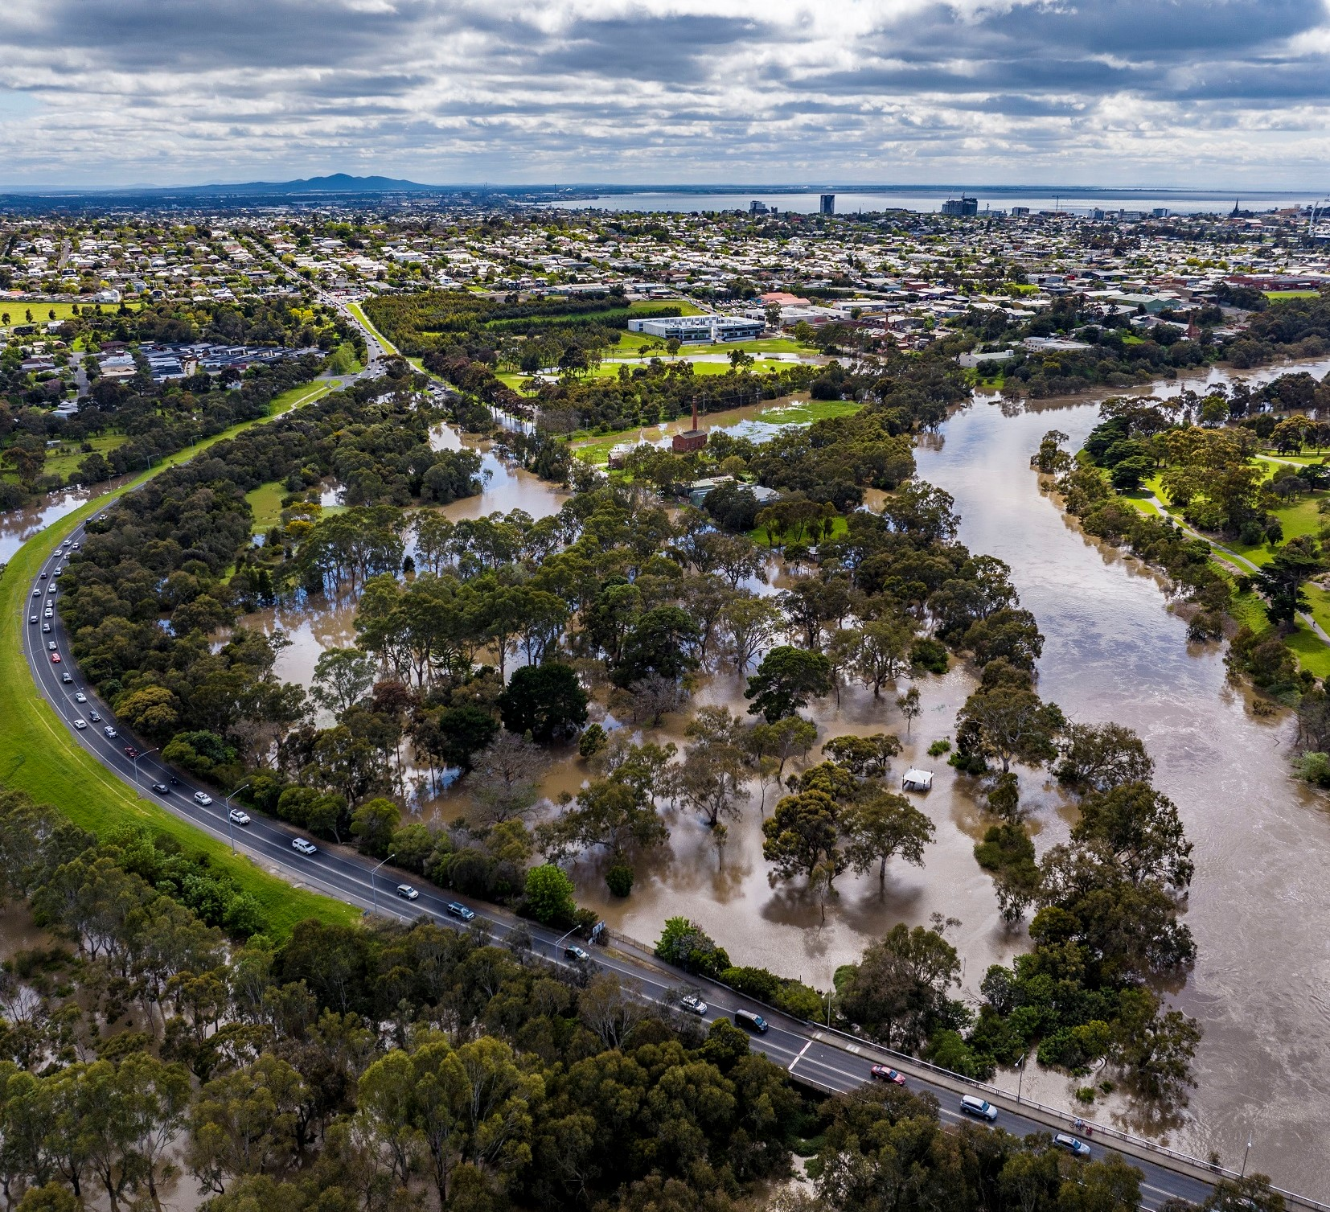

Municipal Emergency Management Plan (MEMP)

Version 2.0 - August 25

Collaborative and Multi-Agency Emergency Management Planning
Table of Contents
Municipal Emergency Management Plan (MEMP) 0
Version 2.0 - August 25 0
Collaborative and Multi-Agency Emergency Management Planning 0
1. INTRODUCTION 4
1.1 Authority 4
1.2 Assurance and Approval 4
1.3 Review 4
1.4 Glossary and Acronyms 4
1.5 Planning Context 4
1.6 Aim and Objectives 5
1.7 Training and Exercising 5
2. Municipal Characteristics 6
2.1 Community profile 6
2.2 Topography 7
2.3 Significant Natural Features 7
2.4 High Consequence Infrastructure 8
2.5 History of Emergencies 10
3. PLANNING ARRANGEMENT 11
3.1 Victorian Emergency Management Planning Framework 11
3.2 Municipal Emergency Management Planning Committee (MEMPC) 11
3.3 MEMPC Structure 12
3.4 Sub-Plans 12
3.5 Restricted operational information 13
4. MITIGATION ARRANGEMENTS 14
4.1 Introduction 14
4.2 Hazard, Exposure, Vulnerability 14
4.3 Risk Assessment Process 15
4.4 Monitoring and Review 17
4.5 Resilience 17
5. RESPONSE ARRANGEMENTS 19
5.1 Introduction 19
Response Management Arrangements 19
5.2 Command, Control, Coordination 19
Classification of emergencies 20
5.3 Consequence Management 21
5.4 Local Response Arrangements 21
Impact Assessment 22
5.5 Financial Considerations 22
5.6 Neighbourhood Safer Places and Community Fire Refuges 23
5.7 Council Resource Sharing 23
5.8 Debriefing Arrangements 24
5.9 Evacuation 24
5.10 Community Information and Warnings 25
5.11 Relief Arrangements (Part of Response) 26
5.12 Relief Management and Governance 27
5.13 Activation of Relief Services 27
5.14 Escalation 27
5.15 Relief Communication 28
5.16 Relief Principles 28
5.17 Relief Planning and Supports 28
5.18 Register.Find.Reunite 29
5.19 Animal Management in Emergencies 29
5.20 Vulnerable or At Risk People and Facilities in Emergencies 29
5.21 Transition to Recovery (Transition out of Response) 32
6. RECOVERY ARRANGEMENTS 33
6.1 Introduction 33
6.2 Objectives of Recovery 33
6.3 Recovery Definition 33
6.4 Escalation 34
6.5 Management Structure 34
6.6 Secondary Impact Assessment 35
6.7 Government Assistance Measures 35
6.8 Recovery Phases 35
6.9 Recovery Communications 36
7. ROLES AND RESPONSIBILITIES 37
7.1 Introduction 37
7.2 Roles and Responsibilities 37
8 APPENDICIES 39
Appendix 1: Document Administration 39
Appendix 2: List of Other Emergencies to Impact the Greater Geelong Region 40
Appendix 3: Greater Geelong MEMPC Core Membership 44
Appendix 4: BSW Non-Major Emergency Protocol 45
Appendix 5: Maps 47

Acknowledgement of Country
We acknowledge the Wadawurrung People as the Traditional Owners of the Land, Waterways and Skies. We pay our respects to their Elders, past and present.
We acknowledge all Aboriginal and Torres Strait Islander people who are part of our Greater Geelong community today.

INTRODUCTION

Authority
In 2020, the Emergency Management Legislation Amendment Act 2018 amended the Emergency Management Act 2013 (EM Act 2013) to provide for new integrated arrangements for emergency management planning in Victoria at the State, regional and municipal levels; and create an obligation for a Municipal Emergency Management Planning Committee (MEMPC) to be established in each of the municipal districts of Victoria, for the purposes of the act, are taken to be a municipal district. Each MEMPC is a multi-agency collaboration group whose members bring organisation, industry or personal expertise to the task of emergency management planning for the municipal district.

The plan has been prepared in accordance with and complies with the requirements of the EM Act 2013 including having regard to the guidelines issued under section 77, Guidelines for Preparing State, Regional and Municipal Emergency Management Plans.

Assurance and Approval
A Statement of Assurance (including a checklist and certificate) has been prepared and submitted to the REMPC pursuant to EM Act 2013 (s60AG).
This Plan is approved by the Barwon South-West Regional Emergency Management Planning Committee.
This Plan comes into effect when it is published and remains in effect until superseded by an approved and published update.

Review
To ensure the plan provides for a current integrated, coordinated and comprehensive approach to emergency management and is effective, it is to be reviewed at least every three years or as required.

Urgent update of this Plan is permitted if there is significant risk that life or property will be endangered if the plan is not updated (EM Act 2013 s60AM). Urgent updates come into effect when published on the municipal council website and remain in force for a maximum period of three months.

This Plan will be reviewed no later than December 2028. This Plan is current at the time of publication and remains in effect until modified, superseded or withdrawn.
Refer to Appendix 1 for document administration.

Glossary and Acronyms
Definitions of words and phrases used in the MEMP have the same meaning as those prescribed in the relevant legislation and should be referred to, they include:
- Emergency Management Act 1986 and 2013
- State Emergency Management Plan (SEMP)
- Local Government Act 2020
- Risk Management Standard ISO: 31000 2018

The MEMP follows the practice of writing a name in full followed by the acronym in brackets after it and is used thereafter in the plan.

Planning Context
The MEMP provides for an integrated, coordinated, and comprehensive approach to emergency management at the municipal level. The Act 2013 requires the MEMP to contain provisions providing for the mitigation of, response to relief and recovery from emergencies (before, during and after), and to specify the roles and responsibilities of agencies in relation to emergency management.

It is recommended that the MEMP be read in conjunction with the Victorian State Emergency Management Plan (SEMP), Regional Emergency Management Plan (REMP) and subplans.

Aim and Objectives
The aim of the Greater Geelong MEMP is to document agreed emergency management arrangements for the prevention of, preparedness for, response, relief and recovery from emergencies that could impact on the municipality and its communities.

The MEMP is consistent with the following that have been consulted and engaged:
- community, through the appointed Community Representatives and others
- sectors of the community, as the MEMPC considers appropriate
- departments or other agencies, the MEMPC considers appropriate.

The MEMP is consistent with the principles underlying the preparation of emergency management plans. Principles require that the plan is:
- prepared efficiently and effectively in a collaborative manner
- to enhance the coordination of public messaging, warnings and advice and communication of messaging within individual agencies
- prepared in a manner that acknowledges and reflects the importance of community emergency management planning.

The broad objectives of the MEMP are to:
- identify hazards and evaluate potential risks that may impact upon the municipality
- implement measures to prevent or reduce the likelihood or consequences of emergencies
- collaborate with emergency services organisations, agencies and stakeholders to manage arrangements for the utilisation and implementation of resources available for use in prevention, preparedness, response, relief and recovery to emergencies
- manage support that may be provided to or from adjoining municipalities
- provide assistance to meet the essential needs of individuals, families and communities during and in the immediate aftermath of an emergency
- assist communities affected by emergencies to recover following an emergency; and
- complement other local, regional and state planning emergency arrangements.

Training and Exercising
The arrangements in the SEMP require the MEMP to be exercised at least once a year. Exercises are a valuable tool to test the arrangements set out in the MEMP.

The MEMP Committee will actively engage in multi-agency exercises and training throughout the year. Any improvements identified during these exercises (or from any events) will form part of the MEMP review or it may be decided by the MEMP Committee that the MEMP be updated immediately.

Exercises are structured to provide the following benefits:
- provide the opportunity for members and stakeholders to test their procedures and skills in simulated emergency situations
- provide an opportunity for the local emergency management community to work together, build capacity and capability
- test the plan and identify areas for continuous improvement; and
- use learnings and outcomes to update and improve the MEMP and sup-plans.

Municipal Characteristics
Greater Geelong is one of the largest Local Government bodies in regional Victoria. The municipality has a population of 289,565 which is forecast to increase by 43% by 2041 to a population of 393,216.
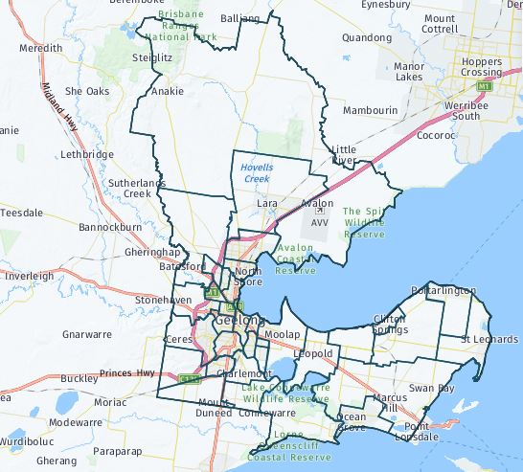
Figure 1: Map of City of Greater Geelong Map

source: http://forecast.id.com.au/geelong

To facilitate this increase in population, the Northern and Western Geelong Growth Area, the largest urban growth project in regional Victoria, will welcome more than 110,000 homes. Source: https://www.geelongaustralia.com.au/futuregrowth

Located 75 kms south-west of the State Capital, Melbourne, Geelong is the largest regional centre in the State of Victoria. The City, is situated on the shores of both Corio Bay and Bass Strait and encompasses the lower reaches of the Barwon River, ensuring that the residents of Geelong are offered one of the best lifestyles in Australia.
The country now known as the City of Greater Geelong (CoGG) is the land of the Wadawurrung Aboriginal people. The name of this language group traditionally meant ‘The people who belong to the ‘water’, in reference to the rivers, creeks, lagoons and other water sources within the Wadawurrung boundary.
For more information on the Wadawurrung & the Kulin Nation, Lands and Way of Life go to: https://www.geelongaustralia.com.au/geelong/documents/item/8d97c1c5405a0b1.aspx

The City’s Gross Regional Product is estimated at $15.42 billion, which represents 3.27% of the state's GSP (Gross State Product).

Community profile
Demographic profile and forecast data highlights some of the more complex risks and issues faced by the Municipality and that has been taken into consideration in Emergency Management Planning.
According to the Australian Bureau of Statistics’ 2021 Census of Population and Housing, our largest age group, at 19 per cent, is parents and homebuilders (35 to 49 years of age), with young workers (25 to 34 years of age) the next largest group at 14 per cent. Older workers and pre-retirees (50 to 59 years of age), Empty Nesters and Retirees (60 to 69 years of age) and Seniors (70 to 84 years of age) all sit around 12 per cent of the population.

Approximately 77 per cent of the community are Australian born, with the United Kingdom, India, New Zealand, Italy and China the main birthplaces outside Australia. Other than English, the most common languages spoken at home continue to include Italian, Croatian, Mandarin, Persian/Dari and Macedonian.
Couples with children made up 27.3 per cent of households, with a further 26.6 per cent being made up of couples without children. Lone person households made up 26.5 per cent and one parent families making up 10.6 per cent.
For more information, and suburb specific breakdown, visit: https://profile.id.com.au/geelong

Topography
The Municipality is bounded by Corio Bay and Port Phillip, a frontage to Bass Strait, a rural area to the west, the Brisbane Ranges to the north and Little River to the east. The landform is essentially flat for a large portion of the 1240 square kilometres. The You Yangs, a 300m high granite outcrop, forms a significant landmark to the north and the Brisbane Ranges rise to the north- west.

The principal river system is the Barwon, which is fed by the Moorabool River entering at Fyansford and the Leigh that enters further upstream. The Barwon passes through Lake Connewarre before it enters the sea at Barwon Heads.
There is limited forestation within the Municipality as most of the rural areas have either been cleared for farming activities or existed as plains in their original form. The Brisbane Ranges is heavily forested as is an area surrounding the You Yangs. Corio Bay and its coastline is relatively well protected in contrast to the coastline and beaches fronting Bass Strait.

The predominant geological formation is newer volcanic basalts which gives rise to highly expansive clays. Barrabool sandstone dominates to the west of the city with alluvium deposits on the Peninsula. There are scattered deposits of Moorabool viaduct sands as well as limestone. Fyansford clays are predominant in the Belmont area. A geological fault line, known as the Newtown Fault, runs east west from Newtown through Queens Park. A probable ancient fault line also exists east of Leopold running north south (see below).

Significant Natural Features
The Greater Geelong area has a number of environmentally significant natural features, including but limited to:

Natural Feature | Location
Brisbane Ranges | Anakie
You Yangs Regional Park | Lara
Serendip Sanctuary | Lara
Lara Lakelands | Lara
Limeburners Bay & North Coast of Corio Bay to Point Wilson – RAMSAR Site | Avalon
Reedy Lake – RAMSAR Site | Moolap
Gateway Sanctuary | Leopold
Lake Connewarre State Game Reserve – RAMSAR Site | Connewarre
Murtnaghurt Lagoon | Connewarre
Buckley Park Foreshore Reserve | Collendina
Ocean Grove Nature Reserve | Ocean Grove
Lake Victoria | Point Lonsdale
Swan Bay Marine Park – RAMSAR site | Swan Bay
Edwards Point Wildlife Reserve | St Leonards

High Consequence Infrastructure
Examples of high consequence infrastructure includes, but not limited to:

Type | Name | Suburb
Major Hazard Facility | Viva Energy Refinery and Polymers Plant | Corio/Lara
Major Hazard Facility | Chemring | Lara
Major Hazard Facility | Quantem /Terminals | Corio
Federal Major Hazard Facility | ADI Point Wilson/Thales ** | Point Wilson
Federal High-Risk Facility | CSIRO Australian Centre for Disease Preparedness | Newcomb
Road | Geelong By-Pass (Ring Road) | From Corio – Waurn Ponds
Road | Princes FWY | From Little River – Waurn Ponds
Road | Hamilton HWY | Fyansford
Road | Midland HWY | Bell Post Hill
Rail | National Railway Line | North Geelong
Rail | Regional Rail Line | North Geelong
High Consequence Product Transport | Various Transports | Corio/Lara
Airport | Avalon Airport | Avalon
Airport | Barwon Heads Airport | Barwon Heads
Water Infrastructure | Lara Flood Level System | Lara
Water Infrastructure | Plummer Flood Levee | Connewarre
Water Infrastructure | Hovells Creek Flood Warning System | Lara
Water Infrastructure | Dams | Various
Water Infrastructure | Black Rock Sewer Treatment Plant | Connewarre
Communication | Mt Anakie Communication and Fire Tower | Anakie
Communication | Ceres Communication Tower | Ceres
Bridge | Barwon Heads Rd Bridge | Barwon Heads
Bridge | James Harrison Bridge | South Geelong
Bridge | Moorabool Railway Viaduct | Batesford
Ports/Terminals | Tasmania Quay | North Geelong
Ports/Terminals | Geelong Port | North Geelong
Ports/Terminals | Port Philip Ferries | Portarlington/ Geelong CBD
River | Barwon River | From Ceres – Barwon Heads
River | Moorabool River | From Batesford - Fyansford
Hospital | Barwon Health | Geelong CBD
Hospital | St John of God Hospital | Geelong CBD
Hospital | Epworth Hospital | Waurn Ponds
Major Entertainment/Sport Precincts | Geelong Showground | Breakwater
Major Entertainment/Sport Precincts | Geelong Racecourse | Breakwater
Major Entertainment/Sport Precincts | Geelong Arena | North Geelong
Major Entertainment/Sport Precincts | Kardinia Park | South Geelong
Major Entertainment/Sport Precincts | Geelong Botanical Gardens | East Geelong
Major Entertainment/Sport Precincts | Geelong Waterfront | Geelong
Major Entertainment/Sport Precincts | Beckley Park | Corio
Major Entertainment/Sport Precincts | Elcho Park Equestrian Centre | Lara
Other | Ford Proving Ground | Little River
Other | Deakin University | Waurn Ponds/ Geelong
Other | Avalon College | Avalon
Other | Geelong Grammar | Corio
Other | Kardinia International College | Bell Post Hill
Other | Prisons | Lara
Other | Big Battery | Lovely Banks
Other | Geelong Hydrogen Hub | Corio
Other | Winchester Australia Pty Ltd | Moolap
**Federal site, so not listed by Victoria’s WorkSafe Authority as a Major Hazard Facility.

For more information and a map of Infrastructure in Greater Geelong, visit https://economy.id.com.au/geelong/infrastructure

History of Emergencies
Floods are a frequent occurrence along the Barwon River Valley, which is fed by the Leigh and Moorabool Rivers
The table below provides an outline of the three most recent emergencies that have occurred in the Greater Geelong Region.

For a list of other emergencies impacting the Greater Geelong region, see Appendix 2.

Incident | Date | Location | Comments
Storm - Wind | 13/02/2024 | Anakie/Lara | Wind gusts experienced were as high as 150km/hr. Widespread damage across the Anakie and Lara areas with trees down and damage to four Transmission Towers in Anakie which impacted electricity across the state.
Flash Flooding | 18/10/2024 | Geelong | Geelong received more than a months rain in one day with large hail and heavy rain leading to flash flooding across Geelong.
Shed Fire | 20/05/2025 | Anakie | Two large sheds caught fire producing toxic smoke due to the contents in the sheds. EPA, VicPol, CFA, FRV and Council were involved.

  - Major Public Events
Greater Geelong experiences a number of major international, national and local sporting and entertainment events annually, including but not limited to:
- The Avalon Airshow
- Cadel Evans Road Race.
- AFL games
- Big Bash Cricket Games
- Basketball Games
- Day on the Green Music Festival
- Geelong Cup
- Royal Geelong Show
- Festival of Sails
- Pako Festival

The region has seen an increase in the number of major public events being hosted with the T20 World Cup held at GMHBA Stadium in 2022.

The Avalon International Airshow is the region’s biggest paid event with on average 200,000 visitors attending across the duration of the event. The Pako Festa, held each February, is the region’s biggest free local event attracting around 100,000 visitors.

For more information visit www.geelongaustralia.com.au/events/default.aspx

PLANNING ARRANGEMENT

Victorian Emergency Management Planning Framework
This plan supports holistic and coordinated emergency management arrangements within the region. It is consistent with and contextualises the SEMP and REMP for the Barwon South West (BSW) region. The REMP is a subordinate plan to the SEMP and the MEMP is a subordinate plan to the REMP.

To the extent possible, this Plan does not conflict with or duplicate other in-force emergency management plans that exist.
Figure 2 outlines this Plan’s hierarchy. This Plan should be read in conjunction with the SEMP and the BSW REMP.

Figure 2: Plan hierarchy

Municipal Emergency Management Planning Committee (MEMPC)
The Greater Geelong Municipal Emergency Management Planning Committee has been established under the Emergency Management Legislation Reform 2018 (EMLR Act 2018) and the EM Act 2013 (the Act 2013) section 59D(b).

The MEMPC is one component of a broader structure that enables appropriate planning, response and recovery activities and arrangements at local and regional levels. Sub-committees and Working Groups are appointed to take on the responsibility of planning for emergencies including the provision of relief and recovery.

The MEMPC membership consists of core/voting members and non-voting members. Core/voting members are those specified in section 59A of the EM Act 2013 and subject matter experts the committee has invited. Non-voting members are previous MEMPC members not reflected in the legislative core membership and agency representatives in a support role.
For a full membership list refer to Appendix 3.

The role of the Committee is to:
- develop a MEMP and the MEMPC Terms of Reference and review annually;
- assist in analysing and evaluating emergency related risks and help produce risk treatment strategies through the municipal sub committees and working groups and sub-plans;
- determine if a sub-committee and or working groups are required for more specific or complex arrangements that either enhance or contextualise this Plan; and
- help create more resilient communities.
It is not the MEMPC’s role to manage emergencies. This is the responsibility of the agencies and personnel identified under the response and recovery arrangements in the SEMP.

MEMPC Structure
Figure 3: MEMPC Structure
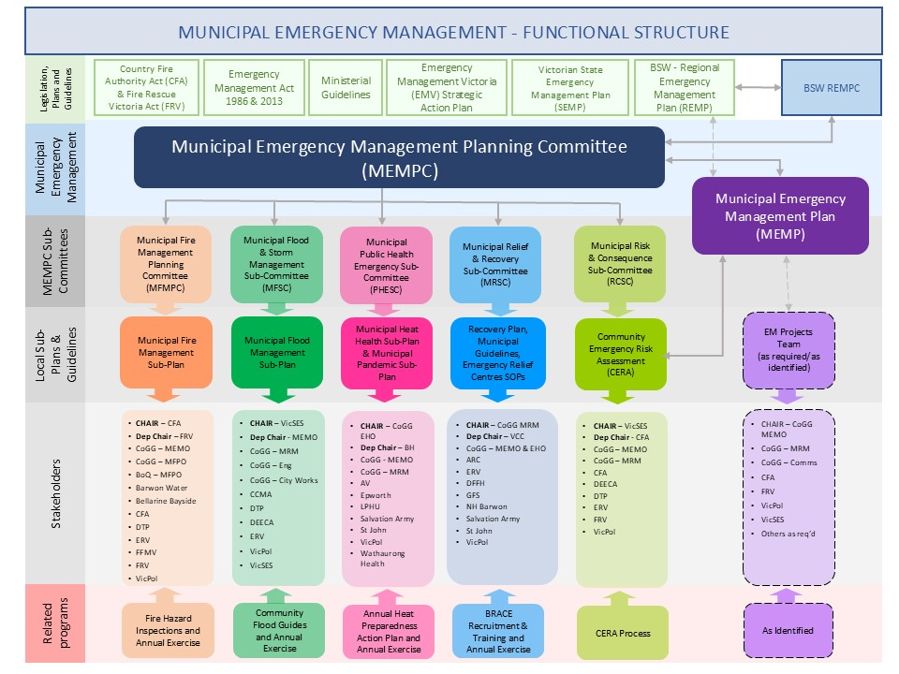

Sub-Plans
All sub-plans are multi-agency plans and may be hazard specific where the consequences are likely to be significant. The MEMPC have determined the following sub-plans are required:
- Greater Geelong MEMP Flood & Storm Sub-Plan
- Greater Geelong & Borough of Queenscliffe Joint Fire Management Sub-Plan
- Greater Geelong Municipal Heat Health Sub-Plan
- Greater Geelong Municipal Pandemic Sub-Plan

All sub-plans to this Plan are subject to the same preparation, consultation, assurance, approval and publication requirements as this Plan, as outlined in Part 6A of the EM Act 2013.

Agencies with roles or responsibilities in a sub-plan must act in accordance with the plan (EM Act 2013 s60AK).
Complementary plans are prepared by agencies, council or industry for emergencies that do not fall within Part 6A of the EM Act 2013 or are not multi-agency shared plans. They may also be prepared under other legislation, governance or statutory requirements for a specific purpose.

Complementary plans do not form part of this Plan and are not subject to approval, consultation and other requirements under the EM Act 2013. Complementary plans are often developed by specific agencies for a specific purpose and are often prepared under agency specific guidelines, arrangements and authorising environments that complement larger State, Regional or Municipal Emergency Plans.

Restricted operational information
Section 60AI (2) of the EM Act 2013 allows the MEMPC and Emergency Management Victoria to exclude information from this published that is related to critical infrastructure, personal information or information that is of a commercially sensitive nature.

A short summary of the restricted information is provided below, including the contact point for seeking access to this information.

Summary of the restricted information (including location within the MEMP, e.g. page or section number) | Reason for restriction | Agency/ies that hold this information in full | Contact point/s
Vulnerable Persons Register | Personal Information | Municipal Council | VicPol
MEMPC Terms of Reference Appendix A – MEMPC Membership | Agency representative contact details | Municipal Council | CoGG

MITIGATION ARRANGEMENTS

Introduction
The prevention of emergencies includes a range of activities that require the allocation of resources (human and financial) and multi-agency support to ensure a coordinated and well-planned approach and outcomes.

Risk management is a shared responsibility. Every effort will be given to consider risks identified at a regional and state level and ensure there are linkages in planning arrangements and risk treatments will be carried out in the context of local, regional and state-wide programs and policies.

The Greater Geelong Municipal Risk and Consequence sub-committee has responsibility to review current risks, identify new and emerging risks, undertake initial risk assessments and make recommendations on treatment options to the MEMPC for endorsement.

Hazard, Exposure, Vulnerability
Risk management is a shared responsibility. Individuals and Households, business and community should mitigate risk by
- Understanding their risk.
- Formulating and implementing policy and regulation (such as land use planning and building regulations and floodplain management).
- Building, operating and maintaining infrastructure.
- Promoting financial resilience to emergencies through home and contents insurance.
- Community engagement to build resilience to and awareness of risks and promote protective actions.
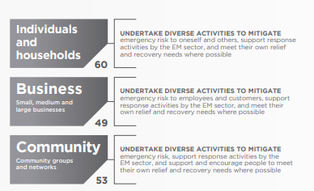
Figure 4: Mitigation is a shared responsibility

Risk Assessment Process
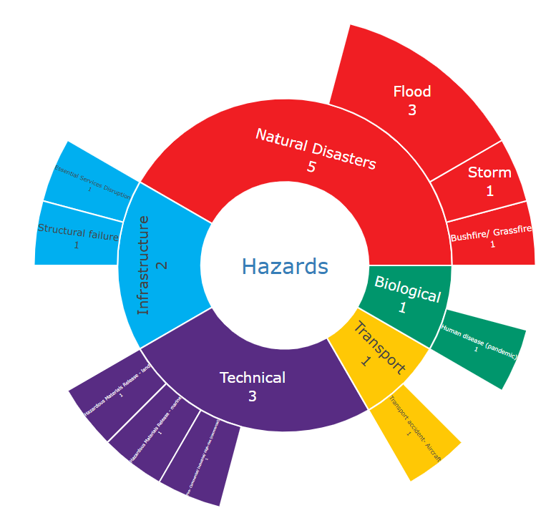
The Greater Geelong MEMPC has endorsed the Community Emergency Risk Assessment (CERA) as its method of risk assessment. The CERA is an ‘all hazards”, “all agencies” integrated risk assessment approach. The CERA Online tool developed by VICSES, assists to identify, and prioritise emergency risks, combines hazard information and intelligence from a number of sources in order to gain a clear understanding of the elements defined “risk” within a specific area that are likely to create most disruption to communities.

These sources include:
- existing ‘single hazard’ risk assessments, (e.g., the Victorian Fire Risk Register (VFRR), Integrated Fire Management Planning (IFMP) and Flood studies)
- new or existing community profile information, (e.g., Part 2 of Municipal Emergency Management Plans
- subject matter experts and local community representatives.
Figure 5: Current hazard categories in Greater Geelong

Through the CERA Tool kit the Greater Geelong MEMPC has identified the below risks.

Hazard | Risk Rating
Flood - Riverine | High
Fire – Commercial/Industrial | High
Bushfire/Grassfire | High
Storm | High
Transport Accident – Aircraft | High
Structural Failure – Dam | Medium
Flood – Storm Surge | Medium
Extreme Temperatures – Heat | High
Hazardous Material Release – Marine | Medium
Hazardous Material Release – Land | High
Essential Services Disruption | High
Human Disease – Pandemic | High

The CERA process is consistent with the Australian Standard AS/NZS ISO 31000:2018 Risk management principals and guidelines
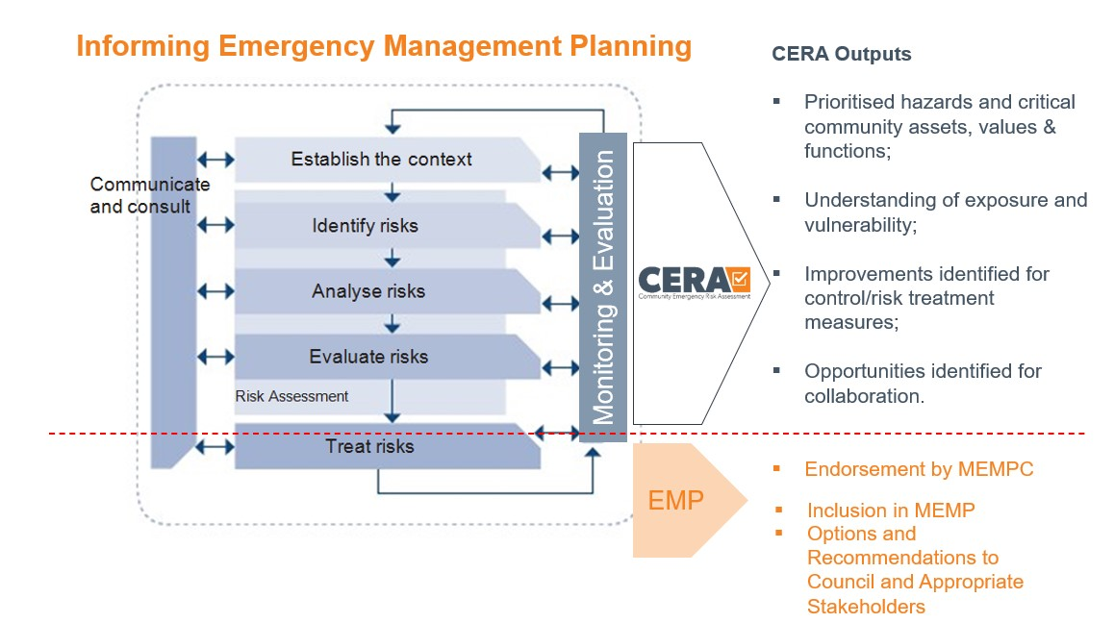
Figure 6: CERA flowchart

The Greater Geelong MEMPC will work towards creating a safer community by identifying, analysing and assessing risks, and where appropriate, identifying treatment options and implementing relevant plans.

The committee recognises that this process may lead to suggested risk treatments that may affect social, political, economic, and/or environmental aspects of the community. All risk treatment recommendations may be affected by the reality of financial constraints.

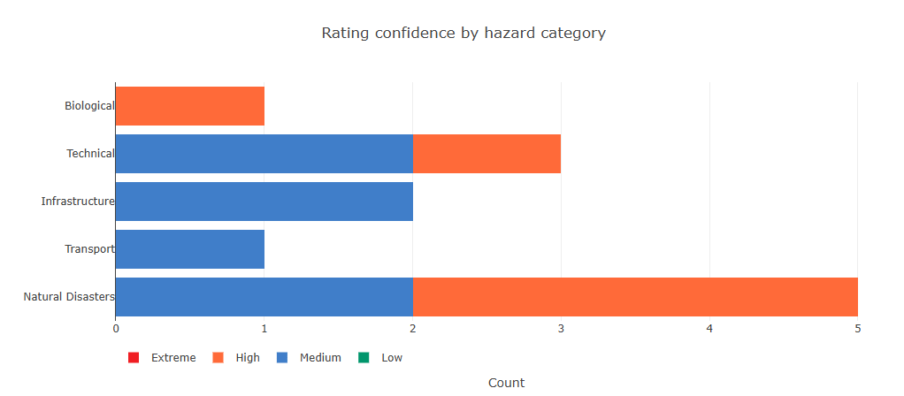
Figure 7: Hazard category risk rating for Greater Geelong

The Committee will invite representatives from various organisations as subject matter experts to support the risk assessment process.

Monitoring and Review
The MEMPC and key stakeholders from the major emergency service/support organisations identified the top risks in the municipal area. These risks are regularly reviewed at the risk and consequence sub-committee. Any changes to hazards and controls are reflected and actioned as soon as identified and assessed. A full risk assessment is undertaken every three years, led by the Greater Geelong Municipal Risk and Consequence sub-committee or major event.

The outputs of the assessment process are used to inform the MEMP, introduce risk action plans and ensure that communities are aware of and better informed about hazards and the associated emergency risks that may affect them.

Resilience
A resilient community is socially connected and has infrastructure that can withstand disaster or shocks and foster community recovery. Resilient communities promote individual and community wellbeing, use of available resources and cohesiveness to strengthen their communities for every day, as well as extreme, challenges.

The ability of a community to respond to an emergency situation and in turn recover from the effects of an emergency will depend on the resilience of the affected community. A key role of the MEMPC is to help create more resilient communities.
Emergency service organisations, agencies and stakeholders have specific programs to build community resilience through awareness and education.

Other prevention and awareness activities to assist with building resilience may include:
- Australian Warning System
- Vic Emergency
- Community development activities
- Provision of information and promotion of practices that support resilience
- Supporting and strengthening the communities psychological and emotional response to an emergency through individual planning
- Legislation, Plans and Strategies, such as the Planning Scheme and Community Health and Wellbeing Strategy 2025–2029.

Community Education
Community education is a vital component in the community understanding risks and preparing for emergencies. The development of relevant and appropriate community education resources and activities empower the community and enhance their resilience through being well informed and therefore being equipped (emotionally and physically) for an emergency.

The MEMPC members and other emergency management services/agencies collaborate to engage the community through:
- including community programs and projects
- emergency expo
- media (e.g. social media, print and publications)
- website
- relevant agency information guides
- Multicultural orientation planning sessions

For more information visit
https://www.cfa.vic.gov.au/home/local-information
https://www.ses.vic.gov.au/plan-and-stay-safe/flood-guides
https://www.parks.vic.gov.au/

Emergency Markers
Emergency markers are installed at complex addresses across the municipality. These markers are designed to pinpoint your exact location during an emergency in public open spaces or hard to define places.

Emergency markers look like street signs with white text on a green background. Each has a unique alphanumeric code of three letters and three numbers. This code is linked to Triple Zero Victoria, formally (ESTA). They receive all the triple zero calls in Victoria and dispatched emergency services as appropriate.

For additional mapping on emergency markers and other location specific resources visit:
https://www.iconyx.com/emergency-markers-map/
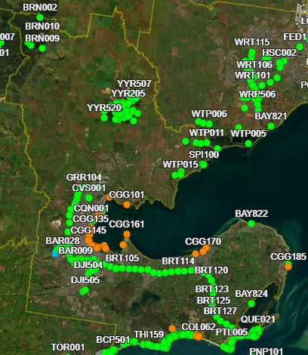
https://www.emergencyplus.com.au
Figure 8: City of Greater Geelong Emergency Markers

RESPONSE ARRANGEMENTS

Introduction
The SEMP defines Emergency Response as the action taken immediately before, during and in the first period after an emergency to reduce the effects and consequences of the emergency on people, their livelihoods, wellbeing and property; on the environment; and to meet basic human needs.

This section outlines the Greater Geelong arrangements for response to an emergency which is consistent with the SEMP.

Response Management Arrangements
Emergency response arrangements provide the structure for establishment of appropriate resources to manage emergencies throughout the State including additional resource requirements and escalation strategies for example requesting assistance from State and Commonwealth.

Emergency events are categorised using three parameters:
- Operational Tier
- Class of Emergency
- Classification

Victorian emergency response management operates at four tiers:
- incident
- regional
- state
- area of operations

Emergencies are managed at the appropriate operational tier until the event may require escalation to a higher level.

Response arrangements are largely hazard-based, and Control Agencies are responsible for developing and maintaining hazard-specific response plans, as sub-plans to the SEMP. Sub-plans include arrangements for readiness, the establishment of control, incident management systems, relief, escalation and de-escalation.

They also include arrangements for communications, coordination, consequence management and community connections.

Classes of emergency as defined in the EM Act 2013 relate to the ‘type’ of emergency.
These are:
Class 1 - a major fire or any other major emergency for which emergency service agencies are the control agency under the SEMP.
Class 2 - a major emergency which is not a Class 1 emergency or a warlike act or act of terrorism or a hi-jack, siege or riot.
Class 3 - a warlike act or terrorist act, a hijack, siege or may also be referred to as security emergencies.

Command, Control, Coordination
Emergency response management is based on the functions of coordination, control, command, consequence management and communications.
Broadly:
- Control is the overall direction of response activities in an emergency, operating horizontally across agencies
- Command is the internal direction of personnel and resources, operating vertically within an agency
- Coordination is the bringing together of agencies and resources to ensure effective response to and recovery from emergencies
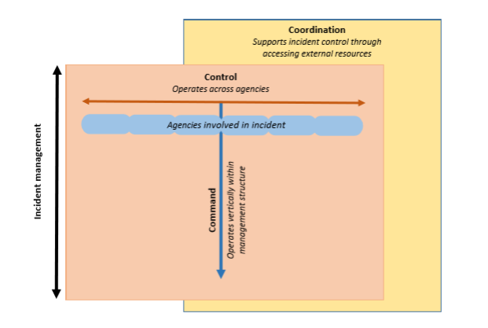
Figure 9: Functions of Command, Control and Coordination in Emergency Management

Additionally, in order to meet the objectives of emergency management in Victoria, those performing the control, command and coordination functions need to ensure:
- the consequences of the emergency are managed; and
- there is communication that meets the information needs of communities, stakeholders and government.

Classification of emergencies
Incident management commonly uses a three-level classification system. Typical features of each level is outlined below.
Level One Emergency
- The response is day-to-day business, and the incident is managed by a control agencies incident management team
- The response is in the incident area only
- The response duration is less than or a single shift.
- There is little to no potential for escalation

Level Two Emergency
- The incident is of medium complexity
- The response duration is multiple shifts
- There are one or more incident areas
- There are multiple hazards involved
- There is potential for escalation to an emergency

Level Three Emergency
- The incident is of high complexity
- The response duration is protracted
- There are multiple incident areas
- Incident is likely to become state of emergency or lead to the declaration of a state of disaster.

Non-Major Emergency
A non-major emergency can be classified as a single incident or small-scale impact emergencies where individuals or families may have had their home or possessions severely damaged or destroyed, through an incident such as a house fire, localised flood, storm, burst pipes or vandalism.

These are emergencies that can be resolved using local resources and significant consequences to the wider community are not anticipated.

The Barwon South-West Non-Major Emergency Protocol outlines the process for activation and roles and responsibilities for these types of emergencies.

See Appendix 4 BSW Non-Major Emergency Protocol for detailed information.

Consequence Management
The objective of consequence management is to minimise the adverse consequences to community as a result of a major emergency. This could be impacts on services and infrastructure.

The safety of community members is the primary consideration in consequence management. Although consequence management is a key consideration for all emergencies, it should not interfere with the control of an emergency.

Consequence in the emergency management context, is the “change in circumstances, planned or otherwise, experienced by a community or its members as a result of an event and its subsequent management”.
The management of the individual hazard may differ, however the consequence for the community requires a coordinated response across agencies. The Emergency Management Commissioner is responsible for ensuring that consequence management is undertaken for major emergencies.

Local Response Arrangements
Activation of local arrangements are outlined within the MEMP Sub-Plans and complementary plans. Each individual agency has activation procedures, and these will be activated in line with the state sub-plans.

Individual agencies may develop preparedness arrangements depending on the agency control/support responsibilities and the level of risk at a given time. These arrangements may include standby arrangements or specific actions. For example, many Class 1 control/support agencies commit to resourcing the BSW Regional Control Team or Regional Emergency Management Team depending on the AFDRS level or risk.

An Incident Management Team (IMT) or Incident Emergency Management Team (IEMT) will be established as part of any emergency situation. This could be a fixed facility or a mobile control point. IMT/IEMTs may be stood up in response to an incident or as a preparedness action (i.e. in preparation for an incident where significant risk exists in the landscape).

When an incident occurs, early notification to other agencies is essential to enable them to implement their own emergency response arrangements to support the coordinated approach to incident management. This is especially important when there is a likelihood that the event could escalate or be protracted.

The emergency arrangements will be activated as below:
• Agencies with control/support responsibilities implement their preparedness arrangements in line with the level of risk.
• Alert / Notification – when an incident occurs the control agency notifies IEMT that an emergency may require resources and keeps them informed about the situational awareness and conditions of the incident.
• Standby – As the threat becomes imminent, members of the relevant agencies may be placed on standby so they can act immediately if required. Alternatively, preparedness arrangements may already be in place and agency resources prepositioned.
• Activation – The operational phase of an incident where agencies are committed to contain or control the emergency.
• Stand down – Once the response to the emergency has been completed all participating agencies are advised to stand down.

For more information on the Transition to Recovery (Transition out of Response) refer to section 5.12
Initial information will generally come from the control agency to the MERC who advises the MEMO and the level of response will depend on the nature and extent of the emergency.

Impact Assessment
Impact assessment is conducted in the aftermath of an emergency to assess the impact to the community and inform government of immediate and longer-term recovery needs.

Impact assessment must be community focused to ensure the data/information will assist decision making on how to best support impacted communities.

It is a three-stage process to gather and analyse information following an emergency event. The three types of impact assessment are:
Assessment Stage | Remarks
Initial Impact Assessment (IIA) | - Initiated in the first 48 hours of an emergency to determine the nature and scale of the impact on people, critical infrastructure, community infrastructure, economy, natural, built and agricultural environments.  - Assessments usually initiated by the Incident Controller.
Secondary Impact Assessment (SIA) | - This phase considers resources available within an affected community and identifies those needs and priorities that can only be met with outside assistance.  - Assessment is coordinated by Recovery Coordinator.
Post Emergency Needs Assessment | - Post Emergency Needs Assessment estimates the cost of destroyed assets across the five recovery ‘environments’.  - Assessment is coordinated by Recovery Coordinator.

Financial Considerations
Agencies are responsible for all costs involved in that agency responding to an emergency. Government agencies supporting the control agency are expected to defray all costs from their normal budgets.

State and Local Governments are responsible for funding their emergency operational expenditures from their general revenues. However, specific financial support arrangements are in place.

Reimbursement for costs associated with an event may be available through the State Government’s Natural Disaster Financial Assistance (NDFA) Scheme. Before an affected municipality can seek reimbursement from the Scheme for an emergency, the emergency must first be ‘Declared’ by the State and an Australian Government Registration Number (AGRN) applied for via the National Emergency Management Agency (NEMA) .

Financial assistance is provided in accordance with the Commonwealth-State Disaster Recovery Funding Arrangements (DRFA). As soon as possible Council should register a notification to claim [link]. The DRFA is governed by the Commonwealth’s Disaster Recovery Funding Arrangements 2018 guidelines.
Further detail for the Victorian context is included in the Victorian DRFA guidelines.

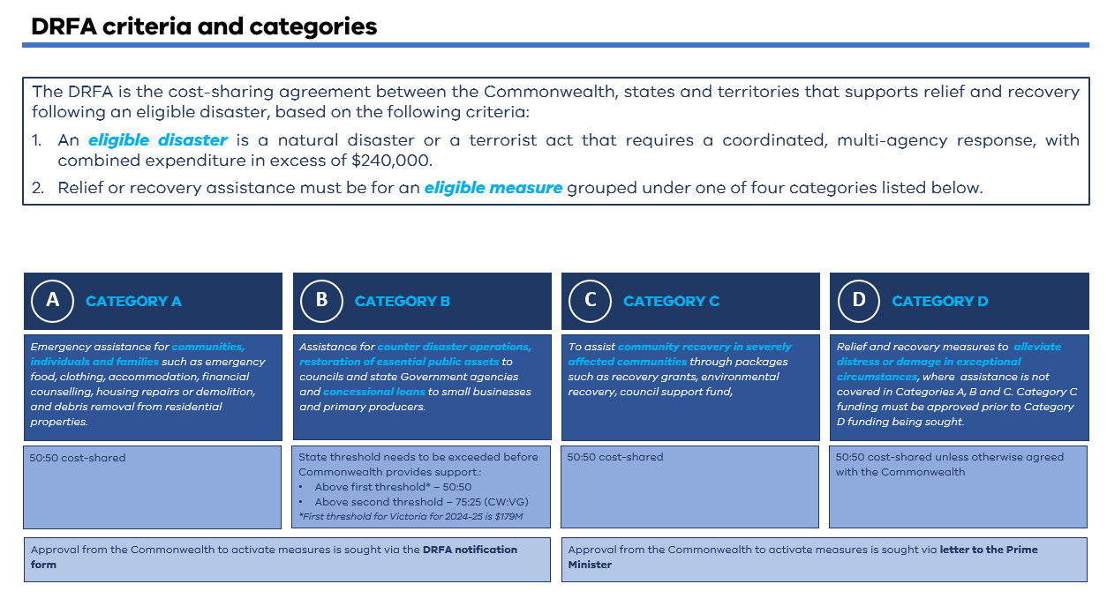

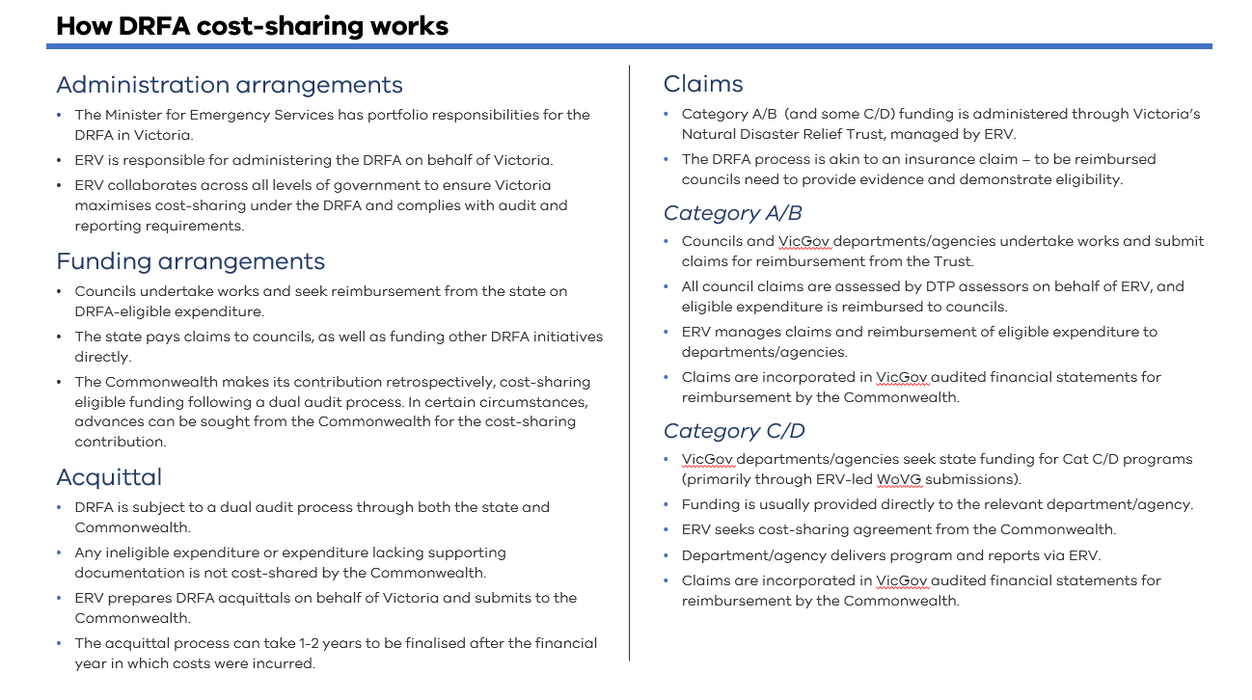
Figure 10: DRFA Categories and Criteria

Neighbourhood Safer Places and Community Fire Refuges
The municipality does not have any declared Neighbourhood Safer Places – Bushfire Place of Last Resort or Fire Refuges.

Council Resource Sharing
CoGG is a signatory to the MAV Inter-Council Emergency Management Resource Sharing Protocol. This protocol sets out an agreed position between councils regarding the provision of resources to assist other municipalities with response and recovery tasks during and after emergencies.

The protocol is intended to clarify operational, insurance and reimbursement issues that may arise through municipal resource sharing arrangements. CoGG and stakeholder agencies also have existing planning relationships with neighbouring municipalities.

Debriefing Arrangements
In a multi-agency event, the Municipal or Regional Emergency Response Coordinator (MERC or RERC), is responsible for ensuring that the Control Agency, for the emergency, organises an operational debrief with participating agencies as soon as practicable after cessation of response activities.

The purpose of a debriefing is to:
- ensure participating agencies understand what happened during an operation or emergency, and
- identify areas of improvement and highlight areas that were handled well, in order to improve the efficiency, effectiveness and safety of future operations or emergencies.

Agencies may choose to undertake debriefs within their own organisations to identify opportunities for improvements.

Evacuation
Victoria Police (VicPol) is responsible for managing evacuation in Victoria. Evacuation is a risk management strategy that involves the movement of people to a safer location and return of them at an appropriate time. As with emergency response activities, the main priority when deciding to undertake evacuation is the protection of life.

There are five stages in the evacuation process:
1. Decision
2. Warning
3. Withdrawal
4. Shelter
5. Return.

In Victoria, evacuation is largely voluntary. The Incident Controller makes a recommendation to evacuate, and it is the choice of individuals as to how they respond to the recommendation. However, in particular circumstances, legislation provides some emergency service personnel with authority to remove people from areas or prohibit their entry.

Special consideration must be given to the evacuation of vulnerable people in the community.
Vulnerable people and those who may care for them, including facilities such as hospitals, aged care facilities, educational facilities and prisons, are likely to need more time, resources, support and assistance to evacuate safely.

Further information on evacuation can be found at Joint Standard Operating Procedure (JSOP) – Evacuation for Major Emergencies (JO3.12) available from EM-COP.

Council may be involved in assisting with the relocation/evacuation operation. Council’s Municipal Recovery Manager plays a lead role in relocation/evacuation operations. In the first instance, it is preferable for residents/evacuees to self-evacuate to a safe neighbour’s property or to a friend or relatives place of residence.

When Emergency Relief Centres are required, Council is the lead agency to establish relief centres supported by Police and agencies. These centres provide temporary short-term shelter as well as an avenue to provide the community with information, and, if needed, personal support.

Red Cross will assume the role of registration of relocated/evacuated people on behalf of Victoria Police, responsible for accessing the Vulnerable Persons Register during an evacuation.

An alternative to evacuation in some circumstances may be to shelter in a suitable home, building, structure, or other safe area. Sheltering in place should be considered as an alternative when the associated risks with evacuation are considered to be greater than the risks of sheltering in place.

Sheltering in place, however, will often not be without risk. Agencies should consider the risks posed to people when sheltering in place and provide advice to them about how to best minimise these. Agencies, in conjunction with their local planning committees, should work closely with their local community to provide advice and alternatives in regard to the suitability of sheltering in place during an emergency.

Some considerations for agencies and people considering taking shelter in place are:
- the nature of the emergency
- quality of the shelter or safer area
- the likely duration of the emergency
- the need for emergency supplies such as water, food and medical supplies
- the need for designated shelter managers, if applicable
- the contents of pre-arranged plans
- the age and health of the affected persons
- timely and relevant communication strategies.

Community Information and Warnings
It is important to ensure that warnings and public information are maintained at an optimum level for specific circumstances where community action is necessary, primarily to protect lives, and also for the protection of property and the environment.

Individuals and communities have a responsibility to prepare themselves in case of an emergency.
To assist them in the preparedness and during emergencies, the official emergency services web site for Victoria is www.emergency.vic.gov.au . It is a single all-emergencies website for Victorians. It is Victoria's primary website for incident information and warnings. Vic Emergency provides a single source of information and advice to help people prepare for, respond to and recover from emergencies.

Vic Emergency has a real-time Google Map display with incidents across Victoria including fires, floods, storms, power outages, hazardous material incidents and traffic incidents.

Warnings
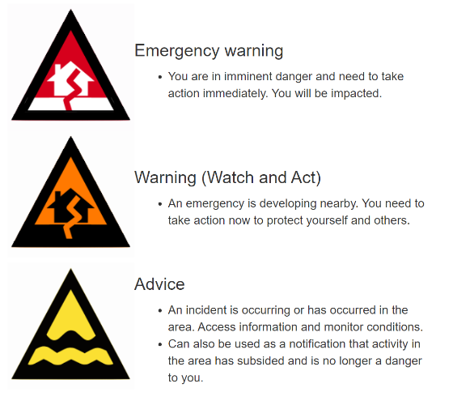
Warnings can be issued at several different levels depending on the type and severity of the event. They can include advice, watch and act, and emergency warnings.
Figure 11: Types of warnings
Emergency warnings are the highest level of warning and aims to warn individuals and communities to prepare for an impending event or in the event of an emergency.

Once a decision has been made to issue a warning, the Incident Controller will determine which method to use (i.e. television, radio or internet) and determine whether an Emergency Alert needs to be issued.

Where an extreme and imminent threat to life exists and authorisation from the Incident Controller is not practicable in the circumstances, warnings may be issued by any delegated response agency personnel with notification to the Incident Controller as soon as possible.

Community Information
The Incident Controller is responsible for issuing warnings and public information. The Regional Controller (where appointed) or State Response Controller for Class 2 state controller should assist if required.

The provision of information to the broader public/community, including those attending an Emergency Relief Centre (ERC), is vitally important to their capacity to understand what is happening, and to assist them in making informed decisions during a time of crisis.
Each agency manages community information through their own social media channels.
Community meetings may form part of the communications strategy for the event and coordinated by the response agency.

ABC 774 is the National Emergency Broadcaster.

Information can also be found through the local emergency broadcasters:
K-Rock FM 95.5
Bay FM 93.9
The Pulse FM 94.7
3YYR FM 100.3
Tourist FM 88

Communication Methods
The methods of communication employed by Greater Geelong include:
- Community Meetings
- SMS/Text Messaging
- Direct liaison with affected persons
- Community Recovery Groups
- Mobile Community Recovery Hubs
- Community Recovery Information Centres (physical and virtual)
- Print Materials
- Radio
- Websites and Social Media

For recovery specific communication, refer to section 6.9.

Relief Arrangements (Part of Response)
Emergency Relief is the provision of essential needs to individuals, families and communities in the immediate aftermath of an emergency.

Emergency Management agencies with relief responsibilities incorporate the principles of relief as outlined in the SEMP and National Strategy for Disaster Resilience. Relief is focused on consequence management and should consider the principles of relief.

Relief encompasses a range of services such as, but not limited to community information, emergency shelter and provision of immediate needs, psychosocial support, material aid, first aid, financial assistance, animal welfare and legal support. It is important that assessment of needs is undertaken for each incident to determine needs.

Relief can be provided at a dedicated Relief Centre, places of community gathering, incident scenes, triage and transfer sites as appropriate, memorials or other locations as appropriate. Relief is considered part of response and must be integrated into the response arrangements, however it is important to note that relief is interconnected with recovery and must be seamlessly integrated with all other early recovery activities and considered in the response phase.

Further information on relief can be found in the City of Greater Geelong Emergency Management Operational Guidelines).

Relief Management and Governance
The City of Greater Geelong is responsible for relief coordination at the municipal level. Emergency Recovery Victoria is responsible for relief and recovery coordination at the regional and state level respectively.

Relief roles and responsibilities are outlined in Part 7 of the State Emergency Management Plan. For local arrangements in relief, a Relief and Recovery Sub-Committee forms part of the Municipal Emergency Management Plan Governance Structure. The Relief and Recovery Sub-Committee may be required to provide leadership in local (municipal) relief and recovery coordination .
This plan aligns with the Barwon South West Regional Relief and Recovery Plan which forms part of the Regional Emergency Management Plan.

The City of Greater Geelong is responsible for the planning, management and operations of Emergency Relief Centres with the assistance of agencies and local service providers identified at the time of the incident. The City has designated a number of facilities that can utilised as Emergency Relief Centres across the city through a formal Facility Audit process.

Activation of Relief Services
The level and type of relief required to support affected communities will be determined in consultation with the Incident Controller, MERC, MEMO and MRM.

The MRM will coordinate the activation of the selected relief team and respective centre or services as depicted by the needs assessment.

Escalation
A formal request for escalation of relief will be made if the emergency event increases in complexity; exceeds the capacity and/or capability of the City of Greater Geelong to respond; or an emergency has affected multiple municipalities within a region or multiple regions. The decision to escalate will be undertaken in consultation with the Incident Controller, MERC, MEMO, MRM and the Regional Emergency Relief Coordinator (Emergency Recovery Victoria).

Escalation of relief should build on existing local arrangement rather than replacing them.
Resources to support Council in its response to a local event may be obtained through the MAV Resource Sharing Protocol or through neighbouring councils.
Refer to section 5.7 for more information
In the event a neighbouring municipality requires support for relief services, including the activation of a City of Greater Geelong relief centre, the MAV resource sharing protocol will be the tool utilised to facilitate this escalation or alternatively a CEO-to-CEO request.

Relief Communication
Dissemination of community information as part of emergency relief assists the community to remain safe and understand support and services available to them.

Relief messaging should be integrated with response messaging, and it should inform the community about relief services and how to get assistance.

Where the formal transition from response to recovery has not yet occurred, the provision of community information remains the responsibility of the Control Agency in consultation with relevant stakeholders to ensure consistent localised emergency relief information.

Where transition has occurred, the Council in consultation with the Recovery Sub-Committee and relevant stakeholders will coordinate the public information.

Relief Principles
The principles for the coordination of relief as outlined in the SEMP are:

- Emergency-affected communities receive essential support to meet their basic and immediate needs.
- Relief assistance is delivered in a timely manner, in response to emergencies.
- Agencies communicate clear, relevant, timely and tailored information and advice to communities about relief services through multiple, appropriate channels.
- Relief promotes community safety and minimises further physical and psychological harm.
- Relief services recognise community diversity.
- Relief is adaptive, based on continuing assessment of needs.
- Relief supports community responsibility and resilience.
- Relief is well-coordinated, with clearly defined roles and responsibilities.
- Relief services are integrated into EM coordination efforts.
- Relief is coordinated and delivered as close to the community as possible, supported by regional and state-based activities as required.

Relief Planning and Supports
The City of Greater Geelong has the lead role in ensuring coordination of relief activities during an emergency (event specific) such as:
- community information (public meetings, newsletters, information sheets, advertising and media requests)
- temporary or emergency shelter and Emergency Relief Centres (ERC)
- food, water and immediate material-aid
- psychosocial and emotional spiritual care and support and health and medical assistance
- reconnecting families and friends
- emergency financial assistance
- animal welfare
- culturally and linguistically diverse communities
- culturally safe facilities and supports
- legal assistance information
- providing advice and referral regarding goodwill, donated goods and services and spontaneous volunteering.

The City of Greater Geelong has a comprehensive Relief Program (BRACE) to support affected communities. This includes the development of plans, guidelines and programs to ensure staff are trained to support relief activities.

Register.Find.Reunite
A critical component of relief is connecting affected persons during and following an emergency. Victoria Police are responsible for the activation of Register.Find.Reunite and will activate Australian Red Cross to manage this service on their behalf. Register.Find.Reunite provides intel for agencies such as Victoria Police to assist with any evacuation planning.

Animal Management in Emergencies
Municipal Councils are the lead for housing displaced companion animals and lost/stray domestic animals. This includes supporting domestic animals and their owners within an Emergency Relief Centre.
Accommodating animals at Emergency Relief Centres should be a last resort. The first option should always be with family or friends outside the affected area that can better provide for the animal.

Department of Energy Environment and Climate Action has the primary responsibility for animal welfare during an emergency event. The Victorian Emergency Animal Welfare Plan defines animal welfare support services in relief. This includes management of displaced animals including livestock, companion animals and wildlife, animal welfare assessment, provision of emergency pet food, fodder and water and planning for longer term recovery.

Vulnerable or At Risk People and Facilities in Emergencies
Vulnerable Persons Register
There are many in the community who would be considered vulnerable or at risk during an emergency depending on the type of event, these may include elderly, children, people with a disability and members of the Culturally and Linguistically Diverse (CALD) community. Local Government facilitates the Department of Families, Fairness and Housing Vulnerable Persons Register and this register can be accessed by Victoria Police during emergencies. Register participants are individually assessed against a set criteria and recorded in the Vulnerable Persons Register.

Vulnerable Facilities
A vulnerable facilities list has been developed by the City of Greater Geelong which provides information on facilities that may have gatherings of at-risk people. This list comprises community halls, community hubs, neighbourhood houses, senior citizens facilities, large event facilities and high frequency tourist venues. This list is reviewed annually or as required and for further information contact the MEMO or MRM.
In addition, data sets for state defined vulnerable facilities are located under Infrastructure on the data tab in EMCop.

Indigenous People and Communities
Indigenous people and communities have distinct needs and can face additional risk throughout evacuation, relief provision and recovery.

Evacuation is a strategy used to reduce loss of life or lessen the effects of a hazard on a community before or during a disaster (AIDR 2023).

In an evacuation, it is important that Emergency Relief Centres and Community Recovery Hubs are culturally safe for all, but in particular for Indigenous people and communities who may have additional layers of complexities that prevent Indigenous people and communities from evacuating and attending Emergency Relief Centres.

Distrust in government and non-Indigenous organisations, exposure to racism and discrimination may contribute to Indigenous people and communities to feel culturally unsafe at an emergency relief centre. In addition, generational trauma experienced and/or carried by some aboriginal people.

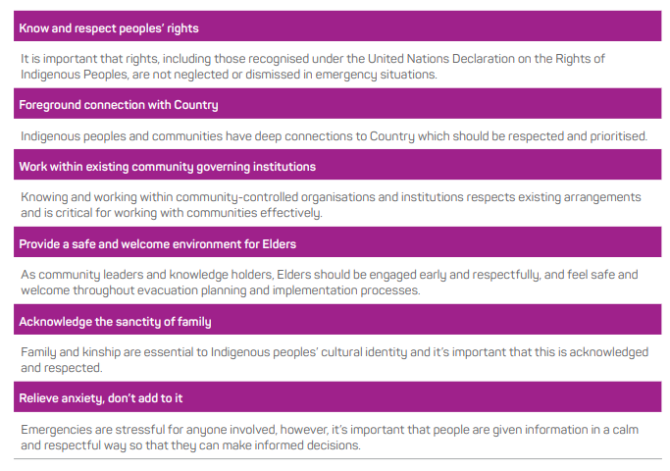
The Principles for evacuation and working with Indigenous people and communities as outlined in the Australian Institute for Disaster Resilience (AIDR) Planning Evacuations with Indigenous Communities (Companion to Evacuation Planning [AIDR 2023] are:
- Know and respect people’s rights.
- Foreground connection with Country.
- Work within existing community governing institutions.
- Provide a safe and welcome environment for Elders.
- Acknowledge the sanctity of family.
- Relieve anxiety, don’t add to it.

Figure 12: AIDR Planning Evacuations with Indigenous Communities

A focus on cultural sensitivity and a trauma informed awareness needs to be a key objective in any evacuation. It is important in the planning to understand what cultural heritage rights Indigenous communities have in at-risk areas. This could include but not limited to physical sites, song lines, stories, art and dance.

Cultural heritage may impact on the decision for Indigenous People and communities to leave in an evacuation as Indigenous people and communities may want to protect traditional areas or objectives of significance from threats of injury or desecration.

The Strategy for Aboriginal Community-led Recovery (the Strategy) guides ERV in supporting Aboriginal communities to lead their recovery and provides guidance to local government in their recovery responsibilities connecting with their aboriginal local stakeholders, corporations and Traditional Owners.
https://content.vic.gov.au/sites/default/files/2023-08/Strategy-for-Aboriginal-Community-led-Recovery-2023.pdf

Emergency Relief Centres and Community Recovery Hubs
Indigenous people and communities should not feel threatened or coerced into making a decision to attend an emergency relief centre. The primary objective of ensuring culturally safe spaces is to minimise racism and discrimination in Emergency Relief Centres and to ensure a safe, relaxed environment that Indigenous Australians feel safe and welcome in. If this is not achieved, Indigenous people and communities may choose not to seek safety.

In Greater Geelong, a culturally safe emergency relief centre has the following considerations :
- Public acknowledgement of the location Traditional Owners on whose land the evacuation centre is located.
- A separate, safe and comfortable space for Elders.
- Provision of social and culturally safe spaces for Indigenous Australians.
- Adequate facilities for families with children and babies.
- Opportunity for local Indigenous organisations and/or service providers to be present at evacuation centres and ensuring they are highly visible.
- Adoption of a trauma informed and healing centred approach in all interactions.
- Consideration how community members get their news and adapt as required.
- Inclusion of Indigenous culturally safety and anti-discrimination training for all BRACE Team Members.

Return and Recovery
Ensuring governments and non-government organisations are culturally responsive in disaster recovery practices is critical. Traditional owners may be eager to return to country soon after the hazard has passed.
It is important to continue the dialogue during the return and recovery phase.

Key objectives of an Aboriginal community-led recovery should include:
- As community leaders and knowledge holders, Elders should be engaged early and respectfully, and feel safe and welcome throughout evacuation planning and implementation processes.
- Assisting those with additional support needs.
- Be open with expectations. What evacuees may see, feel and impacts to services.
- Link with cultural support networks or services and work with Indigenous people and communities to develop an Indigenous-led Recovery Plan.

LGBTIQ+ People and Communities
LGBTIQ+ persons often are at a heightened level of vulnerability and risk of violence, abuse, discrimination and exploitation during displacement. Research through the Gender and Disaster Pod has identified that LGBTIQ+ people may have a reluctance to access emergency supports due to historical and current discrimination, including those delivered by faith-based organisations for fear of consequences from disclosing sexual orientation or gender identify.

Each LGBTIQ+ experience may not be the same. As well as being diverse in their sexuality, gender identify or sex characteristics, LGBTIQ+ people are diverse in other ways. This may include their Aboriginality, ethnicity, skin colour, nationality, refugee or asylum seeker background, migration or via status, language, faith, ability, age, mental health, housing status or geographical location. (Rainbow Ready Roadmap).

During evacuation, it is important that Emergency Relief Centres and Recovery Centres are an inclusive and safe place for members of the LGBTIQ+ community.

Gender Equity and Family Violence in Emergencies
Family violence increases in emergency-affected communities. The compounding effect it has on emergency-related trauma can affect an individual’s ability to act to protect their own safety and wellbeing. Other factors that may increase the risk of family violence includes:
- homelessness
- financial stress
- unemployment
- drug and alcohol abuse
- trauma

The occurrence of family violence increases significantly in emergency-affected communities, especially violence against women.

Family violence can disrupt and impede community recovery. Recovery Planning and actions particularly within the Social Recovery pillars include considerations for addressing family violence. This is informed by the 2019 Family Violence Framework for Emergency Management. This framework outlines ways to address family violence including awareness, communications and public information, collaboration and planning.

People with a Disability, Frail or Aged
People with a disability and people who are frail or aged face additional challenges during emergencies. It is important to incorporate and encourage planning for lived experience and specific supports required throughout all phases of an emergency. Working with at-risk members of the community to build resilience and supports reduces challenges during emergencies. Greater Geelong has a multi-agency focus on building resilience and works with communities to increase individual planning using Person Centred Emergency Preparedness (P-CEP). P-CEP is a process that empowers individuals, particularly those with disabilities or support needs, to create personalised emergency plans. P-CEP provides a process to assess preparedness, capabilities and support requirements, understand their risk and develop a plan.

In addition, planning for emergency relief and recovery centres, guidelines and resources includes specific considerations for people with a disability to reduce challenges in these environments.

Children and Young People
Children have unique vulnerabilities when compared with the adult population and must be considered as a special group. The needs of children are often overlooked because childhood is not always seen as a separate or distinct stage of growth (Allen et al. 2007) – (AIDR Emergency Planning for Children and Young People).

The Emergency Management Planning for Children and Young People informs emergency planning within Greater Geelong. Planning for emergency relief and recovery centres, guidelines and resources and recovery planning has a focus on ensuring children and young people are supported during emergencies.

Transition to Recovery (Transition out of Response)
While it is recognised that recovery activities will have commenced shortly after impact, or preferably, simultaneously with response operations and run concurrently with same, there will be a termination of response activities and a hand over to recovery agencies. It is noted that Recovery has a long term lens and therefore, in practice, it is a transition out of response.

During the Response phase, the Incident Controller, MERC, MEMO and MRM should commence transition planning [out of response] as soon as possible following the start of the emergency.

The early notification of recovery agencies involved in the emergency will ensure a smooth transition of ongoing activities from response to recovery. Issues to be considered for the timing of transition from response to recovery include:
- the nature of the emergency and what ongoing specialist resources are required
- whether a recurring threat is likely to occur compounding the impact on the community
- the extent of the impact on communities, as this may determine the length of the transition period
- the level of loss/damage and the extent to which this has been validated (the stage of impact assessment reached e.g., if phasing into secondary/post impact stages may indicate transition requirements)
- Transition documents articulate the ongoing responsibilities including any rectification works of key stakeholders
- the extent to which the community requires emergency relief services
- the resources required for the activation of recovery arrangements
- The transition agreement will be developed at the appropriate level between the response agency Incident Controller, MERC, MEMO, MRM and the recovery agency coordinator (ERV)

RECOVERY ARRANGEMENTS

Introduction
Recovery is the coordinated process of supporting emergency affected individuals and communities to reconnect and re-establish a level of functioning, coordination and access to services.

Recovery is part of emergency management which includes the broader components of prevention, preparedness and response. Planning for recovery is integral to emergency preparation and mitigation actions may be initiated as part of recovery.

The Municipal Recovery arrangements for the municipal district of Greater Geelong have been developed in accordance with the Emergency Management Act 1986, Emergency Management Act 2013 and align to the SEMP, Regional Emergency Management Plan (REMP) and recovery planning across the Barwon South West Region.

Objectives of Recovery
The cooperation and coordination of services between all levels of government, non-government organisations, community agencies and the private sector is a key objective of recovery.

Key considerations of the recovery arrangements may include:
- General Principles of Recovery
- Recovery Planning and Preparedness
- Clarity of Roles and Responsibilities
- Development of Event Specific Recovery Action Plans
- Long Term Recovery

In addition to the key considerations, Recovery should be community-led and enable participation by all members of the community and should integrate with emergency response and relief activities and commence as soon as possible following the emergency.

Recovery considerations typically fall under four environments that require coordination as part of the recovery process; Social, Economic, Built and Natural.

Consideration will also be given to adapt the recovery framework as necessary to align with Emergency Recovery Victoria’s Recovery Framework - Five Lines of Recovery:

- People and Wellbeing
- Aboriginal Culture and Healing (included in line with ERV Recovery Framework)
- Environment and Biodiversity
- Business and Economy
- Building and Infrastructure

Recovery Definition
The SEMP states that recovery is “the assisting of persons and communities affected by emergencies to achieve a proper and effective level of functioning”.

ERV’s approach to recovery is underpinned by eight principles which support flexible, locally driven, and developed action.

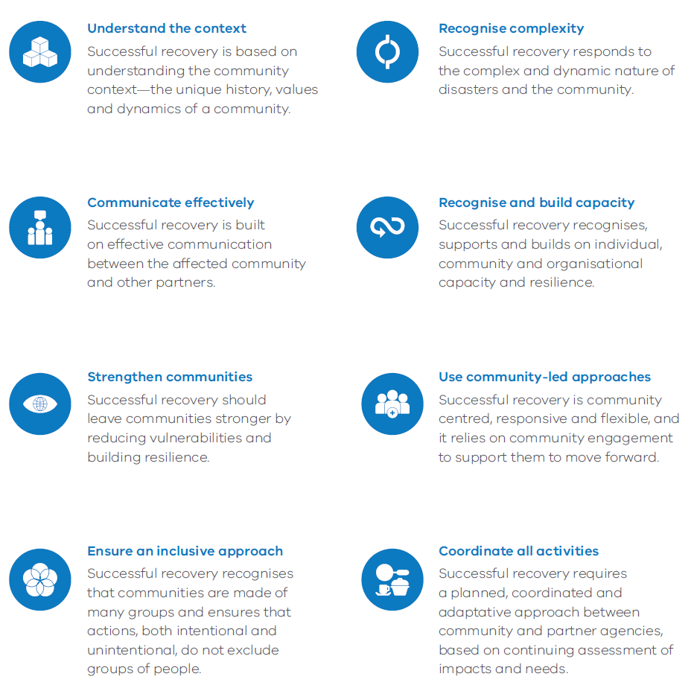
These are based on the National Principles for Disaster Recovery and are outlined below:
Figure 13: Principles of Recovery.

Escalation
Escalation of recovery coordination may escalate from Council coordinated recovery to regional recovery rapidly or over time depending on the emergency context, capacity, recovery environment and community requirements. The following factors may indicate the need for escalation of recovery and formalised regional coordination arrangements:
- The emergency is expected to exceed Local Government Authority capacity to manage recovery coordination.
- The recovery agencies intend to draw on regional or state-tier resources for the foreseeable future in relation to the emergency.
- An increasing scale or changing nature of the actual or expected recovery effort.
- Significant consequences.
- Escalating recovery costs and funding opportunities.
- Initial impact assessments indicate that the damage to private property exceeds the Annual rates base of the municipality.
- High numbers of non-resident landowners impacted by the event.
- International tourists affected by the emergency, and diplomatic assistance is required.

Recovery escalation is undertaken in consultation with the MRM, MEMO, MERC and Emergency Recovery Victoria.

Management Structure
Where the need for formal recovery is identified, the City of Greater Geelong, MRM, may establish an event specific recovery committee. The initial responsibilities of the event specific recovery committee are to formalise the governance structure, oversee the transition out of response to the Transition Plan, establish working groups and develop an Event Specific Recovery Plan.

It is the responsibility of the Event specific Recovery Committee to ensure that affected communities are represented in the recovery arrangements which may be through Community Recovery Groups.

Secondary Impact Assessment
Secondary Impact Assessment (SIA) determines the long term needs of the community. It is informed by the Initial Impact Assessment. Secondary Impact Assessment can take many forms depending on the type of event, extent of damage and needs of affected individuals and communities. This could include but not limited to, appraisal of extent of damage and disruption and outreach support. Local Government coordinates secondary impact assessment at the local level.

The City of Greater Geelong has comprehensive Secondary Impact Assessment Guidelines that outline the coordination of Secondary Impact Assessment including reporting.

Government Assistance Measures
State and Federal government assistance may be available in the recovery efforts following a declared event. The type of support available will depend on the level of impact.

Individuals, families and businesses can source other government assistance opportunities from agencies such as Services Australia, Business Victoria, Department Families Fairness and Housing, Salvation Army or the Australian Red Cross.

Recovery Phases
Recovery is a long process requiring planning in stages across multiple levels that includes:
- Mobilisation and Planning
- Short term (3 months +/-)
- Medium term (12 months +/-)
- Longer term (3-5 years)

The following diagram expands on the phases of recovery:
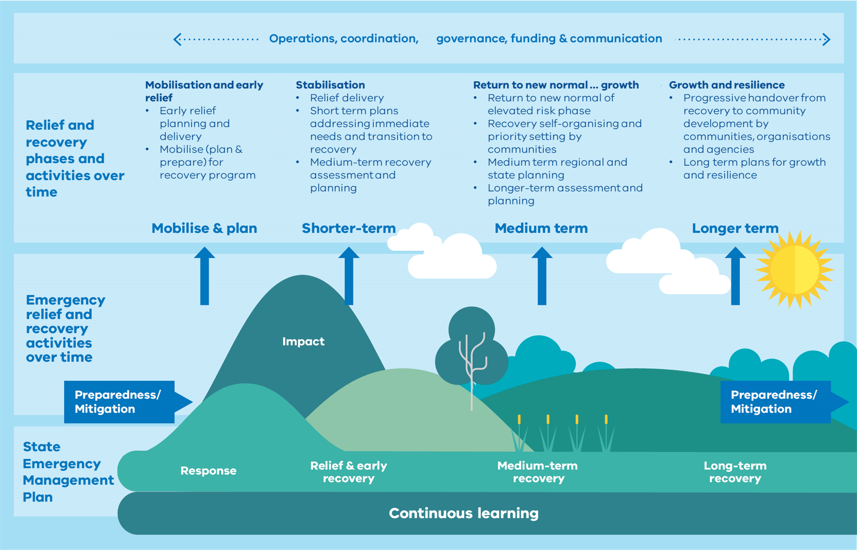
Figure 14: ERV - Recovery Framework

Phases of recovery for individuals and communities
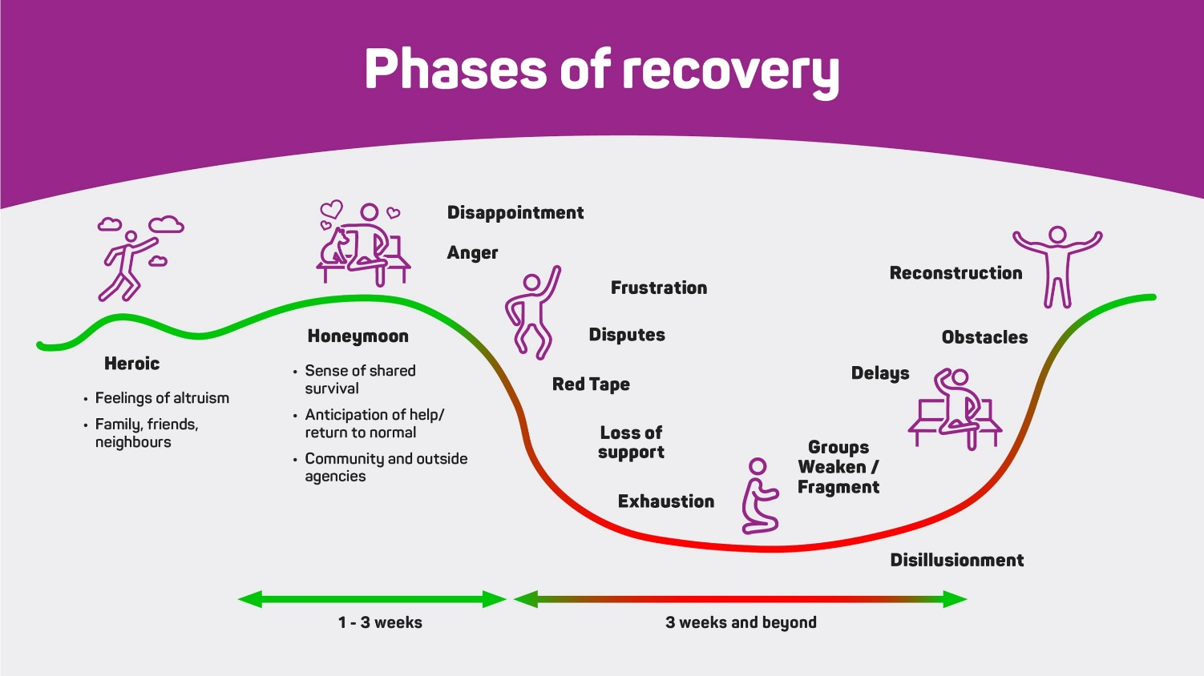
There are a number of phases that individuals and communities often experience as they move through their recovery journey (NEMA Recovery Exercising Toolkit). The path to recovery is not linear or smooth. Setbacks can be distressing but are part of a normal process. The Phases of Recovery figure (below) outlines common experiences at each point in the recovery journey to help inform recovery planning and activities:
Figure 15: Phases of Recovery
Community Led Recovery
Community-led recovery is an approach that gives communities greater opportunity to be involved in decisions and process that contribute to reshaping and rebuilding their lives in ways that works for them.

A community-led approach involves engagement deeply and respectfully with communities so that they can help build back stronger and more resilient.

Recovery Communications
Communicating in recovery is crucial for effective partnership between affected communities, governments, community service organisation and local service providers, and the business sector. Successful recovery involves sharing information, managing expectations and building future resilience. The Australian Red Cross outlines the principles of communicating in recovery being:
- Public information, not public relations
- Respect people
- The right to know
- Build on local assets – Assets-Based Community Development (ABCD)
- Ask the community how they want to receive information
- Acknowledge the impact
- Repeat information
- Remember the “unaffected”
- No spin.
Greater Geelong prioritises the following key messaging attributes to ensure successful communication following emergencies:
- Start Early: Begin communicating as soon as possible after a disaster.
- Be Respectful: Treat affected individuals as rational decision-makers.
- Use Plain Language: Communicate clearly and avoid jargon.
- Tailor Messages: Adapt communication to the specific needs of different groups.
- Provide Practical Information: Offer actionable advice and support.
- Use Diverse Channels: Utilize a range of communication methods (e.g., websites, community meetings, social media, SMS).
- Be Transparent: Avoid spin and be honest about what is happening.
- Acknowledge Impact: Recognize the emotional and practical challenges people face.

ROLES AND RESPONSIBILITIES

Introduction
An agency that has a role or responsibility under this plan must act in accordance with the plan.
The SEMP and REMP outline agreed agency roles and responsibilities, noting that existing duties, functions, power, responsibility or obligation conferred on an agency by law, licence, agreement or arrangement prevail to the extent of its inconsistency with this plan (EM Act 2013 s60AK).

The roles and responsibilities outlined in this plan are specific to the municipality and are in addition to, or variations on, what is outlined in the SEMP and REMP.

Roles and Responsibilities
Activity | Critical task alignment / activity source
Mitigation
Major Hazard Facilities (eg. Viva Energy, Chemring etc) | Planning and preparedness activities for emergencies related to the agency’s assets or area of control.
Barwon Health
St John of God Hospital
Epworth Hospital
Local Public Health Unit
Response (including Relief)
Barwon Health | Provision of Health Services
St John of God Hospital | Provision of Health Services
Epworth Hospital | Provision of Health Services
Local Public Health Unit | Provide Public Health Advice and Support.
Citizens Radio Emergency Service Teams | Telecommunication Support
Victorian Council of Churches- Emergencies Ministry | Personal Support
Australian Red Cross | Personal Support, Register.Find.Reunite
Geelong Food Share | Food Relief
Department Families, Fairness and Housing | Power Dependent Support
Salvation Army | Catering and Material Aid
St John Ambulance Victoria | First Aid
Recovery
City of Greater Geelong | Secondary Impact Assessment and Recovery Outreach
VCC-Emergencies Ministry | Personal Support
Australian Red Cross | Personal Support
Insurance Council of Australia | Insurance Advice
Financial Counselling Victoria | Financial Advice
Blaze Aid | Fencing Recovery
Disaster Legal Help Victoria | Legal Advice

8 APPENDICIES

Appendix 1: Document Administration

Document details
Criteria | Details
Document ID | TBC
Document title: | Greater Geelong Municipal Emergency Management Plan
Document owner: | MEMPC

Version control
Version | Date | Description | Author
A full rewrite of the MEMP was conducted in 2022, where more than 80% of the document was changed, therefore version control will commence at 1.0
V0.1 | Sep 2022 | MEMP Working Group final draft | MEMP Working Group
v0.2 | Oct 2022 | Formatting and copy edit | CoGG Communications & Marketing
v1.0 | 3 Nov 2022 | Distributed to MEMPC for review and Feedback | E. Anderson
V2.0 | May 2025 | Updated Relief & Recovery sections, graphics and CERA risks. | MEMP Working Group

Document approval
This document requires the approval of the MEMPC:
Name | Title | Signature
Anthony Basford  On behalf of the MEMPC | Chair

Audience
The audience for this document is the MEMPC
Terms | Description
Review Date | December 2028

Appendix 2: List of Other Emergencies to Impact the Greater Geelong Region

Date | Incident | Location | Outcome
May 1852 | Riverine flooding | Barwon River | Flood level of 4.91m.
Aug 1909 | Riverine flooding | Barwon River | Flood level of 4.6m.
Aug 1951 | Riverine flooding | Barwon River | Second highest flood level 5.17m.
JUN 1952 | Riverine Flooding | Barwon River | Significant property inundation and disruption with a heigh of 5.47m.
1961 | Fire | Shell refinery | Furnace explosion left two workman dead and 2 critically injured.
JAN 8th 1969 | Bushfire | Lara, Little River &  Princes Hwy | 18 people lost their lives with 44 homes destroyed.
1973 | Riverine flooding | Hovells creek, Lara | Heavy rainfall totalling 190mm in 20hrs resulting in substantial damage.
1977 | Bushfire | Little River x 2 | Grass fires destroyed around 2000 acres each
Nov 1978 | Riverine flooding | Barwon River | Flood level 4.48m
SEP 1980 | Riverine Flooding | Barwon River | Highest ever recorded flood of 5.59m
1982 | Bushfire | Anakie East | Losses of houses & outbuildings.  heavy stock losses  fencing in the Staughton Vale/Anakie, Lara and Little River areas.  2 lives lost.
JAN 14th 1985 | Bushfire | Lara & Little River | 90% of the You Yangs was burnt. The fire killed 4,500 stock, 275km of fencing and five houses. Two people lost their lives.
Oct 1995 | Flood | Barwon River | Major flood reaching 5.23m.
APR 1997 | Grass fire | Ocean Grove Reserve | Fire burnt around 40ha of the south west corner of the reserve.
Sep 25th 1998 | Gas Explosion | Statewide | Major disruption to industrial users after the Longford Gas Plant exploded. This cost over $1.3 billion and left domestic gas users including those in public housing without gas, hot water or heating for 20 days.
Dec 1998 | Recovery | Linton Fires | Loss of 5 Geelong West Fire Fighters
Apr 2001 | Storm & flash flooding | Greater Geelong | Four times the average monthly rainfall fell across three days with sever winds around 105kph.
Oct 2002 | Bali bombing | Impact on Geelong residents who were visiting Bali | Recovery activities
JAN 30th 2004 | Flash Flooding | Highton | Flash flooding across Highton after 80mm fell within a few hours.
Dec 2004 | Tsunami – Asia | Geelong Residents | Impact on Geelong Residents who were in Asia at the time or who had family overseas at the time.
Oct 2005 | Bali Bombing | Geelong Residents | Impact on Geelong Residents who were in Bali at the time or who had family overseas at the time.
JAN 20th 2006 | Bushfire | Anakie | Fire in the Brisbane Ranges burnt 6708 hectares with 35 buildings destroyed.
Aug 2006 | Grass fire | Moolap – south of Woods and Coppards Road | A local burn off in strong winds escaped burning 371ha. DSE and CFA eventually brough it under control after 48hrs.
Feb 2009 | Bushfire – recovery | Black Saturday | Management of donations
JAN 2014 | Gas release | Geelong ‘Gas Gate’, Corio | A gas leak shut down the Princes Hwy in both directions. It was initially thought the leak came from the refinery but was later discovered to be caused by a connection in the natural gas pipeline network.
Feb 9th 2014 | Bushfire | Ceres | 60ha was burnt.
2014 | Fire | Geelong | Fire impacted the Steggles Processing Plant.
2015- 2020 | Potential fire | Broderick Road Lara | Significant multi agency planning and preparedness
Sep 2015 | Methene Event | South Geelong | Elevated levels of methane recorded in buildings situated on top of a former landfill.
SEP 15th 2015 | Structure Fire | Moolap | Fire in the Glass Metals Industry Factory spread to the three-story building.
JAN 27th 2016 | Flash Flooding | Geelong | Significant flash flooding event impacting many suburbs in Geelong. 213 private residents and over 140 community and council venues were impacted when 84mm fell in 45min.
Jan 29th 2016, | Light plane crash | Off the Bellarine Peninsula. | Three bodies were recovered, but the 4th wasn’t found
Mar 3rd 2016, | Hazardous Spill | Corio – Road spill of Butyl Acrylate along Princes FWY and Service Station (Geelong Bound) | 35 people hospitalised
NOV 21st 2016 | Thunderstorm Asthma | Geelong | Public hospitals and Emergency Services experienced a 672% increase in respiratory presentations. 10 people across Geelong and Melbourne died.
Apr 8th & 9th 2017 | Severe storm | Bellarine Peninsula | Strong south-westerly winds with high rainfall totals of 100mm recorded across Ocean Grove and Drysdale.
Dec 25th 2019 | Woodchip fire | Geelong | Large amounts of mulch caught fire on Christmas day, causing a large amount of smoke, to impact air quality in surrounding areas. It took several days for the fire to be put out and air quality to return to normal.
Feb 2020 | Possible Dam Breach | Highton | Support agencies – possible scenario planning
MAR 2020 | Pandemic | Global | COVID 19 Pandemic caused extended lockdown in municipality with high cases and significant impacts on economy. The region experienced a population increase with more Melburnians choosing to isolate in their holiday homes.
Mar 2020 | Toxic chemical Dump | Lara | A company was identified as dumping large amounts of chemical waste at a site in Lara. This led to a large and expensive clean up and legal proceedings.
MAY 20th 2020 | Tornado | Waurn Ponds  /Grovedale | Wind speeds in excess of 160km per hours with a corridor of 60 metres wide and 3km long caused significant damage to houses with some uninhabitable.
Aug 2020 | Riverine Flooding | Barwon | Rain caused the river to peak at the minor flood level in Geelong breaking it banks in low lying areas.
Dec 2020 | Bushfires | Gippsland | Residents concerned about smoke
Jul 2021 | Battery fire | Victorian Big Battery fire, Lara | A 13 tonne lithium battery caught fire during testing at the new Big Battery Plant in Geelong. Over 150 firefighters attended with the fire burning for over 24hrs.
OCT 29th 2021 | Storm | Geelong and Bellarine | Wind gusts of more than 100km caused significant damage to trees and public land with loss of power to large sections of the Bellarine. Heavy rain also saw minor riverine flood levels reached and flash flooding in the Geelong CBD.
Dec 2021 | Shark Attack | Ocean Grove | Significant injuries to 2 individuals as well as trauma to witnesses.
Jan 27th – 30th 2022 | Storm Event | Anakie/ Belmont | A significant Thunderstorm cluster caused heavy rainfall and damaging winds across the region with Anakie and Belmont hardest hit.
Oct – Nov 2022 | Riverine and flash flooding | Geelong | Significant rainfall caused flash flooding, and significant riverine flooding across Geelong and more broadly the State.
Jan 24th 2023 | Flash Flooding | Geelong | A severe thunderstorm saw between 50 – 90mm of rain fall across the city causing widespread flash flooding.
Aug/Sep 2024 | Storm Event | Geelong | Severe Thunderstorms across the region with high winds, heavy rainfall and hail. The coastal areas of the region also saw high tides with some flooding across low lying areas.
Feb 2nd 2025 | Storm Event | Geelong | Two significant storm cells impacted the Geelong region with numerous trees down and houses inundated with water. 55mm of rain fell in Geelong over a few hours leading to flash flooding.

Appendix 3: Greater Geelong MEMPC Core Membership

CONFIDENTIAL

Appendix 4: BSW Non-Major Emergency Protocol

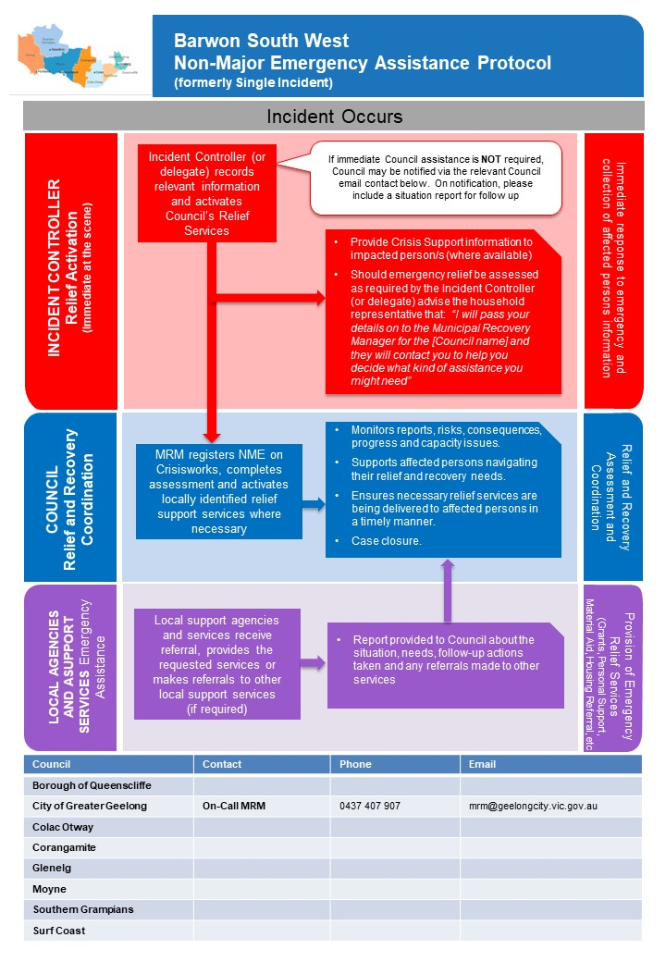

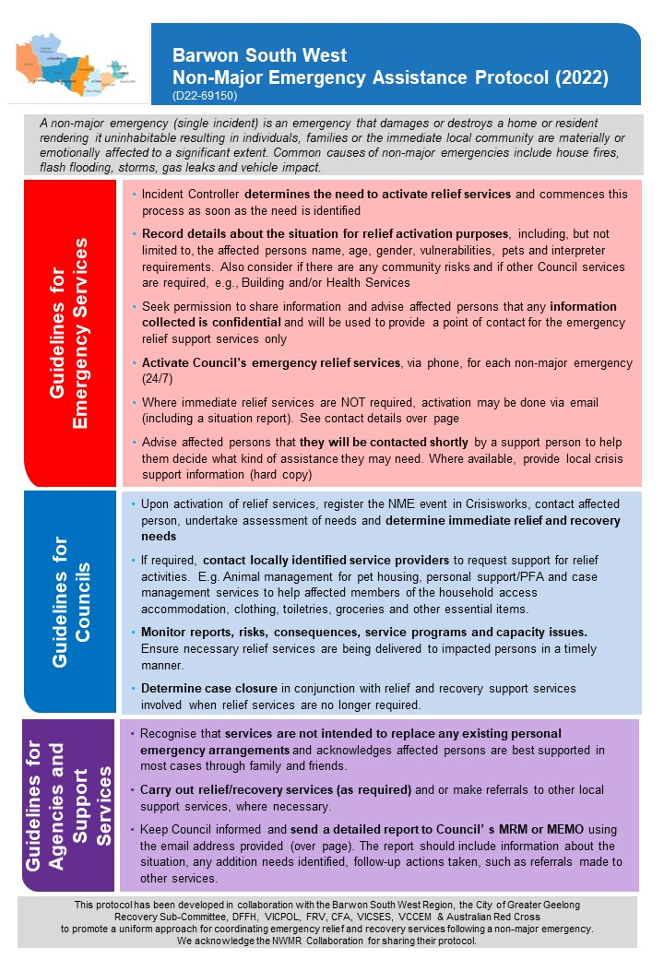

Appendix 5: Maps

Geographical

Electoral Structure
