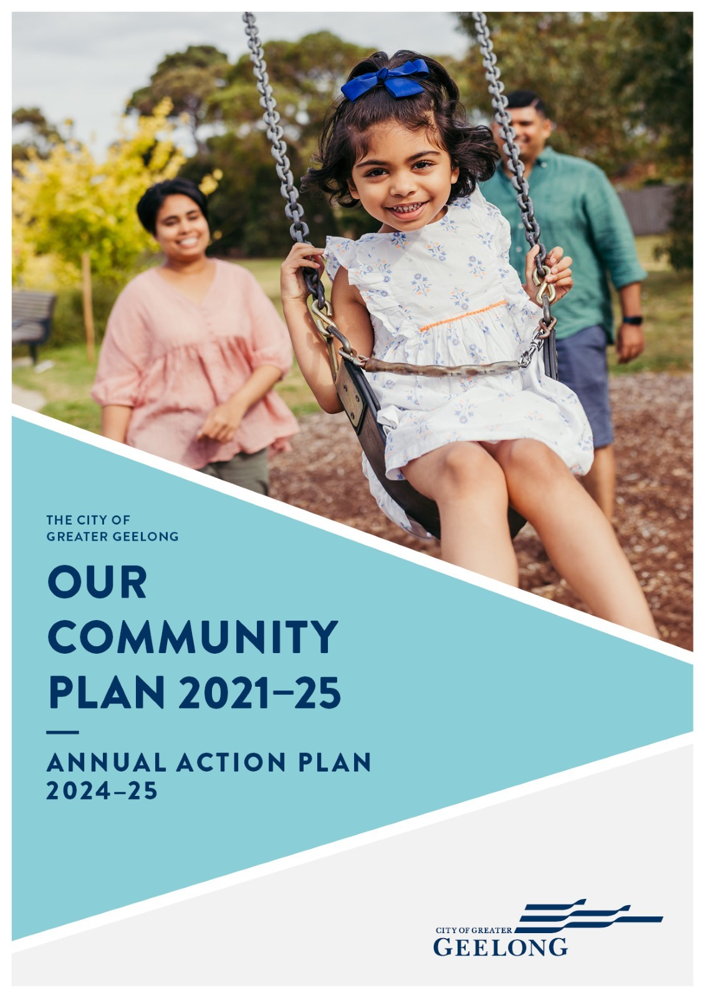

.
QUARTERLY REPORT
DECEMBER 2024
5lgcc

INTRODUCTION

Our Community Plan 2021‒25 outlines how we are working towards the 30-year community vision to make Greater Geelong a clever and creative city-region.
The plan informs the community of what Councillors are aiming to achieve during their four-year term, guides how we allocate resources so we can deliver infrastructure, services and programs to the community to ensure the social, economic and environmental sustainability of our region.
The four strategic directions we’ve chosen to guide us are:
- Healthy, caring and inclusive community
- Sustainable growth and environment
- Strong local economy
- High-performing Council and organisation.
As well as the strategic directions, the plan also outlines:
- Desired outcomes ‒ the future state we’re aiming for in four years and
- Four-year priorities ‒ the priorities we’ll focus on to help achieve our desired outcomes.
For the first time we have integrated the Council Plan and Municipal Public Health and Wellbeing plan – so that the health and wellbeing of our community is central to everything we do. We work with our health and wellbeing partners to identify local health needs and to develop collaborative responses to meet these needs.
The Plan identifies five health and wellbeing priorities which are:
- Tackling climate change and its impact on health
- Increasing healthy eating
- Increasing active living
- Demonstrating and promoting gender equity practices
- Improving mental wellbeing and social connection.

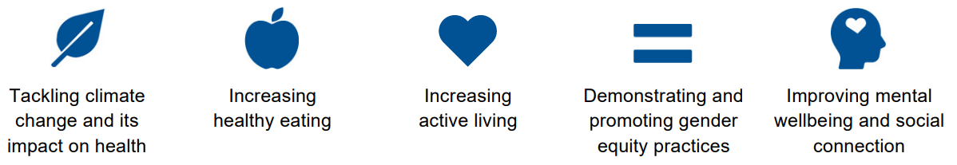

Our Community Plan 2021‒25 is supported by an annual action plan and budget which highlight the projects, initiatives and programs that will take place within the financial year to address our four-year priorities.
This quarterly report was developed to provide a transparent update of our performance in delivering the annual action plan.
Actions that support the health and wellbeing priorities have been identified with the relevant health and wellbeing icon.

STATUS UPDATE

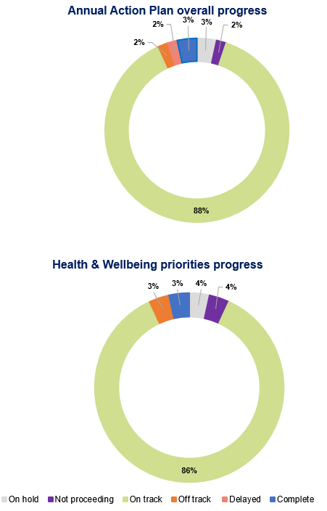
We committed to 58 actions in our Annual Action Plan this year.
At the end of December 2024:
- two actions are ‘complete’
- 51 (88%) actions are ‘on track’
- one action is ‘delayed’
- Deliver the Northern and Western Geelong Growth Areas Precinct Structure Planning (PSP) program
- one action is ‘off track’
- Develop a driving range at Lara Golf Club
- two actions are ‘on hold’
- Review the draft Early Years Infrastructure Plan in line with state government early childhood reforms
- Prepare the Innovate Reconciliation Action Plan (RAP) for endorsement by Reconciliation Australia
- one action is ‘not proceeding’
- Establish the Armstrong Creek Community Garden

STRATEGIC DIRECTION 1
HEALTHY, CARING AND INCLUSIVE COMMUNITY

Desired outcomes
- Our community feels welcome, safe and connected
- Our community has equitable access to health and social services, information and infrastructure
- Healthy behaviours and environments are promoted, supported and accessible

Four-year priorities
  - Help our community, recreation groups and volunteers to prosper and grow
  - Deliver health and community initiatives that are culturally sensitive and accessible across all life stages
  - Foster and embrace community connectedness
  - Demonstrate and promote gender equity practices
  - Foster an inclusive community culture
  - Facilitate social and affordable housing in Greater Geelong
  - Provide access to places, spaces and services where and when people need them the most
  - Strengthen relationships and partnerships with the Aboriginal and Torres Strait Islander communities in Greater Geelong
  - Support the City’s cultural and creative life, history and heritage
  - Provide facilities that foster and facilitate positive health and wellbeing outcomes
  - Respond to the findings of the Royal Commissions into aged care and mental health

Four-year priority | 2024−25 Action | Progress comment | Status
1.1.1 | Partner with Geelong Food Relief to utilise fresh produce from community gardens   | From July to September 2024, we delivered seven crates of excess vegetables from community gardens to Geelong Food Relief.  From October to December 2024, no excess vegetables were available as all plants were removed and the gardens renewed. | On track
1.2.1 | Review the draft Early Years Infrastructure Plan in line with state government early childhood reforms | Work is continuing with the state government to understand impacts of state government reforms to kinder delivery, and future demand for kinder to inform Council's early years planning. | On hold
1.2.2 | Implement the Healthy Choices Guidelines in selected Council owned and operated food retail outlets | Promoting healthy food and drink options at our kiosks and cafes is helping community members make more nutritious choices at our sport and recreation centres. GREEN foods and drinks (as defined by the Victorian Government’s Healthy Choices Guidelines) have increased from an average of 33 per cent to 41 per cent of our total offering. Average food environment scores have increased from 49/100 to 54/100, with the most significant improvements made at Barwon Valley Activity Centre and Lara swimming pool. Our employees are learning about the healthiness of the food and drink options in our kiosks and cafes. GREEN, AMBER and RED classifications have been integrated into our POS system and PowerBI reporting to give employees real-time insights into the products they sell. | On track
1.3.1 | Establish the Armstrong Creek Community Garden     | This project will not proceed as the proposed site was not supported by the community group involved. | Not proceeding
1.4.1 |   Implement the Fair Access Policy | Gender Impact Assessments (GIA+ assessments) to understand the gendered impacts of all current infrastructure and planning projects have been completed for all current infrastructure and planning projects. A partnership has been established with Leisure Networks to help deliver on the City’s Fair Access Policy action plan initiatives. | On track
1.4.2 | Develop the LGBTQIA+ Action Plan utilising the Rainbow Ready roadmap | Results of community engagement to inform the development of the new LGBTQIA+ Action Plan have been finalised and made available on the City’s Have Your Say website. A draft LGBTQIA+ Action Plan is currently being developed and will be presented to Council in 2025, for endorsement for public exhibition and a second phase of engagement. | On track
1.5.1 | Implement first year of the Disability Access and Inclusion Plan 2024−28* | The Disability Access and Inclusion Plan 2024−28 was publicly launched at the Geelong Awards for People with Disability on 3 December 2024. We will continue to engage with the community throughout the lifespan of the action plan to track our progress. Other actions to date include:  - the launch of a new 'Disability and Accessibility' website landing page and accessible events checklist  - delivery of the Sport4All program  - construction commenced for Rippleside Inclusive Playspace (see below). | On track
1.5.2 | Continue construction of the all-abilities playground at Rippleside Park* | Construction continued on the all-abilities playground and changing places toilet facility. The existing public toilets and playground were demolished and civil and drainage infrastructure installed.  Plumbing, electrical, structural steel and cladding was installed on the Rippleside Changing Places facility which will provide access to facilities for people with complex disabilities and their carers. | On track
1.6.1 | Negotiate with developers for social housing contributions within new housing developments | Agreement on the provision of social and affordable housing for Jetty Road Stage 2, Curlewis has been integrated into Amendment C387 to the Greater Geelong Planning Scheme and is awaiting ministerial endorsement. | On track
1.7.1 | Complete the redevelopment design for the Norlane Community Centre | Work on the redevelopment of the centre is continuing in partnership with the Norlane Neighbourhood House and stakeholders. Design development for the community garden and building components have commenced. | On track
1.7.2 | Construct and open the Central Geelong Youth Hub two-year pilot | The Year 1 Report was submitted to the Department of Families, Fairness and Housing on 13 December 2024. Terms of Reference for the Youth Hub Reference Group and Youth Hub Steering Committee have been drafted for review ahead of the first meetings (6 and 25 February respectively). Work on operational planning and programming and development of an evaluation plan is underway. To date, seven organisations have signed a Memorandum of Understanding (MoU) and discussions are ongoing with various community service providers. | On track
1.8.1 | Prepare the Innovate Reconciliation Action Plan (RAP) for endorsement by Reconciliation Australia | Preparation of the Innovate Reconciliation Action Plan (RAP) is currently on hold pending recruitment for the Manager First Nations Engagement and Outcomes position. This position will provide critical expertise and support the expression of interest for the First Nations partnership model for the RAP. | On hold
1.8.2 | Elevate First People’s living cultures, histories and knowledge through curations, exhibitions, and storytelling | Work continued with activities including:  - development of First Nations cloaks/quilts essay  - review of all the Museum-educator led workshops to identify opportunities to embed the priority of learning about Aboriginal and Torres Strait Islander histories and cultures.  - acquiring House of Gold, 2023 by artist Dr Christian Thompson AO, a Bidjara man of the Kunja Nation with Irish and Chinese heritage. The work was originally created at the National Wool Museum  - actively raising awareness of First Nations objects in the collection through print and digital communications, specifically, the seasonal What’s On and social media. This past quarter included Buniya Yaluk – Redgum Island, 2007, Glenn Romanis and Mark Trinham, Wadawurrung Country, Fyansford, Outdoor Collection featured on inside front cover of Museum What's On.  - partnering to produce an early years Acknowledgement of Country song with Auslan signs. Under the guidance of the Acting Best Start Facilitators from Mingo Waloom of Wathaurong Aboriginal Cooperative, it will be rolled out for testing and feedback in early 2025 before being finalised in consultation with Wadawurrung Traditional Owners Aboriginal Corporation. | On track
1.9.1 | Develop a Heritage Strategy | Development of a new Heritage Strategy, to replace the City’s former Heritage Strategy 2017−21 commenced. Community consultation on the strategy is complete with an engagement report due by the end of January 2025. The input of Council will be sought early in 2025 prior to the draft strategy being released for public comment around April 2025. | On track
1.9.2 | Develop a Public Art Strategy | The City’s Public Art Strategy is being refreshed and updated to reset strategic priorities and align with current plans. The strategy will guide sustainable development, identify gaps for future investment in services through established programs and strengthen partnerships and governance. Engagement with internal stakeholders is complete, with external engagement to commence late February/March 2025. | On track
1.10.1 | Deliver the Drysdale Sub-Regional Sporting Precinct Master Plan* | The Cultural Heritage Management Plan has been lodged with Wadawurrung Traditional Owners Aboriginal Corporation, following consultation with Traditional Owners. | On track
1.10.2 | Develop a driving range at Lara Golf Club* | Consultation with stakeholders was extended to ensure the best outcome for the club and value to the community which has resulted in minor delays in completion of detailed design. | Off track
1.10.3 | Plan for the provision of new playing fields in Armstrong Creek as part of the Bloinks Reserve Master Plan | Background work on the master plan is underway with consultants commencing work on an issues and opportunities report for the reserve due for completion in Q3. Armstrong Creek provision analysis report is underway. The provision analysis is a report that will tell us how much and what type of sports infrastructure we require based on population and sports participation data. This supporting document will assist in the development of the draft master plan. Once complete, the master plan will guide the future development of sport and recreation spaces and facilities for the reserve. | On track
1.10.4 | Deliver the upgrade works at Thomson Recreation Reserve* | Detailed design is currently underway for the reserve. The outcome of a grant application to Sport and Recreation Victoria’s Country Football and Netball Program is still pending. | On track
1.10.5 | Construct the Ocean Grove District Ride Centre* | Detailed design has been completed and a tender process for the construction of the Ride Centre will commence in 2025. The Ride Centre will entail both an asphalt pump track and dirt jump tracks with lines of various difficulties, catering for varied levels of rider skill. There will be a shared spectating area, a central shade shelter and various landscaping elements. | On track
LINKS TO THE CLEVER CREATIVE VISION
 |  | 

STRATEGIC DIRECTION 2
SUSTAINABLE GROWTH AND ENVIRONMENT

Desired outcomes
- We are delivering our vision for sustainable growth across the municipality
- We have a choice of housing and lifestyles to meet the diverse needs of our community
- There are connected transport networks throughout the region that support liveability and prosperity
- Greater Geelong has quality, vibrant public spaces
- We are leading a reduction in community emissions and are increasing the City’s resilience to climate change impacts
- We protect and restore our natural environment
- We minimise waste with good design and manage effective recovery of resources

Four-year priorities
  - Meet the housing needs of our future community
  - Meet existing and future transport needs
  - Create engaging places and spaces
  - Deliver best practice Environmentally Sustainable Design principles and vibrant neighbourhoods
  - Achieve carbon neutral in all City-managed operations by 2025 and manage our climate change risks
  - Support our community and region to reduce emissions and build resilience to climate change
  - Reduce the impact of waste
  - Support greater indigenous biodiversity

Four-year priority | 2024−25 Action | Progress comment | Status
2.1.1 | Deliver the Northern and Western Geelong Growth Areas Precinct Structure Planning (PSP) program | The Creamery Road Precinct Structure Plan (PSP) and Development Contribution Plan was adopted by Council at the August 2024 Council meeting. Authorisation for the exhibition of draft planning scheme amendment C450ggee by the Minister for Planning’s is currently pending. Negotiations are ongoing for new PSPs - Batesford North and Elcho Road West (with Heales Road West). | Delayed
2.2.1 |   Develop a background report to inform development of the Integrated Transport Strategy | A summary report for Phase one engagement is complete and available on the City’s Have Your Say page. Phase two of community engagement will commence in early 2025. A draft background report to inform the development of the Integrated Transport Strategy is complete. | On track
2.2.2 | Partner with the Surf Coast Shire to explore options for a future safe cycling route between Geelong and Torquay | Project scoping and procurement is complete and a consultant appointed to work on the options. The City is working in partnership with the Surf Coast Shire on a community engagement plan and survey. The Have Your Say page and survey launched in December 2024. | On track
2.3.1 | Deliver the City's tree planting program | Since July 2024, a total of 1,239 trees have been planted. Planting is scheduled to recommence in the next growing period beginning April 2025. | On track
2.3.2 | Work with state government to improve public spaces and places around the new Geelong Convention and Exhibition Centre, Nyaal Banyul * | On 3 December, Geelong councillors toured the Nyaal Banyul Convention and Exhibition Centre site with Regional Development Victoria and Development Victoria representatives. They also received a briefing on the related Mercer, Gheringhap, and Bayley Streetscape master plan, including a presentation on the proposed Stage 1 of the master plan, the Gheringhap Plaza, located adjacent to Nyaal Banyul - for which the City is seeking budget for the delivery of the plaza. The master plan will be presented to Council for final adoption. | On track
2.3.3 | Support businesses/traders in the activation of outdoor areas | A trial for extended outdoor dining in Little Malop Street commenced on 6 December 2024 and will end on 11 March 2025, with an option to extend to Easter 2025. The trial aims to create a more vibrant and welcoming space, encouraging greater use of our public areas while assessing the potential for long-term implementation. The results of the trial will be used to finalise the City’s Outdoor Dining Guidelines. | On track
2.3.4 | Commence development of an Open Space Strategy | Consultation with internal stakeholders has commenced. Procurement is underway to select a consultant who will prepare the Open Space Strategy. | On track
2.5.1 | Continue the upgrade of street lighting with LED lights & smart control technology including the Central Management System* | Lighting conversion is complete and development of the Central Management System to manage the new lighting network is ongoing. The new LED lights include a smart control device which will be connected to a new wireless network. This will enable remote control adjustment of the lighting output and create a platform for additional Smart City infrastructure to be added. | On track
2.6.1 | Support the delivery of community climate change partnership programs | The City's Climate Change Partnership grant program provides an equitable way to support a range of not for profit community groups and financial support to leading sustainability groups. Climate Change Partnership Grants have had 6 successful projects out of 10 grant applications received while the Environment and Sustainability Grants have had 11 successful out of 13 applications received. | On track
2.7.1 | Commence waste facilities upgrades for future delivery of a Food Organics Garden Organics (FOGO) service | The application process for EPA approval to upgrade the City’s waste facilities continued. Required testing and community engagement for the EPA application was completed in December 2024. The final application to the EPA will be submitted in January 2025 due to a delay finalising the required testing. | On track
2.8.1 | Continue implementing the Sparrovale Wetlands Reserve – Ngubitj yooree Master Plan | The native vegetation offset site annual monitoring reports have been completed and submitted to the Department of Energy, Environment and Climate Action (DEECA) on time. These reports are part of an agreement with DEECA and the City where the City agreed to manage the offset sites in accordance with the Site Management Plan which allows DEECA to monitor progress. As part of this process the City must prepare an annual offset progress monitoring report for DEECA until 2029. | On track

LINKS TO THE CLEVER CREATIVE VISION
 |  | 
 | 

STRATEGIC DIRECTION 3
STRONG LOCAL ECONOMY

Desired outcomes
- We have a global, national and local reputation as a place to do business – especially in our key sectors
- We have a diversified, future-focused and sustainable economy to drive employment and support growth
- We are an influential Council that builds effective private and public partnerships, taking the lead role in advocating for future investment

Four-year priorities
  - Attract and facilitate public and private investment
  - Promote and leverage the competitive strengths and attractiveness of our region, globally, nationally and locally
  - Support entrepreneurs, start-ups, innovation, research and digital connectivity
  - Attract businesses with a carbon neutral and circular economy focus
  - Support local business resilience and recovery from the impacts of the COVID-19 pandemic
  - Attract, retain and enable participation in the workforce to meet industry needs
  - Address high levels of unemployment in targeted areas of our region
  - Promote our region as a trial location for innovation and new technologies
Four-year priority | 2024−25 Action | Progress comment | Status
3.1.1 | Progress delivery of the Market Square Quarter Master Plan and continue to advocate for improved public realm outcomes in the central city | The Market Square Quarter Master plan is being finalised. Implementation plan is being prepared, with external stakeholder consultation commencing. Conversation with key stakeholders is progressing with feedback contributing to finalise the implementation plan. The master plan is scheduled to go to Council for adoption in April 2025, this will include the implementation plan. | On track
3.1.2 | Manage delivery of Commonwealth Games legacy assets | Development Victoria will lead the delivery of three projects in Geelong:  - the re-development of Stead Park, Corio – the schematic design is complete with detailed design commencing in early in 2025  - new indoor sporting facilities at Armstrong Creek – the procurement for a head contractor is underway and will be finalised by February 2025. The successful contractor will commence in July 2025  - and a new indoor sporting complex at Waurn Ponds – an advance tender notice for the head contractor was released in November 2024 with procurement likely to commence in February 2025. The co-design process with Wadawurrung Traditional Owners Aboriginal Corporation has recommenced, with the outcome of the Cultural Heritage Management Plan for the site pending. | On track
3.1.3 | Support actions and advocacy for the Sustainable Destination Master Plan | The City met with more than 20 applicants to discuss how their plans aligned with the Tourism Greater Geelong and The Bellarine’s Sustainable Tourism Destination 10 Year Master Plan with letters of support provided to 18 applicants for funding through state government infrastructure programs.  The Regional Tourism Investment Fund is yet to be announced while the Enabling Tourism Fund has had two successful applications from the Greater Geelong region. | On track
3.1.4 | Establish a strategic alliance with the City of Wyndham | The draft Memorandum of Understanding (MoU) with the City of Wyndham will be considered by the new Geelong council with the aim to adopt the MoU in early 2025. | On track
3.2.1 | Support the Wadawurrung Traditional Owners to produce a cultural tourism plan | The feedback process to inform development of the Cultural Tourism Plan is underway with the plan and feasibility study close to completion. The tourism conference program for February 2025 includes a dedicated Wadawurrung Traditional Owners Aboriginal Corporation (WTOAC) session. The City is working with WTOAC to embed language in visitor publications. | On track
3.2.2 | Deliver the Tastes of Greater Geelong program | Preparation for the 2025 Tastes of Greater Geelong event has commenced. The 2024 Tastes of Greater Geelong evaluation report has been finalised and will be made available when dates for the 2025 program are announced in early 2025. | On track
3.2.3 | Deliver a program of innovative and inclusive workshops, events and initiatives for local businesses | Following a review of the 2024 Geelong Small Business Festival, the City in partnership with the Geelong Chamber of Commerce plan to commence discussions on the 2025 event from February 2025. Our efforts to support local businesses saw us engage with over 4,600 small businesses through events, mentoring, training, and workshops. This year, the City continued to foster partnerships with key industry partners, helping start-up businesses through the Runway Incubator program and supporting 10 women in the Business in Heels Accelerator program. The City’s Business Concierge service also assisted over 450 businesses, providing valuable advice on regulatory requirements, as well as information for those looking to set up or expand their operations. | On track
3.2.4 | Host visits from domestic and international delegations | In celebration of the 30th anniversary with Geelong’s sister city, Lianyungang, China, the City hosted a delegation of 10 key representatives from Lianyungang, including the Mayor, Deputy Mayor, and the Chief Executive Officer of their Chamber of Commerce on 13 December 2024. A formal book exchange between the cities was arranged, with books from the Geelong collection now making their way into a library in Lianyungang.  The City, in partnership with the Advanced Fibre Cluster, will also welcome the Consul-General of Japan on 7 January 2025 to continue discussions about hosting an event in March 2025 to celebrate and further strengthen Geelong’s connections with Japan. This event will be held at the National Wool Museum, following the success of a similar event hosted at the Geelong Gallery in July 2024.  Additionally, the City has secured a partnership with Korean elite baseball team KT Wiz. The team comprising over 80 players, coaches, and officials, will conduct their training camp in Geelong for six weeks starting on 15 January 2025. | On track
3.2.5 | Support Tourism Greater Geelong and The Bellarine to deliver destination marketing programs and improve in-region visitor experiences | Actions to date include:  - wrapping up a winter Visiting Friends and Family Campaign in September 2024  - hosting media familiarisation tours across the region  - attending trade shows targeting the business events sector  - updating the visitor website in December 2024 to provide a better user experience and provide more content about local experiences  - providing new visitor publications - travel planner and touring map, printed and distributed in December 2024. | On track
3.2.6 | Renew the John Landy Field athletics track to World Athletics Class 2 accreditation | The $1.5 million renewal project of the John Landy Field athletics track is complete. The City funded project will ensure the track retains its World Athletics Class 2 accreditation. Along with replacing the ageing track with a brand-new surface in blue and grey, the hammer and discus cages were relocated to allow for more competition events to be carried out at the same time in accordance with World Athletics standards. The upgrade saw 57 tonnes of recycled rubber sourced from used truck tyres installed underneath the track surface. | Complete
3.3.1 | Provide grant programs and share knowledge with local businesses and industry | Two successful applicants have been awarded funding through the City’s Clean Economy Grants program 2024−25.  Boomaroo Nurseries & Wholesale Supplies Pty Ltd received $25,000 for an AI-driven system to optimise boiler operations at the nursery, reducing energy consumption and fuel costs by managing temperature based on real-time data and environmental conditions.  Deakin University received $23,400 for a pilot-scale prototype that will be developed to reduce energy consumption of heating/cooling devices in Geelong households by maximising self-consumption of solar energy to precool/preheat households. | On track
3.8.1 | Enhance the Geelong Digital Twin to visualise and analyse urban development projects across the built and natural environments | The Geelong Digital Twin, an innovative virtual 3D representation of the city, is advancing with updated building data, reflecting new constructions, demolitions, and private land tree canopy coverage. These improvements set the stage for its formal launch in early 2025, offering enhanced insights and documentation for improved urban planning and infrastructure management. | On track
3.8.2 | Deliver AI-driven solutions for traffic optimisation and flow in priority locations | Progress on delivering Artificial intelligence (AI) driven traffic optimisation includes establishing procedures for using Pan, Tilt, and Zoom cameras in analytics, addressing data gaps caused by camera movements, and completing setup in the Market Square Precinct. Work on managing large data volumes is delaying the release of the Geelong Data Exchange Insights dashboard. | On track
LINKS TO THE CLEVER CREATIVE VISION
 | 


STRATEGIC DIRECTION 4
HIGH-PERFORMING COUNCIL AND ORGANISATION

Desired outcomes
- Our services are accessible and meet the diverse needs of our community
- We are acknowledged and recognised as a leading council and organisation
- We have a healthy, safe, inclusive and diverse culture
- We are a financially sustainable and resilient organisation

Four-year priorities
  - Enable a customer-focused approach that delivers efficient and responsive service
  - Communicate and engage effectively with our community to understand their needs and advocate on their behalf
  - Foster excellence and equity in planning for our growing region
  - Continue to strengthen our workforce capabilities and culture
  - Create a more efficient and effective organisation
  - Develop a digital core of brilliant basic technology that supports better ways of working
  - Ensure that our employees are safe at work
  - Focus on economic, social and environmental sustainability

Four-year priority | 2024−25 Action | Progress comment | Status
4.1.1 | Develop a Customer Experience Strategy* | The draft Customer Experience Strategy is complete. The next step will be to develop action plans that support Customer Experience principles. An updated strategy and draft plan will be reviewed internally in early February 2025. | On track
4.1.2 | Develop a business case for the implementation of our future customer relationship management platform | The tender process for the development of business cases for Phase One of the IT strategy has been completed. This significant milestone marks the commencement of detailed design and planning scheduled to kick off early in the new year. Core focus areas include Customer Relationship Management (CRM), Asset and Field work management, and platform integration. | On track
4.1.3 | Complete reviews of selected City services* | The Service Review Framework and Prioritisation Tool are complete. The Framework ensures consistent governance for evidence-based decision making, while the Prioritisation Tool helps create a Service Review Roadmap that focuses on critical services and optimises review frequency based on priority and resources. | On track
4.2.1 | Review the Public Question Time response process | The City’s refreshed Public Question and Submission Time Policy is on track to be adopted by Council in early 2025, after a period of community consultation. | On track
4.3.1 | Develop the Asset Plan 2022−32 (2025−35) that will increase the City's ability to effectively manage its extensive asset portfolio review | Development of asset management principles and objectives for the Asset Plan is underway. The Asset Plan is being developed in conjunction the City’s new Council Plan 2025−2029. | On track
4.4.1 | Refresh the City's organisational values | A refresh of the City’s organisational values, the guiding principles for how the organisation works together to achieve outcomes for our customers and our community, is currently underway. Consultation with employees has commenced and a forum held with leaders to build broader leadership engagement and commitment. Feedback from these discussions will inform future consultations. | On track
4.4.2 | Induct new Councillor Group with a comprehensive training program | Following development of a detailed induction plan and engagement of key training providers, training began on 19 November 2024, all mandatory training will be completed within four months. | On track
4.5.1 | Review our operational decision-making guide | The category review of operational decisions is complete and is being distilled into the framework that will inform the drafting of the guide. We have been slightly delayed in completing the draft guide but will focus on its completion in the first quarter of 2025. | On track
4.5.2 | Implementation of new governance structure and framework for informal meetings of Council. | Appointments of Chair and Deputy Chair for councillor portfolios and councillor representatives on Advisory Committees were finalised at the Council meeting in December 2024. | Complete
4.5.3 | Continue to review and update the structure of the organisation* | Review of and updates to the structure of the organisation to drive effectiveness and efficiency, and better align with community needs are ongoing. | On track
4.6.1 | Deliver priority technology capabilities and investments aligned to our organisational and technology strategies | Implementation of the workforce (HR) dashboards for Senior Leadership Team members is complete. Several drop-in sessions have been hosted, with feedback to date being resoundingly positive. Efforts in this space are now being shifted towards validating finance data use cases, a collective reference for the three finance data initiatives.  Enterprise Bookings discovery and evaluation has been completed and a detailed project brief has been prepared. Following approval of the business case, the next phase of the project, scheduled to commence in late January 2025, will aim to refine costs through detailed planning and design. Upgrades to Empower UX are scheduled to be complete in February 2025. | On track
4.6.2 | Implement an integrated performance and reporting software solution | Implementation training for a pilot group was successfully completed in December. The rest of the organisation will undergo training over the first two months of 2025. | On track
4.6.3 | Develop the City's Cyber Security Strategy and three-year roadmap | The City’s Cyber Strategy remains on track for internal endorsement by 30 June 2025. Feedback workshops will be arranged in 2025 to ensure alignment of tactical and strategic cyber security initiatives. The Managed Detection and Response (MDR) business case has been approved with initial work underway to build the underlying infrastructure. Currently tracking ahead of schedule, this flagship cyber security initiative will be delivered by 31st March 2025. The protection of cardholder payment data is paramount to the overall cyber security program. To help ensure the City achieves compliance with pertinent standards (PCI DSS), a cardholder data environment (CDE) discovery and scope validation activity has been scheduled, along with documentation and process reviews which will both feed into a gap analysis and remediation plans. | On track
4.7.1 | Implement a psychological health and wellbeing framework | The ongoing development of the City's Psychological Safety Framework has included a review of the Victorian Government’s Guide to Developing a Mentally Healthy Workplace Strategy and Action Plan. This is the document that the City’s Psychological Safety Framework is based on.  The framework will also include reference to the respective legislative obligations regarding sexual harassment, bullying and harassment, Respect@Work, The Positive Duty, and psychosocial risks in the workplace. | On track

APPENDIX

Ongoing actions from 2023−24 action plan
2023−24 Action | Progress comment | Status
1.2.1 Develop a policy to make the region’s food system more accessible and resilient | Work continued with Foodprint Melbourne, other local government and community partners to co-design policy development tools that will help us strengthen the resilience of our local food system. A discussion paper was prepared to help community members better understand the opportunities and challenges facing our local food system. Engagement to enable community members to share their vision and aspirations for the future of our food system and have their say on how the City’s current Food Policy can be improved has been delayed until 2025. Delays in progressing this work are related to the need to align this work with enterprise-wide priorities such as the development of the social procurement and catering policies. | Off track
1.7.4 Review our approach to the provision, development and subsidy of Council owned and/or managed community outdoor recreation reserves (Fair Play Strategy) | Following approval of a project management resource, work will now commence in early 2025. It is anticipated that the project will be complete in late 2025. | Delayed
1.9.5 Advocate for funding for the implementation of Bellarine Arts Centre-Potato Shed business case | A report on the Bellarine Arts Centre-Potato Shed business case has been deferred until early 2025 to allow for induction of the new councillor group and the appointment of a project management resource. | Delayed
1.11.1 Consider a phased response to the aged care reforms, to ascertain future participation of Council in Community Care services (Aged care reform) | The Aged Care Bill has entered Parliament and been referred to a Senate Committee. The federal government intends to introduce Support at Home for the Home Care Package program from 1 July 2025, with changes in the terms and conditions, payment mechanisms and amounts. The City will brief the new council early in 2025 in preparation to consider the response they will make. | Ongoing
2.1.2 Prepare the Strategic Assessment under the Environment Protection and Biodiversity Conservation Act and biodiversity conservation strategy for the Northern and Western Growth Areas* | Agency and developer engagement for Structured Decision Making (SDM) process has been finalised and feedback considered. A draft SDM Report has been prepared which provides for increased conservation reserves in the proposed development layout to better protect and enhance threatened species. The SDM report will inform the update to the Strategic Assessment documentation to be considered by the federal government for approval. | Ongoing
2.2.1 Finalise the transport infrastructure and services strategy for growth areas | The supporting summary document for transport infrastructure and services in growth areas has been completed and will help guide direction in the work with Precinct Structure Planning in the future. | Complete
2.3.1 Promote access to sport and physical activity for women and girls through the development of the Ocean Grove Sporting Infrastructure Plan | The final report was issued to stakeholders for approval and support. It will then be considered by council in early 2025. | Ongoing
2.7.1 Update the Waste and Resource Recovery Strategy 2020−2030 to include new focus areas such as food & garden organics recycling and roll out of the municipal container deposit scheme | The review of the current strategy and action plan update is progressing. Results of engagement with internal stakeholders (which has been conducted) will be used to inform the development of updated actions. | Ongoing
3.2.2 Finalise the procurement activities related to redevelopment of the Osborne House site and complete the draft proposal of future activities for council endorsement* | The Expressions of Interest is still under review and advice from internal stakeholders will be considered on the determination to progress the next stage and a possible full ‘Go to Market’ process. This will also be in line with considerations from the newly appointed Councillors. | Ongoing
3.3.2 Partner with AARNet to provide community facilities and public spaces with access to ultra-high-speed internet as part of the Fibre in the North project (Fibre in the North) | Progress on the Fibre in the North project with AARNet includes construction underway on the Rail Trail, with completion into Drysdale still expected by early January 2025. Sections spanning Grubb Road to Queenscliff, are also progressing, with completion targeted for February 2025, while the section spanning Portarlington Road to High Street is on track. These efforts will deliver ultra-high-speed internet to key community spaces. | Ongoing
4.6.2 Commence the detailed design of a digital innovation program across the organisation* | The tender process for the development of business cases for Phase One of the IT strategy has been completed. This significant milestone marks the commencement of detailed design and planning scheduled to kick off early in 2025. Core focus areas include business case Customer Relationship Management (CRM), Asset and Field work management, and platform integration. | Ongoing



