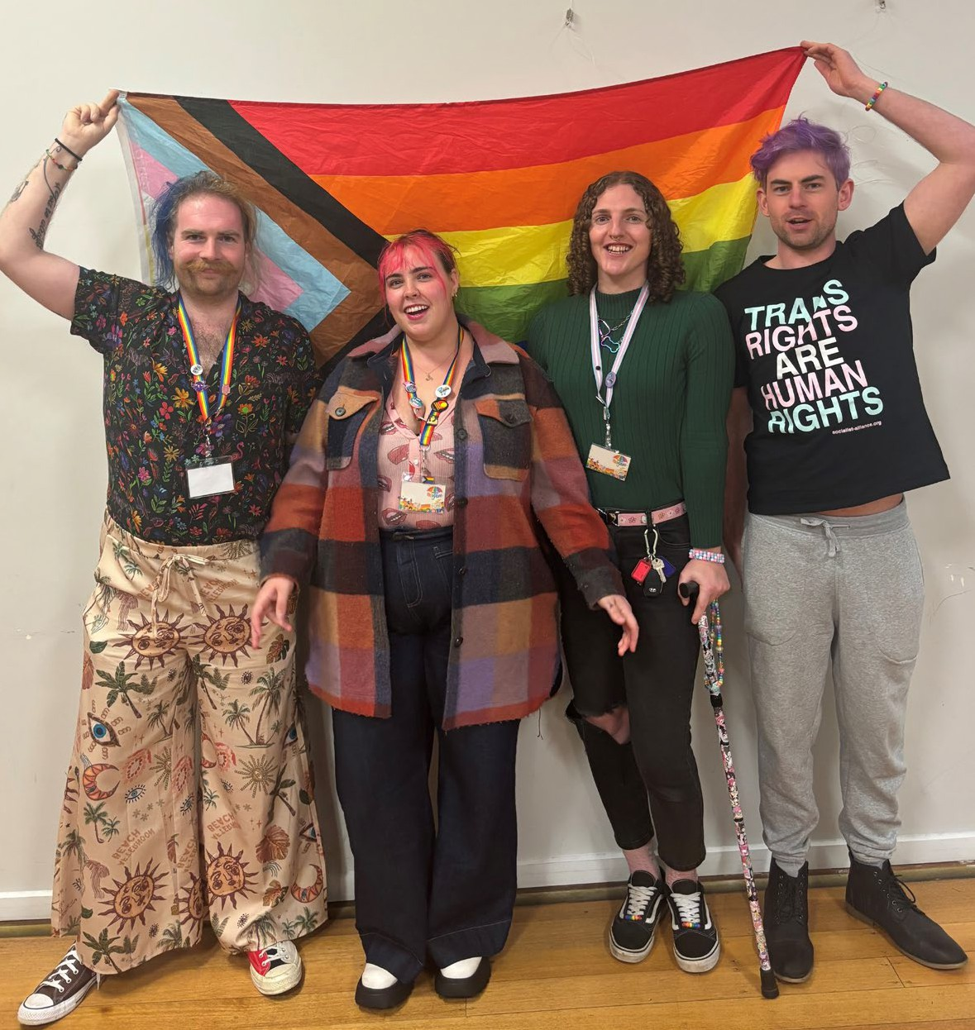


THE CITY OF
GREATER GEELONG

RAINBOW

ACTION PLAN 2025–29
A MORE INCLUSIVE COMMUNITY FOR EVERYONE

We Acknowledge the Wadawurrung People as the Traditional Owners of the Land, Waterways and Skies. We pay our respects to their Elders, past, present and emerging. We Acknowledge all Aboriginal and Torres Strait Islander people who are part of our Greater Geelong community today.

CONTENTS
Message from the Mayor 4
Message from the CEO 5
Introduction 6
Why a Rainbow Action Plan is important 7
How LGBTQIA+ inclusion makes us stronger 8
LGBTQIA+ snapshot 9
Key definitions 10
What guides us 12
What we heard 14
Findings 15
Action Plan 2025-29 16
Continiung commitments 16
Principle 1: Understanding 18
Principle 2: Inclusion 19
Principle 3: Visibility 20
Principle 4: Safety 21
Measuring and reporting 22
References 23

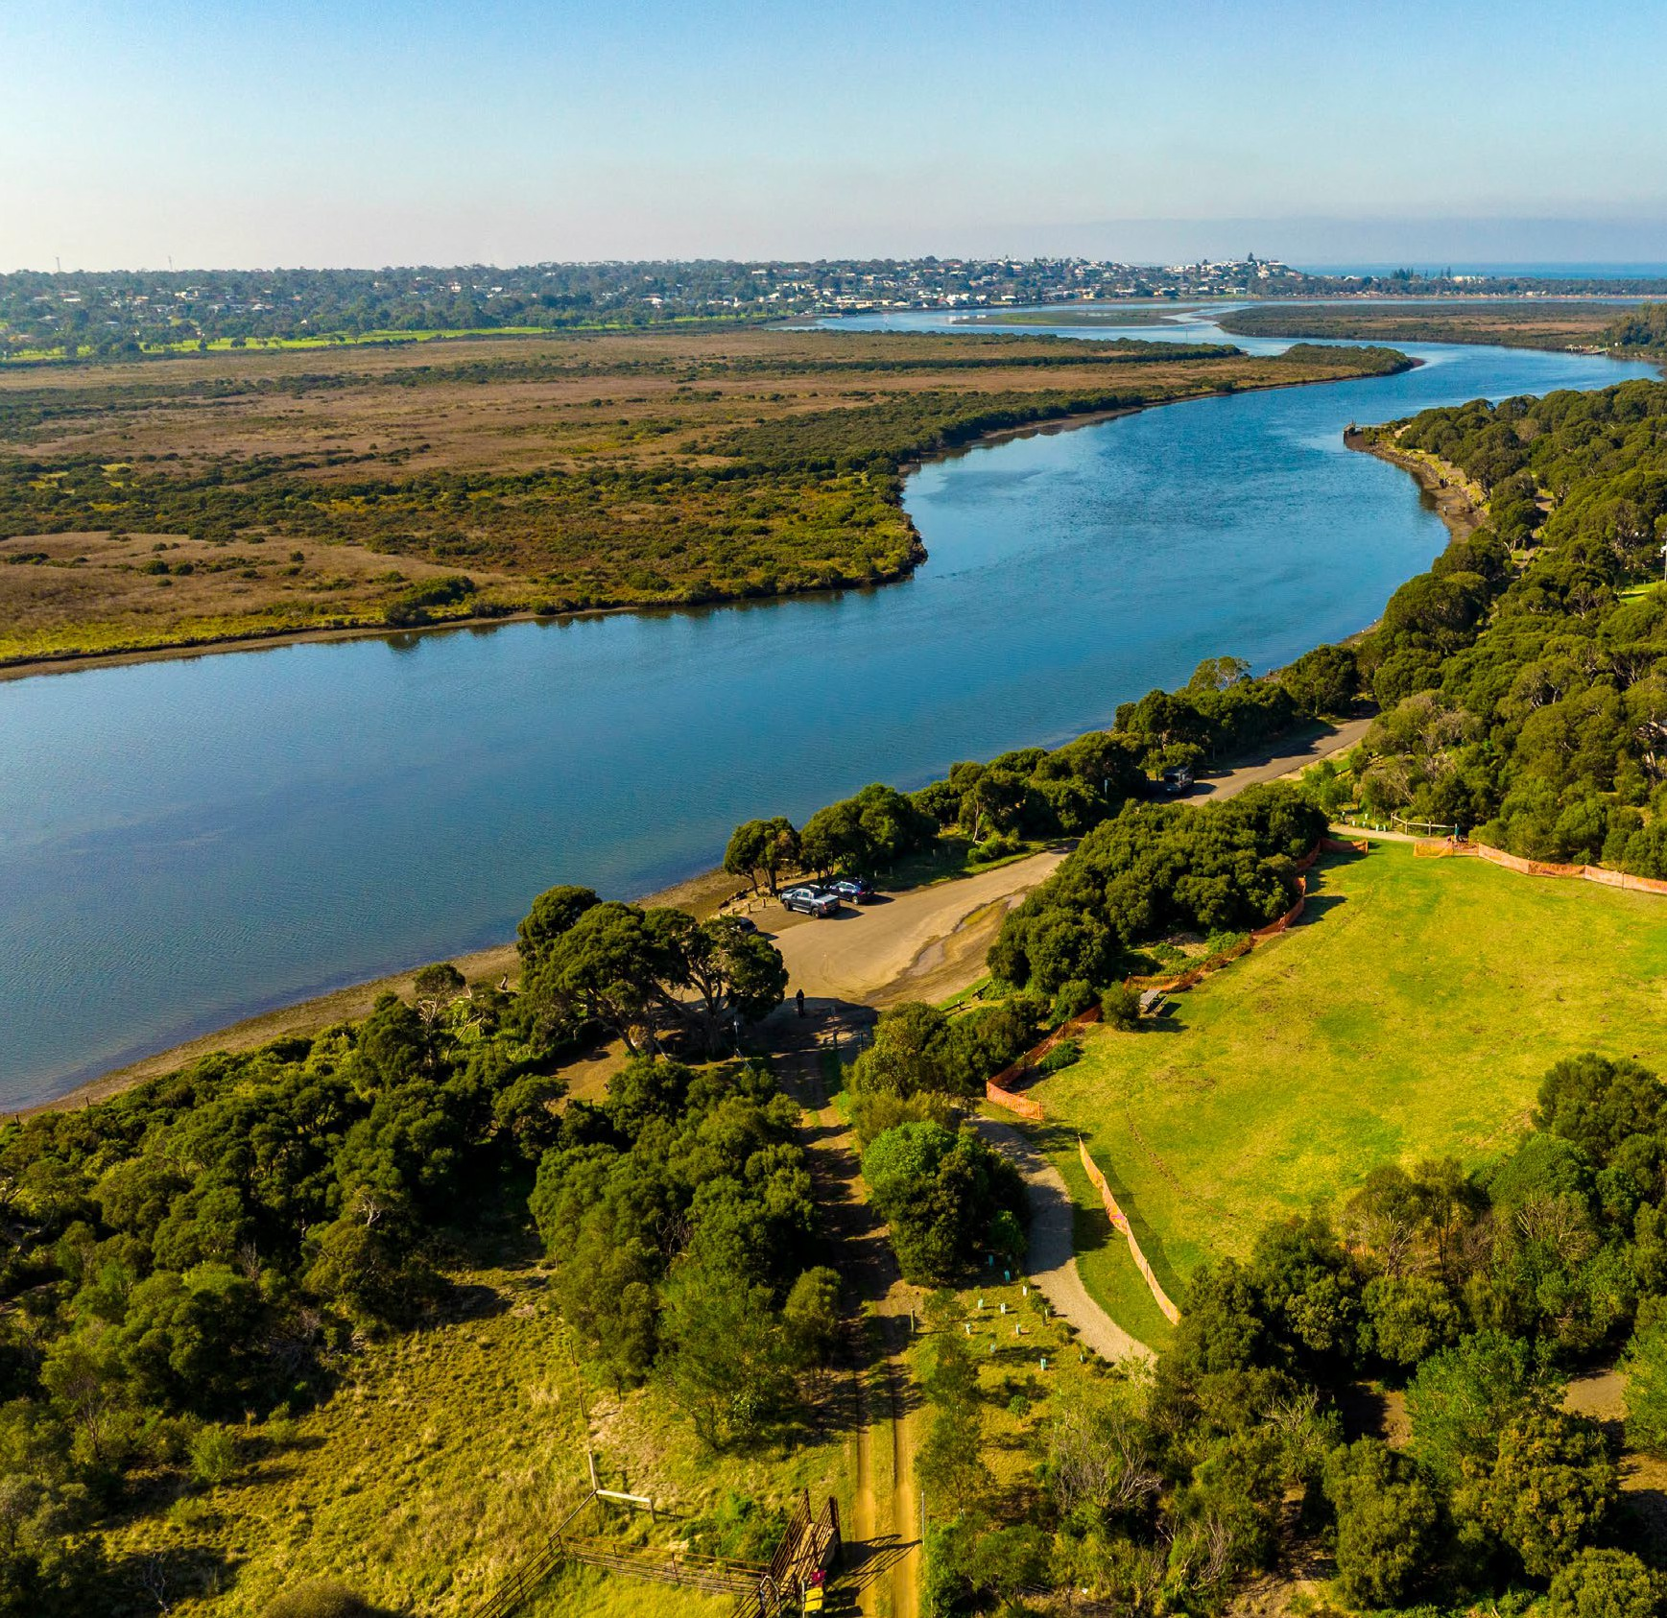

Cover: Geelong Rainbow committee members Mag Gratwick, Mariah Courtis, Audrey Stringer, Dean Cardigan.
Photo: Barwon River, Moonah Park Barwon Heads

2. 3.

MESSAGE FROM THE MAYOR MESSAGE FROM THE CEO

The City of Greater Geelong is proud to present our inaugural Rainbow Action Plan 2025-29.
As a City, we are committed to fostering an inclusive community for all.
We strive to ensure all residents feel safe, respected and valued, while acknowledging the vital contributions of our LGBTQIA+ community make to the cultural and social fabric of our city.
Thank you to all who contributed through the consultation process at our workshops and through the Have Your Say survey. Your experiences and aspirations for the future of Greater Geelong are greatly appreciated and have been critical for building this action plan.
We encourage all Geelong residents to engage with this action plan and play your part in fostering an inclusive, diverse community.
I am excited for the implementation of our Rainbow Action Plan and look forward to seeing meaningful inclusion take place for our LGBTQIA+ community, families and allies.

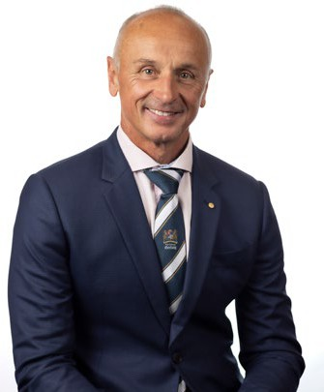


Cr Dr Stretch Kontelj OAM
Mayor
City of Greater Geelong
Our aspiration for an inclusive, diverse, healthy, and connected community workforce is reflected in the City’s commitment to great people.
As demonstrated in our Organisational Strategy 2024-29, we are committed to creating an inclusive organisation that supports and encourages its employees to do their best work, have equal access to opportunities and a fair working environment.
The Rainbow Action Plan 2025-29 sets our organisational goals to ensure our LGBTQIA+ employees feel safe, valued, and supported.
I encourage all employees, leaders and the wider community to engage with the plan and participate in the initiatives and opportunities it outlines.
Our Rainbow Action Plan aligns with our Inclusion Principles of diversity, voice, access and participation.
The plan supports our vision as an employer, for the City to be a place where our diverse workforce can thrive, feel like they belong and work effectively together. Our employees reflect and harness the power of our diverse community.
Thank you to our employees for their commitment and effort into developing our inaugural Rainbow Action Plan. I am excited to see this plan progress and meaningful change take place.

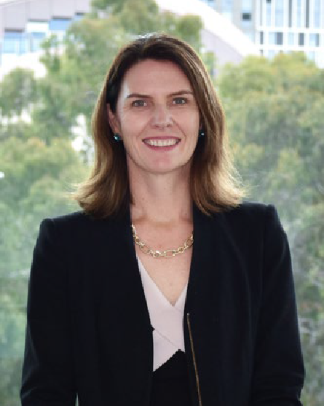
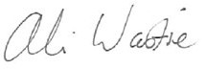

Ali Wastie
CEO
City of Greater Geelong

4. 5.

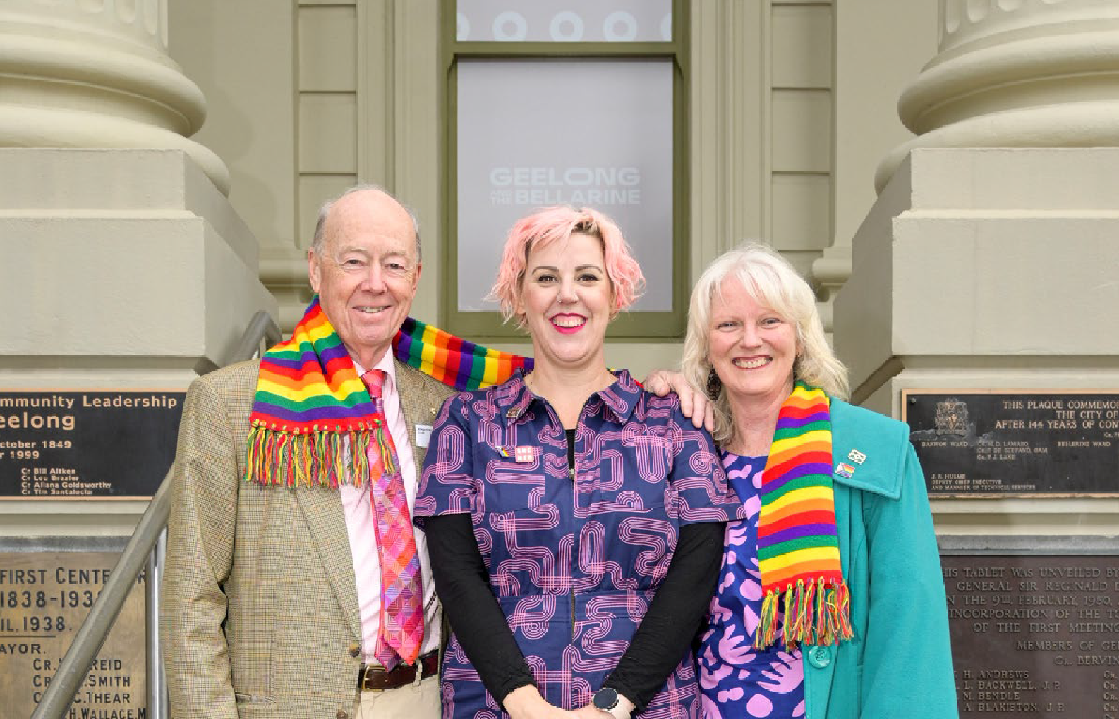
INTRODUCTION

WHY A RAINBOW ACTION PLAN IS IMPORTANT

BACKGROUND
RAINBOW ACTION PLAN
Our Rainbow Action Plan 2025–29 sets out the steps we will take to create a more inclusive and supportive environment for our LGBTQIA+ community and people.
LGBTQIA+ COMMUNITY INCLUSION STATEMENT
The City of Greater Geelong is committed to fostering inclusion for all. We recognise and celebrate the diversity of gender identities, sexual orientations, and lived experiences. We value the rich contributions this diversity brings to our region and our workplace.
Contribution from our community has been critical to the development of this plan, with community members providing input through workshops and a
survey. This input has formed the basis of the outlined actions.
Over the next four years, we will continue to engage with community as the plan is delivered.
Delivering on our Rainbow Action Plan contributes to the delivery of our community’s 30-year vision, Greater Geelong: A Clever and Creative Future and our Council Plan 2025–29.
Achievements will be joint, as we work with the whole

Photo: Councillor Rowan Story AM, RFD, Councillor Emma Sinclair and Councillor Elise Wilkinson.

The City of Greater Geelong has been recognised as a leader in LGBTQIA+ inclusion for many years, primarily due to work in the youth space, including the Gender and Sexuality Project (GASP) that began in 1996. In recent years, this work has progressed beyond the youth sector. Significant achievements include:
- Establishment of the LGBTQIA+ Advisory Committee in February 2023.
- Completion of the Rainbow Crossing in December 2023.
- Leadership of Geelong’s annual high-profile partnership event for IDAHOBIT since 2019.
- Regular youth events and initiation of the Rainbow Youth Advisory Group.
- Flying the rainbow flag and/or transgender flag on days of significance.
- Attracting the National LGBTQIA + conference ‘Better Together’ to Geelong in 2024.
- Inclusive practice across Family Services.
- Range of LGBTQIA+ inclusive workplace practices, including e-learning modules for staff, email signatures and establishment of the Employee Pride Network.
community; residents, businesses and community organisations. The achievements we aim to make together will foster genuine inclusion and support meaningful change for our LGBTQIA+ community.
LGBTQIA+ inclusion is critical to creating a safe, fair and inclusive workforce. This action plan also includes actions that will empower our organisation to become a safer, more inclusive workplace for LGBTQIA+ employees and allies. This action plan aligns to
our organisational, Diversity, Equity and Inclusion Strategy. This strategy is used to demonstrate how we will continuously move towards our goal of a diverse workplace and safe and inclusive organisation.

THANK YOU
The City of Greater Geelong acknowledges the significant effort and enthusiasm of the community and allies who contributed to the development of this Action Plan. We appreciate the ideas and practical solutions that members of the Greater Geelong community contributed.
LGBTQIA+ people face unique challenges and barriers that are often overlooked by general policies and inclusion efforts. A dedicated action plan ensures these needs are identified and addressed in a focused, effective way.
Local government has a legislated role in promoting health and wellbeing for all members of the community, which includes contributing to building social cohesion and improving community safety.

DISCRIMINATION AND INEQUITY
LGBTQIA+ people experience higher levels of harassment, exclusion, and discrimination compared to the broader population. For example, LGBTQIA+ workers in Australia are 50% more likely to face workplace discrimination than their non-LGBTQIA+ peers.1
Systemic barriers in areas such as healthcare, housing, education, and employment create significant inequities, making targeted solutions essential.

SAFETY AND WELLBEING
LGBTQIA+ people face a heightened risk of hate crimes, violence, and harassment, contributing to poorer mental health outcomes and increased social isolation. Discrimination and stigma
can lead to anxiety, depression, and suicidal distress, with LGBTQIA+ individuals experiencing disproportionately high rates of these challenges. Social isolation is also prevalent, particularly in regional areas, where LGBTQIA+ people may have limited support networks.
Addressing these risks requires specific actions that improve safety and wellbeing. This includes strategies to reduce discrimination, foster inclusive communities, and provide accessible, culturally competent services.

REPRESENTATION AND VISIBILITY
LGBTQIA+ people are often excluded from decision- making processes and public life due to discrimination as well as historical, social, and structural barriers.
This lack of representation limits the ability to influence policies and decisions that affect the lives of LGBTQIA+ people. Increasing representation and visibility is essential to ensure that LGBTQIA+ voices are heard and valued, fostering a more inclusive society.

6. 7.

HOW LGBTQIA+ INCLUSION MAKES US STRONGER

Everyone has the right to feel safe, included and valued. This means having equal access to
resources, opportunities and a voice in all areas of life.
When LGBTQIA+ people are supported and included, they can fully participate in community life, contribute their skills and perspectives, and build strong social connections. This strengthens our entire community, making it fairer, safer, and more welcoming for everyone.

A MORE CAPABLE AND
ACCESSIBLE SERVICE DELIVERY
We all take part in community life and use City services. There is a clear need for high-quality, inclusive and accessible services that meet the diverse needs of all community members. By removing barriers and fostering positive experiences for LGBTQIA+ people accessing City services, we not only improve the lives of individuals but also enhance the City’s reputation, service delivery, and overall impact. Removing barriers for this group not only enhances their access but also simplifies access for all individuals.

HEALTHY AND CONNECTED COMMUNITIES
When people feel safe, respected, and included, they are healthier and happier. A welcoming community helps everyone connect, access healthcare, and live with less stress. On the other hand, discrimination, exclusion and violence harm both mental and physical health. By making sure our community is supportive and inclusive, we help everyone live better lives.

INCLUSIVE WORKPLACES
A truly inclusive workplace is one where everyone feels safe, valued, and able to be themselves.
LGBTQIA+ employees who feel safe to be themselves at work experience greater wellbeing, job satisfaction, and connection with their colleagues. A supportive environment reduces the risk of discrimination
and harassment, leading to a healthier and more productive workplace.
Inclusive workplaces also drive innovation and problem-solving. When people feel valued and respected, they are more engaged, creative, and willing to share ideas. Businesses and organisations that embrace diversity attract and retain top talent, including both LGBTQIA+ employees and allies who seek fair and inclusive work cultures.
By fostering a culture of respect and belonging, we create workplaces where everyone can thrive.

ECONOMIC BENEFITS
LGBTQIA+ inclusion is good for the economy. Discrimination and exclusion create barriers to employment, career progression, and
entrepreneurship, leading to lost economic potential. By fostering inclusive policies and practices, we enable LGBTQIA+ people to fully participate in the workforce, contribute to local businesses, and drive economic growth. Furthermore, cities known for their inclusivity attract tourism, investment, and skilled workers, strengthening the local economy.
Supporting LGBTQIA+ inclusion isn’t just the right thing to do—it’s a smart economic strategy that benefits everyone.

HEALTH AND WELLBEING
Geelong Preventative Health • Survey5 found people identifying
as LGBTQIA+ in Greater Geelong:
•
65% self-reported lower levels of health (good, fair or poor) (47% non-LGBTQIA+).
32% provided life satisfaction ratings of 0-6 out of 10 (20% non-LGBTQIA+).
33% classified as being in severe or moderate
psychological distress (11% non-LGBTQIA+).
39% classified as lonely (25% non-LGBTQIA+).
15% less often member of a sports group (29% non- LGBTQIA+).
26% member of a professional group or academic society (14% non-LGBTQIA+).
•

•
•
•
43% walk continuously for more than 10 minutes 7+ times a week (32% non-LGBTQIA+).
10% less often sedentary (20% non-LGBTQIA+).
19% smoke (9% non- LGBTQIA+).
Lower instance of having someone outside the household they can rely on in an emergency (75%, 86% non- LGBTQIA+).
Lower instance of being able to raise $2,000 in a week in an emergency (71%, 82% non- LGBTQIA+).
17% had run out of food and couldn’t afford to buy more (7% non-LGBTQIA+).
18% live in a home where the temperature is always uncomfortable (6% non- LGBTQIA+).
•
•

•
•
14% feel unsafe in the area where they live
(5% non-LGBTQIA+).
22% rated the area where they live as more unsafe than other areas of Greater Geelong
(8% non-LGBTQIA+).
32% had experienced
discrimination (15% non- LGBTQIA+). Of these 29% said it was due to their sexual orientation.
•
•

•
•
•
•
LGBTQIA+ SNAPSHOT
The City recognises the need for better data about the LGBTQIA+ community, especially regarding health, demographics, and diversity. We also acknowledge that some people may feel uncomfortable participating in surveys or sharing personal information, and that non- participation can impact the accuracy of results.2
DEMOGRAPHICS
The 2021 Census counted 78,425 same-sex couples living together in Australia. One in three of these same-sex couples were married (30.0%).3
17.3% of these same-sex couples had children living with them3.
38.1%
of LGBTQIA+ Victorians report having a disability or long-term health condition, including mental health, compared with 17.7% of the general Australian population.6
54.3%
of LGBTQIA+ Victorians report high or very high levels of psychological distress in the past four weeks compared with 13% of the general population.7
73.2%
of LGBTQIA+ Victorians have considered suicide compared with 13.2% of the general Australian population.7
9.
OUR COMMUNITY
9.6% of adults in Greater Geelong identify as LGBTQIA+ (Source: Victorian Population Health Survey 2023). This equates to more than 34,000 adults in Geelong identifying as LGBTQIA+. 4

8.

KEY DEFINITIONS

DEFINING LGBTQIA+
LGBTQIA+ is an abbreviation for lesbian, gay, bisexual, trans and gender diverse, queer or questioning, intersex, asexual, and more. These terms are used to describe a person’s sexual orientation or gender identity8. This is an inclusive umbrella abbreviation of diverse sexualities, genders and sex characteristics.

Everyone has a sex, gender, and sexuality, which relate to our bodies, identities, and how we express ourselves.
L | Lesbian
G | Gay
B | Bisexual
T | Trans and Gender diverse
Q | Queer
I | Intersex
A | Asexual and Aromantic
+ | A plus sign represents the infinite variety of identities outside of, or not represented by, the acronym

Intersex is a term describing people born with sex characteristics (including chromosomes, hormones, and/or anatomy) that don’t fit typical binary notions of

PROGRESS PRIDE FLAG
The City of Greater Geelong uses the Progress Pride Flag as the most inclusive rainbow flag. It is used on Geelong’s Rainbow Crossing and when flying flags on days of significance.
Created in 2018 by non-binary artist and designer Daniel Quasar, the Progress Pride Flag was based on the iconic rainbow flag from 1978 and is celebrated for honouring LGBTQIA+ diversity. The Progress Pride design incorporates an arrow with colours symbolising the intersex community, people who identify as transgender or gender diverse and people of colour, emphasizing the ongoing progress towards equality and intersectionality within the LGBTQIA+ movement.

male or female. It’s not a gender identity or sexuality, but rather a variation in physical sex characteristics.
This highlights that people may identify with many different labels and identities that are not mentioned in the LGBTQIA+ acronym.
It is important to note that definitions and meanings of sexuality and gender continue to change over time.

Inter* Pride Flag
Trans* Pride Flag
People living with HIV/AIDS, those who have died from it,

Life Healing Sun Nature Harmony Spirituality
and the stigma around the virus

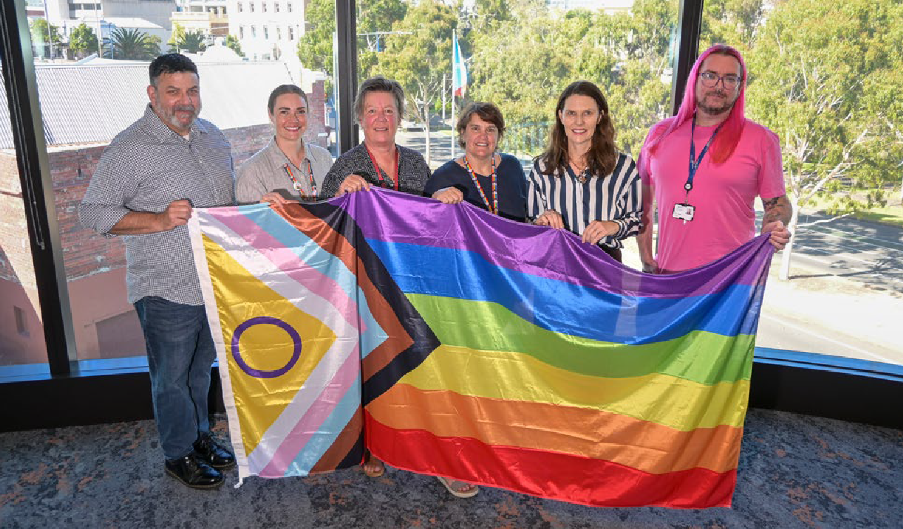
Queer Black People and People of Colour; statement against racism

Image: Progress Pride Flag by Daniel Quasar.

Photo: The City of Greater Geelong Pride Network with CEO Ali Wastie and the Pride Progress Flag 2025.

10. 11.

WHAT GUIDES US

RECOGNISING THE RIGHTS OF THE RAINBOW COMMUNITY
The City of Greater Geelong is, like all councils, subject to a number of legal and regulatory requirements in relation to human rights, discrimination, and equal opportunity.
The Equal Opportunity Act 2010 s 15(2) stipulates that:
- A person must take reasonable and proportionate measures to eliminate...discrimination, sexual harassment or victimisation as far as possible.
The Charter of Human Rights and Responsibilities s 38(1) stipulates that:
- It is unlawful for a public authority to act in a way that is incompatible with a human right or, in making a decision, to fail to give proper consideration to a relevant human right.
The Gender Equality Act 2020 s 7 stipulates that:
- A defined entity must, in developing policies and programs and in delivering services that are to be provided to the public, or have a direct and significant impact on the public —
  - consider and promote gender equality; and
  - take necessary and proportionate action towards achieving gender equality [which means "equality of rights, opportunities, responsibilities and outcomes between persons of different genders" per s 3].
The Local Government Act 2020 s 28(2)(a) stipulates that:
- In performing the role of a Councillor, a Councillor must consider the diversity of interests and needs of the municipal community.

RAINBOW READY ROADMAP
We have committed to using the Rainbow Ready roadmap to guide our Rainbow actions.
The roadmap offers resources to help rural and regional communities in Victoria become more inclusive of lesbian, gay, bisexual, trans and gender diverse, intersex, and queer (LGBTQIA+) people.
It supports the Victorian Government’s LGBTQIA+ Strategy 2022–32 by helping create safer and stronger communities. Developed through consultation
with LGBTQIA+ communities, including feedback from the LGBTQIA+ Rural and Regional Roadshow, the roadmap aims to address challenges faced by LGBTQIA+ people in regional and rural areas.
The roadmap offers practical tools and resources to guide communities in making meaningful local changes to support and celebrate diversity and
LGBTQIA+ people. It is designed to help plan, deliver, and evaluate Rainbow Ready activities, ensuring that initiatives are inclusive and impactful.
The final goal of the roadmap is for communities to earn Rainbow Ready status, which signals that a
setting is safe, welcoming, and inclusive for LGBTQIA+ people. The City of Greater Geelong is using this roadmap to build this action plan for creating a more inclusive community for LGBTQIA+ people and their families.

CITY OF GREATER GEELONG SOCIAL EQUITY FRAMEWORK
The City of Greater Geelong’s Social Equity Framework 2022–25 underpins our work with a commitment to putting equity at the centre of everything we do. It identifies the way the City will consider its many diverse communities and their unique needs to support participation, inclusion and equal opportunity.
We recognise that individuals and groups can be impacted by multiple forms of discrimination and disadvantage, and that an intersectional approach is needed to identify and address this.
The Social Equity framework identifies the following priority populations: People with disability, Aboriginal and Torres Strait Islander peoples, women, LGBTQIA+ community, young people, older people, culturally and linguistically diverse communities, refugees and asylum seekers, rural and peri-rural residents and people facing socio-economic disadvantage.

DIVERSITY, EQUITY AND INCLUSION STRATEGY
The City of Greater Geelong’s Diversity, Equity and Inclusion Strategy sets the framework for a
strategically aligned, organisation-wide approach to inclusion and diversity. This framework demonstrates the pathway we will take to achieve our goal of a diverse workplace and safe and inclusive organisation.
This strategy sets the framework for our internal actions within our action plans. Regular action plans hold us accountable for achieving identified outcomes and commit the organisation to effect positive, sustainable change for our employees. We seek to build awareness and capability, monitor and track
our progress, shape an inclusive environment and embed inclusion across all stages of the employee experience.

ORGANISATIONAL STRATEGY 2024–29
As demonstrated in our Organisational Strategy 2024–29 we are committed to creating an inclusive organisation that supports and encourages its employees to do their best work, have equal access to opportunities and a fair working environment.
We make this commitment with our customers and community in mind knowing that our customers will be better understood and our services more innovative when we are a mature, inclusive and diverse organisation.

GENDER IMPACT ASSESSMENT
A Gender Impact Assessment (GIA) was conducted to inform the development of this plan. The purpose of gender impact assessments is to create better and fairer outcomes, and make sure all people have equal access to opportunities and resources. This ensures we are meeting our obligations under the Gender Equality Act 2020 (VIC).

12. 13.

WHAT WE HEARD FINDINGS

ENGAGING WITH THE
GREATER GEELONG COMMUNITY
Community consultation was undertaken to gain a better understanding on how we can make the LGBTQIA+ community feel more included in Greater Geelong.

HAVE YOUR SAY SURVEY RESPONDENTS
- 220 responses
- 26% identified as being part of the LGBTQIA+ community

- 5% identified as being allies of the LGBTQIA+ community
WHAT WE ASKED
The primary purpose of the community engagement was to hear from the LGBTQIA+ community and allies about how the City can improve LGBTQIA+ inclusion.
This feedback guided the development of our first LGBTQIA+ Action Plan.

WHO RESPONDED
220
ONLINE SURVEYS COMPLETED
39
PEOPLE ATTENDED 4 WORKSHOPS

29
DAYS OF ENGAGEMENT

1
WRITTEN SUBMISSION

693
FEEDBACK RESPONSES IN SECOND-ROUND ENGAGEMENT’
- 38% were aged 35-49 years, 15% 50-59 years and
15% 25-34 years
- 4% were Aboriginal or Torres Strait Islander
- 46% were women, 34% were men, 3% non-binary, 5% self-described their gender and 12% preferred not to say
- 12% identified as people with disability
- 10% were migrants.
VOICES FROM OUR COMMUNITY
The below quotes were received in LGBTQIA+ community consultations for the Rainbow
Action Plan.
‘A lot of people in the community struggle to go out in the evenings because they know they won’t be welcomed in certain spaces. There’s still a large sense of not being accepted, especially if someone presents differently.’
‘It’s also important for Council to make a positive public statement.’
‘There does need to be a greater focus on social activities for the queer community. I think that’s something that needs to be supported by local government. From social connections within the community, it leads to activity and positive outcomes.’
‘We should not be stopping events because of keyboard warriors. We wouldn’t be where we are today if we’d stopped because of attacks on social media.’
‘When I go out alone, I tend to overhear a lot of racist, homophobic, and (...) shaming conversations, which has made me want to shrink away. I’ve even driven home in tears before, thinking, “What am I doing here?” ‘

WHAT THE CITY IS DOING WELL
The City sought feedback from the community to understand what it was doing well to support LGBTQIA+ inclusion. Key examples of positive initiatives highlighted included the installation of the rainbow crossing as a visible symbol of
inclusion, the organisation of LGBTQIA+ events that celebrate diversity, and ongoing consultation with the LGBTQIA+ community to ensure their voices are heard. Additionally, the City's youth services and events were recognised as important contributors to fostering a sense of belonging and support for young LGBTQIA+ individuals. These efforts reflect the City's commitment to creating an inclusive and welcoming environment for all.

BARRIERS
Four key themes outline the challenges to inclusion faced by the LGBTQIA+ community:
- safety and visibility
- connection and community
- resources and leadership
- discrimination and access.

Safety and Visibility
Significant safety concerns were highlighted, both cultural and physical. A lack of cultural safety was reported, which involves not feeling accepted, respected or represented within the community. This was compounded by fears for physical safety, particularly among young people, trans and gender-
diverse individuals, and those who did not conform to traditional appearance norms.
‘In general, walking around Geelong as a visibly queer person can feel unsafe.’

Connection and Community
There was significant discussion among participants about the challenges of building community and finding connections. Many expressed feelings of social exclusion, struggling to find ways to engage with others and often feeling isolated. The search for connection and inclusion was a common theme throughout the discussions.
‘I’ve lived here my whole life, and while things have improved, there’s still a sense of isolation compared to places like Melbourne. The queer community here is small, and for people over 30, the resources
are limited’

Resources and Leadership
Many community LGBTQIA+ initiatives are driven by a small number of dedicated volunteers and community leaders. This places an unsustainable burden on these individuals, often leading to burnout and significant mental and physical health challenges.
‘I’d add that while we have organisations and individuals doing great work, there aren’t enough allies stepping up. It’s mostly the queer community doing the heavy lifting.’

Discrimination and Access
A key issue raised was discrimination and access, with participants highlighting numerous challenges in finding culturally safe and inclusive services, including healthcare, employment, businesses and community activities.
Many felt that general and mental health services were not culturally safe for queer individuals, particularly for trans and gender diverse people.
‘I think we also need to address how services are accessed. Many families want to access mainstream services but face discrimination.’

14. 15.

ACTION PLAN 2025-29

Our understanding of community needs through consultation with the Rainbow Community guided the development
of this plan. Community needs were workshopped by multiple departments within the City of Greater Geelong
to shape the actions included. Where possible, the City will commit to implementing actions in consultation with the Rainbow Community.

STRUCTURE OF THE ACTION PLAN
All principles within this plan hold equal importance, with no one principle taking precedence over the others. The order reflects the structure and is in alignment with the Victorian Government Rainbow Ready roadmap.
To create an enabling environment in Greater Geelong for LGBTQIA+ people we will structure our actions around the four key principles:
- Principle 1: Understanding
- Principle 2: Inclusion
- Principle 3: Visibility
- Principle 4: Safety

ACTION PLAN TIMEFRAME
Year 1: 2025-26
Year 2: 2026-27
Year 3: 2027-28
Year 4: 2028-29

CONTINUING COMMITMENTS

COMMITMENTS
Before outlining the specific actions within the plan, it is important to acknowledge that the City of Greater Geelong has a number of ongoing commitments to LGBTQIA+ inclusion. These commitments form the foundation of our work and will continue to be upheld alongside the actions in this plan.

Maintaining and strengthening partnerships with LGBTQIA+ community organisations
and advocacy groups
- Convening the LGBTQIA+ Advisory Committee.
- Creating safe and inclusive spaces for LGBTQIA+ young people that celebrate their diverse identities and experiences including the Gender and Sexuality Project (GASP).
- Providing LGBTQIA+ young people with opportunities for social connection and support them to participate in community activities
that promote a sense of belonging and social inclusion.
- Empowering LGBTQIA+ young people to share their lived experience, actively participate in decision-making processes and have their voices heard.
- Connecting with other local governments.
- Youth Development Unit capacity building work with schools including the Standout Community of Practice.

Actively fostering a safe, respectful, and welcoming environment for LGBTQIA+ staff, residents, and visitors
- Maintaining the Rainbow Crossing
- Flying flags on days of significance.
- Convey that service is LGBTQIA+ friendly by creating a welcoming and inclusive environment through visual cues and signage.

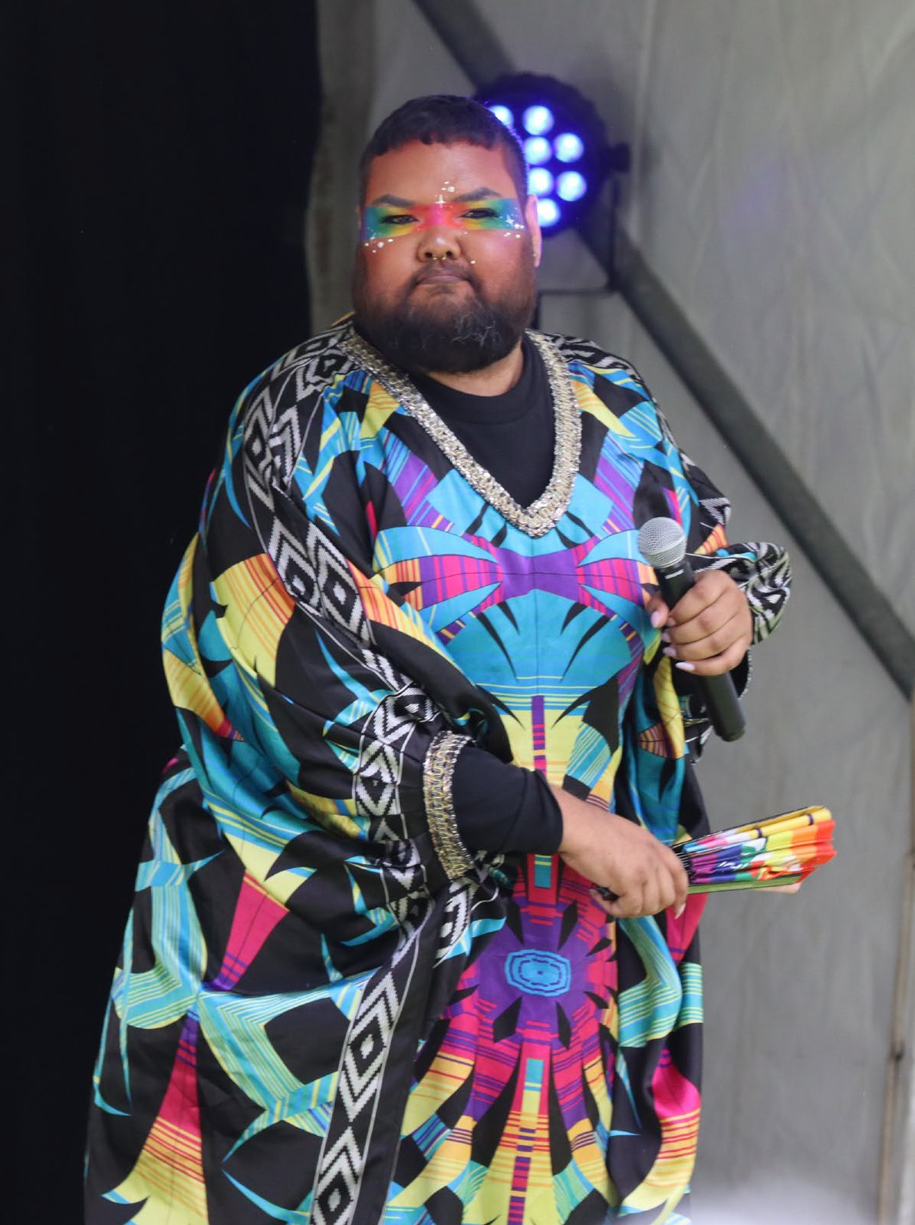
16.
Photo: Performance by 2Joocee at Geelong Rainbow Festival 2024.
17.

PRINCIPLE 1: UNDERSTANDING

LGBTQIA+ inclusion is underpinned by education and understanding
Education to provide all communities with knowledge of LGBTQIA+ experiences, histories and challenges is key to widespread inclusion and meaningful allyship.9

PRINCIPLE 2: INCLUSION

LGBTQIA+ people are included in the journey
Participation of LGBTQIA+ people in activities is critical to achieving and maintaining LGBTQIA+ inclusion. It is also critical for empowering of LGBTQIA+ people. 9

Ref # | Action | Year | KPIs | Lead Unit(s) |  | Ref # | Action | Year | KPIs | Lead Unit(s)
1.1.1 | Develop/source and deliver inclusive | Years 2-4 | Priority setting | Community |  | 2.1.1 | Promote awareness of LGBTQIA+ | Year 1-4 | Number of events attended. | Inclusion &

practice training for community members, including allyship and bystander action training.
identified.
Training approach documented.
Number trainings delivered to priority settings.
Inclusion

    - Identify and deliver public art projects that include LGBTQIA+ histories and experiences.
Year 2 Pilot project initiated Public Art and
Culture

    - Employee rainbow lanyards will be made available to staff who complete the ‘LGBTQ+ inclusion in the workplace training’ to promote safety and visibility in the workplace.
Year 1-4 Number of staff who
have completed training.
Yearly increase in the number of employees joining the internal staff Pride Network.
Number of employees attending Pride Network meetings, events, or activities.
Inclusion & Diversity

Communications

Annual review of all forms and administrative requirements for parents to ensure inclusive language is used.
initiatives and programs for all staff via  communications and events including an employee IDAHOBIT event. |  | Percentage of Senior Leadership presence. | Diversity and  Communications
2.1.2 Strengthen collaboration with LGBTQIA+ community groups and organisations, fostering relationships, shared understanding, and mutual support to advance inclusion and equity. | Year 1-4 | Stakeholder analysis undertaken and documented. | Community Inclusion
2.1.3 Promote opportunities for LGBTQIA+ adults to connect with one another. | Year 1-4 | Increase in City promotion of LGBTQIA+ connection opportunities on website. | Community Inclusion
 |  | Need for newsletter assessed and documented.
2.1.4 All early years services to sign up to the Welcome Here project by Dec 2025. | Year 1-4 | Number of centres engaged in the Welcome here project. | Family Services

Commitment to annual training both internal or external for early years staff.
2.1.5 Support local LGBTQIA+ events through partnerships, capacity building and promotion, while taking a leadership role to deliver an annual community based IDAHOBIT event and a Wear It Purple youth event.

Annual review of forms completed.

Number of staff attendances at training sessions
Year 1-4 Annual community-based
IDAHOBIT and Wear It Purple events held.

Evidence of support for community organisations working on LGBTQIA+ events documented.

Community Inclusion

18. 19.

PRINCIPLE 3: VISIBILITY

LGBTQIA+ people and their culture are visible and celebrated
The visibility of LGBTQIA+ people and initiatives can indicate a shift towards LGBTQIA+ safety and equality. This is an important sign of hope for many LGBTQIA+ people. 9
Ref # | Action | Year | KPIs | Lead Unit(s)
3.1.1 | Enhance the visibility of LGBTQIA+ | Year 1-4 | Percentage of existing | Inclusion &
 | inclusion within organisational |  | procedures and policies | Diversity
 | procedures by reviewing and |  | reviewed for inclusive
 | embedding inclusive language and |  | language and practices.
 | practices across new internal policies
 | and processes. |  | Number of procedures
 |  |  | updated to include
 |  |  | explicit LGBTQIA+
 |  |  | inclusion measures.
3.1.2 | Identify a Rainbow champion at | Year 1 | Rainbow champion | Inclusion &
 | a senior level to lead the work of |  | appointed and | Diversity
 | LGBTQIA+ inclusion. |  | onboarded.
3.1.3 | Embed LGBTQIA+ inclusive language | Year 1-4 | Number of documents | Communications
 | and imagery across council documents |  | reviewed and updated | Marketing
 | and online content |  | with inclusive content
 |  |  | included.
3.1.4 | Collaborate with community | Year 3 or 4 | Pre and post | Inclusion &
 | organisations and businesses to create |  | photographic evidence of | Diversity
 | welcoming and inclusive environments |  | public City spaces. | Community

PRINCIPLE 4: SAFETY

LGBTQIA+ peoples’ safety is a priority
Strategies are in place to identify and reduce risks to the safety of LGBTQIA+ people. Responses to LGBTQIA+- phobic incidents support LGBTQIA+ people and include actions to prevent reoccurrence. 9

Ref # | Action | Year | KPIs | Lead Unit(s)
4.1.1 | Work with the LGBTQIA+ community to identify and prioritise risks to the safety of LGBTQIA+ people. | Year 2 | Community input to meet ‘Collaborate’ standard of the IAP2 framework. | Community Inclusion
 |  |  | Safety risks identified and prioritised.
4.1.2 | Work with our relevant People & Culture colleagues to improve capability and response to  workplace harm and LGBTQIA+- phobia via training and resource  sharing. | Year 2 | Training program established for People Partners. | Inclusion & Diversity
4.1.3 | Develop a clear and coordinated framework to respond to | Year 1 for messaging | Framework developed. | Communications

by promoting the use of visual cues and inclusive signage.

    - Host annual diversity and inclusion workshops at the Geelong Small Business Festival to help businesses improve their ability to create more welcoming workplaces and customer environments, with a focus on LGBTQIA+ inclusion.

Identifying visual cues.

Priority settings identified.

Year 1-4 Number of workshops delivered.

Number of people who attended workshops.

Inclusion

Economic & Cultural
Development
LGBTQIA+-phobic commentary and coverage in media and online platforms, demonstrating leadership, rejecting discrimination, and publicly supporting LGBTQIA+ people and allies.
    - Work with local organisations (for example libraries, hospitality businesses) to identify and provide safe social spaces.
    - All new builds and upgrades will complete a Gender Impact Assessment (GIA) to explore implementing the
recommendations of all gender
Framework implemented.

Year 2 Safe spaces documented.

Promotional activities documented.
Year 1 Number of GIAs completed that
recommended inclusion of all gender facilities.
Community Inclusion

Community Inclusion

Inclusion & Diversity

    - Strengthen LGBTQIA+ content on the Geelong Australia website and communications to enhance visibility, accessibility, and engagement with
initiatives, events, and local resources.
Year 1 for review, then maintenance
Pre and post screen shots of website content.

Percentage of new content aligned to highlighted community needs.
Community Inclusion
facilities
    - Implement actions based on the findings of action 4.1.1

Year 3-4 Based on findings of 4.1.1
safety, a project developed and implemented that falls under the responsibility of local government.

Advocate to other governments and organisations for work identified safety issues outside the remit of local government.

Community Inclusion

20. 21.

MEASURING AND REPORTING REFERENCES

We recognise the importance of monitoring our progress over the life of the plan and reporting back to our community and organisation. The plan is
accompanied by a monitoring, evaluation and learning framework which supports us to regularly track our progress and report on milestones and outcomes.
Progress will be supported by the City’s Inclusion and Diversity governance structure. The organisational Rainbow Reference Group will provide quarterly reporting on actions to our Executive Leadership
Team. This ensures transparency and accountability to support meaningful progress on the Rainbow Action Plan 2025–29.
We will also report on progress through:
- progress reporting on actions with our LGBTQIA+ Advisory Committee
- share case studies of implemented actions.
  - Diversity Council of Australia, 2018. Out at Work: From Prejudice to Pride
  - Rainbow Health Victoria, 2020. Research Matters: How many people are LGBTIQ?
  - Australian Bureau of Statistics, 2022
(abs. gov.au/statistics/people/people-andcommunities/estimates-and-characteristicslgbti-populations- australia/2022 accessed February 2025).
  - Victorian Population Health Survey (2023).
  - ASDF Research, 2025 Geelong Preventative Health Survey 2024.
  - Hill AO, et al. 2020, Private lives 3: the health and wellbeing of LGBTQ people in Australia, Australian Research Centre in Sex, Health and Society, La Trobe University, Melbourne.
  - Victorian Agency for Health information, 2017.The health and wellbeing of the lesbian, gay, bisexual, transgender, intersex and queer population in Victoria. Findings from the Victorian Population Health Survey 2017.

PLANNING, IMPLEMENTATION AND EVALUATION CYCLE

The Action Plan provides the detail of the areas we will be focusing on with our partners.
Action Plan
Evaluation
Implementation and monitoring
(vahi.vic.gov.au/sites/default/ files/2021-12/The-health-and-wellbeing-ofthe-LGBTIQ-population-in-Victoria.pdf accessed February 2025).
  - The Center - What Is LGBTQIA+? (gaycenter.org/community/lgbtq accessed February 2025).
  - Victorian State Government, 2023. Rainbow Ready Roadmap guide B2: setting guide for local government, Department of Families, Fairness and Housing, Melbourne.(https://www.vic.gov.au/sites/default/files/2023-11/ Rainbow-Ready-roadmap-Guide-A-User-Guide.pdf accessed February 2025)

We have the opportunity to evaluate our efforts and to adjust, if necessary, our program of works.
We will continually monitor our program of works to make sure we are heading in the right direction.

22. 23.







This document contains important information about the City of Greater Geelong. Please contact us if you have any questions or would like to request a hard copy of the report.

CITY OF GREATER GEELONG
Wadawurrung Country PO Box 104
Geelong VIC 3220
P: 5272 5272
E: contactus@geelongcity.vic.gov.au geelongaustralia.com.au

© City of Greater Geelong 2025

LATEST NEWS:
@CityofGreaterGeelong @GreaterGeelong @CityofGreaterGeelong CityofGreaterGeelong

