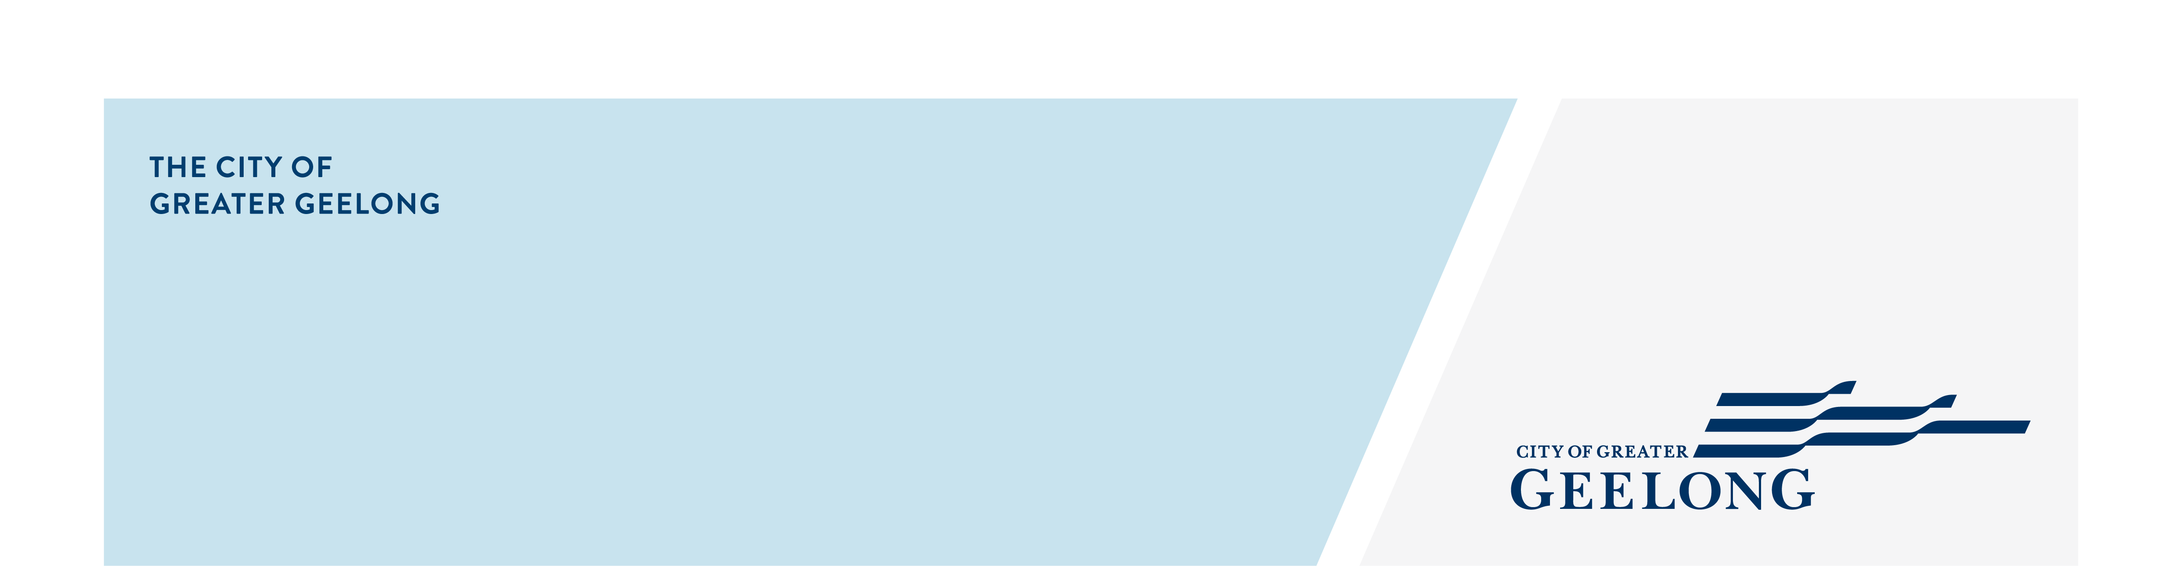
canopy trees checklist

what is a canopy tree?
Under clause 52.37, a canopy tree means a tree that has:
- a height of more than 5 metres above ground level; and
- a trunk circumference of more than 0.5 metres, measured at 1.4 metres above ground level; and
- a canopy diameter of at least 4 metres.
To assist us in assessing your application under clause 52.37 of the Greater Geelong Planning Scheme, the following information must be provided with your application for planning permit:

information requirements:
An application form completed and signed
A recent copy of title for the land (the search should be dated not more than 60 days prior to the application), including a copy of the diagram or relevant plan of subdivision and a copy of any restriction or covenant that may affect the land. (A certificate of title may be obtained online Victorian Land Titles Office )
The application fee
A site plan, photographs or other techniques, including an Arborist report, that accurately describe:
- The location of all canopy trees and other vegetation on the site.
- The canopy trees proposed to be removed, destroyed or lopped, including species, height and canopy diameter.
- The location and details of existing and new canopy trees, including species, type, expected height and expected canopy diameter at maturity, soil conditions and proposed irrigation.
An explanation of why the canopy tree is proposed to be removed, destroyed or lopped and, if applicable, an explanation of why the proposal does not meet the canopy tree requirement
Details of the proposed buildings or works, including plans of the development, if the canopy tree is proposed to be removed, destroyed or lopped to enable construction of a building or the construction or carrying out of works
An assessment of the canopy tree prepared by a suitably qualified person, if the canopy tree is proposed to be removed or lopped due to its health or stability.
Note:
Australian Standard 4970-2025 The Protection of Trees on Development sites states that a competent person is a person who has acquired, through education, training, qualification, experience or a combination of these, the knowledge and skill enabling that person to perform the task required.
Note 1 - The competent person fulfilling project arborist responsibilities shall be suitably experienced and competent in arboriculture. This person will have an Australian Qualification Framework Level 5, Diploma of Arboriculture or equivalent, and be able to perform the tasks required by this document.

