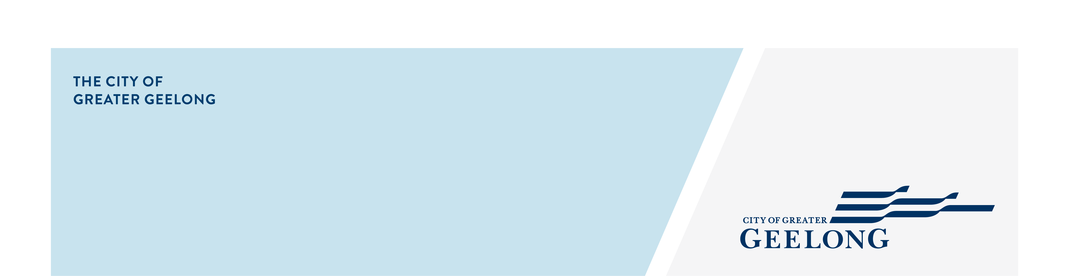
clause 54 checklist

To assist us in assessing your application under clause 54 of the Greater Geelong Planning Scheme, the following information must be provided with your application for planning permit:

information requirements:
Fully dimensioned plans, at a preferred scale of 1:100 or 1:200 including:

- Existing and proposed buildings and works, including title boundaries, dimensions of the site, buildings, garden areas, driveways and parking areas;
- Floor plans
- Elevation plans, including heights above natural ground level;

Site description, as outlined in cl 54.01-1
Design response, as outlined in cl 54.01-2, including a landscape plan
Written statement outlining which standards are met and which are not met.

- Where a standard is met, you must explain/demonstrate how the standard is met (eg the height of the building is 5m (see Plan TP.03).
- Where the standard is not met, you must explain how the development meets the corresponding objective having regard to the decision guidelines.
See our Cl 54 template as a guide
Tree canopy plan that shows:

- Retention and planting of canopy tree(s) as outlined in cl 54.02-6

Shadow diagrams, as required by cl 54.04-3

Note: this includes a set of shadow diagrams showing overshadowing of the existing conditions.
Overlooking diagrams, where required, as outlined by cl 54.04-4

