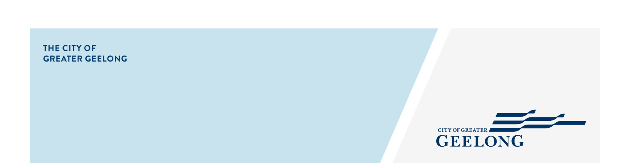
This checklist should be read in conjunction with a letter or email sent to you, with specific requirements relating to your application for a Class 3 Food Business.

SELF ASSESSMENT CHECKLIST

CLASS
3

FOOD BUSINESS

As well as following this advice, the below checklist covers other legal requirements that might impact on your business. If you don’t address them all, it may prevent your business opening on time.

The checklist is for your information and use and does not need to be returned to us.

 | COMPULSORY ITEMS FOR FOOD BUSINESSES
□ | Contact us 5 business days prior to your planned opening date to arrange a pre-opening inspection (contact the Environmental Health Unit on 5272 4411)
□ | Read the Food Safety Guide for Class 3 businesses to understand your record keeping and food safety requirements. For more information see our website
□ | Make sure your staff are well trained for their role. This may include completing formal food handling training, or unaccredited, basic online training like Do Food Safely or All About Allergens.
□ | Make sure all pre-packaged foods are correctly labelled to meet the Food Standards Code. See our handout Food Labelling Requirements for Food Businesses for more information.
□ | Make sure your business fit-out is in line with the Food Standards Code and the Food Premises  Specifications guidelines, available on our website

 | OTHER LEGAL REQUIREMENTS THAT IMPACT YOUR BUSINESS
□ | Contact our Statutory Planning department on 5272 4456 to discuss if a planning permit is required for your business. Also visit: https://www.geelongaustralia.com.au/planning/article/item/8cd9cd661a2c1be.aspx

□ | Contact our Building Services department on 5272 4450 to find out whether you require a building permit. Also visit: https://geelongaustralia.com.au/building/article/item/8cc03628d02372e.aspx
□ | Call our Health and Amenity Unit if you are considering having alfresco dining or an A-frame sign for your business on 5272 4500. Visit this site for more information  https://geelongaustralia.com.au/footpathtrading/article/item/8cef598b610a52e.aspx
□ | Refer to the tobacco reforms website at www2.health.vic.gov.au/public-health/tobacco-reform for information for businesses and the community about smoke-free areas and the laws relating to the sale of tobacco products.
□ | Contact Barwon Water on 1300 656 007 to discuss grease trap and trade waste requirements or visit https://www.barwonwater.vic.gov.au/water-and-waste/trade-waste for more information.
□ | If your business is mobile or of a temporary nature and you plan to operate in other council areas, please apply directly on www.foodtrader.vic.gov.au
□ | If you operate a business from a residential property, it may increase your rates. Please contact our Financial Services team on 5272 4650 for more information.
□ | Home based businesses must operate in line with the Home based business guidelines. Contact our Statutory Planning department to discuss these requirements on 5272 4456.

For more information on Starting a New Food Business, see
https://www.geelongaustralia.com.au/foodindustry/task/item/8d013aba7c8c3d1.aspx

