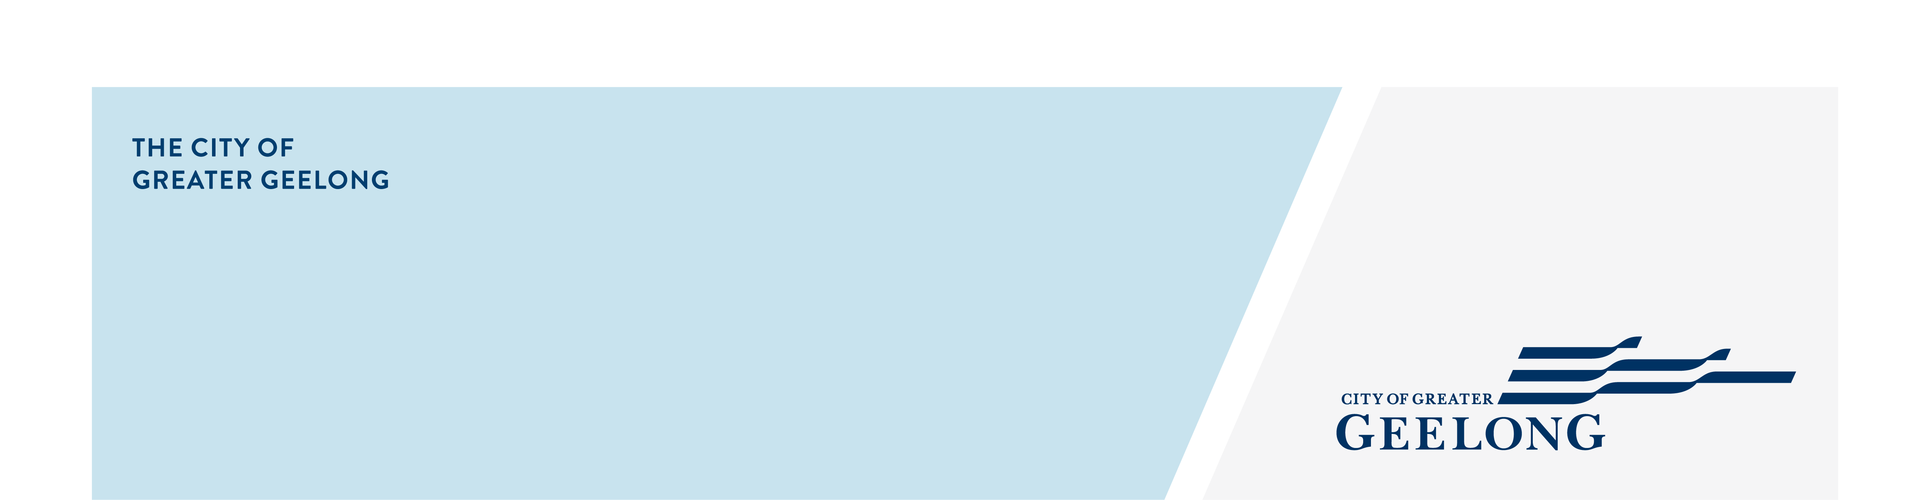
Moorabool street Median Artwork

Moorabool Street Median Artwork Commission
The City of Greater Geelong is seeking design work from a suitably qualified/experienced artist/s or creative team for a median treatment in Moorabool St, central Geelong.
The budget for the design commission is $12,000 ex gst.
Context:
Geelong is the second-largest city in Victoria. Located 75 kilometres south-west of Melbourne, the municipality covers an area of 1,252 square kilometres, comprising suburban, coastal and country areas. Outside of metropolitan Melbourne, the greater Geelong municipality is the most populated region in Victoria, with an estimated resident population of 282,809. Our Vision is that by 2047, Greater Geelong will be internationally recognised as a clever and creative city-region. This will include being forward looking, enterprising and, adaptive. A place that cares for its people and environment. Public art plays a part in the creative recognition of this vision.
Our proximity and connection to metropolitan Melbourne, our unique CBD, townships and suburbs, our natural assets including rural and coastal areas, and our diverse economy makes us a destination location and one of fastest growing regions in Australia. Thriving neighbourhoods, suburbs and cities need spaces for residents to engage creatively and support a lifestyle that they want. Public art has a role to play developing cohesive communities and enhancing cultural identity.
Geelong is a UNESCO City of Design prized for its lifestyle, heritage and creative economy. In recent years, Central Geelong has been revitalised as a dynamic hospitality and shopping district.
The project:
The location of the project is in Moorabool Street. See drawing below. Adjacent to the project site is the new weekly Geelong City Market which welcomes 6000 visitors each Saturday between 9.00am and 2.00pm. This market showcases the very best of Greater Geelong and the Bellarine. The Geelong City Market is the place where locals and visitors come together to eat, drink, connect, and celebrate the best our region has to offer. Historically Moorabool Street has been the heartbeat of Central Geelong.
This Expression of Interest (EOI) is for an artwork design to be executed on the median strip of Moorabool Street between Malop St and Ryrie St. See drawing of site location below. Three artists will be shortlisted from this EOI and engaged to develop designs for the median. Each artist will be paid $1000 to develop a design. The artist awarded the commission will be engaged to develop a design for $12,000.
Scope and responsibilities:
- The design will be executed using a decorative, bonded aggregate surface designed to enhance the site by using Australian recycled-glass, or natural aggregates. CST, (Colour Surface Treatment).
- There are two distinct sections to the median – see highlighted median in yellow below. The total area for the median artwork is 232.68 square metres. Section one is 99.4 square metres. Section 2 is 133.28 square metres.
- There is a possibility for a glow in the dark option in the surfacing. This would activate the work at night.
- The median is flush to the road with a charcoal precast flush kerb edge. The existing material will be prepared by CoGG’s contractor ready for application of the new surface.
- The artist is responsible for the design work only. The CoGG contractor will apply the new surface to the artist’s design.
- The artist design must take into consideration that a contractor will be applying the final design. Intricate patterns will be very difficult to execute. Tape can be applied for simple patterns but more intricate patterns will require templates..
- Colours can be any on the AS2700 colour chart
Site Location:
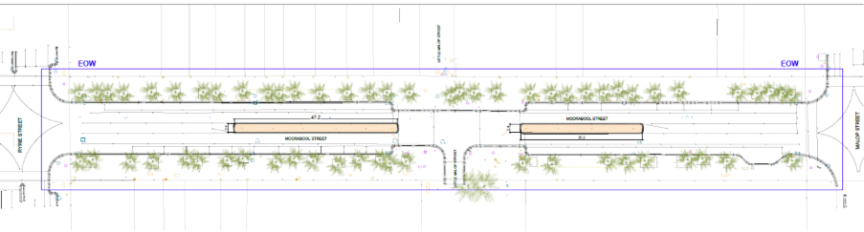
Figure: Moorabool street site. Area in yellow is for the artwork treatment.
Possible thematics:
The artwork should be site driven. The following are possible thematics:
- The adjacent market site was a wetland prior to urbanisation.
- Indigenous flora and fauna (will require approval from Wadawurrung Traditional Owners).
- Moorabool Street as the heartbeat of central Geelong.
- Changing use of Moorabool street over time.
- Inspired by the new Geelong City market; food, creativity, meeting place.
Stage 1
- A short bio demonstrating experience and capabilities relative to the commission, no more than 1 page A4.
- Current CV (2 page maximum)
- 5 images of your artwork/design practise or webpage for viewing examples of work.
- Confirmation of your ability to meet project timelines.
Stage 2
A selection panel will then shortlist 3 artists and provide a fee of $1,000 ex gst to develop:
- Full design concept and drawings including artist statement
An artist will then be selected and contracted. The artist will work with the project team to complete the work which includes the City’s Public Art Team and Public Realm Team.
Timeline:
EOI released: 11 February
EOI Closes: 25 February
Shortlisted artist notified: 3 March
Shortlisted concepts delivered: 10 March
Artist awarded:13 March
Installation w/c: 13 April
Criteria:
- Compliant application submitted prior to the EOI deadline
- Artwork examples submitted must represent the artist’s own original work and reflect artistic excellence, innovation and originality, as evidenced by:
- Professional quality of output and mastery of skills
- Professional methodology and techniques
- Communicates a unique vision or perspective
- Artwork examples are judged to be appropriate to the goals of the project
- Demonstrated professional experience is adequate to meet the demands of the project
- Demonstrated ability to work productively with your client and project stakeholders

Contact: Katharine Oliver – Senior Public Art Officer. Email: publicart@geelongcity.vic.gov.au

