
parking meters

a step-by-step guide

- Check the area signs

Once you’ve parked your vehicle in a
vacant bay, look for a parking meter
nearby with a blue ‘PAY HERE’ sign.

- Read the screen

On the meter screen you will see the
hours you can park, maximum time limit
and tariff fee.

- Enter your registration plate

Enter your registration plate into the machine. Check that you have entered this correctly before proceeding.

- Pay

Select ‘credit card’ payment method from
the screen & follow the on-screen prompts.

- Select Time

Select the amount of time you would like to pay for.
To add time, press the arrow on the right. To remove time, press the arrow on the left.
Press the ‘OK’ button to continue.

- Confirm details

When you see the required time displayed, press the green ‘OK’ button.

(Please note - If the ‘OK’ button is not pressed to proceed within 20 seconds, this will cancel
the transaction and your card will not be debited)

To cancel the transaction, press the red ‘Cancel’ button.

- Request a payment receipt

a) Before April 2026

Follow the on-screen prompts to print a paper receipt.

b) From April 2026
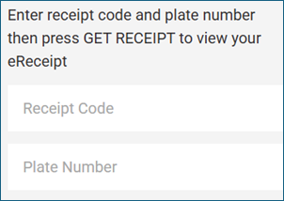
Note the receipt code displayed on-screen.
Go to the website https://my-receipt.com/
Enter the receipt code and plate number.
Press ‘Get Receipt’.

A video demonstration is available - How to retrieve your e-receipt

