






RATES WAIVER
Eligibility criteria: Ratepayers must meet all of the criteria:
- household income under
$65,189
- no property improvements since 1 January 2024 that required a building permit
- the 2025 property valuation (the Capital Improved Valuation CIV) has increased by more than 50 per cent from the previous 2024 level property valuation for your sole and principal place of residence between both valuation years.
Assistance available: Qualifying ratepayers will be entitled to a ‘one-off’ waiver of up to 50 per cent of the dollar amount that their rates increase as a result of the 2025 revaluation.
Excludes waste service charge.
To apply: Search for ‘rates waiver’ on our website.

WHAT IF I DISAGREE WITH SOMETHING ON MY RATES NOTICE?
Please contact us so we can review your situation and try to find a solution.
Please see your rates notice for details of your rights
of appeal.

CHANGE OF ADDRESS
To request a change of residential or mailing address you can complete an online form at geelongaustralia.com. au/updateyourdetails or via email propertycustomerdata@ geelongcity.vic.gov.au
Delays in mail or payments due to an incorrect address are not considered to be an acceptable excuse for late payment of rates, penalties may apply.

HOW IS LAND TAX CALCULATED?
The State Revenue Office will also use the site value in its assessment for any land tax. For more information please contact the State Revenue Office at www.sro.vic.gov.au

WHY HAS MY PROPERTY BEEN REVALUED?
Municipal property valuations are undertaken on an annual basis. The Valuer-General Victoria is responsible for all valuations. Additionally, a supplementary valuation may be conducted throughout the year when a change to the property occurs that affects the valuation.
Valuations are carried out by professional valuers on behalf of the Valuer-General Victoria and properties are assessed according to the Valuer-General Victoria best practice guidelines which can be viewed online at www.land.vic.gov.au
Depending on real estate market trends, properties in parts of the City of Greater Geelong change at different rates than others, property rates will reflect this pattern.
The revaluation in 2025 has shown that residential properties in the City of Greater Geelong have decreased in value by
an average 1.9 per cent compared to the 2024 revaluation.

OBJECTING TO A VALUATION
You are entitled to object to the valuation of your property, however, please ensure you have all relevant sales data to support your objection, for example: copies of sales data, an independent valuation report, etc.
Valuations used for the rates notice are conducted as at 1 January each year.
Please consider this valuation date when submitting an objection as values may fluctuate during the year.
Please note the capital improved value is used for rate objections. Do not add the site value to the capital improved value as it is already included.
Objections must be lodged with the City within two months of the date of the initial rate notice, or within four months if a notice was not issued to you as the occupier of the land.
Objections outside of these times cannot be considered. The City will refer your objection to The Valuer-General Victoria where required.
Objections must be lodged electronically, either to the online portal
ratingvaluationsobjections. vic.gov.au or via our website, search for ‘Valuation objection’.
If you are not satisfied with the outcome of your objection, you may appeal to the Victorian Civil and Administrative Tribunal (VCAT), or the Supreme Court.
You must still pay your rates by the due date.

HAVE YOU?
- Checked your mailing address against your rates notice?
- Determined how you are going to pay your rates – in full, by instalment or direct debit?
- Marked payment dates on your calendar for your chosen payment method?

REGISTER FOR RESIDENTIAL RATES ONLINE AND HAVE YOUR RATES EMAILED TO YOU.
Scan the QR code or visit

geelong.link/Rates

CITY OF GREATER GEELONG WADAWURRUNG COUNTRY PO Box 104
Geelong VIC 3220
P: 03 5272 5272
E: revenue@geelongcity.vic.gov.au www.geelongaustralia.com.au
CUSTOMER SERVICE CENTRE
Wurriki Nyal
137-149 Mercer Street
Geelong VIC 3220 8.00am–5.00pm
NEED MORE INFORMATION?
Please refer to the back of your rates notice, or go to geelong.link/Rates

If you need an interpreter, call the Translating and Interpreting Service (TIS National) on 131 450 and ask them to phone 03 5272 5272
LATEST NEWS:
CityofGreaterGeelong geelong.link/CityNews @CityofGreaterGeelong CityofGreaterGeelong

THE CITY OF
GREATER GEELONG
2025−26

RATES
YOUR INVESTMENT IN YOUR COMMUNITY

WHAT DO MY RATES PAY FOR?
To deliver our diverse range of community and business
Finance costs $0.90

Community experience $1.00
Communications and marketing $1.25
Business and industry experience
Health and local laws Community care
$2.61
$1.39
Statutory and strategic planning and building
$3.34

Community programs
$3.76
and venues
$4.47
$0.46 Customer service

$0.25 Tourism

Capital works

HOW CAN I PAY MY RATES?
You can pay your rates online, by phone, by Direct Debit, through Centrepay or via BPAY.
For more information, see your rates notice.

CAN I RECEIVE MY RATES NOTICE
ELECTRONICALLY?
Yes, visit geelong.link/Rates to register. You will need a copy of your rates notice.
$32.73

DOES THE CITY MAKE MORE MONEY WHEN PROPERTY VALUES GO UP?
No, the City does not collect extra revenue as a result of the revaluation process.
The total combined general rates collected remains the same. The City determines rates by applying a rate in the dollar against the total value of the property. When the total value of all properties increases, we adjust the rate in the dollar

HOW ARE MY RATES CALCULATED?
Rates are calculated by multiplying the valuation of the property by the appropriate ‘rate in the dollar’. A different rate in the dollar is applicable for different land uses.
For example, the calculation for a residential property worth
$752,500 would be:

For details of your property’s valuation and how your rates are calculated please refer to your rates notice.

services, we collect rates and charges from all property
$5.65
$6.06
Recreation
and sports

FOR EVERY

WHAT HAPPENS IF MY PAYMENTS ARE LATE?
to compensate. There is no
windfall gain.

WHAT ASSISTANCE
* The residential property rating differential.





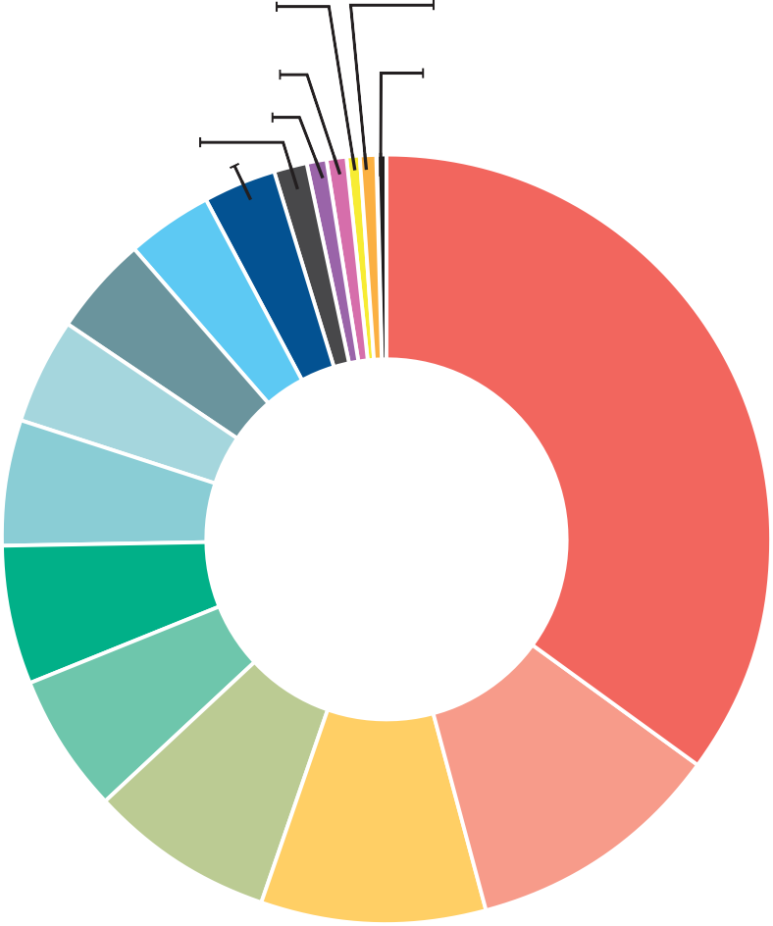
owners in the municipality.
$752,500 x 0.00210278* =
+ waste management charge
Total Council rates and charges
$1,582.35
$509.55
$2,091.90
Plus Emergency Services and Volunteers Fund
Here’s a breakdown, showing how every $100 will be spent in the 2025-26 Budget.
$6.07

Parks and reserve management

Family services

Asset management and maintenance
$10.55

$100 SPENT

Internal services
$11.25
$8.26

Waste management
Penalty interest, as set by the Victorian Government, is charged on all arrears and overdue amounts.
If we have to take action to recover any overdue amount, you may be required to pay recovery and legal costs.

DIFFERENTIAL RATES
The City applies different rates in the dollar for different land uses including residential, farm, vacant, mixed use, commercial and industrial. The rate used reflects the contribution required from the different property groups.
Please see your rates notice for details of your rights
of appeal.

MEASURES ARE IN PLACE?
The City provides a range of payment and assistance measures to suit individual
needs including options such as regular Direct Debit, Centrepay, and Payment Plans.
For the 2025-26 financial year the following rates assistance measures are available:

PENSIONER REBATE
Eligibility criteria: If you hold a current Pension Concession Card (not a Health Care Card) or a Veteran Affairs Gold Card, which stipulates TPI or War Widow, you may be able to claim a rebate on your sole or principal place of residence.
Assistance available: The rebate is 50 per cent of the total rates and charges, up to the maximum Victorian Government rebate amount of $266.00 and a $50 reduction to the Emergency Services and Volunteers Fund.
To apply: Forms are available from the City’s website and must be lodged by 30 June 2026. If you remain eligible and received the rebate last year you do not need
to reapply.

RATES DEFERRAL
Eligibility criteria: For ratepayers including pensioners who are experiencing hardship.

Assistance available:
We will create an individual payment plan. This may include deferral of rates payment, in full or part, depending on individual circumstances.
To apply: Contact us on
(03) 5272 5272 for further information or email hardship@geelongcity.vic. gov.au

