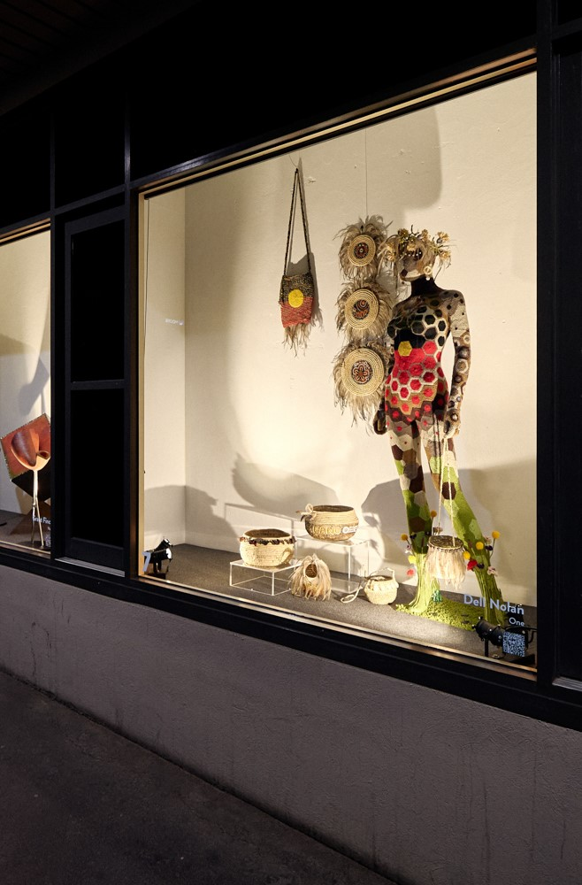

Image: Yarra Street Window Gallery. Round Three.
Window 7, One, by Dell Nolan. Photography by Peter Foster.

YARRA STREET WINDOW GALLERY

EXPRESSION OF INTEREST
GUIDELINES



We Acknowledge the Wadawurrung People as the Traditional Owners of the Land, Waterways and Skies. We pay our respects to their Elders, past, present and emerging. We Acknowledge all Aboriginal and Torres Strait Islander people who are part of our Greater Geelong community today.

Calling all Artists and Designers
Show your work in our 24-hour Window Gallery

Are you an artist or designer looking for a unique platform to showcase your creativity?

The City of Greater Geelong invites you to be part of an exciting opportunity that puts your work on display 24/7.

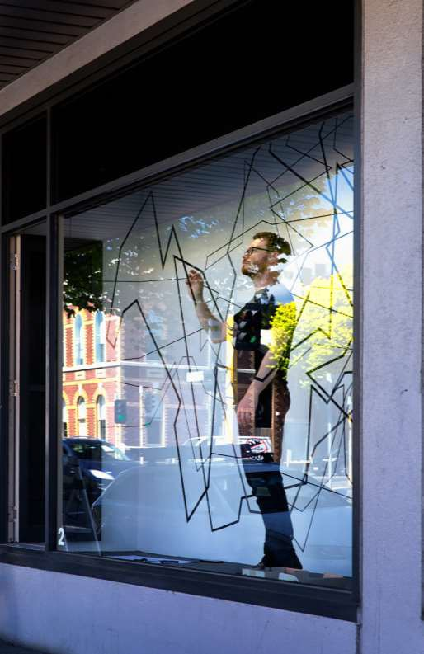
Image: Artist Peter Leigh installing in situ. Round Three.
Photography by Rebecca Hosking.

CONTENTS

Yarra Street Window Gallery Who Can Apply
Why Participate What We Offer
Dates & Window Specifications

How to Apply

Submission Requirements
Successful Applicants Responsibilities
Contact Us
Page 1

Page 2

Page 3

Page 4

Page 5

Page 6

Page 7

Page 8

Page 9

Page 10

Expressions of Interest are now open for the 2025 period.

The City of Greater Geelong presents the Yarra Street Window Gallery, 12 display windows along Yarra Street, in the Market Square Precinct, Geelong.

In partnership with Knight Frank, property management group of the Market Square building, the Yarra Street Window Gallery provides an interdisciplinary creative space enabling community to share and showcase their creative projects with a broad audience, embedding the arts within our everyday experience as citizens of Greater Geelong.

The 24-hour window gallery offers a unique platform for artists, providing continuous exposure to a diverse audience at any time of day or night. This format ensures that art becomes an integral part of daily life, attracting viewers who might not typically visit traditional galleries. The accessibility of the display breaks down barriers, allowing creativity to be experienced by a wide audience regardless of socio- economic status or background.

The Yarra Street Window Gallery delivers on the City’s Arts and Cultural Strategy and Geelong’s UNESCO City of Design designation by promoting local talent and celebrating the region's creative community.

Showcasing local artists raises Geelong’s artistic profile, bolsters its reputation as a creative hub, supports public arts engagement, and promotes inclusivity and diversity, reinforcing the city's identity as a vibrant, creative community.

The Yarra Street Window Gallery also stimulates local businesses and contributes to Geelong's economic vibrancy. By attracting visitors to the area at all times, the gallery supports surrounding businesses and becomes a point of interest for visitors, further enhancing Geelong's appeal as a cultural destination.

The Yarra Street Window Gallery will transform every three months with a new selection of works on display.

Gallery Round iterations will be early 2025, mid 2025 and late 2025. Confirmation of dates shall be communicated with successful applicants.

The City of Greater Geelong does not take any commission or handle any sales of works.

Who can apply?

We invite Greater Geelong-based artists and creatives and those with strong ties to Geelong, from emerging to established, to apply for a three-month exhibition in one of our windows.

We encourage applications from Aboriginal and Torres Strait Islander people, gender and sexuality-diverse individuals, people with diverse cultural background/s and people with disability.

Collectives and curators are also encouraged to apply to showcase their talents, exchange ideas and collaborate on projects. Collectives and curators may apply for consecutive windows.

We are looking for innovative, engaging, and visually striking pieces that make the most of our unique window display format.

We welcome almost all forms of visual arts and design, including but not limited to First Nations art, painting, illustration, sculpture, digital media (film/projection/animation), photography, fashion, jewellery, textiles, lighting design, furniture design, object design, installation art, ceramics, and glass.

Artists are encouraged to experiment with the window display space, leading to innovative art forms as they play with space, lighting, and other elements. The public nature of the gallery fosters direct interaction with the community, enabling artists to engage with a more diverse audience, including those with different schedules and lifestyles. This is a great opportunity to enhance engagement and the sense of connection between artists and the public.

Please consider that content is for 24-hour display and therefore artwork and designs must not include any defamatory or obscene
material.

All artwork/designs/creations are to be original and must not infringe on the copyright of others, nor be of cultural misappropriation, nor infringe on intellectual property or confidentiality of any third party.

You may indicate your preferred Round. You may make multiple submissions. You may show your work in one window only.

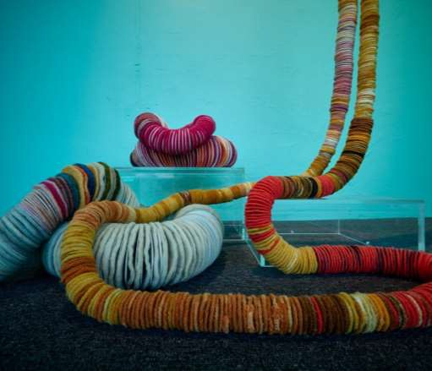
Why participate?

Image: Art by Fiona McDonald. Round Two.
Photography by Peter Foster.

ALIGNING WITH THE
CITY’S ARTS & CULTURAL
STRATEGY

Increased Visibility
Your work will be showcased in a high-traffic area, ensuring maximum exposure.

Community Engagement
Connect directly with the local community and engage with a broader audience in a public setting.

Cultural Contribution
Be a part of transforming Geelong into a vibrant hub of creativity and innovation.

Aligning with the City’s Arts and Cultural Strategy

Promote Local Talent
Help us celebrate and promote the rich creative talent within our region.

Economic Impact
Your participation will attract visitors and stimulate local businesses, contributing to Geelong’s economic vibrancy.

Inclusivity
Ensure that art is accessible to everyone, reflecting the diversity of our community.

Tourism Attraction
Become a part of a cultural destination that draws tourists and enhances Geelong’s reputation as a centre for the arts and design.

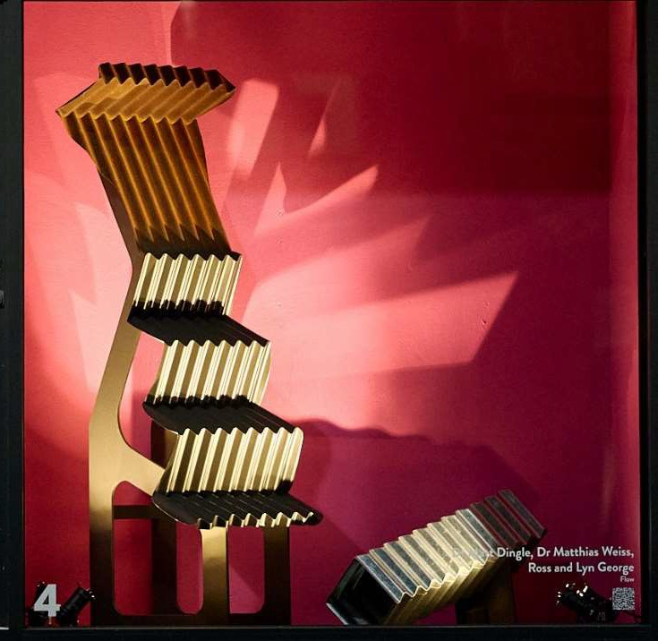
WHAT WE OFFER
Image: Flow. Design by Dr Matt Dingle, Dr Matthias Weiss, Ross and Lyn George.
Round Three. Photography by Peter Foster.

What we offer

Continuous Exposure
Your art will be visible to a diverse audience around the clock, reaching people from all walks of life at all times of the day and night.

Innovative Space
Our window display format challenges you to think creatively about presentation, lighting, and space, pushing the boundaries of your artistic expression.

Public Accessibility
Art becomes a part of the everyday experience for the community, breaking down barriers and making creativity accessible to all.

Fees
It is free to exhibit within the windows and in line with National Association for Visual Artists (NAVA) Code of Practice for Visual Arts, Craft and Design we will pay an exhibition loan fee of $500 per window.

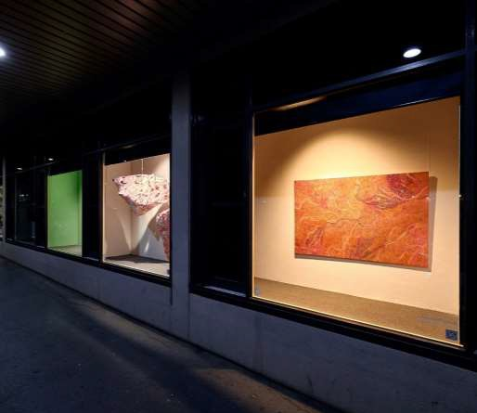
.

Image: Yarra Street Window Gallery, Round One, partial view. Full view of Window 6, Wilyakali Sunrise, by Tracey Polock.
Photography by Peter Foster.

DATES &
SPECS

Dates

The following rounds indicate the exhibition periods with the guideline of an exhibition period being three months.

Round 4: early 2025
Round 5: mid 2025
Round 6: late 2025

Confirmation of dates shall be communicated with successful applicants.

Applications received prior to 23 January 2025 shall be considered for the curation of Round 4, with those not selected and ongoing submissions, considered for the further rounds.

The spaces

Yarra Street Window Gallery consists of 12 windows with the following corresponding dimensions:

Window 2: 2690 x 2030mm
Windows 3 – 10: 2020 x 2030mm
Window 11: 1280 x 2030mm
Window 12 – 13: 1500 x 2030mm

Further dimension details are available via our Yarra Street Window Gallery Site Dimensions document upon confirmation of exhibition round inclusion.

Window 3 is available for film or digital works that will run on a loop.
Audio may be available.
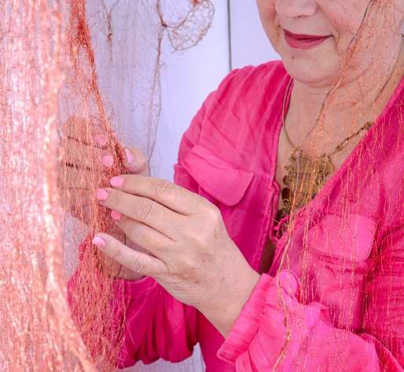

Image: Artist Shelley Hannigan installing in situ. Round Three.
Photography by Rebecca Hosking.

HOW TO EXPRESS YOUR
INTEREST

How to express your interest

Artists are invited to submit their Expressions of Interest (EOI) via the online form. Please note emailed submissions will not be considered.

If you require assistance, or another application method such as a live video conference call, please do let us know via the email artsculture@geelongcity.vic.gov.au or via phone on 5272 5509 and ask to speak with the Arts & Creative Programs Officer.

You may enter several applications for different concepts and ideas.

The Expression of Interest applications shall be reviewed in line with internal guidelines, curatorial direction, and in relation to suitability.

Please advise if you agree for your application/s to be reviewed and considered for follow on Rounds (in the following 12 months).

EOI’s shall remain open for an ongoing period to further accommodate application accessibility, for the ongoing formation of new art ideas and practices, and to facilitate the curatorial process.

Please note we will accommodate requests for certain windows and dates where possible but ultimately, the works will be curated.

Please include in your submission

- 3 - 5 images of the artwork you propose to exhibit within the space.
- If you are making work that is site specific, please send through 3 - 5 images that reflect the work you propose to exhibit.
- Files are to be JPEG/MPEG/JPG/DNG or MP4. Still images are to be a maximum 1MB each and video files under 150MB and no longer than 3 minutes if attached as files.
- Please clearly identify if these images are of your practice, if not yours then whose (for e.g., if it is imagery you are taking inspiration from), and if these are AI generated (and the extent of which).
- You are encouraged to create a PDF folder with all your files and information. Include any additional imagery/information with active links, up to 5MB in size.
- For digital mediums, such as film, animation, and audio:
  - Please include a link to a publicly accessible location (such as Vimeo or Google Drive) with the password (if applicable).
  - Preferred format is MP4 at a high (to medium) resolution with a preferred 2 – 4K.
  - You may include up to three links.
- Please advise how the images/files relate to your EOI. For example, please specify if this is the completed artwork and the date of creation. Or please advise if it is an incomplete creation that forms the basis of your intended artwork.
- If the images/file relate to a completed artwork/design, please advise if it has been displayed elsewhere.
- A one-page Artist CV (in document or PDF format).
- An Artist Bio (up to 250 words maximum).
- An Artwork Statement (about the work being displayed, up to 500 words maximum).
- Social media and/or website page links for further consideration and context of your practice. (If you don’t have these you can still submit.)
- Please indicate if you have a preferred Round/s (that is, when you and your art are available).
Page | 7
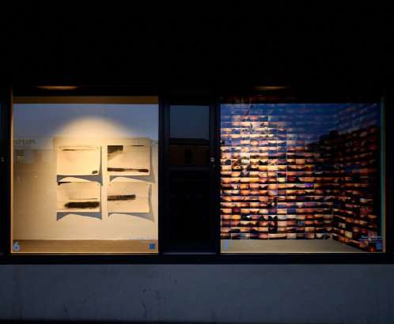

Image: Yarra Street Window Gallery, Round Two.
Window 6: art by Luisa Gioffre-Suzuki Window 7: art by Dean de Landre. Photography by Peter Foster.

SUCCESSFUL APPLICANTS

What will be required of you if you are successful?

If you are selected, the Round shall be communicated and confirmed with you. If you would like to proceed you will be asked to:

  - Forward additional digital files of your artwork if the original files weren’t of the completed/reflective of the exhibition artwork.
  - Be available for phone and/or email communication regarding
installation and display needs/options.
  - Liaise with the Arts & Creative Programs Officer regarding artwork curation, installation needs and options, and artwork title.
  - Be available for the communicated bump in schedule and delivery of the artwork (this will be from 3 - 1 day before the first day of the listed Exhibition Round dates).
  - Potentially be available for publicity opportunities as organised by the City of Greater Geelong (where you will be asked if this is something you agree with time to decide).
  - Collection of the artwork on the scheduled bump out day (usually this will be the day after the last day of the listed Exhibition Round dates).
  - Read, review and sign an agreement confirming the exhibition arrangement, payment and Inward Loan Agreement.

Successful applicants will receive the following.
  - Three-month exhibition within one allocated window and paid
$500 (excluding GST) exhibition loan fee.
  - Professional support to install and deinstall your work/s.
  - A set of high-resolution professional photographs documenting the exhibition.
  - Promotional support through websites, social media, newsletters, and art listings.
  - Exhibition signage including your name and QR code to your
preferred platform.
Page | 8

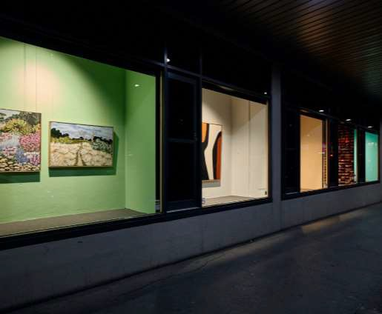
SUCCESSFUL
APPLICANT RESPONSIBILITIES
Image: Yarra Street Window Galley, Round Two, partial street view. Far left Window, art by Abby Sleep. Photography by Peter Foster.

Successful applicants will be responsible for the following.

    - Signing the exhibition agreement.
    - Artwork delivered by allocated dates arranged with the Creative Cities Arts & Creative Programs Officer. Artworks must be delivered ready to hang with professional fixtures.
    - Providing information for promotional material no later than four
weeks prior to your exhibition.
    - Pick up of artworks at the end of the exhibition period by allocated dates in consultation with the Creative City team.
    - Any specialised electrical equipment must be tagged and tested prior to installation.
    - Additional costs associated with advertising or promotions not listed above.
    - Your own Insurance coverage for your works for the duration of
the exhibition.

Page | 9
Page 9

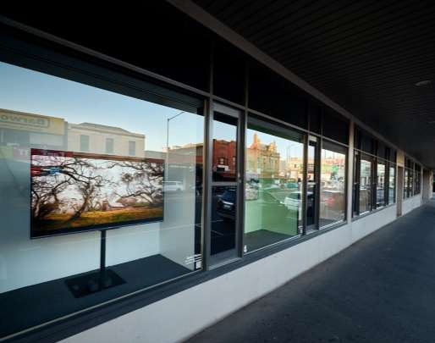
CONTACT US
Image: Yarra Street Window Galley, Round Two, partial street view. Full Window view, art by Sandy Mahon. Photography by Peter Foster.

Contact Us
If you have any further questions, please call the Creative City team on 03 5272 5509 or email artsculture@geelongcity.vic.gov.au .

Page | 10

