CITY OF GREATER GEELONG
CHILD SAFETY





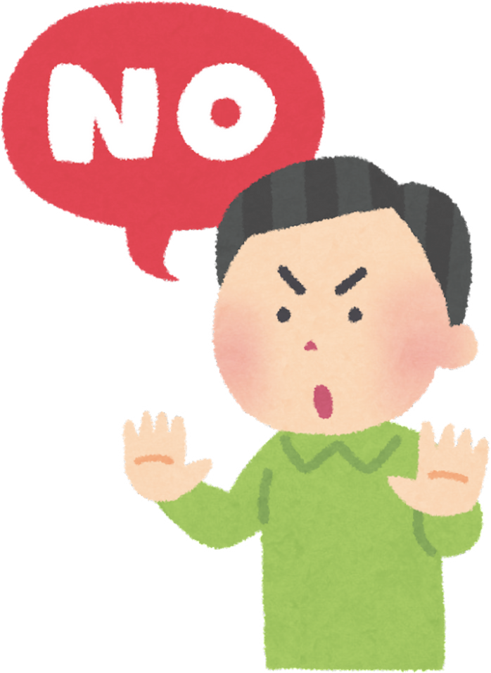
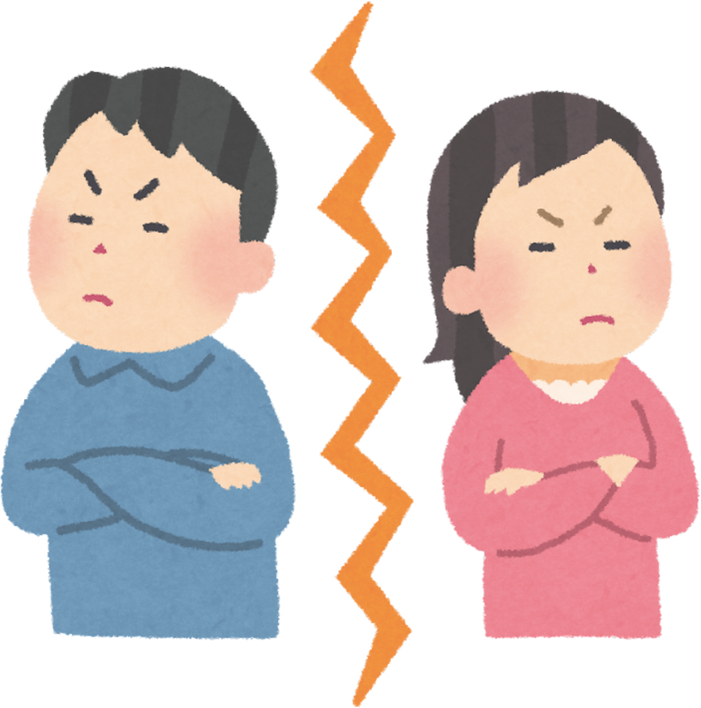
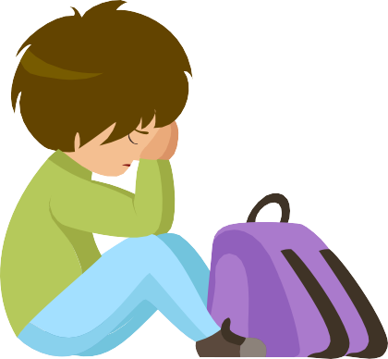
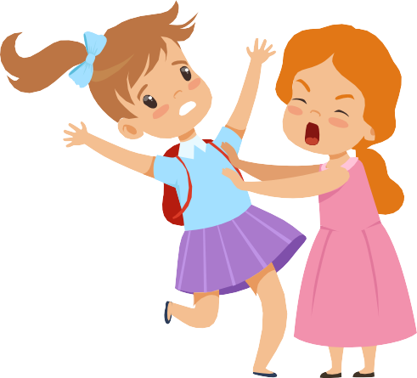
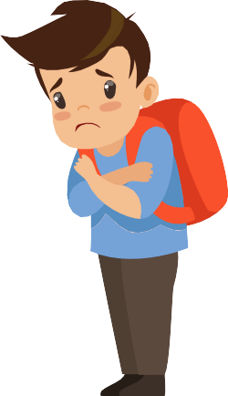
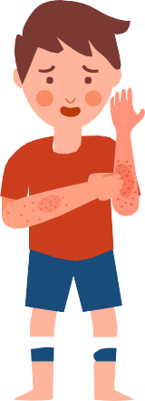

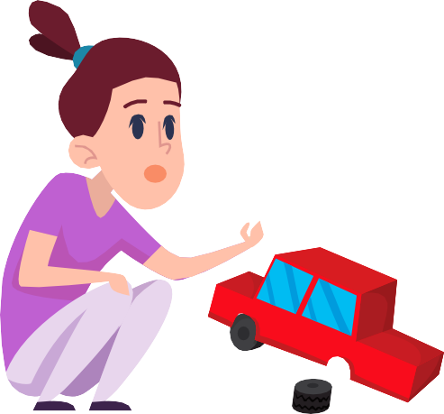
WHO CAN HELP?
WHAT IS YOUR CONCERN ABOUT?

ENVIRONMENT
MYSELF
FRIENDS ADULTS

This includes things like:
- Unsafe playground
- Unknown person
- Broken toys and equipment
- Someone else being hurt
This includes things like:
- Someone forcing me to do something
- Getting Hurt
- Feeling sick or frightened
This includes things like:
- Not feeling safe
- Not being kind.
- Not being my friend
- Seeing my friend hurt
This includes things like:
- Not Listening
- Feeling unsafe or uncomfortable
- Saying unkind words

You can talk or write team member from the People & Employee Relations team

If you need help finding the right person, please call People Assist on
03 5272 5000

You can write to the City’s Integrity
and Review Officers on integrity@geelongcity.vic.gov.au

You can talk or write to Child Safe Officer on
03 5272 4032 or childsafe@geelongcity.vic.gov.au

’

You can talk to a Leader at the
City of Greater Geelong.
A PEOPLE LEADER CHILD SAFETY OFFICER INTEGRITY AND REVIEW PEOPLE PARTNERS /
OFFICERS WORKPLACE RELATIONS

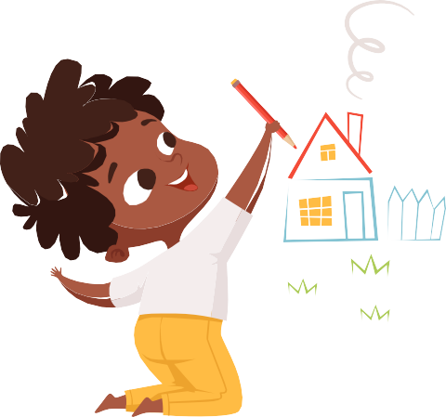
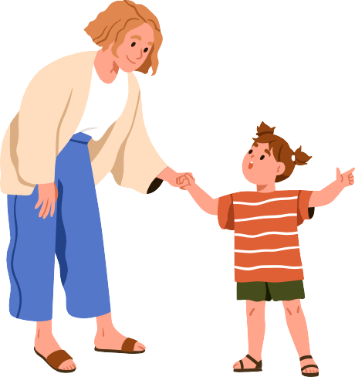
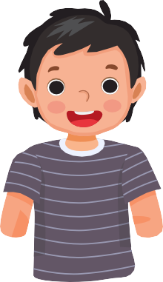
HOW CAN I SHARE MY CONCERNS OR COMPLAINTS?

Ask for help Ask for help from friends, parents or adult
Draw a picture or ask another grown-up
to write a note for you

