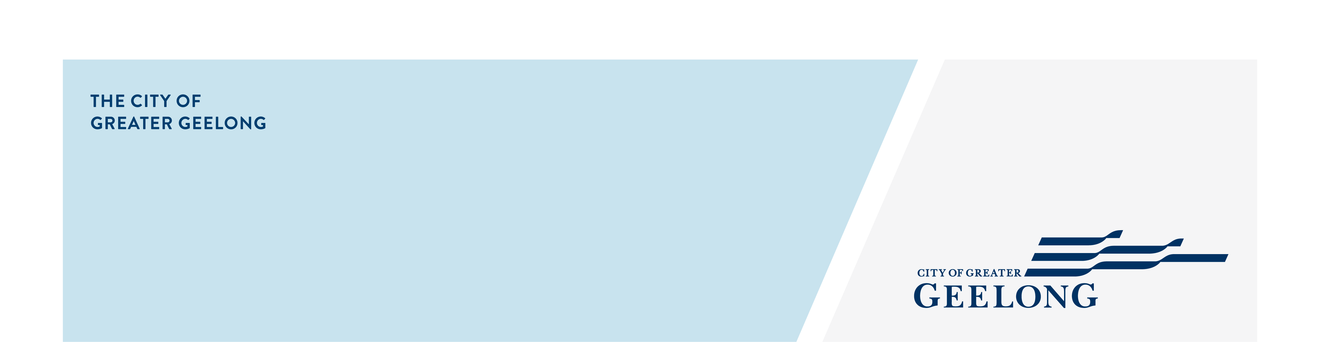
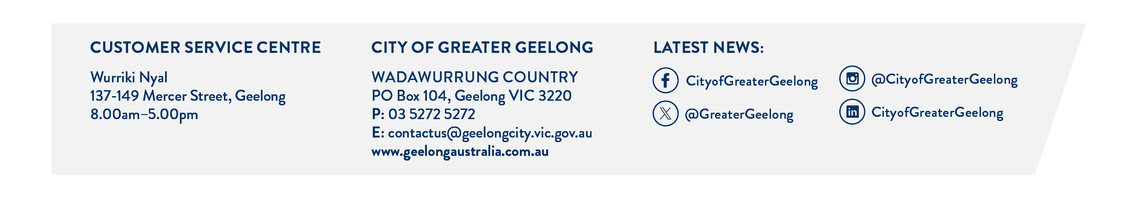
canopy trees

introduction of clause 52.37 (canopy trees)
On 15 September 2025, the Minister for Planning amended all planning schemes, via amendment VC289, by introducing clause 52.37 (Canopy Trees) into the planning scheme.
This clause may trigger the need for a planning permit to remove, destroy or lop a canopy tree in specific circumstances in all residential zones (except for the Low Density Residential Zone).

what is A CANOPY TREE?
Under clause 52.37, a canopy tree means a tree that has:
- a height of more than 5 metres above ground level; and
- a trunk circumference of more than 0.5 metres, measured at 1.4 metres above ground level; and
- a canopy diameter of at least 4 metres.
vicsmart application
If you need a planning permit to remove, destroy or lop a canopy tree under clause 52.37 of the planning scheme, you may be eligible to apply for an application under the VicSmart application process (subject to meeting the requirements of clause 71.06 of the planning scheme).This is a fast-tracked process where, once all the information is submitted, a decision should be made in 10 business days.
If your application is not eligible for the VicSmart application process, the application is exempt from the public notification process (advertising period).
information to be submitted
The information you need to submit with an application can be found on the Canopy tree checklist

assessment of an application
Under clause 52.37 council officers can only assess the application against the purpose of the clause and the matters contained in the decision guidelines of the clause. Broader policies or decision requirements in the planning scheme or section 60 of the Planning and Environment Act 1987 cannot be considered.

For many applications, there will be a requirement to plant replacement canopy trees to protect or enhance canopy tree cover. Clause 52.37-3 sets a minimum canopy tree cover requirement, including the requirement for replacement (new) canopy tree(s).

What is a new canopy tree?
A new canopy tree must be a species and type that will, at maturity, have:
- an expected height of at least 6 metres above ground level; and
- an expected canopy diameter of at least 4 metres.

