BUILD OVER EASEMENT CONSENT
– Locating Information on a Plan of Subdivision
Easement shown on Plan of Subdivision – Easement width shown in Green
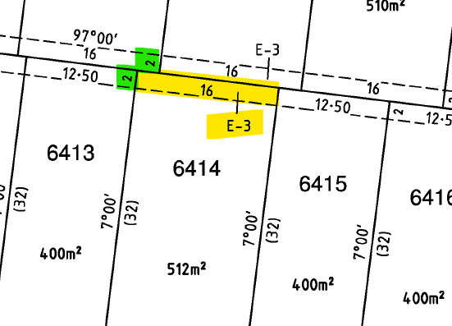
Easement Details shown on Plan of Subdivision
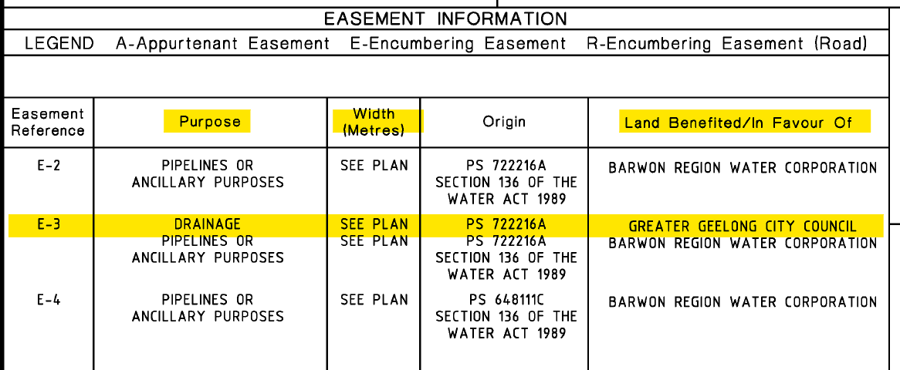
– Typical Angle of Repose Diagram Required
