Design and Development Overlay - Schedule 14 (DDO14)

WHAT IS THE DDO14?

The Design and Development Overlay – Schedule 14 applies to applications for dwellings that are greater than 7.5 metres in height above natural ground level (NGL). The overlay applies to land where it has been recognised that there are significant views such as the coast (ocean and foreshore), Corio Bay, Barwon River, Central Geelong, Barrabool Hills and the You Yangs.

The overlay recognises that dwellings greater than
7.5 metres in height have the potential to impact upon the availability of views from surrounding properties and seeks to achieve the reasonable sharing of views between properties.

The overlay does not wholly protect the available views and recognises that some views may be compromised.

WHAT IS REQUIRED TO BE SUBMITTED WITH AN APPLICATION?

The Schedule to the Overlay specifies an application must demonstrate if there is likely to be an impact by the proposed development on views to significant landscape features (please see attached example).

With an application, the following should be submitted:

- A site context plan showing;
  - The development of the adjoining land (as appropriate);
  - The availability and directionality of views from the surrounding properties across the subject site (including vacant sites).
- Longitudinal drawings (to scale) as appropriate (generally north/south, east/west) which show the proposed development in context with the surrounding properties, the relevant levels of the land and the potential impact upon the available views.
- The portion of the dwelling exceeding 7.5 metres must be clearly indicated.
- Any other information which demonstrates how a reasonable sharing of views has been achieved.

WHAT IF MY DESIGN IMPACTS VIEWS?

If plans indicate that the proposed development is likely to result in an impact upon the views available from surrounding properties, a full view impact analysis report must be submitted. The analysis must demonstrate how the design of the proposed dwelling achieves a reasonable sharing of views having regard to topography, siting, height and visual bulk and the extent of available views.

The report must also demonstrate how the proposal responds appropriately to the Decision Guidelines of the Schedule, as follows:

- The design objectives of the schedule.
- The impact of the proposed buildings and works on the view from another property as result of the design, siting, height, size and bulk (including the roof).
- Whether opportunities exist to avoid a building being visually obtrusive by the use of alternative building designs, including split level and staggered building forms, that follow the natural slope of the land and reduce the need for site excavation or filling.
- The opportunity for a reasonable sharing of views having regard to the extent of the available view(s) and the significance of the view(s) from the properties affected.



For further information or assistance please contact Statutory Planning on 5272 4456

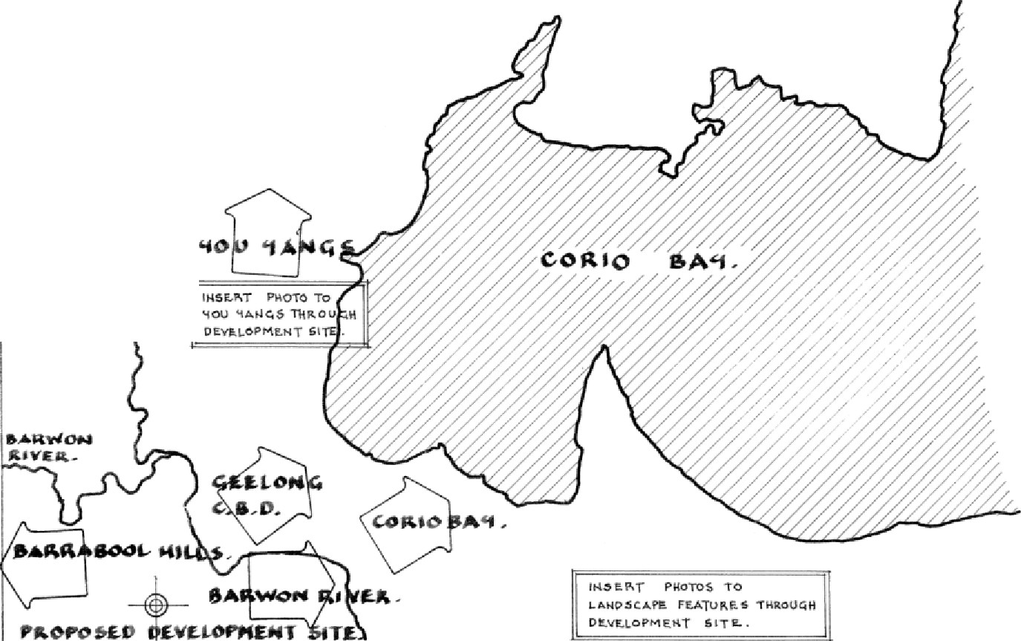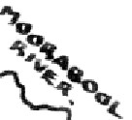

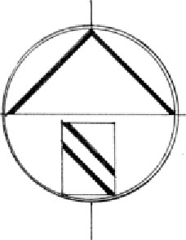
L.OC:.AL.IT't
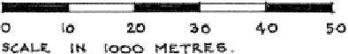

EXAMPLE OF AN
EXTE THROUGH THE SITE. .

NDED LOCALITY Pl.AN DEMONSTRA TING THE DIRECTION OF IMPORTANT

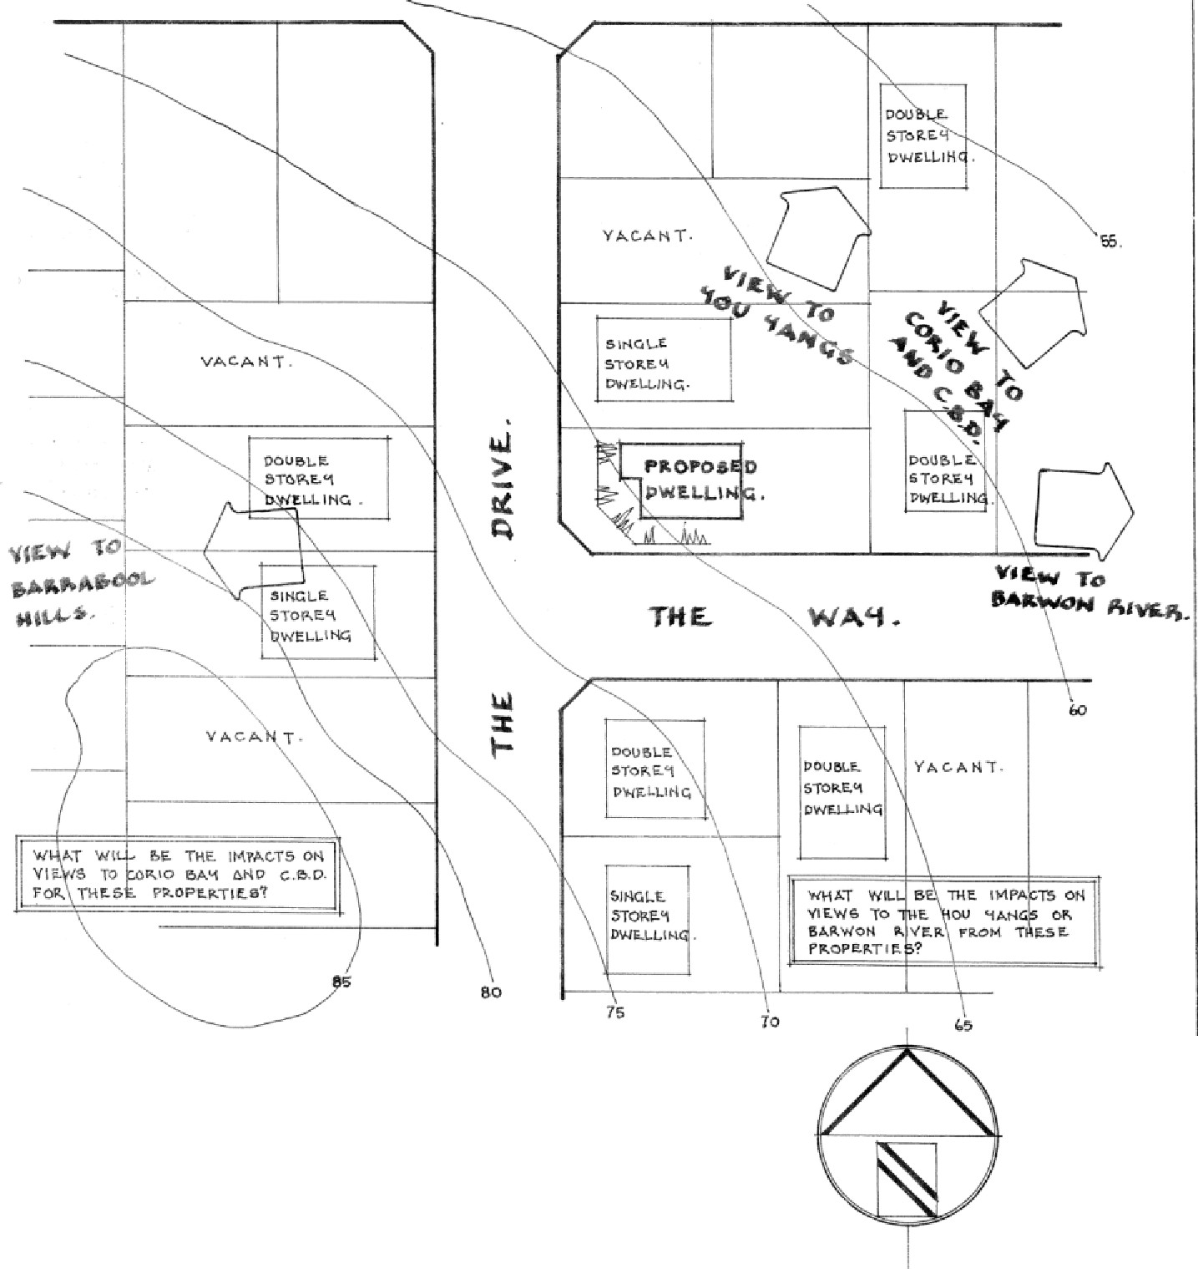
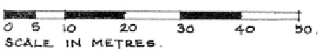
LANDSCAPE FEATURES PROPOSEDDEVROPMENT VISTAS AS AVAil.ABlE THROU6H THE
SITE. CONTEXT
PLAN,
EXAMPLE PLAN OF THE INFORMATION REQUIRED TO BE SHOWN ON A SITE CONTEXT Pl.AN.
NOTE THEFOi.LOWI I P.:;
- • TDHEEVRAOVPAMILEANBTIOLITY DJODIIRNECINTIOGNl.AONf VIEWS THR
NTFEATURES:
D (AND FUR !"'ri-ic DEVROPMENT SITE
FIELD IF REQUIRED)
AND
CONTOURS
NORTH POINT
..
CITY OF CI.UTU.
INSERT PHOTOS OF THE
SITE TO DEMONSTRATE THE AVAILABII.ITY OF THE VIEW.



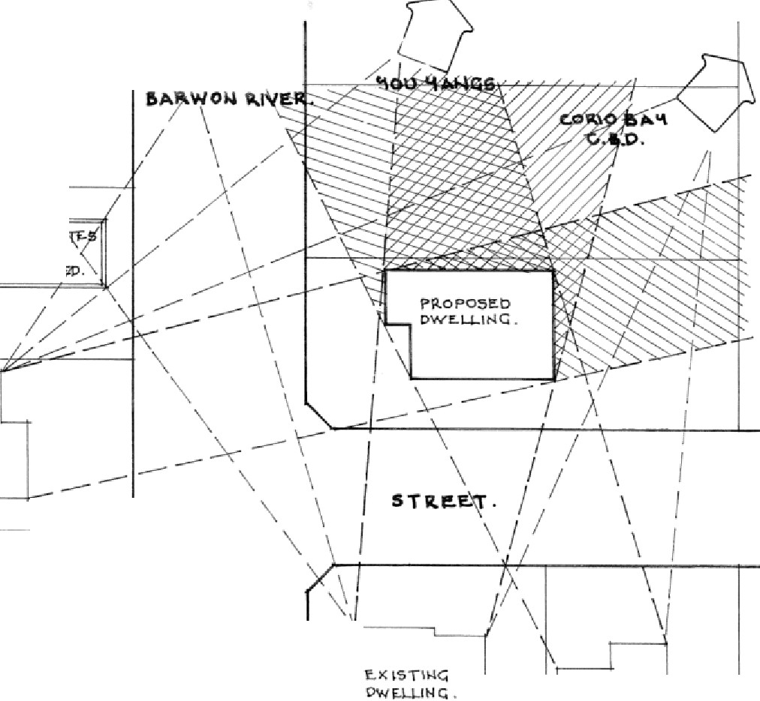
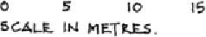

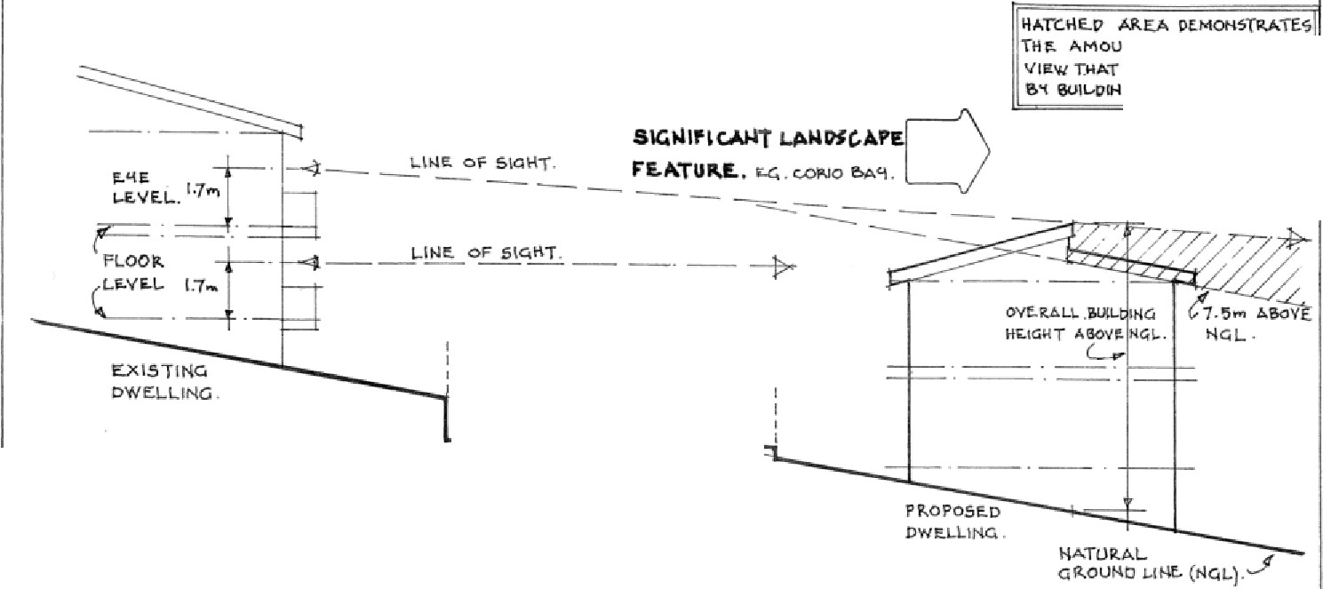
11,\J\,._Jo.bOOL.
1111..1.s.
\
ij"'-TC.1-1£.D AR.EA. OEMONSiR>,.: THE ..._MOOl·H Of' E.XCST' MC. VIEw 11-U•,T NU& IMl"AC..T
0
0
_J
'XIST\HG
OWE.L.L.-INCi..
I­
ll
Ill
"I-
WI
1 nHc.
OWE.LUNG.
£XTENT / IMPACT OH Vl£.W.
EXAMPLE OF Pl.AN DEMONSTRATING EXTENT Of VIEW THAT WILL BE IMPACTED

WRITTEN REsPONSE SHOULD GIVE CONSIDERATION TO,
HAS A SHARING OF VIEW BEEN ACHIEVED? IF SO. HOW?
HAS THE PROPOSED DWEu.ING INTEGRATED DESIGN ELEMENTS TO ALLOW A
SHARING OF VIEWS?
WHAT IS THE SIGNIFICANCE Of THE VIEWS THAT WILL BE IMPACTED? ARE THERE OTHER LANDSCAPE FEATURES THAT BLOC VIEWS?

Pleose note that thesr.: example.s are a guide to QSSi;t in demonstrating if a proposal wilt impact upon views and the extent of the impact. Othe.r tools: may be used onsite To demonstrare. the. impact, such as height poles dnd photographs.
..
cm' OJ CR.t.ATll.
-
---sTRE.E..T.
Cll0$S 6E.CTION OF PEVEl-OPMEHT.
--
-----
0 I
-
-
t

mrr Of E.J(l!rf!MO
:f WIU. E. IM.Pble,"'fet,
a KlilGHT A&o 1.S-.

EXMIPLE LON6ITUDINAL Pl.AN WHICH SHOWS THE PROPOSED DEVELOPMENT IN CONTEXT WITH AN EXISTING DWELLING

IMPORTANT FEATURES TO NOTE: Pl.AN MUST BE TO SCALE
PLAN MUST INDICATE NATURAL GROUND LEVEL
PLAN MUST SHOW PORTION OF THE PROPOSED DWELLING WHICH EXCEEDS 7.5 METl!ES FROM NATURAL GROUND LEVEL
DIRECTION OF SIGNIFICANT VIEW FEATURE

Pleo:s-:: riot-=: that these e.xample.s are. a guide to assist in demonstro.rlng if a propo$01 will impact upon views, and the extent of 1he lmpa.ct. Other tools may be used onsite to d,trnor\$1'1"(1.te the impac1 such as height po!e.s and pho1ographs.

