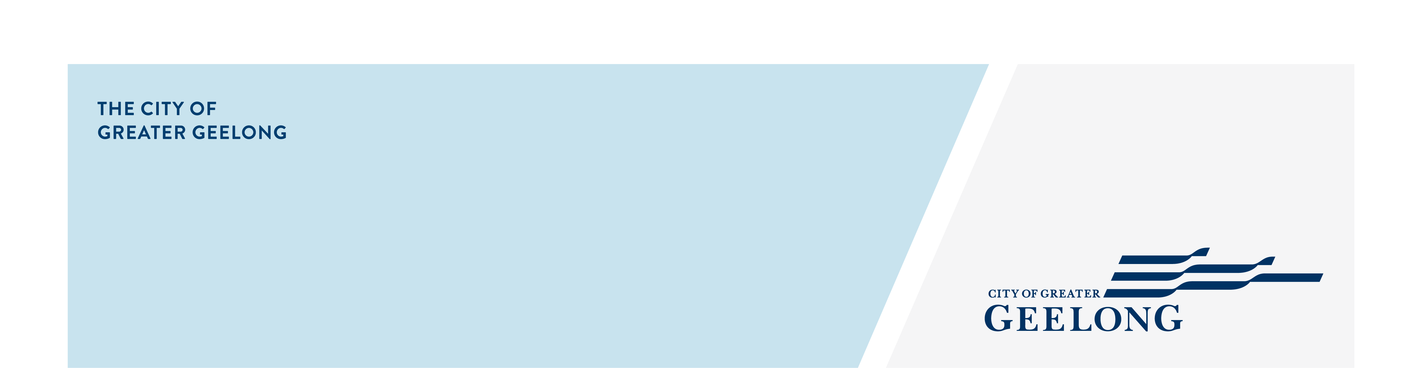
Four to Six Storeys code

To assist us in assessing your application under clause 57 of the Greater Geelong Planning Scheme, the following information must be provided with your application for planning permit:

information requirements:
Fully dimensioned plans, at a preferred scale of 1:100 or 1:200 including:

- Existing and proposed buildings and works, including title boundaries, dimensions of the site, buildings, garden areas, driveways and parking areas;
- Floor plans;
- Elevation plans, including heights above natural ground level;

Site description, as outlined in cl 57.01-1
Design response, as outlined in cl 57.01-2
Written statement outlining which standards are met and which are not met.

- Where a standard is met, you must explain/demonstrate how the standard is met (eg the height of the building is 5m (see Plan TP.03).
- Where the standard is not met, you must explain how the development meets the corresponding objective having regard to the decision guidelines of that standard.
See our Cl 57 template as a guide
Landscape plan that shows:

- Retention and planting of canopy trees;
- Planting of other vegetation, including location, species, number and size at maturity;
- Where required, areas of deep soil and root barriers;
- Irrigation system to support existing and planted vegetation, including details of any alternative water supply sources;
- Selection of vegetation that responds to the site’s environment and geographic factors;
- Location of services
- How the minimum canopy cover required under cl 55.02-7 is met
Natural ventilation plan, as required by cl 57.03-9 or alternatively a ventilation report showing an alternate solution.
Shadow diagrams, as required by cl 57.04-1 if standards E2-2 and E2-3 are not met.

Note: this includes a set of shadow diagrams showing overshadowing of the existing conditions.
Overlooking diagrams, where required, as outlined by cl 57.04-2 where
Blue Factor Report or MUSIC Report as required by cl 57.05-1

