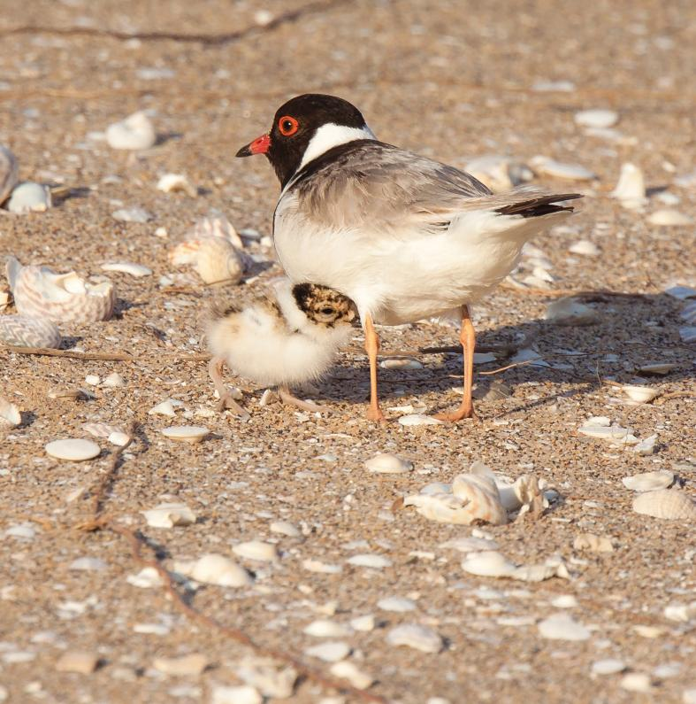

THE CITY OF

GREATER GEELONG

CONSERVATION ACTION PLAN

HOODED PLOVER

WORKING TOGETHER FOR OUR NATURAL ENVIRONMENT

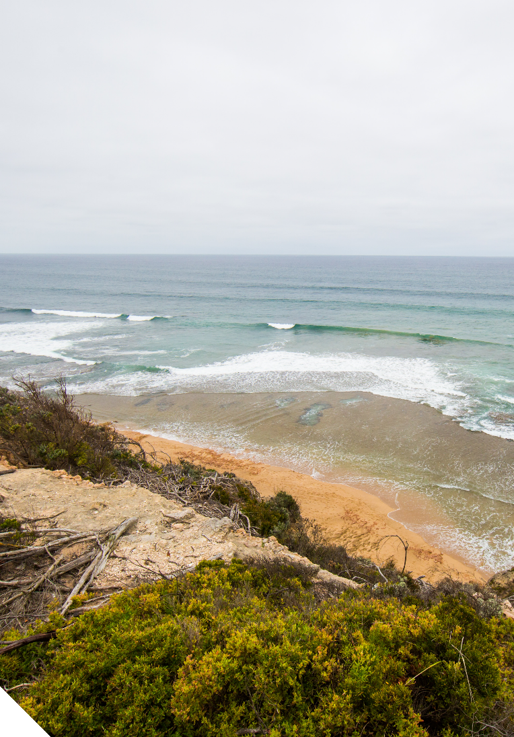
“When I began my immersion into the parallel world of the Hoodies, I had seen the odd piece of beach signage referring to hooded plovers but had never actually seen a bird, despite being a surfer.
Plover to me meant spur-winged plover. I had a lot to learn about the beach I thought I knew. Now I understand how special these creatures are.
Over millions of years they have evolved the ability to survive solely on the strip of seaweed-strewn sand that divides the Great Southland from the Southern Ocean. If any single entity defines the surf beach of south eastern Australia, it has to be the hooded plover.
I don’t want to watch it slide towards extinction if I can do something to help prevent it, and as long
as Hoodies keep trying to live, I’ll keep trying to be their human ally.”

John Murray
BirdLife Australia Volunteer,
Friends of the Hooded Plover, Bellarine Peninsula

THE CITY OF GREATER GEELONG

HOODED PLOVER

CONSERVATION ACTION PLAN

WHY WE NEED A PLAN 4
ABOUT THE EASTERN HOODED PLOVER 6
THREATS TO THE HOODED PLOVER 9
KEY OBJECTIVES 12
WHERE TO FROM HERE? 18

Cover photo: Glenn Ehmke

WHY WE NEED A PLAN

Beach-nesting birds are some of the most threatened birds in the world. As a community, we have a responsibility to

support the survival of beach-nesting bird species. The hooded plover (Thinornis cucullatus cucullatus), locally know as “Hoodies”, is one such vulnerable species that lives and breeds on the surf beaches within the City of Greater Geelong.
Since 2006, the City, under the guidance of BirdLife Australia, has implemented a range of actions to protect the local Hoodies and support their community volunteers.
In 2013, the City facilitated the formation of a multi- representative working group, the Hooded Plover Working Group. Representatives from local coastal management agencies who manage hooded plover breeding areas make up the group. Our collective aim is to work towards National Recovery objectives developed by BirdLife Australia and to ensure a strategic approach toward all aspects of hooded plover management.
The working group includes: BirdLife Australia, Friends of the Hooded Plover (Bellarine and Breamlea), Barwon Coast Committee of Management, the Borough of Queenscliffe, Parks Victoria, Barwon Water and the City’s – Environment and Local Laws Departments.
This Conservation Action Plan documents the objectives and actions the City is committed to in the local conservation of the hooded plover. This Hooded Plover Action Plan consolidates current actions and sets a framework to focus future activities to achieve the most good for this species.
This plan is intended to be a shared resource for the City, other agencies and volunteers who support the hooded plover program in the field.
THIS PLAN’S POLICY CONTEXT
It is the City’s intent to commit to the survival of the hooded plover, through the implementation of this Conservation Action Plan, from here on referred to as the Plan.
The Plan is guided by BirdLife Australia’s beach-nesting bird protocols in accordance with national and state threatened species legislation.

Environmental Protection and Biodiversity Conservation Act 1999 (EPBC Act)
The EPBC Act is the Australian Government’s central piece of environmental legislation. It provides a legal framework to protect and manage nationally and internationally important flora, fauna, ecological
communities and heritage places (Australian Government
- Department of Environment, 2014). The hooded plover is listed as Vulnerable under this legislation.

Flora and Fauna Guarantee Act 1988
The key piece of Victorian legislation for the conservation of threatened species and communities and for the management of potentially threatening processes (Department of Environment and Primary Industries, 2014). The hooded plover is listed as Vulnerable under this legislation.

Flora and Fauna Guarantee Action Statement Number 9.
Action statements are a requirement under the Flora and Fauna Guarantee Act 1988. The Hooded Plover Action Statement outlines research and actions to improve the likelihood of hooded plover species survival.

The City Plan 2018–22 – Putting Our Community First
The City Plan is the overarching strategic plan for City of Greater Geelong. It outlines how we will work towards making Greater Geelong a clever and creative city-region. One of the 11 strategic priorities is to ensure nature reserves, rural and coastal environments are preserved through the application of sustainable development principles.

The City’s Biodiversity Strategy 2003
This strategy highlights the role society must play to ensure the long-term survival of the diversity of species that inhabit our local environments, many of which are at threat from human activity and population growth. It prioritises no further species loss and promotes public awareness around biodiversity.

4

GUIDING PRINCIPLES
COLLABORATE
Bring together agencies, community groups and volunteers to work cooperatively to help the hooded plover species survive and thrive.
LEAD
Provide encouragement, guidance and support to our local community and partners.
DO THE MOST GOOD
Assess and prioritise actions based on what is likely to be most beneficial.

Young chicks feeding on the open beach. They must find their own food from hatching and are unable to fly until five weeks old.
Photo: Glenn Ehmke
CONCENTRATE EFFORT
Work only within our sphere of influence with an understanding of what we are capable of achieving.
VALUE KNOWLEDGE
Seek out specialised knowledge and data from BirdLife Australia and Hooded Plover Volunteers to guide decision-making.
EXCEL
Strive for best practice in decision-making, continuous improvement, action and reporting.
EVALUATE + EVOLVE
Practise adaptive management - measure, review and improve annually.

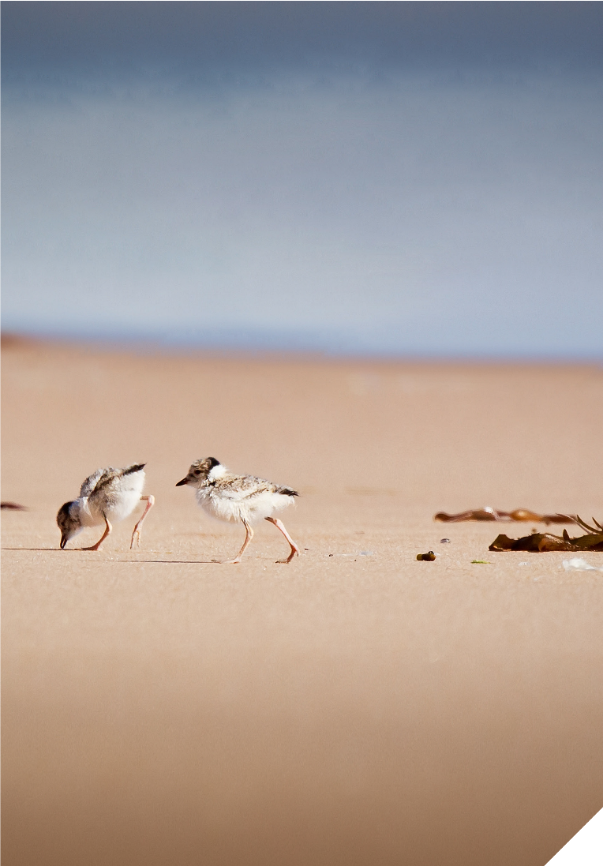

5

ABOUT THE EASTERN HOODED PLOVER

There are two subspecies of hooded plover in Australia, the eastern and western subspecies which are separated by the Great Australia Bight.
The eastern hooded plover (Thinornis culcullatus culcullatus) is a medium-sized sandy-brown plover with a black head, a white nape and a bright red ring around each eye. Eastern Hoodies live and breed only on high energy sandy beach environments. They once occurred along the southeast coast of Australia between South Australia and southern Queensland, including Tasmania, but are now locally extinct in northern New South Wales and Queensland.
The western hooded plover (Thinornis cucullatus tregellasi) only occurs west of the Great Australian Bight in Western Australia. They breed on the south-west Western Australian coast, from Cape Naturaliste to The Great Australian Bight and more typically on lakes up to 250 kilometres inland.

The eastern Hoodies are not abundant and are listed as Vulnerable, under both National and Victorian Threatened Species Legislation. In Victoria, the highest densities
of hooded plovers occur on wide beaches with large amounts of beach-washed seaweed. Hoodies require seaweed to provide habitat for their food source, seaweed eating invertebrates such as sand hoppers. Densities are lowest on narrow, steep beaches, where there are few or no dunes, and where human activities are most intensive (BirdLife Australia, 2012).
Outside of the breeding season, the adult and sub-adult birds flock to local beaches and coastal wetlands. They are not migratory but young birds can disperse looking for new territory and partners. The breeding season extends from late August into April. Towards the start of the breeding season the flocks disband and Hoodies pair up. Each pair occupies and defends a breeding territory on a surf beach. These pairings are for life but some Hoodies have been known to change partners. They do however generally return to their same breeding territory.

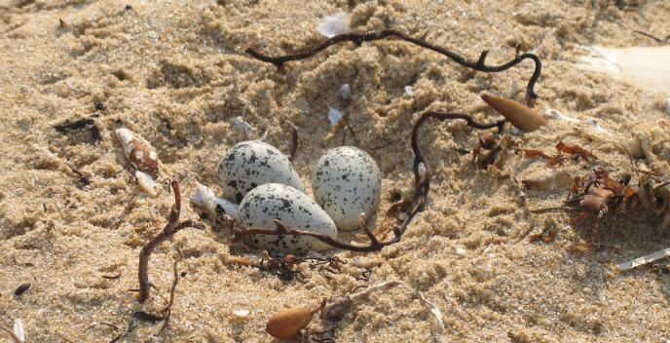
A nest scrape

36

Hooded plovers have a very low reproductive survival rate. They have a nest failure rate of up to 95%, with one local pair having up to 9 nesting attempts in a single season. Since 2006 on the Bellarine Peninsula and Surf Coast beaches, 61% of nests have failed to hatch any eggs, and 74% of hatched chicks have failed to fledge (BirdLife Australia data from 2006/07-2015/16).
Around September breeding pairs create a shallow scrape in the sand above the high-tide mark on the beach or in the dunes. Up to three camouflaged eggs are laid into the shallow scrape. The 28 day incubation period begins once all eggs have been laid.
New chicks are tiny, less than seven centimetres long, fluffy and highly camouflaged. They are mobile after hatching and must search for food to feed themselves. Parents warn the chicks of danger but do not feed them.
Chicks are flightless for the first five weeks. During this period they are highly vulnerable to a range of threats. The chicks are very mobile, ranging up to two kilometres along the beach to find food or shelter.

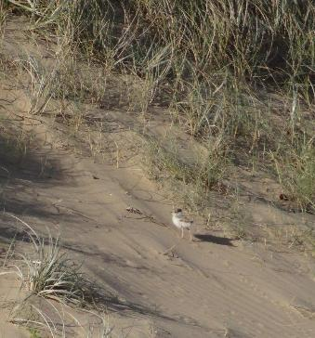
Chick seeking shelter

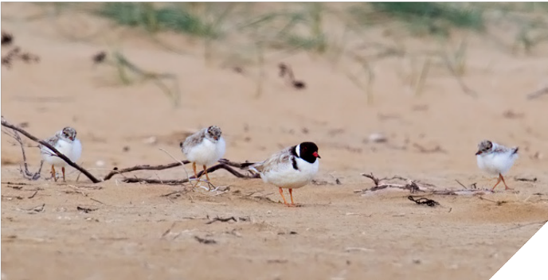
Adult and 3 unfledged chicks at Breamlea in 2015. All 3 chicks eventually fledged after surviving on the beach for 5 weeks. Photo: Geoff Gates

7

WHERE HOODIES LIVE IN OUR REGION
The City of Greater Geelong supports 6.7% of the Victorian population (estimated at around 570 birds).
Our Hoodie population is part of the central hooded plover subpopulation which extends from Moggs Creek in the west to South Gippsland in the east.
Our local hooded plovers are a high priority population. This is because their central location facilitates emigration and immigration between neighbouring subpopulations.
The Bellarine Peninsula ocean beaches extend for 25 kilometres from Thompsons Creek in the west to the Point Lonsdale Lighthouse in the east. Local hoodie breeding sites have been recorded on various sections of these beaches (see Map A below).

We manage approximately nine kilometres of coast, spanning Thompsons Creek to Bancoora Beach, Breamlea and Ocean Grove to Point Lonsdale (see Map B below).
The remaining 16 kilometres is managed by Barwon Coast Committee of Management, the Borough of Queenscliffe and Barwon Water. Adjoining Thompsons Creek, immediately to the west, the coast is managed by the Great Ocean Road Coast Committee and this is also a breeding area for hooded plovers.

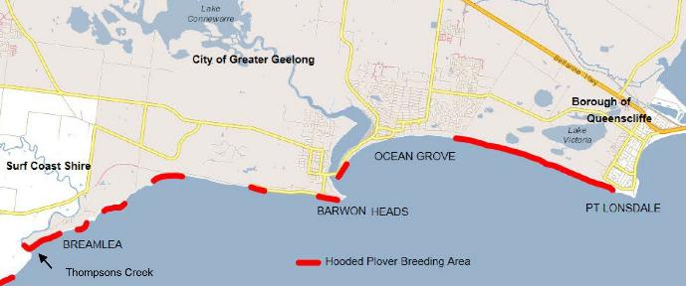

Map A. Hooded plovers breed along the ocean coastline, there are eight main sites within the City of Greater Geelong.

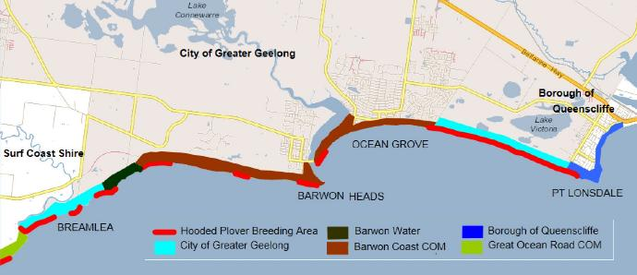

Map B. The distribution of hooded plover breeding areas in relation to coastal management boundaries.

8

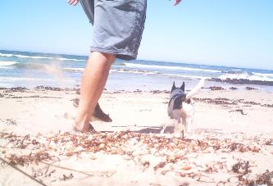

THREATS TO THE HOODED PLOVER
1

Threats to the survival of hooded plovers in our coastal zones include:
- Humans – recreational beach users, horse riders, vehicles, events, boot camps, paragliders, hang gliders.
- Dogs – unsupervised dogs, dogs off leash (even if under effective control), and dogs on leash in situations where disturbance keeps Hoodies away from their nest.
- Predators – foxes, dogs, cats and native birds (including ravens, magpies and gulls but only when in high densities due to human modified environs).
- Oil spills
- Introduced plant species – Sea Wheat-grass (Thinopyrum junceiforme), Marram grass (Ammophila arenaria) and Sea spurge (Euphorbia paralias).
- Climate change and sea level rise infrastructure.
- Very high tides and storm events
- Coastal population growth and increasing beach user numbers in Hoodie breeding habitats.
- Habitat loss or modifications – including loss of non- breeding wetland habitat.
- Town and strategic planning incompatible with hooded plover habitat requirements.

MONITORING THREATS TO HOODED PLOVERS
Hooded plovers have been banded since the late 1990’s and BirdLife Australia’s Beach-Nesting Birds project team has been banding Hoodies since 2010. The current banding method is an orange or white flag ID engraved with two letters on the upper leg, and a metal band on the lower leg.
Banding provides valuable data for research and conservation purposes and gives us a wonderful insight into the secret life of Hoodies. Friends of the Hooded Plover volunteers monitor the birds breeding attempts and record threats observed at each site. This data
is submitted to BirdLife Australia who examine the local threats and how they change overtime, to inform recovery actions.

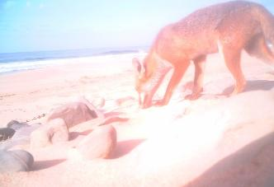

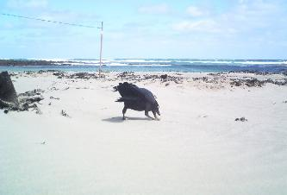
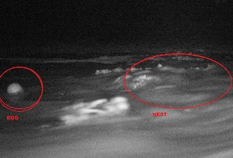
2
3
4

Threats caught on camera. 1. A person and off leash dog walking over a nest. 2. A fox investigating a nest. 3. A raven taking an egg. 4. Eggs washing away due to high tides and rough seas.
Photos: Birdlife Australia

9

THE BIG PICTURE

Our aim is to support the recovery and long-term survival of the hooded plover. Survival is dependent on an annual breeding success of at least 0.4 to 0.5 fledglings per breeding pair. This is the target identified by BirdLife Australia.
To achieve this, we must work together to remove threats that impede the breeding success of our local Hoodie population.
We need to underpin our actions with sustainable practices, adaptive and continuous improvement processes and cooperative and lasting partnerships. We need to identify resources and be open to new approaches.

CONTINUOUS IMPROVEMENT MODEL FOR THE MANAGEMENT OF HOODIE THREATS

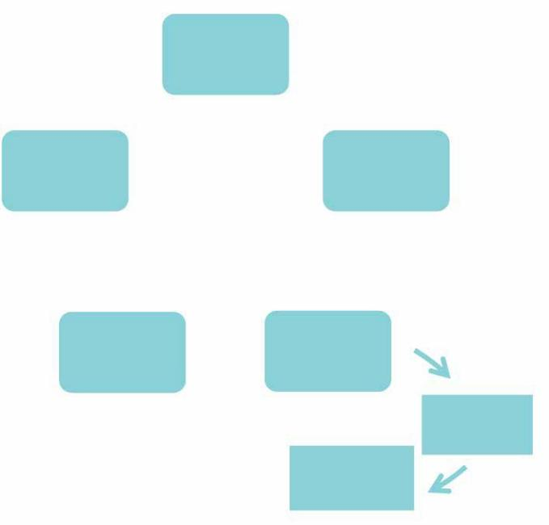


Identify local threats to Hooded Plover breeding success.
I"

Review seasonal program and re- assess threat abatement actions

\

Monitor the success of seasonal breeding in relation to 0.4 to 0.5 Fledglings per breeding pair per annum target.

Risk assess 11 threats¹¹

against practicalities

J

Apply a collaborative strategic approach to threat abatement
t

Modify threat abatement methods if needed...

Monitor threats during breeding season

10

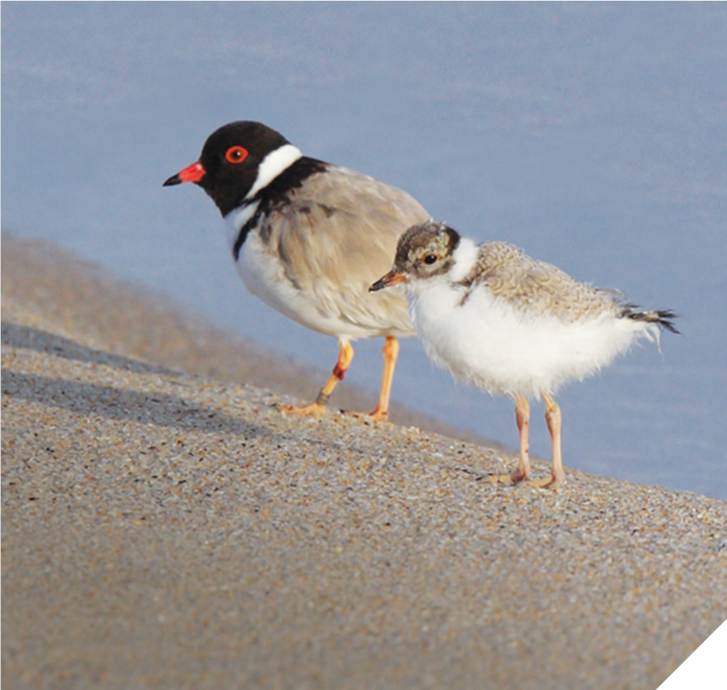
THE BOLD AND THE BEAUTIFUL
Jennie Turner, Friends of the Hooded Plover, Breamlea

A Hoodie soap opera, set on Thirteenth and Bancoora Beaches, starring PC as the femme fatale, AY as Don Quixote of our coast and EH as
Roadknight Romeo. Binge bird viewing at its best. Photo: Glenn Ehmke

Our headliners PC and AY (both banded at Thirteenth Beach) are embroiled in controversy. During the first breeding season they terrorise other Hoodie pairs along the Bellarine and at Breamlea, earning a Bonnie and Clyde reputation as they search for territory.
The following year, after a failed nest, the young, adventurous pair claim a spot on the dune face at Bancoora. With two eggs in their scrape, they get social, hosting a flock of feathery friends from near and far. All fun and games, but unfortunately their eggs don’t hatch.
Next breeding season, our young guns’ early nesting site east of the Bancoora Surf Club is destroyed by human footprints. They then battle on through a fourth season marked by lows and highs – an unsuccessful early nest at Thirteenth Beach, followed by three incubated eggs on their Bancoora patch, and finally, a single chick successfully fledged who now resides at Aireys Inlet!
Like any good soap opera, there’s no happy ever-after. Early in the fifth season, volunteers sight both AY and PC getting amorous … but not with each other. PC moves back to
her old stamping ground Thirteenth Beach with new partner EH. They incubate a lovenest of three eggs, producing a single thriving chick.
Meanwhile, AY has a change of heart and tries desperately to woo PC back to Bancoora. The feeling’s not mutual. Spurned, he’s now alone – single and looking to mingle.
What will the next season hold for our Hoodie headliners?

11

KEY OBJECTIVES
The City have identified four key objectives to direct management actions:

RAISE AWARENESS ABOUT HOODED

PLOVERS

SUPPORT BIRDLIFE

AUSTRALIA STAFF AND

VOLUNTEERS

MANAGE THREATS

TO HOODED PLOVER

BREEDING EFFORTS

APPLY A COLLABORATIVE STRATEGIC APPROACH
GOAL
To have an annual breeding success at least
0.4 - 0.5 fledglings
per breeding pair.

TOWARDS HOODED PLOVER BREEDING PROTECTION

FURTHER INFORMATION

Hooded Plover - BirdLife Australia - www.BirdLife.org.au/bird-profile/hooded-plover

A Practical Guide for Managing Beach-nesting Birds in Australia – BirdLife Australia (2008)- www.birdlife.org.au/projects/beach-nesting-birds/for-coastal-managers

Flora and Fauna Guarantee Action Statement #9 Hooded Plover - Department of Environment, Land, Water and Planning - www.environment.vic.gov.au/ conserving-threatened-species/flora-and-fauna-guarantee-act-1988/action-statements
Barwon Coast Hooded Plover Management Plan Final April 2009 - Barwon Coast - www.barwoncoast.com.au/hooded-plovers-threatened-bird

Environment Protection and Biodiversity Conservation Act 1999 (EPBC Act) - Australian Government - Department of Environment and Energy - www.environment.gov.au/epbc

12

OBJECTIVE 1

RAISE AWARENESS ABOUT THE HOODED PLOVER

Abbreviations: BirdLife Australia Volunteers (BAV) City of Greater Geelong (The City) BirdLife Australia (BA)

 | Action | Who | Timing | Achievement Target
1.1 Raise awareness through informative, consistent signage
1.1.1 | Manage temporary signage at nesting sites in accordance  with BirdLife Australia Beaching  Nesting Bird Guidelines. | BAV  The City | Once nest site has been established and for its duration. | Appropriate signage at 100% of nests for the level of beach use.
1.1.2 | Maintain permanent signage. | The City | All year round. | 100% to be maintained.
1.2 Run broad public educational programs
1.2.1 | Education activities. | The City BA | As required, but mostly December – January (peak holiday period). | At least two per season.
1.2.2 | Advertising campaign. | The City | October – March | Newspaper advertisements – three to six per season.  External advertising (e.g. bus) Advertise in City News.  Social media – five posts per season.
1.2.3 | Wardening of nesting sites at high threat locations. | BAV | Variable – chick dependent. | Supervise nests in high threat locations between 6.00am and dusk.
1.3 Run internal training and educational programs
1.3.1 | Local laws training | BA  The City | Pre patrol (Oct/Nov) | One per year, open to all municipalities.
1.3.2 | Increase internal awareness of staff in other areas of the City. | The City | All year | Two proactive stories per year in internal publications and staff news.  Targeted communication via email and opportunistic communications throughout the year.
1.3.3 | Promote program to senior management and Council. | The City | All year | Annual report on program and maintain regular communications.
1.4 Monitor the effectiveness of training and communication programs
1.4.1 | Undertake annual survey of beach users. | The City | Start and end of the breeding season. | Understand beach users knowledge of hooded plovers breeding and how it changes over time.
SNAPSHOT – GETTING THE MESSAGE OUT THERE

Clear, consistent and engaging materials, resources and education including:
- Temporary signage at established nest sites.
- Directional signage each season, especially in relation to dog controls.
- Conducting training sessions to educate Local Laws officers about species, threats and actions.
- Seasonal advertising and media campaigns.
- Beach patrols during breeding season to help educate beach goers.
- Supporting volunteer wardens during breeding season to help educate beach goers.
- Community-based events educating beach users, new residents, holiday-makers and surf schools.

13

OBJECTIVE 2

APPLY A COLLABORATIVE STRATEGIC APPROACH TOWARDS HOODED PLOVER BREEDING PROTECTION.
Abbreviations: City of Greater Geelong (The City) BirdLife Australia (BA)

 | Action | Who | Timing | Achievement Target
2.1 Working together with external agencies
2.1.1 | Continue the Bellarine Hooded Plover Working Group as the planning mechanism for local hooded plover management. | The City | All year round | Two meetings per season.  Enough communication to enable collaborative integrated actions and review of yearly results.
2.1.2 | City officers to enter information collected during site visits into BirdLife Australia’s ‘My Beach Bird’ data portal. | The City | During breeding season | Data entered after each site visit.
2.1.3 | In collaboration with partners, undertake external liaison and communication with local agencies and groups including Bancoora Surf Life Saving Club, Victorian Hang Gliders and Paragliders Association. | The City | All year round | All relevant agencies and groups communicated with each year.
2.2 Working together with internal Departments
2.2.1 | Effective internal communication with other departments – marketing, events, local laws, planning and so on. | The City | All year round | Regular communication with Local Laws. Weekly contact during the breeding season.  Keep other departments up to date with program, threats and achievements.
2.2.2 | Ensure hooded plovers are protected during beach events through the inclusion of threat mitigation protocol in permit conditions. | The City | All year round | All events permitted within the vicinity of breeding areas follow threat mitigation protocol.
2.2.3 | Develop and improve methods to enhance beach user awareness of dog controls on local beaches. | The City | All year round | Effective ways of notifying beach users identified and implemented by 2019 breeding season.
2.2.4 | Investigate planning control options with strategic planning team to ensure impact of increasing beach use and development on breeding is minimised. | The City | June 2019 | Planning controls in place that prevent coastal development detrimental to Hoodie survival.
2.2.5 | Develop coastal action plan with regional coastal board. | The City | July 2020 | Coastal Action Plan in place that prevents development detrimental to survival and supports action to protect habitat.
2.3 Annual review of the the City’s hooded plover program
2.3.1 | Conduct annual review of Hooded Plover Action Plan and ensure program accords with BirdLife Australia's best practice hooded plover management advice and guidelines. | The City BA | End of yearly breeding season | An effective conservation program that continually improves.
A SNAPSHOT – A WORKING GROUP COMBINING KNOWLEDGE, RESOURCES AND LOCAL ACTION

The Bellarine Hooded Plover Working Group aims to develop a coordinated strategic approach toward hooded plover management including communications, events, activities, threat mitigation works, breeding site management and program review.
The working group includes representatives from:
- Barwon Coast Committee of Management
- Borough of Queenscliffe
- Parks Victoria
  - Barwon Water
  - Friends of the Hooded Plover Bellarine and Breamlea
  - BirdLife Australia
  - City of Greater Geelong

14

OBJECTIVE 3

SUPPORT BIRDLIFE AUSTRALIA STAFF AND VOLUNTEERS

Abbreviations: City of Greater Geelong (The City), BirdLife Australia (BA), BirdLife Australia Volunteers (BAV)

 | Action | Who | Timing | Achievement Target
3.1 Provide support to the Friends of the Hooded Plover (Bellarine and Breamlea) Volunteers
3.1.1 | Supply of signage, fencing materials, chick shelters. | The City | All year round | For all nesting sites on City managed beaches.
3.1.2 | Training to assist volunteers in identifying presence of pest animals (foxes and cats) in the vicinity of breeding areas. | The City | Every second year prior to breeding season. | All volunteers have access to pest animal training.
3.1.3 | Assist the local BA Friends of the Hooded Plover groups with volunteer recruitment. | The City | All year round | Promote groups as opportunities arise - for example when presenting to community and students.
3.1.4 | Seek and support funding opportunities to further advance hooded plover protection. | The City BA  BAV | All year round | All grant opportunities identified and support provided for applications.
3.2 Maintain a close working relationship with BirdLife Australia
3.2.1 | Work closely with BirdLife Australia staff to maintain best practice hooded plover management. | The City | All year round | Continue delivering best practice hooded plover management.
A SNAPSHOT – COMBINING OUR RESOURCES FOR THE GREATER GOOD

The City is committed to taking a lead role in engaging and
supporting our community partners.
Partnerships work through the exchange of ideas, knowledge and resources.
Our role includes:
- Ensuring materials and resources are supplied and stored locally, with access for volunteers to erect temporary fencing and chick shelters, as needed.
- Supporting BirdLife Australia’s volunteer wardens in the field when required.
- Consulting regularly with BirdLife Australia to remain current on knowledge, data, new approaches and opportunities.

15

OBJECTIVE 4

MANAGE HOODED PLOVER BREEDING SITES TO IMPROVE FLEDGING NUMBERS
Abbreviations: BirdLife Australia Volunteers (BAV) City of Greater Geelong (The City) BirdLife Australia (BA)

 | Action | Who | Timing | Achievement Target
4.1 Reduce impacts from beach users and off leash dogs
4.1.1 | Locate nests and ensure beach users are aware of them. | BAV  The City | Late August to April | 100% of nests found and the appropriate signage and  fencing strategy implemented.
4.1.2 | Undertake wardening of chicks at high threat beaches. | BAV | Varies – chick dependant. | Nests in high threat locations are wardened between 6.00am and dusk.
4.1.3 | Local Laws Officers and Environmental Ranger to undertake beach patrols targeting Hoodie breeding areas. | The City | Varies – often starting late December – February/March. | At least two per week (including weekends) during breeding season.  Ensure patrols are undertaken during peak visitor times targeting active breeding sites.
4.1.4 | Ensure beach events, beach businesses, surf schools and other activities do not impact on breeding success of hooded plovers. | The City  Event organisers | Late August – late April (within breeding season). | All activities implement hooded plover Protection Protocols and/or Site Environmental Management Plans (SEMPs).
4.1.5 | Do not allow contractors or sub- contractors to work on Hoodie beaches during breeding season. | The City  Contractors | Works should be done April to  September (outside  breeding season). | No disturbance of breeding sites from contracted works.
4.1.6 | Maintain a policy of no horses on City beaches or dunes. | The City | All year round | No horses using beaches.
4.1.7 | Maintain a “No vehicle” policy on beaches, except for emergency services and maintenance purposes. Adhere  to the City’s strict Standard Operation  Procedure for driving on beaches. | The City Contractors | During hooded plover breeding season. | No vehicles on beaches unless required for emergency or management.
4.1.8 | Provide the Victorian Hang Gliders and Paragliding Association with updated information on hooded plover breeding sites. | The City | All year round and when new nesting locations are discovered. | No disturbance of hooded plover breeding sites from hang gliding or paragliding.
4.1.9 | Using science based data to inform strategic planning decisions, investigate the feasibility of establishing ‘Shorebird Protection Zones’ to better protect significant nesting/flocking sites  from off leash dogs and other human  impacts. | The City BA | By 2021 | Complete investigation and implement recommendations.
4.2 Raise beach user awareness of dog regulations through informative, consistent signage
4.2.1 | Erect temporary dog regulation signage at breeding sites. | BAV  The City | Once nest site has been established | All dog owners are aware of seasonal dog controls.

16

 | Action | Who | Timing | Achievement Target
4.2.2 | Erect temporary signage at car parks to fore warn beach users that hooded plovers are breeding on this beach. | The City | Once nest site has been established | Reduce number of users on breeding beaches during breeding season and increase awareness.
4.2.3 | Maintain or replace any permanent dog regulation signage. | The City | All year round | All beaches have obvious, clear and correct dog signage.
4.2.4 | Create and distribute educational material for dog owners such as the ‘Dogs on Beaches’ guide. | The City | Update prior to breeding season (August) | Beach users aware of dog regulations on beaches.
4.2.5 | Install signage on beach access tracks, at change of regulation sites and other locations as required. | The City | 2020 and as required | Beach users aware of dog regulations and where changes in regulations occur.
4.2.6 | Investigate the feasibility of installing dog regulation zone maps at beach access points. | The City | 2019 | Beach users informed of dog regulation zones prior to accessing beach.
4.3 Reduce predation by foxes
4.3.1 | Implement an integrated fox control program in coordination with other management agencies. | The City Contractors  Adjoining agencies | August to April. | No fox predation of hooded plovers.
4.3.2 | Monitor fox presence at hooded plover breeding sites. | BAV | August to April. | All fox visits to breeding sites identified.
4.3.3 | Targeted fox control around individual breeding sites. | The City  Contractors | As needed | No predation of eggs or chicks at active breeding sites.
4.4 Reduce predation by cats
4.4.1 | Monitor cat presence at hooded plover breeding sites. | BAV | August - April | Identify all breeding sites being visited by cats.
4.4.2 | Instigate a cat trapping program. | The City | As needed | No predation of eggs and chicks at active breeding sites.
4.5 Monitor predation by native predators
4.5.1 | Monitor activity of native predators at breeding sites and follow BA advice and protocols to minimise impacts. | BAV  The City | August - April | All impacts of native predators at breeding sites recorded.
4.6 Reduce weed threats to breeding habitat
4.6.1 | Monitor weed species distribution and identify potential threats to hooded plover breeding success. | The City | All year round | All weed threats to hooded plover habitat identified.
4.6.2 | Control weed infestations threatening known breeding sites including:  Sea Wheat-grass (Thinopyrum junceiforme) Marram grass (Ammophila arenaria)  Sea spurge (Euphorbia paralias) | The City Contractors | April - August | Reduce the impact of weeds on hooded plover habitat.
A SNAPSHOT – WALKING THE TALK

Having a positive impact on the number of chicks that successfully fledge demands the implementation of an array of measures, delivered at critical times by a diversity of
17
people and agencies. It’s about walking the talk, getting out in the field and working together to make the numbers count. Refer to BirdLife Australia’s - A Practical
Guide for Managing Beach-nesting Birds in Australia (2008) for details of protection measures (see Further Information page).

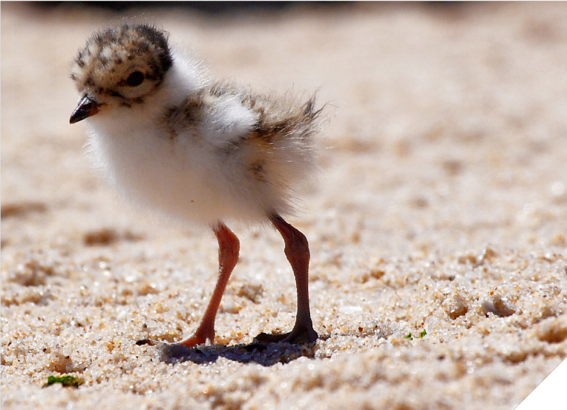

A tiny day old hooded plover chick. Photo: Birdlife Australia

Paul Schefferle Professional Hunter

“We build up a good rapport with the private landowners and land managers who permit us to access their land because they understand the damage done by the foxes. It needs a collaborative approach. The land management boundaries mean nothing to the foxes. It’s frustrating to see foxes returning to areas we’re not permitted to enter. Foxes breed every year so quickly repopulate or overpopulate areas if not controlled”
WHERE TO
FROM HERE?
We are committed to continuous improvement. We will measure and report on progress against this plan’s targets each year and consider how we can evolve the actions and the plan itself.
As a group, our working party will critically evaluate each action to consider its value in achieving our four key goals.
We will remain open minded to new ideas, additional partnerships and fresh approaches, always striving to achieve improved outcomes for the hooded plover.

18

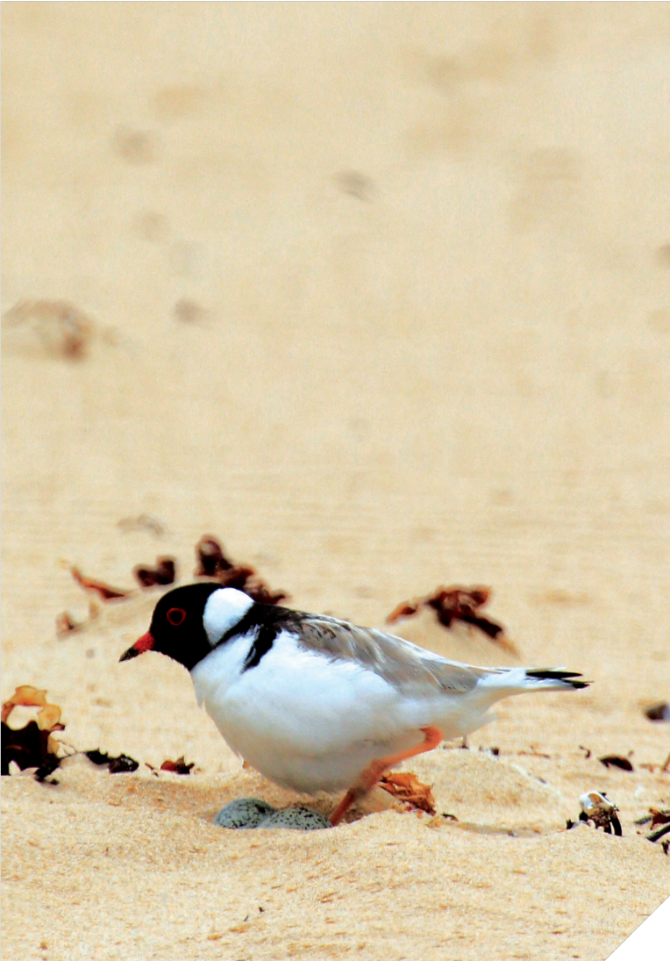
Andrea Dennett

BirdLife Australia Volunteer Coordinator,

Friends of the Hooded Plover, Bellarine Peninsula
“An interest in birds or a conservation issue is enough for some people, but for others it becomes a passion.
The Hoodies are such little battlers and you just want to help them. They have everything going against them, yet they’re resilient and they just keep battling along.
For me, it’s like being converted to a religion. I was converted when a chick hatched on Point Lonsdale beach on the eve of one of the busiest weekends of the year. There were hundreds, perhaps thousands, of people on that beach over the weekend. And there was a wild thunderstorm. Yet, the chick survived it all – the humans, the weather conditions, dogs, foxes and natural predators like gulls and kestrels. When it fledged, we celebrated with champagne on the beach. I was relieved and I was hooked.
We need to keep putting human power towards these chicks. I’ve seen volunteers working like lollipop ladies during the Rip to River event, parting the beach crowds to allow parent birds to get from the nest to the water’s edge and back.
Our typical Hoodie volunteer is 60-plus, female and retired. But we’re all types – we have Liz who recently turned 80 and we have 20-somethings keen to help, too.
Over the last five years or so the City of Greater Geelong has come on board and helped turnaround the program, but the work’s time- consuming and you have to become hardened to the possibility of disappointment. It’s great to be part of a large network of people concerned about Hoodies and other beach nesting birds. Not just our regional coast but interstate and even overseas.”

19







CITY OF GREATER GEELONG
PO Box 104
Geelong VIC 3220
P: 03 5272 5272
E: contactus@geelongcity.vic.gov.au www.geelongaustralia.com.au

CUSTOMER SERVICE CENTRE
Geelong
100 Brougham Street
Geelong VIC 3220 8.00am – 5.00pm
LATEST NEWS:
CityofGreaterGeelong @GreaterGeelong @CityofGreaterGeelong CityofGreaterGeelong

