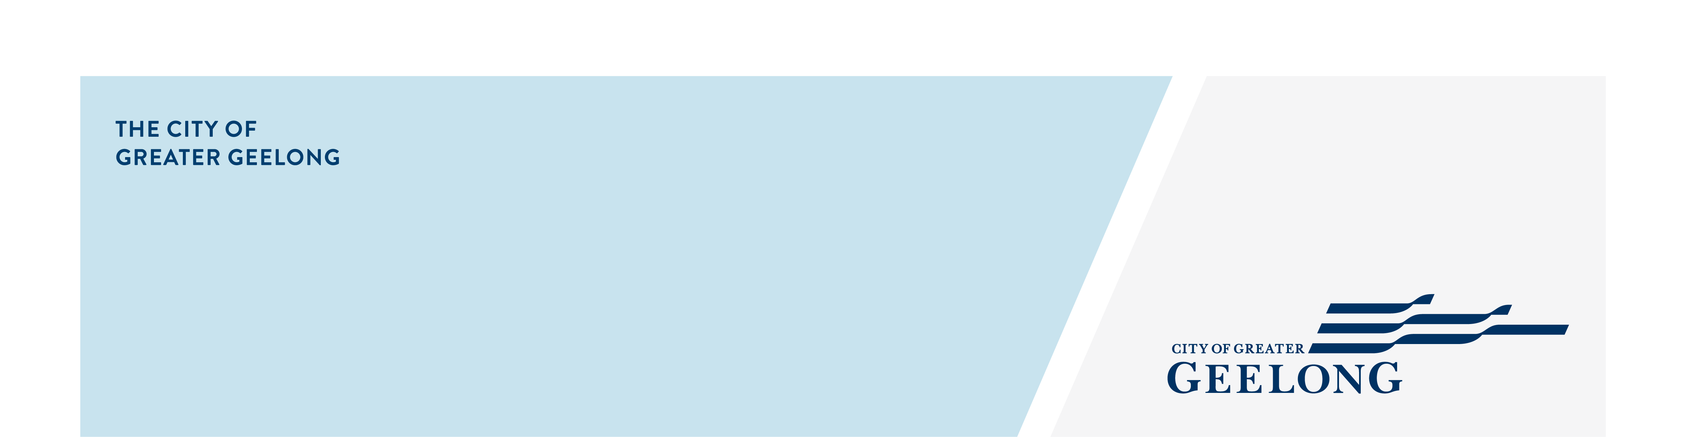
minutes

caos network meeting

16 july 2025, 10:00am-11:30am, geelong regional library

Attendees
Taya Davies (chair), Melissa Bird, Dana Vickers, Sandy McNeilly, Britt Hulbert, Amanda Miggins, Grace Dove, Oliva Dean

Apologies
Lisa Sitlington
- Welcome
Taya Davies completed Acknowledgement of Country

Welcomed everyone to the meeting and introduced the speaker for the meeting.

- City of Greater Geelong – Dana Vickers – Community Engagement
- Dana presented on the role of Community Engagement at the City, how the City is undertaking a Community Engagement Policy Review. She spoke to the types of engagement that are undertaken and how they shape the work that is undertaken at Council.
- Please see session presentation attached.

- Geelong Regional Libraries – Melissa Bird & Sandi McNeilly
- Melissa and Sandy presented about their work in community development and engagement. They spoke to the different ways they connect with community members and the services and programs they deliver.
- Please see session presentation attached.

- Around the Room Discussion
Britt Hulbert – LGBTIQA+ Community Engagement – QHub
- Service expansion to Colac and the inclusion of under 12s in their service provision.
- Recently, five new families have connected to the under 12 services available.
- Visit website for more programs https://ds.org.au/

Amanda Miggins – Senior Community Partnerships Officer – Department of Families, Fairness & Housing
- Amanda provided an update on next Exploring Barwon session.
  - Identity Matters – 30 July, 1:00pm-2:00pm – Registration Link
- Shared information about the Alcohol and Drug Foundation (ADF), which is delivering a series of workshops on systems thinking in 2025. These workshops aim to bring together representatives from local place-based partnerships addressing social disadvantage across Geelong. The overall aims of the project are to:
  - Build on and strengthen existing place-based partnership activity.
  - Provide access to pre- and post-systems maps of the social service system for a specific area.
  - Increase awareness of the activities of aligned place-based networks and partnerships.
  - Identify alignment of efforts, opportunities to reduce duplication, and opportunities to address gaps.
Key contact:
Rusty Brennan, Regional Community Development Manager VIC
0490 914 409
rusty.brennan@adf.org.au

Grace Dove – The Outpost
- New to The Outpost

Olivia Dean – Professor IMPACT Trials– Deakin Uni

- Next Meetings
CAOS Network Meeting – 9 September 2025
Venue: Wurriki Nyal / TEAMS

