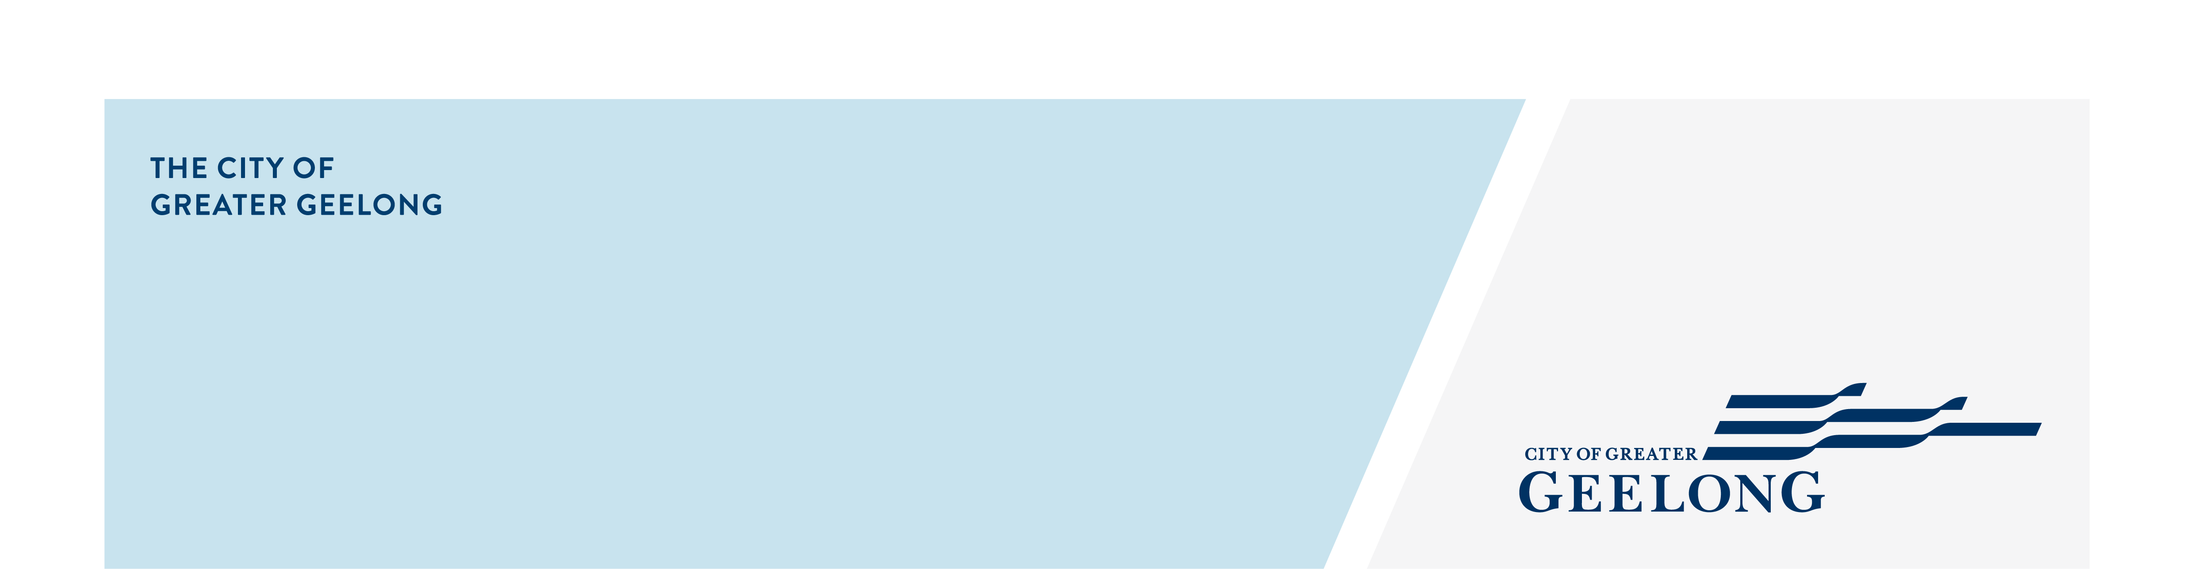
minutes

caos network meeting

3 march 2026, 10:00am-11:30pm, the nest youth hub

Attendees
Lisa Sitlington (chair), Simon Crase, Caroline Caldwell, Marcie Jones, Erica Thompson, Sinead Tobin, Grace Dove, Alison Smith, Sheldan Alexander, Anthea Warlond

Apologies
Libby Preedy, Sally Merryfull
- Welcome
Lisa Sitlington completed Acknowledgement of Country

- City of Greater Geelong – Sheldan Alexander – Social Inclusion Action Group
Sheldan provided an update on the Social Inclusion Action Group and the needs analysis findings on barriers and enablers for connection.

- Around the Room Discussion
Caroline Caldwell – Inclusion Pathway Mentor – The Gordon Skills And Jobs Centre
- Support/Mentor community members who have a disability or barrier with their employment/career journey.
- There is a team who speaks to students/people before applying for free courses to make sure it’s the correct choice.
- Volunteering opportunities are explored which can assist in employment pathway.
- Free Employment & Career Advice at Corio Library, Wednesdays 11:00am-1:00pm - no appointment required
- Centre of Excellence in Disability Inclusion to be completed in 2027, located as The Gordon.
- Reach out with any queries: skillscentre@gordontafe.edu.au
https://www.thegordon.edu.au/industry/skills-and-jobs-centre

Simon Crase – Prevention and Community Engagement Officer – Barwon Community Legal Services
- Changing Minds & Positive Ageing Expo coming up in October.
- Victorian Law Week runs from 18-24 May, having an event with The Good Neighbourhood Project at Norlane.
- Reach out with any queries: simon.crase@barwoncommunitylegal.org.au

Marcie Jones – Community Support Doorways – Salvation Army
- Providing pathways for community members 18 years and over.
- Reach out with any queries: Marcie.jones@salvationarmy.org.au

Sinead Tobin – Women & Mentoring
- Women & Mentoring is a volunteer-based organisation offering an early intervention program that supports women and non-binary people in contact with the legal system.
- Looking for volunteers, 2-day training is provided.
- There is a Lived Experience Peer Group that meets remotely.
- https://www.womenandmentoring.org.au/
- Reach out with any queries: sinead.t@womenandmentoring.org.au

Alison Smith – Carer Engagement Officer - Barwon Health
- Local service outlet for Carer Gateway in the South West Barwon region
- Offer supports, services, events and programs for carers in an unpaid role.
  - Carer Retreats – half day
  - Lunches, walks, movie days
  - Peer support groups
https://www.carergateway.gov.au/
- Reach out for more information: alison.smith2@barwonhealth.org.au

Erica Thompson – Local Connections Program – Mental Health & Wellbeing Local
- At present there are approx. 800 people registered using the service.
- Receiving 250-300 referrals each month, via walk-ins, phone, GP’s
- Monthly newsletter is printed and distributed, if you have any supports, services etc that you would like to offer please email content to Erica (email below).
- Feel free to reach out ggqlocalconnections@barwonhealth.org.au

Grace Dove – Engagement & Operations Lead – The Outpost
- 120 volunteers support the Outpost.
- The Outpost is open 7 days a week providing meals and provisions to about 60 community members per day.
https://www.outpostgeelong.org.au/
- Reach out for more information: hello@outpostgeeling.org.au

Lisa Sitlington – Community Development Project Officer – City of Greater Geelong
- Women in Community Life Celebration Event – 11 March, 5.30pm-7.30pm – Geelong Arts Centre
Registrations: https://tickets.geelongaustralia.com.au/event/iwd2026

- A Lived Experience Workshop – 24 March, 9.00am-12.30pm – Norlane ARC (Aquatic Recreation Centre)
Registrations: Tickets for A Lived Experience Workshop in Norlane from Geelong Australia

- Next Meetings
CAOS Network Meeting – May 2026
Venue: to be advised

