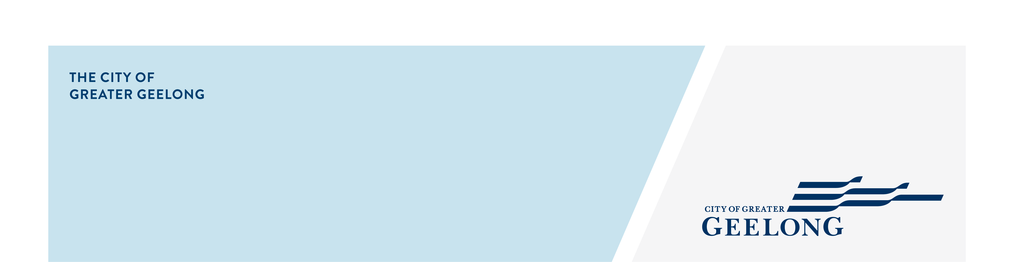
minutes

caos network meeting

6 november 2025, 11:00am-12:00pm, wurriki nyal

Attendees
Lisa Sitlington (chair), Amy Bellia, Simon Crase, Libby Preedy, Narelle Arthur, Taya Davies, Sadhu Spence, Caroline Caldwell, Sally Merryfull

Apologies
Sheldan Alexander, Corinne Telford
- Welcome
Lisa Sitlington completed Acknowledgement of Country

A shortened meeting due to cancellation of speaker, welcomed everyone to the meeting.

- Around the Room Discussion
Libby Preedy – Senior Emergency Management Officer – City of Greater Geelong
- Geelong Recovery Outreach Wider Network (GROWN) Development Project is to cultivate and strengthen connections across Greater Geelong’s diverse community networks, enhancing collaboration and resilience in times of emergency.
Project Objectives
- Strengthen relationships with community groups
- Map and understand community capabilities
- Improve communication and coordination
- Enhance community-led preparedness and recovery
- Promote inclusive and culturally appropriate engagement
- Build local resilience and capacity
- Integrate community networks into emergency planning
Phase 1 focuses on the first 3 objectives (due for completion by end Dec 2025), whilst Phase 2 will look at the remaining objectives (for completion by end Jul 2026).
- Reach out with any queries: libby.preddy@geelongcity.vic.gov.au

Caroline Caldwell – Advisor – Skills And Jobs Centre
- Free Employment & Career Advice at Corio Library, Wednesdays 11:00am-1:00pm - no appointment required
- Free Employment & Career Avice at Armstrong Creek Library, Wednesdays 10:00am-4:00pm – no appointment required
- Term 4 – Getting Australian Job Ready, for new migrants helping them with accounts and documents they will need to work in Australia.
- Reach out with any queries: skillscentre@gordontafe.edu.au
https://www.thegordon.edu.au/industry/skills-and-jobs-centre

Simon Crase – Prevention and Community Engagement Officer – Barwon Community Legal Services
- Positive Ageing event at Club Italia recorded an attendance of 120 people with 40 stallholders on the day, huge success.
- Book Launch (28th November 4:00-5:00pm) of the intergenerational storybook A Life Encyclopedia – I am, I can, I do. This story is a powerful and vibrant collaboration between children’s author Sally Wilson and local artists Samantha Farnsworth and Ruby Lord.
Registrations open via Trybooking - https://www.trybooking.com/DGLUP
- Reach out with any queries: simon.crase@barwoncommunitylegal.org.au

Taya Davies – Senior Community Development Projects Officer – City of Greater Geelong
- Seeking collaborating opportunities on projects.
- Reach out with any queries: tdavies@geelongcity.vic.gov.au

Narelle Arthur – Counsellor – Global Sisters
- Place based space enabling women to make business possible. Offering a free lifecycle business support for women who are unable to participate in mainstream employment or access decent, sustainable work.
- https://globalsisters.org/
- Reach out with any queries: geelong@globalsisters.org

Sadhu Spence – Healthy Community Kitchens - Barwon Health
- Community Kitchen facilitator training, 4th December 9.30am-1.00pm at Grovedale Neighbourhood House, 45 Heyers Rd, Grovedale. For more information: healthycommunities@barwonhealth.org.au
- Reach out for more information: sadhu.spence2@barwonhealth.org.au

Amy Bellia – Employment Pathway Broker - Dept. of Justice Community & Safety
- Always looking for opportunities for collaboration where we can refer our justice clients for support, whether that is for training, education or employment opportunities.
- Exploring Barwon session 26 November, 2:00-2:45pm Register: Microsoft Virtual Events Powered by Teams
- Feel free to reach out amy.bellia@justice.vic.gov.au

Sally Merryfull – Community Engagement Coordinator – Open Door
- Transition to Work Program – helping young people take the next step, supports early school leavers and young people aged 15-24 with intensive, pre-employment assistance to build the skills and confidence needed for meaningful employment or further education.
- Skills for Education and Employment (SEE) program – Free course for eligible participants.
- Community Pathways Expo for CALD Communities on 17th November 12.30pm-2.00pm at Geelong Industry Trade Training Centre (GITTC), Indiana Avenue Corio
- Reach out for more information: sallym@opendoor.org.au
https://opendoor.org.au/

Lisa Sitlington – Community Development Project Officer – City of Greater Geelong
- International Day of People with Disability Event – 3rd December
Registrations: https://tickets.geelongaustralia.com.au/event/idpwd-2025
- 16 Days of Activism against Gender-Based Violence (November 25 - December 10) is a global campaign that aims to end violence against women and girls by raising awareness and encouraging action.
To mark the campaign this year, the Respect 2040 partnership is hosting a 3-part webinar series to engage key audiences, cover critical topics and strengthen prevention efforts.
- Webinar 1: Gendered impact of disasters - Wednesday 26 November 12:00-1:00pm
- Webinar 2: Engaging men and boys – Wednesday 3 December, 12.00 – 1.00pm
- Webinar 3: Community driven change - Wednesday 10 December 12:00-1:00pm
To find out more information and to register for the webinars, visit Respect 2040 – 16 Days of Activism Webinar Series.
- The Sexual Assault and Family Violence Centre is hosting an event for the 16 Days of Activism.
Date: Tuesday 2 December 2025
Time: 9:00am – 1:00pm
Location: GMHBA Stadium, 370 Moorabool St, South Geelong
Tickets: Free – register by 27 November to secure your place.
Registration link: https://events.humanitix.com/together-we-can-collective-conversations-this-16-days-of-activism

- Next Meetings
CAOS Network Meeting – February 2026
Venue: to be advised

