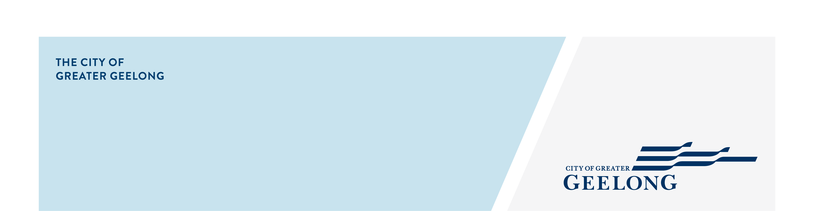
minutes

caos network meeting

9 september 2025, 10:00am-11:30am, wurriki nyal

Attendees
Lisa Sitlington (chair), Britt Hulbert, Grace Dove, Georgia Quill, Bashar Shakour, Simone Armstrong, Nat Nolan, Amy Bellia, Simon Crase, Jennifer Reid, Vongai (CatholicCare)

Apologies
Erica Thompson
- Welcome
Lisa Sitlington completed Acknowledgement of Country

Welcomed everyone to the meeting and introduced the speaker for the meeting.

- City of Greater Geelong – Julia McCusker – Health & Social Equity
- Julia presented on the Home Truths report; this research explores how service providers in Greater Geelong can better support people facing homelessness.
Link to the report: https://www.givewhereyoulive.com.au/resource-centre/advocacy-research
- Please see session presentation attached.
- Questions from Britt Hubbard and Nat Nolan re: homelessness data for the LGBTIQA+ community and People with Disability. Julia to ask the Greater Geelong Homelessness Working Group about the breakdown for LGBTQIA+ and people with a disability within the homelessness service system in Geelong.

- Barwon Community Legal – Simon Crase – Prevention & Community Engagement
- Simon shared details about The Changing Mind and Positive Ageing Expo which is being held at Club Italia on Friday 24th October. There will be guest speakers and a panel discussion, please share with relevant groups and register attendance.
Information and registration link: https://www.trybooking.com/events/landing/1464568
Here is the TedTalk of Dr Lisa Mitchell, she will be one of the speakers at the expo. Reimagining the story of aging | Lisa Mitchell | TEDxBells Beach
- Please see flyer attached.

- Around the Room Discussion
Britt Hulbert – LGBTIQA+ Community Engagement – QHub
- Provide services to the LGBTQIA+ young people and families.
- Work a lot with schools with capacity building and inclusion training.
- Consultants in policies or best practice, anything related to queerness. Known as a one stop shop.
- There are a lot of supports within Geelong for queer folk, people are unaware of how to access them.
- Reach out with any questions: britt.hulbert@ds.org.au
- Visit website for more programs https://ds.org.au/

Georgia Quill – General Manager Community Services – Dept. of Justice
- The next Exploring Barwon “Navigating Alternative Health Pathways with Ambulance Australia” session will have Ambulance Victoria discussing the Triple Zero process as it can be confusing and stressful to people. Also, the other area of discussion will be the new virtual Emergency Department this resource is to help different sectors and their clients.
Thursday 2 October, 11:00am – 11:45am
Registration Link: Microsoft Virtual Events Powered by Teams
- The October Exploring Barwon topic is Harmful Sexualised Behaviour of Young People and Children and facilitated by SAFV Centre.

Grace Dove – Engagement & Operations Lead - The Outpost
- Doors are open every single night to the community.
- Coffee for Compassion campaign – cost of one coffee equals two meals at The Outpost. Have partnered with some local coffee shops.
- Main focus is raising awareness and changing the attitude within the community and out neighbours due to the negative media. Trying to bridge that gap between our guests and neighbours by inviting people to visit and experience our space.
- Looking at creating a social enterprise, a coffee window serving coffee and cake.
https://www.outpostgeelong.org.au/

Bashar Shakour – Community Hub Coordinator - Good Shepherd
- Provide NILS, no interest loans to support clients to purchase white goods, car repairs, rental bonds, vehicles etc.
https://goodshep.org.au/services/loans/
- The Financial Independence Hub (FIH) is a free and confidential service supporting people who have experienced financial abuse to feel more confident with money and plan for the future. It’s not an emergency service.
https://goodshep.org.au/services/fih/
- Reach out for more information: bashar.shakour@goodshep.org.au
https://goodshep.org.au/

Simone Armstrong & Vongai – Counsellor – CatholicCare
- Our counselling team consists of three at present, very busy.
- We work under the banner of Family Relationship Centre, there are many programmes one being Family Dispute Resolution.
https://www.catholiccarevic.org.au/services/family-support/family-dispute-resolution/
- We have the Parenting Orders program which is worked alongside Advanced Care Finder.
https://www.catholiccarevic.org.au/services/family-support/parenting-orders-program/
- Please reach out: simone.armstrong@catholiccare.org.au

Nat Nolan – Leisure Networks
- Partnering with Blind Sports Recreation Victoria to help people who are blind or with low vision to connect to their community, as there isn’t a lot of opportunities out there for them.
- Delivered a Sports Expo at Northern Bay College, working closely with state sporting associations to connect people and show what inclusion and accessibility looks like within local club spaces and places. Had 80 families in attendance.
- Run for Geelong partner, hoping that blind sports participants can walk the Run for Geelong showing that it is accessible for their community.
- Splash Together program, promotes water safety and inclusivity for women from Culturally and Linguistically Diverse (CALD) backgrounds by improving access, building confidence, and strengthening connection in and around water. Provided 20 women from the Afghani community an opportunity to connect with swimming.
- Reach out for more information: nat.nolan@leisurenetworks.org

Amy Bellia – Employment Pathway Broker - Dept. of Justice Community & Safety
- The core objective of an employment pathway broker is around supporting re-offending behaviours.
- Always looking for opportunities for collaboration where we can refer our justice clients for support, whether that is for training, education or employment opportunities.
- Feel free to reach out amy.bellia@justice.vic.gov.au

Jennifer Reid – Child & Family Practitioner - Drummond Street
- New team member at Drummond Street Family Services, with a background in specialised homelessness.
- Work in the therapeutic support space working with young individuals and families that may be experiencing a range of different issues.
- Will be delivering programs, Circle of Security and Tuning into Teens.
- Reach out if you wish to collaborate or require support: Jennifer.reid@ds.org.au

Lisa Sitlington – Community Development Project Officer – City of Greater Geelong
- 2026 Geelong Youth Council Nominations are now open. Looking for 11 young people aged between 12 and 17 years and are passionate about creating change in the community.
https://yoursay.geelongaustralia.com.au/2026-youth-council-nominations
- Geelong Awards for People with Disability. Applications closing Monday 15th September.
https://www.geelongaustralia.com.au/disabilityawards/default.aspx

- Next Meetings
CAOS Network Meeting - November 2025
Venue: to be advised

