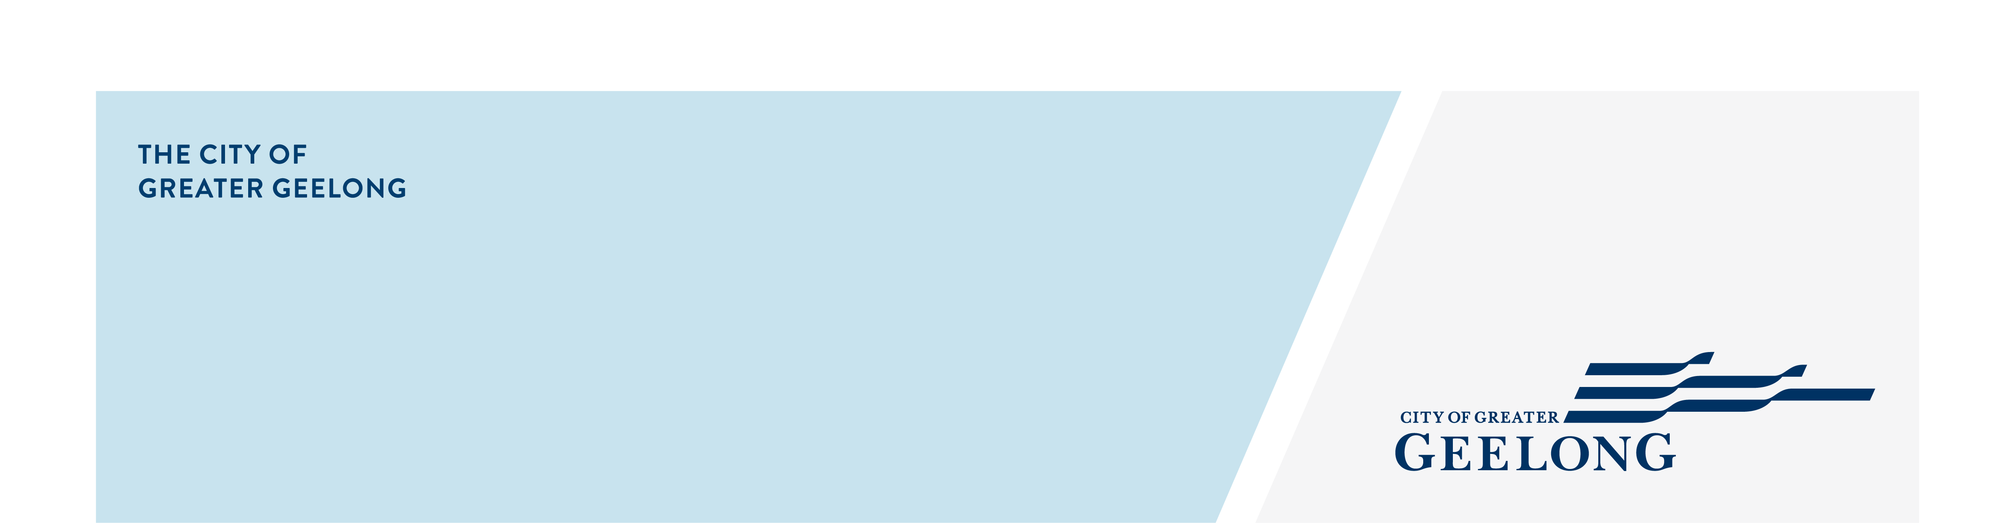
medical bin

application

To complete this form online, please go to www.geelongaustralia.com.au/bins
personal details
first name | SURNAME
property address
suburb | POSTCODE
PHONE NUMBER/MOBILE | RATE NUMBER (on your property’s rates notice)
EMAIL ADDRESS

Medical bin application (2023–24 financial year)
The City of Greater Geelong provides additional bins for medical use free of charge. However, an annual medical certificate must be supplied to maintain this arrangement.

Have you attached a medical certificate to this application?

- Yes
- No (your application will not qualify)

Please describe the additional waste material being generated:

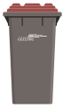
PLEASE TICK ALL THAT APPLY
I would like an ADDITIONAL 140 litre garbage bin (red lid)

I would like to exchange a 120/140 Litre garbage bin for a 240 litre garbage bin (red lid)

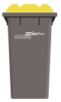
I would like an ADDITIONAL 240 litre recycling bin (yellow lid)

terms and conditions
- A maximum of one additional garbage and/or recycling bin is available for each property.
- The applicant must possess a medical condition requiring disposal of waste that is beyond the capacity of the regular bin service.
- To receive the service free of charge, the applicant must provide a medical certificate as proof, with annual updates for as long as the bins are required.
- Bins will be delivered directly to the property if the applicant meets the eligibility criteria.
- The applicant must only dispose of approved materials in each bin (see www.geelongaustralia.com.au/bins for more information).
- The applicant must maintain the bin in a sound and clean condition, suitable for collection.
- To cancel, go online or request a cancellation form on 5272 5272.
- This arrangement may be reassessed after 12 months, and previous approval does not guarantee future approvals.
- Bins will remain the property of the City of Greater Geelong at all times.
A
Signature ___________________________________________________ Date______________________________________

Return completed form
Email Post Need more information?
wasteadmin@geelongcity.vic.gov.au City of Greater Geelong Contact us on 5272 5272
Attn: Waste
PO BOX 104
GEELONG VIC 3220

Privacy Statement

We will comply with the Information Privacy and Health Privacy Principles as set out in the Privacy and Data Protection Act 2014 and Health Records Act 2001. For more information, search for ‘privacy’ on our website.

