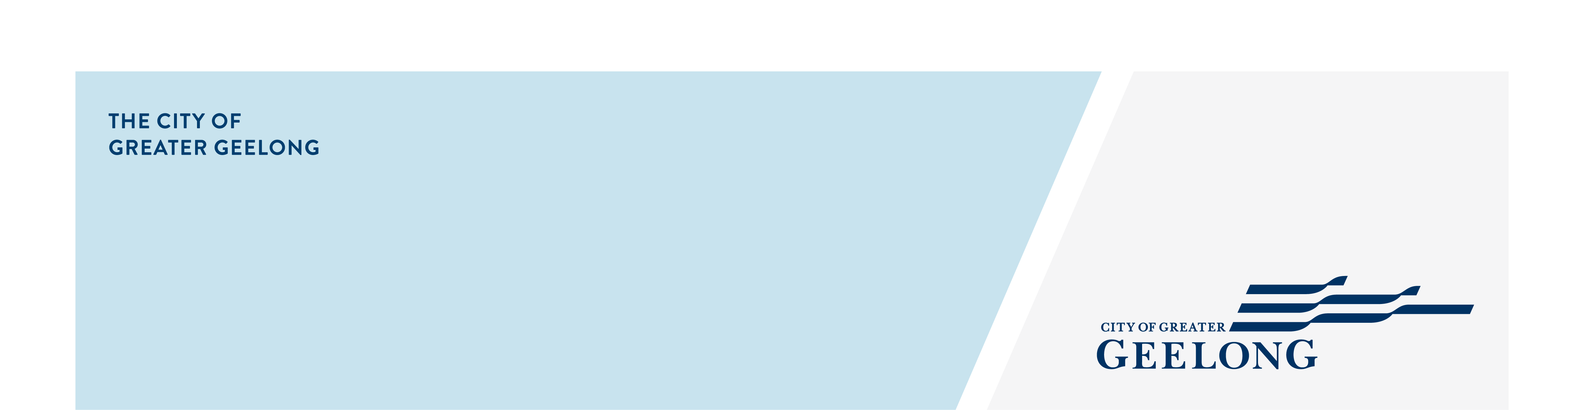
Are you grant ready?

June 2026
This sheet is for community groups that want to apply for a grant. It includes simple tips to help you get ready.
It is general advice only and does not guarantee funding. Always check the grant guidelines, because each grant has its own rules.
Before you apply, work through these three steps.

Be clear about what you want to do (think)
Start by thinking about what you want to achieve and why it matters.
- What does your organisation do?
- Who is in your organisation? (members, volunteers, community)
- What problem or need are you trying to address?
- What activities or actions will help. Do you have a project in mind?
- What do you want to achieve?
- What is the best way to fund your project? Does your group have, or do you need fundraising, sponsorship or a grant?
Remember: identify your issue and decide on your project first, then look for funding.

How will your activity work? (plan)
Think about the practical steps you will put in place.
- Who will help plan and deliver the project?
- Do you have evidence the project is needed?
- Do you need letters of support?
- Have you prepared a budget.
- Do you have a project plan?
- How will you measure success?
- Do you need other documents such as a marketing plan or risk assessment.

Get your information ready (prepare)
Finally collect the details and documents you might need for a funding application.
We have prepared a check list of commonly asked questions and requests for information. Please note you may not need all these items. Make sure you read the guidelines and application form to understand exactly what is need.
Use the checklist to record your answers, so it can be easily shared with other people you are working with.

Funding Application Checklist

Y/N | Information needed | Notes
Organisation basics
Name of your organisation
(This should match the name on your registration documents.)
Any other name your group is known as
(This may be different from your registered name.)
Short description of your group
(This can be a few lines about what your group does.)
 | Year established
Details about your members or participants
(This may include how many people are involved and who takes part.)
Contact details
 | Physical address
 | Postal address
Email address
(Use a group email if you can, not a personal email.)
 | Phone number
 | Website address
 | Social media pages
Financial details
Bank account details
- Name of bank
- Account name
- BSB
- Account number
Proof of bank account
(This may be a bank statement that shows the account name, account number and BSB. Transactions and balances can be hidden.)
Legal and registration details
Type of organisation
(For example, an incorporated association.)
Registration number
(For example, an incorporated association number or ACN.)
 | Australian Business Number (ABN)
 | GST registration
 | Charity status
Rules or constitution
(This explains how your group works. It may also be called a constitution or governing rules.)
Check your details match
(For City of Greater Geelong grants, the legal name, ABN, bank account and insurance details should match.)
Auspice support
(You may need an auspice if your group is not incorporated, cannot apply on its own, or wants administrative or financial support.)
Insurance
Insurance details
- Type of cover (for example, public liability)
- Insurance company
- Policy number
- Expiry date
- Copy of your current insurance certificate
- Will this project be covered?

Committee/Team members
Include the details of committee or team members who approve grant applications and sign documents, such as the grant application or funding agreement, and people who will help plan or deliver the project.

Name | Role | Email | Phone
 | Main contact for the grant
 | President or Chair
 | Vice-President or Deputy Chair
 | Treasurer
 | Secretary
 | Committee member
 | Project team member

