DRYSDALE RESOURCE RECOVERY CENTRE - 2026/2027 PROPOSED FEES
All prices are inclusive of GST and EPA landfill levy

Water Line |  | Heaped
Utilities (up to 0.75m³) | $83.00 | Utilities heaped (up to 1.0m³) | $110.00
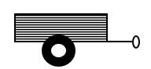 |  | 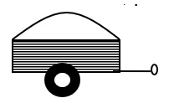
Single axle trailers (up to 0.75m³) | $83.00 | Single axle trailers heaped  (up to 1.0m³) | $110.00
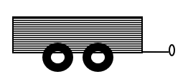 |  | 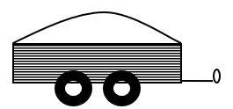
Tandem trailers (up to 1.0m³) | $110.00 | Tandem trailers heaped  (up to 2.0m³) | $220.00
Caged |  | Caged Heaped
Single axle trailers caged  (up to 1.5m³) | $165.00 | Single axle trailers heaped (up to 2m³) | $220.00
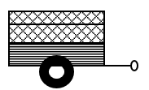 |  | 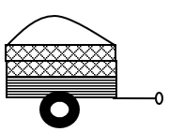
Tandem Trailers caged  (up to 3m³) | $330.00 | Tandem Trailers heaped (up to 4m³) | $440.00
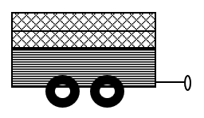 |  | 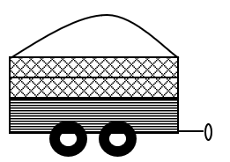

OTHER PRICING

Car half boot load up to 0.5m³ | $21.00 each
Car boot load | $41.50 each
Car tyre up to 1000mm diameter. Limit of 10 | $12.00 each
Car tyre with rim. Limit of 10 | $16.00 each
Truck tyre up to 1200mm diameter. Limit or 10 | $38.50 each
Mattresses any size Limit of 6 | $29.00 each
Fire extinguishers Limit of 6 | $7.00 each
Solar Panels Limit of 5 | $15.00 each
Fridge, Freezers & air conditioners | $20.00 each
Public Asbestos domestic only (must book) | $83.00 each

Where variations in load type occur, a charge of $110.00 per cubic metre will apply.

Enquiries: Drysdale Landfill 5251 2935
DLRRC@geelongcity.vic.gov.au

Beck’s Road (off Murradoc Road) Drysdale
Geelong.link/wastesites

